APPLICATION FOR HOUSEHOLDER PLANNING PERMISSION
DELEGATED REPORT

APPLICATION REFERENCE: | PL/2026/01903
APPLICATION TYPE: | Householder planning permission
SITE ADDRESS: | 57 Whittle Avenue, Calne, SN11 8QN
DEVELOPMENT DESCRIPTION: | Single storey extension to rear & two storey extension to side
RECOMMENDATION: | That Planning Permission be GRANTED

SITE DESCRIPTION/CONTEXT
The subject property is a semi-detached, two-storey dwelling, within the late C20 modern development of Lower Compton, that lies east of Calne, and south of the Hills quarry complex.

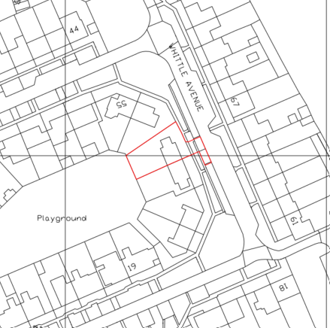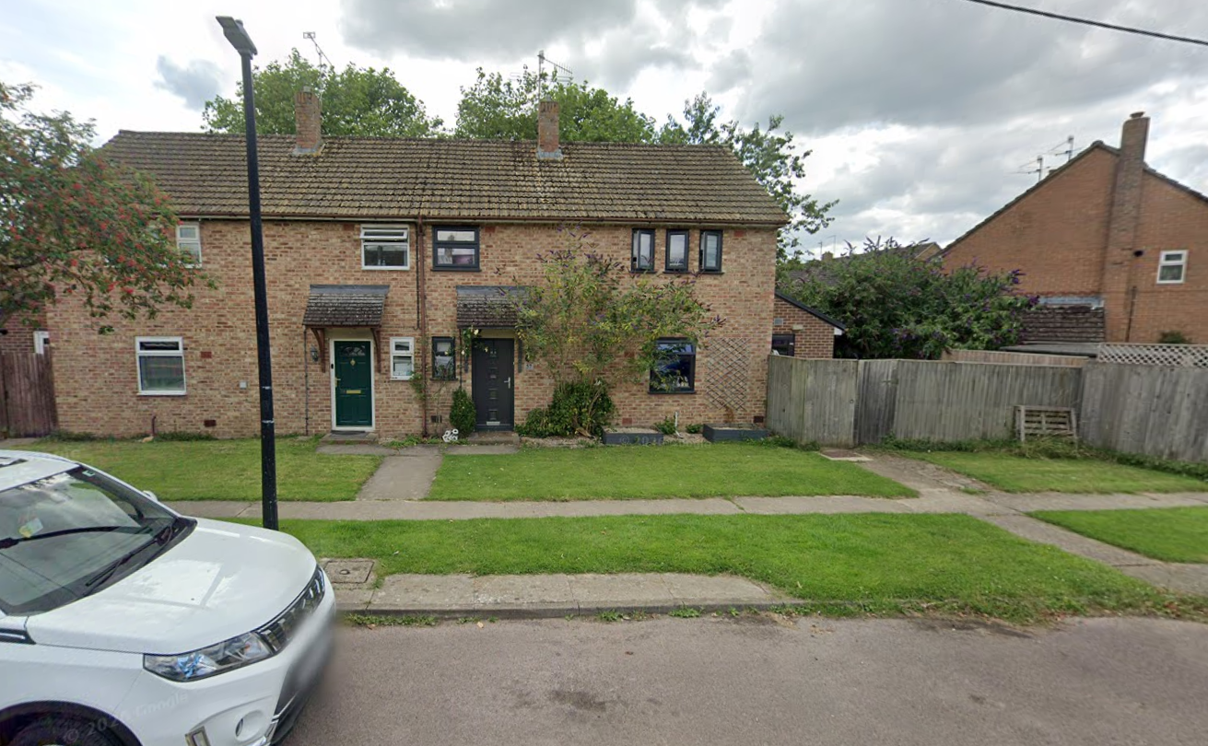

Location Plan and Google Earth Site Photo

The application site is within flood zone 1; of lowest risk but has increased risk of groundwater flooding.

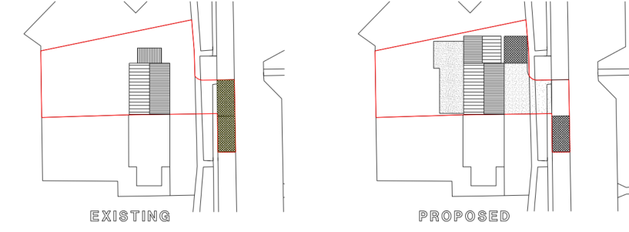

Existing and Proposed Block Plans

PROPOSAL

The proposal seeks planning permission for:
- Demolition of an existing single storey side utility room/store.
- Single storey rear extension (42m²) to create an additional lounge/open plan living.
- Two storey side extension (23m²) to create a GF bedroom, bathroom and utility room, and on the FF a master bedroom with ensuite and dressing room.
- Internal reconfiguration, namely knocking through to create open plan spaces, and corridors, new fenestration.
- Front porch.
- Creation of a disabled parking space in front of the proposed extension, entailing removal of existing allocated on-street parking space to create an access over the footpath which will be retained, install a dropped kerb, and resin-bound gravel over geotextile membrane with a bedding sub base to create new access/parking space.

Proposed materials included brick, concrete tiles, and black uPVC windows/doors, all to match existing, and the introduction of a flat roof.

The property benefits from two on-street parking spaces, one of which would be sacrificed to enable the creation of an off-street parking space in front of the property.

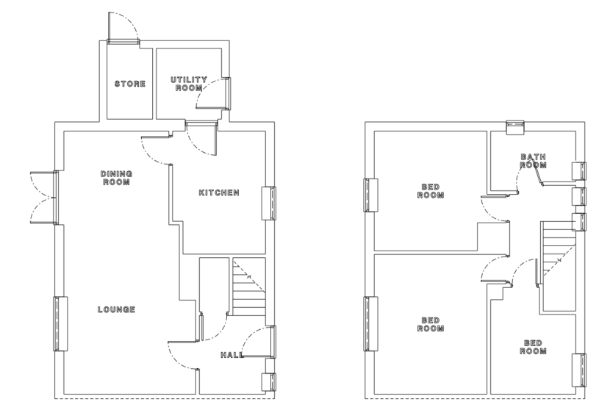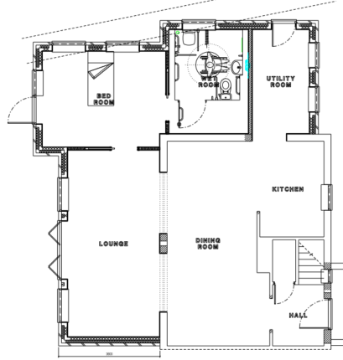

Existing and Proposed Ground Floor Plans

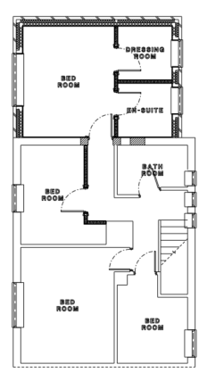

Existing and Proposed First Floor Plans

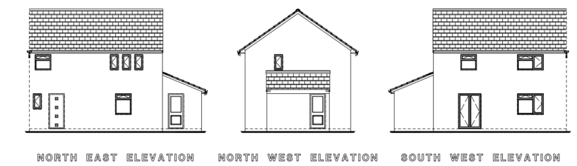

Existing Elevations

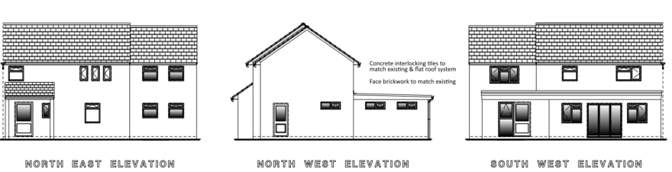

Proposed Elevations

PLANNING HISTORY
19/06406/FUL – proposed two storey side extension and single storey rear extension – approve with conditions – no.51 Dowding Drive
17/08052/FUL – two storey rear extension and front porch extension – approve with conditions – no.70 Whittle Avenue
15/10327/FUL – proposed two storey side extension – approve with conditions – no. 54 Dowding Drive
N/12/04091/FUL – two storey side extension – approve with conditions – no.50 Dowding Drive

RELEVANT POLICIES AND GUIDANCE
The National Planning Policy Framework (NPPF) August 2026
The Planning Practice Guidance
National Design Guide
Wiltshire Design Guide: Appendix D – Design Guidance for Householder extensions

Wiltshire Core Strategy:
- Core Policy 57 Ensuring High Quality Design and Place Shaping
- Core Policy 61: Transport and New Development
- Core Policy 64: Demand Management

Calne Neighbourhood Plan, made 2018.

CONSULTATION RESPONSES

Cherhill Parish Council: No objection, subject to a condition that the property is not subsequently subdivided to form a second dwelling.

Highways: No objection.

REPRESENTATIONS
No comments were received.

ASSESSMENT
Section 38(6) of the Planning and Compulsory Purchase Act 2004 states:

"If regard is to be had to the development plan for the purposes of any determination to be made under the planning Acts, the determination must be made in accordance with the plan unless material considerations indicate otherwise."

In accordance with this statutory requirement, this application has been assessed against the relevant policies of the Development Plan, including the adopted Wiltshire Core Strategy (2015) and, where applicable, any made Neighbourhood Plans.

Design and Impact upon the character and context of the area
Core Policy 57 - Ensuring High-Quality Design and Place Shaping of the Wiltshire Core Strategy seeks to ensure that all new development is of high design quality, reflecting local context, character, and distinctiveness.

It should also be noted that a revised block plan was required, such that all land covered by the application is within the red line site plan. This revised plan remains in line with the submitted certificate B and notification of all parties.

The proposal aims to create additional accommodation to enable independent living for a family member, and open-plan living for inclusive accessibility.

The proposal effectively creates a ground floor annexe, and if a staircase were inserted, a second unit could be created, such that a condition is considered necessary to protect the character of the area.

During the lifecycle of the application, revisions have been received which have enabled a positive outcome, namely a side access door to the ground floor accommodation to ensure the property continues to read as a single dwelling.

Planning history notes similar precedent development in the area for rebuilding side extensions to two storeys. The proposed side extension, by reduced ridge line and matching materials, will enable legibility and successful integration with the host dwelling.

The proposal maximises the available space to the side of the dwelling, improving build quality, gaining floor space and accessibility and whilst a substantial increase of floor area is proposed, it is commensurate to the host dwelling and plot.

Having regard to the above, the proposal complies with the design principles set out in Core Policy 57 of the Wiltshire Core Strategy and Appendix D of the Wiltshire Design Guide.

Amenity
Point vii of Core Policy 57 - Ensuring High Quality Design and Place Shaping of the Wiltshire Core Strategy seeks to ensure that developments do not adversely affect neighbouring properties.

The National Planning Policy Framework (NPPF), particularly Paragraph 135(f), stresses that planning decisions should ensure developments provide a high standard of amenity for existing and future users.

The proposed development has been assessed in terms of its potential impact on the residential amenity of neighbouring properties, with particular regard to loss of light, overshadowing, loss of privacy, and overbearing effects.

Given the proposed flat roof of the rear extension, and spatial gap around the corner to immediate neighbour no.56 beside the proposed 2-storey extension, there are no concerns regarding overshadowing or overbearing.

The proposed development would not give rise to a material loss of light to the neighbouring occupier to the north because the two storey element will sit in the existing shadow of and be subservient to the existing host dwelling. The single storey rear extension will be on an oblique angle to the neighbouring property and at single storey level with a shallow monopitch roof, would not restrict light to habitable rooms of the neighbouring occupiers. Accordingly the proposed development is acceptable in this regard.

The proposal includes clerestory windows facing no.56, at a height to raise no concerns regarding impact to privacy. All other revised and additional windows face down the front or rear gardens, so do not causing negative impact to neighbouring privacy.

The proposal therefore accords with Core Policy 57 point vii in respect of safeguarding residential amenity and Appendix D of the Wiltshire Design Guide.

Highways Impact
Core Policy 57 (xiv) of the Wiltshire Core Strategy seeks to ensure that development must meet the requirements of Core Policy 61. This policy requires proposals to be capable of being served by safe access to the highway network. Core Policy 64 seeks to ensure compliance with parking standards set out in the Local Transport Plan.

The National Planning Policy Framework (NPPF), particularly policies TR3 and TR4 require that development proposals do not have an unacceptable impact on highway safety and that safe and suitable access to the site can be achieved for all users and appropriate parking is provided.

The proposal will increase the property from a 3 to a 5-bed dwelling and as such to meet Wiltshire’s current parking standards, 3 off-street parking spaces are required.

The property is provided with 2 allocated parking spaces adjacent to the road at the front of the property, with the proposal to devote one of these parking spaces and an area of the front garden to create an accessible parking space and access.

Whittle Avenue and the wider estate is not a highway maintained at public expense but remains a private road, such that any parking overspill will be contained within a private estate.

PS6 in the Wiltshire Local Transport Plan (Residential Parking Standards) states that reduced residential parking provision will be considered where any parking overspill can be controlled. The nearest public highway has double yellow lined parking restrictions and it is therefore considered that the application accords with PS6, such that the reduced parking provision is not deemed to cause harm to highway safety.

The proposed development would not result in any adverse impact on highway safety. Adequate parking and turning provision is provided in accordance with Wiltshire’s adopted parking standards, and access arrangements are acceptable.

The proposal is therefore considered to comply with Core Policies 57 (xiv), 61 and 64 of the Wiltshire Core Strategy, the NPPF, and the Wiltshire Local Transport Plan.

Biodiversity Net Gain
Householder planning applications are exempt from the requirement to deliver Biodiversity Net Gain under Schedule 7A, Section 4(2)(a) of the Town and Country Planning Act 1990, as inserted by the Environment Act 2021.

CONCLUSION
The proposed development is considered to be acceptable in terms of its design, scale, and relationship with the surrounding area. It would not result in any unacceptable harm to the character of the locality, the amenities of neighbouring occupiers, nor the interests of highway safety.

The proposal is therefore considered to comply with the relevant policies of the Wiltshire Core Strategy, the Wiltshire Local Plan, and the National Planning Policy Framework. As such, the application is recommended for approval, subject to conditions.

RECOMMENDATION: That Planning Permission be GRANTED subject to conditions.

