Victoria Blackmore/Wiltshire Council
Development Planning Management
Monkton Park Offices
Monkton Park
Chippenham
Wiltshire SN15 1ER
06.08.2026
Dear Victoria Blackmore and Wiltshire Council
5 The Tynings. Objection to Solar Panels on front elevation roof slope. Planning Application. PL/2026/04155. Installation of solar panels to the south-west facing roof of the main dwelling and the roof of the rear extension, together with the demolition of the dilapidated workshop and replacement workshop incorporating biodiversity tower and associated ecological enhancements
Although I appreciate the applicant's desire to renovate this historic building and the importance of renewable energy, I am concerned about the adverse visual impact of the proposed solar panels (now installed) on the prominent front elevation roof slope facing the highway.
1. Alleged adverse visual impact from the highway
Response:
The applicant accepts that the south-west-facing solar panels are visible from the highway; however, visibility should not automatically be considered synonymous with planning harm. The degree of any visual impact should be balanced against the existing character and previous alterations to the terrace, the reversible nature of the installation, and the environmental and energy-efficiency benefits provided.
The installation also supports national policy objectives for renewable energy and the transition to net zero. Improving the energy performance of the property has additionally been discussed with Building Control, who verbally recommended the inclusion of solar generation as part of the wider approach to improving the dwelling's energy performance under Part L.
The location of the panels is functional rather than arbitrary. The four south-west-facing panels provide 1.6 kWp of capacity (45% of overall capacity) and are positioned to exploit afternoon sunlight when other parts of the property become increasingly shaded. The submitted solar assessment confirms that the south-west roof remains illuminated at approximately 4pm while the rear is already significantly shaded.
The representation appears to treat prominence and visibility as synonymous with planning harm. The applicant respectfully considers these to be separate matters: the panels are visible, but the existence and degree of any resulting harm must be demonstrated and weighed against the environmental, renewable-energy and energy-efficiency benefits of the proposal.

On reading the recent past planning history of this site, which included extensions to the property, I agree with the Planning Officers of the Council who felt that this terrace merited non-designated heritage status, and that it met Historic England's guide for such designations. Please refer to planning application PL/2024/03119.

Despite the fact the terrace remains not formally designated a non-designated heritage by the Council the Planning Inspector, in the dismissed Appeal Decision APP/Y3940/D25/3360203, 2nd June 2025, stated in Paragraph 17:-
“I understand that the terrace in which the appeal property is situated is not formally registered as a non-designated heritage asset. Nevertheless, its historic and picturesque appearance makes a direct contribution to the quality of the local street scene. Despite various alterations and extensions, the terrace maintains a relatively consistent appearance along its frontage.”
Non-Designated Heritage Asset Status
The representation appears to place greater weight on the previous Non-Designated Heritage Asset (NDHA) assessment than the subsequent planning history would support.
Application PL/2024/03119 was considered by two planning officers. The first case officer visited the site and progressed the application without identifying the property or terrace as an NDHA. Following a change of case officer due to long-term illness, the subsequent delegated assessment introduced the view that the terrace should be regarded as an NDHA through the planning decision-making process, applying Historic England guidance. This was therefore a planning judgement reached during the later assessment of that particular application, rather than an established heritage designation that had informed the application from the outset. Only one officer identified the Non-designated Heritage Asset status.
The subsequent independent Planning Inspector did not adopt or confirm that NDHA assessment. The Inspector expressly recorded that the terrace “is not formally registered as a non-designated heritage”, while separately recognising its historic and picturesque appearance and contribution to the local street scene. The applicant accepts and respects that assessment of local character.
Since that appeal, two further planning applications have provided Wiltshire Council with a researched Heritage Statement addressing the history, development and significance of the property. Those subsequent assessments have not maintained the earlier NDHA interpretation. This is relevant in demonstrating that the conclusion reached in the delegated report for PL/2024/03119 should not be treated as an established or consistently applied heritage status.
There has also subsequently been wider community consideration of the potential identification of the building and surrounding area through the emerging Neighbourhood Plan. A public consultation/referendum undertaken by Box Parish Council on behalf of the Neighbourhood Plan Steering Group resulted in over 82% of respondents not supporting the proposition that the building or local area met the Historic England threshold for identification as a Non-Designated Heritage Asset. This is not determinative of heritage status in itself, but it provides relevant contextual evidence and demonstrates that the suggested heritage identification does not represent an established or uncontested assessment of the area.
Accordingly, it is considered appropriate for the current application to be assessed on the basis of the available heritage evidence and the property's present planning status, while recognising—as the Inspector did—the historic character and contribution of the terrace to the street scene. The earlier opinion of one case officer that the terrace should be treated as an NDHA should therefore be afforded appropriate weight in the context of the subsequent Inspector's findings, later planning assessments and more recent heritage evidence. To date, no formal evidence has been provided as to why the NDHA status was achieved through the Historic England thresholds.
Furthermore, I note that 1-5 The Tynings is identified on Wiltshire and Swindon Historic Environment Record, MW 180230,
Historic Environment Record – MWI80230
It is acknowledged that Nos. 1–5 The Tynings are recorded within the Wiltshire and Swindon Historic Environment Record under MWI80230. However, some of the historical information originally used to describe the terrace was subsequently found to require clarification and was challenged by the applicant through the submission of primary historical evidence.
In particular, the originally attributed date of the terrace appeared to pre-date the available evidence by approximately 50 years. The applicant subsequently provided historic mapping and supporting documentary evidence to establish a more evidence-based chronology for the development of the terrace. The description of the properties principally as “quarrymen's cottages” was also considered overly simplistic. Primary census information covering the principal period of local quarrying demonstrates that residents of The Tynings and its immediate surroundings represented a range of occupations and trades.
The applicant does not dispute the important historical relationship between Box Hill and the local stone-quarrying industry, nor that a significant proportion of local residents were employed within or associated with that industry. The point is simply that the available primary evidence indicates a more varied social and occupational history than is suggested by describing the terrace exclusively as quarrymen's cottages. The HER entry of Workers Cottages should therefore be considered in the context of the subsequent primary evidence supplied to clarify its historical interpretation.

together with other entries which refer to the importance of Box Hill as an area of historic importance for stone quarrying. For example, Cliff Quarry Box Hill MW 177276 and Hazelbury Quarry MW 177274. The reference to Hazelbury Quarry refers to the fact that Hazelbury probably refers to the whole estate that includes Box Hill.
The terrace, which includes number 5, is therefore a good example of a 19th century terrace of quarrymen's cottages which makes a positive contribution to the character of the area as a former quarryman's settlement and an area of historic stone quarrying importance.

References to Cliff Quarry and Hazelbury Quarry
The representation additionally refers to separate HER entries for Cliff Quarry (MWI77276) and Hazelbury Quarry (MWI77274) as supporting the heritage significance attributed to Nos. 1–5 The Tynings.
These records provide useful evidence of the wider historic importance of quarrying within the Box area. However, they relate to separate sites located some distance from the application property. The representation provides no documentary, functional or physical evidence establishing a direct historical relationship between either quarry site and No. 5 The Tynings or the terrace itself.
The applicant therefore considers that these records should appropriately be regarded as evidence of the wider quarrying history of Box Hill, rather than evidence establishing additional heritage significance for the application property. Any more specific association between these separate HER assets and Nos. 1–5 The Tynings would need to be supported by appropriate historical evidence rather than inferred from their presence within the wider locality.

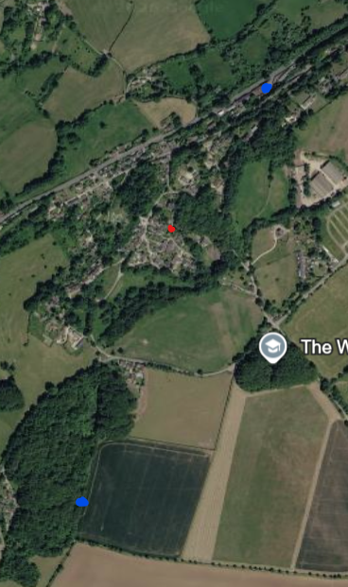
Satellite image of the property identified in red and the two quarry’s in blue
The large solar panels on the front elevation roof slope clearly do not, “preserve the established character of the site.” or “respect the historic character of the property.” as claimed in the supporting Design and Access Statement. The supporting digital 3-D representation of the solar panels and their visual impact on the front elevation of the property/terrace does not accurately represent their true, and full, visual impact.
No photographs have been provided of the terrace, or the property, to show its appearance prior to the fitting of the solar panels.
Character of the Existing Roofscape and Visual Representation
The applicant acknowledges that the solar panels introduce a contemporary element to the front roof slope. However, the assertion that their presence necessarily fails to preserve or respect the established character of the property should be considered against the actual existing character of the terrace rather than an assumption of an unaltered or uniform historic roofscape.
The roofscape of Nos. 1–5 The Tynings already contains a number of visible alterations and variations. These include three roof windows, together with significant differences in the number, form, size and materials of the chimney stacks and pots across the terrace. These features interrupt what might otherwise have been a continuous and uniform slate roofscape and demonstrate that the present appearance of the terrace has evolved over time.
This is consistent with the previous Planning Inspector's assessment, which expressly recognised that the terrace had undergone “various alterations and extensions”, while nevertheless retaining a relatively consistent appearance along its frontage. The applicant considers that this is an appropriate and balanced description of the existing character: the terrace remains readily identifiable and retains its overall architectural form, but it is not an entirely unaltered or homogeneous historic composition.
The proposed solar panels do not alter the underlying roof pitch, ridge, raised stone gable or fundamental architectural form of the dwelling. They are positioned parallel to the existing roof slope and represent a reversible addition associated with improving the energy performance of the property. Their effect should therefore be assessed in the context of the existing, already-varied roofscape and the terrace as it exists today.
With regard to the submitted 3-D representation, this was provided as an illustrative aid to assist in understanding the proposal and was not intended to replace the submitted scaled plans and elevations, which provide the appropriate technical basis for assessing the development. The representation does not identify any specific dimensional or geometric inaccuracy within the 3-D image, and therefore the assertion that it does not show the “true and full visual impact” is not substantiated by any comparative evidence.
The absence of a separate pre-installation photograph should similarly not prevent an objective assessment of the proposal. The previous appearance and established character of the property are documented through the planning history, submitted drawings and other available photographic evidence. Nevertheless, images below have been provided for comparison.

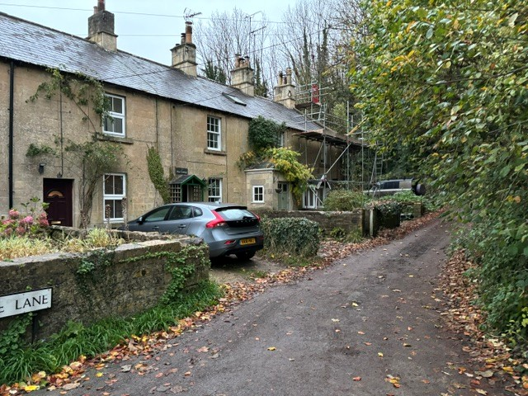
Love lane showing differing windows, chimney, prches, driveways, conservation lights

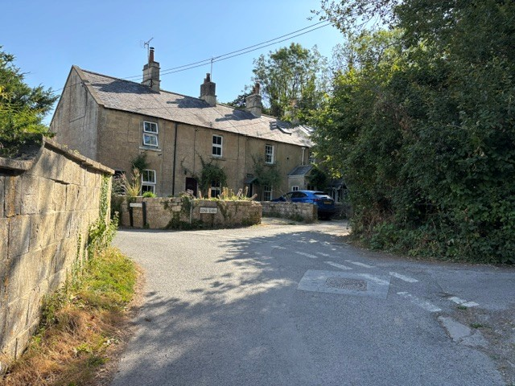
View from Barnetts Hill showing differing chimney materials and construction, missing garden walls, differing windows, porches roofscape
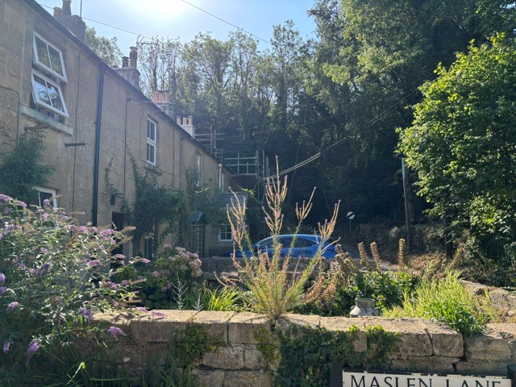
View from Maslen Rd with PV fitted
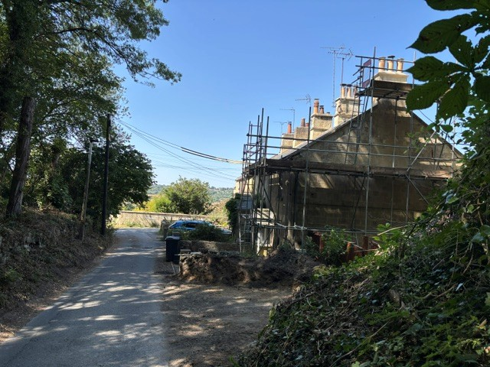
View from Love Lane with PV fitted
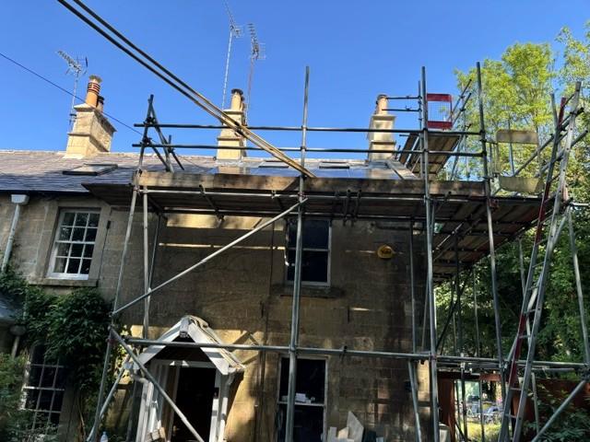
View from South West
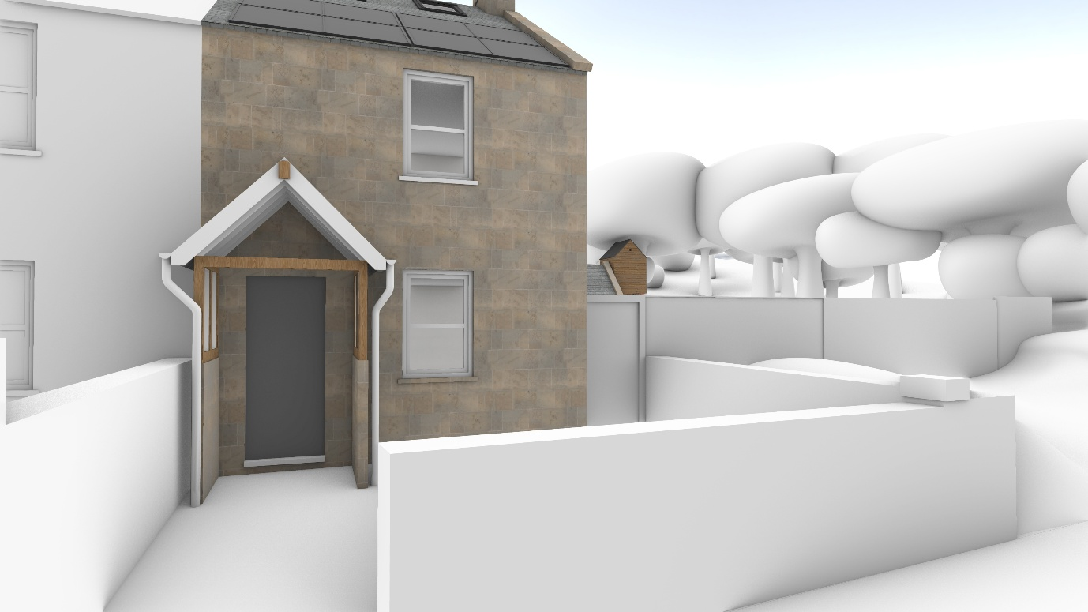
Comparison view from South West
Prior to the erection of the above large solar panels the roof of number 5, and the terrace, was an almost continuous expanse of slates apart from the addition of some small rooflights. The front elevation of the terrace retaining to a large degree its important, intended design uniformity. A consistent appearance, which is also noted by the Inspector in his 2025 decision.
Comprising an array of 8 large solar panels, and stretching for the most part the whole width of the cottage at number 5, and on its front elevation, the panels are an incongruous, dominant feature, interrupting the continuity, scale of the roofscape and the homogeneous use of slate on the terrace. The solar panels are in marked contrast in terms of material used in their construction, colour, size and pattern to the slates used on the roof. Their adverse visual impact, harm, emphasised by their installation some distance above the existing roof slates, they stand proud of it, and the fact that they are located remarkably close to the attractive raised stone coping detail on the gable of number 5.

Visual Impact, Roofscape and Gable Coping
The objection materially overstates the scale of the installation. It refers to an array of eight solar panels on the front roof slope, whereas the submitted proposal comprises four panels on this elevation. This is clearly shown within the Design and Access Statement, elevation drawings and 3D visualisations submitted with the application. The assessment of visual impact should therefore be based upon the four-panel arrangement actually proposed.
It is accepted that the four panels extend across a significant proportion of the roof slope and introduce a different material into the existing slate roofscape. However, the panels do not extend across the full width of the cottage, as suggested by the objection. Their layout and orientation have been deliberately selected to reduce their visual prominence.
The panels are installed in portrait orientation, which limits the vertical extent of the array on the roof slope and maintains greater areas of visible slate above and below the installation. This also reduces their apparent height when viewed obliquely from the highway, rather than creating a taller and more prominent array extending further up the roof slope.
The panels are black, with a low-reflective finish. While clearly distinguishable from the natural slate, their dark and visually recessive appearance provides a substantially closer relationship with the existing dark slate roof than would be the case against a lighter or more contrasting roofing material. The installation should therefore be assessed in the context of the roof as it actually exists rather than simply on the basis that the materials are different.
The suggestion that the installation adversely affects the raised stone coping to the gable is also not supported by the proposed arrangement. The panels do not cover, intersect or physically encroach upon the stone coping, which remains fully visible and legible as an architectural feature. A clear separation is maintained between the solar array and the coping detail.
The panels are approximately 180 mm above the plane of the roof slope. This is a conventional roof-mounted arrangement and has been designed to keep the equipment as close to the roof plane as reasonably practicable, consistent with the approach to minimising visual effect contained within Schedule 2, Part 14, Class A of the Town and Country Planning (General Permitted Development) (England) Order 2015, as amended.
Accordingly, while the proposal inevitably introduces a visible modern renewable-energy installation to the roof, the description of an eight-panel array extending across effectively the whole roof and adversely affecting the gable coping does not accurately describe the development before the Council. The planning assessment should instead be based upon the submitted four-panel scheme, its limited projection from the roof, dark low-reflective finish, portrait arrangement and retained separation from the architectural detailing of the building.

The 8 large solar panels also create a cluttered appearance to the roof of the historic property, and this also detracts from the appearance of the historic terrace.
Proposals for the solar panels on the front elevation roof slope do not conserve the character of the historic cottage/terrace or the wider area but cause visual harm.
The continued use of the property is not dependent on solar panels attached to the front elevation roof slope. Electricity generated from the panels on the front elevation, which to a degree appears compromised by surrounding tree canopies, benefits the householder through the reduction in energy costs. However, these appear predominantly private, rather than substantial public or environmental benefit, and of a small scale.
Environmental and Public Benefits
The assertion that the continued use of the property is not dependent upon the solar panels is not considered relevant to the assessment of their environmental benefit. There is no requirement for a renewable-energy installation to be essential to the continued occupation of a dwelling before the benefits of renewable generation can be afforded weight in the planning balance.
The suggestion that the benefits are predominantly private because the installation reduces the householder's electricity costs also presents an incomplete assessment. While reduced electricity expenditure is clearly a private benefit, it is a consequence of generating and consuming renewable electricity on site and does not negate the wider environmental benefits of doing so.
Generation at the point of consumption reduces the amount of electricity that the property needs to draw from the distribution network. Electricity generated and consumed on site also avoids some of the transmission and distribution losses associated with electricity supplied from more distant generation. When generation exceeds immediate household demand, the proposed battery system allows energy to be stored for later use, further increasing the proportion of locally generated electricity consumed within the property.
The comment regarding surrounding tree canopies also appears to be an assumption rather than an assessment supported by generation or shading evidence. The submitted system has deliberately been distributed across different roof orientations to provide generation at different periods of the day. The four south-west-facing panels provide an important afternoon generation component, complementing the panels on the other roof slope and the proposed battery storage.
It is accepted that a four-panel array represents a relatively small individual contribution. However, domestic renewable-energy generation is inherently delivered through the cumulative contribution of many individual installations. Its environmental benefit cannot reasonably be dismissed simply because each individual domestic installation is modest in scale.
The proposal therefore provides both private and wider environmental benefits. Any reduction in household energy costs does not alter the fact that the installation generates renewable electricity at the point at which it is consumed, reduces reliance upon grid-supplied electricity and forms part of the wider transition towards decentralised low-carbon energy generation.
Accordingly, the planning balance should consider the actual environmental contribution of the proposed installation alongside its visual effects, rather than characterising its benefits as predominantly financial or private.

It appears there are other practicable alternative locations for solar panels, where additional renewable generation can be achieved, thereby minimising harm to the external appearance of the cottage/terrace when seen from the highway and its prominent and attractive front elevation. For example, solar panels used on the rear roof slope of the main building and on its rear lean-to roof, or on the roof of the proposed outbuilding. If the location of the new outbuilding does not lend well to additional panels on the roof for generating electricity perhaps it could be moved to a better location in the rear garden, and solar panels then attached to the roof.
Ground mounted solar panels in the rear garden may also be considered as a way of achieving alternative additional renewable energy, whilst minimising impact on the prominent and attractive front elevation of this historic building and terrace.
Suggested Alternative Locations for Solar Panels
The objection identifies a number of possible alternative locations for solar panels. However, no technical assessment, shading analysis, generation calculation, cable-loss assessment, ecological assessment or landscape assessment is provided to demonstrate that these locations represent practicable or preferable alternatives to the submitted scheme.
The fact that another part of the site could physically accommodate solar panels does not, by itself, establish that it represents an equivalent or effective location for renewable-energy generation.
The proposed solar installation has been designed as a whole-property energy system, with panels positioned on different roof orientations to generate electricity at different periods of the day. The rear-facing panels provide generation earlier in the day, while the four south-west-facing panels provide an important afternoon generation component. This complements the proposed battery storage and allows a greater proportion of the electricity to be generated close to the time and place at which it is consumed.
The suggestion that further panels should simply be placed on the rear roof slope therefore does not provide an equivalent alternative. Additional panels with the same orientation would tend to reproduce the same generation profile rather than providing the later-day generation achieved by the four south-west-facing panels. The suggestion does not also consider the available roof space and practicality of mounting to the rear of the property.
Similarly, the suggestion that the proposed outbuilding should be relocated within the garden specifically to accommodate solar panels goes considerably beyond identifying an alternative panel position. The location of an outbuilding must be considered against its own planning, functional, landscape and ecological constraints. Moving an entire building solely to create a different orientation for solar generation cannot reasonably be assumed to represent a preferable planning solution without an assessment of those consequences.
Ground-mounted panels would likewise introduce development into the garden and wider landscape rather than utilising an existing developed roof surface. No assessment has been provided to demonstrate that such an arrangement would result in less overall environmental or landscape impact. The use of existing buildings and previously developed surfaces for renewable-energy infrastructure also avoids unnecessary additional occupation of undeveloped land.
There are also practical considerations associated with locating generation progressively further from the point of consumption, including additional cabling, installation works and electrical losses. While such losses may individually be modest, they form part of the proper technical comparison between alternative locations and should not simply be disregarded.
Most importantly, the submitted proposal should be assessed on its own planning merits. The relevant question is whether the four-panel south-west-facing installation causes an unacceptable degree of harm when its actual visual effect is balanced against the renewable-energy and environmental benefits of the scheme. The existence of hypothetical alternative locations does not itself demonstrate that the submitted location is unacceptable.
The suggested alternatives are therefore acknowledged, but they have not been supported by evidence demonstrating their generation performance, shading, electrical efficiency, ecological implications, landscape effects or overall practicability. They should consequently not be treated as equivalent alternatives to the technically integrated scheme that has actually been submitted for determination.

I hope my comments are helpful to officers, and Wiltshire Council, in their consideration of this application.
Overall Summary and Planning Balance
The comments made by Mrs Banks are acknowledged and the concern regarding the introduction of solar panels onto the south-west-facing roof slope is understood. It is accepted that the panels will be visible from the highway and that they introduce a modern material into an established slate roofscape. The applicant does not seek to suggest otherwise.
However, it is important that the application is determined on the basis of the development actually proposed and the evidence before the Council, rather than assumptions about its scale, performance, purpose or possible alternative locations.
In particular:
- The proposal comprises four panels on the south-west-facing roof slope, not eight. This is consistently demonstrated within the submitted Design and Access Statement, elevations and 3D visualisations.
- The panels do not occupy the entire width or height of the roof. Their portrait arrangement has deliberately been selected to limit their vertical extent and visual prominence.
- The panels have a black, low-reflective finish, providing a relatively recessive appearance against the existing dark slate roof.
- The array does not cover, intersect or encroach upon the raised stone gable coping, which remains visible and legible as an architectural feature.
- The panels project approximately 180 mm from the roof plane and have been designed to remain as close to the roof as reasonably practicable.
- The four south-west-facing panels perform a specific function within the overall energy system by providing later-day renewable generation, complementing generation from the differently orientated panels and the proposed battery storage.
- The benefits of the installation are not solely financial or private. Generating renewable electricity at the point of consumption reduces demand for grid-supplied electricity and contributes, albeit at an individual domestic scale, to wider carbon-reduction and renewable-energy objectives.
- Assertions regarding significant tree shading have not been supported by a shading or generation assessment.
- The suggested alternative locations have similarly not been supported by comparative calculations or assessments addressing generation, orientation, shading, cable runs and losses, ecology, landscape effects or overall practicality.
- Relocating the proposed outbuilding or introducing ground-mounted panels into the garden would themselves have planning, landscape, ecological and practical consequences and cannot simply be assumed to represent less harmful alternatives.
The applicant therefore accepts the legitimate planning question raised by the objection: whether the visual effect of four solar panels on this roof slope is acceptable. What is disputed is the characterisation of that effect as necessarily causing unacceptable harm, particularly where parts of the objection rely upon an incorrect number of panels or upon assumptions for which no supporting assessment has been provided.
The installation is also reversible. Unlike the permanent alteration or removal of historic fabric, the panels and their mounting system can be removed in the future, allowing the underlying slate roof and its overall form to remain.
The planning balance should therefore be based upon the actual four-panel proposal: its limited projection, dark non-reflective appearance, separation from the stone coping, reversible nature and its functional contribution to an integrated renewable-energy and battery system.
The applicant respectfully submits that the limited visual change resulting from four carefully positioned panels should be weighed proportionately against the environmental benefits of generating renewable electricity at the property. Visibility from the highway does not, in itself, amount to unacceptable visual harm.
For these reasons, it is considered that the proposal represents a proportionate and carefully considered intervention which retains the fundamental form and architectural detailing of the terrace while enabling a modest but meaningful contribution towards renewable-energy generation and reduced reliance upon grid-supplied electricity.

Yours faithfully
Mrs A Banks

