HOUSEHOLDER PLANNING PERMISSION & LISTED BUILDING CONSENT
CASE OFFICER REPORT

APPLICATION REFERENCE: | PL/2026/03118 & PL/2026/03450
APPLICATION TYPE: | Householder Planning & Listed Building Consent.
SITE ADDRESS: | 23 St Margarets Street, Bradford On Avon, BA15 1DN
DEVELOPMENT DESCRIPTION: | To replace the existing cladding (part of which is damaged) on the garage walls and the side basement wall of the house.
RECOMMENDATION: | Approve with Conditions.

PROPOSAL
The proposal seeks planning permission and listed building consent for the replacement of existing exterior cladding on the garage walls and side basement wall of the main house. The external cladding which is already there in place, is aged, damaged and needs to be replaced.

SITE DESCRIPTION/CONTEXT
23 St Margarets Street, is two storey end of terrace building located within the Market Town of Bradford on Avon. The property is situated on the east side of the A363 spinal route out of the town and to the south of the main railway line into Bradford on Aon, the area is residential in character where there are a number of established dwellings in place. The host property is set back from the road within its own domestic curtilage.

The site lies within the Bradford on Avon Conservation Area, and the building is of Grade II listed status. The immediate vicinity has an established developed residential character, with a grouping of similar buildings, garden land and some ancillary domestic buildings within the vicinity. The site is located within an area of ecological designation within the Bath and Bradford on Avon Bat SAC.

RELEVANT PLANNING HISTORY
Proposal / Summary
W/14/11326/LBC Refurbishment of the interior lower ground floor, and repairs and improvements to recent exterior extensions. Approved.
W/14/11273/FUL Repairs and improvements to recent exterior extensions. Approved.
W/00/01605/LBC & W/00/01116/LBC Removal of fence and gate and erection of 1.8m high stone wall. Approved.
PL/2025/09899 Internal alterations to install a bathroom on the top floor of the house. Approved.

RELEVANT POLICIES AND GUIDANCE

Wiltshire Core Strategy:

- Core Policy 57 Ensuring High Quality Design and Place Shaping
- Core Policy 58 Ensuring Conservation of the historic environment
- Core Policy 50: Biodiversity and Geodiversity
- Core Policy 51: Landscape
- Core Policy 58: Ensuring the Conservation of the Historic Environment
- Core Policy 61: Transport and New Development
- Core Policy 64: Demand Management
- Core Policy 67: Flood Risk

Bradford on Avon ‘made’ Neighbourhood Plan; Conservation Area.
Wiltshire Design Guide: Appendix D – Design Guidance for Householder extensions

The National Planning Policy Framework (NPPF Revised on 17.08.2026)

The Planning Practice Guidance

National Design Guide

Emerging Wiltshire Local Plan:
At Full Council on 19 May 2026, the elected members of Wiltshire Council agreed to withdraw the emerging Wiltshire Local Plan. The said Plan has no material weight for the purposes of the application.

In accordance with Regulation 19 of the Town and Country Planning (Local Planning) (England) Regulations 2026, on 30th June 2026 Wiltshire Council published a notice of intention to prepare a new local plan for Wiltshire. The next stage is a Scoping Consultation which commences on 2nd September 2026. This plan is at a very early stage and currently carries no weight for decision making.

CONSULTATION RESPONSES
Bradford on Avon Preservation Trust: Object to the application and comment that the cladding should be constructed from natural timber and of an appropriate colour.

Bradford on Avon Town Council: Object to the application and also comment that the cladding should be constructed from natural timber and of an appropriate colour.

Conservation Officer: No objections and offers comments in support, as discussed within this report.

REPRESENTATIONS
No comments were received.

PRINCIPLE OF THE PROPOSAL.
The principle of the proposed scheme is acceptable for the reasons as discussed below.

ASSESSMENT
Section 38(6) of the Planning and Compulsory Purchase Act 2004 states:

"If regard is to be had to the development plan for the purposes of any determination to be made under the planning Acts, the determination must be made in accordance with the plan unless material considerations indicate otherwise."

In accordance with this statutory requirement, this application has been assessed against the relevant policies of the Development Plan, including the adopted Wiltshire Core Strategy (2015).

Design and Impact upon the upon the character and context of the area

Core Policy 57 - Ensuring High Quality Design and Place Shaping of the Wiltshire Core Strategy seeks to ensure that all new development is of high design quality, reflecting local context, character, and distinctiveness.

The proposals can be viewed within the plan snippets taken from the submitted plans:

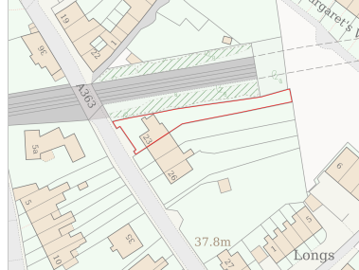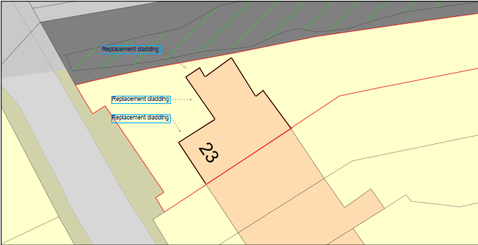
Location Plan Site Plan

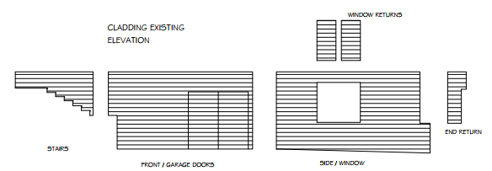
Existing Elevations.
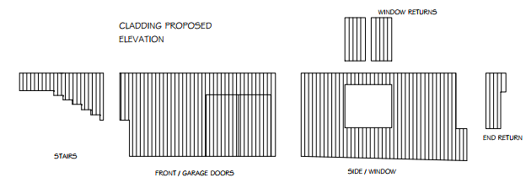
Proposed Elevations.

The proposal would see the removal of the existing cladding which would be replaced with new cladding on a like for like basis. The replacement cladding would be constructed from a cedar effect composite material and would be located on the recently constructed modern garage and the side basement wall of the property, these would be located on the north west side of the property, with the modern additions having no historic significance. The previous 2014 permission relates to the cladding and so the principle for its use and retention is well established. The proposed scheme would hang the cladding in a vertical manner and would change the colour from grey to brown.

The principle and design of the replacement cladding is acceptable and accords with Core Polies 57 and 58 of the Wiltshire Core Strategy.

Amenity
Point vii of Core Policy 57 - Ensuring high-quality Design and Place Shaping of the Wiltshire Core Strategy seeks to ensure that developments do not adversely affect neighbouring properties.
At the national level, Policy DP3 of the National Planning Policy Framework requires development proposals to respond positively to their context and integrate with and enhance their surroundings. Development should also reflect, where relevant, the principles of liveability, climate resilience, nature, movement, built form, public space and local identity

The proposed re-cladding would serve to improve the visual aesthetics of the site as the current cladding is old and in need of replacing. As the cladding would face away from neighbours, it would not harmfully impact on neighbouring amenity and so the proposal therefore accords with Core Policy 57 in terms of visual amenity.

Heritage Impact – Listed Building & Conservation Area.
From the point of view of the historic environment the main statutory tests are set out within the Planning (Listed Building and Conservation Areas) Act 1990.

Section 66 requires that special regard be given to the desirability of preserving listed buildings, their settings or any features of special architectural or historic interest which they possess.

Section 72 and 16(2) of the Planning (Listed Building and Conservation Area) Act 1990 and Core Policy 58 of the Core Strategy requires the Council to pay special attention to the desirability of preserving or enhancing the character or appearance of the Grade II listed building and also the surrounding designated Conservation Area.

The NPPF at section 20 relates to and deals with ‘Conserving and enhancing the historic environment’ and more specifically subsection HE4: ‘Securing the conservation of heritage assets’ relates to the conservation and maintenance of the heritage assets, which in this case is the replacement of the existing cladding.

The Council’s Core Strategy Policy CP58 ‘Ensuring the conservation of the historic environment’ requires that designated heritage assets and their settings will be conserved, and where appropriate enhanced, in a manner appropriate to their significance and encourages proposals which improve the condition of heritage assets at risk.

The Grade II listing for 23 St Margarets Street is as follows:

Small terrace, formerly known as Victoria Terrace. Mid to late C19. 2 storeys plus attic and basement. Ashlar. Pilasters divide the front. Stringcourse. Ground floor partly with banded rustication. Hipped slate roof with 2 wooden dormers, with paired round-headed lights and barge-boards with pinnacles. Dormer roofs have deeply projecting eaves supported by moulded brackets. Sash windows in plain reveals on upper floor, thin glazing bars. Round-headed lights in twos and threes with projecting
surrounds on ground-floor. 2 doorways (numbered as Nos 2 and 3) with entablature and pediment with finial over, supported by pilasters flanking the door. 6-panel wooden doors with rectangular fanlights. Garden wall along the street of rusticated blocks supporting openwork balustrade incorporating a circular motif. 4 pairs of gatepiers with entablatures and copings on top. Steps up inside the wall towards the terrace.

Nos 23 to 26 (consec) and garden wall form a group.

Listing NGR: ST8263860660

The significance of the building lies in its historic past and architectural merits, its form, layout and architectural expression/detailing and the use of high-quality ashlar stone material also contributes to the character of the principal building and that of the surrounding conservation area.

The Bradford on Avon Conservation Area derives part of its character from the presence of such ashlar stone constructed buildings, vernacular materials, informal spaces and the general built form, with No. 23 making a positive contribution to that character.

The ‘Design, Access and Heritage Statement’ clarifies that the proposed fabric would be ‘vertical cedar effect composite cladding’, this therefore confirms that the materials are modern and that it meets the requirements of the NPPF. As previously described, the cladding would be replaced on a like for like basis.

The council’s Conservation Officer has been consulted, who is supportive and has not raised any objections and has commented:

‘The proposed works look to replace the damaged modern composite cladding with the same product and colour. This is considered to be a ‘like-for-like’ replacement of a modern finish and therefore there is no harm to the significance of the listed building or to the character of the conservation area’

Officers consider the use of the cladding would be appropriate even though the colour would change from grey to a brown timber effect colour, which would sit alongside the Bath stone colour; it is concluded that the character, setting and significance of both the listed building and Conservation Area would also be retained for the future.

Ecology Impact CP50 requires no net loss of biodiversity on site. The site is located within the Bath and Bradford on Avon Bat SAC, however, due to the minor nature of the proposed works, located within an established residential area, it is considered unlikely to result in harm to any ecology of the area. However, it is considered necessary to include the council’s standard informative relating to bats.

Biodiversity Net Gain. This application is exempt from the requirement to deliver Biodiversity Net Gain under Schedule 7A, Section 4(2)(a) of the Town and Country Planning Act 1990, as inserted by the Environment Act 2021, because the proposal is in part a householder application and is also de minimis.

CONCLUSION
The proposed development is acceptable in terms of its design, scale, and relationship with the host building and also the surrounding area. It would not result in any unacceptable harm to the character of the locality, the amenities of neighbouring occupiers, or the interests of heritage or ecology.

The proposal is therefore considered to comply with the relevant policies of the Wiltshire Core Strategy, the Wiltshire Local Plan, and the National Planning Policy Framework. As such, the application is recommended for approval, subject to the conditions set out below.

RECOMMENDATION: Planning Permission and Listed Building Consent be GRANTED subject to conditions.

Location plan received on 14.05.2026. Site Plan received on 01.06.2026. Existing cladding elevations,
Proposed cladding elevations, Floor Plan received on 27.05.2026

Heritage, Design & Access Statement received on 14.05.2026. Planning application form received on 02.06.2026

