Bartlett Tree Experts

Planning Permission Application
Property Address: Kwik Fit, Old Station Yard , Gloucester Road, Malmesbury, Wiltshire SN16 9JS

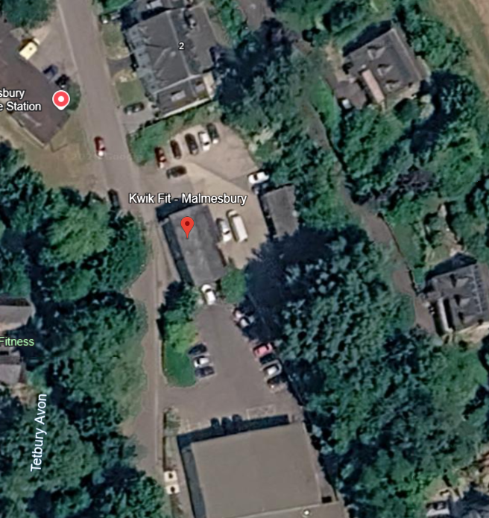
G1: Mixed Species:
Location: Behind garage building
Specification:
• Prune for 3m building clearance
• Crown raise to clear buildings by 3m

