APPLICATION FOR HOUSEHOLDER PLANNING PERMISSION
DELEGATED REPORT

APPLICATION REFERENCE: | PL/2026/02267
APPLICATION TYPE: | Householder planning permission
SITE ADDRESS: | The Willows, 7B Stormore, Dilton Marsh, Westbury, BA13 4BH
DEVELOPMENT DESCRIPTION: | Proposed timber shed in garden.
RECOMMENDATION: | That Planning Permission be GRANTED

SITE DESCRIPTION/CONTEXT
The subject property is a detached bungalow in the village of Dilton Marsh, in an area of modern development leading north off the historic street through what was once the historic hamlet of Storemore and Red Pit (farmhouse to the north of the subject dwelling).

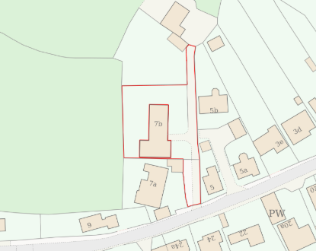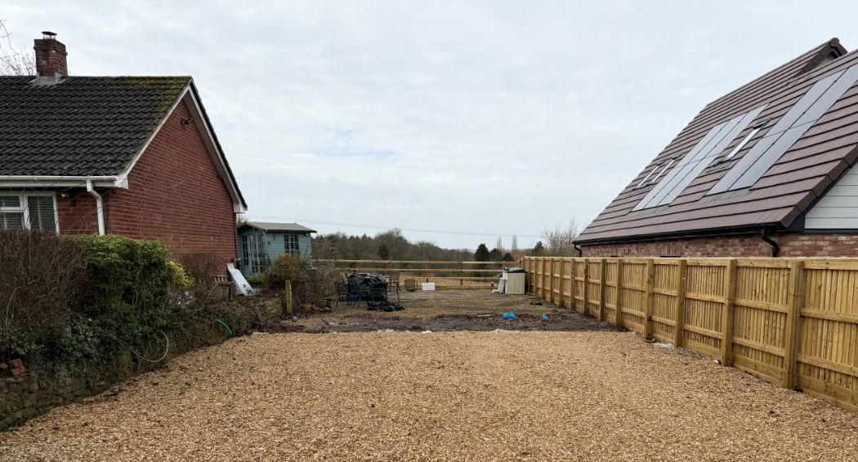

Location Plan and submitted site photo

The application site is with the Bath and Bradford on Avon Special Conservation Area for Bats.

PROPOSAL

The proposal seeks planning permission to replace a pergola (already removed) with a timber shed measuring 5m x 6m x 3m high, to the north of the property, abutting the boundary with a newly built bungalow.

The application is required as PD rights were removed under W/97/0437/FUL – such that no further buildings on the former agricultural land now incorporated into the domestic curtilage, for classes E and F of Schedule 2, Part 1, require planning permission.

All as per drawings and elevations below:

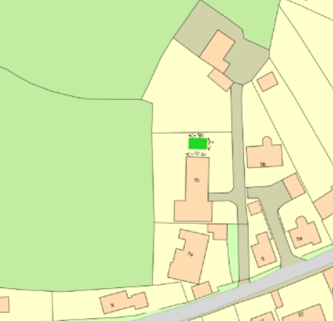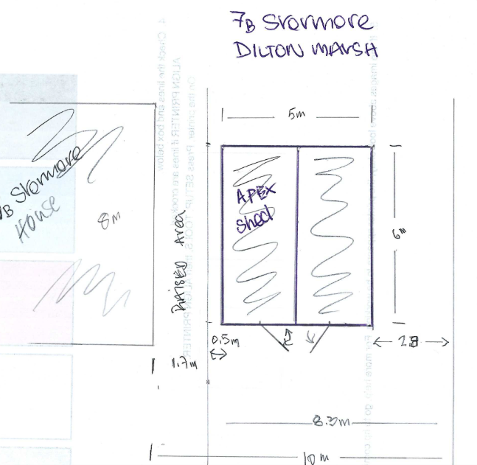

Proposed Block Plan and proposed ground floor plan

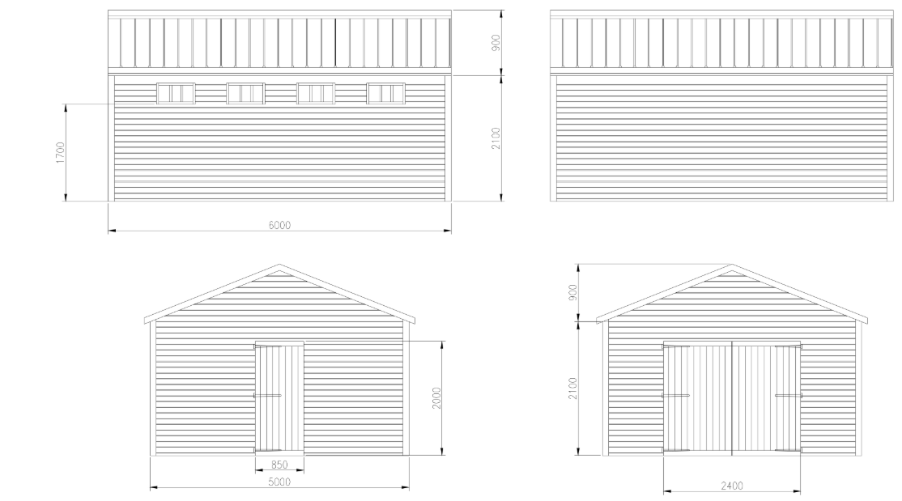

Proposed Elevations

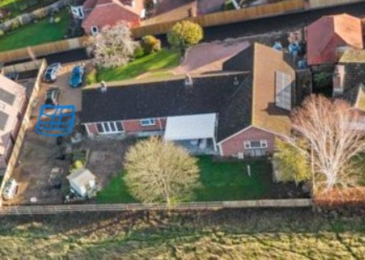

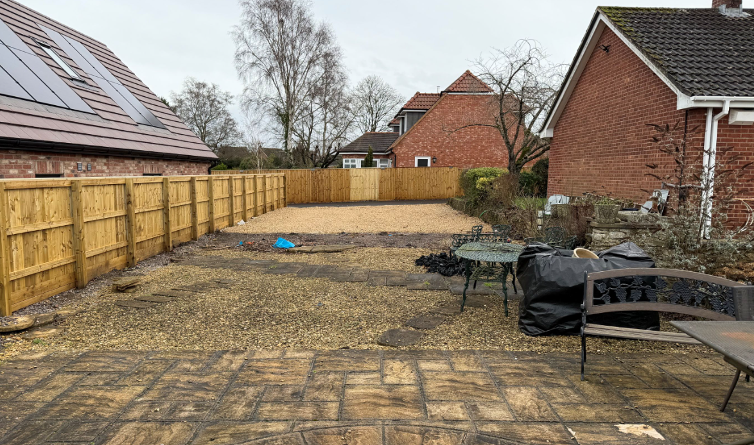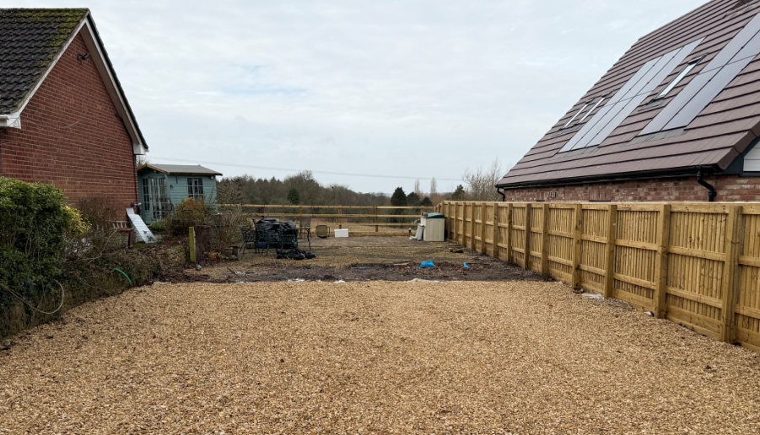

Submitted site photos

PLANNING HISTORY
W/00/00421/FUL - Full planning permission Decision - Approve with Conditions Date: 10/4/2000 – Garage and bedroom extension
W/78/00258/HIS - Historic apps 1974 to 1983 Decision - Approve with Conditions Date: 12/5/1978 – Erection of bungalow and garage
W/97/00437/FUL - Full planning permission Decision - Approve with Conditions Date: 5/6/1997 – Extension to dwelling and new detached double garage and change of use of agricultural land/buildings to domestic

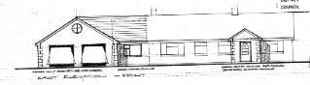
W/76/00501/HIS - Historic apps 1974 to 1983 Decision - Refused Date: 26/7/1976 – Outline application for one dwelling and garage
W/12/01299/FUL - Full planning permission Decision - Approve with Conditions Date: 28/8/2012 – Front and side extensions
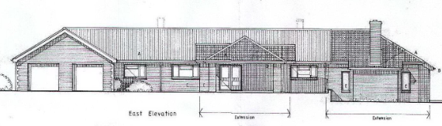
PL/2024/07165 - Removal/variation of conditions Decision - Approve with Conditions Date: 10/12/2024 – Variation of condition 2 (approved plans) relating to application PL/2022/06197 (Demolition of office/storage building and erection of 3 detached dwellings).
PL/2022/06197 - Full planning permission Decision - Approve with Conditions Date: 7/6/2023 – Demolition of office/storage building and erection of 3 detached dwellings
W/04/00245/FUL - Full planning permission Decision - Refused Date: 5/4/2004 – Conversion of domestic ancillary building into dwelling – land adjacent no.7B.
W/09/03301/OUT - Outline Planning Decision - Refused Date: 29/12/2009 – One dwelling – land rear of no.5.
W/13/00279/FUL - Full planning permission Decision - Approve with Conditions Date: 15/4/2013 – Erection of detached dwelling – land rear of no.5.
W/96/00132/FUL - Full planning permission Decision - Approve with Conditions Date: 4/3/1996 – Erection of car shelter – no.7A.

RELEVANT POLICIES AND GUIDANCE
The National Planning Policy Framework (NPPF)
The Planning Practice Guidance
National Design Guide
Wiltshire Design Guide: Appendix D – Design Guidance for Householder extensions

Wiltshire Core Strategy:
- Core Policy 57 Ensuring High-Quality Design and Place Shaping
- Core Policy 50: Biodiversity and Geodiversity

Dilton Marsh Neighbourhood Plan, made 2017

CONSULTATION RESPONSES
Dilton Marsh Parish Council: At a meeting held on 18th June 2026 Members resolved to Object to the application on the grounds that there are discrepancies between the application form and the supporting drawings. The application states that the ridge height of the building would be 2.5 m however, the drawings show a ridge height of 3m. The Parish Council requests that this discrepancy is investigated and the details confirmed prior to any decision being made.

Officer’s Notes - The Parish Council highlighted that the drawings and application form had contrary proposed ridge heights. A confirmed set of elevations and an email from the applicant confirmed the drawings are right with a proposed ridge height of 3m. The email and this note is included here for confirmation. The Parish Council confirmed they had no further queries.

REPRESENTATIONS
No comments were received.

ASSESSMENT
Section 38(6) of the Planning and Compulsory Purchase Act 2004 states:

"If regard is to be had to the development plan for the purposes of any determination to be made under the planning Acts, the determination must be made in accordance with the plan unless material considerations indicate otherwise."

In accordance with this statutory requirement, this application has been assessed against the relevant policies of the Development Plan, including the adopted Wiltshire Core Strategy (2015) and, where applicable, any made Neighbourhood Plans.

Design and Impact upon the upon the character and context of the area
Core Policy 57 - Ensuring High-Quality Design and Place Shaping of the Wiltshire Core Strategy seeks to ensure that all new development is of high design quality, reflecting local context, character, and distinctiveness.

The proposed structure has been confirmed by the applicant to be for ancillary residential storage, not for vehicles, and not for a driveway, and as such the description of development remains and does not need to be amended, and this assessment considers the erection of a garden shed in place of a now demolished pergola. As such, highways have not been required to consult.

The erection of most garden structures generally fall under permitted development, but the proposal site, had permitted development rights removed under a previous application (W/97/0437/FUL). This means that any additional structures on the former agricultural land, which is now incorporated into the domestic curtilage, under classes E (incidental buildings) and F (hard surfaces) of Schedule 2, Part 1, requires planning permission.

The proposed shed would be sited on an area of land to the side of the house, where there was previously a pergola that did not benefit from planning permission.

The host dwelling has undergone various extensions/development, and the wider area now clearly reads as residential. PD rights are generally removed to control further development to manage the urbanisation and density of structures.

Given the modern, residential character of the area, a further shed is assessed to not further alter the prevailing character. The proposed scale, materials and design of the shed are for a standard shed and so appropriate to the residential cul de sac.

Having regard to the above, the proposal complies with the design principles set out in Core Policy 57 of the Wiltshire Core Strategy and Appendix D of the Wiltshire Design Guide.

Amenity
Point vii of Core Policy 57 - Ensuring High-Quality Design and Place Shaping of the Wiltshire Core Strategy seeks to ensure that developments do not adversely affect neighbouring properties.

The National Planning Policy Framework (NPPF), particularly Paragraph 135(f), stresses that planning decisions should ensure developments provide a high standard of amenity for existing and future users.

The proposed development has been assessed in terms of its potential impact on the residential amenity of neighbouring properties, with particular regard to loss of light, overshadowing, loss of privacy, and overbearing effects.

The proposal for a standard shed, at a height of 3m, besides a standard boundary, the nearest neighbour being a taller bungalow, raises no concern with overshadowing or overbearing. And as a non-habitable space, would not impact neighbouring privacy.

The proposal therefore accords with Core Policy 57 point vii in respect of safeguarding residential amenity and Appendix D of the Wiltshire Design Guide.

Ecology Impact
Core Policy 50 of the Wiltshire Core Strategy seeks to protect and enhance biodiversity and geodiversity, including through ensuring that development avoids harm to protected species and habitats.

The National Planning Policy Framework (NPPF), in Paragraphs 193, requires that development minimises impacts on and provides net gains for biodiversity, including ensuring mitigation is secured where harm cannot be avoided.

The application site is with the Bath and Bradford on Avon Special Conservation Area for Bats. The proposal is for a new non-habitable structure besides an established dwelling within a residential area.

An informative is included as a precautionary measure, raising the profile of the Bat SAC, including that if any evidence of bat activity is detected, that the applicant should follow the advice of a professional ecologist or contact Natural England.

The proposals pose no loss of biodiversity, and the application does not meet the threshold set out in legislation to demonstrate BNG. The scale and nature of development is such that significant harm to biodiversity is unlikely.

As such, the development complies with Core Policy 50 of the Wiltshire Core Strategy and the relevant provisions of the NPPF.

CONCLUSION
The proposed development is considered to be acceptable in terms of its design, scale, and relationship with the surrounding area. It would not result in any unacceptable harm to the character of the locality, the amenities of neighbouring occupiers, or the interests of ecology.

The proposal is therefore considered to comply with the relevant policies of the Wiltshire Core Strategy, the Wiltshire Local Plan, and the National Planning Policy Framework. As such, the application is recommended for approval, subject to the conditions set out below.

RECOMMENDATION: That Planning Permission be GRANTED subject to conditions.

