APPLICATION FOR HOUSEHOLDER PLANNING PERMISSION
DELEGATED REPORT

APPLICATION REFERENCE: | PL/2026/04161
APPLICATION TYPE: | Householder Planning Permission
SITE ADDRESS: | 29 Willow Grove, Trowbridge, BA14 0HA
DEVELOPMENT DESCRIPTION: | Refurbishment including roof form alterations, rear garage extension and external changes.
RECOMMENDATION: | That Planning Permission be GRANTED

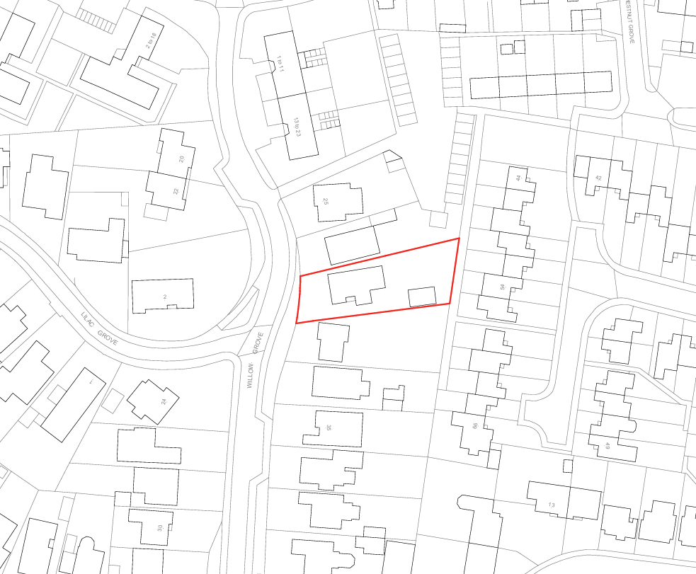
PROPOSAL

The application seeks planning permission for a series of alterations and extensions to the existing bungalow. These include the replacement of the existing flat roof over the rear extension with a new gable-ended pitched roof and a modest infill extension to form a kitchen/dining room, incorporating a new rear door and side elevation window. The proposal would also consolidate two existing side-facing gable features into a single gable on the side elevation, creating a more unified roof form.

In addition to the above, a rear extension is proposed to the existing detached garage to provide a garden office. Associated works also include the installation of a rear pergola, replacement weatherboard cladding to the front gable using materials of a similar appearance to the existing, replacing the existing roof and the removal of existing chimney stacks. Internal alterations are also proposed to reconfigure the dwelling whilst retaining four bedrooms overall.

SITE DESCRIPTION / CONTEXT

The application site comprises a detached bungalow situated within a row of three detached bungalows in an established residential area within the Trowbridge Settlement Boundary. The surrounding area is characterised by a variety of dwelling styles and materials, with the neighbouring properties comprising a mix of red brick, rendered and weatherboard-clad buildings. The host dwelling is primarily constructed of buff brick with areas of weatherboard cladding and occupies a comparatively spacious plot with extensive hardstanding to the front and a private rear garden. The site is located within the Trowbridge and Westbury Bat Mitigation Strategy Grey Zone and within Flood Zone 1, where the Council's Strategic Flood Risk Assessment identifies negligible risk from fluvial, surface water and groundwater flooding. Public Right of Way TROW107 lies approximately 22 metres to the north of the site, separated by intervening residential development.

PLANNING HISTORY

Reference No. | Proposal / Summary | Decision
W/78/00899/HIS | Extension to provide two bedrooms | Approved

RELEVANT LEGISLATION, POLICIES AND GUIDANCE

Wiltshire Core Strategy:

Core Policy 1 Settlement Strategy;
Core Policy 2 Delivery Strategy;
Core Policy 29 Spatial Strategy: Trowbridge Community Area;
Core Policy 50 Biodiversity and Geodiversity;
Core Policy 51 Landscape;
Core Policy 57 Ensuring High-Quality Design and Place Shaping;
Core Policy 60 Sustainable Transport;
Core Policy 61 Transport and Development;
Core Policy 64 Demand Management;
Core Policy 67 Flood Risk

The National Planning Policy Framework (NPPF) and Planning Practice Guidance (PPG)

Wiltshire Design Guide - Appendix D – Design Guidance for Householder extensions

The Wiltshire Local Transport Plan 2011 – 2026: Car Parking Strategy (March 2015).

The Wiltshire Local Transport Plan 4 (LTP4) (March 2025)

New Wiltshire Local Plan: At Full Council on 19 May 2026, the elected members of Wiltshire Council agreed to withdraw the emerging Wiltshire Local Plan. The said Plan has no material weight for the purposes of the application.

In accordance with Regulation 19 of the Town and Country Planning (Local Planning) (England) Regulations 2026, on 30th June 2026 Wiltshire Council published a notice of intention to prepare a new local plan for Wiltshire. The next stage is a Scoping Consultation which commences on 2nd September 2026. This plan is at a very early stage and currently carries no weight for decision-making.

CONSULTATION RESPONSES

Trowbridge Town Council – No Objection

Local Highway Authority (Wiltshire Council) – No Objection

REPRESENTATIONS

No comments received.

ASSESSMENT

Section 38(6) of the Planning and Compulsory Purchase Act 2004 states:

"If regard is to be had to the development plan for the purposes of any determination to be made under the planning Acts, the determination must be made in accordance with the plan unless material considerations indicate otherwise."

In accordance with this statutory requirement, this application has been assessed against the relevant policies of the Development Plan, including the adopted Wiltshire Core Strategy (2015) and, where applicable, any made Neighbourhood Plans.

The proposed works constitute alterations and extensions to an existing dwellinghouse within its established residential curtilage and located within the Principal Settlement of Trowbridge. The development would not result in the creation of an additional dwelling, nor would it alter the established residential use of the site. Accordingly, the principle of extending and altering the dwelling and outbuilding is considered acceptable, subject to detailed assessment of the proposal's design and impacts.

The proposed garden office would remain ancillary and incidental to the residential use of the dwellinghouse and would not facilitate the creation of a separate planning unit or independent accommodation.

Design and Impact upon the Character and Context of the Area

Core Policy 57 of the Wiltshire Core Strategy seeks to secure high-quality design which responds positively to local character and distinctiveness. At the national level, Policy DP3 of the National Planning Policy Framework requires development proposals to respond positively to their context and integrate with and enhance their surroundings. Development should also reflect, where relevant, the principles of liveability, climate resilience, nature, movement, built form, public space and local identity. Assessment of design quality therefore requires consideration of the scale, appearance, massing, materials, layout and relationship of the proposal with both the host site and the wider character of the surrounding area.

The proposed alterations are considered to represent a positive and coherent enhancement to the appearance of the dwelling. The replacement of the flat-roofed rear extension with a pitched gable roof would create a more sympathetic and visually attractive form that better reflects the character of the host property. Similarly, the consolidation of the existing side-facing gables into a single gable would simplify the roofscape and result in a more cohesive architectural composition. The proposed materials are specified to match or be similar to those existing, including the replacement weatherboard cladding and roofing materials, thereby ensuring visual continuity across the site.

The garage extension would effectively continue the form and roofline of the existing detached garage and would appear as a logical and subordinate addition. Overall, the proposal is considered to preserve and enhance the character and appearance of the host dwelling and the surrounding street scene. Having regard to the above, the proposal complies with the design principles set out in the NPPF Policy DP3, Core Policy 57 of the Wiltshire Core Strategy, and Appendix D of the Wiltshire Design Guide.

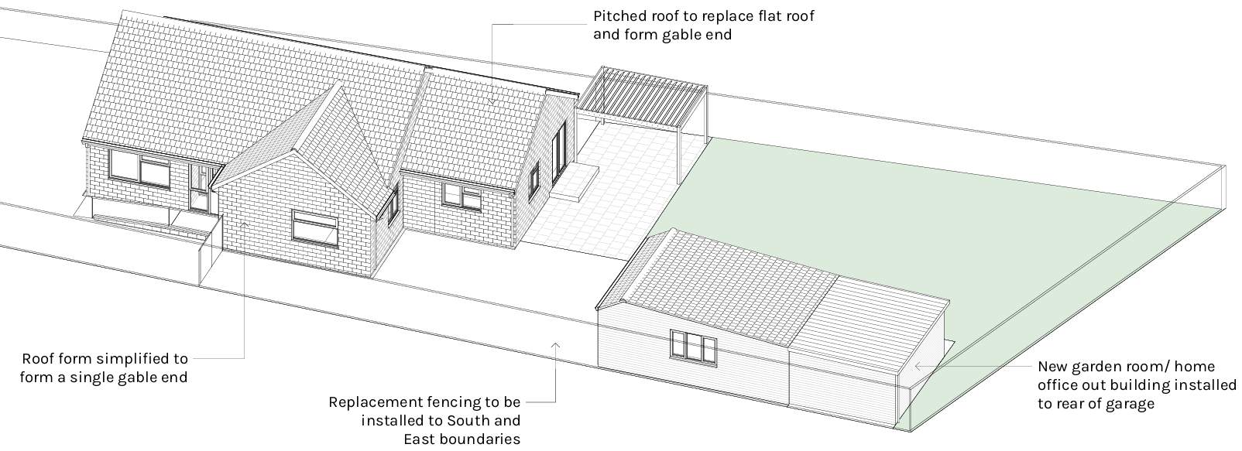
Proposed Development

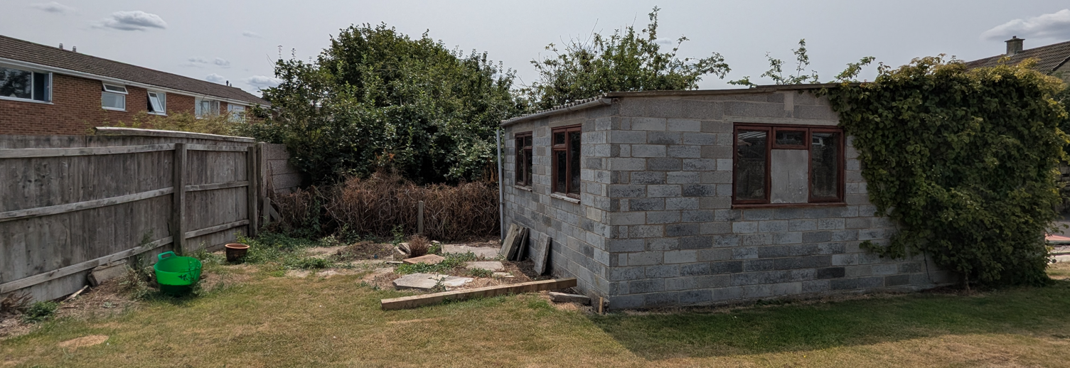
Site Image

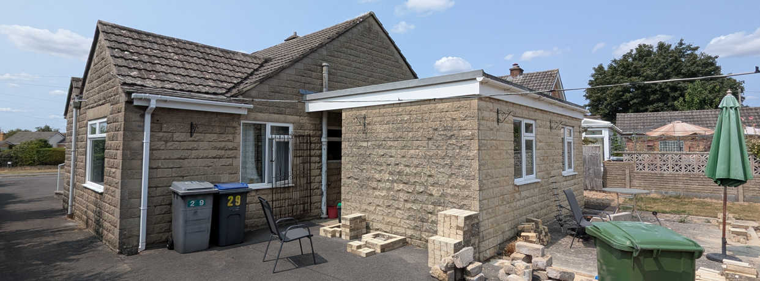
Site Image

Amenity

Core Policy 57 criterion vii seeks to ensure development does not have an unacceptable impact upon the amenities of neighbouring occupiers. Nationally, Policy P3 requires development proposals to provide healthy living conditions for occupiers and users and to avoid unacceptable impacts arising from loss of light, outlook, privacy, noise, disturbance or other forms of pollution. Policy DP3 additionally requires development to create liveable and attractive places for existing and future users. Accordingly, the assessment below considers the effect of the proposal upon neighbouring occupiers and whether acceptable living conditions would be maintained.

The proposed development would not give rise to any unacceptable impacts on the amenities of neighbouring occupiers. Whilst alterations to fenestration are proposed, these are confined to ground floor level and are orientated towards the application site itself, ensuring no significant overlooking or loss of privacy would occur. Furthermore, direct views from the proposed ground-floor fenestration would be mitigated by existing boundary treatments.

The alterations to the dwelling would remain below the ridge height of the main roof, and the replacement of the flat roof with a pitched roof on the rear extension would not result in significant overbearing impacts or loss of light to neighbouring properties, given the modest scale of the extension and the roof's sloping form away from the shared boundary. The consolidation of the side gables would broadly retain the established scale and massing currently experienced by neighbouring occupiers. Furthermore, the proposed garage extension would be of limited height and comparable to the existing boundary treatment, resulting in no material impact upon neighbouring residential amenity.

The proposal therefore accords with Core Policy 57 point vii in respect of safeguarding residential amenity and Appendix D of the Wiltshire Design Guide.

Transport and Highways

Core Policies 60, 61 and 64 of the Wiltshire Core Strategy seek to promote sustainable transport, secure safe access arrangements and ensure adequate parking provision. Nationally, Policies TR3 and TR4 of the National Planning Policy Framework require development to be located in sustainable locations where appropriate, provide safe access arrangements, prioritise walking, wheeling and cycling, and provide suitable parking provision having regard to the nature and location of the development. Policy TR6 confirms that development should be refused where it would result in a severe adverse impact on the transport network or an unacceptable impact on highway safety after consideration of any mitigation measures.

The proposal would not adversely affect highway safety or parking provision. Although the internal layout of the dwelling would be altered, the property would continue to provide four bedrooms overall and therefore would not intensify the residential use of the site.

Existing vehicular access arrangements would remain unchanged, and ample on-site car parking provision would continue to be provided within the existing curtilage of the dwelling. The existing garage would also be retained, and as this is shown on the submitted drawings to have internal measurements of 6.65m by 4.50m it would be counted as an on-site car parking space for the dwelling, as it would satisfy the internal size requirement of 6mx3m, in accordance with the Council’s adopted car parking strategy. Consequently, no objections are raised on highway or parking grounds.

Ecology

Core Policy 50 of the Wiltshire Core Strategy seeks to protect and enhance biodiversity interests and ensure development avoids unacceptable harm to ecological assets. National policy is set out within Policies N2 and N6 of the National Planning Policy Framework. These policies require development proposals to minimise impacts upon biodiversity, protect important habitats and species, and secure opportunities for biodiversity enhancement where appropriate. Where significant harm to biodiversity cannot be avoided, adequately mitigated or compensated for, development should be refused. Biodiversity Net Gain (BNG) was established as a mandatory aspect of planning evaluation through Schedule 7A of the Town and Country Planning Act 1990 (as amended by the Environment Act 2021 Schedule 14). Householder development is exempt from the statutory Biodiversity Net Gain requirements introduced through Schedule 7A of the Town and Country Planning Act 1990 (as amended). Nevertheless, proposals should seek to avoid ecological harm and incorporate biodiversity enhancements where appropriate.

The site lies within the Trowbridge and Westbury Bat Mitigation Strategy Grey Zone. The proposed alterations to the dwelling are largely confined to the existing built form and roof structure, with no substantial encroachment into areas of ecological value. The garage extension would be constructed on an area of maintained garden and is therefore unlikely to result in significant habitat loss. Given the nature and scale of the works, the proposal is not considered likely to result in adverse impacts on protected species or ecological interests. Nevertheless, it would be appropriate to draw the applicant's attention to their responsibilities under wildlife legislation through an informative, particularly in relation to bats and nesting birds that may be encountered during construction works.

Flooding and Drainage

Core Policy 67 of the Wiltshire Core Strategy seeks to ensure that development is directed away from areas at greatest risk of flooding and is designed to minimise vulnerability to flooding whilst avoiding any increase in flood risk elsewhere. National planning policy relating to flood risk and drainage is contained within Policies F4 to F8 of the National Planning Policy Framework. Collectively, these policies establish a risk-based approach to the location and assessment of development proposals. The Framework requires flood risk to be properly assessed where necessary, seeks to direct development towards areas at the lowest risk of flooding through the application of the sequential approach where applicable, and ensures that development remains safe for its lifetime without increasing flood risk elsewhere. The policies also support the incorporation of sustainable drainage measures where appropriate in order to manage surface water runoff and reduce the potential for flooding.

The application site is located within Flood Zone 1 and within an area identified by the Council's Strategic Flood Risk Assessment as having negligible flood risk. The majority of the proposed works comprise alterations to existing buildings and therefore would not materially alter site drainage characteristics. Whilst the proposed garage extension would introduce a modest increase in built footprint of approximately 19 square metres, this increase is limited in extent and is not considered sufficient to result in any notable drainage or flood risk concerns. Accordingly, the proposal is considered acceptable in terms of flood risk and surface water management.

CONCLUSION

The proposed alterations and extensions are considered to represent an appropriate form of residential development that would improve the appearance and cohesion of the existing dwelling without causing unacceptable impacts upon the character of the area, neighbouring residential amenity, highway safety, ecology or drainage. The principle of development is acceptable, and the proposal accords with the relevant provisions of the development plan. Accordingly, the application is recommended for approval.

RECOMMENDATION: That Planning Permission be GRANTED subject to the following conditions:

1.
The development hereby permitted shall be begun before the expiration of three years from the date of this permission.
REASON: To comply with the provisions of Section 91 of the Town and Country Planning Act 1990 as amended by the Planning and Compulsory Purchase Act 2004.

2.
The development hereby permitted shall be carried out in accordance with the following approved plans and documents:

Proposed Site Plan (25-SZ-748-1000 P01)
Proposed Garage Plan and Elevations (25-SZ-748-3000 P01)
Proposed Elevations (25-SZ-748-2000 P01)
Proposed Floor and Roof Plans (25-SZ-748-1001 P01)
Site Location and Existing Site Plan (25-SZ-748-0010 P01)

REASON: For the avoidance of doubt and in the interests of proper planning.

