HOUSEHOLDER PLANNING APPLICATION.
CASE OFFICER REPORT

APPLICATION REFERENCE: | PL/2026/03003
APPLICATION TYPE: | Householder
SITE ADDRESS: | 14 Stormore, Dilton Marsh, Westbury, BA13 4BH.
DEVELOPMENT DESCRIPTION: | First Floor Front and Rear Dormer with render external walls and slate roof.
RECOMMENDATION: | Approve with Conditions.

PROPOSAL
The proposal seeks planning permission for the construction of two small sized dormer windows on the front and rear elevations of a main side roof on the host principal dwelling and to replace existing roof tiles with new slate.

SITE DESCRIPTION/CONTEXT
The site is a dwelling located within an established residential development within the Large Village of Dilton Marsh. The principal dwelling is a two-storey detached property located within its own spacious grounds and set back from the adjacent highway. The dwelling benefits from an off-road parking area to the front elevation and an attached garage. The surrounding properties are all similar in style comprising of detached buildings.

The site is within a Special Landscape Area and is within the Salisbury Plain Spa 6400 metre buffer zone, it is also within the Bath and Bradford on Avon Bat SAC and outside of but near to the border of the yellow zone of the adopted Trowbridge Westbury Bat Mitigation Strategy (TWBMS).

RELEVANT PLANNING HISTORY
Proposal / Summary
PL/2026/01452 First Floor Dormer and Rear Extension Approved

RELEVANT POLICIES AND GUIDANCE

Wiltshire Core Strategy:

- Core Policy 57 Ensuring High Quality Design and Place Shaping
- Core Policy 50: Biodiversity and Geodiversity
- Core Policy 51: Landscape
- Core Policy 58: Ensuring the Conservation of the Historic Environment
- Core Policy 61: Transport and New Development
- Core Policy 64: Demand Management
- Core Policy 67: Flood Risk

Dilton Marsh Neighbourhood Plan, Special Landscape Area.

Wiltshire Design Guide: Appendix D – Design Guidance for Householder extensions

The National Planning Policy Framework (NPPF Revised on 17 August 2026)

The Planning Practice Guidance

National Design Guide

Emerging Wiltshire Local Plan:
At Full Council on 19 May 2026, the elected members of Wiltshire Council agreed to withdraw the emerging Wiltshire Local Plan. The said Plan has no material weight for the purposes of the application.

In accordance with Regulation 19 of the Town and Country Planning (Local Planning) (England) Regulations 2026, on 30th June 2026 Wiltshire Council published a notice of intention to prepare a new local plan for Wiltshire. The next stage is a Scoping Consultation which commences on 2nd September 2026. This plan is at a very early stage and currently carries no weight for decision making.

CONSULTATION RESPONSES
Dilton Marsh Parish Council: No objections.

Ecology: No objections subject to informative/s.

REPRESENTATIONS
One email of comment was received raising the following point:

- Contractors’ vehicles not to park on the white line opposite the Red Pit entrance and exit, as this causes problems when turning in and out.

PRINCIPLE OF THE PROPOSAL.
The principle of the proposed scheme is acceptable for the reasons as discussed below.

ASSESSMENT
Section 38(6) of the Planning and Compulsory Purchase Act 2004 states:

"If regard is to be had to the development plan for the purposes of any determination to be made under the planning Acts, the determination must be made in accordance with the plan unless material considerations indicate otherwise."

In accordance with this statutory requirement, this application has been assessed against the relevant policies of the Development Plan, including the adopted Wiltshire Core Strategy (2015) and the Neighbourhood Plan for Dilton Marsh.

Design and Impact upon the upon the character and context of the area
Core Policy 57 - Ensuring High Quality Design and Place Shaping of the Wiltshire Core Strategy seeks to ensure that all new development is of high design quality, reflecting local context, character, and distinctiveness. The proposals can be viewed within the plan snippets taken from the submitted plans:

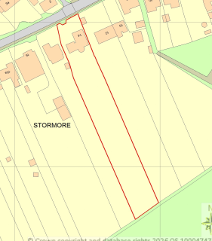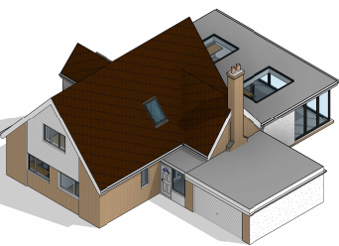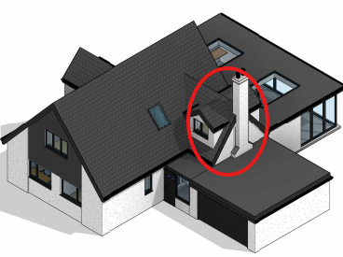
Location Plan Existing & proposed 3D elevations

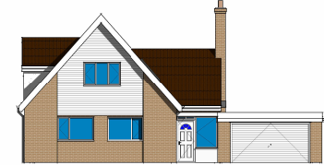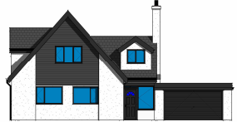
Existing & Proposed Front Elevations.

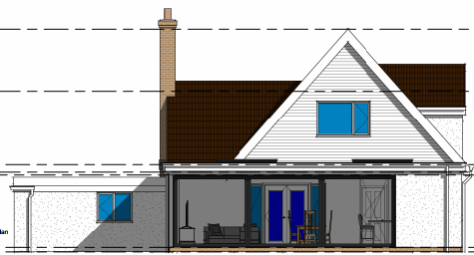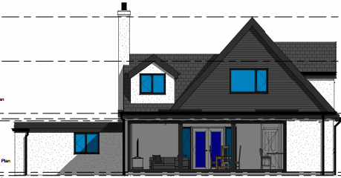
Existing & Proposed Rear Elevations.

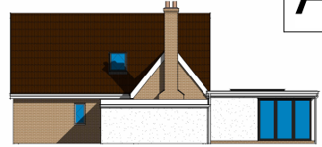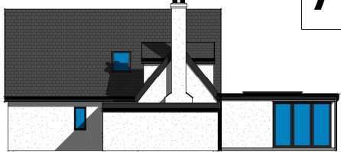
Existing & Proposed Side Elevations.

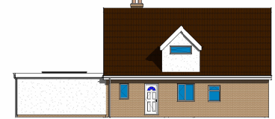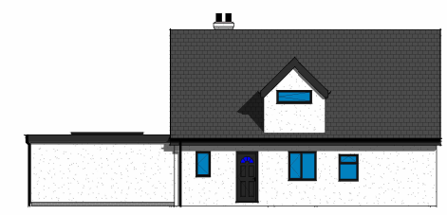
Existing & Proposed Side Elevations.

The proposal would see the construction of a small sized dormer window on the front and rear elevation on one of the building’s main roof slopes, as shown circled in the above plan snippets. Materials would match those as existing. The existing rooftiles of the property would be changed to slate tiles.

In terms of design, the dormer windows would be small in size and would mimic the existing roof profile of the building’s front and rear elevations and so would not look out of keeping, likewise, due to their small size, they would be a subordinate addition to the main house.

Therefore, in summary, having regard to the above, the proposal complies with the design principles set out in Core Policy 57 of the Wiltshire Core Strategy and Appendix D of the Wiltshire Design Guide.

Amenity
Point vii of Core Policy 57 - Ensuring high-quality Design and Place Shaping of the Wiltshire Core Strategy seeks to ensure that developments do not adversely affect neighbouring properties.
At the national level, Policy DP3 of the National Planning Policy Framework requires development proposals to respond positively to their context and integrate with and enhance their surroundings. Development should also reflect, where relevant, the principles of liveability, climate resilience, nature, movement, built form, public space and local identity.

The proposed dormer windows would create a small room at first floor level which would look out onto the front and rear of the site. The building already has high level fenestration at first floor level and so would not create new levels of overlooking. It is noted that the front facing dormer would look onto the site’s front garden and parking area and highway beyond, whilst the rear proposal would look onto the site’s spacious rear garden. Both windows would offer oblique views and there would not be any direct overlooking of neighbours.

Likewise, due to the location, orientation and separation distances of the proposal with its neighbouring properties, there would not be any overshadowing or loss of light to the most immediate neighbour at No’s.12 or 14a.

The proposal therefore accords with Core Policy 57 point vii. in respect of safeguarding residential amenity and Appendix D of the Wiltshire Design Guide.

Ecology Impact
CP50 requires no net loss of biodiversity on site. The application site sits within a sensitive ecological location in that it is within the Salisbury Plain SPA 6400 metre buffer zone, it is also within the Bath and Bradford on Avon Bat SAC and outside of but near to the border of the yellow zone of the adopted Trowbridge Westbury Bat Mitigation Strategy (TWBMS). Consequently, the council’s ecologist was consulted who commented that the proposal may therefore have the potential to result in significant adverse impact on the special features of that site. Appropriate Assessment (AA) under Section 63 of the Habitats Regulations was carried out by the relevant Competent Authority (the LPA) to determine the potential significant effects and the suitability of any measures proposed to avoid or mitigate those effects. It was assessed that the proposals would not require the removal of any vegetation within the yellow zone, therefore, the principals of the TWBMS were not considered further.

The Bath and Bradford-on-Avon Bats SAC is designated for Bechstein’s, Lesser Horseshoe and Greater Horseshoe bats. The principal residential building is not likely to be suitable for such species, as photographs provided by the applicant showed that the lofts are felt-lined between the tiles and beams (with no obvious tears, thereby making access for void-dwelling bats very difficult), likewise, the roof spaces are used by the household occupants for storage, thereby creating obstructions for bats internally.

No bat habitat is proposed to be removed, and no new external lighting is proposed. Overall, it was the ecologist’s view that there was no mechanism for adverse effect on Annex II bats and therefore on the Conservation Objectives of the SAC. Consequently, the application was screened out of Appropriate Assessment.

The potential impacts of the proposed works on other protected species of bats – including crevice-dwellers were considered by the council ecologist who visited the site and carried out a brief assessment of the roof area.

The ecologist found that the existing roof tiles were in good condition and were tightly sealed, with no missing mortar, and there no were gaps under the tiles of notable concern.

The soffits were well-sealed with no significant points of rotting, and were at a low height at single storey, so therefore on balance of evidence, a full bat survey was not considered to be necessary by the ecologist. It was therefore considered by the council ecologist that it was unlikely that the works would adversely affect other protected taxa such as reptiles or amphibians.

The ecologist requested that two informatives relating to bats and external lighting be attached to the final decision notice, this request is considered to be both reasonable and necessary.

As such, the development complies with Core Policy 50 of the Wiltshire Core Strategy and the relevant provisions of the NPPF.

Biodiversity Net Gain
This application is exempt from the requirement to deliver Biodiversity Net Gain under Schedule 7A, Section 4(2)(a) of the Town and Country Planning Act 1990, as inserted by the Environment Act 2021, because the proposal is a householder extension.

Special Landscape Area
It is noted that the site is within a Special Landscape Area (SLA), however, for the above discussed reasons and due to the proposals’ small size being located within an established residential area, it is appraised that there would be no harm inflicted on the open character of the surrounding SLA.

CONCLUSION
The proposed development is acceptable in terms of its design, scale, and relationship with the surrounding area. It would not result in any unacceptable harm. The proposal is therefore considered to comply with the relevant policies of the Wiltshire Core Strategy, the Wiltshire Local Plan, and the National Planning Policy Framework. As such, the application is recommended for approval, subject to the conditions set out below.

RECOMMENDATION: Planning Permission be GRANTED subject to conditions.

