
CRICKLADE TOWN COUNCIL 27th JULY 2026
MAC MIC STRATEGIC LAND LIMITED WC REF 2026/02134

Site: Land north and south of Stones Lane and north of Malmesbury Road, Cricklade, SN6 6JP
Proposal: Outline permission for up to 315 dwellings with associated access and infrastructure including Suitable Alternative Natural Greenspace. All matters reserved except for access
1. Background
This application was previously considered at the meeting of the CTC Planning, Conservation and Transport Committee on 1st June 2026. Councillors resolved to OBJECT to the proposed development.
Since then the applicant has been required to carry out an Environmental Impact Assessment (EIA) and an Environmental Statement has been produced detailing the works carried out for the EIA and the conclusions that can be drawn. We are pleased to see that the applicant has considered the matters raised in our 1st June submission and provided a written response. Further, various other consultees have now filed their submissions.
CTC is therefore taking the opportunity to review this latest material and making an updated consultation response to Wiltshire Council to replace the 1st June submission.

2. Summary of Proposed Development
The application consists of two parcels of land. The larger southern area (17.22 ha = 42.6 acres) will accommodate all the dwellings and areas of Suitable Alternative Natural Greenspace (SANG) and open space. The smaller parcel to the north of Stones Lane (3.50 ha = 8.6 acres) will just be SANG. The total area is therefore 20.72 ha = 51.2 acres.
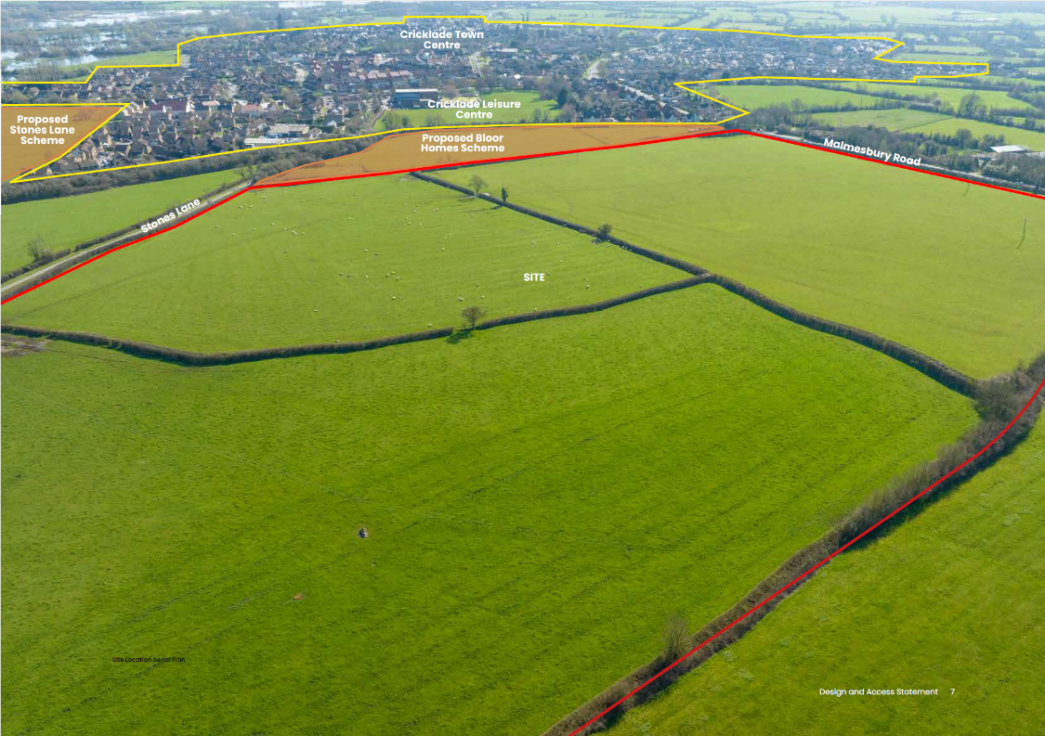

Between the site and the Leisure Centre is a development site being promoted by Bloor Homes for 49 dwellings. An outline application has been submitted (WC reference 2021/10404) but is yet to be determined.
All matters are reserved except for access, but as a masterplan, surveys and other plans have been submitted with indicative details then we will comment on them also.
The applicant carried out a Public Consultation earlier in 2026 and the three most important aspects raised by respondents were: (i) roads & traffic, (ii) facilities & infrastructure, and (iii) surface water management and so special consideration will be given to these aspects below.
315 dwellings represents the largest single development in Cricklade by far and would result in an increase of 17-18% in the size of the town in terms of the number of dwellings.

3. Key Constraints
An Esso underground fuel pipeline runs just inside the eastern boundary of the main site which will require the establishment of a 6m wide buffer either side which must be kept free at all times.
Extra high voltage electric cables also run inside the eastern boundary and these will remain in situ. High voltage electric cable cross the south-western corner and the intention is that these should be buried.
Footpath CRIC30 is a public right of way running from Stones Lane across the northern boundary of the larger section and which will be incorporated into the layout of footpaths to be created.

4. Environmental Impact Assessment (EIA) and Environmental Statement (ES)
Excerpt from the ES:
“2.1 EIA is defined by the Institute of Environmental Management and Assessment (IEMA) as ‘an
assessment process applied to both new development proposals and changes or extensions to
existing developments that are likely to have significant effects on the environment’. EIA has two main purposes, firstly to inform decision-makers of the environmental consequences of a proposed
action/development and, secondly, to improve the environmental and sustainable credentials of a
development through feedback into the design process and application of appropriate enhancement and mitigation measures. In essence, the EIA process should not only inform the decision-making for the project, but also comprise a design tool that is integral to the design of a project.
2.2 The EIA process enables assessment of the effects resulting from the development upon a range of environmental aspects, including those on natural resources such as air, water, soil, those on the natural environment including habitats and species, and those on the surrounding communities including visual effects and impacts on the local population. The effects are considered across the entire lifecycle of a project, including demolition, construction and operation through to the decommissioning of the development at the end of its ‘life’

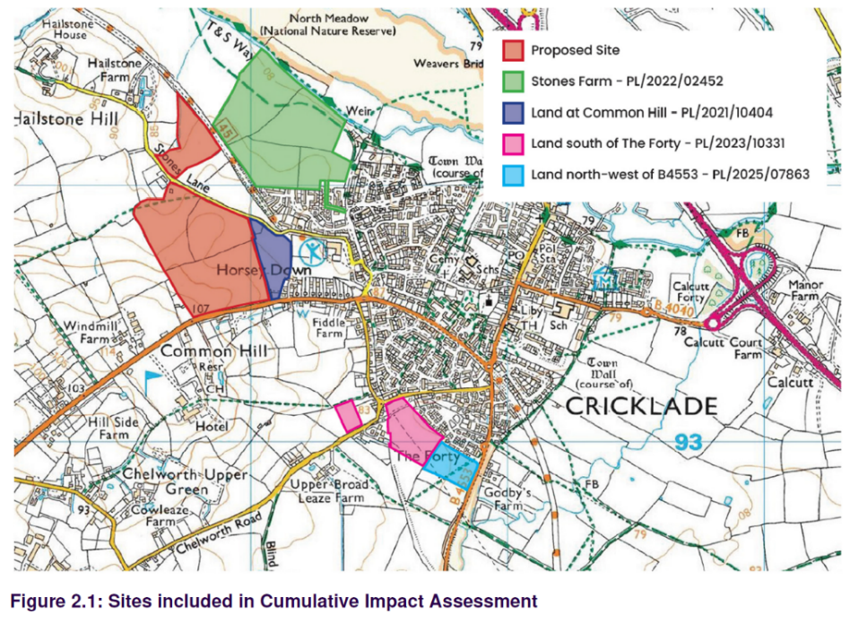
The applicant commissioned Carter Jonas to carry out the EIA and write the subsequent ES. Most of the supporting documentation was already available having been used as part of their initial planning application.

An interesting aspect is that the EIA has been designed to include the cumulative impact of the other four major housing proposals in the findings as shown here:

However, in our 1st June submission we requested that the road traffic capacity computations should be re-performed with the Hannick and Bellway developments included. It does not appear that this has been done and so the comprehensiveness of this ‘cumulative’ assessment must be queried.
It is not clear what value the EIA has added. A report commissioned from an independent third party would carry more weight.

5. Highways and Vehicular Access
Vehicular access will be from a new junction to be constructed on the B4040 on Common Hill. The current limit past the site is the national 60mph limit. The start of the 30mph limit on entering Cricklade will require moving further west than is proposed in the Bloor scheme.
A traffic count was commissioned by the applicant’s agent which showed that at a point 75m to the west of the proposed new entrance road the speeds during 13th/19th January 2026 were:
 | Average Speed | 85th percentile speed  (ie 85% travel below)
Eastbound (towards Cricklade) | 44.6 mph | 50.6 mph
Westbound (away from) | 42.6 mph | 48.8 mph

It is probable that a survey not during the winter months would show a higher result.
In the CTC response to the public consultation carried out by the applicant earlier this year we requested that a roundabout be constructed here in the interests of road safety. It would also have the community benefit to the residents on Common Hill of slowing traffic as it enters the built up area which at the moment is a cause of concern to them. This suggestion was also raised by respondents to the Public Consultation. However, it is not deemed necessary by the WC Highways Engineer but he has raised the possibility of a right hand turn lane for vehicles entering the site when travelling from the Cricklade direction which would hopefully increase road safety.

The applicant has dismissed the need for a roundabout and, using industry metrics, also dismissed the need for a right hand turn lane for vehicles entering the site.
This is not the correct response to an identified high-risk location. A fatal road traffic collision occurred just a kilometre away to the west earlier this year. Traffic descends Common Hill into Cricklade at too high a speed. The installation of a roundabout would improve road safety for residents of the proposed development and for other road users. We note that the Wiltshire Council sponsored Road Safety Partnership has a Vision Zero:
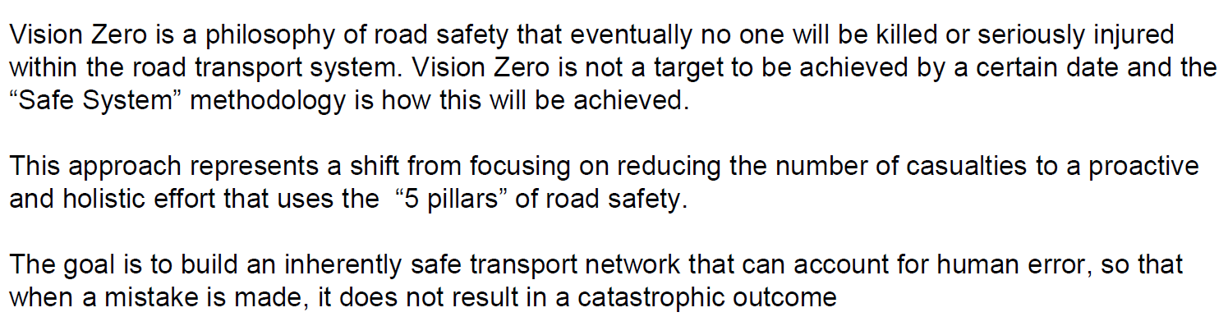
The first pillar of road safety aims for safer roads by planning & development and highway design which is the opportunity that should be taken here.
An emergency access is proposed to the north of the site onto Stones Lane which would have a drop-down bollard to prevent use other than for emergencies. It is important that additional traffic is not directed onto Stones Lane. An emergency entrance could be created onto Common Hill.
Projections have been provided to assess the impact of the development on the surrounding road network. TRICS data (from journey to work patterns on similar developments) predict these vehicular movements:
 | Arriving | Departing | Total
Morning peak 8am to 9am | 49 | 127 | 176
Afternoon peak 5pm to 6pm | 111 | 54 | 165

The traffic flows are expected to be:
A419 north 27% | A419 south 37% | B4040 west 21% | B4553 (Purton Road) 15%

Modelling work has been carried out for several local junctions and statistics of the Turning Circle and Jubilee Clock roundabouts are shown below as an appendix. The computations have been carried out including an estimate of further traffic growth and the build out of the Bloor and Newland developments. The computations should be re-performed with the Hannick and Bellway developments to also be included.
The results indicate that both junctions will continue to operate at or below capacity with a Ratio of Flow to Capacity (RFC) below 0.85. This will come as a surprise to regular travellers through Cricklade who will frequently be stationary on Calcutt Street after coming in from the A419. This can sometimes produce the dangerous situation of cars backed-up on the dual carriageway.

6. Landscape Masterplan (see page 7 below)
The overall site is split into two elements: the housing section (42.6 acres) to the south of Stones Lane, and the Sustainable Alternative Natural Greenspace (SANG) section to the north (8.6 acres).
- Housing section
The design layout is only indicative but we make some comments here.
The three fields that make up this section will have the mature hedgerows maintained, except where the roadways need to be laid, which we welcome.
The houses are located in the centre of the site with a substantial amount of greenspace around the periphery which the masterplan shows that it could provide:
- Footpaths around the perimeter and attenuation ponds,
- Linking footpaths to the adjacent Bloor Homes Horsey Down site – these are essential to achieve the ‘connectivity’ required by TT2 in the Cricklade Neighbourhood Plan. Public Right of Way CRIC30 runs across the north of the site.
- Local Equipped Area for Play, a natural play trail, community orchard in the south west corner, allotments to the north, some ‘kickabout’ space, and areas for wildflower meadow, tree and scrub planting.
- In our 1st June submission we mentioned that it would seem preferable for the Local Equipped Area for Play (LEAP) to be located in the centre of the residential area, not at the entrance close by the busy B4040. The WC Urban Design Officer shared that view and so it is disappointing to see it still proposed to be positioned by the main road.
- A buffer inside the western boundary to allow for the fuel pipeline and overhead extra high voltage cables.
- We note that the route of the Public Right of Way (CRIC30) that crosses the northern tip of the residential section will be retained which means that the northern attenuation pond must be split into two sections.

- Suitable Alternative Natural Greenspace (SANG) section
This section is separated from the housing section by Stones Lane. It will consist of areas of wildflower meadow, tree and scrub planting with recreational footpaths laid out.
The objective of the SANG is twofold:
- To prevent additional recreational pressure on the internationally important North Meadow Special Area of Conservation (SAC) by providing suitable paths on the SANG for the new residents to use
- To reduce the recreational pressure on North Meadow by providing an attractive alternative to the residents – especially dogwalkers - currently living in the vicinity.
The eastern boundary of this site is adjacent to the Old Railway Line which is a safe route into the Cotswold Lakes to the north. It is popular with cyclists (National Cycle Route 45) and so a cycle path should be provided across the SANG, not just footpaths. In our 1st June submission we noted that the plans do not show a link from the SANG to the old railway line that runs along the eastern boundary but this should be provided to enable walkers and cyclists to travel further afield. In the applicants response we note that they are of the view that such a link would be detrimental to the problem of recreational pressure on North Meadow. We do not share that view, a direct link to the Old Railway Line will provide recreational benefits to the residents of the proposed development

7. Landscape Visual Impact
The submitted report includes visual impact assessments from surrounding locations. The most clearly impacted will be, as expected, those close to the site, for example from the B4040 as it passes the site to the south and from Stones Lane to the north. Indeed, the submitted Landscape and Visual Impact Assessment admits that from certain viewpoints the Year 1 impact will be major adverse’. To mitigate the visual impact two main approaches are proposed:
- Leaving a buffer of open space at the highest point on the site in the south-west corner which will also reduce the loss of amenity to the neighbouring dwelling.
- A planting scheme has been devised and so the visual impact of the houses will reduce over time.
However, we have concerns. The report submitted makes no attempt to produce graphics to show what the views will be after the houses are built. This is a large development on a sensitive site on rising ground above the town and so more should be done to mitigate the visual impact and, as a minimum, the 2.5 storey houses should be removed from the scheme.
In our 1st June submission we requested such graphics to show what the views will be after the houses are built and we are not aware of any such graphics being produced.
The proposed masterplan is shown on page 7 below.

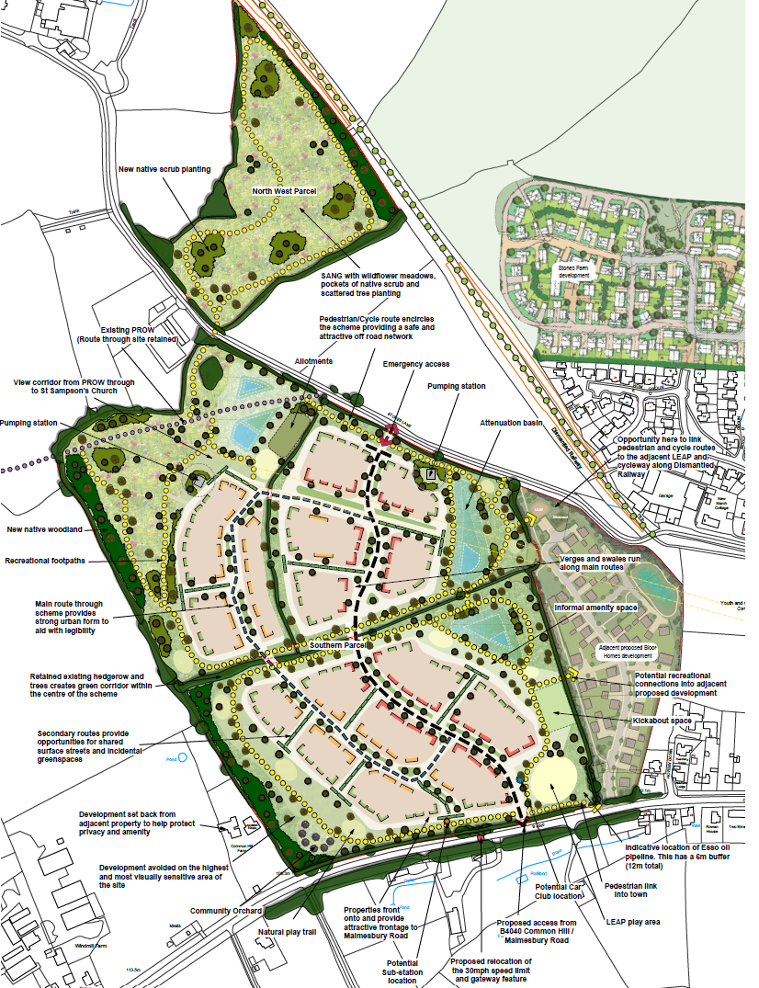

8. Site Layout
As mentioned previously, the main area of land will have all the dwellings and open space whereas the northern section will just be SANG which gives the following outcome:
 | To be developed | Undeveloped | Total
Main section | 7.87 | 9.35 | 17.22
Northen section (SANG) | - | 3.50 | 3.50
Total | 7.87 ha | 12.85 ha | 20.72 ha
 | 38% | 62% | 100%

When considering the Landscape Masterplan we welcomed the significant amount of open space around the main section and the northern SANG area. However, to achieve the stated housing number of 315 the housing density of the built up area (not the overall site) will be 40 dwellings per hectare. This is higher than seen on recent developments but this ‘densification’ is one way of achieving higher housing numbers without the loss of too much greenfield land.

9. Connectivity and Active Travel
The Cricklade Neighbourhood Plan policy TT2 ‘Off Road Routes in Cricklade’ states “.. new residential developments should provide improved pedestrian and cycle routes to the town centre, schools, leisure centre and other facilities and put the emphasis on improving the pedestrian experience” The current emphasis on ‘active travel’ raises the importance of the subject.
This is especially important for children living on the new development to be guaranteed a safe route to school on either foot or cycle.
Pedestrian access will be by footway on Common Hill which will require extending from its current paved limit at the entrance to Horsey Down. The Bloor Homes development must also provide such a link should it gain consent. This will not be a safe walking route unless, at the least, it is made shared use and streetlighting installed to the new 30mph limit boundary.
Another option, especially for residents in the north of the site, would be for pedestrians and cyclists to use Stones Lane to access the town centre. However, this is single track with tight bends, no footway and poor lighting and so is not suitable for such a key link. The applicant regards this as a “quiet lane” but it remains our opinion that this is unsuitable for any pedestrian other than one able to hop onto the grass verge should a car approach.
The applicant references links via the Bloor Homes site to National Cycle Route 45 on the old railway line. Whilst this option would be much preferable it is not deliverable because it crosses third party land. This is not acceptable. We note the WC Highways Engineers has similar views but is suggesting a s106 contribution of £80k to upgrade and widen the NCR45 to form a shared use path. The liability could be shared with Bloor Homes should their scheme progress and consent received from landowners CTC and Cotswold Lakes Trust.
The masterplan shows two linking footpaths to the Bloor site and provision should certainly be made for these links to take place if both applications should receive consent.

10. Travel Plan
The Travel Plan states that the site is “within walking and cycling distance” of local amenities and provides distance tables which show that the town centre high street is accessible on foot in 16 minutes.
However:
- Walking back from the town centre will take longer because it is uphill – not good for the less able residents or those carrying a bag of shopping.
- Distances are measured from the centre of the site, not from actual access points and so some journeys will be further than stated.
- No assessment is provided of the quality, safety, continuity or lighting of walking routes.
- The B4040 is given as a reasonable walking corridor, despite being beside a busy road

The above will mean that many of the new residents will be accessing the town centre by car but there does not seem to be any projections of the amount of this vehicular access or where they will park, given the well-known parking constraints in the town centre.

The Travel Plan sets out a variety of initiatives that would be aimed at reducing vehicular traffic (known as a modal shift) and a Travel Plan Coordinator will be funded by the developer for five years with defined targets to be monitored by WC.
Discussions have taken place with a car club operator that has expressed interest in the location and so two parking spaces would be provided for this purpose.
The indicative road layout has been designed to include a loop to enable a bus service to access the site. This would probably be an extension of the Stagecoach service 53 which currently stops at the Bishopsfield bus shelter. The route of the 53 is from Cricklade to Swindon town centre in one direction (via Purton, Lydiard, Link Centre and Outlet Centre) and from Cricklade to the Orbital Centre in the other. The comments of the WC Highways Officer are positive but go on to say:
“The applicant raises the intent of consulting with Stagecoach bus company but will need to be negotiated with the bus team within Wiltshire Council. The Passenger Transport Team were consulted as part of the process for assessing this application and indicated that a sum of £855,000 for this service will be required. The total cost of this enhanced service is currently £171,000 per annum which is partially funded from funds obtained from Central Government and currently only available until March 2028. Therefore, the funding request will be provided via a S106 contribution with the first payment provided by March 1st, 2028.”
Whilst the sum does seem large (it represents 5 years at the current whole route subsidy of £171k per annum) we strongly support the provision of such an enhanced bus service. It would enable residents of the new development to access the town centre as well as destinations further afield.
The applicant has rejected this proposal as not being justified or appropriate because it is not in accordance with the NPPF. However the applicant remains willing to consider any robust evidence and it is our opinion that this matter should be pursued.
11. Historic Environment Assessment
The applicant has commissioned a detailed report examining historic records and maps. It suggests that the expectation of buried archaeology is low to moderate. There is some ridge and furrow but this is not at all unusual around Cricklade. Aerial photography from 1971 indicates two features on the site worthy of investigation (page 14 of the HEA), and historic maps indicate that the current field layout dates from 1816-79. The tunnel queried on page 15 was for the North Wilts Canal.
The County Archaeologist has conditioned a full geo-physical survey, probably to be followed by the digging of test pits.

12. Biodiversity and the Environment
The site itself is mainly low-value grassland but does include important hedgerows and supports species such as bats, birds, badgers and great crested newts, with nearby North Meadow Special Area of Conservation (SAC) that could be affected.
Mitigation is proposed, including habitat retention, biodiversity net gain and a SANG to reduce pressure on protected areas—but these rely on effective design, long-term management, and funding.
An Ecological Impact Assessment and a Biodiversity Net Gain Report have been submitted. The BNG report indicates that there will be increases of 18.49% in Habitat units and 17.51% in Hedgerow Units, thereby achieving the 10% minimum requirement.
The North Meadow SAC is of international significance and is just 300m to the north of the application site. The North Meadow Interim Mitigation Strategy (NMIMS) has been drawn up by Wiltshire Council, Cotswold District Council and Swindon Borough Council with the main objective of mitigating the recreational pressure on North Meadow. For developments of more than 49 dwellings a SANG must be provided, together with the payment of a Strategic Access Management and Monitoring (SAMM) contributions of £356 per dwelling.
The applicant has commissioned a Shadow Habitats Regulation Assessment which states:
“In conclusion, provided the measures, as described in this report, are carried out, there would be no adverse effect on the integrity of the North Meadow and Clattinger Farm SAC, or any other European / international designated site as a result of the Proposed Development.” (para 5.15)
The submission from Cricklade Court Leet, which owns a part of North Meadow together with being deeply involved in its management, states that they take a contrary view. The essence of their position is that it is well evidenced that recreational pressure on protected sites such as North Meadow comes mainly from residents in the immediate vicinity and that the only way to approach any sort of guarantee of mitigation is to prevent further development within a buffer zone.
13. Agricultural Land Assessment
The submitted report classifies the land as Grade 3b – moderate quality agricultural land. The soils on the site are identified as being slowly permeable seasonally waterlogged clayey soils with similar fine loamy over clayey soils and so the site is classified as wet because of limited drainage capacity.

14. Storm Water Drainage and Flooding
The site is not susceptible to flooding apart from an area to the north which will be left undeveloped. However, with the site on higher ground above the town then the potential for flooding to neighbouring sites on lower ground is of particular concern to those residents.
The approach proposed by the Drainage Consultant to achieve the betterment requirement for drainage flow offsite is by way of four attenuation ponds to the east and north of the main parcel of land with two particular discharge points from the site:
- to the north through a pipe under Stones Lane into an open ditch along the western boundary of the SANG and then down to the Thames. The consultant put forwards the same solution we mentioned in our February response to the Public Consultation which consists of routing the water from the two eastern attenuation ponds to the northern ponds so that it all follows this SANG route thereby bypassing the built up areas of West Mill Lane and Reeds by reducing the volume of water past the Leisure Centre outlined in b) below.

- at the mid-point of the eastern boundary, but here there are problems identifying connectivity and/or whether the ditch and pipe network is suitable. The uncertainty is understandable because some of the infrastructure is underground and dates from the opening of the railway in 1883. Currently stormwater pools under the bridge that carries Stones Lane over the old railway line - but eventually it runs parallel to Stones Lane in a combination of open ditch and culvert, under Stones Lane by the Leisure Centre car park, and then into a culvert next to West Mill Lane eventually into the disused canal down to the Thames.

On 1st June we noted that the overland ditch following the hedge line running west-east across the development site (between the eastern attenuation ponds) will be left to drain as now. In the interests of community benefit it would be preferable for this to be diverted to the northern attenuation ponds as described in a) also. This request still stands.

15. Foul Water Drainage
The proposed scheme is for foul water to flow by gravity to pumping stations in the north west and the north east of the housing section of land. From there it will be pumped to the join the main 225mm sewer on Common Hill at a maximum of 10 litres per second and thence, by gravity, to Cricklade.
The capacity constraints of the Cricklade Sewage Treatment Works (STW) are well known and so Thames Water, in their letter to the applicant’s agent of 25th March 2026, state that they are unable to meet the needs of the development at this time. Their customary position is that, although they are legally required to connect, they will work up a solution which has three elements:
- Modelling 9 – 12 months
- Design 6 months
- Construction up to 18 months
These timings are just indicative but show the maximum time could be 36 months. Any upgrades (known as ‘off-site reinforcement’) will be carried out at the cost of Thames Water but the process will only start when, and if, outline planning consent is obtained. The letter also states:
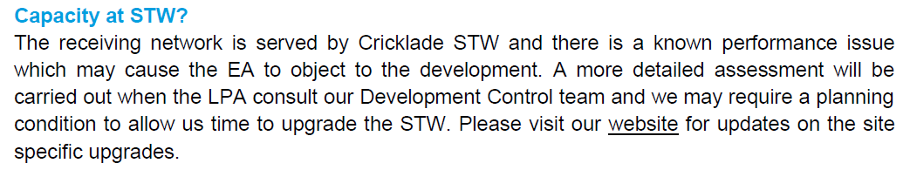

Thames Water are required to publish their discharge statistics and the figures for 2025 show that for the year there were 59 untreated discharge events at the STW amounting to a total of 641 hours ie over 12 hours per week on average. The volume of untreated discharge is not made public.
The latest extract (26th July 2026, unchanged from 30th May 2026) from the TW website for their Improvement Programme for Cricklade STW says:

The capacity of the STW is being increased from 26 to 30 litres per second.
In our 1st June submission we raised two points and we are pleased to see that the consultant commissioned by the applicant has responded to these points in their updated Flood Risk Assessment and Utilities Technical Note (blue italics) as follows:
Q1 The increase in capacity will be welcomed by the residents of Cricklade who are dismayed at the frequency of untreated discharges into the Thames. However, the 4 litre per second increase is in danger of being overwhelmed by the 10 litre p/s of this Mac Mic proposal. If it costs £7m to add 4 litre p/s, will it cost £17.5m to add a further 10 litre p/s? Or is even feasible at all? Unfortunately there will probably be no answer to this question from the interested parties to this application.

A1 3.3 The formal design for the FW pumping station has not been undertaken as yet and so the final discharge rate has not been confirmed or agreed with Thames Water. The 10l/s discharge rate reflects an initial assumption for the pre-application capacity check based on similar pumping stations. Therefore the agreed final discharge rate may be lower or higher than the quoted 10l/s.

3.4 It is important to note that the comments from Thames Water did not raise an objection to the quoted 10l/s discharge rate itself, just the capacity of the sewage treatment plant and so Thames Water must have considered that the 10l/s discharge rate would be acceptable once the capacity improvements have been completed. One of the benefits of a pump station is that Foul Water can be discharged at quiet times when there is spare capacity in the sewage network, for example overnight. This would be dependent on providing sufficient attenuation within the pump station but this would be confirmed during the detailed design stage when the capacity of the pumping station and the discharge rate is confirmed.

Q2 The quote above from the Thames Water letter of 25th March refers to the Environment Agency possibly objecting. This seems unlikely because they are not one of the statutory consultees and so they might be unaware of this proposal, although we could bring it to their attention.

A2 Whilst no formal objection has been received from the Environment Agency, it is considered that it would be for the same reason as the Thames Water objection, namely insufficient capacity in the sewage treatment plant resulting in sewage discharge into the River Thames. Consequently, the sewage treatment plant improvements should reduce the potential for discharges into the river,
thereby responding to any potential objection from the Environment Agency.
The response given in paragraph 3.4 is especially interesting. The inference drawn by the consultant from the comments of Thames Water surely cannot be the meaning that TW intended. The simplest way to resolve the ambiguity is to ask TW to clarify.
The possibility of a timed release from the two on-site pumping stations into the mains sewer to avoid periods when the capacity constraints are especially tight is worthy of exploring further. However we know that the levels of untreated discharge are at their peak during periods of heavy rain which can occur at any time of the day or night.

16. Waste Audit
The Waste Audit Statement states that waste minimisation and management will comply with national and local standards. However, with this just being an outline application by a land promoter (not the final developer) there is limited information for us to consider at this early stage.

17. Utilities – Electrical Supply
There will be no gas supply to the site and so a higher capacity electrical supply will be required than would have previously been the case. There is also the requirement for all houses to have an Electric Vehicle charge point. The provision of solar panels appears not to have been decided yet.
Two options are being considered, providing:
- Air source heat pumps = site requirement of 5,424 kVA or,
- Electric boilers = site requirement of 7,725 kVA
Scottish & Southern Energy Networks have notified the applicant that there is only 3,000 kVA spare capacity at the moment which is only enough to supply 158 houses that have air source heat pumps or 122 that have electric boilers. This would mean that a phased approach to the development of the 315 houses will be needed.
Although two electric cables cross the development site on telegraph poles these are not suitable to provide the connection and so an underground cable will be required to be run from the substation on the Fiddle.
SSEN have said that a local capital improvement scheme is planned but it has not yet been approved by Ofgem and so no timelines are available as to when an increased capacity will be available.
18. Health Services
We have been aware for some time that the two GP practices in Cricklade have been operating at virtually full capacity. This is borne out by the 19th June 2026 submission from the NHS Bath & North East Somerset, Swindon and Wiltshire Integrated Care Board.
It states that a s106 payment of £327,436 will be required to refurbish or extend GP premises using the formula:
315 units @ 2.3 per dwelling = 725 people, requires 62.10 sq m floor space @ £5,273 per sq m

19. Housing Mix
The WC Core Strategy has a requirement for a 40% provision of Affordable Housing which equates to 126 to be split between affordable rent, shared ownership and first homes as shown in the table below. We would wish to see Social Rent homes also being provided, not just Affordable Rent.
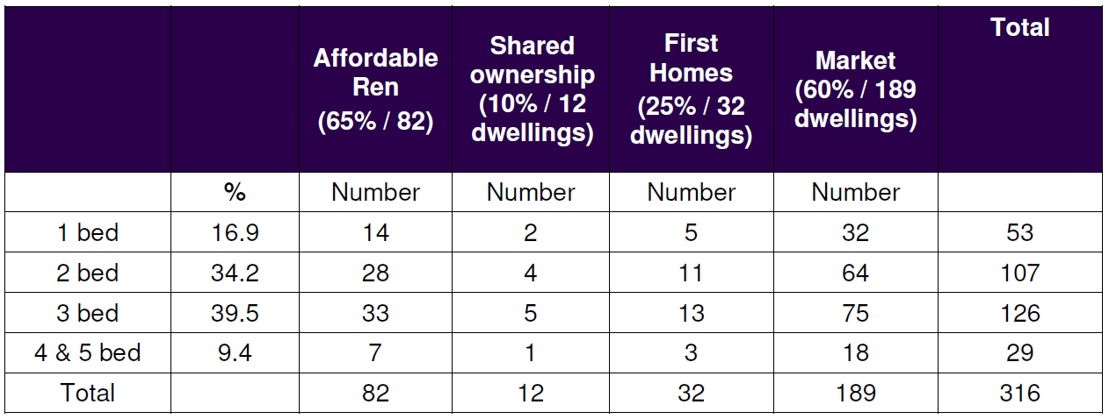

The applicant has based the Housing Mix allocation on the findings of the Housing Needs Assessment commissioned by CTC from AECOM as part of the preparatory work of the Cricklade Neighbourhood Plan Review. This brings forward a much higher proportion of smaller (1 & 2 bed) market homes than is usually seen. This will benefit first time buyers and older homeowners looking to downsize and is welcome.

20. Planning Context
a) The Wiltshire Council Core Strategy adopted in January 2015 sets out comprehensive planning policies county wide and at a more local level.

Core Policy 1 sets out a hierarchy of settlements in the county - excluding Swindon which is dealt with by Swindon Borough Council. New housing development is to be concentrated in the principal settlements.

Wiltshire Council Core Strategy Hierarchy of Settlements
Principal Settlements (3) | Chippenham, Trowbridge, Salisbury
Market Towns (12) | e.g. Royal Wootton Bassett, Malmesbury, Marlborough, Calne
Local Service Centres (7) | includes Cricklade, Pewsey, Wilton
Large Villages | e.g. Purton, Lyneham, Ashton Keynes, Minety
Small Villages | e.g. Latton, Purton Stoke

The Core Strategy states that:
“Local Service Centres are defined as smaller towns and larger villages which serve a surrounding rural hinterland and possess a level of facilities and services that, together with improved local employment, provide the best opportunities outside the Market Towns for greater self-containment. Local Service Centres will provide for modest levels of development in order to safeguard their role and to deliver affordable housing.”

CTC agrees with the classification of Cricklade as a Local Service Centre

Core Policy 2 sets out the planned distribution of new housing. The total for the county is allocated among three Housing market Areas and then Community Areas, with Cricklade falling within the Royal Wootton Bassett & Cricklade ‘remainder’ which comprises Cricklade, Purton, Lyneham and a number of smaller settlements. The indicative housing requirement is 385 for the plan period 2006 to 2026. This number has been achieved with developments in Cricklade at Hitchings (70), Culverhay (44) and Jenners Yard (25).

b) The Cricklade Neighbourhood Plan was passed at referendum in 2018. Policy H1 shows the Settlement Boundary (below) outside which development will not be supported. The Neighbourhood Plan is in the process of being reviewed and a Draft NPR will be issued for public consultation shortly.
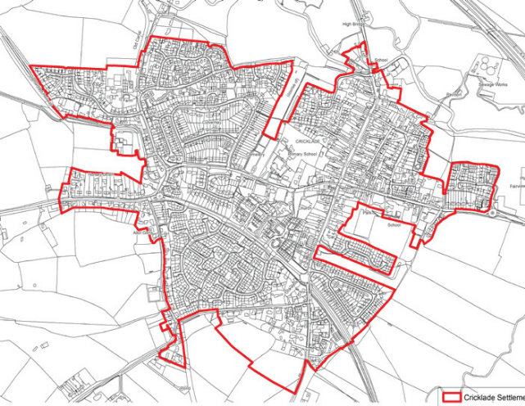

c) The Wiltshire Council Local Plan will be the replacement for the Core Strategy. A Draft Plan to cover the period to 2038 was in production for several years and through various stages of public consultation. In November 2024 it was submitted to the Planning Inspectorate for examination. That process moved slowly in 2025 and ultimately led to the two Inspectors issuing an ultimatum to WC to either withdraw the Draft or proceed with it and have it recommended for refusal. Following planning officers recommendations, WC voted to withdraw that Draft Plan on 19th May 2026.
That Draft Local Plan indicated a residual housing requirement for Cricklade of 52 dwellings during the period to 2038. However, in January 2025 Newland Homes were granted outline consent on appeal for 140 dwellings at their site at Stones Farm and so the indicated number has already been achieved. Cricklade is classified as a Local Service Centre and so is just expected to “provide for modest levels of development.”
d) National Planning Policy Framework (NPPF) sets the high-level planning policies for England. Specific reference is made to the need for ‘sustainable’ development’ and how that should be achieved. In December 2024 the NPPF was significantly amended and higher levels of housebuilding are now required nationwide. The target for Wiltshire has increased by 84%.
e) A new Local Plan. Following the withdrawal of the Draft Plan mentioned in b) above, the next step is for Wiltshire Council to commence work on a new Local Plan which will need to incorporate the higher housing targets set out in the NPPF. The timetable for the production of this new Local Plan is much shorter with completion expected by mid-2029. At this very early stage it is not known if the existing 52 figure for Cricklade will be increased by 84% (to 96) or whether another method of allocation would be appropriate. The withdrawn Draft Local Plan retained the classification of Cricklade as a Local Service Centre and we would expect that to be carried over to the new plan.
21. Planning Statement
The Planning Statement submitted by the applicant recognises the fact that the site is outside the Settlement Boundary. Notwithstanding this, the applicant is relying on the overriding provisions of the National Planning Policy Framework that state that policies such as a settlement boundary cannot be relied upon where the Local Planning Authority cannot demonstrate that they have a five-year housing land supply. This is the crux of the applicant’s submission.
The latest figures that we have from WC indicate there is currently a 2.42 year land supply (base date 1st April 2024) which is well below the five year target. The applicant therefore concludes that the presumption in favour of sustainable development dictates that consent should be granted unless the adverse impacts significantly and demonstrably outweigh the benefits.
It is the opinion of CTC that there are significant adverse impacts of the scheme including:
- Congestion impact on traffic and especially parking provision in the town centre
- Inadequate pedestrian and cycle links to the town centre
- Inadequate capacity at the Cricklade Sewage Treatment Works
- Impact on the two GP surgeries of higher patient numbers
- Impact on the internationally important North Meadow Special Area of Conservation
As mentioned above, Cricklade, as a Local Service Centre, is expected to “provide for modest levels of development.” In the current plan period to 2026 there have been at least 139 dwellings delivered (Hitchings 70, Culverhay 44 and Jenners Yard 25) which has more than achieved the contribution to the Royal Wootton Bassett & Cricklade Area ‘Remainder’ (which consists of Cricklade, Purton, Lyneham and a number of small villages) requirements of the Core Strategy. There is the prospect of 140 further dwellings on the Newland Homes site at Stones Farm which received outline consent at appeal in January 2025. This level of development is more than modest and there are other applications in Cricklade from Bloor Homes (mentioned previously), Hannick Homes (49) and Bellway Homes (43).

22. Community Benefits
Wiltshire Council admitted to a lack of a five-year housing land supply early in 2020. Consequently, Cricklade Town Council issued the following statement in July that year:
“We take this opportunity of stating that CTC will resist any development outside the settlement boundary as defined by Policy H1 in the Cricklade Neighbourhood Plan (CNP) unless there are clear and exceptional community benefits arising.
The CNP sets out the development proposals for the plan period 2016-2026 and the following sites are currently in the process of being built out: Hitching (70 dwellings), Culverhay (44) and Stones Farm (25) thereby providing an additional 139 dwellings in the town. This is more than adequate to meet the needs of the Wiltshire Council Core Strategy. The CNP was made in April 2018 and so, by any reasonable definition, cannot be regarded as out of date.
We call upon Wiltshire Council to stand behind this position when considering all future applications for development outside the Cricklade Settlement Boundary during the plan period to 2026.”
CTC has supported some development outside the settlement boundary - such as the small site for three dwellings on The Forty which enabled the pedestrian link from Hitchings to The Forty to be brought about. However, whilst this current application provides some community benefits, they are not obviously “clear and exceptional” because most are being provided as a legal necessity or because the development could not proceed without that expenditure.

23. Statement of Community Involvement (SCI)
CTC has a policy on engaging with developers with the aim of achieving the best outcome for new and existing residents in Cricklade. The applicant attended the public meeting of the CTC Planning, Conservation & Transport Committee on 9th February to present the scheme and answer questions.
A public consultation was organised by the applicant in the period 9th February to 1st March 2026 when 2,140 letters were distributed to households. A specific website was set up with details of the proposed development. There were 163 responses to the consultation which the applicant has summarised in the SCI.
We always recommend that such consultations should also include a public session where all residents have the opportunity to meet with representatives of the developer and ask questions. Viewing plans on laptop and telephone screens is not easy and there is no substitute for face to face contact for asking questions. There are plenty of suitable venues in the town for such an event. It is unfortunate that such an event was not held in this instance, particularly in view of the magnitude of the scheme. To ensure residents – especially those not tech savvy – were not disadvantaged, CTC made the offer of putting a display board in our front office (open 5 days a week) and our staff were able to assist a number of residents to make online submissions.
The Town Council did make a submission to the applicant summarising the points discussed at the Planning Committee meeting on 9th February and requesting that it be included in the SCI report. Unfortunately this has not happened.
24. Summary
While the proposals include positive landscaping, recreational space, and ecological features, these benefits must be balanced against the significant concerns relating to infrastructure capacity, traffic impact, environmental effects, and the long-term urbanisation of the rural edge of Cricklade.

The proposed development is very large when compared recent developments and would represent a major expansion westwards on rising ground above the town. The application is premature because until the Bloor Homes site is brought forwards there are no means of providing safe walking and cycle routes to the town centre and other facilities.
25. Conclusion
Cricklade Town Council OBJECTS to this application on the grounds of non-compliance with:
- Wiltshire Council Core Policies CP1 - Settlement Strategy and CP2 - Delivery Strategy
- Cricklade Neighbourhood Plan Policies H1 - The Settlement Boundary and TT3 Off Road Routes
- Cricklade Neighbourhood Plan Policy H8 - Foul Water Management, Flood Risk and Surface Water Management,
- Wiltshire Council Core Policy CP50 - Biodiversity and Geodiversity
Further, the following elements show that the site is not currently deliverable and so should be REFUSED:
- Ecology: the inability to quantify the impact on the North Meadow SAC remains a significant concern,
- Access and Traffic Density: the vehicular access proposals do not adequately address the increased risk to pedestrians and cyclists on the B4040 or lack of car parking in the town centre
- Surface Water Drainage: the application fails to recognize the surface water flooding that already exists on and around the site, and which would be exacerbated by the development,
- Foul Water Management: the application fails to recognize the extent of the sewerage capacity issues that already exist.
In the event this planning application receives consent
- Mandatory Pre-Construction Conditions should be placed on the grant:

- Sewage Capacity – increase size of existing pipe system & treatment works capacity
- Surface Water Drainage – runoff to be diverted to the northern ditch, away from the existing built up area.

- Conditions on this application to be carried forward to Reserved Matters should consent be given:

- Housing Mix: Bungalows are needed for this area. The 2.5 storey houses should be removed from the scheme as visually they appear as 3 storey. CTC need a condition that is binding to deliver 126 affordable housing shared between shared ownership/first home owners & affordable rent (ideally to include Social Rent too) along with those from the open market so another 64 x 2bed and 32 x 1bed places.

- Green Space: ensure the mix of developed space and green space is appropriate; that green spaces do not get smaller than the current plans.

- Play Area: As per the Urban Design Officer feedback, the play area should not be at the entrance to the estate next to a busy road. CTC have previously suggested that the play area should be in the centre of the estate.

- Design Concept: Urban Design states that the design of developments that are outside settlement boundary should be exceptional. We agree with their comments including their final conclusion.

