Ox Lea Barn
Devizes Road,
Rowde,
SN10 2BQ

Supporting Statement and Information for Application
Sheep Isolation Shed and Pig Housing

August 2026

Mr and Mrs Mills

Ox Lea Barn was established in 2016. The agricultural holding consists of circa 16 acres, a mix of grazing and agricultural buildings. The owners breed rare breed Oxford Down Sheep and Oxford Sandy and Black pigs. The rare breed lamb and pork meat boxes are sold locally by private sale to customers in Wiltshire with the best animals true to type sold as breeding stock. The rams make excellent terminal sires producing fast growing lambs and the ewes have good mothering ability. Over the last few years, the applicants have found it increasingly difficult to house the pigs on the farm’s main yard and so an alternative solution is now required. In addition, new Oxford Down rams brought in as part of the planned pedigree breeding programme are required to remain in quarantine on arrival at Ox Lea Barn. In the UK, quarantining incoming sheep is a critical biosecurity measure that involves a 21 - 28 day isolation period. It protects the home flock from risk of illness and disease.
A suitable quarantine area has been identified within the Ox Lea Barn holding. The applicants feel it is now apparent that a combination use building sited away from the farm’s main yard and buildings is needed to fulfil both requirements and reduce the risk of incoming disease.

Proposal
The owners of Ox Lea Barn are seeking full planning permission to erect a modest size steel frame shelter/quarantine shed at the furthest point of the holding. The shed will be a 33ft x 17ft steel portal frame, open wood clad down to 4ft concrete panel base with fibre cement roofing. The proposed site for the new shed was historically mapped and identified as a dairy cattle shed with an adjacent concrete yard area when the land formed part of the neighbouring dairy at Ox House farm (see 1885 map). The old cattle yard that remains is located in a secluded area of the Ox Lea Barn holding and is not overlooked by any neighbouring properties. The old cattle building is no longer visible above ground level, but now forms part of the concrete cattle yard/pen now used as hard standing to store agricultural materials and wrapped fodder storage for livestock winter feed. The old cattle yard area currently holds circa 300 reclaimed railway sleepers that have been stacked in the location since 2019. The railway sleepers are stacked in bundles of 24 and the structure stands at approximately 10 ft in height. These railway sleepers are used on the holding as building material and for repairs. The stack has greatly reduced in recent months due to recent planned infrastructure and construction. The footprint area that the sleepers occupy is circa 84 square metres. The holding yard is enclosed by stock fencing with seven bar galvanised stock gates into the sheep pasture. There are no immediate hedgerows or trees adjoining the proposed site. The historical dairy/cattle yard is used regularly by the applicants as a holding area for health checks and other animal welfare husbandry such as sheep shearing and medicating sheep.

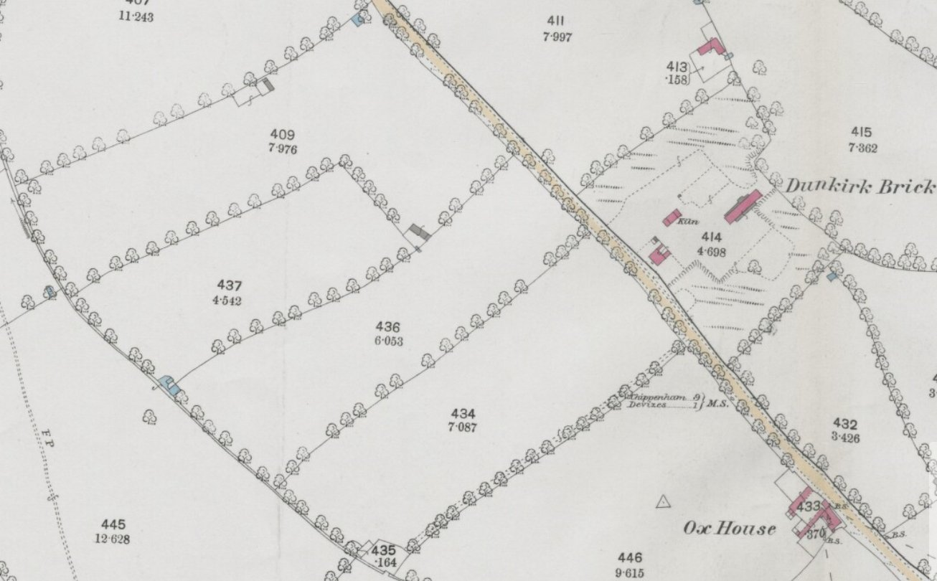
1885 map (courtesy of National Library Scotland)

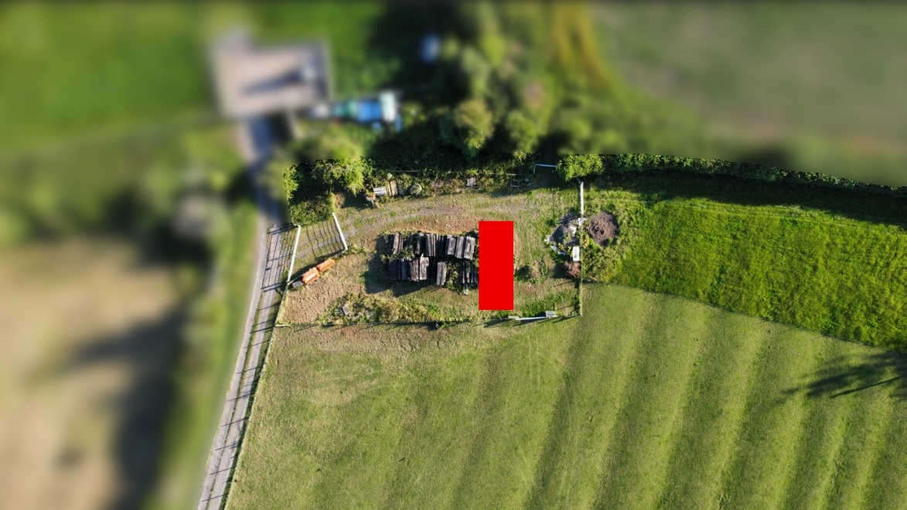
Old cattle yard aerial view and proposed location for building in red- North bottom right of picture

The proposed building is of a modest size of 52 square metres and will occupy part of the footprint where the railway sleepers are currently stored. The shelter will provide vital housing for the breeding of rare breed pigs and much needed quarantine housing for new Oxford Down sheep coming onto the farm. The building will also provide a general animal shelter at other times throughout the year when the weather conditions are inclement. The proposed building will be of a sympathetic style to fit in with the location and it will be constructed out of material that will blend with the landscape over time. The applicants propose to plant a hedge along the north east fence line to further soften the structure’s initial appearance until the open clad boarding fades to ash grey.

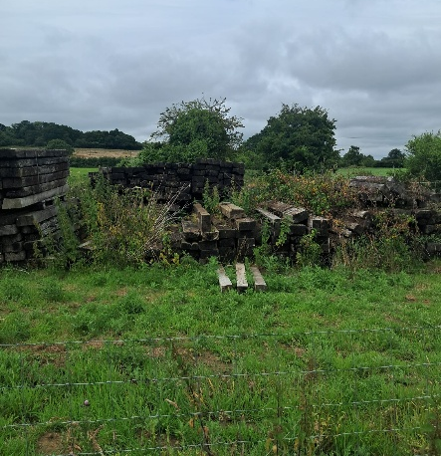
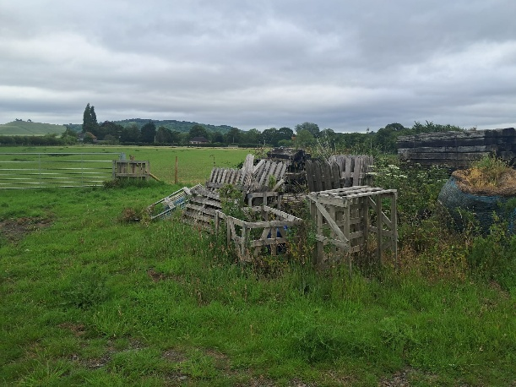

Old cattle yard looking south-west
Old cattle yard looking north-east

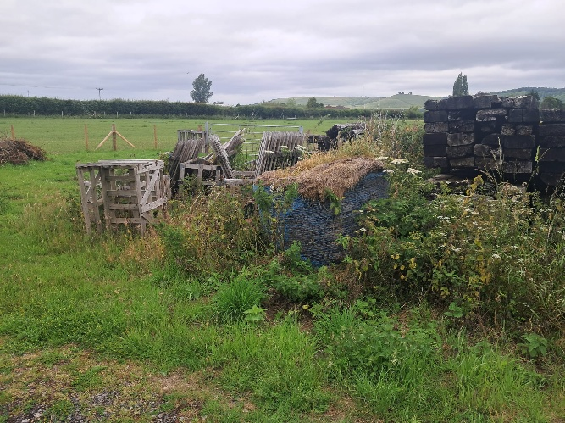
Old cattle yard looking north

History of the site

Table 1 – Planning History
Application Number | Purpose | Decision Date | Decision
17/00035/FUL | Erection of agricultural building to house livestock and associated equipment along with the creation of a hardcore access track. | 14/03/2017 | Approved with Conditions
18/07263/APD | Proposed agricultural barn for storage of hay and fodder | 23/08/2018 | Prior approval not required
PL/2022/00576 | New access onto A342 | 31/03/2022 | Approved with Conditions
PL/2023/10214 | Agricultural building for the storage if machinery and provide a workshop. | 01/02/2024 | Approved with Conditions
PL/2026/01535 | Hardcore yard area around existing agricultural building | 26/06/2026 | Approved with Conditions

Access
Access to the proposed new isolation shed will be by via the private entrance from the A342 approved under planning permission PL/2022/00576 identified with a red line on the site map. The proposal will not increase the number of vehicle movements currently associated with the property.

Flood Risk & Contamination
The Site is not located in a flood risk zone and is therefore considered to have a low probability of flooding as identified by the Environment Agency flood risk map. The site is also not considered at risk from surface water flooding. The site is not considered to be contaminated or at risk of future contamination.
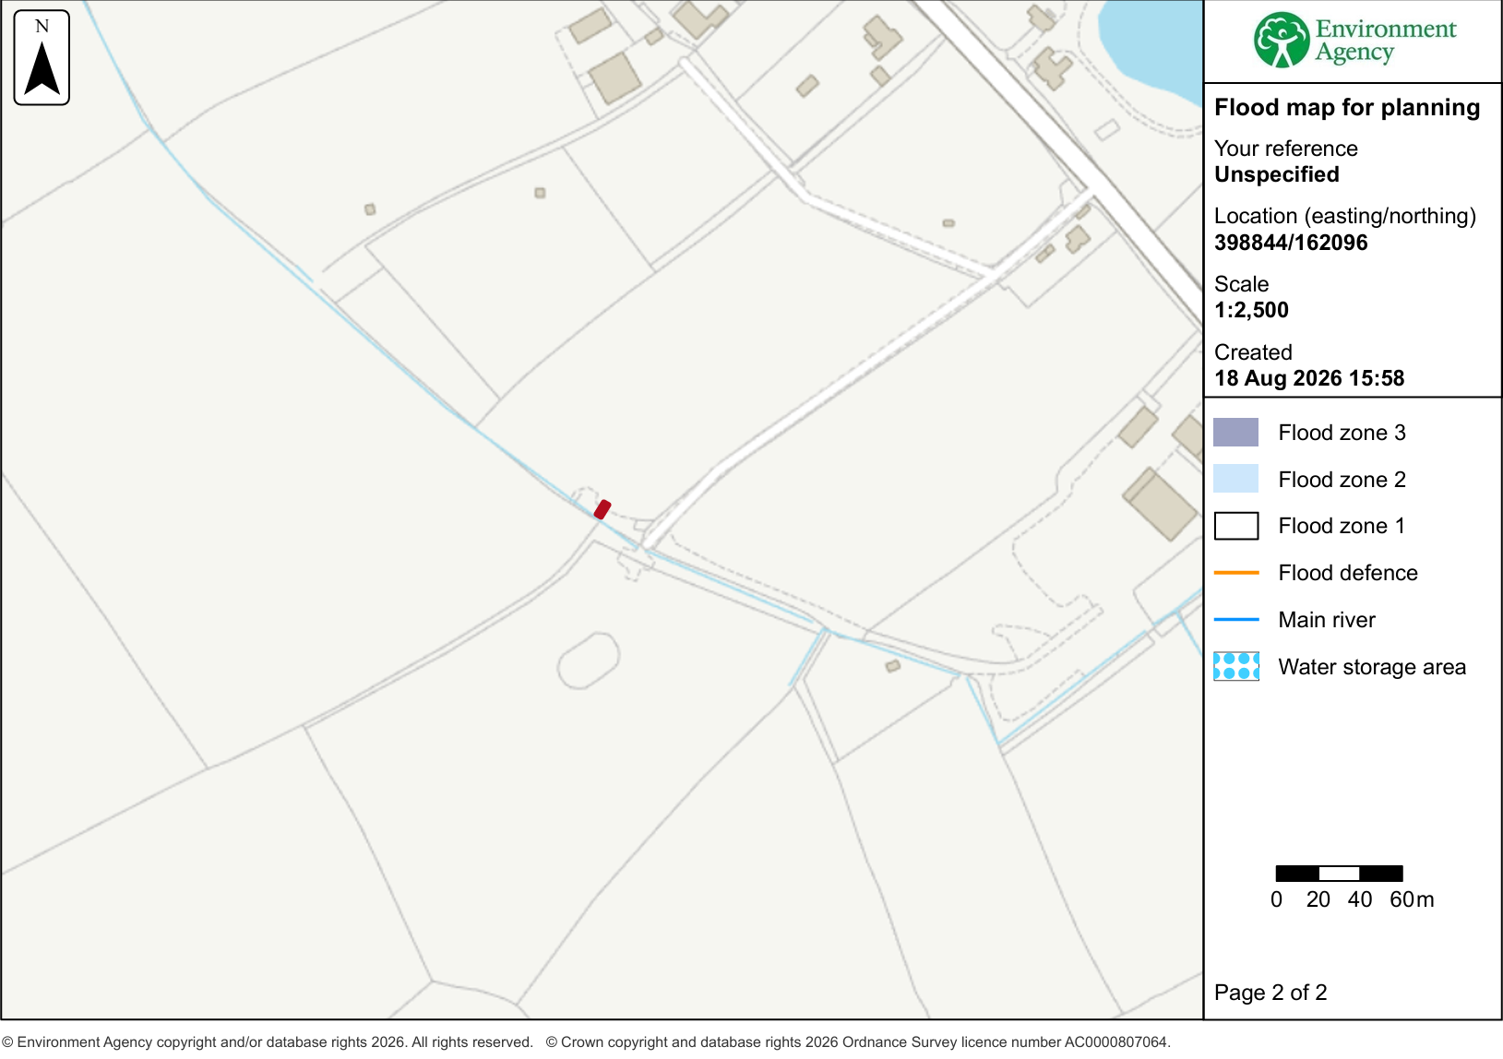
Flood Risk Map -Source: https://flood-map-for-planning.service.gov.uk/

Ecology
The applicants consider the use of the historical agricultural cattle shed area and concrete yard clearly seen on historical maps and photographs will exempt them from the requirement for a BNG survey as the proposed concrete yard area for the new building is already in situ. No part of the proposed structure will encroach on the trees/hedgerow in the location. The applicants have proposed to plant a new hedgerow on the yard boundary to the north east side of the fenced yard which will add to the well-established and maintained ancient hedgerow on the entire holding circa 865 metres. The applicants are keen to sight an additional owl box on the holding and they feel the new building would support a new internal barn owl box through consultation with the Barn Owl Trust.

Summary
In summary, the applicants wish to continue building on the success of their breeding programme at Ox Lea Barn and this proposed modest size building for the isolation of sick and new sheep and pigs will be integral for continued growth and success of the breeding programme and farming enterprise. The applicants hope that the local authority will support this vital agricultural building.

National Planning Policy Framework
The National Planning Policy Framework (2023) sets out, in paragraph 84, that planning policies and decisions should allow the sustainable growth and expansion of all types of business in rural areas, through well-designed new buildings.

Local Plan
The application is compliant with Wiltshire Core Strategy and more specifically the following policies are considered relevant: Core Policy 34 (Additional Employment Land) aims to promote modern agricultural practices and appropriate diversification of the rural economy. It states that outside of defined settlement boundaries, appropriate developments will be supported that supports sustainable farming and food production through allowing development required to adapt to modern practices. The proposed building, is to be used in association with the existing agricultural use and therefore expected to be considered acceptable in principle in accordance with this policy.

