APPLICATION FOR FULL PLANNING PERMISSION
CASE OFFICER REPORT
APPLICATION REFERENCE: | PL/2026/01962
APPLICATION TYPE: | Full Planning Application
SITE ADDRESS: | Abbeyfield House, 2 Trowbridge Road, Bradford On Avon, BA15 1EP.
DEVELOPMENT DESCRIPTION: | Proposed replacement of timber sash windows with uPVC windows.
RECOMMENDATION: | Approve with Conditions

PROPOSAL
The proposal seeks planning permission for the proposed replacement of aged timber framed windows, with new heat efficient uPVC double glazed units.
SITE DESCRIPTION/CONTEXT
The site is a two-storey substantial building, known as Abbeyfield House, at 2 Trowbridge Road, Bradford on Avon. The building is not listed and is located within the Bradford on Avon Conservation Area and occupies a frontage position along the Trowbridge and Junction Road, which is characterised by established large sized residential properties. The building is used as a full-time residence for sheltered housing by the Abbeyfield Society for the elderly and/or vulnerable residents.
The building is constructed from a light-coloured ashlar stone with a parapet roof design.

RELEVANT PLANNING HISTORY
Proposal / Summary
W/90/01298/FUL Two storey extension to form kitchen dining facilities and additional bed-sit accommodation Approved.
W/2025/09976 Application for a Certificate of Lawfulness Proposed replacement of timber sash windows with uPVC windows Refused.

RELEVANT POLICIES AND GUIDANCE
Wiltshire Core Strategy:

- Core Policy 57 Ensuring High Quality Design and Place Shaping
- Core Policy 50: Biodiversity and Geodiversity
- Core Policy 51: Landscape
- Core Policy 58: Ensuring the Conservation of the Historic Environment
- Core Policy 61: Transport and New Development
- Core Policy 64: Demand Management
- Core Policy 67: Flood Risk

Bradford on Avon ‘Made’ Neighbourhood Plan

Bradford on Avon Conservation Character Assessment.

Wiltshire Design Guide: Appendix D – Design Guidance for Householder extensions.

The National Planning Policy Framework (NPPF August 2026).

The Planning Practice Guidance.

National Design Guide.

Emerging Wiltshire Local Plan:
At Full Council on 19 May 2026, the elected members of Wiltshire Council agreed to withdraw the emerging Wiltshire Local Plan. The said Plan has no material weight for the purposes of the application.

In accordance with Regulation 19 of the Town and Country Planning (Local Planning) (England) Regulations 2026, on 30th June 2026 Wiltshire Council published a notice of intention to prepare a new local plan for Wiltshire. The next stage is a Scoping Consultation which commences on 2nd September 2026. This plan is at a very early stage and currently carries no weight for decision making.

CONSULTATION RESPONSES
Bradford on Avon Preservation Trust: Object to the application and make the following comments:
-Care taken in the past in regard to the building’s extension and windows
-Important within the Conservation Area, no evidence of window rot.
-Windows do not match profile
- Precedent of windows elsewhere not a valid argument.

Bradford on Avon Town Council: Object to the application and make the following comments:
-Replacement windows don’t match those as currently in place.
-Window frames are too ‘chunky’.
-Higher specification detailed windows are required.
-NPPF in support of such principles relating to windows.

Conservation Officer/s: Offers comments as discussed throughout this report.

REPRESENTATIONS
Two emails of representation were received raising the following points:
-Change in windows would impact on the building, out of character of the building & surrounding area.
-Neighbouring properties have sash windows.
-Understand need for heat retention, use of secondary glazing.
-Use of alternative remedies for heat retention, such double glazed units in wooden frames.
-Inappropriate window replacements not welcomed.

ASSESSMENT
Section 38(6) of the Planning and Compulsory Purchase Act 2004 states:

"If regard is to be had to the development plan for the purposes of any determination to be made under the planning Acts, the determination must be made in accordance with the plan unless material considerations indicate otherwise."

In accordance with this statutory requirement, this application has been assessed against the relevant policies of the Development Plan, including the adopted Wiltshire Core Strategy (2015) and the Bradford on Avon ‘Made’ Neighbourhood Plan for Bradford on Avon.

Design and Impact upon the upon the character and context of the area
Core Policy 57 - Ensuring High Quality Design and Place Shaping of the Wiltshire Core Strategy seeks to ensure that all new development is of high design quality, reflecting local context, character, and distinctiveness. The proposals can be viewed within the plan snippets taken from the submitted plans:

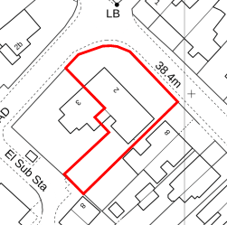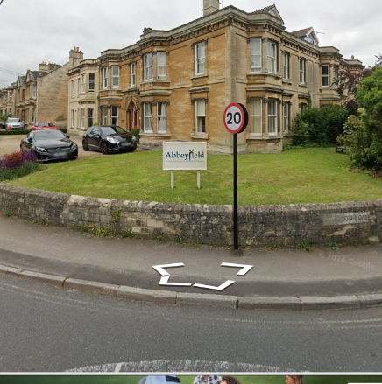
Location Plan Site photograph from Street View.

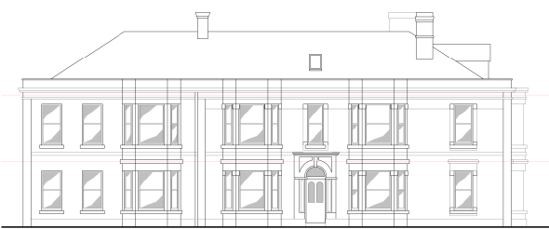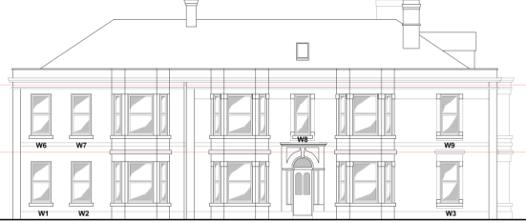
Existing North East Elevation Proposed North East Elevation

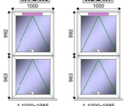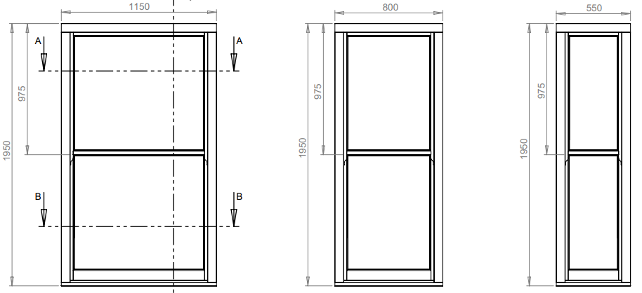
Fig. 1 (Superseded) Fig.2 Revised proposed slim framed sash windows.

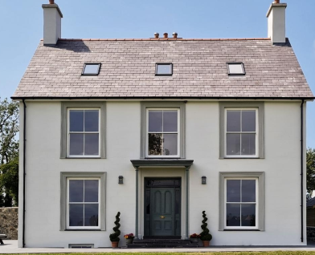
Example of Roseview replacement windows.

The proposal would see the removal and replacement of windows. The design and style of the original proposed UPVC framed windows consisted of top opening, standard thick framed examples, which were not considered as being appropriate or suitable within the Conservation Area, and to which the neighbour representations and Town Council and Preservation Trust relate to.

Examples of this initial design of window are shown in Fig.1 which consisted of standard top opening UPVC framed fenestration and which were superseded by the applicant following officer discussions with the agent as to their non suitability. It was also this design and style of window which led to the refusal of the certificate of lawfulness within PL/2025/09976.

Heritage Matters.
From the point of view of the historic environment the main statutory tests are set out within the Planning (Listed Building and Conservation Areas) Act 1990.

Section 66 requires that special regard be given to the desirability of preserving listed buildings, their settings or any features of special architectural or historic interest which they possess.

Section 72(1) of the Act requires the Council to pay special attention to the desirability of preserving or enhancing the character or appearance of designated Conservation Areas.

The Council’s Core Strategy Policy CP58 ‘Ensuring the conservation of the historic environment’ requires that designated and non-designated heritage assets and their settings will be conserved, and where appropriate enhanced, in a manner appropriate to their significance and encourages proposals which improve the condition of heritage assets at risk.

The revised replacement fenestration would be manufactured and supplied by a firm called Roseview Windows and would utilise their Ultimate Rose range. These range of windows are slimmer framed and manufactured using UPVC, Fig.2 above shows their detailing and are bespoke and utilised within properties located within the conservation areas and of listed status. As previously mentioned, Abbeyfield House is not listed but is within a Conservation Area and can be argued to be a non-designated heritage asset (NDHA). It is noted that this style and design of window has in the past been supported in its use within the district by heritage officers.

This design of fenestration is totally different to the standard ‘cheaper’ top opening thick framed windows and consist of acceptable thinner frames.

Two sets of Conservation Officer comments were received for this application, as there has been a change of officers within the authority. The first set of comments identified and discussed the general policies relating to the CA and the NDHA and identified the significance of the area as the being the historic past and architecture of the town. It is noted within the Bradford on Avon Conservation Area Character Assessment that the document discusses the common theme of building materials relating to the use of limestone and rubble stone for building construction.

The conservation officer did not support the use of the initial window design as not being accurate replacements and requested details of the slimmer window design. As previously commented, the initial window design has now been superseded, with revised slimmer framed fenestration being submitted for consideration.

Within the second set of conservation officer comments, a variety of matters were discussed, including policy and general guidance; the significance of the NDHA building were described as laying within its historic and architectural merits. The conservation officer has taken note of the revised details and has commented:

‘A revised window has been proposed, which is a UPVc sash window. The mid-rail is 35mm, with an 85mm bottom rail and 61mm frame. These are much reduced from the previously proposed windows, responding more to a traditional timber frame. Within the information submitted there is a choice of finishes and a choice of horns, none have been specified in the information provided. This could be condition if approval is proposed.’
Such revised window details are shown within the plan snippet labelled as Fig.2 above, and large scale window sections have also been provided, thereby negating the need to request such details via condition. It is considered relevant and necessary to condition compliance with such details as suggested.

In terms of compliance with the newly revised NPPF, section 20 relates to heritage matters and is called ‘Conserving and enhancing the historic environment’. Policy HE1(e)recognises the importance of NDHA’s and that they should be identified and supported as such, with Policy HE7 further supporting their presence and advising that their significance should not diminished or harmfully impacted upon by proposals. In this instance the existing windows are slim wooded framed sash windows, which would be replicated on a like for like basis by the replacement proposals. The existing frames are finished in white as would be the upvc proposals, therefore there would not be any demonstrable harm to the significance of the principal building in accordance with HE7.

The site is in a Conservation Area and so section HE9 (1) (a) and (b) are within the NPPF are relevant in that the importance of Abbeyfield House is recognised, such that the building makes a positive contribution to the character and appearance of the CA and that its significance is not harmfully impacted on by the proposals because of the proposed like for like replacements. The building is over 10 metres away from the pedestrian paved area and so unless subjected to close scrutiny, the difference in window frame materials would not be readily discernible.

Policy HE9(2) is also of relevance in that the policy recognises that not all built forms or elements of the CA serve to contribute to significance. In this instance the existing window frames consist of timber, however, upvc frames are permissible within a CA and there is such fenestration within the vicinity. The use of upvc for the proposed windows on alike for like basis would not result in the loss of a building and equally as described and explained above, would not harm the significance of the surrounding CA or the NDHA.

Policy HE9(3) of the Framework states: Proposals which conserve those elements of a conservation area that make a positive contribution to the area (or which better reveal its significance) should be supported. As explained throughout, officers are satisfied with the current revised scheme, on a like for like replacement basis, would not harm and would conserve the character and significance of the surrounding CA.

It is acknowledged that the conservation officer still objects to the scheme, but the benefits of the proposed fenestration such as improved thermal efficiency and visual appearance serve to outweigh any minor less than substantial harm.

The proposals would be covered and secured by planning condition and the proposal complies with the design principles set out in Core Policy 57 of the Wiltshire Core Strategy and Appendix D of the Wiltshire Design Guide.

Amenity
Point vii of Core Policy 57 - Ensuring High Quality Design and Place Shaping of the Wiltshire Core Strategy seeks to ensure that developments do not adversely affect neighbouring properties. The National Planning Policy Framework (NPPF), paragraph DP3 stresses that planning decisions should ensure developments provide a high standard of amenity for existing and future users.
The impact on amenity in this instance relates to the visual impact of the windows on the host building and the surrounding public realm, albeit the building is within the Bradford on Avon Conservation Area. The use of a quality window manufacturer such as Roseview Windows are appropriate for the provision of sensitive designed fenestration, which is appraised as being wholly acceptable within the surrounding heritage context of the area.

The proposal therefore accords with Core Policy 57 point vii and CP58 and areas of the NPPF as discussed above.

Ecology Impact CP50 requires no net loss of biodiversity on site. The site is located within the Bath & Bradford on Avon Bat SAC, but due to the nature of replacing existing fenestration with new windows, would not have any impact on biodiversity matters. Likewise in terms of BNG contribution, the proposed works are subject to de minimis exemption.

CONCLUSION
The proposed replacement window works are acceptable in terms of design, scale, and relationship with the surrounding area. It would not result in any unacceptable harm to the heritage character of the locality, the amenities of neighbouring occupiers, or ecology.

The proposals are therefore considered to comply with the relevant policies of the Wiltshire Core Strategy, the Wiltshire Local Plan, and the National Planning Policy Framework. Consequently, any minor less than substantial harm to the CA or principal building has been sufficiently outweighed by the distinct advantages of thermal efficiency and visual appearance or impact on the surrounding CA.
The application is recommended for approval, subject to the conditions set out below.

RECOMMENDATION: Planning Permission be GRANTED subject to conditions.

