APPLICATION FOR FULL-PLANNING PERMISSION
CASE OFFICER REPORT

APPLICATION REFERENCE: | PL/2026/01541
APPLICATION TYPE: | Full planning permission
SITE ADDRESS: | 9 Quartermaster Road, West Wilts Trading Estate, Westbury, BA13 4JT
DEVELOPMENT DESCRIPTION: | Erect extension to existing engineering building.
RECOMMENDATION: | Approve with Conditions

SITE DESCRIPTION/CONTEXT

The site lies within the West Wilts Trading Estate and contains an industrial building

Location plan excerpt:

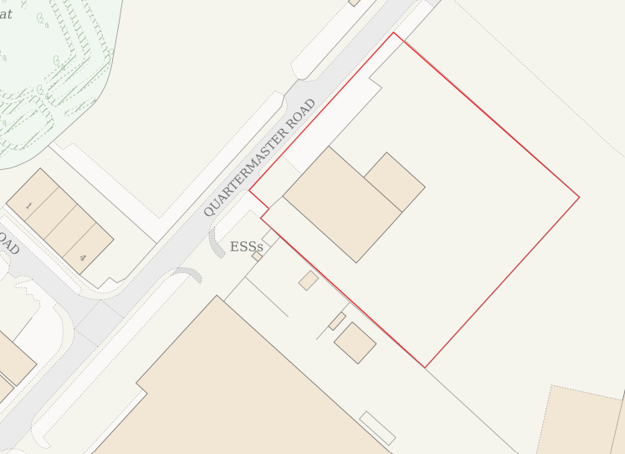

Context plan:

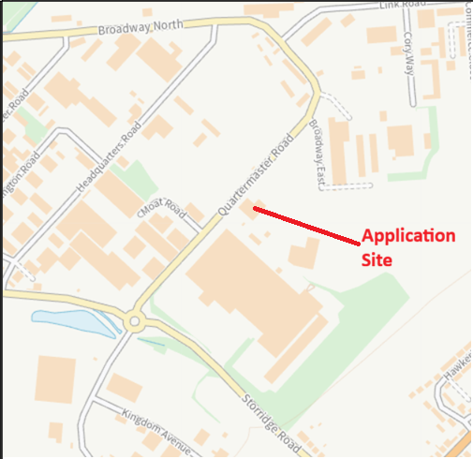

From the submitted Planning Statement:

“The overall size being 7385m2 with the existing building being 1128m2 located on the western side of the site, alongside Quartermaster Rd. The site functions as Spectra, a commercial vehicle repairs workshop. The site remains open plan, with no obstructions or little soft landscape throughout.

“Spectra’s workshop is located roughly 12m from the roadside. The furthest west point of the warehouse is aligned with the road access from Quartermaster Rd, with the opening being 6.5m across. The site offers 10 car park spaces on the NW face of the warehouse, with the building entrance being along this wall. Access by car to the building is via the palisade metal gated entrance (fixed via brick wall) which is parallel to the warehouse, alongside the pedestrian access. The access then opens up and provides access to the workshop from the roller doors on the SW, SE, NE faces.

“To the NW face (alongside the proposal) a metal palisade fence extends 30m from the existing building edge, in line with the workshop wall. From this point it is a brickwork wall, which provides a place for vehicles subject to bodywork to be parked. A small number of trees run along the NW boundary of varying quality.

“On the SW of the site, the boundary is 12m from the workshop. Beyond the boundary is a warehouse for Welton Bibby & Baron.

“On the NE and SE side of the property is an expansive car parking extending for roughly 90m off the boundary and.

“The workshop is a typical industrial unit, with corrugated steel clad, typical of many industrial buildings.

The site is not located within a conservation area, nor near any listed buildings. The site is within Flood Zone 1 and has negligible risk of groundwater flooding other than just at the entrance which is at risk of surface water flooding.

Flood risk map:

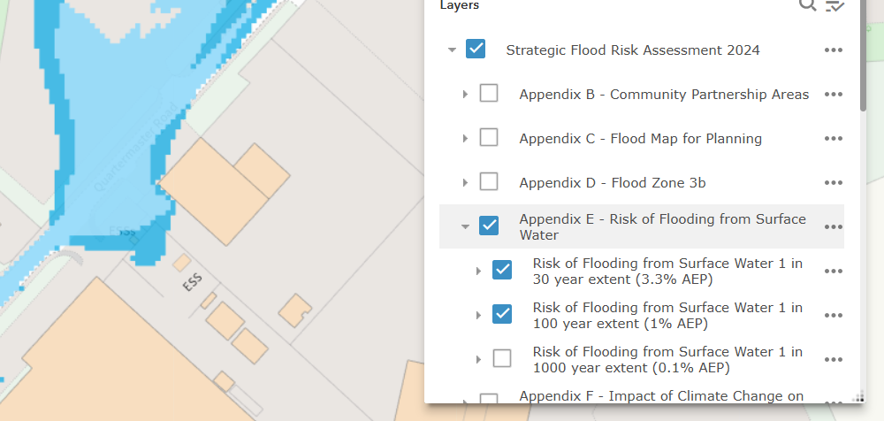

PROPOSAL

This scheme proposes an extension of the existing building, infilling and extending the north corner. This extension would match the existing building in terms of form and materials, extending the existing roof ridge.

PLANNING HISTORY

None relevant.

RELEVANT LEGISLATION, POLICIES AND GUIDANCE

National Planning Policy:
- National Planning Policy Framework (NPPF)
- Planning Practice Guidance (PPG)
- National Design Guide
Development Plan:
The development plan for Wiltshire comprises the Wiltshire Core Strategy (WCS) (adopted January 2015) and any made neighbourhood plans, which remains the principal statutory planning document guiding development across the county. In line with Section 38(6) of the Planning and Compulsory Purchase Act 2004, planning decisions must be made in accordance with the development plan unless material considerations indicate otherwise.

Though the development plan is considered as a whole, those parts deemed to be particularly relevant to this application are listed below:

The adopted Wiltshire Core Strategy (WCS), with particular regard to:

- Core Policy 1 Settlement Strategy;
- Core Policy 2 Delivery Strategy;
- Core Policy 3 Infrastructure Requirements;
- Core Policy 32 Spatial Strategy Westbury Community Area
- Core Policy 35 Existing Employment Land
- Core Policy 41 Sustainable Construction and Low-Carbon Energy;
- Core Policy 50 Biodiversity and Geodiversity;
- Core Policy 57 Ensuring High Quality Design and Place Shaping;
- Core Policy 60 Sustainable Transport;
- Core Policy 61 Transport & Development;
- Core Policy 62 Development Impacts on the Transport Network;
- Core Policy 63 Transport Strategies
- Core Policy 64 Demand Management
- Core Policy 67 Flood Risk;
- Core Policy 68 Water Resources;

Draft Wiltshire Local Plan Policies

At Full Council on 19 May 2026, the elected members of Wiltshire Council agreed to withdraw the emerging Wiltshire Local Plan. The said Plan has no material weight for the purposes of the application.

In accordance with Regulation 19 of the Town and Country Planning (Local Planning) (England) Regulations 2026, on 30th June 2026 Wiltshire Council published a notice of intention to prepare a new local plan for Wiltshire. The next stage is a Scoping Consultation which commences on 2nd September 2026. This plan is at a very early stage and currently carries no weight for decision making.

Neighbourhood Plan:

Westbury Neighbourhood Plan 2022 to 2036 (Made March 2024)

Supplementary Planning Documents and other Guidance:
- Wiltshire Design Guide (adopted April 2024)

ISSUES

The main issues that need to be addressed in this case include:

- Whether the development is acceptable in principle (CP 1 and 2)
- Whether the scheme constitutes high quality design (CP 57)
- Whether the proposal would have a negative effect upon highway safety, including if there is sufficient parking for the proposed development (CP 61 and 64)
- Whether the site can be adequately drained without increasing flood risk elsewhere (CP 67)
- Whether there would be any harmful impacts upon protected species or priority habitats (CP 50)

CONSULTATION RESPONSES

The views of consultees are material considerations in the determination of the application. However, the decision-maker must exercise their own planning judgement. Where consultees raise concerns or recommend conditions, these have been considered and are addressed within the assessment section of this report.

WC Highways: No objection. “I note the proposed B2 extension. The proposals will result in an additional internal floor area of 328m2, bringing the total to 1,420m2. The site has 25 car parking spaces existing, which I consider adequate to accommodate the proposals. Therefore, I recommend that no Highway objection is raised, subject to the following condition being attached to any permission granted” (Condition supplied).”

WC Ecology: No objection subject to conditions. HRA completed successfully.

WC Drainage: No objection subject to conditions.

WC Arboricultural Officer: No objection. “I am satisfied that the Tree Report and Tree Protection Plan provide sufficient consideration and protection for the trees on and off site. Please can this report and plan be added as approved documents and their compliance conditioned.”

Parish Council: No objection

REPRESENTATIONS
In accordance with the requirements of the Town and Country Planning (Development Management Procedure) (England) Order 2015 (as amended), the application was publicised by way of:

- Neighbour notification letters sent to adjoining and nearby properties;
- A site notice displayed near the site

These methods were used to inform interested parties and provide a period of 21 days for comments to be submitted.

No representations have been received.

ASSESSMENT
Section 38(6) of the Planning and Compulsory Purchase Act 2004 states:

"If regard is to be had to the development plan for the purposes of any determination to be made under the planning Acts, the determination must be made in accordance with the plan unless material considerations indicate otherwise."

In accordance with this statutory requirement, this application has been assessed against the relevant policies of the Development Plan, including the Wiltshire Core Strategy (2015) and, where applicable, any made Neighbourhood Plans. Consideration has also been given to the policies of the National Planning Policy Framework (NPPF) as a material consideration in the assessment.

The assessment below considers each of the main issues identified above. Each topic is assessed in turn with reference to the relevant policy context, the evidence submitted, consultee responses, and all other material considerations, before a conclusion is reached.

Principle of Development
Policy Context
Core Policy 1: Settlement Strategy of the WCS establishes a hierarchy of settlements to guide where development should be focused. The policy prioritises growth in:
- Principal Settlements (e.g., Salisbury, Chippenham, Trowbridge) – main focus for strategic growth.
- Market Towns – support local services and employment; suitable for sustainable development.
- Local Service Centres – smaller towns and villages with a range of services; limited development supported.
- Large and Small Villages – development should be limited and respond to local needs.
- Outside the defined settlements – development is strictly controlled and generally not supported unless exceptional circumstances apply.
.
Core Policy 2: Delivery Strategy of the WCS sets out how development will be distributed and delivered across Wiltshire. The policy emphasises:
- Sustainable patterns of growth, reducing the need to travel and supporting local services.
- Development should be plan-led, aligning with the settlement strategy and supported by infrastructure.
- Windfall development (not allocated in plans) must still comply with the principles of sustainable development.
- Development outside settlement boundaries is generally not permitted, unless it meets specific policy exceptions (as set out in paragraph 4.25 of the WCS).

Together, CP1 and CP2 ensure that new development is strategically located, sustainable, and supports the character and function of Wiltshire’s communities.

Assessment

The proposal would meet the terms of CP1 and CP2 as this supports the employment aims of the Core Strategy. CP35 seeks to directly support existing employment sites, such as the West Wilts Trading Estate.

The proposed extension is required due to the growing business on site and therefore this proposal is, in principle, acceptable and conforms to the identified policies.

Conclusion

For the above reasons the proposal is acceptable in principle.

Design and Impact on the Character and Appearance of the Area and Local Amenity
Policy Context
Core Policy 57 of the WCS requires high-quality design that:
- Enhances local character.
- Responds to the natural, historic, and built environment.
- Retains important features (e.g., trees, hedges).
- Supports sustainable construction and compatibility with surrounding uses.
- Creates safe, legible, and accessible spaces.

Section 12 of the NPPF emphasises design that is:
- Visually attractive.
- Functionally effective.
- Contributes to the quality of the built environment.

The Wiltshire Design Guide encourages sensitivity to local character, materials, and architectural styles and supports modern living standards while maintaining aesthetic and functional quality.

Building for a Healthy Life Framework promotes healthy, inclusive, and sustainable places. The document encourages:

- Walkability.
- Access to green space.
- Active design principles for well-being.

Assessment
In assessing this aspect of the proposal, regard has been had to the site context, the details of the proposed development, the relevant development plan policies, and all other material considerations. The key considerations are set out below.

This is an existing building, a functional building that sits within a trading estate. The proposed extension would match the existing building in terms of design, form and materials. The extension would not result in an addition of disproportionate scale.

Proposed layout:
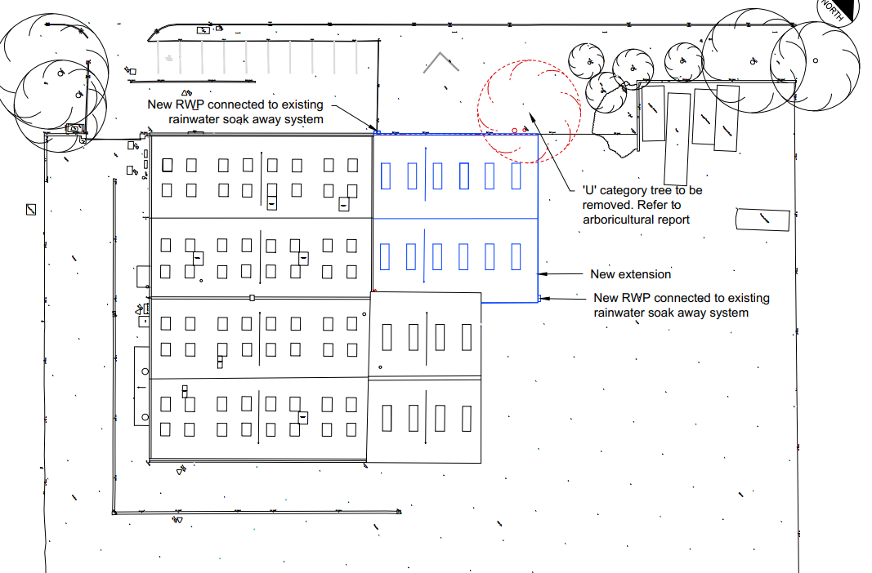

Proposed elevations:
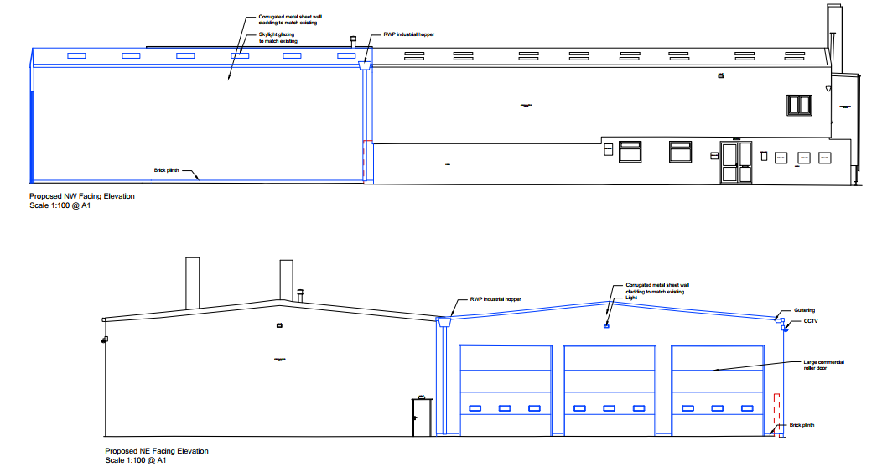

Conclusion
Having regard to the above, it is considered that the proposed extension sits within the terms of CP57. The utilitarian and functional design not only matches the existing building but would also be appropriate given the prevailing character of the trading estate.

Highways Impacts and Parking
Policy Context
Transport implications are a key factor in assessing planning applications, especially for larger developments. Proposals must demonstrate:
- Safe and suitable access for all users, including pedestrians, cyclists, and those with mobility impairments.
- No severe residual impacts on the surrounding highway network.
- Promotion of sustainable travel, reducing reliance on private vehicles.
- Adequate parking and cycle provision, in line with adopted standards.
- Protection and enhancement of public rights of way and active travel routes.

Relevant policies include Core Policies 60–64 of the Wiltshire Core Strategy, supported by the Wiltshire Local Transport Plan, Car Parking Strategy, and Cycling Strategy. The Local Cycling and Walking Infrastructure Plan (LCWIP) and LTN 1/20 (DfT) provide further design guidance for active travel infrastructure.

Proposals must also ensure safe access for refuse collection vehicles and comply with the Wiltshire Council Waste Storage and Collection SPD (2017).

Where necessary, Transport Assessments or Statements should be submitted to evaluate impacts and identify mitigation. Planning conditions or legal agreements may be used to secure off-site improvements, travel plans, or contributions to sustainable transport infrastructure.

Assessment
In assessing this aspect of the proposal, regard has been had to the site context, the details of the proposed development, the relevant development plan policies, and all other material considerations. The key considerations are set out below.

This is an existing business on a trading estate that seeks to expand. The Council’s Highway Authority find no objection providing the parking spaces are available prior to the first use of the enlarged building.

There are bus stops less than 300m away from the site, meaning that the site need not rely on private cars for employees to travel to and from work.

Conclusion
Having regard to the above, it is considered that the proposal is compliant with the transport and parking requirements.

Ecology and Biodiversity
Policy Context
The ecological impact of development is a key planning consideration, especially for larger schemes. Proposals must assess and address potential effects on:

- Protected species
- Priority habitats
- Ecological networks
- Green and blue infrastructure

Core Policy 50 of the Wiltshire Core Strategy requires development to:

- Avoid harm to ecological assets.
- Deliver measurable Biodiversity Net Gain (BNG), in line with the Environment Act 2021.
- Support habitat restoration and connectivity.
- Integrate biodiversity into site design.

The Green & Blue Infrastructure Strategy (2022–2030) promotes nature recovery, ecosystem services, and habitat connectivity through development.

Unless exempt, National policy requires a minimum of 10% Biodiversity Net Gain (BNG) for major developments, demonstrated via:

- Biodiversity Metric calculations
- Ecological assessments (e.g. PEAs, Phase 1 surveys, protected species surveys)

Assessment
In assessing this aspect of the proposal, regard has been had to the site context, the details of the proposed development, the relevant development plan policies, and all other material considerations. The key considerations are set out below.

The Council’s ecology team have considered the proposal and have commented the following:

Habitat Regulations Assessment (HRA)

Salisbury Plain Special Protection Area (SPA)
This application site lies within the 6.4 km buffer zone of the Salisbury Plain Special Protection Area (SPA). A test of likely significance has been carried out by the relevant Competent Authority (Wiltshire Council) as required by Regulation 63 of the Conservation of Habitats and Species Regulations 2017 (as amended). The application is not for residential development and therefore no associated increase in recreational pressure is anticipated. No other mechanism for adverse effect on the Salisbury Plain designated sites has been identified and Appropriate Assessment under Regulation 63 Conservation of Habitats and Species Regulations 2017 (as amended) is not required.

Bath and Bradford-on-Avon Bats Special Area for Conservation (SAC)
The application site is located within a consultation zone for bats associated with the Bath & Bradford on Avon Bats Special Area of Conservation (SAC) and therefore has potential to result in significant adverse impact on the special features of that site.

Trowbridge and Westbury Bat Mitigation Strategy
The site is located within the ‘grey hatched’ recreational zone of the Trowbridge Bat Mitigation Strategy (TWBMS). This zone relates to areas within the wider zone of influence where impacts may arise from increased recreational pressure.
As this proposal relates to commercial development, the elements of the TWBMS concerning recreational pressure associated with residential development are not directly applicable in this instance.

A test of likely significance has been carried out by the relevant Competent Authority (Wiltshire Council) as required by Regulation 63 of the Conservation of Habitats and Species Regulations 2017 (as amended). This concluded that given the scale and nature of the development combined with the separation of 3km between the SAC-associated roost and the application site, there is no mechanism for adverse effect. The HRA has concluded that the application is not likely to have significant impacts on the SAC and subsequently the application is screened out of Appropriate Assessment.

Protected Species and Habitat

The submitted ECOLOGY & BIODIVERSITY NET GAIN (BNG) ASSESSMENT 12th November 2025 by ABR Ecology Version 1 provides a clear overview of the species present on site. The report includes appropriate mitigation recommendations to avoid or minimise potential impacts on biodiversity. Notably, the installation of bat and bird boxes has been proposed to enhance roosting and nesting opportunities on site, contributing to biodiversity gain. The ecological surveys have been undertaken by a suitably qualified ecologist and are in accordance with current industry guidelines. The recommendations made are considered proportionate and appropriate to the findings, and I am in agreement with the conclusions drawn in the submitted report. In order to ensure that these recommendations are accommodated and are enforceable within the development, the condition set out below requires that the locations of bat and bird boxes are shown on site plans.

Biodiversity Net Gain

Under Schedule 7A of the Town and Country Planning Act 1990 (as inserted by Schedule 14 of the Environment Act 2021) this application is required to deliver 10% Biodiversity Net Gain (BNG). The Biodiversity Gain Plan condition will automatically apply if approval is forthcoming.
A completed statutory metric calculation (BNG Metric 20th October 2025) confirming the baseline and predicted post- development biodiversity units of the site has been submitted.
Information in the completed on-site baseline habitat tabs is accepted as accurate based on the information submitted. The pre-development (baseline) situation is summarised below.
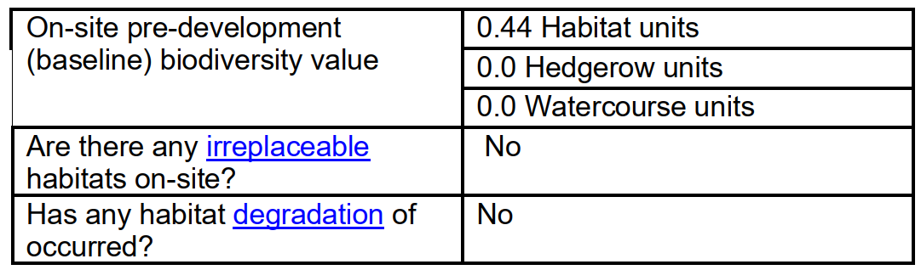
The application proposes to deliver the required biodiversity net gain through the use of off-site biodiversity units. Any off-site biodiversity gain site must be registered on the national Biodiversity Gain Site Register and be formally allocated to this development before the Biodiversity Gain Plan can be approved and the relevant condition discharged. The Council advises that all off-site gains must be secured for a minimum period of 30 years through either a planning obligation (Section 106 Agreement) or a Conservation Covenant. Applicants should be aware that Wiltshire Council will not enter into a Section 106 Agreement for off-site biodiversity gains unless the offsite gain site has been verified. Evidence of registration, allocation to the development, and the legal mechanism securing the habitat enhancements should therefore be provided as part of the Biodiversity Gain Plan. Further information regarding verification of off-site gain sites can be obtained from Wiltshire Council via the Ecology Chargeable Service (ecologychargeableservice@wiltshire.gov.uk).

The ecology team also provided conditions which are to be duly imposed on the decision.

Conclusion
Having regard to the above, it is considered that the scheme would not result in harm to matters of ecological interests as detailed above.

Trees and Arboricultural Impact
Policy Context
Core Policy 51 of the Wiltshire Core Strategy seeks to protect and enhance landscape character, including important trees and woodland features.

Assessment
The scheme has been considered by the Council’s arboricultural officer, and they have found that the Tree Report and Tree Protection Plan provide sufficient consideration and protection for the trees on and off site.

Conclusion
It is considered that the proposal would not result in unacceptable harm to trees of amenity value, subject to the scheme being carried out in compliance with the above referenced documents.

Flood Risk and Drainage
Policy Context
Core Policy 67 of the Wiltshire Core Strategy and NPPF paragraphs 170–182 require:
- Avoidance of increased flood risk.
- Use of appropriate mitigation measures.
- Application of the sequential and exception tests for developments in Flood Zones 2 or 3.

Sustainable Drainage Systems (SuDS) are required for all major developments and must:
- Manage runoff near its source.
- Improve water quality.
- Support biodiversity and amenity.
- Be integrated into the site layout and green infrastructure.

Assessment
In assessing this aspect of the proposal, regard has been had to the site context, the details of the proposed development, the relevant development plan policies, and all other material considerations. The key considerations are set out below.

The LLFA acknowledges the inclusion of an attenuation tank within the proposed development, designed to restrict surface water discharge from the extension to the existing private drainage network.

In support of the proposal, a hydraulic modelling assessment has been submitted, demonstrating the performance of the drainage system under various storm events. Also, an exceedance flow plan has been submitted.

The submitted drainage strategy states that infiltration testing was undertaken, with results indicating clay ground conditions and no observed water loss within the trial pit over a 4-hour period.

Furthermore, it is noted that the access to the site is located within an area at high risk of surface water flooding.

Since the proposal is for a relatively small extension to an existing commercial building, the intensification of the use would also be fairly limited. It is therefore considered that to require additional drainage information, such as an emergency plan for evacuation, is neither necessary nor reasonable, and thereby does not meet the tests for conditions set out by government.

Conclusion
Having regard to the above, it is considered that the site can be satisfactorily drained given the information already submitted.

Public Sector Equality Duty (PSED)
In reaching this decision, due regard has been had to the Public Sector Equality Duty under Section 149 of the Equality Act 2010. This requires the Local Planning Authority to have regard to the need to eliminate discrimination, advance equality of opportunity and foster good relations between persons who share a protected characteristic and those who do not.

The Local Planning Authority is satisfied that the proposal would not result in any unlawful discrimination and that any impacts on protected groups have been appropriately considered as part of this assessment.

PLANNING BALANCE AND CONCLUSION
In reaching a decision, all identified harms and benefits must be weighed in the overall planning balance, having regard to Section 38(6) of the Planning and Compulsory Purchase Act 2004 and the provisions of the National Planning Policy Framework.

At the heart of the NPPF there is a presumption in favour of sustainable development requiring local planning authorities to approve development proposals that accord with an up-to-date development plan without delay; and where there are no relevant development plan policies, or the policies which are most important for determining the application are out-of-date, permission should be granted unless (taken from paragraph 11d of the NPPF):

- The application of policies in the NPPF that protect areas or assets of particular importance provides a clear reason for refusing development proposed; or
- any adverse impacts of doing so would significantly and demonstrably outweigh the benefits, when assessed against the policies in the NPPF taken as a whole;

The principle of development is considered acceptable when assessed against the settlement strategy of the Wiltshire Core Strategy and the emerging Local Plan.

The proposal is broadly compliant with relevant local and national planning policies in respect of design, scale, highway safety, flood risk and drainage, ecology and biodiversity, subject to the recommended conditions.

The development would deliver clear benefits, including supporting a growing business in a sustainable location, which weighs positively in the overall planning balance.

No material considerations have been identified that would significantly and demonstrably outweigh these benefits or indicate that permission should be refused, having regard to the assessment above and the representations received.

Accordingly, the proposal is considered acceptable in planning terms and in accordance with the Wiltshire Core Strategy, the National Planning Policy Framework, and all other relevant material considerations.

RECOMMENDATION:
That Planning Permission be GRANTED, subject to conditions

All conditions imposed have been assessed against the six tests set out in paragraph 56 of the National Planning Policy Framework and are considered to be necessary, relevant to planning, relevant to the development to be permitted, enforceable, precise and reasonable in all other respects.

