APPLICATION FOR LISTED BUILDING CONSENT
OFFICER DELGATED REPORT

APPLICATION REFERENCE: | PL/2026/03983
APPLICATION TYPE: | Listed building consent (Alt/Ext)
SITE ADDRESS: | 16 Cross Keys, Corsham, SN13 0DT
DEVELOPMENT DESCRIPTION: | Renovating existing windows to double glazed slimline units to improve thermal and acoustic insulation.
RECOMMENDATION: | Approve

SITE DESCRIPTION/CONTEXT
The subject property is a GII designated, C18 pair of cottages, now converted to a single dwelling. A previously approved application, saw an attached outbuilding converted to an annexe, such that the location plan below reads as 3 cottages (hatched area is the annexe). There is a shared private driveway encircling from the north and terminating to the SE. Attached to the rear/north is GII, C18 cottages, nos. 14 and 15.

The building is designated for its special architectural and/or historic interest under the Planning (Listed Buildings and Conservation Areas) Act 1990.

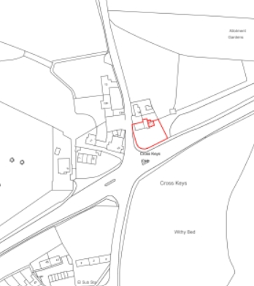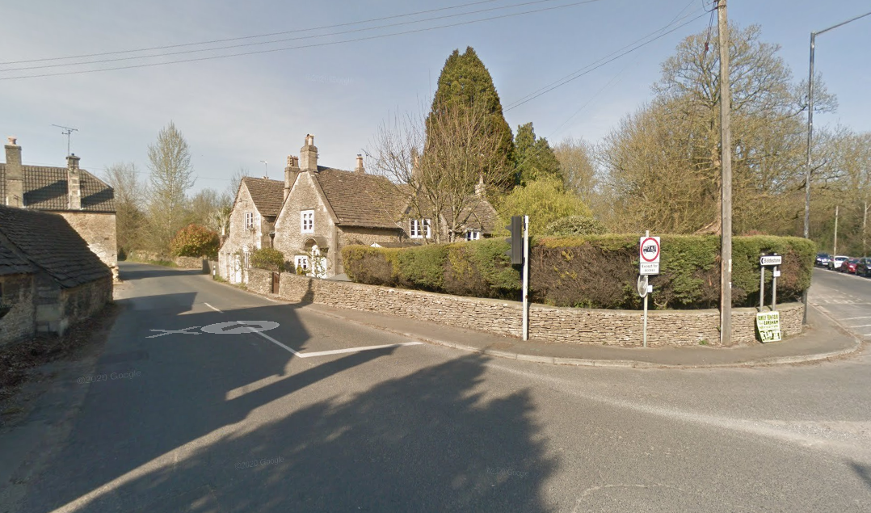
Location Plan and Google Earth Photo

Built of rubble stone, with flush quoins, under a stone tiled roof at 1 ½ storeys, the property lies at the crossroads of Cross Keys Road (running south to Corsham) and Bath Road (running east to Pickwick). This location makes the property’s SE and SW elevations highly visible, and as a local landmark, on the northwest edge of the Corsham Conservation Area, surrounded by other listed buildings.

In identifying the two cottages in drawings below, it is noted the east cottage has a trellis porch on the SE elevation, and hood on brackets to the west cottage’s SW elevation.

PROPOSAL

The proposal is to replace the 9 existing single glazed timber casements with openable lights, with DG, slimline timber casements with openable lights, set in 18mm ovolo glazing bars with pinned, painted beads for a finer details.

The submitted Listed Building Statement shows the 9 subject casements within mullions are all modern, in a poor state of repair and advanced decay.

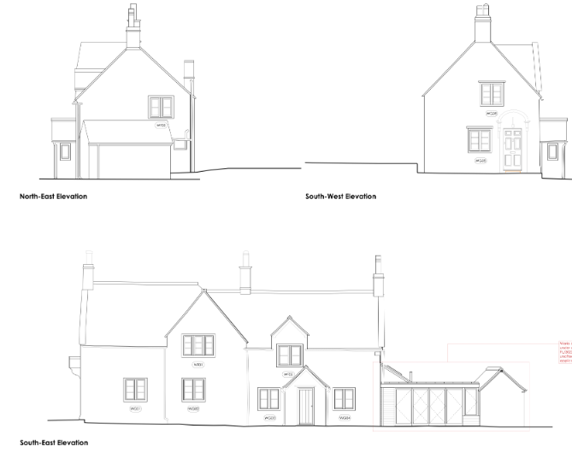
Proposed Front (SE), Side (NE) and Side (SW) Elevations

RELEVANT PLANNING HISTORY
N/91/01797/LBC - Listed building consent Decision - Approved Date: 30/10/1991 – DEMOLITION OF PORCH/NEW PORCH AND ACCESS
N/99/02438/LBC - Listed building consent Decision - Unknown Date: 12/1/2000 – STRIP AND RETILE STONE ROOF
N/05/01297/LBC - Listed building consent Decision - Approve with Conditions Date: 26/7/2005 – Repaint Window Frames in White
N/09/00295/FUL - Full planning permission Decision - Approve with Conditions Date: 18/8/2009 – External Alterations and Extension to Roof of Attached Outbuildings
N/09/00296/LBC - Listed building consent Decision - Approve with Conditions Date: 18/8/2009 – Internal & External Alterations and Extension to Roof of Attached Outbuildings
PL/2022/08915 - Householder planning permission Decision - Approve with Conditions Date: 7/6/2023 – Alterations to an existing ground floor extension of a listed building to form self-contained accommodation
PL/2022/09076 - Listed building consent (Alt/Ext) Decision - Approve with Conditions Date: 7/6/2023 – Alterations to an existing ground floor extension of a listed building to form self-contained accommodation

RELEVANT LEGISLATION, POLICIES AND GUIDANCE
Legislation
From the point of view of the historic environment the main statutory tests are set out within the Planning (Listed Building and Conservation Areas) Act 1990. Section 16 requires that special regard be given to the desirability of preserving listed buildings, their settings or any features of special architectural or historic interest which they possess.

Section 72(1) of the Planning (Listed Building and Conservation Areas) Act 1990 also requires the Council to pay special attention to the desirability of preserving or enhancing the character or appearance of designated Conservation Areas.

National Policy and Guidance
The National Planning Policy Framework (NPPF) August 2026 sets out government policy, including in respect of the historic environment.

Chapter 20 - Conserving and enhancing the historic environment, recognises heritage assets as an irreplaceable resource. Heritage assets should be conserved in a manner appropriate to their significance, with harm avoided unless there is a clear and convincing justification. Decision-makers are required to apply a balanced approach, giving substantial weight to the conservation of heritage assets and weighing any harm to significance against the public benefits of the proposal.

Chapter 5 of the NPPF sets out policies for Meeting the challenge of climate change and gives substantial weight to the benefits of improving the energy efficiency of existing buildings and/or drawing energy from district heat networks, renewable and low carbon sources (including through the installation of heat pumps and solar panels where these do not already benefit from permitted development rights).

National Planning Practice Guidance provides guidance on interpreting the NPPF.

Historic England’s Conservation Principles, Policies and Guidance (2008) provides policy and guidance for the “sustainable management of the historic environment”. Additional guidance on the application of policies set out in the NPPF is contained within their publications:
- Historic Environment Good Practice Planning Advice Note 2 – Managing Significance in Decision-Taking in the Historic Environment (2015)
- Historic Environment Good Practice Planning Advice Note 3 – The Setting of Heritage Assets 2nd edition (2017)
- Historic England Advice Note 2 – Making changes to Heritage Assets (2025)
- Historic England Advice Note 18 – Adapting Historic Buildings for Energy and Carbon Efficiency (2026)
- Traditional Windows: their care, repair and upgrading (2017)

Historic England’s publication ‘Traditional Windows – Their Care, Repair and Upgrading (2017)’ encourages the retention of windows that contribute to the significance of listed buildings but sets also out their approach to the alteration/replacement of windows where this is acceptable in principle:

- Where historic windows, whether original or later insertions, make a positive contribution to the significance of a listed building they should be retained and repaired where possible. If beyond repair they should be replaced with accurate copies.
- Where historic windows have already been replaced with windows whose design follows historic patterns, these usually make a positive contribution to the significance of listed buildings. When they do, they should therefore be retained and repaired where possible. If beyond repair they should be replaced with accurate copies.
- Where historic windows or replacement windows of historic pattern survive without historic glass it may be possible to introduce slim-profile double-glazing without harming the significance of the listed building. There are compatibility issues to consider as the introduction of double-glazing can require the renewal of the window frame to accommodate thicker glazing, thereby harming significance. These issues are covered in Section 4 of this guidance.
- Where historic windows have been replaced with ones whose design does not follow historic patterns, these are unlikely to contribute to the significance of listed buildings. Replacing such windows with new windows of a sympathetic historic pattern, whether single-glazed or incorporating slim-profile double-glazing, may cause no additional harm. It also provides an opportunity to enhance the significance of the building, which is the desired outcome under national policy.
- Where a new window or re-glazing is agreed, the reflective properties of secondary and double-glazing as compared to modern, polished single-glazing, do not usually harm the significance of the building. But when new multi-paned windows are proposed, the desirability of reproducing broken reflections by individually glazing each pane should be considered. Where the aesthetic value of the building is high, then the impact on the whole of the relevant elevation should be considered, including the desirability of accurately matching other windows.

Wiltshire Core Strategy:
Whilst not directly relevant to listed building consent applications, the below policies give an indication of the Council’s approach to development affecting heritage assets:

- Core Policy 57 ‘Ensuring high-quality design and place shaping’: A high standard of design is required in all new developments, including extensions, alterations, and changes of use of existing buildings. Development is expected to create a strong sense of place through drawing on the local context and being complementary to the locality.

- Core Policy 58 ‘Ensuring the conservation of the historic environment’ requires that “designated heritage assets and their settings will be conserved, and where appropriate enhanced, in a manner appropriate to their significance.”

ISSUES
Impact upon the preservation of the listed building or its setting or any features of special architectural and/or historic interest.

CONSULTATION RESPONSES
Corsham Town Council: no objection, subject to approval of Wiltshire Council’s Conservation Officer.

It should be noted that whilst the Conservation Officer did not consult, he authorised this report and decision.

REPRESENTATIONS
In accordance with the requirements of Section 5(1) of the Planning (Listed Buildings and Conservation Areas) Regulations 1990 (as amended) the application for listed building consent was publicised by way of:

- A site notice displayed near the site;
- An advertisement placed in the local press.

These methods were used to inform interested parties and to allow a statutory consultation period of 21 days for representations to be submitted.

Below is a summary of the representations received during the consultation period. In accordance with the provisions of the Planning (Listed Buildings and Conservation Areas) Act 1990, only matters relevant to the consideration of the building’s special architectural or historic interest have been taken into account in the assessment of this Listed Building Consent application.

ASSESSMENT
In accordance with Section 16(2) of the Planning (Listed Buildings and Conservation Areas) Act 1990, special regard has been given to the significance of the listed building, including its architectural and historic interest, and the desirability of preserving both the building and its setting. Relevant policies within the National Planning Policy Framework (NPPF), particularly Section 20: Conserving and Enhancing the Historic Environment, have also been taken into account. These policies require that any harm to the significance of a designated heritage asset must be clearly justified and weighed against the public benefits of the proposal.

In order to be acceptable, the application needs to be assessed against the following criteria:

Information considered/submitted
Policy HE5 of the NPPF requires applicants to assess the significance of any heritage assets affected by a proposal, including the contribution made by their setting, and to identify the likely effects of the development on that significance. Sufficient information should be provided to enable a clear understanding of the significance of the heritage asset and its setting, and the impact of the proposal upon it.

Decision-makers must be satisfied that assessments accurately reflect the effects on heritage assets caused by development proposals. In this case, the application is supported by a RIBA Stage 3 Planning Statement, which details the significance of the dwelling, condition of the existing windows and reasons for replacement.

Assessment of significance:
According to the National Planning Policy Framework (NPPF), significance is defined as:

“The value of a heritage asset to this and future generations because of its heritage interest. The interest may be archaeological, architectural, artistic or historic. Significance derives not only from a heritage asset’s physical presence, but also from its setting.”

Historic England further categorises significance into four key values:

- Evidential – the potential of the asset to yield evidence about past human activity.
- Historic – the ways in which the asset illustrates aspects of history.
- Aesthetic – the sensory and design qualities of the asset.
- Communal – the meanings and associations attached to the asset by people.

In this case the significance of the building lies largely with its age, its historic fabric and architecture - its form, layout and architectural expression/detailing and use of high-quality design materials which have significant aesthetic and architectural interest, and which contribute to the character of the Conservation Area.

The building, and this proposal has 9 mullioned windows, which are features of special architectural interest that contribute to its heritage significance. The Historic England listing highlights 4 cyma-moulded windows with drip stones, two (GF and FF) on the SW elevation, and two on the SE (GF and FF) elevation, and the other 3-light and 2-light windows.

In total, the windows to be replaced are:
6x SE elevation – various sizes
2x SW – one on GF and FF
1x NE – FF, above new extension

The proposal seeks to replace the later modern casements, without alteration to the stone mullions.

Impact of proposals on the significance and setting of the building/structure:
Understanding the impact of proposed works on a listed building requires a careful and proportionate assessment of how those changes affect the asset’s heritage significance and its setting. This includes both the physical alterations to the building itself and any changes to its spatial or visual relationship with surrounding structures or spaces.

The significance of a heritage asset is not static; it is shaped by its architectural, historic, and communal values, and by how these are experienced in context. Therefore, any intervention must be considered in light of the asset’s identified significance, with attention given to both potential harm and benefits. Benefits may include repairs that support the long-term conservation of the building, improved energy performance, or enhanced public access and understanding.

This assessment is grounded in the statutory duty under Section 16 of the Planning (Listed Buildings and Conservation Areas) Act 1990, which requires special regard to be given to the desirability of preserving the building and its features of special interest. It is also informed by national policy, particularly policies HE4-9 of the National Planning Policy Framework (NPPF), and relevant local heritage policies and guidance.

Cyma moulded stone or timber mullion windows are characteristic of particular periods from C18.
The stone mullions are proposed to be retained with the existing modern windows likely replicating historic simple casement designs.
So whilst still making a positive contribution to the significance of the building, the poor state of repair and advanced rot of the existing modern casements, justifies replacement.
Slimline DG units replicate the shallow profile and single reflection appearance of traditional single glazing. Their use often requires alterations to the window frame.
The proposed works, by removing modern casements, and replacing with improved spec modern casements of almost identical design with improved detailing of glazing bars, would have a neutral impact on the significance of the building, not harming historic fabric (dependent on window details), retaining architectural detailing and exiting materiality. A condition is required necessary for further details of proposed joinery details.
Benefits would be improved energy efficiency and therefore viability of the building.
It is noted the NE window is currently opaque glazed but given its line of sight over the side garden/driveway, and not towards neighbours, there is no concern with replacement of clear glazing.
Proposed replacements, of improved thermal and acoustic performance, retaining simple casement scale, design, improved glazing bar details, will also conserve the architectural details and therefore significance of the listed building.

CONCLUSION
The NPPF confirms that when considering the potential impact of a development proposal on the significance of a designated heritage asset, substantial weight should be given to the asset’s conservation (and the more important the asset, the greater the weight should be). It makes clear that any harm to a designated heritage asset will be a matter of considerable importance and weight which requires clear and convincing justification.

In this case, the impact of the proposals on heritage assets will be largely positive, replacing modern fabric and replacing with improved spec modern casement.

In this case the proposals will have no effect on the significance of the heritage asset. On this basis no specific justification is required however it is considered the works will assist in securing the future use of a heritage asset in support of its long-term conservation.

The requirements of current conservation legislation, policy or guidance are considered to be met and the application is recommended for approval.

RECOMMENDATION:
That Listed Building Consent be GRANTED, subject to the following conditions:

