CASE OFFICER'S REPORT

Application Reference: PL/2025/03913
Application Type: Full planning permission
Consultation ends: 12/09/2025
Case officer: Russell Brown
Site Address: 61 Alcock Crest, Warminster, BA12 8NF
Proposal: Erection of 14 No. residential dwellings with associated works following demolition of 36 No. existing residential flat.
Recommendation: Approve with conditions

POLICIES

The Wiltshire Core Strategy (WCS) - The following Core Policies (CP) are relevant when assessing this application: CP1 (Settlement Strategy), CP2 (Delivery Strategy), CP3 (Infrastructure Requirements), CP31 (Warminster Area Strategy), CP41 (Sustainable construction and low-carbon energy), CP43 (Providing affording homes), CP50 (Biodiversity and geodiversity), CP52 (Green Infrastructure), CP57 (Ensuring High Quality Design and Place Shaping), CP60 (Sustainable Transport), CP61 (Transport and Development), CP62 (Development Impacts on the Transport Network), CP64 (Demand Management), CP67 (Flood Risk), CP69 (River Avon SAC).

When adopting the WCS, some policies remain saved from the West Wiltshire District Local Plan (1st Alteration) (WWDLP). Those which are relevant to this application include: U1a (Foul Drainage/sewerage treatment)

Wiltshire Waste Core Strategy - WCS6 (Waste Audit)

The following document list also merits due consideration:
Wiltshire’s Community Infrastructure Levy – Planning Obligations Supplementary Planning Document (Planning Obligations SPD)
Wiltshire’s Community Infrastructure Levy - Charging Schedule (Charging Schedule)
Wiltshire’s Community Infrastructure Levy - Regulation 123 List (123 List)
Wiltshire Local Transport Plan 2011-2026 – Car Parking Strategy
Wiltshire Housing Land Supply Statement (Updated Base Date April 2023 – Published June 2024).
Update on Housing Land Supply in light of Revised NPPF (December 2024).
Wiltshire Design Guide (2024)

The National Planning Policy Framework (NPPF) and National Planning Practice Guidance (NPPG)

Warminster Neighbourhood Plan

At Full Council on 19 May 2026, the elected members of Wiltshire Council agreed to withdraw the emerging Wiltshire Local Plan. The said Plan has no material weight for the purposes of the application.

In accordance with Regulation 19 of the Town and Country Planning (Local Planning) (England) Regulations 2026, on 30th June 2026 Wiltshire Council published a notice of intention to prepare a new local plan for Wiltshire. The next stage is a Scoping Consultation which commences on 2nd September 2026. This plan is at a very early stage and currently carries no weight for decision making.

CONSULTATION RESPONSES
(WC = Wiltshire Council)

Warminster Town Council – “no objection to the application, subject to confirmation that the external lighting plan conforms to Cranborne Chase’s dark sky reserve standards.”

WC Highways – No objection subject to conditions.

WC Public Protection – No objection subject to conditions due to construction/demolition work occurring in close proximity to existing residential dwellings.

WC Urban Design – No objection

WC Arboricultural Officer – The Arboricultural Officer is satisfied that the information provided in the Arboricultural Method Statement and Tree Survey, prepared by Tim Pursey and dated April 2025, and the Tree Protection Plan, Ref: TP3108/2402/TPP, demonstrates that sufficient protection will be provided during construction.

Wessex Water – No objection subject to connection agreements.

WC Public Open Space – As the dwellings being demolished are greater than the amount of dwellings replacing them, there is no requirement for open space on this site.

WC Ecology – No objection subject to conditions.

WC Rights of Way – Public Footpath WARM11 is positioned between the buildings. This footpath should be kept open during construction. A dropped kerb should be installed as part of this development to allow improved access to the footpath. If the footpath needs to be closed during demolition or construction, then the applicant will need to apply for a closure of the footpath giving 12 weeks’ notice of the closure.

WC Housing Enabling – No objection. “The s106 Agreement should have an either/or clause in terms of securing the Affordable Housing. This means that either 30% affordable housing is provided at nil subsidy OR 100% affordable housing is provided with subsidy, which will give Selwood the possibility of using Homes England if needed.”

WC Education – Confirm that they have no comments to make.

WC Archaeology – Confirm that there are no archaeological issues to raise.

REPRESENTATIONS

One letter has been received from a member of the public raising concerns over the parking arrangements and that the number of cars may increase, resulting in parking problems.

The Salisbury & Wilton Swifts group also requested that swift boxes be incorporated into the design.

ASSESSMENT

Section 70(2) of the Town and Country Planning Act 1990 and section 38(6) of the Planning and Compulsory Purchase Act 2004 require that the determination of planning applications must be made in accordance with the Development Plan, unless material considerations indicate otherwise. The National Planning Policy Framework (NPPF) is a key material planning consideration. Local planning authorities should consider whether otherwise unacceptable development could be made acceptable through the use of conditions or planning.

Core Policy 57 of the Wiltshire Core Strategy states: “A high standard of design is required in all new developments, including extensions… Development is expected to create a strong sense of place through drawing on the local context and being complementary to the locality. Applications for new development must be accompanied by appropriate information to demonstrate how the proposal will make a positive contribution to the character of Wiltshire …”

Site and Proposal
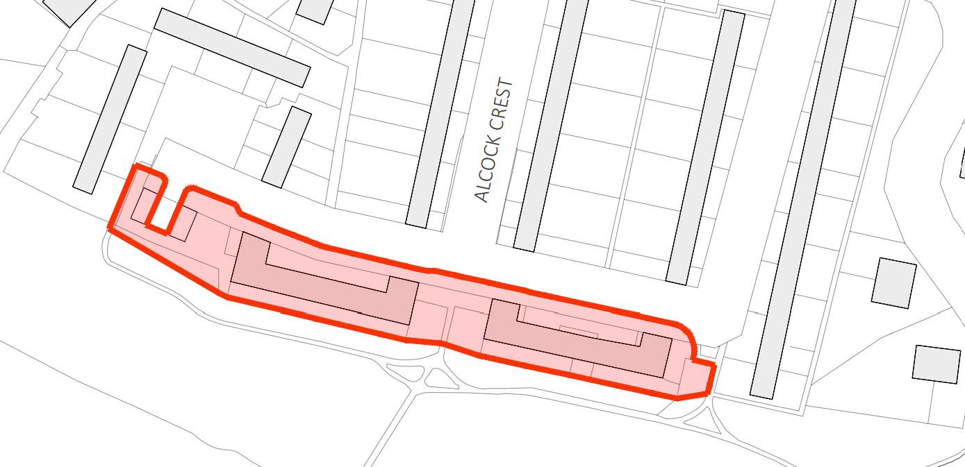
Location Plan:

This site sits within a residential area of Warminster. The site formerly had two blocks of 36No. affordable flats, which were demolished after being found to be no longer fit for purpose operated by Selwood Housing, a registered affordable housing provider.

The proposal is to replace these with a mixture of semi-detached and detached houses, 14No. dwellings in total. The mix would be 4 x 1 bed flats, 5 x 2 bed houses and 5 x 3 bed houses.

The site sits within the settlement boundary of Warminster, where residential development is in principle acceptable. It is also within the River Avon SAC with regard to nutrients and phosphates where additional loading needs to be mitigated.

The site is not within a Conservation Area and there are no listed buildings that would be affected.

Principle of development

This scheme meets the terms of the NPPF (2026) policy HO7, which states “substantial weight should be given to the benefits of providing homes which will contribute towards meeting the evidenced accommodation needs of the community, as identified through needs assessments prepared for the area of the local planning authority and other relevant evidence.”

This is a 100% affordable housing scheme, where 36 affordable flats are to be replaced with 14 modern affordable houses. This meets the local identified need for affordable housing and therefore falls within the provisions of the above NPPF policy.

The former blocks of 36No. flats were demolished under a prior approval notice. Consequently, the site is now a brownfield / PDL site. The applicant, Selwood Housing, seeks permission to build 14 modern affordable homes. These would continue to be operated as affordable units.

The provision of 14 new modern homes would better meet local needs and would contribute to the Housing Land Supply.

Currently the Council can demonstrate a 2.8-year supply, below the 5-year supply target. Therefore, these proposed units would contribute to that supply. The houses are in accordance with the Wiltshire Core Strategy CP1, CP2 and CP31 and would contribute to the Housing Land Supply.

Detailed design

The design is a fairly standard contemporary dwelling aesthetic.

Proposed elevations:
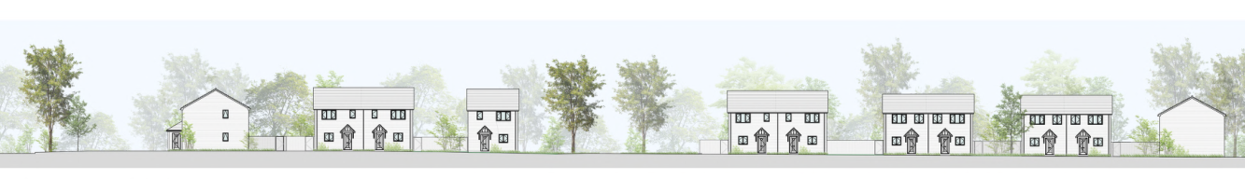

This would fit in with the surrounding character of the street scene and is therefore an acceptable approach.

The materials would be a red brick with concrete roof tiles and uPVC windows. Again, this is an appropriate treatment for this area.

Affordable Housing

The Housing Enabling team has commented that this site requires a provision of 30% affordable housing provided with nil subsidy OR a 100% affordable housing with subsidy in order to comply with the Council’s Affordable Housing policy CP43. This would require the completion of a s106 legal agreement to secure the affordable housing provision.

Impact on Highways

The proposed block plan shows the parking which meets the parking standards. The parking spaces, are all accommodate as off-street parking. This should minimise the amount of parking needed on the immediate surrounding highways. There would be no harm to highway safety.

Proposed block plan showing parking and landscaping:
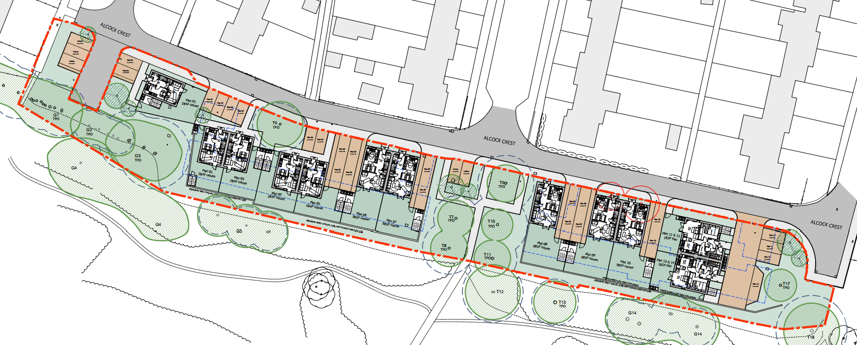

Impact on neighbouring and public amenity

Most of the proposed dwellings would look north (front elevation) and south (rear elevation) in terms of the windows. This gives plenty of distance between the nearest neighbouring properties, which are side-on to the proposed dwellings, to obviate overlooking issues.

The side elevations of the proposal have no windows proposed at first floor level, apart from the flats. These side elevations of the flats would actually be in the same configuration as the houses, as they are orientated through 90 degrees. The built form in terms of scale would be less that the buildings that has been demolished, and therefore there would be no issues related to overbearing or overshadowing.

Impact on future occupiers
The future occupiers would have private gardens and would not be closely overlooked. The siting of the dwellings would be consistent with surrounding densities and have gardens of similar size to its neighbours.

Impact on ecology

As the number of dwellings is being reduced from 36 to 14, the ecology team have confirmed that the River Avon SAC would not be harmed in terms of the nutrients entering the system. The scheme would actually represent a betterment in this regard.

The existing blocks of 36 flats have been demolished under a prior notification procedure, and so there is no habitat remaining. Nevertheless, a bat study has been completed which confirms that no bats were recorded at the site.

The proposal includes the provision of one roof tile bat roosting features per dwelling.

The ecology team have also confirmed that the development fits within the Salisbury Plain SPA Appropriate Assessment which has been agreed with Natural England at strategic level.

A number of trees are being removed for the development, with some being retained, however new trees are being planted within the new landscaped areas.

CONCLUSION

With reference to NPPF and the Wiltshire Core Strategy, the proposed development would result in higher quality units that better meet the local need and in terms of functionality and overall design.

Additionally, there would be a betterment in terms of ecology and the impact on River Avon SAC and drainage arrangements. The scheme is neutral in terms of highways impacts.

Therefore, with particular regard to provision of improved housing in a sustainable location and improved overall design, and the contribution to the HLS, the arguments weigh in favour of granting permission subject to a successful signing of a s106 agreement to secure the 30% affordable housing provided with nil subsidy OR a 100% affordable housing with subsidy.

RECOMMENDATION
Approve subject to s106 legal agreement and conditions.

