APPLICATION FOR HOUSEHOLDER PLANNING PERMISSION DELEGATED REPORT

APPLICATION REFERENCE: | PL/2026/03287
APPLICATION TYPE: | Householder planning permission
SITE ADDRESS: | 6 Angler Road, Salisbury, SP2 9PB
DEVELOPMENT DESCRIPTION: | Proposed Upward Extension and retain outbuildings (gym/bar)
RECOMMENDATION: | That Planning Permission be GRANTED

PROPOSAL

The proposal seeks planning permission for the erection of an upwards extension involving the raising of the ridge height and the insertion of three dormers to the rear and three dormers to the front.

Existing front and rear elevations shown below

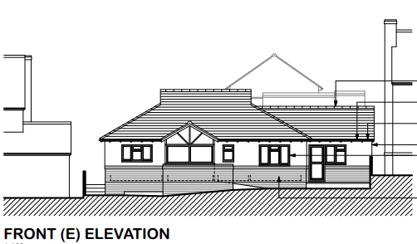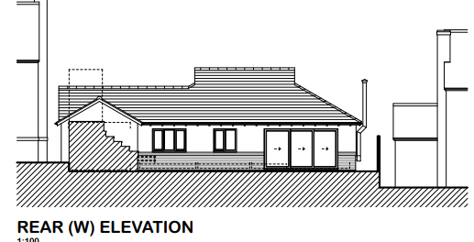

Proposed front and rear elevations shown below

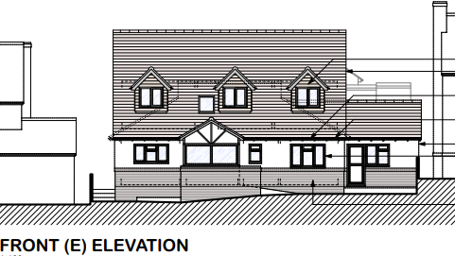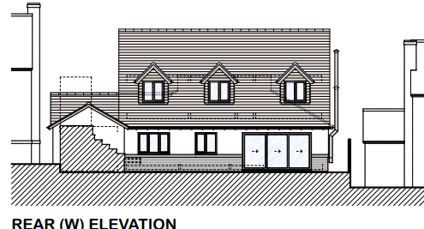

Existing side elevations shown below

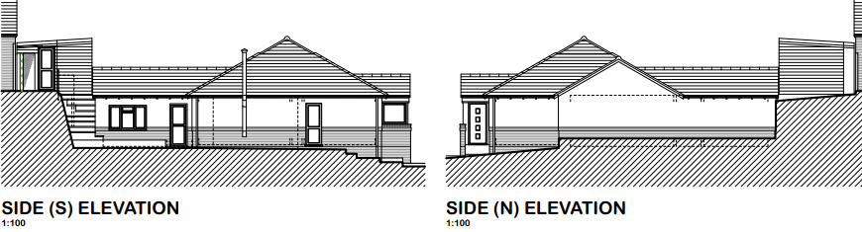

Proposed side elevations shown below

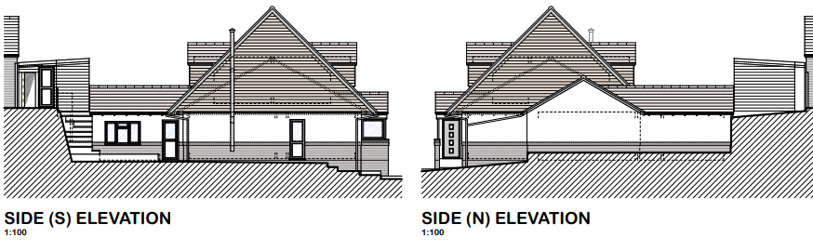

During the course of the application, the scheme was amended to also seek consent for the retention of existing outbuildings used as a gym and bar. These structures were added to the plans and description as they do not benefit from planning permission and permitted development rights were removed for such structures on the original consent for the estate. The proposals therefore also seek to regularise these structures.

SITE DESCRIPTION/CONTEXT

The application site is a single storey detached dwelling located within an established residential area within a fairly modern housing development. It is situated within the settlement boundary of the principal settlement of Salisbury, as defined by Wiltshire Core Strategy (WCS) policies CP1, CP2 and CP20. The property is located on the west side of Angler Road in an elevated position towards the northern end of the cul-de-sac. The housing estate within which the application site is located comprises a mix of two storey and single storey dwellings and indeed, as is shown below, the application site is located between two, two storey dwellings.

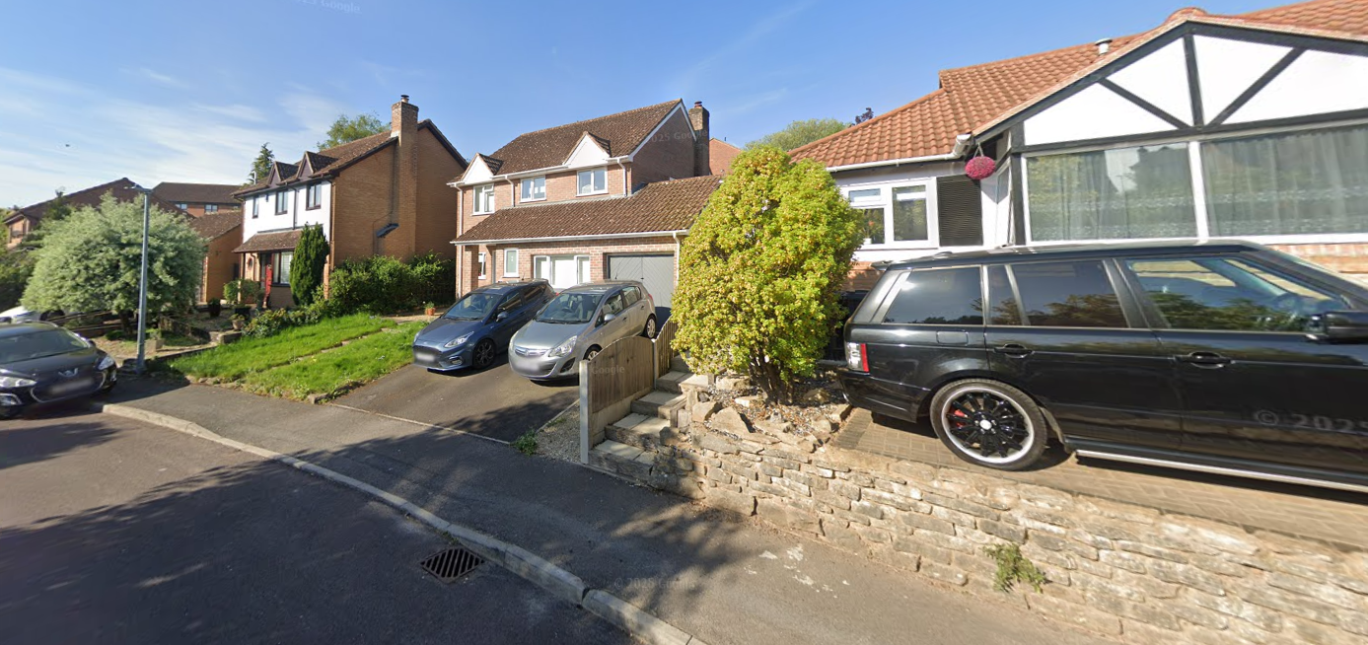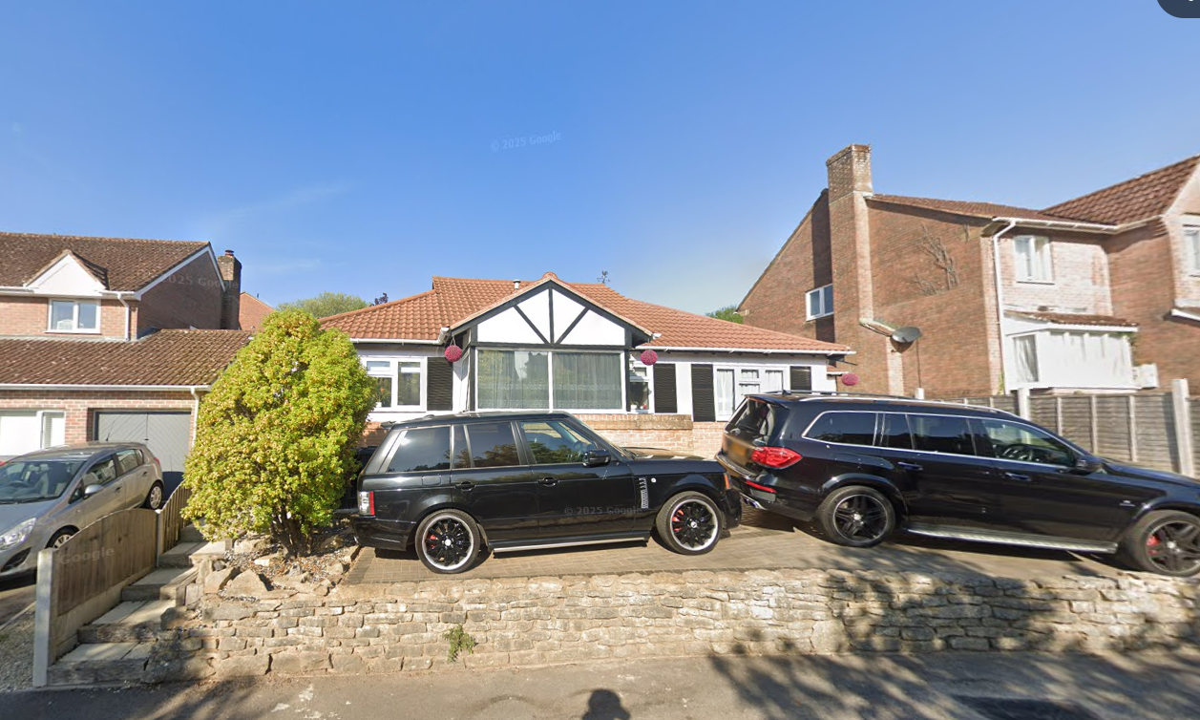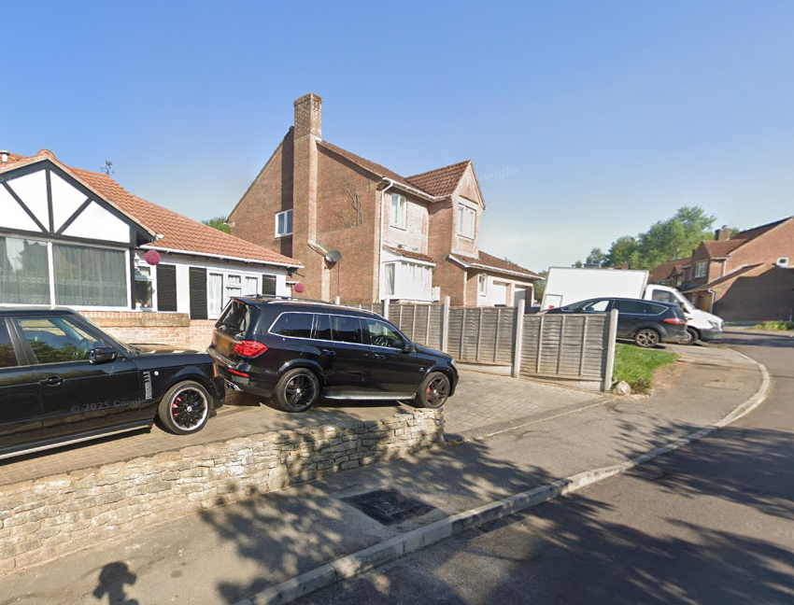

The application site has a small front garden used for off road parking, to the side is a detached annexe and to the rear is an enclosed garden on a split level due to the rising topography of the locality.

Whilst the site is in Flood Zone 1 and is not in the immediate vicinity of any rivers, it is situated within the catchment of the Hampshire River Avon Special Area for Conservation (SAC). However, due to the nature of the application, these designations do not have any bearing on the assessment of this application as the proposals will not result in any additional impact for this ecological feature.

PLANNING HISTORY

Proposal / Summary
S/1979/0022 - Historic apps 1974 to 1983 Decision - Approve with Conditions Date: 2/5/1980 – Deemed application - O/L for residential development with access to Devizes Road (Quid. parish)
S/1983/0300 - Full planning permission Decision - Approve with Conditions Date: 22/11/1985 – OUTLINE APPLICATION - RESIDENTIAL DEVELOPMENT ANDCONSTRUCTION OF NEW ESTATE ROAD AND TRAFFIC ROUNDABOUT
S/1986/1883 - Reserved Matters Decision - Approve with Conditions Date: 18/2/1987 – APPROVAL OF MATTERS RESERVED - ERECTION OF 271 RESIDENTIAL UNITS AND CONSTRUCTION OF VEHICULAR AND PEDESTRIAN ACCESSES
S/1987/1114 - Reserved Matters Decision - Approve with Conditions Date: 26/8/1987 – MINOR AMENDMENTS TO HOUSE TYPES & LAYOUT (30 DWELLINGS) PHASE I FUGGLESTONE RED

RELEVANT POLICIES AND GUIDANCE

The National Planning Policy Framework (NPPF)
The Planning Practice Guidance
National Design Guide

Wiltshire Core Strategy:

Core Policy 1 Settlement Strategy
Core Policy 2 Delivery Strategy
Core Policy 20 Spatial Strategy: Salisbury Community Area
Core Policy 50 Biodiversity
Core Policy 57 Ensuring High Quality Design and Place Shaping
Core Policy 61: Transport and New Development
Core Policy 64: Demand Management
Core Policy 69 River Avon SAC

Wiltshire Design Guide: Appendix D – Design Guidance for Householder extensions
Salisbury Neighbourhood Development Plan 2020 to 2038
Creating Places Design Guide

CONSULTATION RESPONSES

City Council: No objection

Highways: no objection

REPRESENTATIONS

No comments were received.

ASSESSMENT

Section 38(6) of the Planning and Compulsory Purchase Act 2004 states:

"If regard is to be had to the development plan for the purposes of any determination to be made under the planning Acts, the determination must be made in accordance with the plan unless material considerations indicate otherwise."

In accordance with this statutory requirement, this application has been assessed against the relevant policies of the Development Plan, including the adopted Wiltshire Core Strategy (2015) and, where applicable, any made Neighbourhood Plans.

Design and Impact upon the character and context of the area

Core Policy 57 - Ensuring High Quality Design and Place Shaping of the Wiltshire Core Strategy seeks to ensure that all new development is of high design quality, reflecting local context, character, and distinctiveness.

The application site is a detached bungalow within a residential cul-de-sac characterised by a mix of single-storey bungalows and two-storey dwellings. Whilst the surrounding area comprises a varied built form, the host dwelling is one of a limited number of bungalows within the street scene. The proposed development would involve an upward extension, increasing the accommodation from a three-bedroom bungalow to a six-bedroom dwelling, together with the retention of the existing one bedroom annexe accommodation. The proposal would significantly alter the scale and appearance of the existing building.

The introduction of a first floor and the associated front and rear dormers would result in a form of development that is not seen elsewhere within the locality. In particular, dormer features of the nature proposed with this application are not a characteristic feature of Angler Road, and their addition would create a noticeably different appearance to the existing dwelling and street scene as a whole. The scale of built form proposed also approaches the upper limits of what could reasonably be accommodated on the plot, creating concerns that the proposal represents a relatively intensive form of development on what is a fairly small and constrained residential site.

However, it is noted that the wider estate contains a mix of building types, heights and designs, including both single-storey and two-storey dwellings. The application property is also positioned between two, two-storey dwellings, such that the resulting building would not appear wholly incongruous within the wider context. The overall height of the proposed extension is also comparable with the heights of the two adjacent properties providing a transition between the height and form of the neighbouring property to south and that to the north; and thus, an appropriate variance in the roofscape and roofline. Therefore, whilst the proposal results in a relatively heavy roof form and represents a substantial alteration to the form and appearance of the existing bungalow, the development would not appear so visually intrusive or incongruous within the mixed street scene as to justify a reason for refusal on design or appearance grounds.

The application also seeks retrospective consent for the retention of the gym and bar outbuildings within the rear garden. Having regard to their scale, design and siting, these structures are considered subordinate to the host dwelling and are contained within the rear garden where they are not readily visible from the public realm. As such, they do not result in any material harm to the character or appearance of either the host property or the wider area.

On balance, whilst the proposal would introduce a more dominant and less sympathetic form of development than currently exists and would result in some limited harm to the character and appearance of the dwelling and immediate street scene, that harm is not considered so significant as to warrant refusal. The proposal is therefore considered to achieve an acceptable level of compliance with Core Policy 57 of the Wiltshire Core Strategy and the guidance contained within Appendix D of the Wiltshire Design Guide.

Amenity

Point vii of Core Policy 57 - Ensuring High Quality Design and Place Shaping of the Wiltshire Core Strategy seeks to ensure that developments do not adversely affect neighbouring properties.

Policy P3 of the NPPF requires development to contribute positively to the creation of healthy, safe and inclusive places. In particular, Policy P3(b) seeks to ensure that development provides a high standard of amenity for existing and future users and safeguards the reasonable living conditions of neighbouring occupiers. In assessing amenity impacts, regard should be had to matters including privacy, outlook, daylight and sunlight, overbearing impacts, noise and disturbance, and the overall quality of the living environment created by the development.

The proposed development has been assessed in terms of its potential impact on the residential amenity of neighbouring properties, with particular regard to loss of light, overshadowing, loss of privacy, and overbearing effects.

The proposed front-facing dormers would introduce first floor windows to the front elevation. However, these windows would face towards properties on the opposite side of Angler Road and would be separated by the public highway and involve intervening distances typically found within a suburban street scene. As such, any overlooking arising from these windows would be typical of that experienced between facing residential properties and is not considered to result in unacceptable harm to residential amenity.

The application property is positioned in relatively close proximity to the neighbouring dwellings on either side (No 7 to the north and No 5 to the south) and, as a result of the upward extension, there would inevitably be some increase in the perceived scale and presence of the building. The neighbouring properties each contain first floor side windows facing towards the application site; however, these serve bathrooms and are obscurely glazed. As these windows do not serve habitable rooms, any impact on outlook or light available to them is not considered to result in significant amenity concerns.

Whilst the increased ridge height and roof massing would be more noticeable when viewed from neighbouring properties, the resultant relationship is not considered so overbearing or oppressive as to warrant refusal in this instance, particularly given the mixed character of the estate, which includes a high number of two-storey dwellings

The principal amenity consideration relates to the increased height and bulk of the dwelling, together with the rear-facing dormers, and the potential for overlooking towards No. 8 Angler Road to the rear. During the course of the application, the applicant was requested to provide a section drawing to demonstrate the relationship between the proposed dormers and No. 8. This confirms that whilst views towards No. 8 would be possible from the rear dormer windows, the significant difference in land levels results in No. 8 occupying a materially higher position than the application property, despite the proposed increased height.
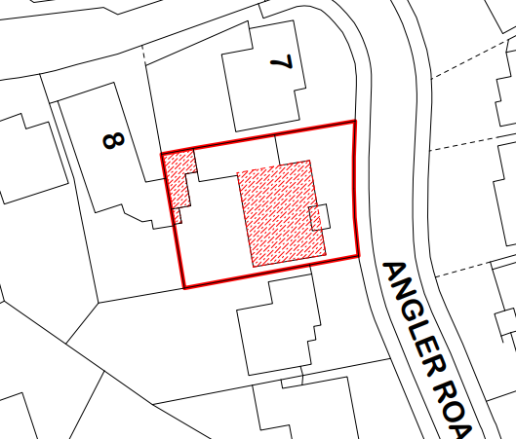
The applicant’s existing terraced garden also continues to provide over 9 metres of separation between the two properties.

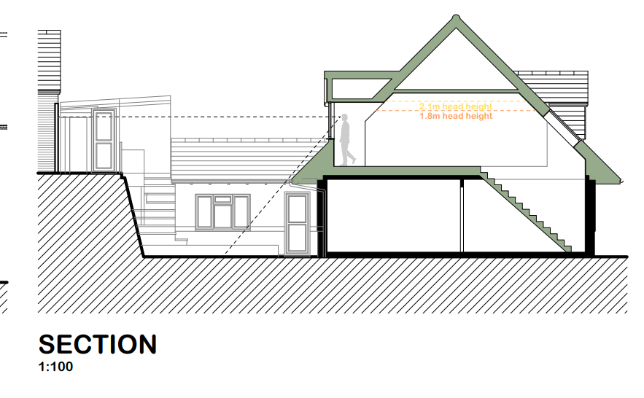
The rear dormers would be visible from No. 8, and some perception of overlooking would occur. However, having regard to the submitted section, the positioning of the dormer windows, and the relative land levels/and garden separation between the two properties, it is considered that opportunities for loss of light or direct overlooking into the neighbouring dwelling and its private amenity space would be limited. Whilst the relationship is finely balanced and some harm to neighbouring amenity would arise, the degree of overlooking and loss of privacy resulting from the proposal is not considered so significant as to warrant refusal, especially given the site’s urban context.

Of note, during the application process, Officers did request that the dormers were reduced in number and that the internal layout reconfigured so that the bathrooms faced to the rear with bedrooms to the front. With bathrooms to the rear the windows could all be obscure glazed and restricted opening which would lessen the amenity impact concerns towards neighbouring properties. It was also requested that the dormer serving the wardrobe was replaced with a rooflight, again, having two rather than three rear dormers would be better in terms of perceived overlooking towards neighbouring dwellings. However, the applicant indicated that the layout as submitted worked for them and for various reasons to change the scheme as Officers requested was not feasible. Therefore, the development has been determined based on the plans as submitted. It is however considered appropriate to condition the wardrobe dormer to be obscure glazed and fixed shut windows to lessen the amenity impacts towards No8, although it is also noted that no neighbouring objections or representations have been received in response to the application.

The retained gym and bar outbuildings have also been considered in terms of their impact on neighbouring residential amenity. Given their scale, position and separation from neighbouring dwellings, they do not result in any unacceptable loss of light, outlook or privacy. No amenity concerns are therefore raised in respect of these structures.

Accordingly, on balance, the proposal is considered to accord with Core Policy 57(vii) of the Wiltshire Core Strategy and would not result in an unacceptable impact on neighbouring residential amenity.

The proposal therefore accords with Core Policy 57 point vii in respect of safeguarding residential amenity and Appendix D of the Wiltshire Design Guide.

Highways Impact

Core Policy 57 (xiv) of the Wiltshire Core Strategy seeks to ensure that development must meet the requirements of Core Policy 61. This policy requires proposals to be capable of being served by safe access to the highway network. Core Policy 64 seeks to ensure compliance with parking standards set out in the Local Transport Plan.

The transport policies of the NPPF seek to ensure that development provides safe and suitable access for all users and that any impacts on highway safety are appropriately considered.

The proposal will increase the property from a 3 to a 6 bed dwelling and as such 3 off street parking spaces are required to meet Wiltshire’s current parking standards. The Council’s highways officer has been consulted and has raised no objections; their comments are included in full below.

The proposal will increase the property from a 3 to a 6 bed dwelling and as such 3 off street parking spaces are required to meet Wiltshire’s current parking standards.
I am aware that the garage has previously been converted into a self-contained one bed annexe, which has a separate front door, kitchen and bathroom and no connecting door into the main property.
Therefore, the main property should be provided with 3 off street parking spaces and the annexe an additional space, totalling 4, however the site can only accommodate 3 spaces.
Angler Road is a no through cul-de-sac with on street parking available, which does not seem to be oversubscribed and adequate on street parking is therefore available to accommodate any overspill from the dwelling. It is therefore considered that should the household have an additional vehicle and it were to be parked on the highway, it would not have an adverse impact on the highway network.
I therefore raise no highway objection.

Given that the application includes a parking plan to show that three off road parking spaces are available within the site and the lack of objection from the highways officer, there are no concerns regarding highways safety issues accordingly.

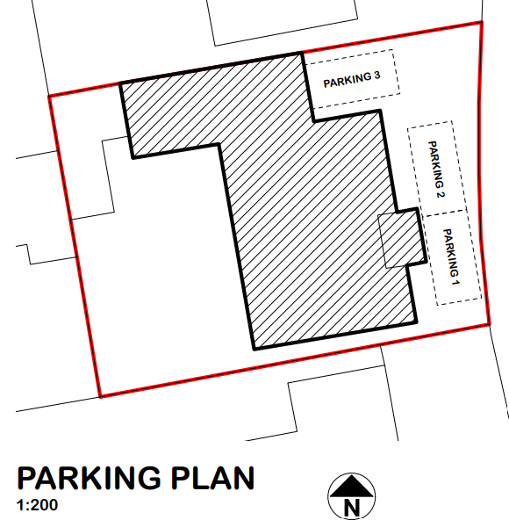

The proposal is therefore considered to comply with Core Policies 57 (xiv), 61 and 64 of the Wiltshire Core Strategy, the NPPF, and the Wiltshire Local Transport Plan.

Ecology Impact

Core Policy 50 of the Wiltshire Core Strategy seeks to protect and enhance biodiversity and geodiversity, including through ensuring that development avoids harm to protected species and habitats.

Policy N2 of the NPPF seeks to conserve and enhance biodiversity and support nature recovery. Development proposals should minimise impacts on habitats and species and, where relevant, demonstrate that appropriate mitigation measures are secured where harm cannot be avoided.

The application proposal is not of a type that is likely to result in any additional impact or harm for any statutory or non-statutory ecological designations in the area, and the scale and nature of the development is such that significant harm to biodiversity is unlikely.

Biodiversity Net Gain - Householder planning applications are exempt from the requirement to deliver Biodiversity Net Gain under Schedule 7A, Section 4(2)(a) of the Town and Country Planning Act 1990, as inserted by the Environment Act 2021.

As such, the development complies with Core Policy 50 of the Wiltshire Core Strategy and the relevant provisions of the NPPF.

CONCLUSION

On balance, whilst the proposal raises some concerns in respect of its scale, design and relationship with neighbouring properties, the identified harm is limited and does not reach a level that would justify a refusal of the scheme. Having regard to the mixed character of the surrounding area and the overall relationship with neighbouring dwellings, the proposal is considered to accord with the overall character of the area and is compliant with Core Policy 57 of the Wiltshire Core Strategy and other relevant development plan policies and the relevant provisions of the NPPF.

RECOMMENDATION: That Planning Permission be GRANTED subject to conditions.

1.The development hereby permitted shall be begun before the expiration of three years from the date of this permission.

REASON: To comply with the provisions of Section 91 of the Town and Country Planning Act 1990 as amended by the Planning and Compulsory Purchase Act 2004.

2.The development hereby permitted shall be carried out in accordance with the following approved plans and documents:

Application form received 22/05/2026
Location and block plan Drg no 2605-PL00 received 14/07/2026
Plans and elevations as proposed Drg no 2605-PL02D received 13/08/2026

REASON: For the avoidance of doubt and in the interests of proper planning.

3. Materials to be used in the construction of the works hereby permitted shall be as stated on the application form and approved plans.

REASON: In the interests of visual amenity and the character and appearance of the area.

4. The dormer window in the west elevation serving the wardrobe shall be glazed with obscure glass only to an obscurity level of no less than level 5 and permanently fixed shut prior to the first occupation of the development hereby permitted and shall be maintained as such for the lifetime of the development.

REASON: In the interests of residential amenity and privacy.

5. The gym hereby approved shall remain incidental to the enjoyment of the dwellinghouse known as 6 Angler Road and shall not be used as habitable accommodation or for any commercial purposes.

REASON: In the interests of residential amenity and to ensure the development remains incidental to the host dwelling.

6. Notwithstanding the provisions of the Town and Country Planning (General Permitted Development) (England) Order 2015 (or any Order revoking or reenacting or amending that Order with or without modification), no windows, doors or other form of openings other than those shown on the approved plans, shall be inserted in the north, south and west elevations above ground floor ceiling level of the development hereby permitted.

REASON: In the interests of residential amenity and privacy.

