Design and Fire Statement Planning for the replacement of front door at:
24 HIGH ST. POTTERNE, DEVIZES, WILTSHIRE, SN10 5NA
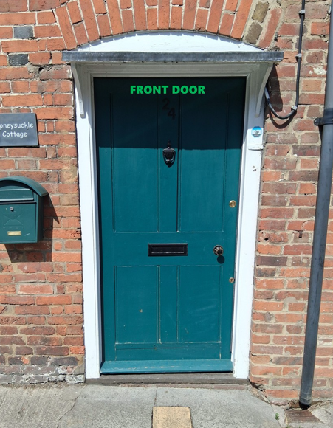
The property has its own entrance and exit doors. Whatever fire and evacuation system is currently in place for the owners of the property will remain intact and will not be altered in any way during the installation by Anglain Home Improvements.
The proposal is to replace the front door at the property.
The existing front door is to be replaced with a high-quality product. The new replacement front door will not reduce or restrict any current means of escape.
The new door will provide better weather proofing and thermal efficiency that the current one there.
Everest are FENSA registered.
Conclusion: As the application relates to the replacement the front door at the property, there is no requirement for a separate fire statement, and the above should be considered as a reasonable exception to the policy below

