
HERITAGE DESIGN, ACCESS & HERITAGE STATEMENT

SITE ADDRESS: 24 HIGH ST. POTTERNE, DEVIZES, WILTSHIRE, SN10 5NA

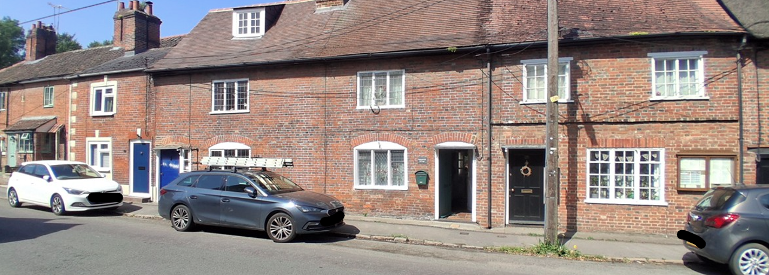

ST 9958 POTTERNE HIGH STREET (west side)
14/162 Nos 23 to 25 (consec)
GV II
Row of three houses, late C18, red brick with plain tile roof and ridge stack between Nos 23 and 24. Two storeys and attic. One C20 dormer to No 23. Nos 23 and 24 are a symmetrical pair each with one-window range of leaded triple casements and door, ground floor openings with cambered heads. No 23 has door to left, widened for inserted sidelight, no 24 has door to right. Both doors have small timber pent hoods on brackets. No 25, under single roof has different fenestration, C20 metal casements, 2 above, one to ground floor right. Door has flat timber hood on brackets. Small projecting brick band.
Listing NGR: ST9947258455

The site is to the south of the village of Kibworth Beauchamp.
The surrounding area around the site is Residential only with a mix of Buildings.

CONTEXT AND STATEMENT OF HISTORIC SIGNIFICANCE
Everest have been contracted to replace the front door at the property.

SURROUNDING AREA: The surrounding properties either side are very similar in style and design with painted timber front doors.

AMOUNT: 1 x front door

LAYOUT: The new front door will replace the one in situ.

SCALE: The door will be in proportion to the house as it will be in the original opening.

LANDSCAPING: Our proposal will not require any landscaping as this is for front door replacement only.

ACCESS: Access will be gained by entering the property via the main entrance.

APPEARANCE: We appreciate the importance of retaining the properties history and the importance of maintaining its unique features however we would ask that a fair balance is struck between the visual aesthetics of the property and the wellbeing and standard of living for the occupants.

The benefits to the homeowner using our Everest front door are that they is minimal maintenance and as such the aesthetics of the property will be maintained without the reliance of too much future upkeep.

We are proposing to replace the front door with an Olive Green, RAL 6011 timber door.

We have tried to produce a range of doors which specifically address the design concerns commonly raised in connection with conservation areas or listed buildings.

DEVELOPMENTS WITHIN OR AFFECTING CONSERVATION AREA, LISTED BUILDING OR ITS SETTING. We have carefully considered the proposed changes to the property and feel that the new door should not have a detrimental effect on the property as a whole and its surrounding area or setting as the product is to be sympathetic in design to the area and surrounding properties.
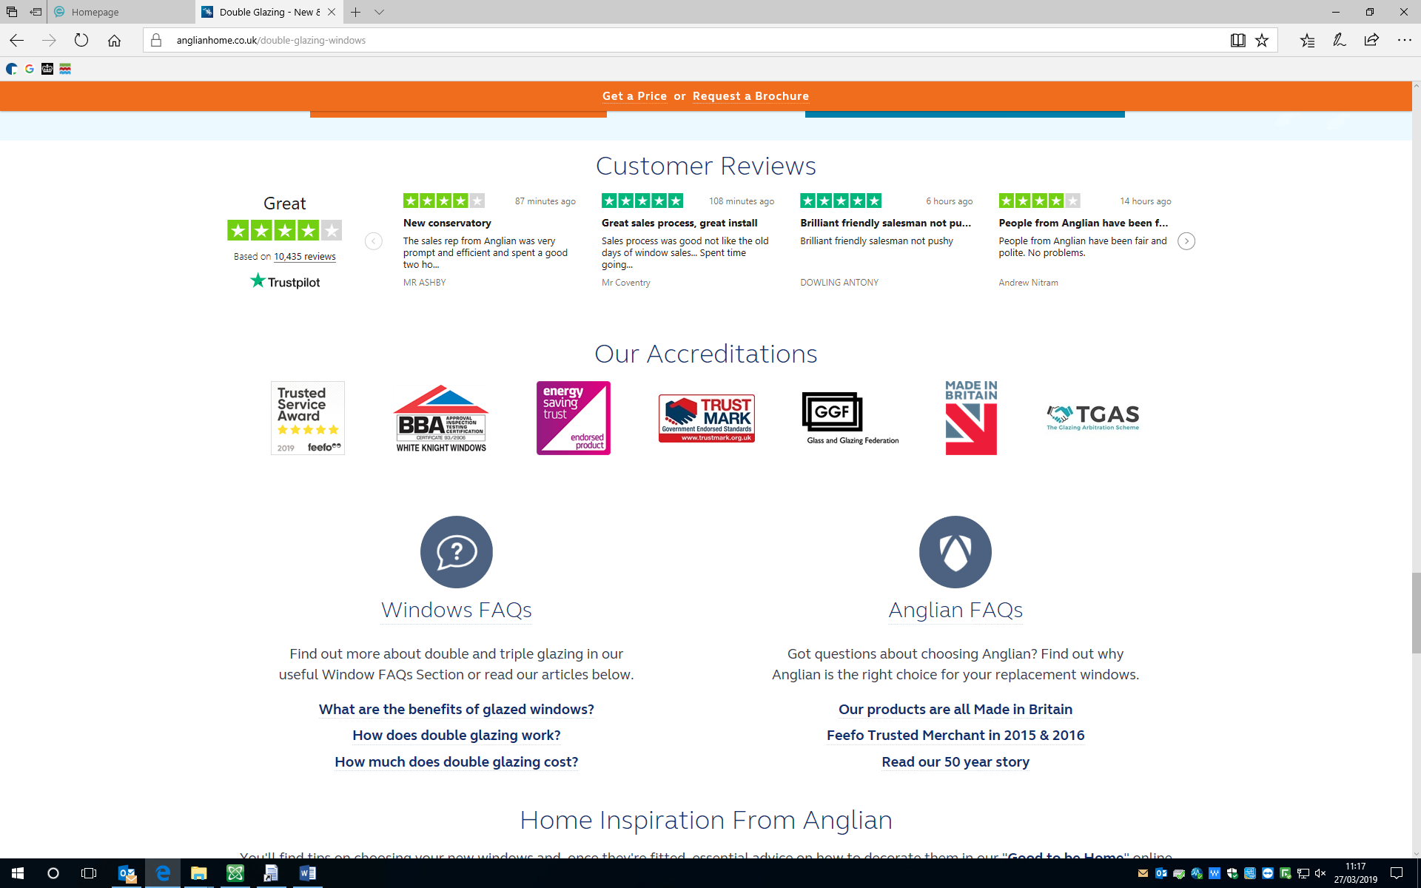

PHOTOS OF EXISTING FRONT DOOR

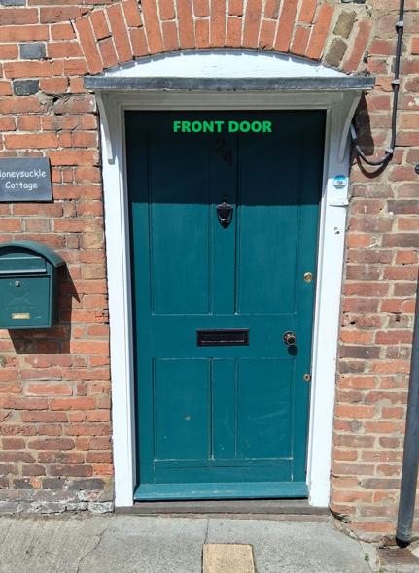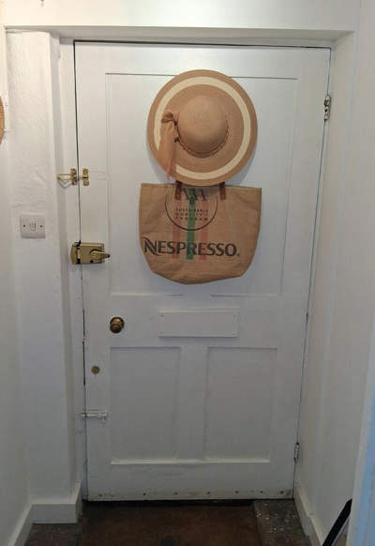

PROPOSED DOOR

