APPLICATION FOR HOUSEHOLDER PLANNING PERMISSION
DELEGATED REPORT

APPLICATION REFERENCE: | PL/2026/03914
APPLICATION TYPE: | Householder Planning Permission
SITE ADDRESS: | 10 Balmoral Road, Trowbridge, BA14 0JS
DEVELOPMENT DESCRIPTION: | Single storey rear extension and first floor side extension to a dwelling
RECOMMENDATION: | That Planning Permission be GRANTED

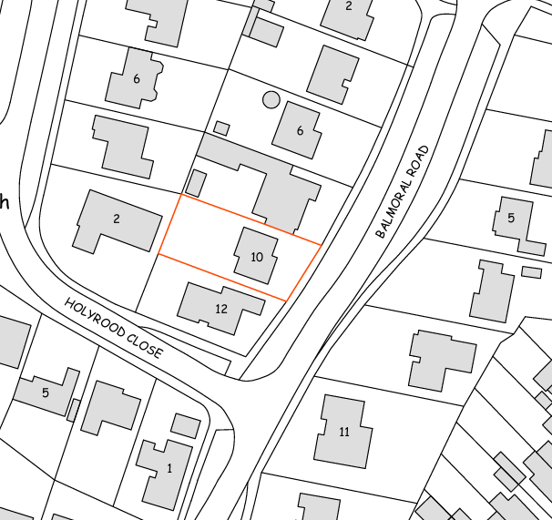
PROPOSAL

The application seeks planning permission for a two-storey side extension and a single-storey rear extension to an existing detached dwelling. The two-storey side extension would be constructed above and would extend the existing attached single-storey garage, extending the built form to align with the garage footprint and incorporating a two-storey front gable projection above the garage. The proposal also includes a single-storey rear extension spanning the full width of the dwelling, including the extended side element, to provide enlarged kitchen/dining accommodation and an office. The development would increase the property from a three-bedroom dwelling to a four-bedroom dwelling through the creation of an additional principal bedroom with associated en-suite accommodation above the garage. External materials comprise light grey composite cladding and through-colour render, with white uPVC windows and concrete roof tiles to match the existing dwelling.

SITE DESCRIPTION / CONTEXT

The site comprises a detached two-storey dwelling located within a modern residential estate on the south-western edge of Trowbridge. The surrounding area is predominantly residential in character and consists of detached and semi-detached dwellings of broadly similar scale and appearance set within medium to low density suburban development. Properties in the locality commonly feature cream render, buff brickwork or red brick, white uPVC fenestration and concrete tiled roofs. The site lies within the Trowbridge Settlement Boundary, identified as a Principal Settlement within the Wiltshire Core Strategy. It is located within the Trowbridge and Westbury Bat Mitigation Strategy Grey Zone and falls within Flood Zone 1, with SFRA mapping indicating negligible risk from groundwater or surface water flooding. No other significant site-specific constraints are identified.

PLANNING HISTORY

No relevant planning history has been identified for the site subject of this application.

RELEVANT LEGISLATION, POLICIES AND GUIDANCE

Wiltshire Core Strategy:

Core Policy 1 Settlement Strategy;
Core Policy 2 Delivery Strategy;
Core Policy 29 Spatial Strategy: Trowbridge Community Area;
Core Policy 50 Biodiversity and Geodiversity;
Core Policy 51 Landscape;
Core Policy 57 Ensuring High-Quality Design and Place Shaping;
Core Policy 60 Sustainable Transport;
Core Policy 61 Transport and Development;
Core Policy 64 Demand Management;
Core Policy 67 Flood Risk;

The National Planning Policy Framework (NPPF) August 2026 and the Planning Practice Guidance (PPG)

Wiltshire Design Guide - Appendix D – Design Guidance for Householder extensions

The Wiltshire Local Transport Plan 2011 – 2026: Car Parking Strategy (March 2015).

The Wiltshire Local Transport Plan 4 (LTP4) (March 2025)

New Wiltshire Local Plan: At Full Council on 19 May 2026, the elected members of Wiltshire Council agreed to withdraw the emerging Wiltshire Local Plan. The said Plan has no material weight for the purposes of the application.

In accordance with Regulation 19 of the Town and Country Planning (Local Planning) (England) Regulations 2026, on 30th June 2026 Wiltshire Council published a notice of intention to prepare a new local plan for Wiltshire. The next stage is a Scoping Consultation which commences on 2nd September 2026. This plan is at a very early stage and currently carries no weight for decision-making.

CONSULTATION RESPONSES

Trowbridge Town Council – No Objection

Local Highway Authority (Wiltshire Council) – No Objection

REPRESENTATIONS

No comments received.

ASSESSMENT

Section 38(6) of the Planning and Compulsory Purchase Act 2004 states:

"If regard is to be had to the development plan for the purposes of any determination to be made under the planning Acts, the determination must be made in accordance with the plan unless material considerations indicate otherwise."

In accordance with this statutory requirement, this application has been assessed against the relevant policies of the Development Plan, including the adopted Wiltshire Core Strategy (2015) and, where applicable, any made Neighbourhood Plans.

The proposed development relates to the extension of an existing dwellinghouse within its established residential curtilage and within the defined settlement boundary of Trowbridge. As such, the proposal represents a form of domestic development that is acceptable in principle, subject to compliance with relevant design, residential amenity, ecological, highways and drainage considerations. The proposal would not result in the creation of a new dwelling or a change of land use and is therefore considered to accord with the general objectives of sustainable development and the efficient use of land within existing settlements.

Design and Impact upon the character and context of the area

Policy CP57 of the adopted WCS seeks to secure high-quality design which responds positively to local character and distinctiveness. At the national level, Policy DP3 of the NPPF requires development proposals to respond positively to their context and integrate with and enhance their surroundings. Development should also reflect, where relevant, the principles of liveability, climate resilience, nature, movement, built form, public space and local identity. Assessment of design quality therefore requires consideration of the scale, appearance, massing, materials, layout and relationship of the proposal with both the host site and the wider character of the surrounding area.

The proposed extensions are considered to achieve an acceptable design response to the host dwelling and surrounding area. The two-storey side extension would largely continue the existing built form by infilling above the attached garage and creating a more balanced frontage through the introduction of a gabled projection. Similar forms of development, including full two-storey built forms and front gable projections, are evident within the wider estate and therefore the proposal would not appear incongruous within the street scene. Whilst composite cladding is not a dominant feature of immediately adjoining properties, examples are present within the wider locality (refer to site photographs provided on the following page) and its use as a complementary feature material, rather than as the principal finish to all elevations, is considered acceptable. The proposed render, roof tiles and uPVC windows would closely reflect the materials of the host dwelling. Overall, the proposal is considered to integrate satisfactorily with both the existing dwelling and the prevailing character of the area.

Having regard to the above, the proposal complies with the design principles set out in the NPPF Policy DP3, CP57 of the adopted WCS, and Appendix D of the Wiltshire Design Guide.

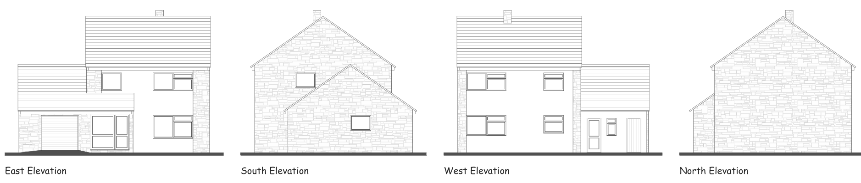
Existing Elevations

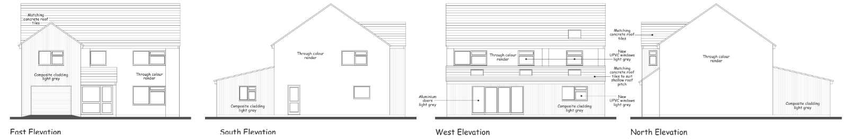
Proposed Elevations

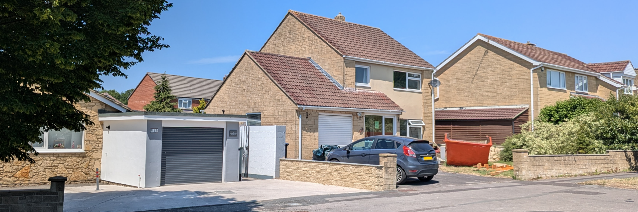
Site Image
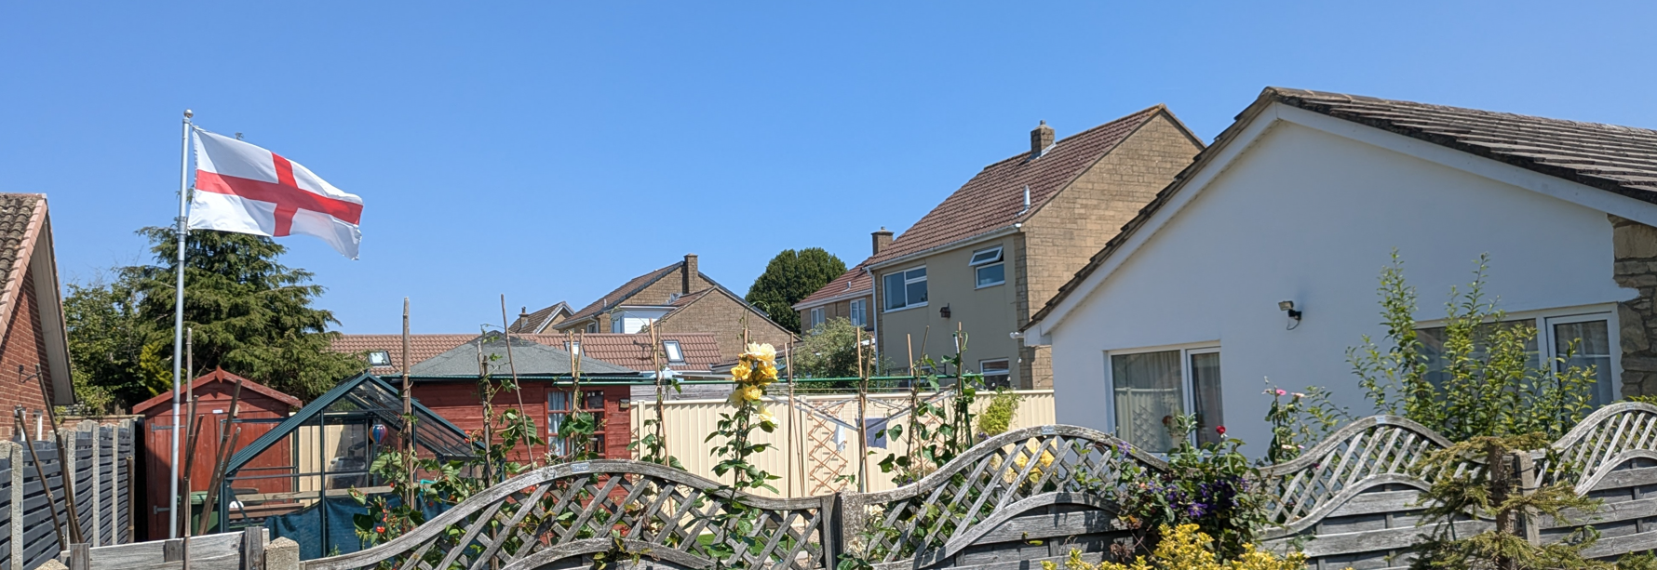
Site image

Amenity

Criterion vii of CP57 seeks to ensure development does not have an unacceptable impact upon the amenities of neighbouring occupiers. Nationally, Policy P3 requires development proposals to provide healthy living conditions for occupiers and users and to avoid unacceptable impacts arising from loss of light, outlook, privacy, noise, disturbance or other forms of pollution. Policy DP3 additionally requires development to create liveable and attractive places for existing and future users. Accordingly, the assessment below considers the effect of the proposal upon neighbouring occupiers and whether acceptable living conditions would be maintained.

The proposed development would not result in any unacceptable impact upon the living conditions of neighbouring occupiers. The single-storey rear extension would project approximately 4 metres beyond the existing rear elevation, with a maximum height of approximately 3.4 metres reducing to around 2.6 metres at the eaves. Given its modest scale, separation from boundaries and the presence of existing boundary treatments, the extension is not considered to result in unacceptable overbearing impacts or loss of light to neighbouring properties. The orientation of the site and the position of the nearest neighbouring dwellings further reduce the potential for harmful overshadowing. In respect of privacy, the rear extension contains only ground-floor glazing serving the applicant's garden.

With regard to the two-storey element, this would introduce a rear-facing first-floor window serving the en-suite bathroom and three windows serving the proposed new bedroom, including a standard casement window in the side (south-facing) elevation and a smaller window within the gable of the northern elevation.

Given the intervening distances, the oblique nature of views available from the rear window, and the limited outlook afforded by the side window over neighbouring private amenity space, it is not considered that the proposal would result in any material loss of privacy or unacceptable overlooking. Views over the existing bungalow to the south-west are already obtained from existing fenestration, and it is not considered that the introduction of the side-facing window would result in harmful window-to-window conflict or a significant loss of privacy compared to the existing situation. To the north, the proposed side-facing window would predominantly afford views towards the front parking area of No. 8 Balmoral Road, where public views are already available.

The proposal therefore accords with CP57 point vii and the NPPF in respect of safeguarding residential amenity and Appendix D of the Wiltshire Design Guide.

Transport and Highways

Core policies CP60, CP61 and CP64 of the WCS seek to promote sustainable transport, secure safe access arrangements and ensure adequate parking provision. Nationally, Policies TR3 and TR4 of the NPPF require development to be located in sustainable locations where appropriate, provide safe access arrangements, prioritise walking, wheeling and cycling, and provide suitable parking provision having regard to the nature and location of the development. Policy TR6 confirms that development should be refused where it would result in a severe adverse impact on the transport network or an unacceptable impact on highway safety after consideration of any mitigation measures.

CP64 outlines the need for development to comply with a minimum level of parking standards. This is further discussed through the Wiltshire Local Transport Plan, and policy PS6 which identifies that new residential development is required to take account of dwelling size and the mix of associated parking function.

The proposal would not alter the existing vehicular access arrangements serving the site. Although development is proposed above and around the existing garage, the garage itself would be retained. The existing driveway would continue to provide at least three off-street parking spaces. This level of parking provision accords with Wiltshire Council's parking standards for a four-bedroom dwelling, which requires a minimum of 3 on-site car parking spaces for a 4+ bedroom dwelling. The Council’s Local Highway Authority has considered the proposal and raises no objection It is important to mention that garages can only be considered an allocated car parking space where they meet the internal size requirements of 3mx6m. The proposal is therefore not considered to result in any adverse impacts on highway safety or parking provision.

Ecology

Policy CP50 of the adopted WCS seeks to protect and enhance biodiversity interests and ensure development avoids unacceptable harm to ecological assets. National policy is set out within Policies N2 and N6 of the NPPF. These policies require development proposals to minimise impacts upon biodiversity, protect important habitats and species, and secure opportunities for biodiversity enhancement where appropriate. Where significant harm to biodiversity cannot be avoided, adequately mitigated or compensated for, development should be refused. Biodiversity Net Gain (BNG) was established as a mandatory aspect of planning evaluation through Schedule 7A of the Town and Country Planning Act 1990 (as amended by the Environment Act 2021 Schedule 14). Householder development is exempt from the statutory Biodiversity Net Gain requirements introduced through Schedule 7A of the Town and Country Planning Act 1990 (as amended). Nevertheless, proposals should seek to avoid ecological harm and incorporate biodiversity enhancements where appropriate.

The proposal is limited to extensions within the footprint of the existing dwelling and areas of managed residential garden. The proposed development would be fully contained within the confines of the established residential curtilage of 10 Balmoral Road. As such, the development and associated works are unlikely to adversely affect protected species or important ecological features.

The site lies within the Trowbridge and Westbury Bat Mitigation Strategy Grey Zone. Having regard to the nature of the proposal as an extension to an existing dwelling within an established residential curtilage, and in the absence of evidence of habitat loss or impacts upon bat habitat, the proposal is not considered likely to result in significant effects upon the Bath and Bradford-on-Avon Bats SAC

With due regard to the scale and nature of the proposal and the absence of identified ecological constraints, the development is not considered to give rise to significant ecological impacts. Subject to compliance with any relevant ecological requirements, the proposal is considered acceptable in ecological terms.

Flooding and Drainage

Policy CP67 of the WCS seeks to ensure that development is directed away from areas at greatest risk of flooding and is designed to minimise vulnerability to flooding whilst avoiding any increase in flood risk elsewhere. National planning policy relating to flood risk and drainage is contained within Policies F4 to F8 of the NPPF. Collectively, these policies establish a risk-based approach to the location and assessment of development proposals. The NPPF requires flood risk to be properly assessed where necessary, seeks to direct development towards areas at the lowest risk of flooding through the application of the sequential approach where applicable, and ensures that development remains safe for its lifetime without increasing flood risk elsewhere. The policies also support the incorporation of sustainable drainage measures where appropriate in order to manage surface water runoff and reduce the potential for flooding.

Householder proposals and small extensions below 250 square metres are exempt from both the sequential test and exception test under Policy F5(2)(c), although flood risk considerations remain material where site-specific constraints have been identified.

The site is located within Flood Zone 1 and is identified as being at negligible risk from groundwater and surface water flooding. Whilst the proposal would result in a modest increase in impermeable area of approximately 47.5 square metres, the increase is relatively minor in scale and appropriate rainwater goods are proposed as part of the development. There is no evidence to indicate that the proposal would give rise to increased flood risk on or off site, and no drainage constraints have been identified. Accordingly, the proposal is considered acceptable with regard to drainage and flood risk matters.

CONCLUSION

The proposed extensions represent an acceptable form of residential development within the settlement boundary of Trowbridge. The development would appear compatible with the character and appearance of the host dwelling and surrounding area, would not result in unacceptable impacts upon neighbouring residential amenity, and raises no significant concerns in respect of ecology, highways, parking, drainage or flood risk. The proposal is therefore considered to comply with the relevant provisions of the development plan and is recommended for approval.

In the overall planning balance, the proposal represents a proportionate extension to an existing dwelling within a sustainable residential location. No significant adverse impacts have been identified and the development accords with the relevant policies of the development plan when read as a whole.

RECOMMENDATION: That Planning Permission be GRANTED subject to the following conditions:

1.
The development hereby permitted shall be begun before the expiration of three years from the date of this permission.
REASON: To comply with the provisions of Section 91 of the Town and Country Planning Act 1990 as amended by the Planning and Compulsory Purchase Act 2004.

2.
The development hereby permitted shall be carried out in accordance with the following approved plans and documents:

Proposed Plans and Elevations 10BMR-P-02
Location Plan 10BMR-P-03

REASON: For the avoidance of doubt and in the interests of proper planning.

