CASE OFFICER'S REPORT

Application Reference: | PL/2026/02171
Application Type: | Full planning permission
Consultation ends: | 19 May 2026
Case officer: | Steven Sims

Site Address: | Kingston Farm, Holt Road, Bradford on Avon, BA15 1TS
Proposal: | Change of Use of Supercar Barn (Use Class B8) and adjoining infill extension to a Mixed Use of Storage (Use Class B8) and Café/event space (Use Class E (b) & (c) (iii)) forming a sui generis mixed-use operation. (Retrospective)
Recommendation: | Approve with Conditions

PROPOSAL AND SITE DESCRIPTION

The site

The application relates to a site (0.3 ha) that contains a complex of barns off the B3107 (Holt Road), to the east of Bradford on Avon. Whilst it is understood that the site was originally wholly agricultural, many have buildings been converted to alternative uses in recent years as detailed in the planning history section of this report.

The site is served by an existing vehicle access off Holt Road and an existing car park located directly off this access can accommodate 32 cars.

The site is located within the open countryside and within the West Wiltshire Green Belt. The site is also located within the Bath and Bradford on Avon Bat Special Area of Conservation (SAC). The site does not lie within Flood Zones 2 or 3 however the site is subject to high levels of groundwater flooding and parts of the site are susceptible to high levels of surface water flooding (as detailed on the Council’s strategic flood risk map copied in the drainage section below).
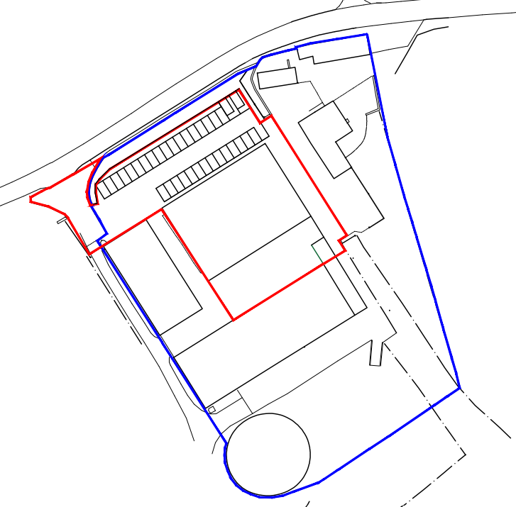
Location plan

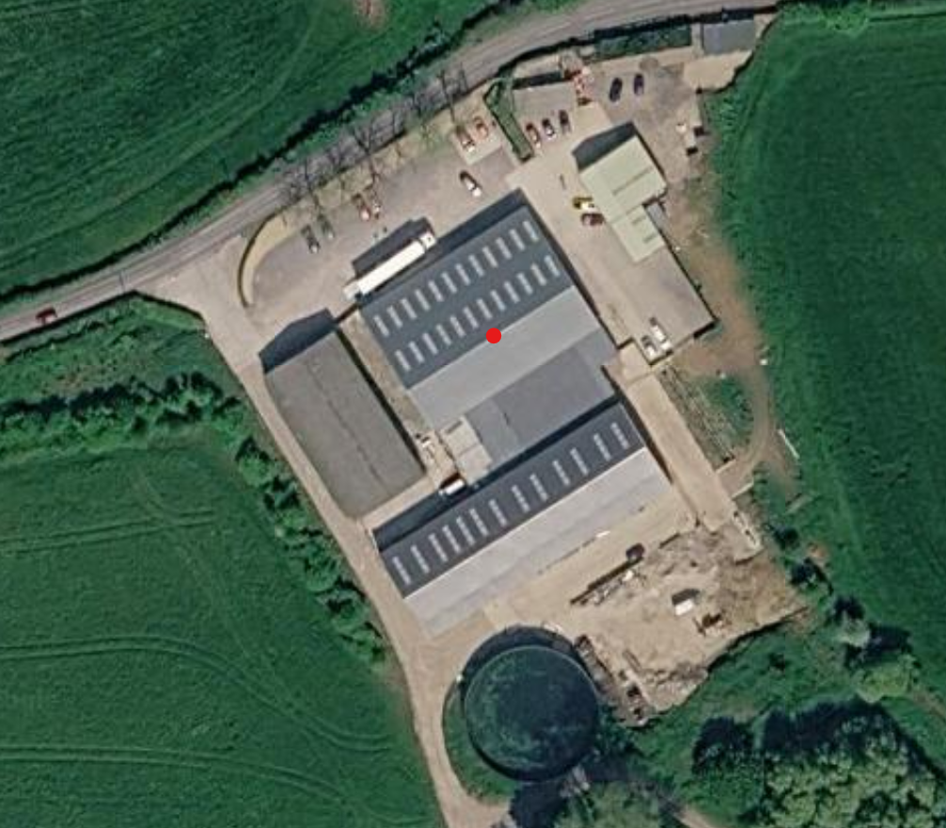
Aerial view (Google Maps)

The application

This is a full retrospective application for change of use of the existing barn (Use Class B8) and adjoining infill extension (approved under application PL/2025/08539) to a mixed use of storage (Use Class B8) and café/event space (Use Class E (b) and (c) (iii) (sale of hot food and drink for consumption (mostly) on the premises and the provision of other appropriate services in a commercial, business or service locality). No external alterations to the building are proposed.
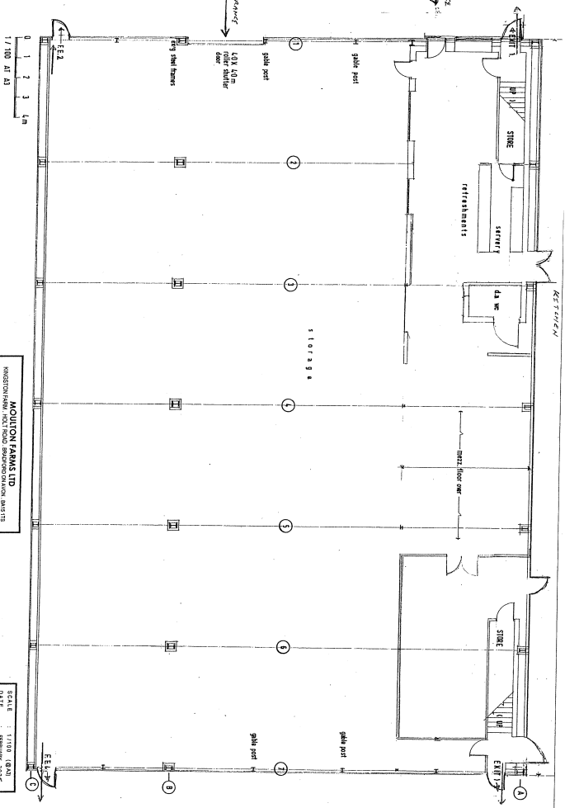
Main barn ground floor

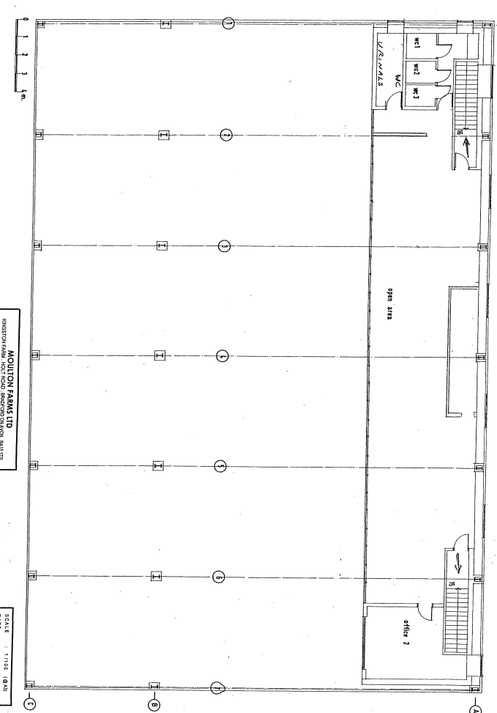
Main barn first floor

The site is currently used for the storage and display of supercars and hypercars. Visitors attend the site to view the vehicles, and both indoor and outdoor events associated with this use have taken place since 2021, albeit without the benefit of planning permission. The current proposal seeks to regularise the existing use of the café and wider site, enabling daytime and evening events centred on the display and viewing of the vehicles.

Use of the main building and site will typically include the following –
- The site would normally be open for visitors to view the super/ hyper cars from 9am to 4pm Wednesday-Sunday
- The café would also normally operate between 9am-4pm Wednesday-Sunday
- Outside events would be held twice monthly and finish by 4pm with visitors leaving by 5pm (these outside events typically involve local/ regional car and bike clubs gathering to view the hyper/ super cars or classic cars and bikes)
- Evening events would be held up to 24 times per year (also twice monthly) to finish by 12am/midnight
- Overspill parking for larger events would be made available on the adjacent land (up to 28 days/year)

In terms of live/ incidental music on site –
- Music will be played as background music during cafe opening hours
- During the outdoor events music will be played as background/ incidental music
- During evening events live music is proposed for certain events

In summary the current scheme seeks permission/ regularise use of the barn plus approved extension for mixed use storage/ display/ events/ cafe use. No external alterations to the buildings are proposed and no servicing or repair of cars will be carried out on site.

The applicants advise the scheme will support approximately 17-20 full-time jobs.

POLICIES

Wiltshire Core Strategy (WCS) 2015
Core Policy 1: Settlement Strategy; Core Policy 2: Delivery Strategy; Core Policy 7: Spatial Strategy for the Bradford on Avon Community Area; Core Policy 34: Additional employment land; Core Policy 35: Existing Employment Land; Core Policy 38: Retail and Leisure; Core Policy 48: Supporting rural life; Core Policy 50: Biodiversity and Geodiversity; Core Policy 51: Landscape; Core Policy 57: Ensuring High Quality Design and Place Shaping; Core Policy 60: Sustainable Transport; Core Policy 64: Demand management; Core Policy 67: Flood Risk

National Planning Policy Framework 2026 (the Framework) and Planning Practice Guidance (PPG)

Other
Wiltshire Local Transport Plan 2011 – 2026

Wiltshire Local Transport Plan 2025 – 2038 (endorsed at full council on 11 March 2025)
Bradford on Avon Neighbourhood Plan 2013-2026 (in particular Policy E1)
Planning Consultation Guidance Note Noise and Vibration (PCGNNV) 2023

Wiltshire Council’s Emerging Local Plan (WLP) 2020-2038

At Full Council on 19 May 2026, the elected members of Wiltshire Council agreed to withdraw the emerging Wiltshire Local Plan. The said Plan has no material weight for the purposes of the application. In accordance with Regulation 19 of the Town and Country Planning (Local Planning) (England) Regulations 2026, on 30th June 2026 Wiltshire Council published a notice of intention to prepare a new local plan for Wiltshire. The next stage is a Scoping Consultation which commences on 2nd September 2026. This plan is at a very early stage and currently carries no weight for decision making.

RELEVANT PLANNING HISTORY

PL/2025/08539 – The erection of an extension and change of use to B8 use (retrospective application) – Approved

PL/2023/11083 – Proposal to convert and extend an existing agricultural barn, changing use to class B8 and class E, with associated internal and external alterations. – Approved

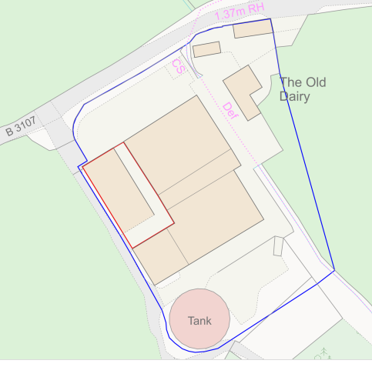
Site plan PL/2023/11083

PL/2022/02254 – (Retrospective) Proposed Change of Use of 113m2 of barn from B8 use to Class E flexible commercial use and associated operational development including, installation of windows, doors, a mezzanine floor and internal stairs. – Approved

NOTE – condition 2 of this application restricted the 113m2 E class use to office use only
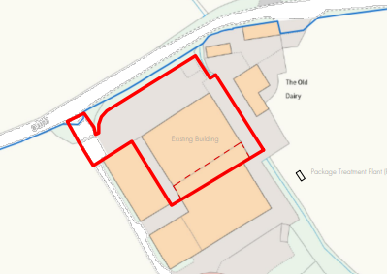
Site plan PL/2022/02254

20/10397/FUL - Change of use from flexible uses permitted via Class R to B8 Use. - Approved with conditions
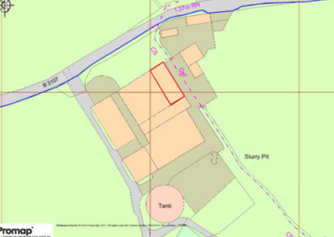
Site plan 20/10397/FUL

19/08523/FUL - Change of Use of Part of an Agricultural Building to B8 Use - Approved with conditions
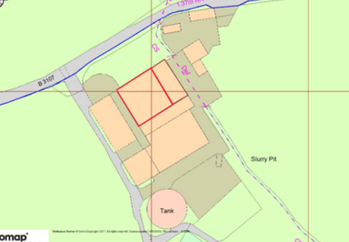
Site plan 19/08523/FUL

17/06275/PNCOU - Notification for Prior Approval under Class R - Change of Use of Agricultural Building to Flexible Uses (B8) - Prior approval not required
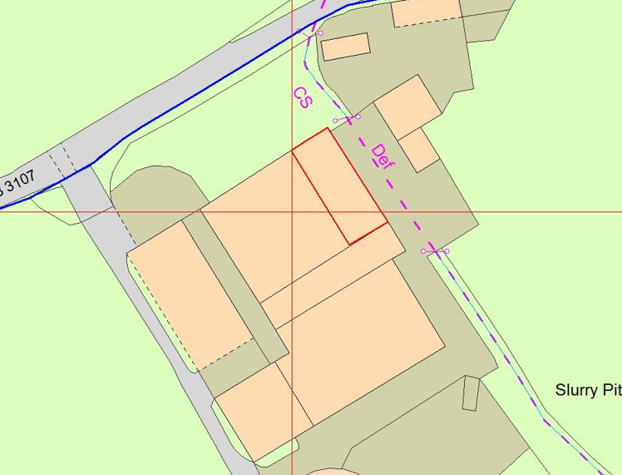
Site plan 17/06275/PNCOU

16/06815/PNCOU - Notification for Prior Approval under Class R - Proposed change of use of existing agricultural building to a flexible use within Shops, Financial and Professional services, Restaurants and Cafes, Business, Storage or Distribution, Hotels, or Assembly or Leisure - Prior approval granted

CONSULTATION RESPONSES

Bradford on Avon Town Council: No objection

South Wraxall Parish Council: No objection

Highways Team: No objection (follow on comments requested a plan detailing overspill parking)

Ecology Team: No objection subject to condition

Public Protection: No objection subject to conditions

Bradford on Avon Preservation Trust: Object - concerns relate to the use of the cafe, to its opening hours and to events held at the premises, highway safety and for pedestrians walking to events along a road with no footpath. Note past events have been stewarded with staff in high visibility jackets directing traffic

REPRESENTATIONS

One letter of objection has been received providing the following summarised comments –
- Highway safety issues
- Noise issues
- Adverse impact on local tourism
- Antisocial behaviour (cars racing circuits in area)

ASSESSMENT
Section 38(6) of the Planning and Compulsory Purchase Act 2004 states:

"If regard is to be had to the development plan for the purposes of any determination to be made under the planning Acts, the determination must be made in accordance with the plan unless material considerations indicate otherwise."

In accordance with this statutory requirement, this application has been assessed against the relevant policies of the Development Plan, including the adopted Wiltshire Core Strategy (2015) and, where applicable, any made Neighbourhood Plans.

Principle of development

The principle of development for use of the barn plus extension for storage purposes was approved under applications PL/2025/08539, 20/10397/FUL and 19/08523/FUL.

Flexible commercial use (any use falling within Class A1 (shops), Class A2 (financial and professional services), Class A3 (restaurants can cafes), Class B1 (business), Class B8 (storage or distribution), Class C1 (hotels) or Class D2 (Assembly and leisure) of the Schedule to the Use Classes Order) was approved for a section of the barn under application 17/06275/PNCOU (see red line plan snippet above).

Office use was approved for a small section of the barn under application PL/2022/02254.

The current scheme seeks permission/ regularise use of the barn plus approved extension for mixed use storage/ events/ cafe use.

Core Policy 1 of the WCS identifies the four tiers of settlement - ‘Principal Settlements’, ‘Market Towns’, ‘Local Service Centres’, and ‘Large and Small Villages’. The subject site is beyond the limits of development for Bradford on Avon and is therefore considered to be a development in the open countryside. CP1 advises that development outside of defined settlement boundaries will generally be strictly controlled, however it is accepted that certain types of development in the countryside are acceptable.

The ‘made’ Bradford on Avon neighbourhood plan (BNP) states in objective 3 on page 16 of the plan that “diversification of rural businesses including the use of redundant rural buildings for alternative employment uses” should be encouraged. Furthermore, Policy E1 of the BNP states that “sustainable business and employment development within or adjacent to Bradford on Avon will be supported”.

Policy E2 1. a. of the new NPPF states, to support business growth substantial weight should be given to the economic benefits of proposal for commercial development which allow businesses to invest, expand and adapt.

Policy E4 1. goes onto state, in applying policy E2 sustainable growth of businesses in rural area should be supported, including through, amongst others, the conversion of existing buildings, facilities to support rural leisure and tourism and measures to retain and expand accessible local shops and services.

Policy E4 2. states development proposals to meet business needs in rural areas may need to be located outside settlements, and in locations that are not well served by public transport. In these circumstances development proposals should take opportunities, where they exist, to use previously developed land, and sites that are physically well-related to existing development.

Core Policy 34 of the WCS states outside the Principal Settlements, Market Towns and Local Service Centres, developments will be supported that:
i. are adjacent to these settlements and seek to retain or expand businesses currently located within or adjacent to the settlements; or
ii. support sustainable farming and food production through allowing development required to adapt to modern agricultural practices and diversification; or
iii. are for new and existing rural based businesses within or adjacent to Large and Small Villages; or
iv. are considered essential to the wider strategic interest of the economic development of Wiltshire, as determined by the Council.

Where they:
a. meet sustainable development objectives as set out in the polices of this Core Strategy and
b. are consistent in scale with their location, do not adversely affect nearby buildings and the surrounding area or detract from residential amenity and
c. are supported by evidence that they are required to benefit the local economic and social needs and
d. would not undermine the delivery of strategic employment allocations and
e. are supported by adequate infrastructure.

Accompanying text to Core Policy 35 (paragraph 6.16 of the WCS) states ‘It will also be important to retain existing employment uses outside the Principal Employment Areas to maintain diversity and choice of sites for employers and allow for local business expansion.’

Core Policy 38 states proposals for retail or leisure uses on sites not within a town centre in excess of 200 sqm gross floorspace, including extension of existing units, must be accompanied by an impact assessment which meets the requirement of national guidance and established best practice, and demonstrates that the proposal will not harm the vitality or viability of any nearby centres.

Core Policy 48 states proposals to convert and re-use rural buildings for employment, tourism, cultural and community uses will be supported where they satisfy the following criteria:
i. The building(s) is/are structurally sound and capable of conversion without major rebuilding, and with only necessary extension or modification which preserves the character of the original building.
ii. The use would not detract from the character or appearance of the landscape or settlement and would not be detrimental to the amenities of residential areas.
iii. The building can be served by adequate access and infrastructure.
iv. The site has reasonable access to local services.

Whilst the site is outside of a settlement boundary, it is relatively close to the boundary for Bradford on Avon (approx. 430 metres distant to the eastern edge of the town and approx. 1.4km from the town centre). The building and premises already exist and have supported the sites use for events and a café associated with viewing hyper/ super cars since 2021.

The current proposal would employ up to 20 staff and make a positive contribution to the local economy, in accordance with the objectives of Core Policy 34 in supporting employment growth and rural enterprise. The use would take place within an existing building that has hosted events since 2021 and remains in good condition, thereby representing an appropriate reuse of an established facility. The site lies approximately 1.4km from Bradford on Avon town centre, providing access to a range of services and facilities. While public transport options in the immediate vicinity are limited, the proximity to the town centre enables opportunities for access by cycling, and as such the location is considered reasonably sustainable in the context of rural development.

In terms of Core Policy 48, the proposal represents an appropriate form of rural diversification, supporting leisure and tourism activity without the need for substantial new development. The nearest residential property is located approximately 140 metres to the northeast, providing a reasonable level of separation. Potential impacts arising from noise and general disturbance associated with events can be adequately controlled through the imposition of planning conditions, ensuring that no unacceptable harm to residential amenity or the wider environment would occur. No external alterations are proposed as such the scheme would not result in additional harm to the rural character of the area. Access to the site is existing and the development would result in no significant harm to highway safety in the immediate area.

Overall, the scale, nature and location of the proposal are considered appropriate, and it would support the rural economy without resulting in significant adverse impacts, in accordance with the requirements of Core Policies 34 and 48.

With regard to Core Policy 38, there is no proposed retail use, however the use of the barn for display for members of the public to view hyper and supercars would be considered a leisure use. This type of event is specialised and is likely to attract a specific audience seeking to view these vehicles rather than a more generalised audience. It is highly unlikely that such a use would be suitable for a town centre and the café/events use is largely associated with the main use/attraction of the vehicle display. As such, it is considered that the scheme would not harm the vitality or viability of any nearby centres and the 200 sqm threshold in the development plan policy is not applicable in this case.

There is no objection to the principle of the development subject to consideration of all material planning issues and site-specific constraints.

Impact on the openness of the Green Belt

There are no relevant development plan policies relating to the Green Belt at local level therefore the NPPF provides policy direction. The NPPF states under section 13 Protecting Green Belt land ‘The objective of Green Belt policy, as set out in this chapter, is to prevent urban sprawl by keeping land permanently open. The government attaches great importance to Green Belts, the essential features of which are their openness and permanence.’

Policy GB6 1. of the NPPF states development in the Green Belt is inappropriate unless it falls within one of the categories in policy GB7. Paragraph GB6 2. states inappropriate development is, by definition, harmful to the Green Belt and should not be approved except in very special circumstances. Such circumstances will not exist unless the potential harm to the Green Belt by reason of inappropriateness and any other harm resulting from the proposed development, is clearly outweighed by other considerations. In making this assessment, substantial weight should be given to the harm to the Green Belt which would be caused, including harm to its openness.

Policy GB7 1. of the NPPF states, the following categories of development are not inappropriate in the Green Belt and include, amongst others, the reuse, extension, alteration or replacement of an existing building, provided that the existing building is of permanent and substantial construction.

The application, as set out, is for change of use only and the existing building has previously been converted, and no external alterations are proposed. However, the explanatory information also includes reference to outdoor events which are understood to include land within the applicant’s ownership (as denoted by the blue line). Such events are considered to take place no more than 24 times per year (twice per month), which is less than the 28 days for temporary uses of land within the permitted development order (where land is not within the curtilage of a building). With this limitation, the impact of such events is temporary in nature and would not harm the openness of the Green Belt. Given the context and planning history of the site, it is concluded that the proposals are appropriate development in the Green Belt. The proposals would therefore preserve openness and not conflict with the purposes of including land within the Green Belt.

Impact on the character of the area

Core Policy 51 of the CS outlines that development should protect, conserve and where possible enhance landscape character and must not have a harmful impact upon landscape character. Core Policy 57 requires a high standard of design in all new developments.

The application is for change of use only and no external alterations are proposed. The applicants state no additional external lighting is proposed (additional external lighting will be conditioned). As such it is considered the development would cause no harm to the landscape character of the area. The temporary outdoor events are limited and involve no operational development, accordingly the impact on the character of the area would be negligible.

Impact on neighbour amenity

Core Policy 57 of the WCS requires a high standard of design in all new developments and that development has regard to the compatibility of adjoining buildings and uses, the impact on the amenities of existing occupants and ensuring that appropriate levels of amenity are achievable within the development including the consideration of privacy, overshadowing, vibration, and pollution (e.g. light intrusion, noise, smoke and fumes).

The application site is located within a wider complex of former agricultural buildings which have subsequently changed use either by utilising permitted development rights or from being granted planning permission for alternate uses including Class B8 and Class E. The applicants advise the use of the building / site for events and viewing of the hyper/ super cars has been in operation since 2021 with events being held with up to 500 people in attendance. The applicant also advises the café, which can seat 50/60 people, has been in operation since 2021. The current proposal aims to regularise these uses and events.

The current scheme proposes to regularise events held inside and outside the existing storage building as detailed above. In terms of live/ incidental music on site it is proposed that music will be played as background music during cafe opening hours. During outdoor events music will be played as background/ incidental music. During evening events amplified music will not be a regular occurrence, but the applicants advise such activities cannot be ruled out in connection with the occasional event.

The nearest adjacent residential property to the site is located 140 metres distant to the northeast. The buildings on site have permission for storage and commercial class E uses where it was considered these uses would not result in significant harm to the amenity of adjacent occupiers.

The Council’s Environmental Health team acknowledges that the applicant's stated intention is for music associated with the routine operation of the premises to be limited to background/incidental music ancillary to the primary use of the site, namely the café, vehicle display areas and associated commercial activities. The applicant has also indicated that whilst DJs, live music and other forms of amplified entertainment are not intended to form part of the site's normal operation, such activities cannot be ruled out in connection with the occasional event. Should amplified music etc take place the applicant will be required to submit a noise impact assessment prior to commencement the activities in order to protect the amenity of adjacent residents.

The Council’s Environmental Health team advise concerns remain regarding the potential for noise disturbance to nearby noise-sensitive receptors arising from music and entertainment uses, particularly during the evening and night-time period when background noise levels are likely to be lower. Furthermore, no acoustic assessment has been provided to demonstrate that the building design, site layout and operational arrangements would be capable of adequately controlling noise associated with amplified music, DJ-led entertainment or live performances. Wiltshire Council's technical guidance on this matter (PCGNNV) recognises entertainment noise as a potentially significant source of disturbance and advises that appropriate assessment and mitigation should be secured where necessary to protect residential amenity. As such the Council’s Environmental Health team recommend conditions relating to the control of incidental and amplified music are imposed on the development. In addition, conditions will be imposed limiting the number and timing of indoor and outdoor events each year.

The Council's Environmental Health team has advised that indoor events should cease by 11:00pm. However, the applicant has requested permission for operating hours extending until 12:00am. The applicant advises that indoor events have been taking place on the site since 2021 and that the Council's Public Protection team has not received any substantiated complaints relating to noise arising from these events. However, there is a third party representation which raises the potential for noise and impacts cannot be ruled out since the extent of previous events is unqualified. However, given suggested Conditions 7 and 8, the residual risk of unacceptable noise impact is reduced to an acceptable level and it is considered reasonable in this instance to permit indoor events until 12:00am subject to specific controls on amplified music.

As such it is considered the development would not cause the level of harm to the amenity of adjacent residents to warrant a recommendation for refusal.

Highway/parking issues

Core Policy 61 of the WCS seeks to ensure that all new developments are capable of being served by safe access to the highway network. Core Policy 64 sets out to manage the demand for parking.

Policy TR6 4. of the NPPF states development proposals should be refused if they would have a severe adverse impact on the transport network (in terms of capacity and congestion, including cumulative impacts), or an unacceptable impact on highway safety; taking into account any mitigation measures proposed as well as any wider network improvements, including measures to support sustainable patterns of movement.

The site is served by an existing vehicle access off Holt Road and an existing car park located directly off this access can accommodate 32 cars. An area to the east of the main barn would be used as overspill parking associated with the larger events. The applicants advise overspill parking for the larger events would also be made available on the adjacent land (up to 28 days/ year).

The Council's Highways Officer has requested an overspill parking plan identifying parking spaces and associated manoeuvring areas. However, the area proposed for temporary overspill parking does not contain marked parking bays, and similar temporary parking arrangements have previously operated without such markings. In these circumstances, it is not considered reasonable or practical to require the submission of a detailed parking layout plan on the basis that event parking would be best managed according to the need for the particular event. Therefore, to ensure that appropriate measures are in place to safeguard highway and public safety during events, a condition will be imposed requiring the submission and approval of a Traffic Management Plan.

No alterations to the existing parking provision or the access are being proposed, and the Council’s highways officer confirms the access and visibility are considered adequate.

As such it is considered sufficient parking is available on site to accommodate the larger events and the scheme will not result in severe impact upon the highway network or result in an unacceptable impact on highway safety.

Ecology issues

Core Policy 50 of the Wiltshire Core Strategy requires all development to demonstrate no net loss of local biodiversity resource and to secure the integrity of local ecological networks. Core Policy 50 also requires development to seek opportunities to enhance biodiversity. In addition, the NPPF encourages development proposal to consider the environmental qualities of land proposed for development, including habitats, landscape character and the natural beauty of the countryside, and identify opportunities for those qualities to be conserved or enhanced (Policy N2 1.a.).

The site is located within the Bath and Bradford on Avon Bat Special Area of Conservation (SAC). The application is for change of use only and no external alterations are proposed. The applicants also state no additional external lighting is proposed. A condition will be imposed requiring the submission of details of any new external lighting before installation.

A test of likely significance has been carried out by the relevant Competent Authority (Wiltshire Council) as required by Regulation 63 Conservation of Habitats and Species Regulations 2017 (as amended). The Habitats Regulations Appraisal (HRA) has concluded that the application is not likely to have significant impacts on the SAC because the barn has already been converted to storage use under previous applications and an Appropriate Assessment is not required.

The application is submitted as a retrospective application and is therefore exempt from Biodiversity Net Gain (BNG) requirements. In addition, the scheme would also be ‘De minimis’.

Drainage/ flooding issues

Core Policy 67 of the WCS states all new development will include measures to reduce the rate of rainwater run-off and improve rainwater infiltration to soil and ground (sustainable urban drainage) unless site or environmental conditions make these measures unsuitable.

The site does not lie within Flood Zones 2 or 3 however it is susceptible to high levels of ground and surface water flooding as detailed on the Council’s strategic flood risk map copied below. The flood risk maps indicate the area susceptible to surface water flooding is limited to the east/ northeast of the main building including a section of the carpark.

Policy F4 2.c. of the NPPF states land identified in a strategic flood risk assessment or the Flood Map for Planning as being at risk of flooding from any source should be accompanied by a site-specific flood risk assessment.

Policy F5 2. of the NPPF states the sequential test should be used in areas known to be at risk now or in the future from any form of flooding, other than for, amongst others, development that is considered a change of use (excluding caravans and camping sites etc).

Policy F7 1. states development proposals should not present a risk from flooding to potential occupiers, users, or visitors, and should not increase flood risk elsewhere.

Policy F7 2. states where development is proposed in a location known to be at risk from any form of flooding, now or in the future, it should be refused unless, amongst others, within the site, the most vulnerable development is located in areas of lowest flood risk and any residual risk can be safely managed and it can be demonstrated that flood risk will not be increased elsewhere.

The application is not supported by a site-specific flood risk assessment and is not accompanied by a sequential test. The scheme involves the change of use only of an existing barn used for storage and display purposes with associated café and events use, equivalent to uses falling mainly within use class E. No alterations or extension to the existing barn are proposed. Occasional outdoor events on the adjacent land are also proposed and limited by condition to 24 such events per year.

The main building and site have permission for use for storage and class E purposes while the current scheme looks to regularise the use of the site for events use with a combination of storage, cafe and event uses. Due to the scheme being change of use only and the site consisting of mainly existing hard surfacing, it is considered the development would not result in increased flood risk elsewhere in terms of ground water or surface water risk. In terms of the risk to potential occupiers, users and visitors, it is not considered that the proposed use would be more vulnerable than the approved use in terms of ground water flood risk since ground water flooding to the building would not normally occur suddenly. In terms of surface water risk, this would be present for access and egress but there is refuge within the building and on land which isn’t vulnerable to surface water flooding.

The proposal references use of the outside space around the main building for outdoor events including overspill parking associated with larger events, however no additional development is proposed in these areas, and these are limited in number by condition. In practical terms most outdoor events would likely be cancelled during flood events as the display of high end or classic vehicles would not be compatible with such conditions. As such the risk during temporary events is not considered to warrant a flood risk assessment.

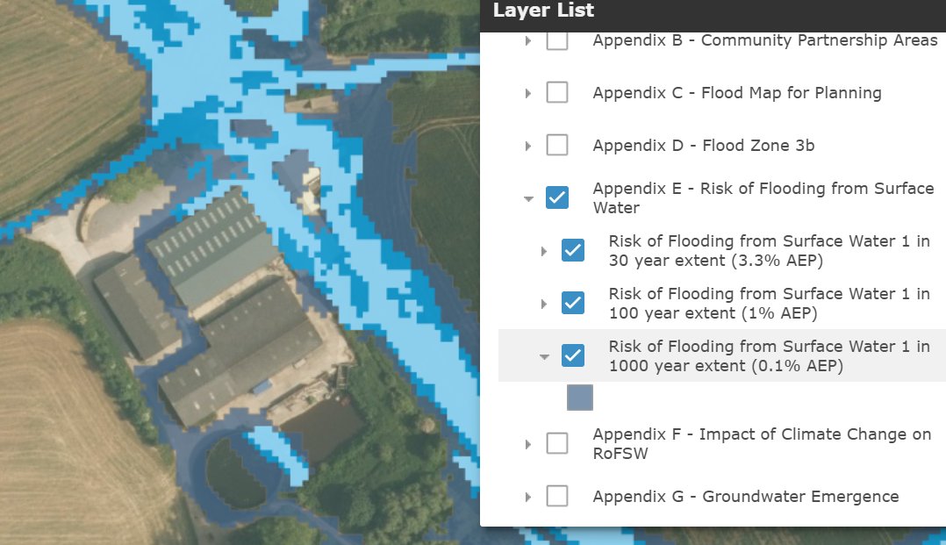
Surface water flooding details (Council GIS)

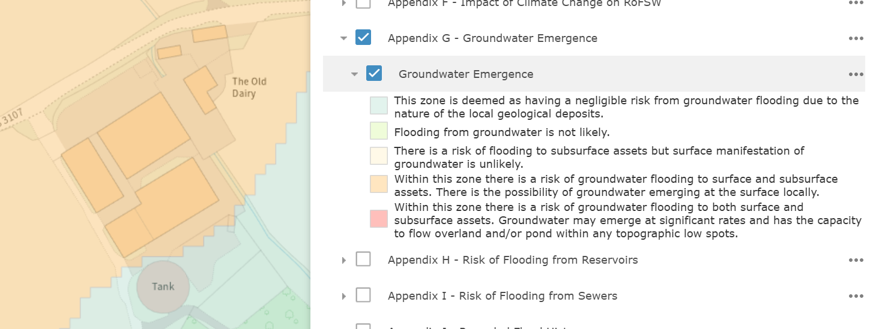
Ground water flooding details (Council GIS)

Based on the above, it is not considered that there is an unacceptable risk to future users of the building and as such it is considered the development complies with Core Policy 67 of the Wiltshire Core Strategy and with the NPPF in this regard.

Other issues

Third parties have raised the issue of anti-social behaviour in the form of cars being raced in the area. However, this issue has limited weight in the planning balance and is a matter for the Police.

CONCLUSION

Planning law requires that applications for planning permission must be determined in accordance with the development plan unless material considerations indicate otherwise. The introduction of national development plan policies in the revised NPPF do not change the legislative basis for decision-making, however these are relevant to the assessment of the proposal and to the weight to be attributed to development plan policies.

The proposed development is located in the countryside outside of any defined settlement, however it is in a relatively sustainable location having regard to the highway network and proximity to settlements for the nature of the use proposed. It would provide demonstrable economic benefits to the community in terms of supporting an existing business and providing employment in the local area. The café and events use would also attract some element of tourism/leisure use.

In terms of neutral impacts, officers are satisfied that the development would not harm the amenity of neighbouring residents, subject to conditions in respect of noise/amplified music. Sufficient off-road parking is available on site to accommodate the normal operation of the proposed use including events, subject to a condition in respect of traffic management, and the development is served by safe access to the road network. In addition, the scheme is served by existing drainage connections, and the change of use would cause no harm to local biodiversity interests, the character of the area or the openness of the Green Belt.

The proposal is therefore recommended for approval.

RECOMMENDATION: Approve subject to conditions

