

Habitats Reg Assessment for Reg 77 Application
  - Dunns House, St Pauls Road, SALISBURY, SP2 7BF

Report for: FTB Cubica Ltd
Version: 4.0
Date: 24 June 2026

Version History
Version | Date | Comments
1.0 | 20 Feb 26 | Draft to Client
2.0 | 20 Feb 26 | Final with update water consumption figures
3.0 | 20 May 26 | Layout change to remove 4x 3 bedroom flats and replace with 8 X 1 bedroom
4.0 | 24 Jun 26 | Amends following consultation with Natural England

Disclaimer
Copyright David Baxter Environmental Limited. All rights reserved. No part of this report may be copied or reproduced by any means without prior written permission from David Baxter Environmental Limited. If you have received this report in error, please destroy all copies in your possession or control and notify David Baxter Environmental Limited. This report has been prepared for the exclusive use of the Client and unless otherwise agreed in writing by David Baxter Environmental Limited, no other party may use, make use of or rely on the contents of the report. No liability is accepted by David Baxter Environmental Limited for any use of this report, other than for the purposes for which it was originally prepared and provided. Opinions and information provided in this report have been prepared by David Baxter Environmental Limited using due skill, care and diligence and no explicit warranty is provided as to their accuracy. The contents of this report are based upon the information available at the time. It should be noted, and it is expressly stated, that no independent verification of any of the documents or information supplied by the Client to David Baxter Environmental Limited has been made.
Contents
Executive Summary 1
Impacts 1
Mitigation Plans to include in an Appropriate Assessment 1
1 Background 2
1.1 Adverse effects of the development on nearby Habitats Sites 2
2 Nutrient Budgets for the Development 4
2.1 Development Proposal 4
2.2 Nutrient Budget Calculation Assumptions 4
2.3 Occupancy Rate Assumptions 4
2.4 Nutrient Budget Results 7
3 Mitigation Plans 7
4 Conclusion 8
Appendices 9
Appendix 1 Dunns House Nutrient Budget 9
Appendix 2 Dunns House Development Plans 9
Appendix 3 Natural England (NE) Regulation 76 Consultation Response 9
Appendix 4 Dunns House Occupancy Rate Calculation 9
Appendix 5 Wiltshire Ecological Mitigation Contributions Calculator 9
List of Figures
Figure 1 Site Location 2
Figure 2 Location of site (red pin) relative to Habitats Regs Designated Areas 3
Figure 3 Values used in nutrient budget calculator for Dunns House 4
Figure 4 Natural England’s Guidance on Deriving Robust Occupancy Figures 5
Figure 5 Census 2021 Data on Occupancy rates for 1 and 2 bedroom properties in Wiltshire 6
Figure 6 New Forest District Council occupancy rates by dwelling size 7
Figure 7 Average occupancy at Dunns House 7
Figure 8 Mitigation budget result 8

Executive Summary

Impacts
The proposal to convert office space into 48 dwellings at Dunns House, Salisbury SP2 7BE will impact the integrity of both the Hampshire Avon SAC and the New Forest SPA.
The development will lead to a net increase in the Total Phosphorus (TP) released to the Hampshire Avon Special Area of Conservation (SAC) nutrient neutrality catchment of 3.36 kg/yr until April 2030. Thereafter, Salisbury Wastewater Treatment Works will be upgraded. From April 2030, the net increase reduces to 0..84 kg/yr of TP entering the nutrient neutrality catchment.
These figures are derived from a nutrient budget calculation (Appendix 1) which uses the Government’s latest published version of the River Avon SAC Budget Calculator. The assumptions used to populate this spreadsheet are included in the report, the average occupancy rate of 1.87 persons per dwelling is derived from NE advice received via Regulation 76 consultation response.

Mitigation Plans to include in an Appropriate Assessment
Because of the location of the development within the 13.8km impact zone of the New Forest SPAs, together with the net increases in nutrient release within the Hampshire Avon SAC, an Appropriate Assessment for this development would be required.
For the LPA to conclude that there would be No Significant Adverse Effect on the River Avon SAC, the Regulation 77 application will be accompanied by:
- A unilateral undertaking to ensure that the flats are developed to standards that ensure water use of 85 litres per head per day is achieved
- evidence that mitigation of the nutrient budgets has been secured for the relevant periods through the purchase of 3.36kg of Phosphorus credits from Wiltshire Council’s Hampshire Avon SAC mitigation scheme.
For the LPA to conclude that there will be No Significant Adverse Effect on the New Forest SPA, the applicant will pay the required SAMM Fee of £660 per dwelling to Wiltshire Council for 48 dwellings, plus the 10% administration fee.

Background
This report has been prepared to assess the mitigation of Habitats Regulations impacts required for a Regulation 77 application in relation to a Planning Application (PL/2025/08099) that was made to Wiltshire Council to convert office space at Dunns House, Salisbury SP2 7BE into 44 dwellings. On 14 May 2026, a further change of use request (PL/2026/01936) approved an alteration to the original proposal for the four 3 bedroom flats (one on each floor) to eight 1-bedroom flats (2 on each floor), giving a total of 48 dwellings. Details attached in Appendix 2.

Adverse effects of the development on nearby Habitats Sites
Figure 1 shows the location of the proposed development (‘the Site’).
The Site is within the Hampshire Avon Operational Catchment. Planning permission to develop here is affected by the nutrient neutrality requirements of the Habitats Regulations. In this case these are applied to protect River Avon Special Area of Conservation (SAC), which requires that any additional releases of Phosphorus arising because of the development are mitigated within the catchment.
Figure 1 Site Location
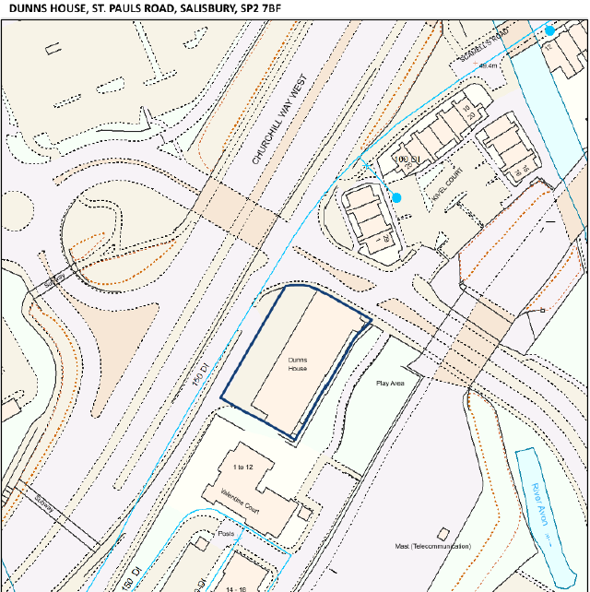
The site is also within the inner 13.8km zone of impact for the New Forest SPA. The Site is outside the Salisbury Plain SPA zone of impact. Figure 2, obtained from Wiltshire Planning Explorer on 15 May 2026, shows this,
Figure 2 Location of site (red pin) relative to Habitats Regs Designated Areas
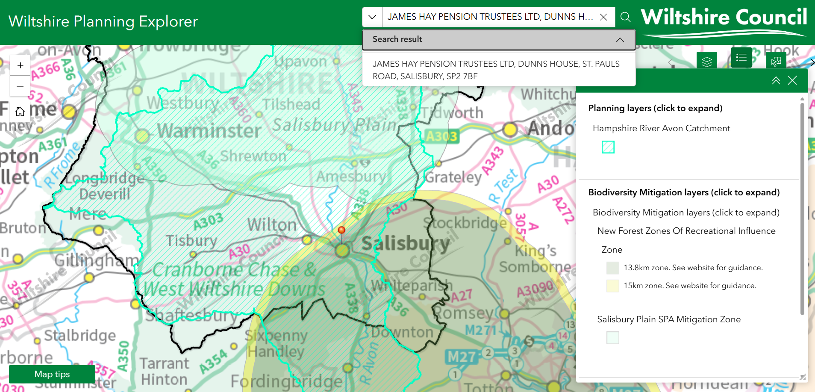
As such, a nutrient budget and mitigation plan will be required for the development, and the development must also contribute financially towards the Strategic Access Management and Monitoring (SAMM) for the New Forest, as set out in Wiltshire’s New Forest Mitigation Strategy that was adopted in 2024.

Nutrient Budgets for the Development

Development Proposal
Although the planning application involves the conversion of an existing building, the proposal leads to an increase in dwellings providing overnight accommodation and hence is subject to the nutrient neutrality requirements of the River Avon SAC. Details of the initial development plan for 44 dwellings and the planning officer’s report for the inclusion of 4 further dwelling units are attached at Appendix 2.

Nutrient Budget Calculation Assumptions
As of 19 May 2026, Wiltshire Council require the Government’s latest River Avon SAC Nutrient Neutrality Calculator to be used to calculate the Nutrient Budget of the new development. The values to be used for Dunns House are set out below in Figure 3.
Figure 3 Values used in nutrient budget calculator for Dunns House
Parameter | Value | Explanation
Date of First Occupancy | 01/09/2026 | A date in the future before April 2030 to ensure that credits required before upgrades to Salisbury Wastewater Treatment works are calculated.
Average Occupancy Rate | 1.87 | See note on occupancy rates below – this approach was ratified by NE in their Reg 76 consultation response (Appendix 3 and 4)
Water usage (litres/person/day) | 95 | Client’s architect has confirmed that detailed design will be able to include features that enable an 85 l/head/day level of water efficiency. A unilateral undertaking to ensure this will be included in the Reg 77 application. NE response under Reg 76 (Appendix 3) requested that an additional buffer of 10 l/h/d be added to the nutrient calculation
Development proposal (dwellings/units) | 48 | 4 x studio flats, 28 x 1-bed flats, 16 x 2-bed flats. As per prior notice approvals in Appendix 2, summarised in Figure 7.
Wastewater Treatment Works | Salisbury (Petersfinger) | As per sewer drainage information provided by Wessex Water.
Operational catchment | Hampshire Avon | The footprint and urban nature of the development do not change, hence changes in nutrient losses from changes in land use are not applicable. The current and future land use sections of the calculator are therefore not relevant to the budget calculation.
Soil drainage type | NA
Annual average rainfall band (mm) | NA
Within nitrate vulnerable zone (NVZ) | NA
Current Land use | NA
Future Land use | NA
SUDS | No SUDS assumed

Occupancy Rate Assumptions
The Office for National Statistics puts the average occupancy of Wiltshire dwellings at 2.4 people per home. However, there is considerable variation in the composition of different households within Wiltshire. For instance, Salisbury has the highest overall proportion of one-person households (34%) and the majority of the flats in proposed the development at Dunns House are for 1 bedroom only. Hence the assumption of 2.4 occupants per dwelling in each flat at Dunns House will be incorrect.
The 2021 Census Data gives a detailed breakdown of occupancy rates by Local Authority according to the number of bedrooms in dwelling. The data for Wiltshire is filtered and shown in Figure 5. This shows that average occupancy of 1 bedroom properties in Wiltshire is 1.23 people and average occupancy of two bedroom properties is 1.83.
However, Natural England’s response under a Regulation 76 consultation (Appendix 3) advised that a lower occupancy rate should only be used for 1 bedroom units and that this figure should be assumed to be 1.6; for other units a standard occupancy of 2,4 should be used. We have followed this advice and therefore note that, because of our evidence of lower occupancy rates, this is a precautionary approach.
Figure 4 Census 2021 Data on Occupancy rates for 1 and 2 bedroom properties in Wiltshire
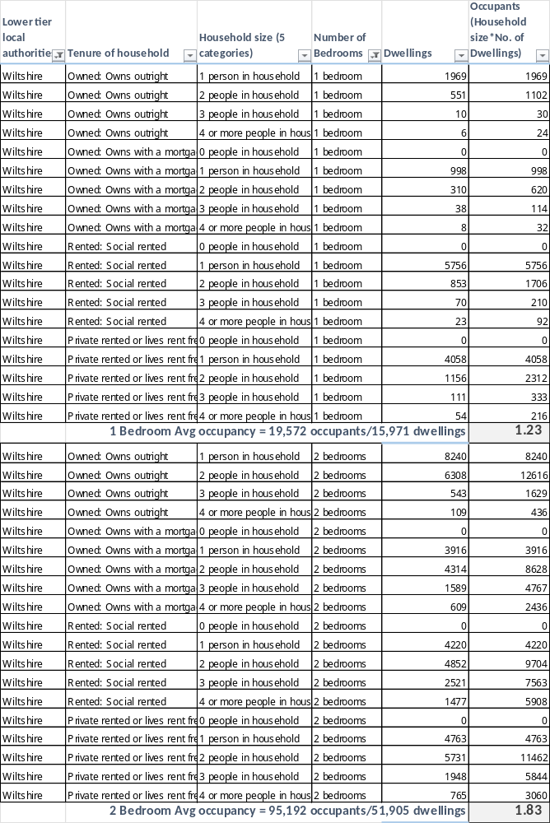
For developments comprising multiple different sized dwelling units (as at Dunns House) we need to calculate an average occupancy across all the dwellings. A completed calculation for Dunns House is attached at Appendix 4, summarised in Figure 5.
Figure 5 Average occupancy at Dunns House
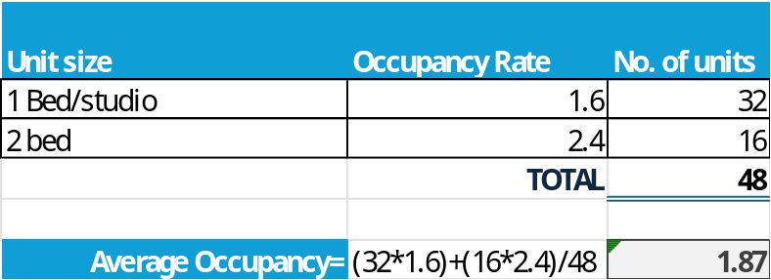

Nutrient Budget Results
Appendix 1 contains the complete nutrient calculator spreadsheet using the assumptions detailed in Figure 5. These are summarised in Figure 6.
Figure 6 Mitigation budget result
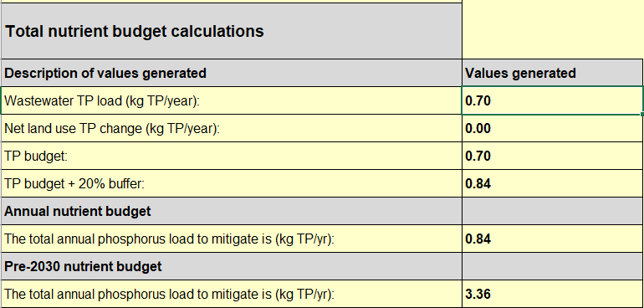

Mitigation Plans
Wiltshire Council offers a nutrient neutrality scheme for the River Avon SAC catchment, charging £42,500 per kg of total phosphorus, plus a 5% administration fee. Certain criteria must be met to be eligible to buy these credits, but it seems likely that these criteria are met. Hence, nutrient mitigation will be achieved by purchasing 3.36kg of Phosphorus credits from Wiltshire Council. Additionally, a unilateral undertaking will be created to ensure that the flats are designed to ensure that water use of 85 litres per head per day is ensured.
Similarly, mitigation for the recreational disturbance impacts of the development on the New Forest SPAs will be achieved by paying the required fee of £660 per dwelling (48 dwellings) plus 10% administration fee.
Details of the planned payments are attached as Appendix 4.

Conclusion
An Appropriate Assessment of the proposal to convert office space into 48 dwellings at Dunns House, Salisbury SP2 7BF can assume No Significant Adverse Effect on either the Hampshire Avon SAC or New Forest SPA , provided the mitigation plans are enacted and secured against the development.

Appendices

Appendix 1 Dunns House Nutrient Budget
The full budget calculator with NE required assumptions is attached below.
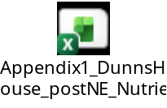

Appendix 2 Dunns House Development Plans
Original plans for 44 dwellings given prior approval PL/2025/08099.

Officer report for additional 4 dwelling as per PL/2026/01936


Appendix 3 Natural England (NE) Regulation 76 Consultation Response
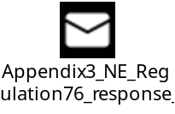

Appendix 4 Dunns House Occupancy Rate Calculation
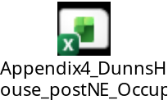

Appendix 5 Wiltshire Ecological Mitigation Contributions Calculator

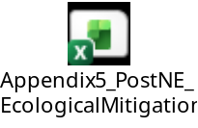

https://experience.arcgis.com/experience/88c3030c2e864645aaec7dc3e0ac4cb6/page/Page
https://www.wiltshire.gov.uk/planning-bio-development
https://www.gov.uk/government/publications/river-avon-sac-nutrient-neutrality-calculator
https://www.wiltshireintelligence.org.uk/cajsna/housing/
https://www.wiltshire.gov.uk/article/6209/Phosphorus-and-nitrogen-mitigation

