APPLICATION FOR PRIOR NOTIFICATION - AGRICULTURAL
CASE OFFICER REPORT

APPLICATION REFERENCE: | PL/2026/04608
APPLICATION TYPE: | Prior notification: Building
SITE ADDRESS: | Merkins Farm, Bradford Leigh, Bradford On Avon, BA15 2RW
DEVELOPMENT DESCRIPTION: | New agricultural barn (steel frame clad in timber with low level brick base)
RECOMMENDATION: | Prior Approval Required

SITE DESCRIPTION/CONTEXT
The proposal site is stated to be within an agricultural unit of 7.63ha, which has been in agricultural use for over 23 years.

Merkins Farm has diversified since the caravan site closed in 2021, to include a Farm Café, the Farm House and 4 other tax point addresses, for holiday and rental cottages.
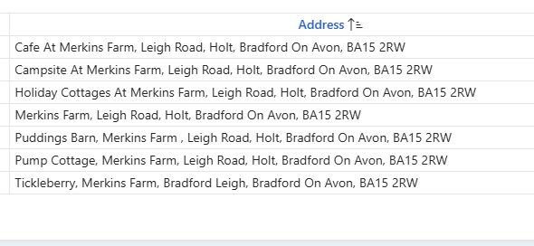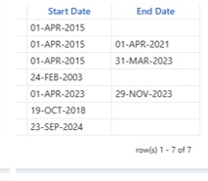

The Merkins Farm Café started in 2011; retrospective planning permission being approved in 2017 (17/11606/FUL). The café is a converted steel portal framed agricultural building.

The café relies on a close connection to the three fields; maximising views, with mown private footpaths for customers, a shepherds hut and outdoor shed seating.

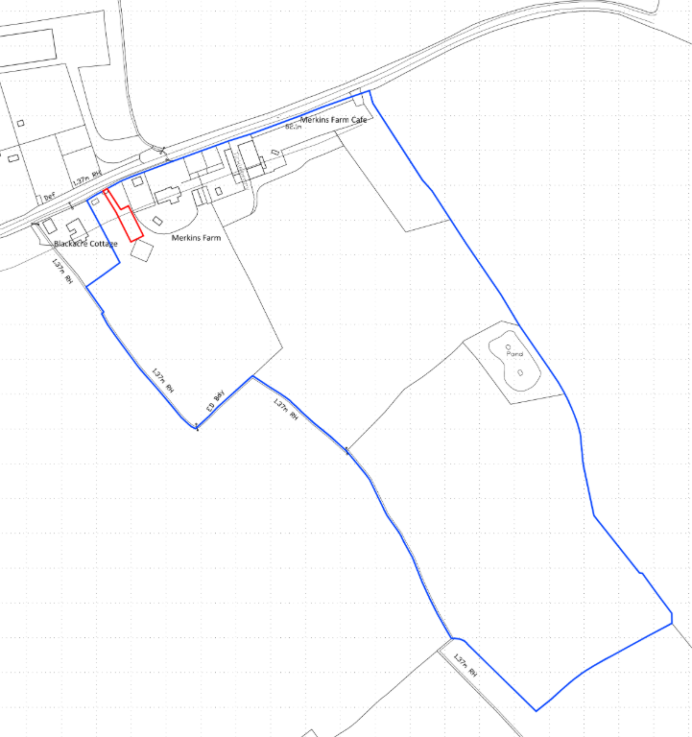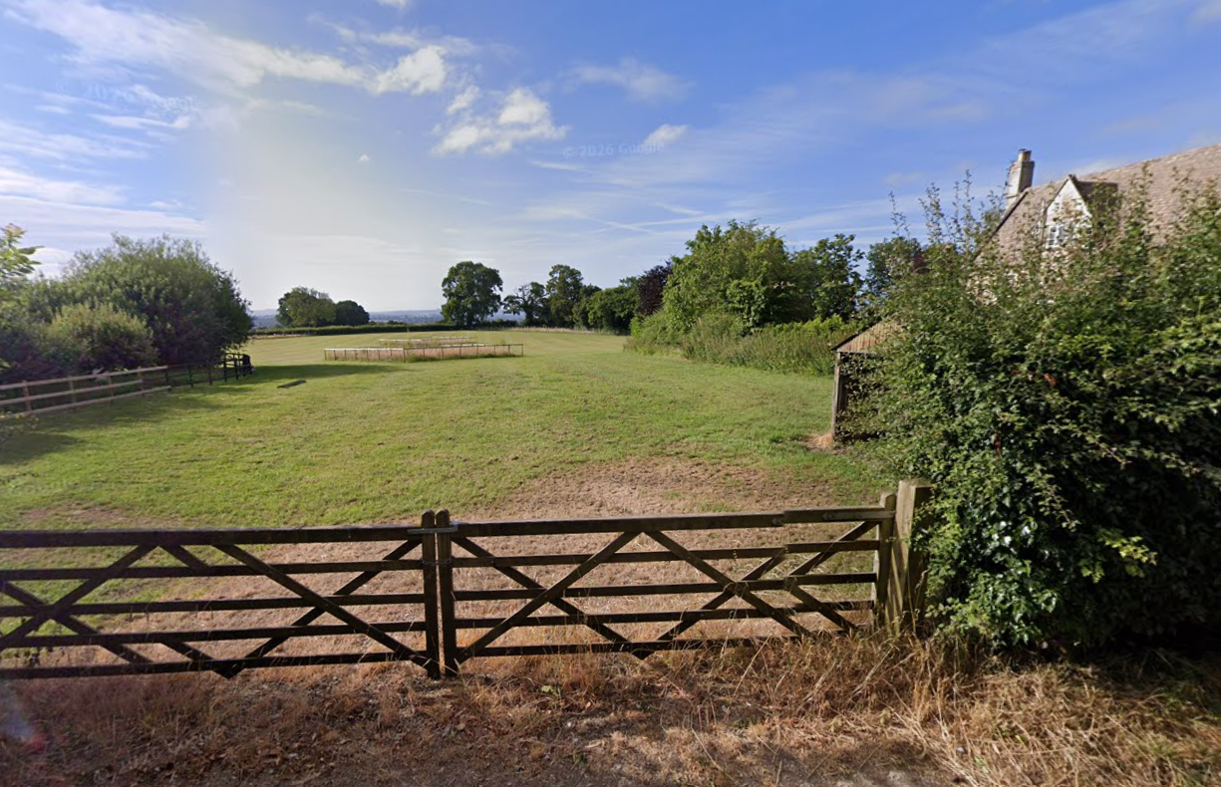
Location Plan and Google Earth Site Photo of Proposal Site from Highway

The site comprises 3 fields; the north-western one, which includes the red line site plan for the proposed barn, is 1.3ha, and stated to be tenanted/grazed, with a small copse to the south which includes a treehouse. The other two fields (northeast and southeast) are in arable use and stretch south from the farm café car park past a pond and copse.

The site is within West Wiltshire Green Belt.

As the various historic maps show below, the first agricultural building appeared in the 3rd epoch, with the farmhouse and proliferation of barns appearing 5th epoch, such that all can be considered modern.

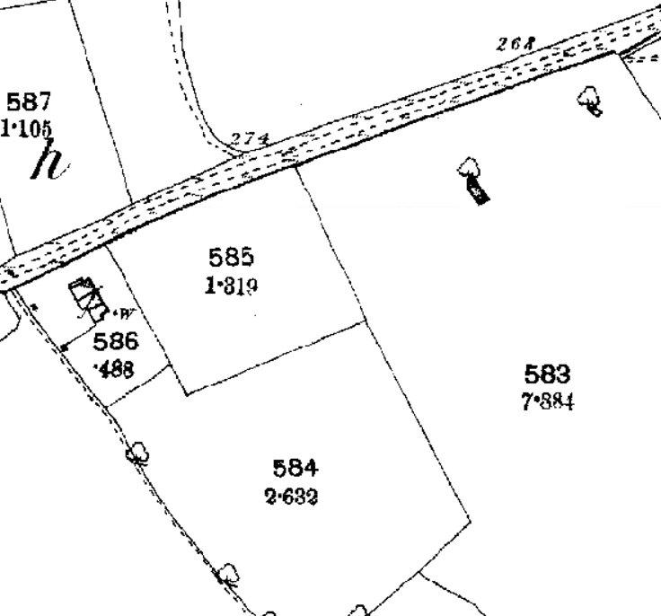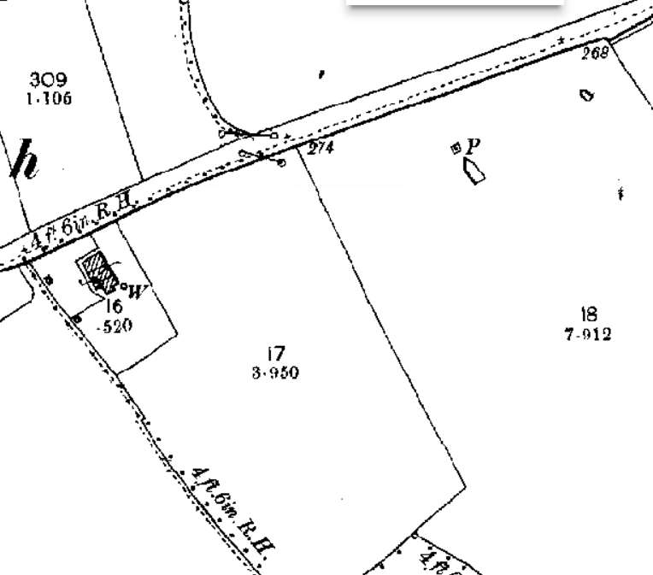
1st and 2nd epoch mapping
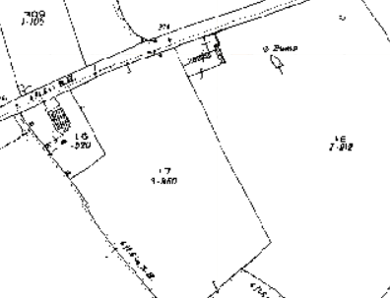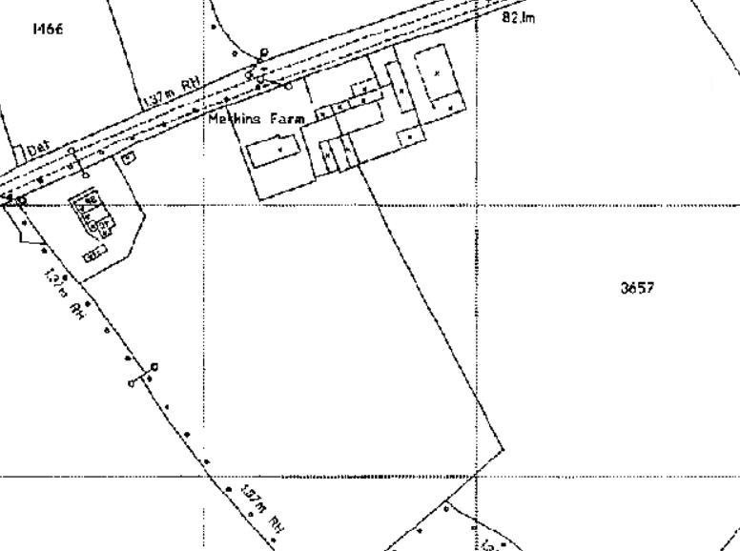
3rd and 5th epoch mapping

1st epoch mapping (1868-1899) shows nearest neighbour Blackacre Cottage, was once three cottages, and which is considered a NDHA, despite subsequent works. This cottage faces Merkins Farm and is included at the edge of the historic settlement of Bradford Leigh, which retains its historic form and character of a loose scatter of housing and farms. GII, early C19 no.102 Bradford Leight is the next building approx. 200m to the west.

Merkins Farm to the east, and the holiday cottages, which were a residential conversions of agricultural barns, are all C20, and so modern in character.

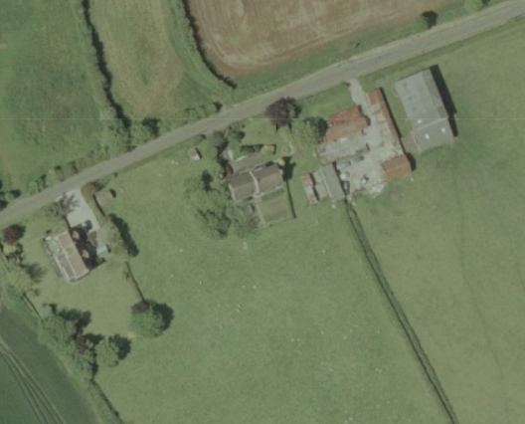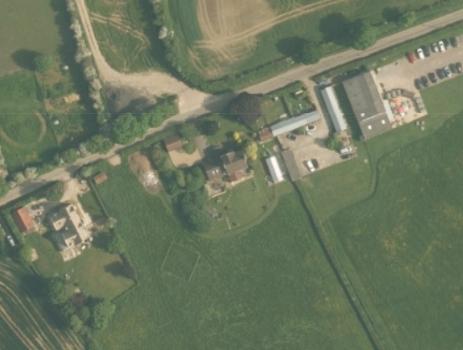
Aerial mapping of 2002 and 2020 show the number of changes across the site.

The proposal site is over 25m (28m) from a metalled road, 30m from Blackacre Cottage, and 25m from Merkins Farmhouse.

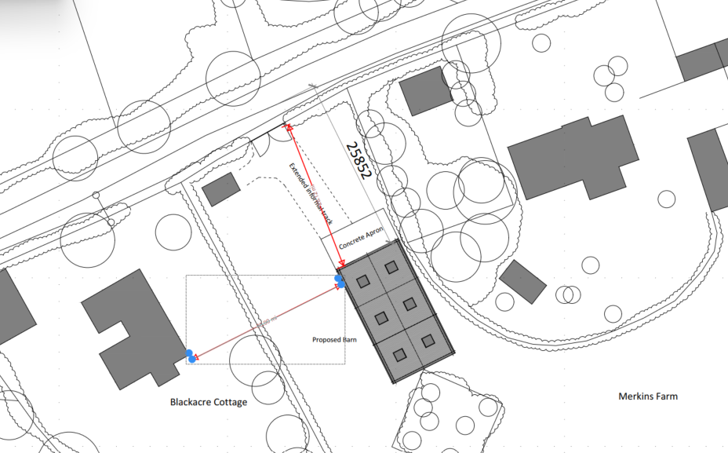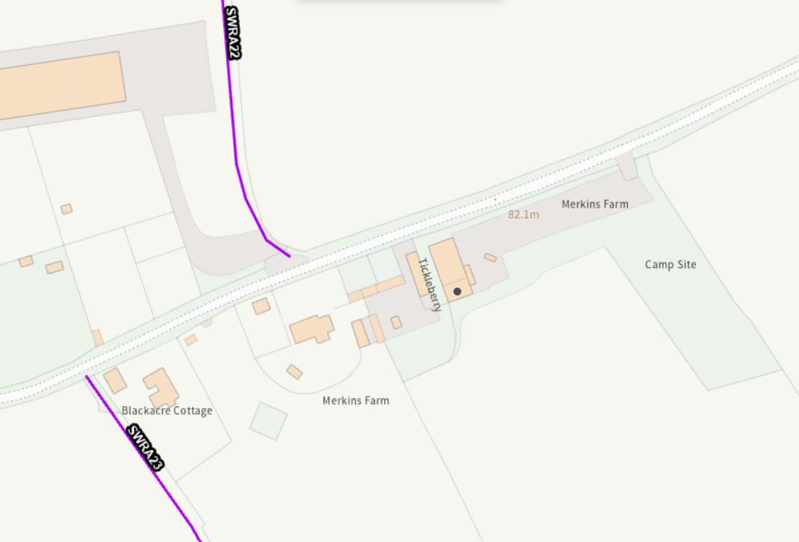

Public Right of Way SWRA22 terminates north of the farmhouse/highway and SWRA23 runs south from Blackacre Cottage to Holt, as it links to Holt34 affording views of the proposal site.

PROPOSAL
The proposal is for a steel-framed agricultural building for the storage of agricultural machinery, and hay. This is the second PN application on this site in 2026.

The proposed building would be 18.85m long, 9.7m wide (182.8m²), 3.6m to eaves, 5.7m to ridge.

Proposed materials include a red brick plinth, vertical, black stained timber cladding, black rainwater goods, and brown, profiled cementitious roof sheeting.

The proposed building would include 6 rooflights, one personnel door facing east (towards Merkins Farmhouse), and a single vehicle access door facing north to the highway.

It is noted that this application does not include details of an access track.

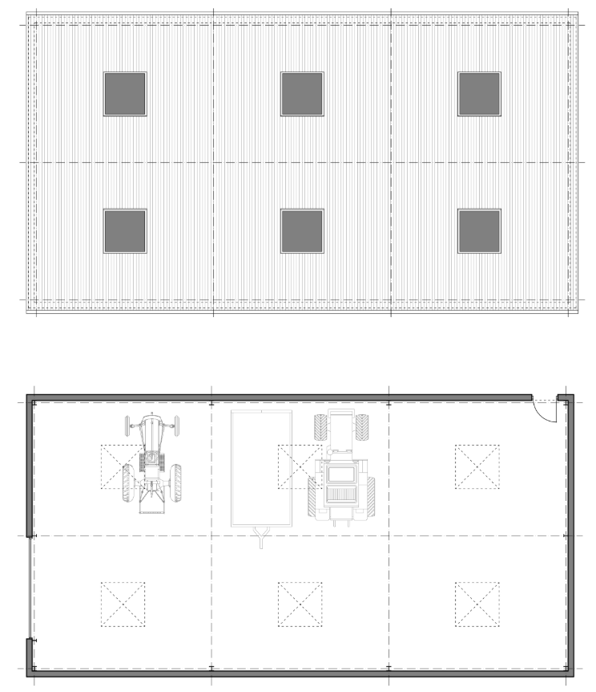
Proposed Roof and Ground Floor Plan

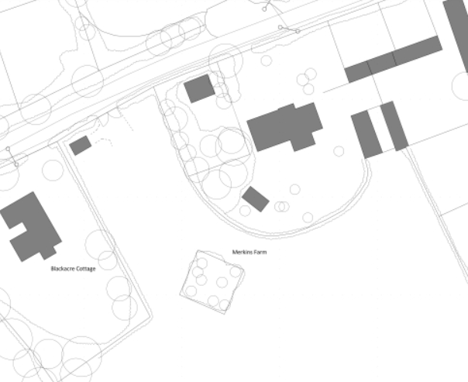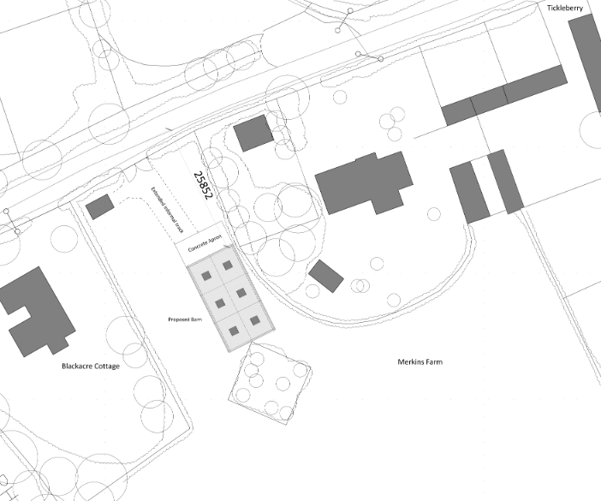
Existing and Proposed Block Plans

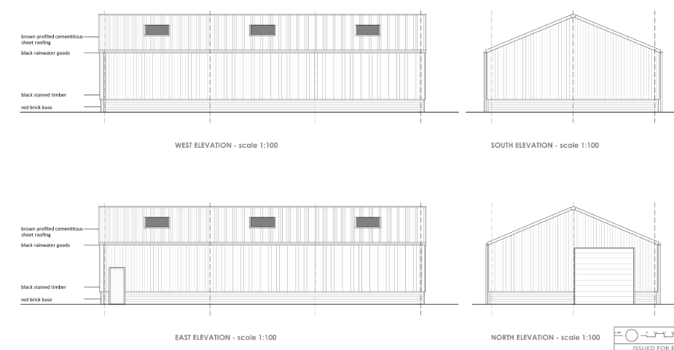
Proposed Elevations

RELEVANT PLANNING HISTORY
W/04/02032/FUL - Full planning permission Decision - Approve with Conditions Date: 8/12/2004 – Proposed replacements front roof and proposed porch – Merkins Farm House
W/04/02314/FUL - Full planning permission Decision - Approve with Conditions Date: 14/2/2005 – Change of use and associated conversion works to develop two agricultural storage barns into 3 holiday units – Barns at Merkins Farm
17/11606/FUL - Retrospective change of use from a redundant agricultural building to a cafe (A3) – approve with conditions – Merkins Café
PL/2026/03122 – Steel framed agricultural building – refused – same site

It is noted that the planning history of other locally approved barns under PN are not relevant here, as appropriate to each site, its constraints, any immediate residential buildings and clear justification/reasonable necessity of the farming unit.

Planning history of a site is not relevant for Prior Notification application (beyond exemption criteria), but local concerns highlighted and questioned the planning history, including the approved conversion of various barns stated to be redundant to the farming business, and unregularised extensions.

As such, it is necessary to state that any concerns regarding the various development on site can be clarified by requesting an enforcement check of the site. It is noted that the agent confirmed poor relations with the wider community such that it must be confirmed that these concerns are not relevant to this application.

RELEVANT LEGISLATION, POLICY AND GUIDANCE
This application is assessed under Article 3 of the Town and Country Planning (General Permitted Development) (England) Order 2015 (as amended), which grants planning permission for certain types of development described in Schedule 2 of the Order. The grant of permission is subject to the limitations, conditions, and provisions set out within the relevant Classes of permitted development.

Under Schedule 2, Part 6, Class A of the Town and Country Planning (General Permitted Development) (England) Order 2015 (as amended), certain types of agricultural development may be permitted, including:

- The erection, extension, or alteration of a building;
- The formation or alteration of a private way;
- Excavations or the deposit of waste material
- The placing or assembly of a tank in any waters.

Where such development is proposed, the developer is required to apply to the local planning authority for a determination as to whether prior approval is needed. This prior approval process is limited in scope and relates only to the following matters:

- The siting, design, and external appearance of the building;
- The siting and means of construction of the private way;
- The siting of the excavation or deposit;
- The siting and appearance of the tank.

The development would consist of the erection of an agricultural building on an established agricultural unit where development under Class Q or Class S of Part 3 (changes of use) has been carried out within the last 10 years, but not the last 2 years – 17/11606/FUL and W/04/02314/FUL.

ASSESSMENT

Principle of Development:
Part 6 of the GDPO: Agricultural and forestry, Class A – agricultural development on units of 5 ha or more, states in part A, that Permitted Development, includes:

“The carrying out on agricultural land comprised in an agricultural unit of 5 hectares or more

(a) works for the erection, extension, or alteration of a building; or
(b) any excavation or engineering operations,

which are reasonably necessary for the purposes of agriculture within that unit.”

The application form confirms that the proposal site is an agricultural unit over 5ha. As such, it has been clarified that PD rights under Part 6, Class A, of the GDPO are relevant to this application.

The GDPO states under Interpretation of Classes A-C, D.1 – (1) For the purposes of Classes A, B and C – “’agricultural land’ means land which, before development permitted by this Part is carried out, is land in use for agriculture and which is so used for the purposes of a trade or business and excludes any dwellinghouse or garden;” with “’agricultural unit’ means agricultural land which is occupied as a unit of the purposes of agriculture.”

No Class Q or S development has taken place within the last 2 years, and the scheme does not relate to a dwelling.

Therefore, being an agricultural unit of more than 5ha, Schedule 2, Part 6, Class A, of the Town and Country Planning (General Permitted Development) (England) Order, applies.

Reasonable Necessity:
The agricultural unit for this application is stated to be 7.63ha.

The application does state that off-site storage of crop/fodder is no longer practical and this raises questions as the stated unit is 7.63ha.

The application states the three fields are perennial cropping grassland/grazing and an annual arable crop. The proposed barn would be located directly between dwellings, and not at a location best suited to machinery and crop storage, nor of a design or location for feeding livestock. The proposal does not include details of tracks from the highway or within the site to the cultivated land.

The application states that the agricultural unit is physically segregated and functionally independent from the farm cafe, but the website and site visits show a reliance on the land for setting, customer use and access. The entire site is connected to Merkins Farm Café, a very successful farm café, with holiday accommodation; not primarily an agricultural use, at best mixed use/sui generis, which could be confirmed if under a single business identifier (not included in land registry map).

There is conflicting information from third parties, officer’s site visits and the application. The application states the southwest field is used for grazing, with 3 dated google earth images and a statement from a tenant farmer that he keeps cows and sheep onsite.

Wiltshire Council’s own aerial mapping, although incomplete, includes only one image of a herd of 6 cows in the last 20 years, in 2008, see below. Third party comments and photos show an area of land regularly mown, with a treehouse, benches and mown footpaths. The application does not sufficiently demonstrate the use of this land.

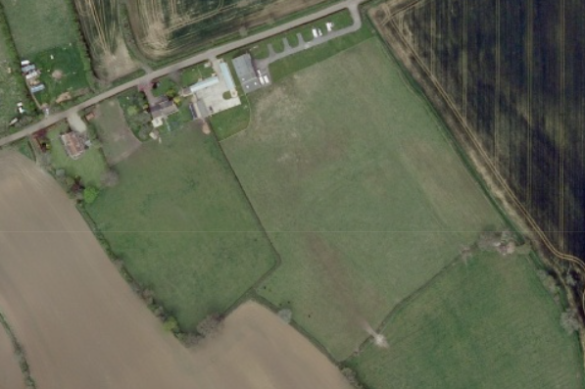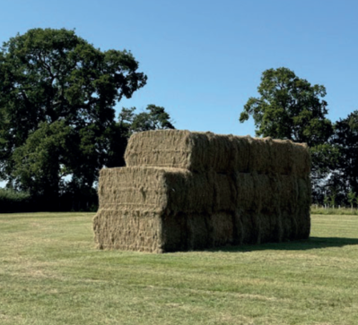

The application includes a land registry map of the holding to show Rural Farm Payments eligibility. Evidence of inclusion in this legacy land-area subsidy, but not registration with the replacement sustainable land management incentives raises concerns.

There is no submitted evidence of payments be that Rural Farm Payments or from the tenant farmer, or indeed farm accounts, to demonstrate that the agricultural unit is wholly separate from the farm café as is stated.

Despite the tenant’s letter, justification would have been better served by business accounts of the farming unit alone, not redundant FPS eligibility.

A submitted photo of this year’s hay harvest, included above, shows a single crop of only 20 bales, which does not justify a building of the proposed size.

The application states the agricultural unit has been in constant use since the current owners purchased it 23 years ago. Various barns on site have been converted for residential or commercial use over the last 10 years, each application reliant on these barns being redundant, the unit apparently not requiring a barn for storage of crop or machinery, such that a barn is not required for the business to remain viable and there is no submitted evidence of further farm diversification or land increase for a new functional need.

So whilst additional information could be sought to confirm reasonable necessity on the grounds that this is an active agricultural unit, that requires a barn of this size, be that directly from the applicant or via a Rural Consultant consultation, this has not been sought in light of the larger concern and reason for refusal, of siting, and impact on neighbouring amenity.

Wiltshire has policies specifically to support rural businesses, namely CP48 and CP49. Merkins Farm Café is a successful café and holiday letting business. In considering the whole planning unit, which would be mixed use incorporating the commercial and agricultural uses, a proactive way forward would be a pre-application enquiry to holistically consider the whole site.

Paragraph 1 of GB6 ‘control of development in the Green Belt,’ states that ‘development in the Green Belt is inappropriate unless it falls within one of the categories in policy GB,’ in this case the exception is for agriculture. The site is within Green Belt, and does meet this exception, such that any future application may be policy compliant.

This would enable a wider consideration of the requirements and opportunities for development, ensure support of a rural enterprise whilst managing siting and visual, landscape, greenbelt and neighbouring amenity impacts.

Eligibility:
The proposal is eligible for consideration under Class A provided it meets the limitations and restrictions set out therein. The proposal must therefore also meet criteria a-k, under Class A of Part 6 of the GDPO.

Criteria (i) states development is not permitted under Part A if:

‘it would consist of, or include, the erection or construction of, or the carrying out of any works to, a building, structure or an excavation used or to be used for the accommodation of livestock or for the storage of slurry or sewage sludge where the building, structure or excavation is, or would be, within 400 metres of the curtilage of a protected building;’

The proposal site is within 30m of two residential dwellings, one however the farm dwelling within the agricultural unit. The proposals are for the storage of crop and machinery only.

For avoidance of doubt, therefore all criteria have been satisfied.

The siting, design, and external appearance of the building
The proposed barn would be located within West Wiltshire Green Belt and is close proximity to a NDHA, further listed building, and 30m/25m to two residential dwellings, and as such the siting, design and external appearance must be assessed.

The site is 28m from a public highway, such that a barn of this scale would have a clear visual impact on the sense of openness of the Green Belt, from the highway vantage point, but also from the nearby PROW, users of the café (the website highlights a 180º panoramic view) and from across the verdant valley, as demonstrated by site photos below.

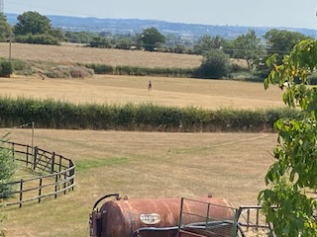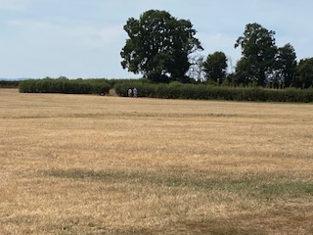
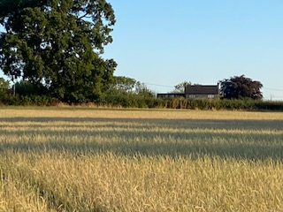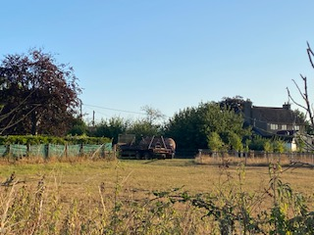

The proposed barn is stated to be infill between two dwellings. As historic maps and aerial maps show above, the proposed barn would consolidate further the various C20 modern farmhouse and diversified farm buildings, linking them to the historic dwelling Blackacre Cottage and further historic buildings, creating a dense line of buildings along the highway, elongating the farm and altering the historic scattering of dwellings/farms.

At the proposed scale and siting, the proposed barn would not integrate within the wider landscape character or landform and is considered obtrusive and conspicuous atop the hill, blocking a view through to the verdant landscape.

Private views would be impacted but are not relevant to GDPO. The proximity of the proposed barn to Blackacre Cottage, and Merkins Farm, and its proposed operations, would have a direct, negative impact upon neighbouring amenity and privacy. Despite Merkins Farm being within the farm unit, it is essential to assess impact on amenity in case it is sold in the future.

Whilst a red brick plinth is unusual and costly for an agricultural building, with ramifications for ventilation and crop storage, the proposed materials are considered appropriate to the rural setting. The proposed building is considered to be a standard agricultural building in scale and form.

The design of the barn is questioned with only a single access door facing the highway, which would restrict all access to be from the highway, or create a pinch-point beside Blackacre Cottage, such that crop storage, removal of machinery, or removal of crop for feeding, would be compromised, as would neighbouring amenity.

It is appreciated that the proposed orientation, does optimise the minimal distance of 30m to the neighbouring Blackacre Cottage.

The proposed barn is larger in all dimensions from previously refused 2026 PN application PL/2026/03122. This application does not address the concerns raised by that refusal. Of greatest concern is the siting, design and external appearance, in close proximity to two residential budlings.

If evidence were submitted to sufficiently demonstrate justified need, there are much better locations for a barn that would not impact neighbouring amenity and enable a better functional connection to the land it would serve. The application fails to state why other sites were not considered but is on a proposal site previously refused on grounds of amenity and visual impacts.

It is noted that given the various copses, the pond and high hedging, such as that surrounding the unregularised shepherd’s hut, there are numerous other locations, better placed for farming activity, utilising the established access, which is wide enough for a tractor/trailer to turn into, with existing hard landscaping, raising the narrative of farming for the café, working with the landform and natural features, to sit well within the landscape, so as not dominating or impacting the sense of openness or neighbouring amenity.

CONCLUSION
The proposed development has been assessed against the provisions, limitations, and conditions set out in Schedule 2, Part 6, Class A of the Town and Country Planning (General Permitted Development) (England) Order 2015 (as amended). Based on the submitted plans, supporting documentation, and the findings of this report, it is concluded that the proposal does comply with the criteria for permitted development and therefore falls within the scope of Class A.

Having considered the relevant matters, it is further concluded that the proposal fails to demonstrate that the development would be acceptable in terms of its siting, design, or external appearance.

RECOMMENDATION:
That prior approval be REFUSED.

A
APPENDIX 1 – PERMITTED DEVELOPMENT CHECKLIST
 | Permitted Development | Yes / No
A | Does the proposal involve the carrying out, on agricultural land forming part of an agricultural unit of 5 hectares or more, of either:  (a) works for the erection, extension, or alteration of a building; or  (b) any excavation or engineering operations,  which are reasonably necessary for the purposes of agriculture within that unit? | Reasonable necessity not demonstrated
Criteria (A.1) – Development not permitted by Class A:
(a) | Is the development proposed to be carried out on a separate parcel of land forming part of the agricultural unit that is less than 1 hectare in area? | Yes
(b) | Would the development consist of the erection or extension of any agricultural building on an established agricultural unit where development under Class Q or Class S of Part 3 (changes of use) has been carried out within the last 10 years? | Yes
(c) | Would the development consist of, or include, the erection, extension, or alteration of a dwelling? | No
(d) | Would it involve the provision of a building, structure or works not designed for agricultural purposes? | No
(e)(i) | Would the ground area covered by any works or structures (excluding fences) for accommodating livestock or plant/machinery arising from engineering operations exceed 1,000 square metres? | No
(e)(ii) | Would the ground area of any building erected, extended, or altered under Class A exceed 1,500 square metres? | No
(f) | Is any part of the proposed building, structure, or works within 3 kilometres of the perimeter of an aerodrome and would exceed 3 metres in height? | No
(g) | Is any part of the proposed building, structure, or works not within 3 kilometres of an aerodrome and would exceed 12 metres in height? | No
(h) | Would any part of the development be within 25 metres of a metalled part of a trunk road or classified road? | No
(i) | Would the development consist of, or include, the erection or construction of, or works to, a building, structure, or excavation used or intended for the accommodation of livestock or storage of slurry/sewage sludge, and be within 400 metres of the curtilage of a protected building? | No
(j) | Would the development involve excavations or engineering operations on or over article 2(4) land that are connected with fish farming? | No
(k)(i) | Would any building for storing fuel for or waste from a biomass boiler or anaerobic digestion system be used for storing waste not produced by that system or fuel not produced on land within the unit and be within 400 metres of the curtilage of a protected building? | No
(k)(ii) | Would any building for storing fuel for or waste from a biomass boiler or anaerobic digestion system and be within 400 metres of the curtilage of a protected building? | No
(l) | Would the erection or extension of a building be carried out on land or a building that is, or is within the curtilage of, a scheduled monument? | No

