APPLICATION FOR HOUSEHOLDER PLANNING PERMISSION
DELEGATED REPORT

APPLICATION REFERENCE: | PL/2026/03522 and PL/2026/03840
APPLICATION TYPE: | Householder planning permission and Listed Building Consent
SITE ADDRESS: | Hawthorn Cottage, Mildenhall, Marlborough, SN8 2LP
DEVELOPMENT DESCRIPTION: | Removal of a garden room, tile hanging to replace white painted timber boarding, new garden walling and provision of a lean-to to greenhouse (Retrospective)
RECOMMENDATION: | That Planning Permission be GRANTED

This is a joint report for PL/2026/03522 (HPP) and PL/2026/03840 (LBC). Each considers different legislation, guidance and policy.

SITE DESCRIPTION/CONTEXT
The subject building is a GII listed, mid C18, 2-storey dwelling, with cellar, built in brick under a tiled roof, once symmetrical evidencing internal layout alterations. The property benefits from a large rear garden which includes a kitchen garden area to the southeast of the property, and a single storey flat-roofed extension that stretches to the side/west of the property and is hidden from the streetscape by landscaping as seen by the site photo below.

The property is central to the historic core of Mildenhall as it clusters around the Church and main through highway and lies within Mildenhall’s Conservation Area.

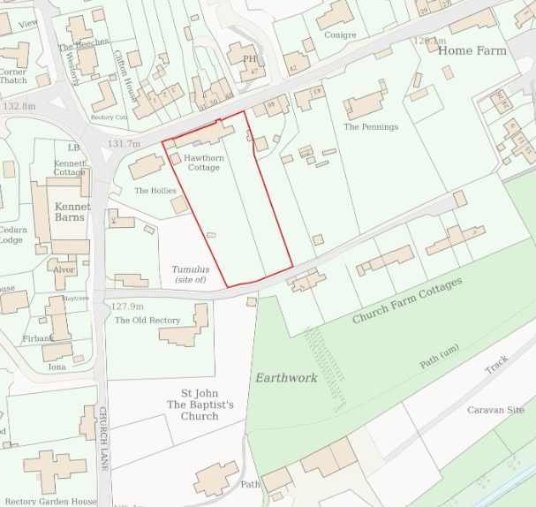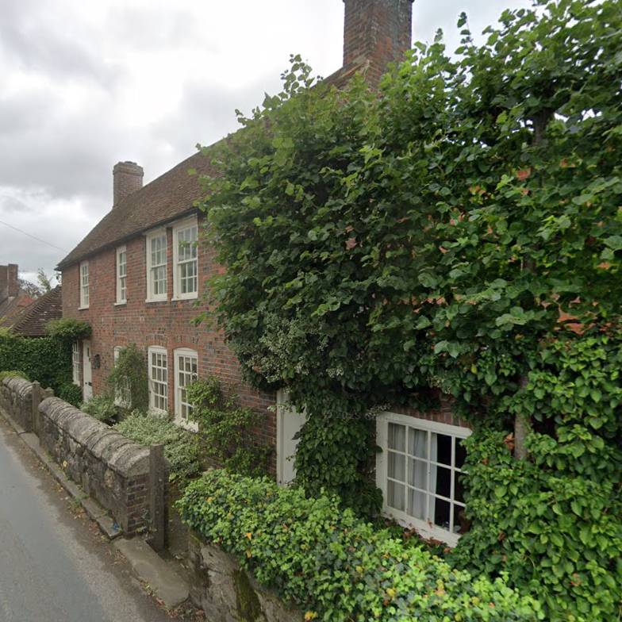

Location Plan and Google Earth Site Photo

The application site is subject to the following planning policy constraints:
- North Wessex Downs National Landscape (formerly AONB)
- Flood zone 1 of lowest risk, with increased risk of groundwater flooding (25%<50%).

PROPOSAL

The proposal seeks planning permission for retrospective works completed between 1990-1992:
- Removal of a C20 garden room
- Insertion of tile hanging to replace painted timber boarding on a C20 extension
- New garden walling
- Erection of a lean-to greenhouse

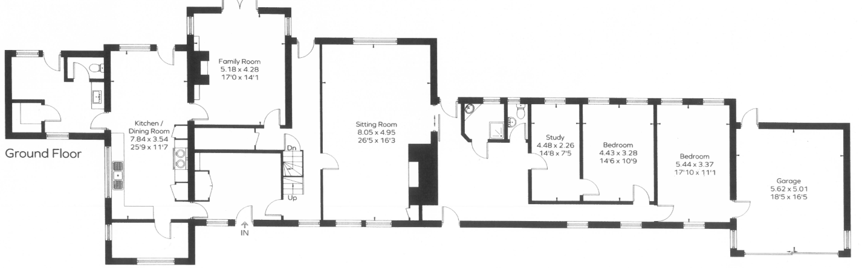

Ground Floor Plan

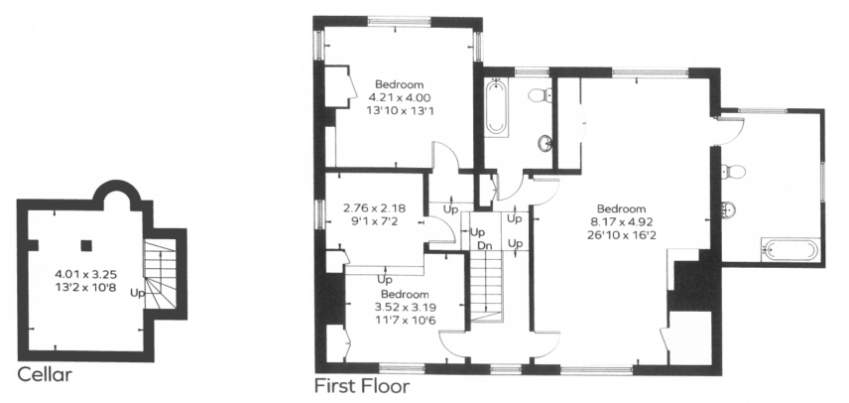

First Floor Plan

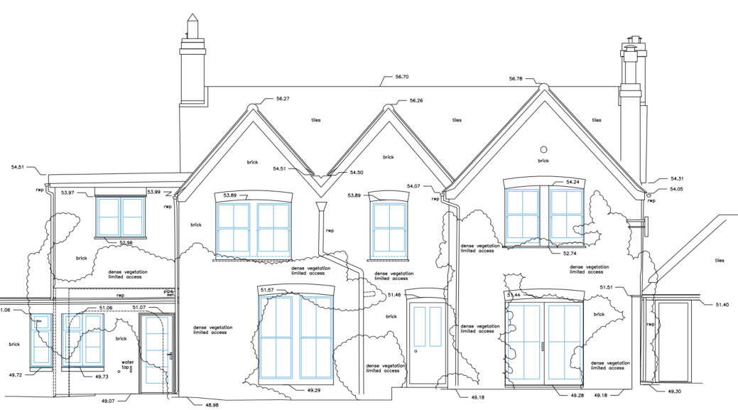

Rear Elevation

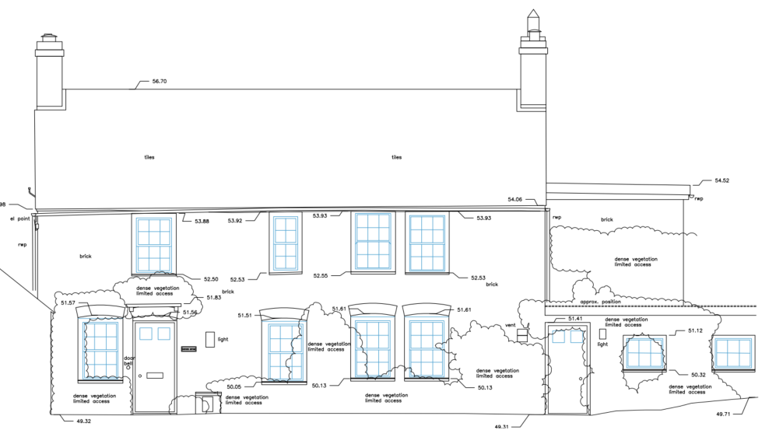

Front Elevation

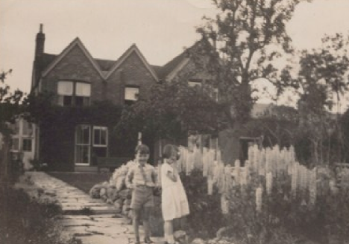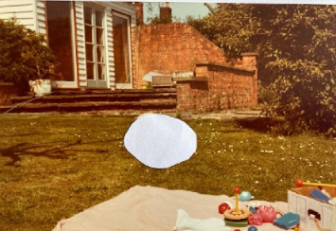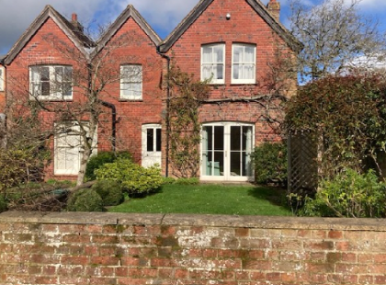

Site photos from 1938, 1980s (showing garden room) and existing rear elevations

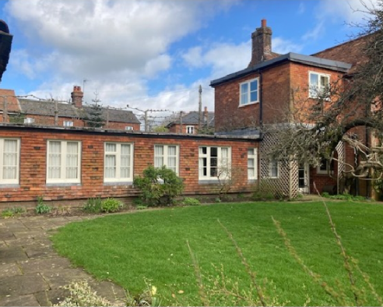

Tile hanging on modern side extension

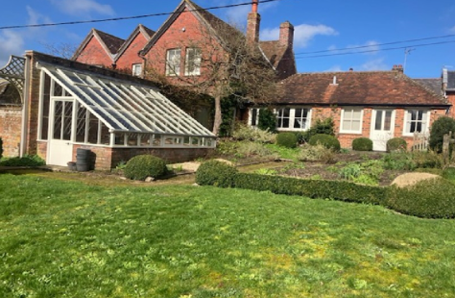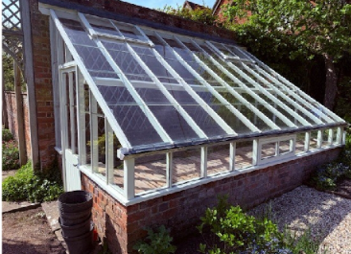

Extended garden wall and lean-to greenhouse

PLANNING HISTORY
K/57565/LBC - Listed building consent Decision - Approve with Conditions Date: 14/12/2007 – Renovate timber framed building. Remove existing box hedge on front elevation to roadside and extend existing wall
K/57567/F - Full planning permission Decision - Approve with Conditions Date: 14/12/2007 – Renovation of timber framed outbuilding and extension of front boundary wall
K/83/0740 - Full planning permission Decision - Approve with Conditions Date: 25/10/1983 – Extension

RELEVANT POLICIES AND GUIDANCE
The National Planning Policy Framework (NPPF)
The Planning Practice Guidance
National Design Guide
Wiltshire Design Guide: Appendix D – Design Guidance for Householder extensions

The Planning (Listed Building and Conservation Area) Act 1990,
Sections 16 and 66: Listed Buildings
Section 72: Conservation

Wiltshire Core Strategy:
- Core Policy 51: Landscape
- Core Policy 57 Ensuring High-Quality Design and Place Shaping
- Core Policy 58: Ensuring the Conservation of the Historic Environment
- Core Policy 67: Flood Risk

Mildenhall Neighbourhood Plan, made 2023.

CONSULTATION RESPONSES
Mildenhall Parish Council: no response.
Archaeology: submitted a ‘no comment.’
Conservation: No objection.

REPRESENTATIONS
No comments were received.

ASSESSMENT
Section 38(6) of the Planning and Compulsory Purchase Act 2004 states:

"If regard is to be had to the development plan for the purposes of any determination to be made under the planning Acts, the determination must be made in accordance with the plan unless material considerations indicate otherwise."

In accordance with this statutory requirement, this application has been assessed against the relevant policies of the Development Plan, including the adopted Wiltshire Core Strategy (2015) and, where applicable, any made Neighbourhood Plans.

Heritage, Design and Impact upon the upon the character and context of the area
From the point of view of the historic environment the main statutory tests are set out within the Planning (Listed Building and Conservation Areas) Act 1990.

Section 66 requires that special regard be given to the desirability of preserving listed buildings, their settings or any features of special architectural or historic interest which they possess.

Section 72(1) of the Act requires the Council to pay special attention to the desirability of preserving or enhancing the character or appearance of designated Conservation Areas.

The Council’s Core Strategy Policy CP58 ‘Ensuring the conservation of the historic environment’ requires that designated and non-designated heritage assets and their settings will be conserved, and where appropriate enhanced, in a manner appropriate to their significance and encourages proposals which improve the condition of heritage assets at risk.

The Council’s Core Strategy CP 57: Ensuring high-quality design requires a high quality of design in all new developments. The policy requires applicants to “demonstrate how the proposal will make a positive contribution to the character of Wiltshire through (amongst other things) responding to the value of the natural and historic environment and being sympathetic to and conserving historic buildings and landscapes. Development is required to respond positively to the existing in terms of building layouts, built form, height, mass, scale, building line, plot size, elevational design, materials, streetscape and rooflines to effectively integrate the building into its setting.

The NPPF outlines government policy for planning. Chapter 20 of the NPPF 'Conserving and enhancing the historic environment' sets out the Government's high-level policies concerning heritage and sustainable development.

Paragraph 1 of HE4 of the NPPF, states that ‘Heritage assets, as an irreplaceable resource,
should be conserved in a manner appropriate to their significance. To achieve this, development proposals which would
affect the significance of heritage assets, including any contribution made by their setting
should:

Paragraph 1 of HE6 of the NPPF, states that ‘when considering the potential effect of a development proposal on the significance of a designated heritage asset, substantial weight should be given to the asset’s conversation. This is irrespective of whether any potential effect amounts to a positive effect, harm, substantial harm, or total loss of significance.

The building, being GII, must be assessed as to the proposals impact to the historic fabric of the building under LBC. It also must be assessed as to impact to its setting, impact to the setting of surrounding listed and non-designated heritage assets, and the Conservation Area under planning permission.

Understanding the impact of proposed works on a listed building requires a careful and proportionate assessment of how those changes affect the asset’s heritage significance and its setting. This includes both the physical alterations to the building itself and any changes to its spatial or visual relationship with surrounding structures or spaces.

The significance of a heritage asset is not static; it is shaped by its architectural, historic, and communal values, and by how these are experienced in context. Therefore, any intervention must be considered in light of the asset’s identified significance, with attention given to both potential harm and benefits. Benefits may include repairs that support the long-term conservation of the building, improved energy performance, or enhanced public access and understanding.

The significance of the building lies largely with its historic fabric and architecture - its form, altered layout and architectural expression/detailing and use of high-quality design materials which have significant aesthetic and architectural interest, and which contribute to the character of the Conservation Area.

The submitted D&A statement highlights that the owners demolished an existing but failing modern garden room addition in the 1990s.

Permission for a timber framed outbuilding (K/57565/LBC and K/57567/F) in 2007, did not refer to the proposed retrospective works.

The submitted site photos from the 1980s show an unsympathetic garden room against an uncluttered rear elevation, with historic maps confirming a mid C20 date.

As such, it is considered that the removal of the garden room enhances and reveals the building’s rear elevation and retrospective approval is uncontentious.

Again, the replacement of timber cladding on the single storey extension with tile hanging, is probably an aesthetic improvement, better managing integration with the host dwelling.

The garden walls and lean to are also uncontentious.

The retrospective works have not impacted historic fabric and better revealed the significance of the designated heritage asset, whilst ensuring the building remains watertight and with improved materials.

They also enhance the setting of the host dwelling, and by virtue of their location to the rear of the dwelling, so distanced from neighbouring listed buildings and the Conservation Area, they do not harm any other heritage assets nor their setting.

This assessment therefore finds a neutral impact, and the significance of the Listed Building is maintained.

The proposal, by virtue of its scale, use of materials, and heritage benefits, is considered to preserve the character and appearance of the listed building, its setting, and the Conservation Area. It would not result in harm to the significance of any heritage assets, and no objections have been raised by the Conservation Officer.

The development is therefore considered to comply with Core Policy 57 and 58 of the Wiltshire Core Strategy and Sections 66 and 72 of the Planning (Listed Buildings and Conservation Areas) Act 1990, as well as the relevant provisions of the NPPF.

Amenity
Point vii of Core Policy 57 - Ensuring High-Quality Design and Place Shaping of the Wiltshire Core Strategy seeks to ensure that developments do not adversely affect neighbouring properties.

The proposed development has been assessed in terms of its potential impact on the residential amenity of neighbouring properties, with particular regard to loss of light, overshadowing, loss of privacy, and overbearing effects.

The proposed works are restricted to the rear of the property, are related to materials, non-habitable spaces and removal of structure so do not impact neighbouring amenity.

The proposal therefore accords with Core Policy 57 point vii in respect of safeguarding residential amenity and Appendix D of the Wiltshire Design Guide.

National Landscape
Core Policy 51 of the Wiltshire Core Strategy requires all development to protect, conserve, and where possible enhance the character and quality of Wiltshire’s landscapes, giving particular weight to designated areas such as National Landscapes.

Paragraph 1 of section N4; ‘Protected Landscapes,’ of the NPPF states that ‘substantial weight should be placed on the importance of conserving and enhancing the natural beauty of these [National Landscapes], and to conserving and enhancing wildlife and cultural heritage in National Parks and the Broads.

Again, the proposed works are restricted to the rear of the property, within a dense cluster of dwellings within a Conservation Area village, and are related to materials, non-habitable spaces and removal of structure so do not impact the National Landscape.

The proposal, by virtue of its scale and siting, would not harm the special qualities or scenic character of the North Wessex Downs National Landscape.

The development therefore complies with Core Policy 51 of the Wiltshire Core Strategy and Paragraph 187 of the NPPF in conserving and enhancing the National Landscape.

Drainage and Flood Risk
Core Policy 67 of the Wiltshire Core Strategy and section F7 of the NPPF requires that all new development avoids increasing flood risk on-site or elsewhere and, where appropriate, incorporates sustainable drainage measures.

Householder development is considered Minor Development, under the Flood Risk planning guidance, if “physical extensions to the existing dwelling itself,” and, barring a few exceptions not relevant here, “are unlikely to raise significant flood risk.” The proposal to remodel an existing property, is therefore deemed to not result in any loss of land prone to flood risk.

The existing drainage arrangements are unaltered by the proposals, and the proposal is deemed to be safe for its users for the intended lifetime of the development with respect to the level and nature of the flood risk.

The proposal therefore complies with Core Policy 67 of the Wiltshire Core Strategy and the policy in the NPPF, ensuring that flood risk is not increased and that surface water drainage is appropriately managed.

Biodiversity Net Gain
Householder planning applications are exempt from the requirement to deliver Biodiversity Net Gain under Schedule 7A, Section 4(2)(a) of the Town and Country Planning Act 1990, as inserted by the Environment Act 2021.

Listed Building Consent:

CONCLUSION
The NPPF confirms that when considering the impact of a proposed development on the significance of a designated heritage asset, great weight should be given to the asset’s conservation (and the more important the asset, the greater the weight should be). It makes clear that any harm to a designated heritage asset requires clear and convincing justification.

The overall impact of the proposals on heritage assets will be neutral, offering improvements to materiality and overall form. On this basis no specific justification is required however it is considered the works will assist in securing the future use of a heritage asset in support of its long-term conservation. The requirements of current conservation legislation, policy or guidance are considered to be met.

RECOMMENDATION:
That Listed Building Consent be GRANTED, subject to conditions.

Householder Planning Permission:

CONCLUSION
The proposed development is considered to be acceptable in terms of its design, scale, and relationship with the surrounding area. It would not result in any unacceptable harm to the character of the locality, the amenities of neighbouring occupiers, or the interests of heritage or drainage.

The proposal is therefore considered to comply with the relevant policies of the Wiltshire Core Strategy, the Wiltshire Local Plan, and the National Planning Policy Framework. As such, the application is recommended for approval, subject to the conditions set out below.

RECOMMENDATION: That Planning Permission be GRANTED subject to conditions.

