Design, Access & Heritage Statement
for
1 The Mews, Newman Road, Devizes SN10 5LU

- Features on the existing site

The property has a Grade II listing, being a curtilage building to the old Wiltshire County Mental Hospital, a separate and older Bath stone building situated approximately half a mile away, on Thomas Wyatt Road.

‘The Mews’ is a more recent building, built of more standard construction. It previously contained medical wards for the main hospital. As part of the conversion of the Mews (circa 2005), it is apparent from photos of the interior of the houses (as seen on Rightmove sold house prices website) that extensive renovations to the interior layout of the building took place, which included removal of internal walls like those under this application (eg. No. 8)

- Details of access issues

The internal alterations have no adverse impact on access or circulation. Conversely, expanding the opening between the kitchen and living area enhances overall internal accessibility. The increased opening width improves ease of movement between primary living spaces, offering enhanced mobility and modern living standards, particularly for wheelchair users.

- Details of the works

1 The Mews is a three-bedroom residential dwelling created during the 2005 conversion. The layout established at conversion comprised a distinct kitchen/diner and living room, linked via an internal door, with separate hallway access (Photo 1).

The kitchen is southerly facing and benefits from direct, warm natural sunlight throughout most of the day and which provides passive solar heat gain during colder months. Conversely, the living room which is northerly facing, receives minimal direct, warm sunlight, making it naturally cooler, dimmer, and more shadowy throughout the day, particularly in the autumn & winter months.

I previously operated under the misconception that curtilage listing applied solely to the exterior of the property. Following receipt of your pre-application response (ENQ/2026/01571), I now recognise that this designation extends to the interior as well. Had I correctly understood the full extent of the designation at the outset, I would have sought Listed Building Consent prior to undertaking any alterations. Regrettably, as the works have already taken place due to this misunderstanding, this application is submitted retrospectively to regularise the alteration.

The doorway and a section of the wall (approximately 1.9m wide and 2.4m high) between the kitchen and living room was removed to establish an open-plan layout (See Photo 2 & Plan 1). This alteration creates a semi-open-plan layout, significantly improving natural light distribution and thermal efficiency into the previously dim living area.

The removed section comprised modern plasterboard and timber studwork lining a central brick skin. Structural engineers, 2PS Design, assessed the work and provided calculations for the installation of a steel beam to replace the removed wall section to ensure the stability of the property at all times and that the works were carried out in accordance with the Construction, Design and Management Regulations. The calculations are attached to this application.

As part of the work, a segment of the living room floor was opened to facilitate the installation of necessary structural supports. During this process, some floorboards were damaged or missing. Restoration will be undertaken to install reclaimed pitch pine floorboards to match the existing material and ensure a cohesive finish across the entire floor. This work will be carried out by the same professional flooring company who restored other flooring in the house. The beam was boxed in using the appropriate fire rated materials and plastered and finished to match other openings created in the property during its original conversion (See Photo 3).

Total Building Control, based in Bath, carried out building control checks on the work completed and were responsible for submitting all required notices and updates to Wiltshire Council building control. The final certificate issued by them is attached to this application.

The alterations are entirely contained within the interior of No. 1 The Mews and do not affect external elevations, the surrounding setting, or neighboring properties. Informal conversations with Mews neighbours in nos 2, 4, 6 & 9 was met with support for the work.

Photo 1: Living room access via the kitchen
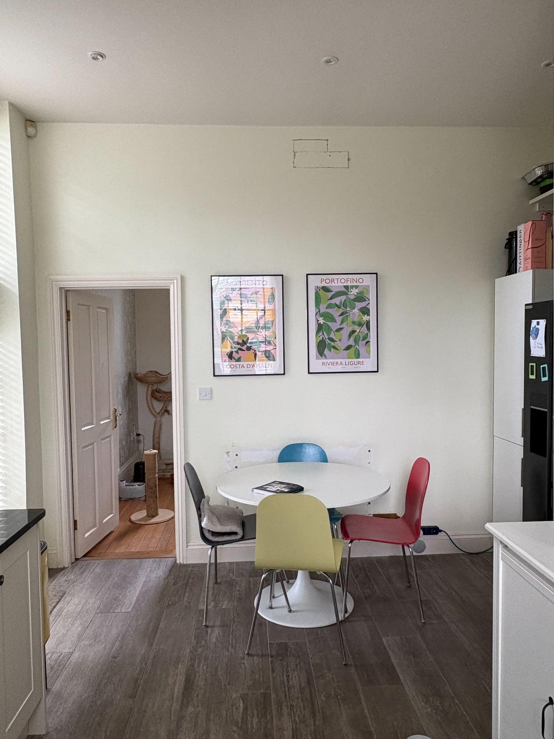

Photo 2: New opening created following removal of wall portion
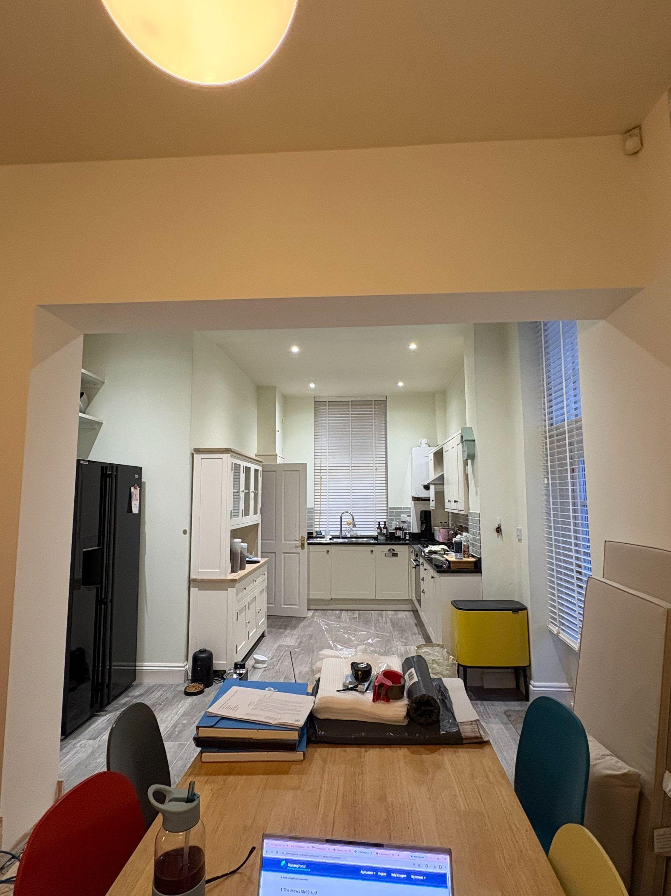

Plan 1: Floorplan with red box showing section of wall removed
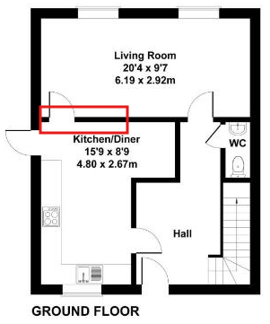

Photo 3: Same style existing opening in hallway
