

TOWN & COUNTRY PLANNING ACT 1990:
SECTION 192 (as amended by Section 10 of the Planning & Compensation Act 1991)

Certificate of Lawful Use or Development - Proposed Use or Development
Application Reference Number: PL/2026/04453
Decision Date: 18/08/2026

Applicant: | Whitlock & Lowe Ltd  The Millworks, Heath Mill Road, Wombourne, South Staffordshire, WV5 8AP
At: 4 Manor Farm Lane, Patney, Devizes, SN10 3RB

Wiltshire Council hereby certify that on 16 July 2026 the operations described in the First Schedule to this Certificate in respect of the land specified in the Second Schedule to this Certificate and edged red on the plan attached to this certificate are lawful within the meaning of section 192 of the Town and Country Planning Act 1990 (as amended) for the following reasons:

The proposed mobile unit meets the statutory definition of a caravan under the Caravan Sites and Control of Development Act 1960, in terms of its mobility and dimensions. It is to be sited within the residential curtilage of the existing dwelling and used in a manner incidental to the main house, without forming a separate or independent planning unit. As such, the stationing of the unit does not constitute development and does not require planning permission. The use remains within Class C3 residential use, and a certificate of lawfulness should therefore be granted.

SCHEDULE 1: Siting of Single Unit Caravan for Ancillary Family Accommodation

SCHEDULE 2: 4 Manor Farm Lane, Patney, Devizes, SN10 3RB

Signed
Nic Thomas - Director of Planning, Economy and Regeneration

Notes -
1. This Certificate is issued solely for the purpose of Section 191 of the Town & Country Planning Act 1990 (as amended).
2. It certifies that the use or development specified in the First Schedule taking place on the land described in the Second Schedule would have been lawful on the specified date and thus would not have been liable to enforcement action under Section 172 of the 1990 Act on that date.
3. This Certificate applies only to the extent of the proposed use or development described in the First Schedule and to the land specified in the Second Schedule and identified on the plan below:
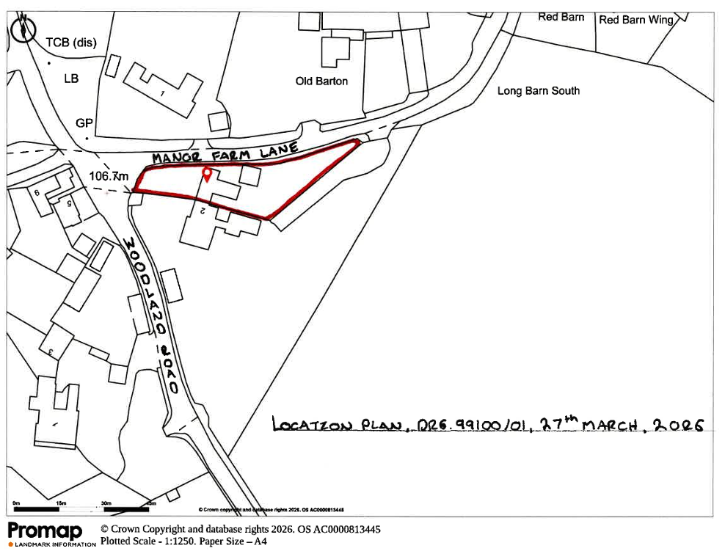
Any use or development which is materially different from that described or which relates to other land may render the owner or occupier liable to enforcement action.
4. The effect of the Certificate is also qualified by the proviso in Section 192 (4) of the 1990 Act, as amended. This states that the lawfulness of a described use or operation is only conclusively presumed where there has been no material change before the use is instituted or the operations begun in any manner relevant to determining such lawfulness.

