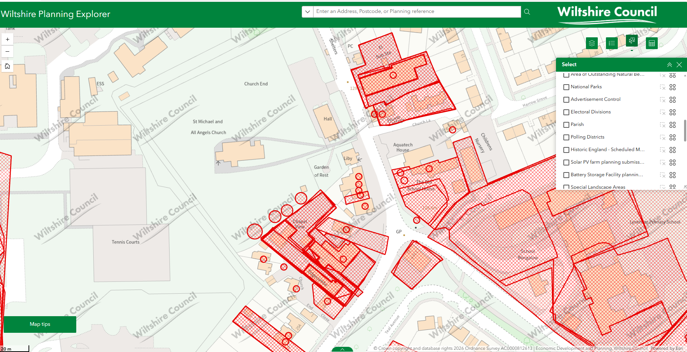
This is where the trees need pruning along the boundary line.

