APPLICATION FOR FULL PLANNING PERMISSION
DELEGATED REPORT

APPLICATION REFERENCE: | PL/2026/04173
APPLICATION TYPE: | Full planning permission
SITE ADDRESS: | 34-36 Warminster Road, Westbury, BA13 3PE
DEVELOPMENT DESCRIPTION: | Proposed Replacement Fenestration & Rendering Front elevation
RECOMMENDATION: | That Planning Permission be GRANTED

PROPOSAL

The proposal seeks full planning permission for replacement windows on the front elevation of the host building alongside permission to render the front elevation.

SITE DESCRIPTION/CONTEXT

The proposal relates to the ground floor of a two-storey building at 34-36 Warminster Road in Westbury. The application site benefits from Prior Approval consent under Class MA of the Town and Country Planning (General Permitted Development) (England) Order 2015 (as amended), reference PL/2026/01864, for the conversion of part of the existing commercial premises to form two residential flats.

The property lies just outside the Westbury Conservation Area which covers the historic core of the town. The application site falls within the recreational impact zone of the Salisbury Plain Special Protection Area for birds and is in the Bath and Bradford on Avon Special Area of Conservation for bats as well as the grey, hatched zone of the Trowbridge and Westbury Bat Mitigation Strategy (TWBMS).

PLANNING HISTORY

Proposal / Summary
W/75/00165/HIS Ground floor shop extension and first floor dwelling extension - Approved
W/84/00445/Ful Change of use to Chinese take-away and restaurant – Approved with conditions
W/84/01077/FUL Alterations and additions to shop and dwelling – Approved
W/86/00967/FUL Alteration of approved opening hours of fish and chip shop and restaurant to 9.00-24.00 Monday-Saturday and 9.00-23.00 Sunday - Refused
W/86/01418/FUL Alteration of approved opening hours for chines restaurant from 9.00-23.00 hrs on Sunday – Approved with conditions
W/88/00616/FUL Extension to kitchen - Approved
W/90/00694/FUL New cold room – Approved
W/09/02199/FUL First floor extension over existing chip shop and changes to extract system - Approved with conditions
PL/2026/01864 Class MA: Change of use from Commercial, business and service uses to dwellinghouses (2 x 1 bed flats) - Approved

RELEVANT POLICIES AND GUIDANCE
The Wiltshire Core Strategy (WCS) 2015
Core Policy 2 Delivery Strategy
Core Policy 32 – Spatial Strategy for the Westbury Community Area
Core Policy 50 – Biodiversity and Geodiversity
Core Policy 57 - Ensuring High Quality Design and Place Shaping
Core Policy 58 - Ensuring the Conservation of the Historic Environment
New Wiltshire Local Plan
At Full Council on 19 May 2026, the elected members of Wiltshire Council agreed to withdraw the emerging Wiltshire Local Plan. The said Plan has no material weight for the purposes of the application.
In accordance with Regulation 19 of the Town and Country Planning (Local Planning) (England) Regulations 2026, on 30th June 2026 Wiltshire Council published a notice of intention to prepare a new local plan for Wiltshire. The next stage is a Scoping Consultation which commences on 2nd September 2026. This plan is at a very early stage and currently carries no weight for decision making.
Westbury Neighbourhood Plan 2023-2036
Wiltshire Design Guide: Appendix D – Design Guidance for Householder extensions
The National Planning Policy Framework (NPPF) August 2026
The Planning Practice Guidance
National Design Guide

CONSULTATION RESPONSES
Westbury Town Council: No objection

REPRESENTATIONS
No comments were received.

ASSESSMENT
Section 38(6) of the Planning and Compulsory Purchase Act 2004 states:

"If regard is to be had to the development plan for the purposes of any determination to be made under the planning Acts, the determination must be made in accordance with the plan unless material considerations indicate otherwise."

In accordance with this statutory requirement, this application has been assessed against the relevant policies of the Development Plan, including the adopted Wiltshire Core Strategy (2015) and, where applicable, any made Neighbourhood Plans.

Principle of Development
The proposed development comprises works to residential propertie set within the settlement boundary of Westbury. The proposed development would be undertaken wholly within the confines of the application site and as such the principle of development is acceptable subject to the following considerations

Heritage, Design and Impact upon the character and context of the area
From the point of view of the historic environment the main statutory tests are set out within the Planning (Listed Building and Conservation Areas) Act 1990.

The Council’s Core Strategy Policy CP58 ‘Ensuring the conservation of the historic environment’ requires that designated and non-designated heritage assets and their settings will be conserved, and where appropriate enhanced, in a manner appropriate to their significance and encourages proposals which improve the condition of heritage assets at risk.

The Council’s Core Strategy CP 57: Ensuring high quality design requires a high quality of design in all new developments. The policy requires applicants to “demonstrate how the proposal will make a positive contribution to the character of Wiltshire through (amongst other things) responding to the value of the natural and historic environment and being sympathetic to and conserving historic buildings and landscapes. Development is required to respond positively to the existing in terms of building layouts, built form, height, mass, scale, building line, plot size, elevational design, materials, streetscape and rooflines to effectively integrate the building into its setting.

The NPPF outlines government policy for planning. Chapter 20 of the 2026 NPPF 'Conserving and enhancing the historic environment' sets out the Government's high-level policies concerning heritage and sustainable development.

The application site lies within Westbury town centre, just outside of the conservation area, and within the vicinity of the building lie two listed buildings. Therefore, any works to the host building have to be appraised in relation to any impact upon the immediate setting of the listed buildings as well as the character and appearance of the conservation area.

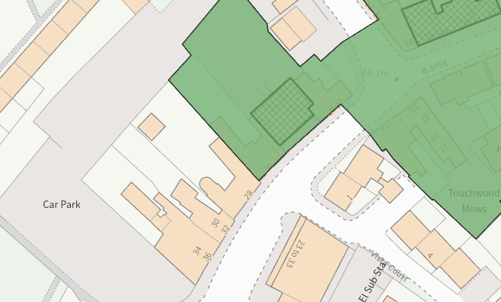
Conservation area (green wash) and listed buildings (hatched black)

The proposal relates to changes to the existing fenestration arrangement and the rendering of the external wall on the principal elevation facing the public highway. The proposal would see an additional pedestrian door inserted on the front elevation accessing the new residential units that were approved via the prior approval consent.

The prior approval process restricts external alterations to buildings and therefore this application has been submitted to facilitate the necessary access to the two individual planning units via the principal elevation fronting the public highway.

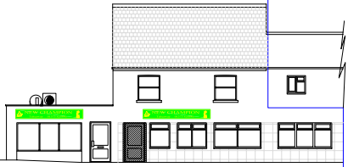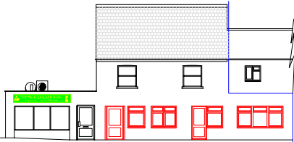
Existing (left) and proposed (right) front elevation

The proposed fenestration would comprise of white uPVC units, with the existing tiled finish to the front elevation replaced by an off-white rendered finish. These external alterations would enhance the domestic appearance of the building that would help to identify its residential character. The updated materials would help illustrate the visual differentiation of the residential accommodation from the adjoining fish and chip restaurant, located to the south.

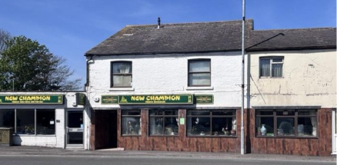
Existing front elevation of the host building

The use of appropriate materials would ensure the proposal would integrate into the existing built form within the surrounding setting and existing street scene. The small-scale nature of the development is commensurate to the size of the application site and the proposal by virtue of its design, and use of materials, is considered to preserve the character and appearance of the conservation area and setting of the listed buildings nearby.

Officers consider that it would not result in harm to the significance of any heritage assets, the development is therefore considered to comply with Core Policies 57 and 58 of the Wiltshire Core Strategy and Section 66 and 72 of the Planning (Listed Buildings and Conservation Areas) Act 1990, as well as the relevant provisions of the NPPF.

Having regard to the above, the proposal complies with the design principles set out in Core Policy 57 of the Wiltshire Core Strategy and Appendix D of the Wiltshire Design Guide.

Amenity
Point vii of Core Policy 57 - Ensuring High-Quality Design and Place Shaping of the Wiltshire Core Strategy seeks to ensure that developments do not adversely affect neighbouring properties.

The National Planning Policy Framework (NPPF), particularly Policy L2 1d(ii), stresses that ‘substantial weight should be given to the benefits where a development proposal would maintain safe access and egress for occupiers and users, and acceptable living standards for residents and neighbours in terms of access to daylight, sunlight, privacy and external amenity space’

The proposed development has been assessed in terms of its potential impact on the residential amenity of neighbouring properties, with particular regard to loss of light, overshadowing, loss of privacy, and overbearing effects.

The proposal seeks minor alterations to the existing fenestration and rendering of the front elevation of the host building. The fenestration arrangement would be similar to existing with all windows overlooking the public highway to the southwest, therefore no overlooking concerns are raised.

There would not be any increase in mass or scale to the existing building, therefore, no concerns are raised in relation to any potential adverse overbearing or overshadowing impacts or loss of light to neighbouring occupiers.

The proposal therefore accords with Core Policy 57 point vii in respect of safeguarding residential amenity and Appendix D of the Wiltshire Design Guide.

Ecology Impact
Core Policy 50 of the Wiltshire Core Strategy seeks to protect and enhance biodiversity and geodiversity, including through ensuring that development avoids harm to protected species and habitats.

The National Planning Policy Framework (NPPF), in Paragraphs 193, requires that development minimises impacts on and provides net gains for biodiversity, including ensuring mitigation is secured where harm cannot be avoided.

This proposal falls within the recreational impact zone of the Salisbury Plain Special Protection Area for birds. Therefore, potential disturbance to nesting birds through the creation of additional visitor numbers to the Salisbury Plain has to be assessed. However, given that this proposal relates to works to the principal elevation of the host building only, without the creation of separate independent living accommodation, it is considered that there would not be any adverse impacts on the Special Protection Area.

The application site sits within the Bath and Bradford on Avon Special Area of Conservation for bats as well as the grey, hatched zone of the Trowbridge and Westbury Bat Mitigation Strategy (TWBMS). Therefore, due consideration has to be given to the potential disturbance of any bats because of the proposed development.

The proposed development comprises small scale works to existing fenestration and the treatment of external coatings to an existing residential development that does not involve works to the roof. Given the established high density urban residential nature of the location, it is considered highly unlikely that any bats would be affected and significant effects relating to the disturbance to bats can be ruled out.

As a precautionary measure an informative would be added to any decision that in event any evidence of bat activity is detected that the applicant should follow the advice of a professional ecologist or contact Natural England.

As such, the development complies with Core Policy 50 of the Wiltshire Core Strategy and the relevant provisions of the NPPF.

Biodiversity Net Gain
As of April 2024, unless exempted, applications need to demonstrate no net loss and a minimum of 10% net gain in biodiversity (BNG) on the site, in line with the requirements of the NPPF, PPG, WCS policy CP50 (Biodiversity and Geodiversity) and the Environment Act.

Based on the information submitted the biodiversity gain planning condition is not considered to apply to this application as the development meets the following criteria and is therefore below the de minimis threshold, meaning the development:

- does not impact an onsite priority habitat (a habitat specified in a list published under
section 41 of the Natural Environment and Rural Communities Act 2006); and

- impacts less than 25 square metres of onsite habitat that has biodiversity value
greater than zero and less than 5 metres in length of onsite linear habitat (as defined
in the statutory metric)

The proposal therefore meets the requirements contained in policy CP50 of the Wiltshire Core Strategy and the relevant provisions of the NPPF.

CONCLUSION
The proposed development is considered to be acceptable in terms of its design, scale, and relationship with the surrounding area. It would not result in any unacceptable harm to the character of the locality, the amenities of neighbouring occupiers, or the interests of heritage, or ecology.

The proposal is therefore considered to comply with the relevant policies of the Wiltshire Core Strategy, the Wiltshire Local Plan, and the National Planning Policy Framework. As such, the application is recommended for approval, subject to the conditions set out below.

RECOMMENDATION: That Planning Permission be GRANTED subject to conditions.

