APPLICATION FOR HOUSEHOLDER PLANNING PERMISSION
DELEGATED REPORT

APPLICATION REFERENCE: | PL/2026/04170
APPLICATION TYPE: | Householder planning permission
SITE ADDRESS: | Ash House, 124a The Midlands, Holt, BA14 6RG
DEVELOPMENT DESCRIPTION: | Proposed single storey rear extension, conversion and extension of garage to create additional living accommodation, proposed front entrance porch.
RECOMMENDATION: | That Planning Permission be GRANTED

PROPOSAL

The proposal seeks planning permission for an entrance porch, single storey rear extension, and conversion and extension of an existing garage to ancillary living accommodation.

SITE DESCRIPTION/CONTEXT
This application relates to a detached dwelling, Ash House, located within an established residential area in Holt. The host dwelling benefits from an off-road parking area to the front elevation and a detached garage. The general area comprises of a mixture of housing types and styles of different periods.

The application site lies within the Holt Conservation Area and to the northeast of the host dwelling lies a grade II listed building No’s 125 and 127 The Midlands.

PLANNING HISTORY

Proposal / Summary
PL/2021/11766 - Householder planning permission Decision - Approve with Conditions Date: 16/2/2022 – Demolition of existing conservatory; erection of single storey rear extension and timber frame porch.
W/98/01404/FUL - Full planning permission Decision - Approve with Conditions Date: 26/11/1998 – Erection of detached house and garage with associated works

RELEVANT POLICIES AND GUIDANCE

Wiltshire Core Strategy:

The Wiltshire Core Strategy (WCS) 2015
Core Policy 2 Delivery Strategy
Core Policy 29 – Spatial Strategy for the Trowbridge Community Area
Core Policy 57 - Ensuring High Quality Design and Place Shaping
Core Policy 58 - Ensuring the Conservation of the Historic Environment
Core Policy 60 – Sustainable Transport
Core Policy 61 – Transport and Development
Core Policy 64 – Demand Management
New Wiltshire Local Plan
At Full Council on 19 May 2026, the elected members of Wiltshire Council agreed to withdraw the emerging Wiltshire Local Plan. The said Plan has no material weight for the purposes of the application.
In accordance with Regulation 19 of the Town and Country Planning (Local Planning) (England) Regulations 2026, on 30th June 2026 Wiltshire Council published a notice of intention to prepare a new local plan for Wiltshire. The next stage is a Scoping Consultation which commences on 2nd September 2026. This plan is at a very early stage and currently carries no weight for decision making.
Holt Neighbourhood Plan 2016-2026 Made January 2017

Wiltshire Local Transport Plan 3 2011 – 2026 (March 2015) (including car parking strategy)

Wiltshire Design Guide: Appendix D – Design Guidance for Householder extensions

The National Planning Policy Framework (NPPF) August 2026

The Planning Practice Guidance

National Design Guide

CONSULTATION RESPONSES

Holt Parish Council: No comment
Wiltshire Council Highways No objection
Wiltshire Council Conservation No comment

REPRESENTATIONS
No comments were received.

ASSESSMENT
Section 38(6) of the Planning and Compulsory Purchase Act 2004 states:

"If regard is to be had to the development plan for the purposes of any determination to be made under the planning Acts, the determination must be made in accordance with the plan unless material considerations indicate otherwise."

In accordance with this statutory requirement, this application has been assessed against the relevant policies of the Development Plan, including the adopted Wiltshire Core Strategy (2015) and, where applicable, any made Neighbourhood Plans.

Heritage, Design and Impact upon the character and context of the area:
From the point of view of the historic environment the main statutory tests are set out within the Planning (Listed Building and Conservation Areas) Act 1990.

Section 66 requires that special regard be given to the desirability of preserving listed buildings, their settings or any features of special architectural or historic interest which they possess.

Section 72(1) of the Act requires the Council to pay special attention to the desirability of preserving or enhancing the character or appearance of designated Conservation Areas.

The Council’s Core Strategy Policy CP58 ‘Ensuring the conservation of the historic environment’ requires that designated and non-designated heritage assets and their settings will be conserved, and where appropriate enhanced, in a manner appropriate to their significance and encourages proposals which improve the condition of heritage assets at risk.

The Council’s Core Strategy CP 57: Ensuring high quality design requires a high quality of design in all new developments. The policy requires applicants to “demonstrate how the proposal will make a positive contribution to the character of Wiltshire through (amongst other things) responding to the value of the natural and historic environment and being sympathetic to and conserving historic buildings and landscapes. Development is required to respond positively to the existing in terms of building layouts, built form, height, mass, scale, building line, plot size, elevational design, materials, streetscape and rooflines to effectively integrate the building into its setting.

The NPPF outlines government policy for planning. Chapter 20 of the 2026 NPPF 'Conserving and enhancing the historic environment' sets out the Government's high-level policies concerning heritage and sustainable development.

The application site lies within the Holt Conservation Area and to the northeast of the host dwelling lies a grade II listed building No’s 125 and 127 The Midlands. Therefore, due consideration needs to be given to any impact of the proposed development on these heritage assets.

The proposal seeks to remove the existing conservatory on the rear elevation of the host dwelling and erect a single storey flat roof extension, the extension would consist of a flat roof form with roof lanterns inserted to illuminate the internal space and would sit at a height of 3.3m.

The extension would span across the width of the rear elevation of the host dwelling and would adjoin the garage building that would be extended forward on the front elevation, to create an L-shaped plan to the rear. Patio doors and a window would be inserted on the rear elevation with a glazed pedestrian door on the west side elevation accessing the existing driveway area.

The garage building would maintain the existing pitched roof form with full height glazed panels replacing the existing garage door, patio doors would be inserted on the rear elevation and a pedestrian door inserted on the east side elevation.

The elevations on the rear extension and garage extension would consist of red brick to match the existing with dark framed aluminium fenestration. Double roman roof tiles would be added to the extended garage roof, and the flat roof extension would consist of a single ply membrane.

To the front elevation the applicant proposes erecting a pitched roof porch positioned centrally. It would consist of timber elevations siting on a small dwarf wall with glazed panels either side of the front door and glazed panels on the side elevations.

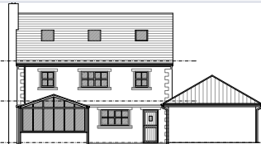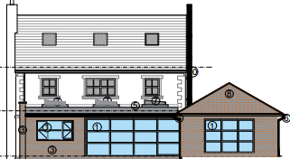
Existing (left) and proposed (right) rear elevation of the host dwelling

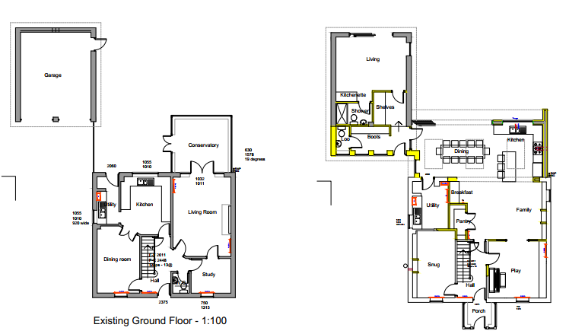
Existing (left) and proposed (right) ground floor plan of the host dwelling

The use of appropriate materials would ensure the proposal would integrate into the surrounding setting and existing street scene and would not result in any harm to the prevailing character and appearance of the area. The dwelling would also retain a reasonable sized garden and sufficient parking space.
It is considered that the extensions would by virtue of their height, scale and design constitute complementary additions to the host dwelling that would appear commensurate to the size of the property and plot.

Given the limited works proposed, that would be set within the built envelope of the application site, it is considered that there would be no harm to the conservation area. The proposal, by virtue of its scale, design, and use of materials, is considered to preserve the character and appearance of the conservation area and the setting of the listed buildings nearby.

Having regard to the above, the proposal complies with the design principles set out in Core Policies 57 and 58 of the Wiltshire Core Strategy, Section 66 and Section 72 of the Planning (Listed Buildings and Conservation Areas) Act 1990, as well as the relevant provisions of the NPPF and the Wiltshire Design Guide.

Amenity
Point vii of Core Policy 57 - Ensuring High Quality Design and Place Shaping of the Wiltshire Core Strategy seeks to ensure that developments do not adversely affect neighbouring properties.

The National Planning Policy Framework (NPPF), particularly Paragraph L2 1d(ii), stresses that substantial weight should be given to the benefits where a development proposal would maintain safe access and egress for occupiers and users, and acceptable living standards for residents and neighbours in terms of access to daylight, sunlight, privacy and external amenity space.

The proposed development has been assessed in terms of its potential impact on the residential amenity of neighbouring properties, with particular regard to loss of light, overshadowing, loss of privacy, and overbearing effects.

All windows proposed would overlook the applicant’s private residential curtilage and given the single storey nature of the build no overlooking concerns are raised.
Given the detached nature of the host dwelling, single storey nature of the extensions and separation distances to neighbouring occupiers no adverse overbearing, overshadowing impacts are raised, or any concerns in regard to loss of light to neighbouring occupiers.
Based on the information submitted, officers are satisfied that the applicant intends to use the converted garage building for purposes ancillary to the residential use of the main dwelling. However, a future owner/occupant of the site may however have a different objective and given the size of the converted garage building and its positioning, there is a risk that it could be altered internally and used independently. This could potentially negatively affect local character and create other issues such as parking pressures.
Therefore, a condition would be applied on any planning permission granted, to ensure that the accommodation shall remain as ancillary to the host property and not as separate independent accommodation.
The proposal therefore accords with Core Policy 57 point vii in respect of safeguarding residential amenity and Appendix D of the Wiltshire Design Guide.

Highways Impact
Core Policy 57 (xiv) of the Wiltshire Core Strategy seeks to ensure that development must meet the requirements of Core Policy 61. This policy requires proposals to be capable of being served by safe access to the highway network. Core Policy 64 seeks to ensure compliance with parking standards set out in the Local Transport Plan.

In order to comply with the Wiltshire Local Transport Plan 2011 – 2026: Car Parking Strategy (March 2015) three on-site car parking spaces would be required for a 4+ bed dwelling (standard min. size 2.4m x 4.8m).
The proposed scheme would remove the existing garage as a parking space by converting it to habitable accommodation therefore 3 off road parking spaces would need to be provided within the front driveway.

An updated parking plan was submitted which illustrated how the required on-site parking spaces would be provided on the existing driveway and the Council’s Highway officer raised no objections.
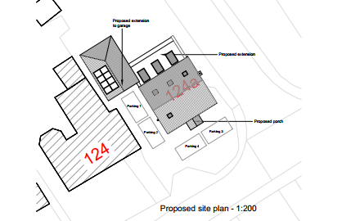
Proposed site plan with parking provision

Officers consider that the proposed development would not result in any adverse impact on highway safety, adequate parking and turning provision is provided in accordance with Wiltshire’s adopted parking standards, and access arrangements are acceptable.

The proposal is therefore considered to comply with Core Policies 57 (xiv), 61 and 64 of the Wiltshire Core Strategy and the Wiltshire Local Transport Plan.

Biodiversity Net Gain
Householder planning applications are exempt from the requirement to deliver Biodiversity Net Gain under Schedule 7A, Section 4(2)(a) of the Town and Country Planning Act 1990, as inserted by the Environment Act 2021.

CONCLUSION
The proposed development is considered to be acceptable in terms of its design, scale, and relationship with the surrounding area. It would not result in any unacceptable harm to the character of the locality, the amenities of neighbouring occupiers, or the interests of highway safety or heritage.

The proposal is therefore considered to comply with the relevant policies of the Wiltshire Core Strategy, the Wiltshire Local Plan, and the National Planning Policy Framework. As such, the application is recommended for approval, subject to the conditions set out below.

RECOMMENDATION: That Planning Permission be GRANTED subject to conditions.

