APPLICATION FOR HOUSEHOLDER PLANNING PERMISSION DELEGATED REPORT

APPLICATION REFERENCE: | PL/2026/04122
APPLICATION TYPE: | Householder planning permission
SITE ADDRESS: | Fosgate House, Upper Chute, Andover, SP11 9EW
DEVELOPMENT DESCRIPTION: | Detached Garden Office
RECOMMENDATION: | That Planning Permission be GRANTED

PROPOSAL

The proposal seeks planning permission for the erection of a detached single-storey outbuilding within the residential curtilage of Fosgate House. The building would be used for purposes incidental to the enjoyment of the dwellinghouse, specifically as a home office.
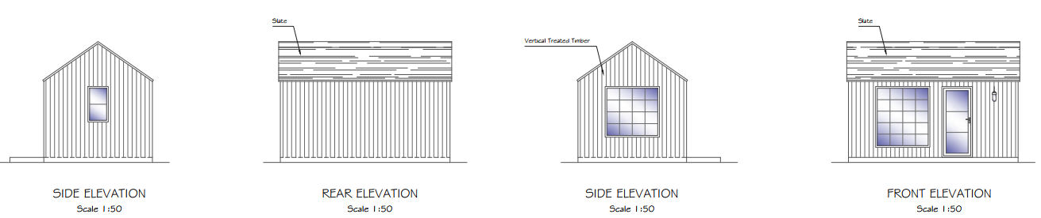

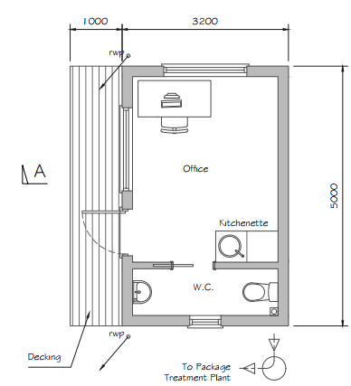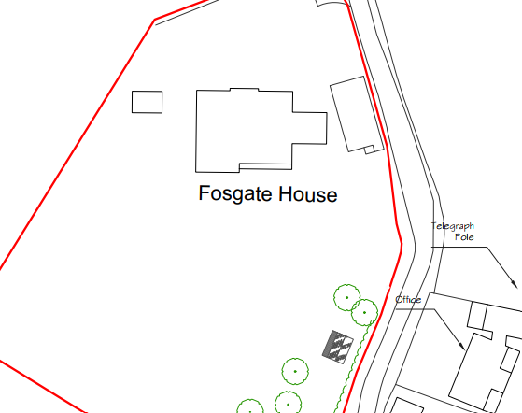

SITE DESCRIPTION/CONTEXT

The application site relates to Fosgate House, a large, detached dwelling located on the western side of Forest Lane North, Upper Chute. The property occupies a generous rural plot on the edge of the village and is set within extensive residential curtilage with formal gardens and areas of surrounding pastureland under the applicant's ownership. The site lies within the Upper Chute Conservation Area and the North Wessex Downs National Landscape (formerly AONB).

The dwelling is positioned within an elevated rural landscape, although parts of the garden are located at a lower level than the main house. The site is characterised by mature landscaping, including established boundary hedgerows and trees, which provide a degree of enclosure. The surrounding area is predominantly agricultural in character, with open fields adjoining the site on multiple sides and limited neighbouring properties in close proximity. The nearest residential properties are located on the opposite side of Forest Lane North and are separated from the site by the road.

Public right of way footpath CHUT18 passes to the west of the site.

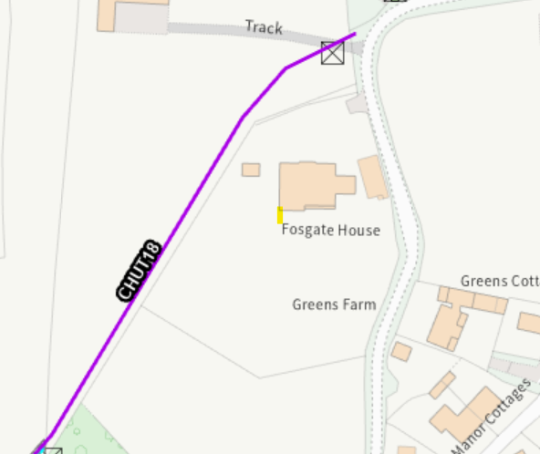

The site is located within the River Test Catchment.

PLANNING HISTORY

Proposal / Summary
K/50503/F - Full planning permission Decision - Refused Date: 10/8/2004 – Stable block and storage.
K/54898/F - Full planning permission Decision - Approve with Conditions Date: 22/9/2006 – Change of use of agricultural land to garden
K/41858 - Full planning permission Decision - Approve with Conditions Date: 21/12/2001 – The erection of a detached dwelling and a detached garage with living accommodation.
K/46839 - Full planning permission Decision - Approve with Conditions Date: 17/2/2004 – The erection of a single storey side extension.
K/39368 - Full planning permission Decision - Approve with Conditions Date: 7/9/2000 – Demolition of 2 No cottages and outbuildings and construction of new house and garage with ancillary staff accommodation.
PL/2024/01565 - Householder planning permission Decision - Approve with Conditions Date: 5/4/2024 – Erection of bespoke garden room to rear elevation
PL/2024/04517 - Householder planning permission Decision - Approve with Conditions Date: 23/7/2024 – Provision of pool house, pergola and swimming pool
PL/2026/01189 - Householder planning permission Decision - Approve with Conditions Date: 28/4/2026 – Construction of a hard surfaced tennis court with surround fencing
K/32690 - Full planning permission Decision - Approve with Conditions Date: 23/5/1996 – Change of use from grazing to play area for village children.
K/46957 - Full planning permission Decision - Refused Date: 27/2/2004 – Erection of new stables and storage
K/51973/F - Full planning permission Decision - Approve with Conditions Date: 13/6/2005 – Stable block and storage

RELEVANT POLICIES AND GUIDANCE

Planning (Listed Buildings and Conservation Areas) Act 1990 – Section 72

The National Planning Policy Framework (NPPF) August 2026
The Planning Practice Guidance
National Design Guide

Wiltshire Core Strategy:
- Core Policy 1 Settlement Strategy
- Core Policy 2 Delivery Strategy
- Core Policy 26 Spatial Strategy Tidworth Community Area
- Core Policy 50 Biodiversity and Geodiversity
- Core Policy 51 Landscape
- Core Policy 57 Ensuring High Quality Design and Place Shaping
- Core Policy 58 Ensuring the Conservation of the Historic Environment

Wiltshire Design Guide
The Chutes Design Guide
North Wessex Downs National Landscape Management Plan
Upper Chute Conservation Area Designation Statement

CONSULTATION RESPONSES

Parish Council – none received

REPRESENTATIONS

No comments were received.

ASSESSMENT

Section 38(6) of the Planning and Compulsory Purchase Act 2004 states:

"If regard is to be had to the development plan for the purposes of any determination to be made under the planning Acts, the determination must be made in accordance with the plan unless material considerations indicate otherwise."

In accordance with this statutory requirement, this application has been assessed against the relevant policies of the Development Plan, including the adopted Wiltshire Core Strategy (2015) and, where applicable, any made Neighbourhood Plans.

Character, Design, Heritage and Landscape Impacts

From the point of view of the historic environment the main statutory tests are set out within the Planning (Listed Building and Conservation Areas) Act 1990.

Section 72(1) of the Act requires the Council to pay special attention to the desirability of preserving or enhancing the character or appearance of designated Conservation Areas.

The Council’s Core Strategy Policy CP58 Ensuring the conservation of the historic environment’ requires that designated and non-designated heritage assets and their settings be conserved, and where appropriate enhanced, in a manner appropriate to their significance and encourages proposals which improve the condition of heritage assets at risk.

Policy HE9 of the NPPF requires development within or affecting conservation areas to conserve those elements that contribute positively to their character and appearance

The Council’s Core Strategy CP 57 Ensuring high quality design requires a high quality of design in all new developments. The policy requires applicants to demonstrate how the proposal will make a positive contribution to the character of Wiltshire through (amongst other things) responding to the value of the natural and historic environment and being sympathetic to and conserving historic buildings and landscapes. Development is required to respond positively to the existing character of the area in terms of building layouts, built form, height, mass, scale, building line, plot size, elevational design, materials, streetscape and rooflines to effectively integrate the building into its setting.

Core Policy 51 of the Wiltshire Core Strategy requires all development to protect, conserve, and where possible enhance the character and quality of Wiltshire’s landscapes, giving particular weight to designated areas such as National Landscapes.

NPPF policy N4 (Protected Landscapes) states that development proposals within Protected Landscapes should be limited in scale and extent and sensitively located and designed to avoid harm to their statutory purposes and special qualities. Substantial weight should be placed on the importance of conserving and enhancing the natural beauty of these areas. Policy N4 also states that Development proposals within the setting of Protected Landscapes should be sensitively located and designed to avoid or minimise adverse impacts on the Protected Landscape.

The proposed outbuilding would be used as a home office incidental to the residential use of Fosgate House. It would be a modest, single-storey structure that would remain subservient to the host dwelling.

The outbuilding would be sited within the large residential curtilage of the property, where it would sit comfortably to the rear of the existing dwelling. Whilst the site lies within the Conservation Area and North Wessex Downs National Landscape, the outbuilding would be located in a relatively discreet position to the rear of the property. Although glimpsed views may be possible from the public right of way to the west, the building would be viewed in the context of the existing dwelling and garden and would benefit from existing boundary planting and the site's varied topography.

The scale of the proposed building is subservient to the host dwelling and its siting within the large curtilage would not be overbearing or detrimental to the character and appearance of the property or wider area. The choice of materials is considered to be appropriate for this location with the use of a slate roof to match the host dwelling.

By reason of its scale, siting and design, the proposal would not result in harm to the character or appearance of the site, the Upper Chute Conservation Area, the wider National Landscape or the visual amenity of the surrounding area. The proposal therefore accords with Core Policies 51, 57 and 58 of the Wiltshire Core Strategy.

Amenity

Point vii of Core Policy 57 - Ensuring High Quality Design and Place Shaping of the Wiltshire Core Strategy seeks to ensure that developments do not adversely affect neighbouring properties.

NPPF Policies DP3 and P3 of the NPPF 2026, require development to respond appropriately to its setting and would not result in unacceptable impacts on neighbouring living conditions

The proposed development has been assessed in terms of its potential impact on the residential amenity of neighbouring properties, with particular regard to loss of light, overshadowing, loss of privacy, and overbearing effects.

The proposed outbuilding would be located within the existing large residential curtilage of Fosgate House and would be used for purposes incidental to the enjoyment of the dwellinghouse as a home office. The building would be well separated from neighbouring residential properties due to the size of the site and its position within the garden. The nearest neighbouring dwelling lies to the east, on the opposite side of Forest Lane North, separated from Fosgate House by the highway and established boundary vegetation.

Given the separation distances involved, together with the intervening road corridor, mature hedgerows and existing landscaping, the proposed development would not result in any material overlooking, loss of privacy or unacceptable visual intrusion. Furthermore, owing to its single-storey scale and position within a lower part of the site, the building would not appear overbearing when viewed from neighbouring land and would not give rise to any significant loss of daylight or sunlight.

The use as a home office is incidental to the primary residential use of the site and is not considered likely to generate levels of activity or disturbance beyond those typically associated with the current use and level of occupation of the dwellinghouse.

Accordingly, it is concluded that the proposal would not result in any adverse impact on neighbouring residential amenity and accords with the objectives of Core Policy 57 of the Wiltshire Core Strategy.

Ecology Impact

Core Policy 50 of the Wiltshire Core Strategy seeks to protect and enhance biodiversity and geodiversity, including through ensuring that development avoids harm to protected species and habitats.

Policy N2 of the NPPF requires development proposals to consider existing environmental qualities and opportunities to conserve and enhance natural features. Given the limited scale of the proposal within an established residential curtilage, no significant ecological impacts are identified.

Whilst the site lies within the River Test Catchment, the proposal relates to a small-scale domestic outbuilding and would not create any additional residential accommodation. As such, no adverse nutrient neutrality impacts would arise. It is noted that the proposal includes a WC, the applicant has confirmed that the WC would connect to the existing foul drainage system and would not require the installation of any new drainage infrastructure.

Biodiversity Net Gain -Householder planning applications are exempt from the requirement to deliver Biodiversity Net Gain under Schedule 7A, Section 4(2)(a) of the Town and Country Planning Act 1990, as inserted by the Environment Act 2021.

As such, the development complies with Core Policy 50 of the Wiltshire Core Strategy and the relevant provisions of the NPPF.

CONCLUSION

The proposed outbuilding is considered acceptable by reason of its scale, design, siting and intended use. It would not result in unacceptable harm to the character or appearance of the site, the Upper Chute Conservation Area, the North Wessex Downs National Landscape, neighbouring amenity or ecological interests. The proposal therefore complies with Core Policies 50, 51, 57 and 58 of the Wiltshire Core Strategy and the relevant provisions of the NPPF. Planning permission is recommended for approval subject to conditions.

RECOMMENDATION: That Planning Permission be GRANTED subject to conditions.

1. The development hereby permitted shall be begun before the expiration of three years from the date of this permission.

REASON: To comply with the provisions of Section 91 of the Town and Country Planning Act 1990 as amended by the Planning and Compulsory Purchase Act 2004.

2. The development hereby permitted shall be carried out in accordance with the following approved plans:

Application form received 01/07/2026
Proposed elevations, floor, site and location plan Drg no 1643-01 Rev C received 17/08/2026

REASON: For the avoidance of doubt, in the interests of proper planning

3. The materials to be used in the construction of the external surfaces of the development hereby permitted shall match in material, colour and texture to those detailed on the approved plans, the slate roof shall match the slate on the roof of the host dwelling (Fosgate House).

REASON: For the avoidance of doubt and in the interests of visual amenity and the character and appearance of the area.

4. The outbuilding hereby permitted shall be used only for purposes incidental to the enjoyment of the dwelling known as Fosgate House and shall not be used as habitable accommodation or for commercial purposes.

REASON: In the interests of proper planning and to safeguard the character of the area and residential amenity.

5. Any external lighting that is installed shall be designed and implemented to minimise sky glow, glare and light trespass. It shall be designed in a downward facing position at all times and shall meet the criteria for Environmental Zone E0 as defined by the Institute of Lighting Professionals ‘Guidance Notes for the Reduction of Obtrusive Light’ 2021. Any external lighting installed at the site shall be retained and maintained as such thereafter for the lifetime of the development.

REASON: In the interest of amenity; in the interests of protected species; and to protect the dark skies and special qualities of the National Landscape.

