APPLICATION FOR FULL PLANNING PERMISSION
CASE OFFICER REPORT

APPLICATION REFERENCE: | PL/2026/00280
APPLICATION TYPE: | Full planning permission
SITE ADDRESS: | 15 Castle Street, Trowbridge, BA14 8AS
DEVELOPMENT DESCRIPTION: | Proposed Erection of 2 Semi-Detached Dwellings with associated landscaping
RECOMMENDATION: | REFUSE

SITE DESCRIPTION/CONTEXT: This full planning application relates to the redevelopment of an existing town centre site and the erection of two semi-detached dwellings. As set out within the planning history of this report, the site was previously subject to a planning application under application reference PL/2022/09736 which permitted the construction of 6 flats. This previous application has been implemented in so far as the approved demolition of the existing buildings has been undertaken, but the erection of the consented building has not yet commenced. From reviewing the submitted Design and Access Statement, it is understood that this is due to the proposal for a new block of flats no longer being financially viable for the applicant.

The application site relates to a vacant brownfield site located in the town centre, along Castle Street, which comprises a mix of residential and commercial uses. The subject site is located adjacent to a modern block of flats that were approved under application reference PL/2021/10112.

The site is located within the Trowbridge Conservation Area and within the vicinity of a number of listed buildings, including: the Grade II nos 52-62 Castle Street and Court House opposite the site to the east; the Grade II listed Castle Factory and Brick Mills to the west of the site; the Grade II listed Mill at Angle to the south-west; and the Grade II listed Home Mill buildings, Court Street to the north of the application site beyond the unlisted neighbouring 11 Castle Street commercial units.

In addition, the site is located within the grey hatched zone of the Trowbridge and Westbury Bat Mitigation Strategy (TWBMS).

In terms of flood risk, the application site is located in Flood Zone 1 and not in an area at risk of surface water flooding with reference to the Flood map for planning – GOV.UK and is shown on the Council’s Strategic Flood Risk Assessment (SFRA) map to be in an area at negligible risk of groundwater flooding.

PROPOSAL: The proposal is seeking planning permission for the construction of a semi-detached pair of two-storey 3-bed dwellings.

The proposed dwellings would be constructed from red brick laid in Flemish bond on the front elevation with ashlar stone quoins and cills, with the side and rear elevations to be completed in stretcher bond, under a natural slate roof with solar panels to the rear.

Over the course of the application’s determination period, the proposal has been revised in an attempt to address the objections raised by the Council’s highways and conservation departments.

The original proposal sought to provide four on-site car parking spaces immediately to the front of the proposed dwellings. Following concerns from officers (refer to the consultation section below), the proposal was amended to reduce the car parking provision to one space per dwelling and bring the buildings closer to the road. Concerns were still raised by officers regarding this revision to the scheme, and as such the proposal was revised a second time.

The latest revisions sought to make the development ‘car-free’ in order to overcome the objection initially raised by the Council’s highways department regarding the on-site car parking provision. This has resulted in the land immediately to the front of the proposed semi-detached pair being removed from the application site (shown in the blue-edged line, but outside the red application site boundary) but with the proposed buildings still being set back within the site, as demonstrated in the below extract taken from the submitted proposed block plan (drawing no. AH2022/98 Sheet 3 of 3).

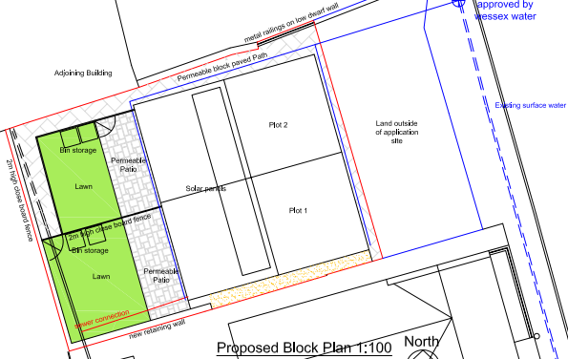

Proposed block plan (as revised) as taken from drawing no. AH2022/98 Sheet 3 of 3

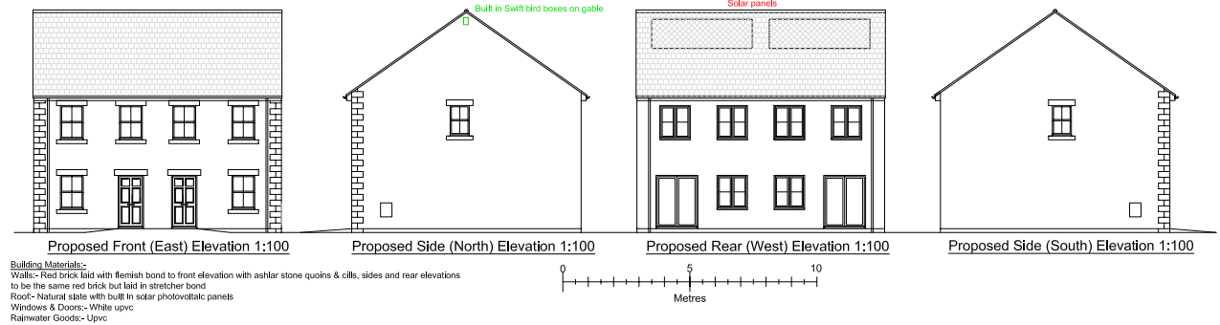

Proposed elevations as taken from drawing no. AH2022/98 Sheet 1 of 3

RELEVANT PLANNING HISTORY: The following planning history is relevant to the site subject to this application. It is also important to mention that to the south of the application site, planning permission has been previously granted for the construction of a three-storey block of flats (as approved under application reference PL/2021/10112).

PL/2024/04697 - Variation of conditions 2 (approved plans), 3, 4 & 5 on Pl/2022/09736 to re-word the conditions to reference new plans and change to compliance conditions – Approved with conditions in August 2024

PL/2023/05129 - Discharge of Conditions 7 and 8 of PL/2022/07710 (Variation of condition 2 of PL/2021/10112 - Proposed residential development with the erection of a building containing 6 dwellings) – Conditions discharged in July 2023

PL/2022/09736 - Proposed Demolition of Hand Car Wash & Erection of Building for 6 Dwellings – Approved with conditions in May 2023. This application permitted the demolition of the existing buildings and the construction of a block of 6 flats on the site, as illustrated by the extracts provided below:

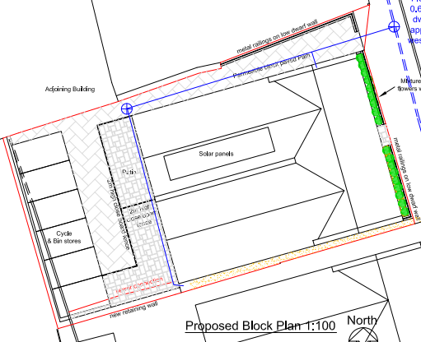
Extract of the approved proposed block plan as taken from drawing no. AH2022/98 Sheet 4 of 4 pursuant to PL/2022/09736

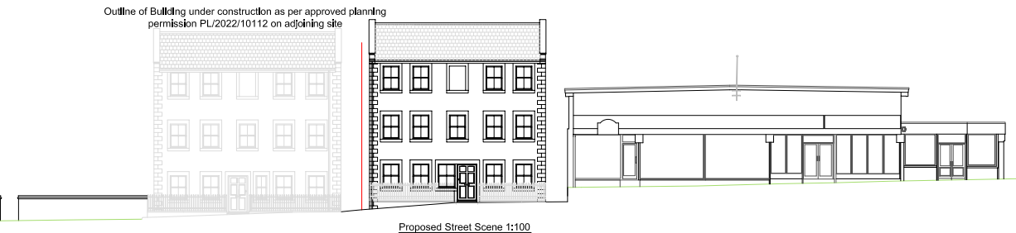
Proposed street scene elevation as taken from drawing no. AH2022/98 Sheet 3 of 4 pursuant to PL/2022/09736

RELEVANT LEGISLATION, POLICIES AND GUIDANCE

Statutory Legislation: Town and Country Planning Act 1990; Planning (Listed Buildings and Conservation Areas) Act 1990; Planning and Compulsory Purchase Act 2004

National Planning Policy: National Planning Policy Framework (NPPF); Planning Practice Guidance (PPG); National Design Guide

Development Plan: The development plan for Wiltshire comprises the Wiltshire Core Strategy (WCS) (adopted January 2015) and any made neighbourhood plans, which remain the principal statutory planning document guiding development across the county. In line with Section 38(6) of the Planning and Compulsory Purchase Act 2004, planning decisions must be made in accordance with the development plan unless material considerations indicate otherwise.

Though the development plan is considered as a whole, those parts deemed to be particularly relevant to this application are listed below:

The adopted Wiltshire Core Strategy (WCS), with particular regard to:

- Core Policy 1 Settlement Strategy;
- Core Policy 2 Delivery Strategy;
- Core Policy 29 Spatial Strategy: Trowbridge Community Area;
- Core Policy 41 Sustainable Construction and Low-Carbon Energy;
- Core Policy 50 Biodiversity and Geodiversity;
- Core Policy 57 Ensuring High Quality Design and Place Shaping;
- Core Policy 58 Ensuring the Conservation of the Historic Environment;
- Core Policy 64 Demand Management;
- Core Policy 67 Flood Risk

New Wiltshire Local Plan: At Full Council on 19 May 2026, the elected members of Wiltshire Council agreed to withdraw the emerging Wiltshire Local Plan. The said Plan has no material weight for the purposes of the application. In accordance with Regulation 19 of the Town and Country Planning (Local Planning) (England) Regulations 2026, on 30th June 2026 Wiltshire Council published a notice of intention to prepare a new local plan for Wiltshire. The next stage is a Scoping Consultation which commences on 2nd September 2026. This plan is at a very early stage and currently carries no weight for decision-making.

Supplementary Planning Documents and other Guidance:
- Wiltshire Design Guide, adopted March 2024)
- Wiltshire Local Transport Plan (LTP3) 2011-2026, adopted March 2011 - including the Car Parking Strategy, adopted 2015 and Cycling Strategy, adopted 2014
- Wiltshire Local Transport Plan 4 (LTP4) 2025-2038, adopted March 2025
- Trowbridge and Westbury Bat Mitigation Strategy (TWBMS)

ISSUES: The main issues that need to be addressed in this case include: the principle of the development; impact on the conservation area and nearby listed buildings; impact on neighbour amenity; living conditions for future occupiers; highways; ecology.

CONSULTATION RESPONSES: The views of consultees are material considerations in the determination of the application. However, the decision-maker must exercise their own planning judgement. Where consultees raise concerns or recommend conditions, these have been considered and are addressed within the assessment section of this report.

Trowbridge Town Council: No objection, subject to no significant adverse impact on neighbourhood amenity.

Wiltshire Council Archaeology: No objection subject to condition

Wiltshire Council Conservation: Object – based on the latest set of revisions, the Council’s conservation officer has commented that “The application details have been revised to remove the area in front of the proposed building from the application site. It remains unclear how this area will be treated; however, in the absence of any specific proposals or details demonstrating how parking will be prevented, it seems almost certain that the area will, in practice, be used for parking as originally proposed.
The revision therefore fails to address the concerns regarding poor and inappropriate design, including the position of the development in relation to the established building line, which were raised in my original comments. I therefore maintain my objection and refer you back to my comments dated 17 March 2026”.

An extract of the comments dated 17 March 2026 referenced in the above is provided below for completeness:

Assessment: the proposals seek consent for the construction of a pair of semi-detached dwelling with a similar overall appearance to the relatively recently constructed block of flats on the neighbouring site.
Paragraph 207 requires that applicants describe the significance of any heritage assets affected, including any contribution made by their setting. This should include sufficient information to provide a clear understanding of the significance of the heritage asset and its setting and the potential impact of any proposals on that significance. In this case, no heritage statement has been submitted and there is nothing providing any assessment of the historical development of the site or objective assessment of impact and it has not been demonstrated that this has been understood. Paragraph 208 of the NPPF also provides for the local planning authority to make its own assessment of impact and the following heritage comments are offered on this basis.

The current structures and use detract from the area and their removal is welcomed. There is no objection in principle to the use of the site for residential purposes as this echoes its historic use.

It is entirely regrettable that this site has come forward separately from the adjacent site. The result illustrates the downside of piecemeal incremental development as the opportunities that a comprehensive redevelopment of the wider site would have offered for the enhancement of the area are now lost. It is also regrettable that an appropriate heritage statement has not been used to inform the nature of the proposed redevelopment. This could have resulted in a scheme which better reflected the historic layout, grain and character of the historic area, and which reinforced local distinctiveness as intended by the NPPF. Instead, the proposal simply repeats the general form of the neighbouring scheme whilst pushing it back within the site to allow parking in front. The result is a pastiche design which poorly reflects the historic layout and character of the site and of remaining historic development in the vicinity. Whilst the drawings are at small scale and lack detail to allow the design to be fully assessed, the wide gable span of the block, lack of chimneys and the location within the site in a car dominated arrangement are features of the scheme which are particularly at odds with surrounding development and which significantly reduce the quality of the development when compared to the previously approved scheme.

In summary, the proposed development represents a poor design which is out of character with historic development in the area and which would lead to the erosion of the character and appearance of the area and setting of the listed buildings located opposite and which will diminish the significance of these assets. The proposals are therefore at odds with Section 66 and 72 and with CP58 and CP57 which requires a high standard of design in all new development. It is noted that the site is currently scruffy and in need of upgrading, such that it fails to contribute positively to the significance of the identified designated assets (CA and LBs). However, the current scheme fails to take the opportunity offered to improve the situation as anticipated by Paragraph 210 of the NPPF.

The development only relates to a small area within the conservation area which is already in poor condition and the impact of the proposed development could therefore be considered as causing ‘less than substantial harm’ for the purposes of interpreting the NPPF.

Conclusion: The NPPF confirms that when considering the impact of a proposed development on the significance of a designated heritage asset, great weight should be given to the asset’s conservation (and the more important the asset, the greater the weight should be). It makes clear that any harm to a designated heritage asset requires clear and convincing justification and that “This is irrespective of whether any potential harm amounts to substantial harm, total loss or less than substantial harm to its significance.”

In this case the proposals will result in a level of harm to the significance of the conservation area and neighbouring listed buildings via the incremental erosion of the character and appearance of the area from poorly designed development. As a result, from a built conservation perspective, the proposals fail to meet with the requirements of current conservation legislation, policy or guidance and I therefore object to the application.

Wiltshire Council Ecology: No objection subject to condition. A Habitats Regulation Assessment (HRA) has been completed with a positive conclusion and has been agreed by Natural England.

Wiltshire Council Highways: Following the submission of the latest set of revision plans, which omit the on-site car parking, the following comments were received:

I refer to the revised plans which appear to omit the area to the front of the dwellings that was originally proposed for car parking. As previously stated, I am in favour of a car free development in this location; as the land is within the applicant's control, although now not part of the application, I would welcome a robust boundary treatment to ensure the development was kept car free in perpetuity”.

Wiltshire Council Public Protection: No objection subject to conditions

REPRESENTATIONS: In accordance with the requirements of the Town and Country Planning (Development Management Procedure) (England) Order 2015 (as amended), the application was publicised by way of:

- Neighbour notification letters sent to adjoining and nearby properties;
- A site notice displayed near the site; and
- An advertisement placed in the local press

These methods were used to inform interested parties and provide a period of 21 days for comments to be submitted.

Below is a summary of the representations received during the consultation period. Only material planning considerations have been taken into account in the assessment of this application. Non-material issues, such as property values or private legal disputes, cannot be considered in the determination process.

Third-party Representations: One representation in support of the application was received, commenting that the proposal would have less impact on their flat. One objection was submitted on behalf of the Trowbridge Civic Society, who have offered the following:

- Inappropriate frontage parking on a prominent town centre site
- Road safety concerns
- Loss of the historic building line along Castle Street
- Encouragement to use sustainable transport
- Suggestion that cycle parking or alternative rear-access parking arrangements would be more appropriate
- Need for the development to meet a high standard of design appropriate to a sensitive historic town centre setting
- Request for brickwork to match the adjoining development
- Concern that the roof design lacks visual interest and quality, with a suggestion to incorporate chimneys
- Concern over the use of PVC windows, particularly if they are imitation sash windows with outward-opening casements

Each material planning issue raised is addressed within the assessment below.

ASSESSMENT: Section 38(6) of the Planning and Compulsory Purchase Act 2004 states:

"If regard is to be had to the development plan for the purposes of any determination to be made under the planning Acts, the determination must be made in accordance with the plan unless material considerations indicate otherwise."

In accordance with this statutory requirement, this application has been assessed against the relevant policies of the Development Plan, including the Wiltshire Core Strategy (2015) and, where applicable, any made Neighbourhood Plans. Consideration has also been given to the policies of the National Planning Policy Framework (NPPF) as a material consideration in the assessment.

The assessment below considers each of the main issues identified above. Each topic is assessed in turn with reference to the relevant policy context, the evidence submitted, consultee responses, and all other material considerations, before a conclusion is reached.

Habitats Regulations Assessment (HRA): Regulation 63 of the Conservation of Habitats and Species Regulations 2017 (as amended) requires the Local Planning Authority, as the competent authority, to consider whether a plan or project is likely to have a significant effect on a European site, either alone or in combination with other plans or projects. Where likely significant effects cannot be ruled out, an Appropriate Assessment must be undertaken.

The proposed development has been assessed, having regard to its location, scale and nature, and its potential to affect designated European sites, including Special Areas of Conservation (SACs) and Special Protection Areas (SPAs).

Following assessment of the proposal, the Council’s ecologist has confirmed that the proposal would not adversely affect the integrity of the Bath and Bradford on Avon Bats Special Area for Conservation (SAC), either alone or in combination with other plans or projects. This conclusion is reached having regard to the conservation objectives of the site and is secured by mitigation measures which are considered effective and deliverable, and which are secured by planning condition and a Section 111 legal agreement.

Principle of Development: Policy CP1 of the adopted Settlement Strategy of the WCS establishes a hierarchy of settlements to guide where development should be focused. The policy prioritises growth in:
- Principal Settlements (e.g., Salisbury, Chippenham, Trowbridge) – main focus for strategic growth.
- Market Towns – support local services and employment; suitable for sustainable development.
- Local Service Centres – smaller towns and villages with a range of services; limited development supported.
- Large and Small Villages – development should be limited and respond to local needs.
- Outside the defined settlements – development is strictly controlled and generally not supported unless exceptional circumstances apply.

Policy CP2 of the WCS sets out how development would be distributed and delivered across Wiltshire. The policy emphasises:
- Sustainable patterns of growth, reducing the need to travel and supporting local services.
- Development should be plan-led, aligning with the settlement strategy and supported by infrastructure.
- Windfall development (not allocated in plans) must still comply with the principles of sustainable development.
- Development outside settlement boundaries is generally not permitted, unless it meets specific policy exceptions (as set out in paragraph 4.25 of the WCS).

Together, CP1 and CP2 ensure that new development is strategically located, sustainable, and supports the character and function of Wiltshire’s communities.

The application site is located within the defined settlement boundary of Trowbridge and is located in an area where existing residential use forms part of the established character and appearance of the area. The location of the development is therefore in an area where there is a presumption in favour of sustainable development.

The proposal accords with CP1 and CP2 as it represents the reuse of an existing parcel of land within a town centre location and within the defined settlement boundary of the Principal Settlement, where residential uses are supported.

The proposal would contribute towards the delivery of housing within the Principal Settlement of Trowbridge, consistent with the spatial strategy for the Trowbridge Community Area under CP29.

On this basis, the principle of the development is supported and would comply with the adopted WCS and the NPPF, subject to assessment of other material and technical considerations.

5 Year Housing Land Supply: The Council’s Housing Land Supply Statement (HLSS) published on June 2026, using a base date of April 2025, provides the latest position on the Council’s ability to demonstrate a five-year supply of deliverable housing land, which is a material consideration in the determination of planning applications.

The NPPF was revised in December 2024 and reintroduced the requirement to meet five years’ worth of deliverable sites and a buffer to be applied to the five-year housing requirement in all circumstances, and has revised the Local Housing Need calculation to establish the five-year housing requirement. These factors have resulted in a substantial increase in the five-year housing requirement to be met from the previous calculation. When this is assessed against the housing land supply which can be delivered within five years, the recalculation shows a significant reduction in the number of years’ supply. The resulting position shows that the Council can currently demonstrate a 2.8 years housing land supply of housing at a unitary authority level. This is considered to be a substantial shortfall.

The absence of a five-year housing land supply is a material consideration in the determination of this application. In accordance with Paragraphs 78 and 11(d) of the NPPF, for applications involving the provision of housing, where there is a shortfall in the supply of deliverable housing sites, the most important policies for determining the application should be considered out of date. The current housing land supply shortfall is a factor that must be considered in the planning balance, and in this case, as a five-year housing land supply cannot be demonstrated, the weight that can be applied to the most important policies for determining this application should be assessed and altered in the light of the shortage in housing land supply.

Accordingly, paragraph 11(d) of the NPPF is engaged. The benefits of delivering additional housing in a sustainable location must therefore be given significant weight in favour of the proposal and weighed against the adverse impacts identified elsewhere in this report, including heritage and design impacts.

Design and Impact on Heritage Assets: Policy CP57 of the WCS requires high-quality design for all development that:
- Enhances local character.
- Responds to the natural, historic, and built environment.
- Retains important features (e.g., trees, hedges).
- Supports sustainable construction and compatibility with surrounding uses.
- Creates safe, legible, and accessible spaces.

Section 12 of the NPPF emphasises design that is:
- Visually attractive.
- Functionally effective.
- Contributes to the quality of the built environment.

The Wiltshire Design Guide encourages sensitivity to local character, materials, and architectural styles and supports modern living standards while maintaining aesthetic and functional quality.

From the point of view of the historic environment, the main statutory tests are set out within the Planning (Listed Building and Conservation Areas) Act 1990.

Section 66 (Planning Permission) requires that special regard be given to the desirability of preserving listed buildings, their settings or any features of special architectural or historic interest which they possess.

Section 72(1) of the Act requires the Council to pay special attention to the desirability of preserving or enhancing the character or appearance of designated Conservation Areas.

The NPPF outlines government policy for planning and Chapter 16 sets out the Government's high-level policies concerning heritage and sustainable development. In particular:

Paragraph 208 requires local planning authorities (LPAs) should “avoid or minimise any conflict” between the heritage asset’s conservation (which includes achieving its optimum viable use) and any aspect of a proposal.

Paragraph 210 requires local planning authorities to take account of the desirability of sustaining and enhancing the significance of heritage assets and putting them to viable new uses and of new development making a positive contribution to local character and distinctiveness.

Paragraph 212 requires “great weight” to be given to an asset’s conservation “irrespective of whether any potential harm amounts to substantial harm, total loss or less than substantial harm to its significance.”

Paragraph 213 advises that harm to the significance of a designated heritage asset should require “clear and convincing justification”.

Paragraphs 214-215 require a balanced approach with any harm which would be caused being weighed against the potential public benefits which might be achieved.

Paragraph 220 advises that not all elements of a Conservation Area or World Heritage Site will necessarily contribute to its significance. Loss of a building (or other element) which makes a positive contribution to the significance of the Conservation Area or World Heritage Site should be treated either as substantial harm or less than substantial harm as appropriate.

Policy CP58 of the WCS requires that designated and non-designated heritage assets and their settings will be conserved, and where appropriate enhanced, in a manner appropriate to their significance and encourages proposals which improve the condition of heritage assets at risk.

Policy CP57 requires a high quality of design in all new developments and for proposals to “demonstrate how the proposal will make a positive contribution to the character of Wiltshire through (amongst other things) responding to the value of the natural and historic environment and being sympathetic to and conserving historic buildings and landscapes”. Development is required to respond positively to the existing in terms of building layouts, built form, height, mass, scale, building line, plot size, elevational design, materials, streetscape and rooflines to effectively integrate the building into its setting.

It is duly appreciated that the subject site relates to a vacant site, since the demolition of the existing buildings, within a town centre location and within the defined Conservation Area, in proximity to existing listed buildings. It is not considered that the application site contributes positively to the existing character and appearance of the conservation area.

The existing buildings fronting Castle Street are generally arranged close to the public highway, with little or no setback from the pavement. Many of the listed buildings opposite the application site directly abut the public highway. Whilst there are some exceptions, including the commercial units located to the north of the site, and it is acknowledged that the western side of Castle Street displays a less formal pattern of development than the eastern side, the immediate locality is predominantly characterised by buildings positioned directly adjacent to the highway. This existing built form is illustrated in the extract below taken from the case officer’s site photographs:

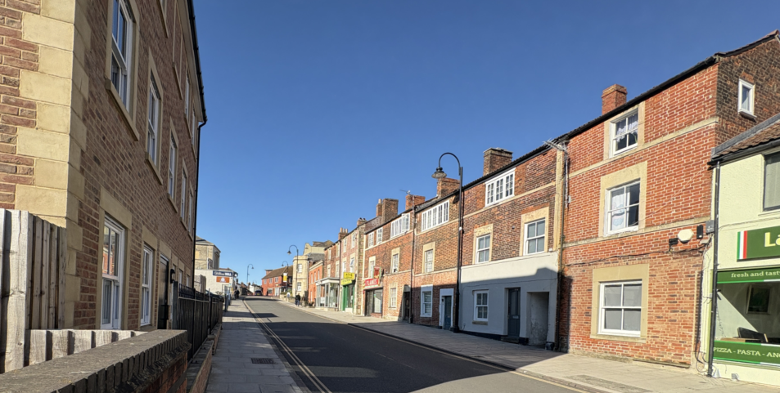

The proposed development is shown to have a more generous setback from the road compared to existing buildings. The proposed development would be sited away from Castle Street, with the area to the front of the proposed semi-detached pair measuring 5.5m wide. In contrast, the neighbouring building that was approved under application reference PL/2021/10112 is shown to be positioned 1m from the public highway, which fails to complement the existing pattern of development and building lines as required by CP57 of the WCS.

The Council’s conservation officer has objected to the proposed development, as whilst the redevelopment of the site for residential use is supported in principle, the proposed design of the semi-detached pair is considered to fail to respond appropriately to the historic character of the site and its surroundings.

The conservation officer acknowledges that the site lies within the Trowbridge Conservation Area and opposite a terrace containing several listed weavers' cottages. Historically, the site was occupied by a terrace of dwellings, but the proposal introduces a pair of semi-detached houses set back from the street, which is unsympathetic to the historic pattern of development, characterised by buildings positioned close to the street frontage.

The conservation officer has also acknowledged the absence of a heritage statement and considers the proposal to adopt a "pastiche" design that replicates aspects of the neighbouring development rather than responding to local historic character.

Paragraph 207 of the NPPF requires applicants to describe the significance of any heritage assets affected, including any contribution made by their setting. As above, no dedicated heritage statement has been submitted as part of this application. While sufficient information is available to allow officers to determine the application, including a site visit, the absence of a robust heritage assessment reduces confidence that the design has been informed by a proper understanding of the significance of the conservation area and nearby listed buildings.

In terms of design, the use of red brick, laid in Flemish bond on the principal elevation, together with a natural slate roof, is welcomed. However, the proposed building is considered to exhibit an overly wide gable span and lacks features such as chimneys, resulting in a form of development that is not considered to adequately complement or respond sympathetically to the historic character and appearance of the area.

It is noted within the submitted representations that concerns were raised regarding the proposed fenestration. Given the sensitive historic setting of the application site, the use of uPVC windows could be a concern in relation to the character and appearance of the conservation area. If planning permission was to be granted, a condition controlling external materials and joinery details would be necessary.

Paragraphs 215 and 216 of the NPPF require any identified harm to the significance of a designated heritage asset to be categorised as either substantial harm or less than substantial harm, and for that harm to be weighed against the public benefits of the proposal.

In assessing the level of harm, it is concluded that the proposal would result in less than substantial harm to the significance of both the Trowbridge Conservation Area and the setting of the nearby listed buildings.

The identified harm arises from the erosion of the established historic character and appearance of the area; the failure of the development to reflect the historic layout, grain and form of development along this part of Castle Street; the introduction of a development form and layout that detracts from the setting of the listed buildings opposite the site; and the loss of an opportunity to secure a more sensitive, historically informed form of development that could positively contribute to the Conservation Area.

The public benefits arising from the proposal include the provision of two additional dwellings on a sustainable town centre site within the Principal Settlement, the contribution towards the housing supply at a time when the Council cannot demonstrate a five-year housing land supply, and the redevelopment of a vacant site. These benefits attract moderate weight. However, the identified public benefits are not considered sufficient to outweigh the less than substantial harm arising to the significance of the conservation area and the setting of nearby listed buildings.

In summary, although the existing site fails to contribute positively to the heritage significance of the area, and the proposal would deliver two additional dwellings at a time when the Council is seeking to improve its housing land supply through the delivery of new homes, the proposal is considered to result in less than substantial harm through poor design and an inappropriate relationship with the historic streetscape and nearby heritage assets, particularly to the conservation area and the listed buildings opposite the application site (Nos. 52-61B Castle Street).

Having carefully considered the public benefits arising from the delivery of two dwellings, redevelopment of a vacant site and contribution to housing supply, these benefits do not outweigh the identified heritage harm.

Consequently, the proposal conflicts with Sections 66 and 72 of the Planning (Listed Buildings and Conservation Areas) Act 1990, policies CP57 and CP58 of the adopted WCS, and the heritage objectives of the NPPF. The proposal would therefore be refused on this basis.

Amenity for Existing and Future Occupiers: Policy CP57 (Point vii) of the WCS requires development to respect the amenity of existing occupants and ensure appropriate amenity levels for future residents.

Paragraph 135 of the NPPF, reinforces the need for development to provide a high standard of amenity for both existing and future users. Criterion 135(f) requires that development ensure a high standard of amenity for existing and future users.

The Wiltshire Design Guide promotes layouts that safeguard privacy, outlook and living conditions, including guidance on the expected size of outside amenity areas for new dwellings.

The proposed development comprises a pair of two-storey semi-detached dwellings located between existing residential and commercial development. Having regard to the scale, siting and orientation of the proposed dwellings, it is not considered that the development would result in any significant adverse impacts in terms of loss of light, outlook, overbearing impact or loss of privacy to neighbouring occupiers in the block of flats.

Whilst first-floor windows are proposed within the side elevations, the plans indicate that these serve bathrooms and would be obscure glazed, thereby preventing overlooking. Similarly, the approved plans for the neighbouring block of flats have been reviewed, and it confirms that the side-facing windows overlooking the proposed application site serve non-habitable rooms, which would prevent overlooking and privacy issues.

Whilst the site is located within a town centre location, the proposal is seeking planning permission for the construction of a semi-detached pair of dwellings, each with three bedrooms, meaning that it can be reasonably assumed the proposed dwellings would appeal to families.

The adopted Design Guide, which elaborates on CP57 of the adopted WCS, is a material consideration in determining planning applications. Section 9.2 of the Design Guide sets out expectations of what private amenity space should be provided for new dwellings and requires all dwellings to be provided with a private open space. In section 9.2.2, there is a requirement for garden areas for all houses to be at least equivalent to the footprint of the house as a minimum and sets out the following:

- In general, a north facing garden for a typical 2 storey house should be minimum of 12m long or up to 15m long for a typical 3 storey house.
- In general, a south, east or west facing garden should be a minimum of 10m deep.

The Design Guide continues in section 9.2.3 that "gardens should avoid excessive shading from planting and overshadowing from buildings i.e. from proximity to trees and neighbouring buildings - generally no more than one third of the minimum private garden area stated should be in shade at any one time" and encourages in section 9.2.4 for garden shapes to be usable "avoiding irregular pointed corners and narrow strips".

The submitted plans show the provision of undersized rear outside amenity areas for each dwelling, with the floor area of each dwelling measuring 44m2 and the garden for Plot 1 scaling as 31m2, and 24m2 for Plot 2 from drawing AH2022/98 Sheet 3 of 3, which falls short of the required garden size detailed in the adopted Wiltshire Design Guide and therefore further calls into question this proposal represents a high-standard of design.

The applicant was encouraged to pursue a car-free development and to reposition the proposed pair of semi-detached dwellings closer to the highway in order to address concerns raised in relation to the original scheme submitted as part of this application. Whilst the on-site parking provision has subsequently been removed, the dwellings remain set back from the public highway. As a result, the proposal not only continues to fail to reflect the historic pattern of development and established building line along this part of Castle Street, but the retention of this setback represents an inefficient use of the site, reducing the depth of the rear gardens, resulting in smaller private amenity spaces than could otherwise be achieved.

As detailed on the submitted plans, the garden provision for the 2-storey properties would be constrained by the proposed boundary treatments and the proposed dwelling itself, which would limit the amenity value of these outside spaces. In addition, due to the orientation of the proposed semi-detached pair and the relationship with the adjacent three-storey building, it is likely that the existing built form would cast a shadow over the proposed gardens, which would adversely affect the quality, usability and perceived openness of the private amenity areas.

The proposed garden areas would be relatively limited in depth and functionality due to the siting of the dwellings within the plot and their relationship with surrounding built development. As a result, the private outdoor space would provide a constrained living environment for future occupiers and would fall materially below the expectations set out within the Wiltshire Design Guide

On this basis, for the reasons highlighted above, this proposal fails to comply with criterion vii of CP57 of the adopted WCS, paragraph 9.2.2 of the Wiltshire Design Guide SPD and paragraph 135f of the NPPF, which require new developments to provide a high standard and appropriate level of amenity for both existing and future users.

Highways Impacts and Parking: In terms of highway matters, proposals must demonstrate:
- Safe and suitable access for all users, including pedestrians, cyclists, and those with mobility impairments.
- No severe residual impacts on the surrounding highway network.
- Promotion of sustainable travel, reducing reliance on private vehicles.
- Adequate parking and cycle provision, in line with adopted standards.
- Protection and enhancement of public rights of way and active travel routes.

Relevant policies include Core Policies 60–64 of the Wiltshire Core Strategy, supported by the Wiltshire Local Transport Plan, Car Parking Strategy, and Cycling Strategy. The Local Cycling and Walking Infrastructure Plan (LCWIP) and LTN 1/20 (DfT) provide further design guidance for active travel infrastructure.

Proposals must also ensure safe access for refuse collection vehicles and comply with the Wiltshire Council Waste Storage and Collection SPD (2017).

As previously noted, the proposal initially sought to provide on-site parking to the front of the semi-detached pair, with two parking spaces proposed for each dwelling. The Council's highways officer objected to the scheme on the basis that vehicles would be required to reverse over an established pedestrian route in order to access the parking spaces. This was considered unacceptable from a highway safety perspective and contrary to the promotion of active travel.

The scheme was subsequently amended to provide one on-site parking space per dwelling. However, as vehicles would still be required to manoeuvre across the existing footway, the highways officer maintained the view that parking to the front of the properties would remain unacceptable.

Given the highly sustainable location of the site within the town centre, the applicant was encouraged to pursue a car-free development. There are a number of public car parks in the vicinity of the site, with access to bus services and the railway station, all of which are within an easy walking distance from the subject site.

A further set of revised plans were submitted on 18 June 2026 which removed the proposed on-site parking provision and excluded the area to the front of the dwellings from the application site.

Following receipt of the latest set of revised plans, the highways officer removed their objection and reiterated their preference for the development to remain car-free in perpetuity. To secure this, they advised that a robust boundary treatment should be provided along the site frontage to prevent the area outlined in blue from being used for vehicle parking in the future.

No details of the proposed boundary treatment along the Castle Street frontage have been submitted as part of the application. However, this matter could be addressed through a planning condition requiring the submission and approval of such details. Given the site's historic setting and noting that the neighbouring block of flats is enclosed by railings on their front elevation, the Council considers that an appropriate frontage treatment, such as matching railings, would be a suitable option to deter the future introduction of parking within the site while preserving the character and appearance of the area.

Subject to a condition securing an appropriate frontage boundary treatment preventing the future use of the frontage area for vehicle parking, the proposed car-free development would not result in an unacceptable impact on highway safety.

Ecology and Biodiversity: The ecological impact of development is a key planning consideration, and it is duly noted that the application site is located within the grey hatched zone of the TWBMS. Proposals must assess and address potential effects on:
- Protected species
- Priority habitats
- Ecological networks
- Green and blue infrastructure

Policy CP50 of the adopted Wiltshire Core Strategy (WCS) requires development to:
- Avoid harm to ecological assets.
- Deliver measurable Biodiversity Net Gain (BNG), in line with the Environment Act 2021.
- Support habitat restoration and connectivity.
- Integrate biodiversity into site design.

The Green & Blue Infrastructure Strategy (2022–2030) promotes nature recovery, ecosystem services, and habitat connectivity through development.

The application site is located within the grey zone of the TWBMS, associated with the Bath & Bradford on Avon Bats Special Area of Conservation (SAC), and therefore the proposal has potential to result in significant adverse impact on the special features of the SAC. An Appropriate Assessment (AA) under Section 63 of the Conservation of Habitats and Species Regulations 2017 (as amended) must be carried out by the relevant Competent Authority (the LPA) to determine the potential significant effects and the suitability of any measures proposed to avoid or mitigate those effects.

The grey medium risk zone represents an area where new residential development is likely to result in increased recreational use of important woodland bat sites. In order to conclude the AA favourably, new residential development proposals for 49 dwellings or less within the grey hatched medium risk zone are expected to provide a financial contribution of £925 per dwelling towards the Council’s strategic recreational pressure mitigation scheme.

It is appreciated that the subject site is located within a town centre location and the site is currently vacant, so no bat habitat would be lost. The AA concludes no adverse effects on the SAC site, subject to the financial contribution being secured by way of a legal agreement.

The Council’s ecologist has confirmed that the site is unlikely to support roosting bats as it possesses no buildings, trees, or other potential roosting structures. The site is within an urban centre, surrounded by street lighting, shops and further housing, and the proposal would not result in the loss of any green habitat. As such, it is unlikely that the works would adversely affect other protected and notable wildlife such as reptiles, amphibians or badgers.

There are records of breeding swifts 40m northeast and 60m northwest, and there are also bat records that appear to be associated with the River Biss 240m south, and greenspace (open park) 340m east. In line with the NPPF and with CP50, applications must ensure that gains for biodiversity, relevant to local habitats and wildlife populations, should form part of the proposed development. As such, biodiversity enhancements, such as provisions for bats and swifts, and wildlife-friendly planting should be incorporated within the proposal and could be secured by planning condition if officers were minded to recommend the application for approval.

In terms of Biodiversity Net Gain (BNG), which became mandatory under Schedule 7A of the Town and Country Planning Act 1990 (as inserted by Schedule 14 of the Environment Act 2021) in February 2024, the proposal is considered to fall within the de minimis exception, based on the submitted information, as it would impact less than 25m2 of no-site non-priority habitat.

CIL & S111 CONTRIBUTIONS

CIL: The proposed development would be liable for CIL as set out in the Wiltshire CIL Charging Schedule dated May 2015. This is a charge that local authorities can impose on new developments in their area. The money generated through the levy would contribute towards the funding of infrastructure to support growth and is payable upon commencement of development. The site would fall under CIL charging Zone 2 where the sum equates to £55 (index-linked) per square metre of floor space created.

Section 111 (s111) Legal Agreement: A Section 111 legal agreement would be required to secure the cost towards strategic mitigation towards the TWBMS, which would amount to £1850 for 2 dwellings. The strategic mitigation must be secured upon the granting of planning permission by completion of s111 process. In the absence of a s111 to secure the necessary funding, this would form a reason to refuse the application.

PLANNING BALANCE AND CONCLUSION: In reaching a decision, all identified harms and benefits must be weighed in the overall planning balance, having regard to Section 38(6) of the Planning and Compulsory Purchase Act 2004 and the provisions of the National Planning Policy Framework.

In this instance, significant weight is afforded to the delivery of two additional dwellings on a vacant town centre site within a sustainable location, particularly in light of the acknowledged shortfall in the Council's housing land supply. Moderate weight is also attributed to the reuse of a vacant site and associated economic activity during construction.

Against these benefits, the proposal would result in less than substantial harm to the significance of the Trowbridge Conservation Area and the setting of nearby listed buildings (particularly to the listed buildings opposite the application site Nos. 52-61B Castle Street) through a design, layout and siting of the proposed semi-detached pair that fail to respond positively to the established historic pattern of development and building line of Castle Street. The proposal would also fail to provide adequate private amenity space for future occupiers.

The existence of the extant planning permission for six flats is acknowledged as a material consideration and establishes a realistic fallback position. However, the current application must be assessed on its own merits. The existence of an alternative implementable permission does not outweigh the identified design, heritage and amenity concerns associated with this proposal.

Having regard to the statutory duties under Sections 66 and 72 of the Planning (Listed Buildings and Conservation Areas) Act 1990, and giving great weight to heritage conservation as required by the NPPF, the identified public benefits are not considered sufficient to outweigh the identified harms. The proposal therefore conflicts with CP57 and CP58 of the Wiltshire Core Strategy and the NPPF when read as a whole.

RECOMMENDATION: That Planning Permission be REFUSED.

