HURST ASSOCIATES
CHARTERED BUILDING SURVEYORS

BUILDING SURVEY UNDERTAKEN ON
MANOR HOUSE, GREAT HINTON, WILTSHIRE BA14 6BZ
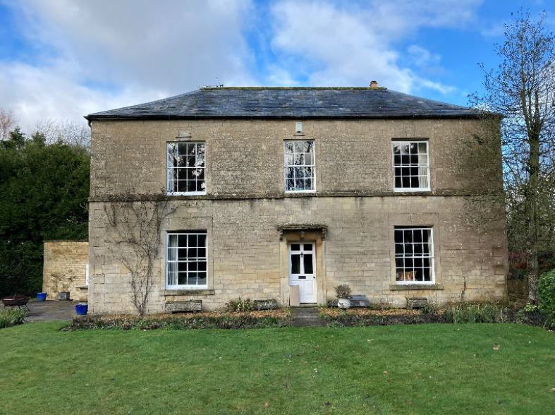

ON BEHALF OF
MR K HOWES & MS C LAWRENCE


AH/SH
29th January 2021
Mr K Howes and Ms C Lawrence
Sent by email
BUILDING SURVEY REPORT ON THE MANOR HOUSE, GREAT HINTON, WILTSHIRE BA14 6BZ

REPORT ON INSPECTION CARRIED OUT TO MANOR HOUSE, GREAT HINTON, WILTSHIRE BA14 6BZ
DATE OF INSPECTION 29TH JANUARY 2021
The weather at the time of the inspection was overcast with intermittent light rain following heavy overnight rain. Temperature around 8°C.
At the time of the inspection the property was furnished and occupied by the Vendor.

1. CONFIRMATION OF INSTRUCTIONS
To inspect the property, prepare a report upon its condition and advise the Client as to the need for any specialists' reports, if considered necessary by the Surveyor.
This report shall be for the private and confidential use of the Client for whom the survey is undertaken and the Client's solicitor only, in connection with the purchase of the property, and must not be reproduced in whole or in part or relied upon by third parties for any use without the express written authority of this Practice. The copyright of this report remains with Hurst Associates (Bath) Limited.
Where referred to in this report, left side and right side of the property are to be read as if standing facing the elevation referred to, unless specific contrary indication is given.
The property is a Listed Grade II Georgian country house with later additions built in natural local stone under a series of pitched roofs covered in natural slate. Within the grounds there is a tennis court, swimming pool, timber stable and detached stone built garage. The property sits in a plot of approximately three acres laid mainly to lawn.
The property was Listed on the 29th January 1988. List Entry No is 1262853 classified Grade II. Listing National Grid Reference ST9098459252

GARAGE
There is a stone built garage adjacent to the car parking area to the north of the house. This is built in natural local rubble stone with dressed stone quoins and part brickwork detailing. There are two buttresses located to the north elevation providing some restraint to the north elevation. The garage has a mono-pitched roof covering in corrugated sheeting.

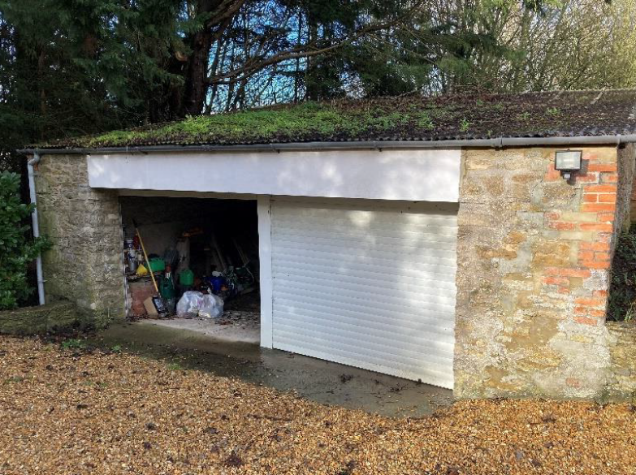

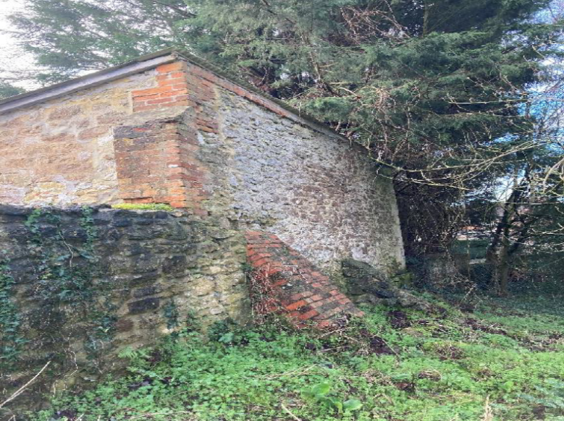

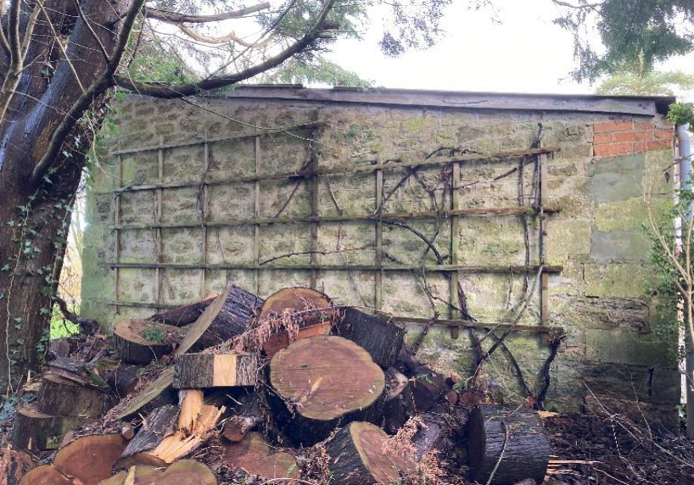

Movement is noted through the external walls to the garage and this would appear to be for a combination of reasons. The foundation system to the garage is likely to be at a relatively shallow depth. This is the elevation where two buttresses have been provided in an attempt to provide some restraint. Movement is also noted to the south west corner of the garage.
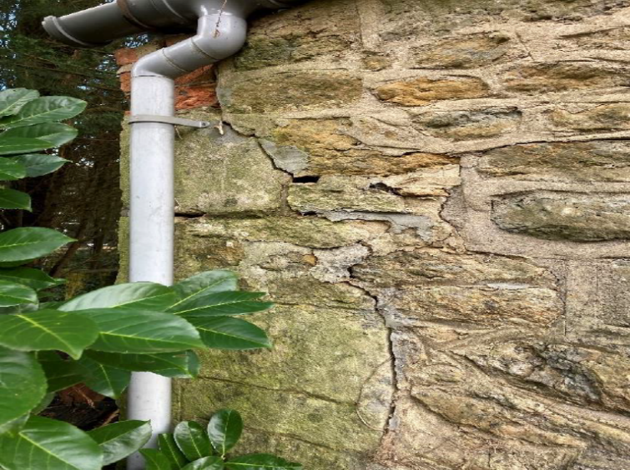

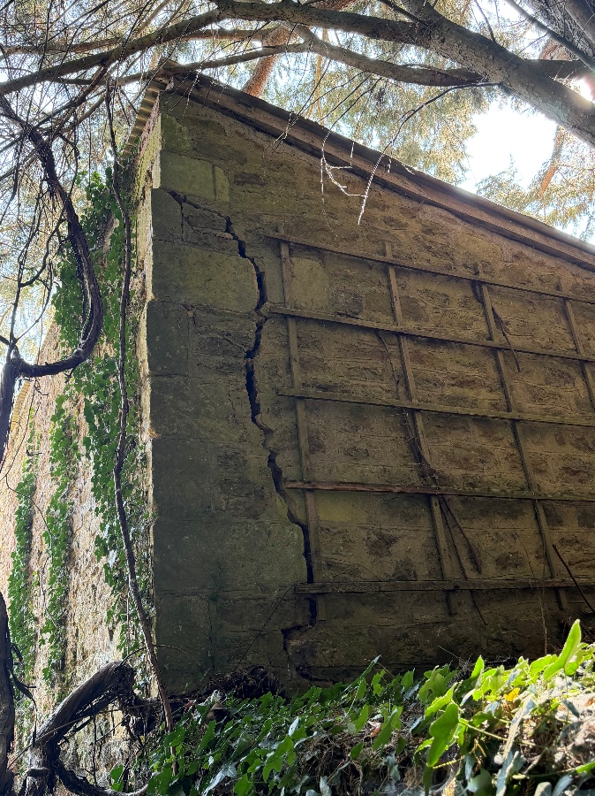

The proximity of the, now fallen and removed, adjacent large mature tree and the effect that its root had on the garage structure in conjunction with the drainage gulley and downpipe which appear to discharge straight into the ground are causing the instability. Fracturing is also noted through the concrete apron to the front of the garage and there is an open gulley to the interior of the garage which discharges straight through the west elevation wall causing further saturation of the ground.

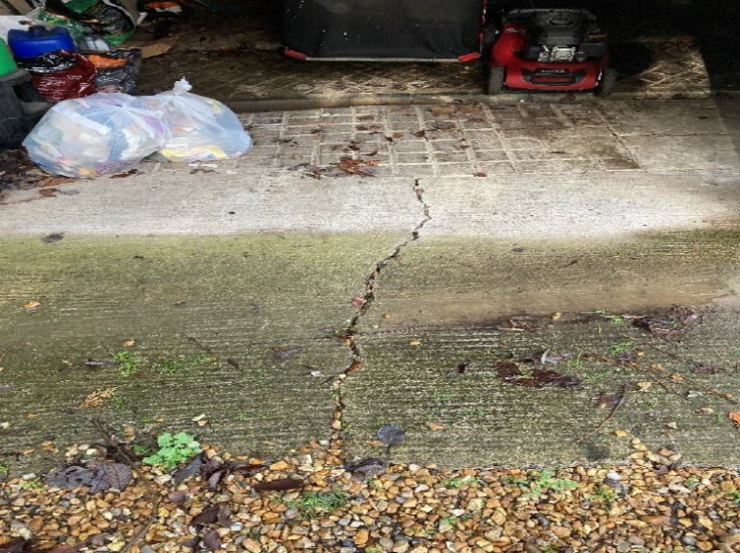

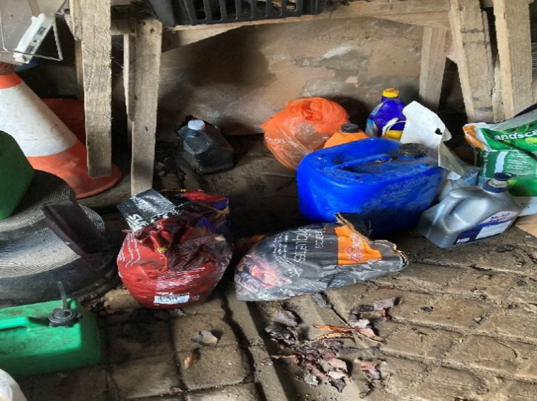

The internal floor is a mix and match of varying materials and much movement has occurred to the finishes over time.
Originally the building would have two large lateral ties and these appear to have been removed but the remainder of the ends of the ties are noted in the north elevation wall.

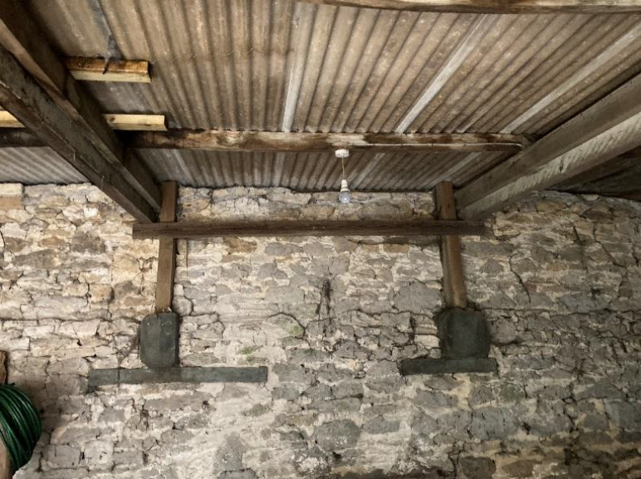

Two large section timber roof beams are supported by vertical timbers. These in turn support 100mm x 50mm timber purlins which in turn support the corrugated Asbestolux sheeting. The sheeting is fractured in many places and new timbers have been sleeved above the purlins in an attempt to prevent further movement here. The purlins show evidence of much water ingress.

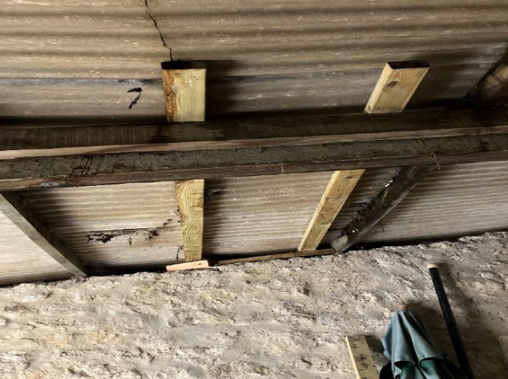

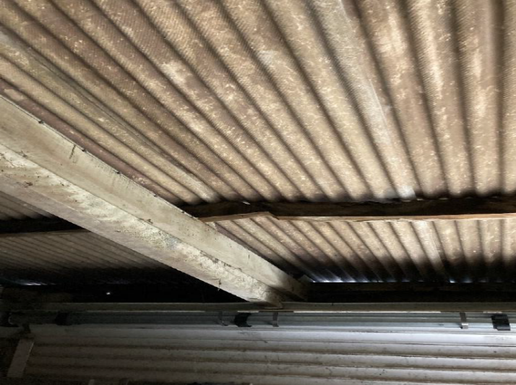

Deflection to the lower purlins has caused a spliced joint to open up and further fracturing of the panels here has allowed water ingress. The roof to the garage certainly has very limited life and I would recommend this is replaced immediately. Some consideration should be given to providing more robust restraint to the external walls as part of any refurbishment programme.

