Design and Access Statement

The Manor House, Main Street, Great Hinton, Wiltshire

Demolition of Condemned Double Bay Garage to Two Storey, Four Bay Garage

Claudia and Kevin Howes

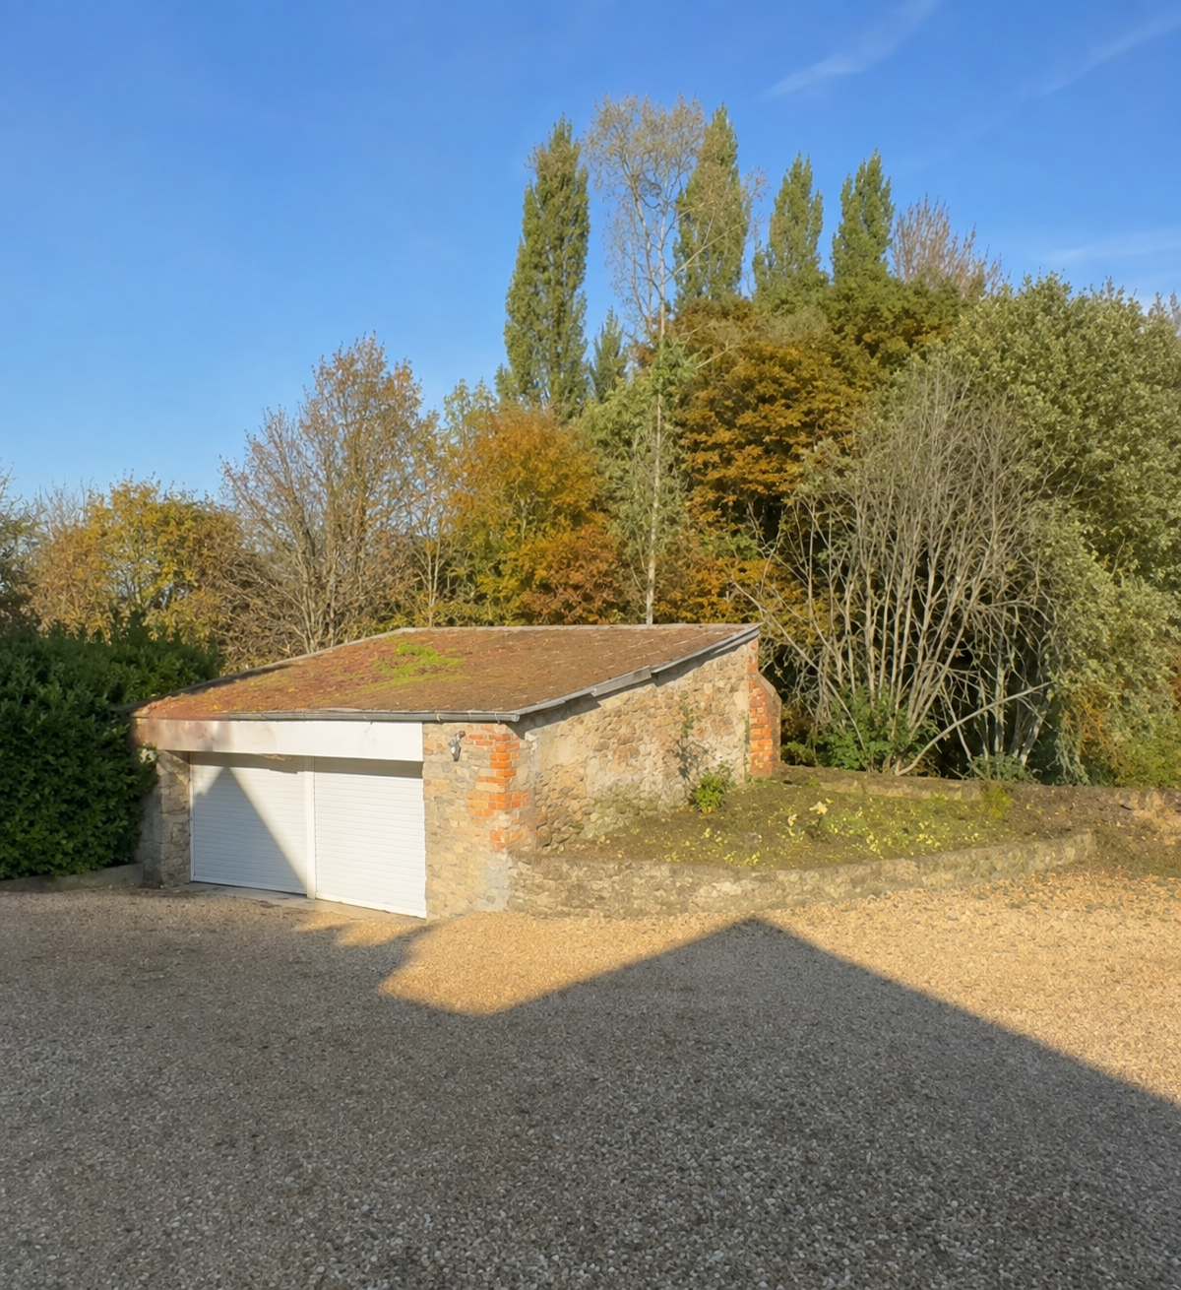
Introduction

The Manor House is a Grade 2 Listed Building that sits within gardens and grounds in excess of 3 acres on the eastern edge of the village.

The building was first listed in January 1988; its listing entry number is 1262853.
This document has been prepared as supporting information to the submitted ‘Householder Application for Householder planning on the demolition and replacement of an outbuilding within the boundary of a Grade II listed building.
Grade 2 Listed Building Details

The Historic England listing documentation details the listing as follows:
‘Detached house. Early 1g" century. Dressed limestone, hipped Welsh slate roof with brick stacks. Two storey, 3 window. Central door with 4 fielded panels and integral transom light, flat stone hood on brackets. 16 pane sash in plain architrave either side. Plat and to sill of first floor windows, central 12 pane sash with flanking 16 pane sash. Lean to conservatory attached to left return. Rear two storey wing with casement on lower roof line.’

The Property

The Manor House is an example of a late Georgian country house with later additions and consists of the following accommodation:

Ground Floor:
Entrance Hall, Cloakroom, Dining Room, Kitchen/Breakfast Room — extended in 2007 in
place of the earlier conservatory, utility room.
Cellar
First Floor:
5 bedrooms, 3 bathrooms, attic rooms.

The house sits approximately in the middle of its gardens and is screened by a well
established tree-lined boundary.

Planning History
W/94/00696/LBC_ Enlargement of kitchen window approved 7/11/94

W/96/01353/FUL Addition of a conservatory adjacent to the kitchen approved on
12/2/1996

W/07/03340 Full Application for the demolition of the existing conservatory
and the construction of new addition of accommodation and 2" floor level, replacement of
some windows and re-alignment of the south elevation. This application was approved on
23/11/2007.

A further application W 89/01474/FUL was made for loose boxes for horses with
accompanying storage at the rear of the property. This was approved on 19 /9/1989.

PL/2021/10681 Addition of glazed bi-fold doors to kitchen/breakfast room in lieu of a pair of French doors and three windows. Approved 05/1/2022

The Proposal

This application is for the demolition of a condemned two bay flat roof, unusable garage, to be replaced with a four bay, two storey garage.
This is illustrated on the submitted plans and elevations.

The existing garage / outbuilding sits at the rear of the property and is accessed by a long private drive curving around the back of the main house. Existing vehicular access is fully retained. There is no, new highway access required with pedestrian arrangements unchanged; The new proposed garage will sit on the same footprint as the original but extend out further to the right, maintaining the same distance, adjacency from the house.

Conclusion
The proposed will ensure the property has a usable garage for its occupants with storage space that reflects the size and requirements of a detached dwelling of this capacity and nature. The garage is subordinate to the listed house and does not compete with the house architecturally.

Repair and retention are not reasonable or appropriate. For example, structural deterioration, inadequate foundations, roof failure, movement, damp, unsuitable construction and disproportionate repair requirements currently exist.

The simple, wooden and earthy design of the external weatherboarding and glazed element will complement the buildings Grade 2 listing and natural surroundings.

Both the existing building and the new proposed are surrounded by trees and hedge-lined boundaries and therefore cannot be seen from the Main Street approach into Great Hinton or any neighbouring properties.

The size of the new garage has been increased to reflect modern vehicle dimensions, secure storage, bicycles, garden equipment, workshop/storage requirements.

The additional size has been designed to minimise its impact by using part of the original footprint and ensure the view from the house are not affected by the height of the new proposed garage.

The proposal for this new natural design is more sympathetic and in keeping with the main building and its surroundings than the existing, which is made of a newer modern brick and has no architectural/historic merit, unlike the stone of the main house. The garage will have views towards the house and away from the property, looking down to open ground within the boundary.

