APPLICATION FOR FULL PLANNING PERMISSION
DELEGATED REPORT

APPLICATION REFERENCE: | PL/2026/02625
APPLICATION TYPE: | Full Planning Permission
SITE ADDRESS: | Fitzmaurice Primary School, Frome Road, Bradford On Avon, BA15 1LE
DEVELOPMENT DESCRIPTION: | Erection of a 5m x 5m timber gazebo adjacent to the playground to provide a dedicated outdoor learning space
RECOMMENDATION: | That Planning Permission be GRANTED

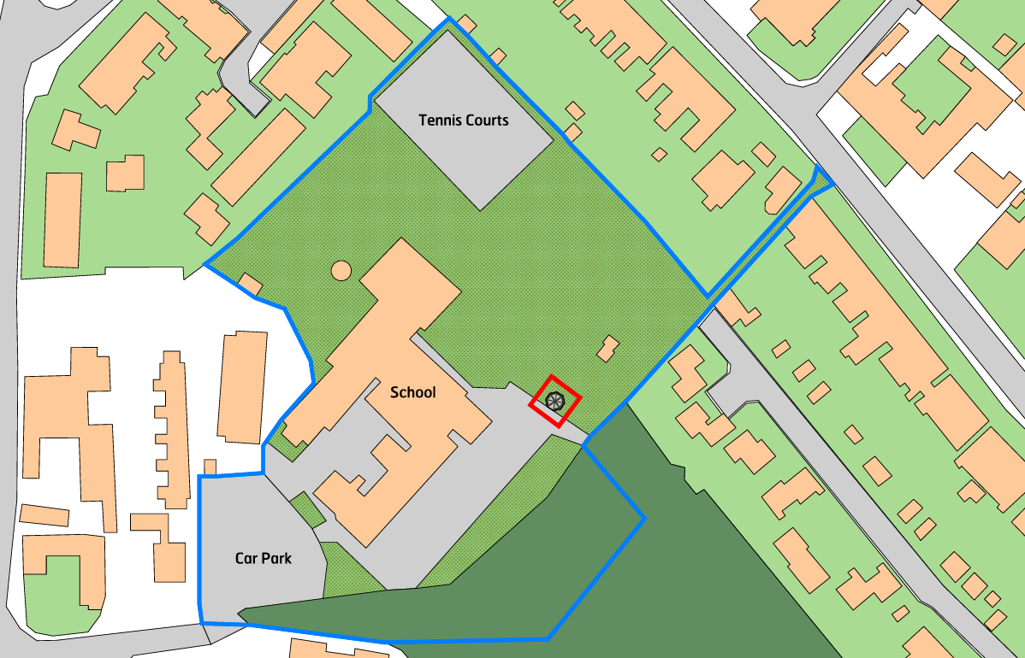

PROPOSAL

The application seeks planning permission for the erection of a detached octagonal gazebo/bandstand style structure within the grounds of the primary school. The proposed structure would measure 4.9 metres in width and length, with a maximum height of 3.9 metres to the apex of the pitched roof. The gazebo would comprise a timber frame construction with an octagonal felt-covered roof rising to a central point and would be positioned within an existing area of school grounds between the main school building and the larger playing field.

SITE DESCRIPTION / CONTEXT

The application site forms part of an established primary school located within the Bradford on Avon settlement boundary and within the Bradford on Avon Conservation Area. The school comprises a mixture of traditional bath stone buildings alongside more modern elements finished in off-white render, white cladding, clay tile roofing and white uPVC windows and rainwater goods. The proposed gazebo would be sited within an open area of school grounds between the school buildings and playing fields. A public footpath runs along part of the south-eastern boundary, although mapping indicates that the public right of way terminates before reaching the section directly adjacent to the proposed location. The site lies within Flood Zone 1 and is identified as being at a low risk of groundwater flooding. Ecological constraints include Greater Horseshoe and Lesser Horseshoe Bat Core Roost Buffers and the Greater Horseshoe SAC Parcel Buffer, while an area of priority habitat woodland is located beyond the southern boundary of the school.

PLANNING HISTORY

Reference No. | Proposal / Summary | Decision
W/00/01561/FUL | Construction of open sided glazed roofed covered way linking separate blocks of school buildings | Approved
W/06/00728/FUL | Flat roof single storey link between two buildings to include a disabled toilet | Approved
W/11/02388/FUL | Proposed covered play area | Approved

RELEVANT LEGISLATION, POLICIES AND GUIDANCE

Wiltshire Core Strategy:

Core Policy 1 Settlement Strategy;
Core Policy 2 Delivery Strategy;
Core Policy 7 Spatial Strategy: Bradford on Avon Community Area;
Core Policy 50 Biodiversity and Geodiversity;
Core Policy 51 Landscape;
Core Policy 57 Ensuring High-Quality Design and Place Shaping;
Core Policy 58 Ensuring Conservation of the Historic Environment;
Core Policy 60 Sustainable Transport;
Core Policy 61 Transport and Development;
Core Policy 64 Demand Management;
Core Policy 67 Flood Risk;

Bradford on Avon Neighbourhood Plan 2013-2026

The National Planning Policy Framework (NPPF) and The Planning Practice Guidance (PPG)

Wiltshire Design Guide

The Wiltshire Local Transport Plan 2011 – 2026: Car Parking Strategy (March 2015).

The Wiltshire Local Transport Plan 4 (LTP4) (March 2025)

New Wiltshire Local Plan

At Full Council on 19 May 2026, the elected members of Wiltshire Council agreed to withdraw the emerging Wiltshire Local Plan. The said Plan has no material weight for the purposes of the application.

In accordance with Regulation 19 of the Town and Country Planning (Local Planning) (England) Regulations 2026, on 30th June 2026 Wiltshire Council published a notice of intention to prepare a new local plan for Wiltshire. The next stage is a Scoping Consultation which commences on 2nd September 2026. This plan is at a very early stage and currently carries no weight for decision making.

CONSULTATION RESPONSES

Bradford on Avon Town Council – No Objection

REPRESENTATIONS

One comment was received from the Bradford on Avon Preservation Trust stating support for the application on the basis that it would enhance the amenity of the school grounds.

ASSESSMENT

Section 38(6) of the Planning and Compulsory Purchase Act 2004 states:

"If regard is to be had to the development plan for the purposes of any determination to be made under the planning Acts, the determination must be made in accordance with the plan unless material considerations indicate otherwise."

In accordance with this statutory requirement, this application has been assessed against the relevant policies of the Development Plan, including the adopted Wiltshire Core Strategy (2015) and, where applicable, any made Neighbourhood Plans.

The proposed development represents an ancillary structure associated with the lawful and established use of the site as a primary school. The site is located within the Bradford on Avon settlement boundary where educational uses are established and supported in principle. The gazebo would provide additional outdoor teaching, recreational or sheltered space in connection with the existing school operation and would not result in any change of use of the site. As such, the principle of development is considered acceptable.

Design and Impact the upon the character and context of the area

Core Policy 57 Ensuring High Quality Design and Place Shaping of the Wiltshire Core Strategy requires all new development to achieve a high standard of design that responds positively to its local context. Proposals must reinforce and enhance local character and distinctiveness, relate appropriately to the surrounding landscape, and demonstrate a thoughtful response to existing townscape features. This includes careful consideration of elements such as building height, scale, massing, building line, materials, and overall appearance, ensuring new development integrates harmoniously with its setting.

The proposed gazebo is modest in scale, measuring approximately 4.9 metres across and 3.9 metres in height, and would occupy a limited area within the wider school grounds. The timber frame construction is considered appropriate within the context of the site, particularly given the presence of woodland along the southern boundary and existing cladding elements within the school campus. Whilst the materials do not directly replicate those of the main school buildings, the structure is clearly subordinate and ancillary in nature, and its simple design reflects that of a typical park or educational shelter. The felt roof covering is also not considered incongruous, given the presence of similar roofing materials on parts of the existing school buildings. Overall, the proposal would integrate satisfactorily within its surroundings and would not result in any harmful visual impact.
Having regard to the above, the proposal complies with the design principles set out in Core Policy 57 of the Wiltshire Core Strategy and the Wiltshire Design Guide.

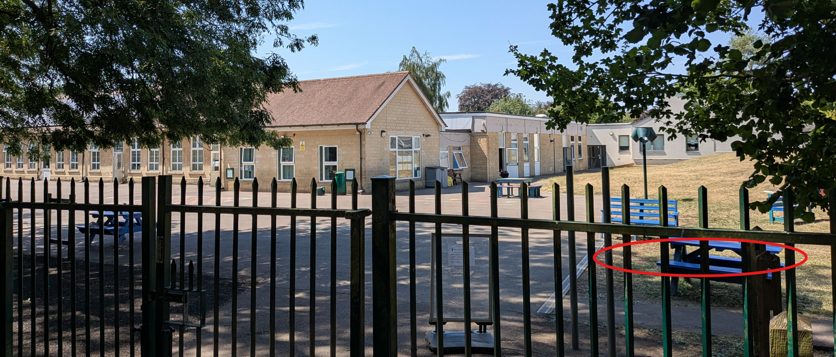
Site Image and indicative location for gazebo

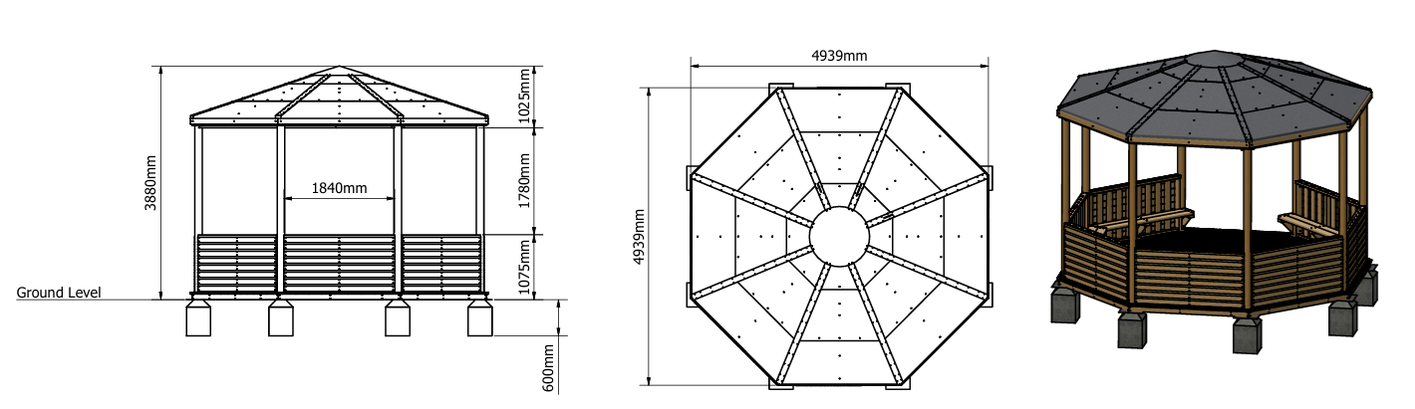
Proposed Elevations and 3D Render

Conservation and Heritage

Core Policy 58 outlines development consideration with regard to the historic environment. The policy states that heritage assets and their settings must be conserved and, where appropriate, enhanced through any proposed development.

The site lies within the Bradford on Avon Conservation Area; however, the proposed gazebo would be located within a part of the school grounds that is largely screened from wider public views by existing buildings, boundary vegetation and the site's established layout. There are no nearby listed buildings with which the development would have a significant visual relationship, and the structure would be viewed primarily from within the school grounds themselves. Given its modest scale, ancillary nature and limited visibility, the proposal would preserve the character and appearance of the Conservation Area and would result in no harm to designated heritage assets.

Amenity

Point vii of Core Policy 57 Ensuring High Quality Design and Place Shaping of the Wiltshire Core Strategy seeks to ensure that developments do not adversely affect neighbouring properties. The National Planning Policy Framework (NPPF), particularly Paragraph 135, stresses that planning decisions should ensure developments provide a high standard of amenity for existing and future users.

The proposed gazebo would be situated well within the school grounds and at a substantial distance from neighbouring residential properties. Owing to its limited footprint and height, the structure would not result in any loss of light, overshadowing, overbearing impact or loss of privacy to surrounding occupiers. Whilst the gazebo may provide a focus for outdoor activity, it would be located within an existing school environment where outdoor recreation already occurs, including within adjacent hardstanding and seating areas. Furthermore, existing boundary vegetation and separation distances would mitigate any potential noise effects. As such, the proposal is not considered to give rise to any unacceptable impact on residential amenity.

The proposal therefore accords with Core Policy 57 point vii in respect of safeguarding residential amenity and the Wiltshire Design Guide.

Transport and Highways

Core Policy 60 of the WCS states that Council will support and encourage safe and efficient movement of people and, where necessary, mitigate the impact of development on transport users and local communities. Core Policy 61 specifies that development should demonstrate that consideration has been given to a hierarchy of transport users and that proposals must, where relevant, serve as a safe access to the highway network. Paragraph 116 of the NPPF states that “Development should only be prevented or refused on highways grounds if there would be an unacceptable impact on highway safety, or the residual cumulative impacts on the road network, following mitigation, would be severe, taking into account all reasonable future scenarios”.

The proposal would not alter existing vehicular or pedestrian access arrangements to the site and would not affect parking provision within the school. As an ancillary structure serving the existing educational use, the development would not generate additional vehicle movements or traffic demand. Accordingly, no highway safety or transport-related concerns arise from the proposal.

Ecology

The WCS, through Core Policy 50, states that development proposals are expected to avoid and reduce disturbance of sensitive wildlife species and habitats. Biodiversity Net Gain (BNG) was established as a mandatory aspect of planning evaluation through Schedule 7A of the Town and Country Planning Act 1990 (as amended by the Environment Act 2021 Schedule 14).

The proposed development would be located on an area of managed grassland within an established school setting adjacent to existing hardstanding. The site of the structure is not considered to provide significant ecological value and there is no indication that the proposal would result in the loss of important habitats or impacts upon protected species. Although the site falls within various bat-related consultation buffers and lies in proximity to an area of priority habitat woodland beyond the southern boundary, the scale and nature of the proposal are such that no adverse ecological effects are anticipated. The proposal is therefore screend out of the requirement for Appropriate Assessment under the Habitats Regulations. The footprint of the structure also falls below the threshold for mandatory Biodiversity Net Gain requirements. The proposal is therefore considered acceptable in ecological terms.

Flooding and Drainage

Core Policy 67 Flood Risk of the Wiltshire Core Strategy requires all development to be located, designed, and constructed to minimise vulnerability to flooding and to avoid increasing flood risk elsewhere. Proposals must demonstrate that surface water can be managed safely and sustainably, incorporating appropriate drainage solutions—such as sustainable drainage systems (SuDS)—that ensure runoff rates and volumes do not exceed pre‑development levels. Development should provide measurable betterment where necessary, ensuring that drainage strategies are robust, technically compliant, and aligned with national policy. The NPPF sets out the application of a sequential, risk-based approach to the location of new development in paragraph 172.

The site is located within Flood Zone 1, which is the area of lowest probability of fluvial flooding. Whilst the Council's Strategic Flood Risk Assessment identifies a low risk of groundwater flooding, the proposed gazebo would introduce only a very limited area of additional impermeable surface in the form of the roof covering. Given the modest scale of the development and the negligible increase in surface water runoff that would result, no drainage or flood risk concerns are identified.

CONCLUSION

The proposed gazebo constitutes a modest ancillary addition within the grounds of an established primary school located within the settlement boundary. The development is acceptable in principle and, by virtue of its scale, design and siting, would integrate appropriately within the site without harming the character and appearance of the area or the Bradford on Avon Conservation Area. Furthermore, the proposal would not adversely affect residential amenity, ecology, drainage arrangements or highway safety. For these reasons, the development is considered to represent sustainable development and is recommended for approval.

RECOMMENDATION: That Planning Permission be GRANTED subject to the following conditions:

1.
The development hereby permitted shall be begun before the expiration of three years from the date of this permission.
REASON: To comply with the provisions of Section 91 of the Town and Country Planning Act 1990 as amended by the Planning and Compulsory Purchase Act 2004.

2.
The development hereby permitted shall be carried out in accordance with the following approved plans and documents:

Gazebo Plan 1 (23 April 2026)
Gazebo Plans 2 (23 April 2026)
Gazebo Dimensions (30 June 2026)
Site Plan (21 May 2026)
Location Plan (29 June 2026)

REASON: For the avoidance of doubt and in the interests of proper planning.

