APPLICATION FOR FULL-PLANNING PERMISSION CASE OFFICER REPORT

APPLICATION REFERENCE: | PL/2026/02587
APPLICATION TYPE: | Full planning permission
SITE ADDRESS: | Netton Barn, Netton, Salisbury
DEVELOPMENT DESCRIPTION: | Conversion of Barn to 1no. Dwelling, Creation of Garden, Parking, Installation of Package Treatment Plant and Associated Works (Part Retrospective)
RECOMMENDATION: | Approve with Conditions

SITE DESCRIPTION/CONTEXT

The application site is located in an isolated location in the hamlet of Netton, which comprises of a small cluster of residential dwellings but is mainly rural in character with fields forming a large part of the locality. Netton is a settlement considered to be too small to be eligible for Small Village status, as defined by Wiltshire Core Strategy (WCS) core policies 1 (Settlement Strategy), 2 (Delivery Strategy) and 4 (Spatial Strategy for the Amesbury Community Area) and is therefore considered to be in the open countryside.
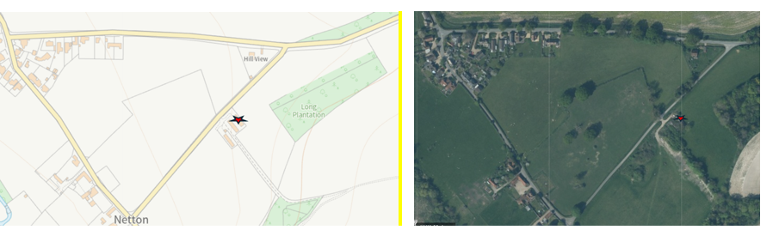
The site is located outside of the conservation area which is shown below as the shaded darker green area, nearby listed buildings also shown below as hatched black. The application site is surrounded by open countryside/fields.

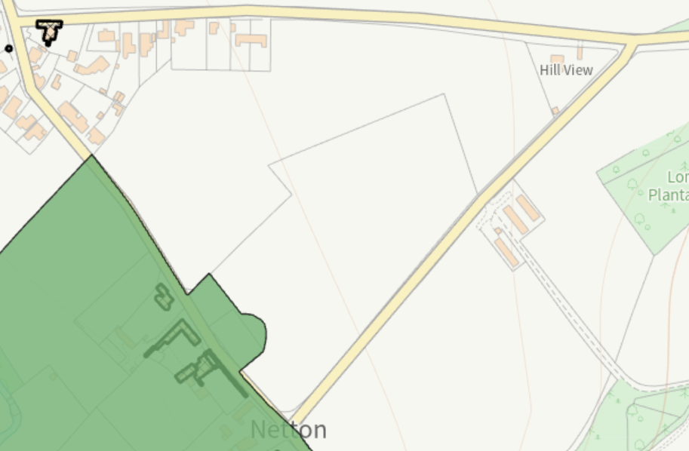
The application site relates to an existing former agricultural building (poultry shed) which became a general storage shed, located within an agricultural holding relating to land surrounding this building. The building subject to this application is one of three former poultry sheds on the site. The other two buildings were in poor state of repair and partial collapse as well as being very overgrown and were redundant, these have recently been removed from site due to a condition on the extant Class Q application.

The building is rectangular in shape with a pitched roof and has an approx. internal floor area of 123 metres square. The site is located within a Special Landscape Area as defined by saved policy C6 of the Salisbury District Local Plan (SDLP). Whilst the site is located within Flood Zone 1 and some distance from any rivers, the site is located within the River Avon Catchment Area. Public right of way – bridleway DURN20 crosses the site in a south easterly direction using the existing site access from the road. The land has an Agricultural Land Classification of Grade 3.

Existing building as approved under PL/2024/10916 shown below

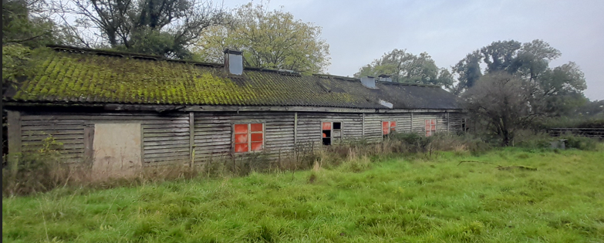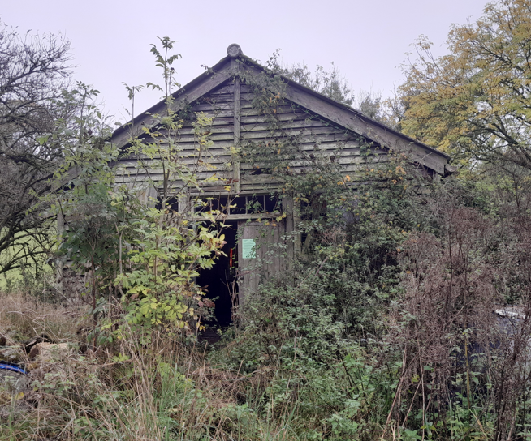

PROPOSAL

The application is seeking full planning permission for the conversion of an existing barn to one dwelling with the creation of a garden, parking, installation of package treatment plant and associated works.

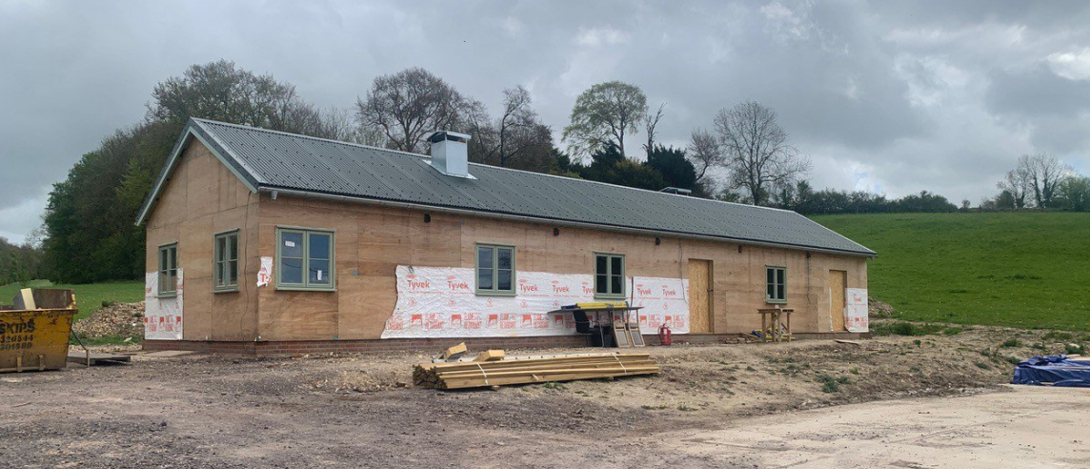

The existing former poultry barn benefits from an implemented Class Q Prior Approval (Ref. PL/2024/10916) for conversion to a single dwelling. The approved conversion works have commenced following the approved plans and elevations, keeping a similar form, scale, layout and external appearance approved building, hence the part retrospective nature of this current application. A photo of the building in situ is shown above.

The applicant submitted a Regulation 77 application, our ref: PL/2025/06702 relating to the Habitats Regulations Assessment (HRA) process under the Conservation of Habitats and Species Regulations 2017 to secure mitigation for phosphate loading within the River Avon SAC catchment. It was established through the course of this application that it was not possible to install a PTP within the constrained red line site of the Class Q approval and that the PTP would need to be sited further from the barn conversion on land that was still agricultural. This application was subsequently withdrawn and, a full planning application would be required to install the PTP with the applicant required to secure mitigation through another means.

It was discussed that the applicant could submit a full planning application for a barn conversion using the Class Q approval as a fallback position and include additional land and further details to address the nutrient issue.

This application in essence seeks permission for:

- Retention and completion of the barn conversion to a single dwelling (part retrospective).
- Creation of a larger residential curtilage than could reasonably be achieved under Class Q.
- Provision of parking and associated residential infrastructure.
- Installation of a Graf One2Clean package treatment plant and associated drainage infrastructure.
- Landscaping and garden areas associated with the dwelling.

During the course of the application amendments have been made to the proposals relating to the red line and parking when it was established that the original red line plan incorrectly included part of the public right of way.

PLANNING HISTORY

Proposal / Summary
20/06265/FUL - Full planning permission Decision - Refused Date: 28/10/2020 – Change of use of existing redundant barn and land to create one dwelling, parking and residential curtilage.
PL/2022/03395 - Full planning permission Decision - Withdrawn by Applicant Date: 22/8/2022 – Demolition of two existing barns, conversion of existing redundant barn to residential, parking and associated works.
PL/2024/08810 - Prior approval Part 3 Class Q: Agricultural buildings to dwellinghouses Decision - Prior Approval Refused Date: 20/11/2024 – Change of Use from Barn to create 1 x 3 bed residential dwelling under Schedule 2, Part 3, Class Q (a and b) of the General Permitted Development Order 2015 (as amended)
PL/2024/10916 - Prior approval Part 3 Class Q: Agricultural buildings to dwellinghouses Decision - Prior Approval Granted Date: 14/1/2025 – Change of Use from Barn to create 1 x 3 bed residential dwelling under Schedule 2, Part 3, Class Q (a and b) of the General Permitted Development Order 2015 (as amended)
PL/2025/06702 - Regulation 77 Application Decision - Withdrawn by Applicant Date: 17/12/2025 – Application under Regulation 77 of the Conservation of Habitats and Species Regulations 2017 (as amended), for the phosphate mitigation associated with the approved conversion of Netton Barn to a single dwelling under Class Q of the GPDO
PL/2025/07860 - Approval of details reserved by a condition Decision - Approve with Conditions Date: 24/11/2025 – Discharge of Condition 2 of PL/2024/10916 Relating to statement/letter report must be provided for approval by the local planning authority in writing, which confirms the historical uses of the site/building and how development works will address any potential for land contamination

RELEVANT LEGISLATION, POLICIES AND GUIDANCE

Statutory Legislation:

National Planning Policy:
- National Planning Policy Framework (NPPF)
- Planning Practice Guidance (PPG)
- National Design Guide

Development Plan:
The development plan for Wiltshire comprises the Wiltshire Core Strategy (WCS) (adopted January 2015) and any made neighbourhood plans, which remains the principal statutory planning document guiding development across the county. In line with Section 38(6) of the Planning and Compulsory Purchase Act 2004, planning decisions must be made in accordance with the development plan unless material considerations indicate otherwise.

Though the development plan is considered as a whole, those parts deemed to be particularly relevant to this application are listed below:

The adopted Wiltshire Core Strategy (WCS), with particular regard to:

Core Policy 1: Settlement Strategy
Core Policy 2: Delivery Strategy
Core Policy 3: Infrastructure Requirements
Core Policy 4: Spatial Strategy for the Amesbury Community Area
Core Policy 41: Sustainable Construction and Low Carbon Energy
Core Policy 45: Meeting Wilshire’s Housing Needs
Core Policy 48: Supporting Rural Life
Core Policy 50: Biodiversity and Geodiversity
Core Policy 51: Landscape
Core Policy 57: Ensuring high Quality Design and Place Shaping
Core Policy 61: Transport and New Development
Core Policy 64: Demand Management
Core Policy 69: River Avon SAC

Salisbury District Local Plan 2011

Saved Policy C6: Special Landscape Area (SLA)

Wiltshire Housing Site Allocations Plan (February 2020) (WHSAP)

Other:

Wiltshire Design Guide
Wiltshire Local Transport Plan 2011-2026: Car Parking Strategy
Adopted Supplementary Planning Document 'Creating Places Design Guide’ April 2006
Creating Places Design Guide

ISSUES

Principle
Design, character and landscape impacts
Amenity
Highways
Ecology

CONSULTATION RESPONSES

Highways – no objection subject to conditions

Ecology - no objection subject to conditions

Rights of Way – no objection

Parish Council – no comments have been received

REPRESENTATIONS

One third party comment received which is included in full below, these comments were received on the original plans submitted and not on the amended plans received.

On behalf of the British Horse Society Wiltshire Access Team, I fully support the objection to this application made by Jane Hughes of Wiltshire Council Rights of Way team. Bridleways have the same status as public roads, and this application is therefore applying to develop land which is in fact part of the legal width of a public highway.

ASSESSMENT

Section 38(6) of the Planning and Compulsory Purchase Act 2004 states:

"If regard is to be had to the development plan for the purposes of any determination to be made under the planning Acts, the determination must be made in accordance with the plan unless material considerations indicate otherwise."

In accordance with this statutory requirement, this application has been assessed against the relevant policies of the Development Plan, including the Wiltshire Core Strategy (2015) and, where applicable, any made Neighbourhood Plans. Consideration has also been given to the policies of the National Planning Policy Framework (NPPF) as a material consideration in the assessment.

The assessment below considers each of the main issues identified above. Each topic is assessed in turn with reference to the relevant policy context, the evidence submitted, consultee responses, and all other material considerations, before a conclusion is reached.

Principle of Development

The principle of the conversion of the agricultural building to a single dwelling has already been established through the grant and implementation of Prior Approval under Schedule 2, Part 3, Class Q of the Town and Country Planning (General Permitted Development) (England) Order 2015 (as amended) reference PL/2024/10916. The lawful fallback position weighs significantly in favour of the proposal, as the conversion of the building to a dwelling can be completed irrespective of the outcome of the current application.

As such, the current application does not in essence require a reassessment of whether the building is suitable for residential conversion or whether a dwelling is acceptable in this location. These matters have already been established through the Class Q consent and its implementation. The key considerations are therefore more limited to the acceptability of the proposed residential curtilage and the associated package treatment plant and drainage infrastructure.

The proposed curtilage would provide a practical and proportionate residential setting for the approved dwelling, allowing for outdoor amenity space and associated domestic uses. Subject to its visual and landscape impacts being acceptable, the principle of a modest extension of the residential curtilage is considered reasonable in the context of the implemented Class Q fallback position

Furthermore, the provision of a package treatment plant is necessary to facilitate lawful residential occupation of the approved dwelling and to address nutrient neutrality requirements associated with the River Avon SAC catchment. In principle, foul drainage infrastructure represents an ancillary and essential component of the approved residential use.

Accordingly, having regard to the extant and implemented Class Q approval, the proposal is considered acceptable in principle, with the determination of the application resting on the detailed assessment of landscape impact, residential amenity, drainage, ecology and any other material planning considerations.

Design, character and landscape impacts

The NPPF puts great emphasis on the need for good design. Section 12 of the NPPF seeks to achieve well designed places and requires that development should function well and add to the overall quality of the area; be visually attractive as a result of good architecture; be sympathetic to local character; and establish a sense of place.

Core Policy 57 sets out the criteria for design and place shaping. A high standard of design is required in all new developments. Development is expected to create a strong sense of place through drawing on the local context and being complimentary to the locality. Applications for new development must be accompanied by appropriate information to demonstrate how the proposal will make a positive contribution to the character of Wiltshire.

Core Policy 51 of the Wiltshire Core Strategy requires all development to protect, conserve, and where possible enhance the character and quality of Wiltshire’s landscapes.

Saved Policy C6 states that 'Within the Special Landscape Area, proposals for development in the countryside will be considered having particular regard to the high quality of the landscape.

Where proposals would not have an adverse effect on the quality of the landscape, they are acceptable in this regard subject to the following criteria;

i) siting and scale sympathetic to the landscape; and
(ii) high standards of landscaping and design appropriate to the locality.

The National Design Guide and recently adopted Wiltshire Design Guide, along with the Council’s adopted Creating Places Design Guide, all expand on this general desire to create attractive homes that are appropriate for their context.

The site is located in a rural location within the open countryside and is surrounded by agricultural land. The existing barn benefits from implemented Prior Approval under Class Q (PL/2024/10916) and works have commenced in accordance with that consent. Whilst the current application proposes some amendments to the external appearance of the building when compared to the approved Class Q scheme, these are limited principally to changes in fenestration and external detailing. The overall form, footprint, scale, height and agricultural character of the converted building remain substantially as approved under the Class Q permission.

The amendments to the external appearance are not considered to fundamentally alter the character of the conversion. The proposed openings remain proportionate to the building and are typical of agricultural barn conversions. The converted building would continue to read as a simple rural structure and would remain clearly subservient to its countryside setting. Consequently, whilst the proposals result in some changes to the detailed appearance of the approved scheme, they are not considered to give rise to any significant additional visual harm when compared to the implemented Class Q fallback.

Approved Class Q elevations

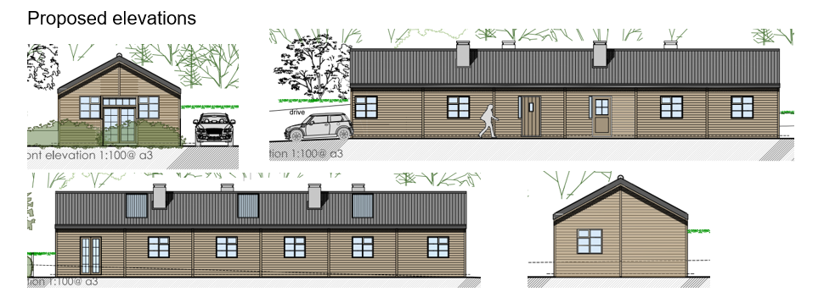

Proposed barn conversion elevations
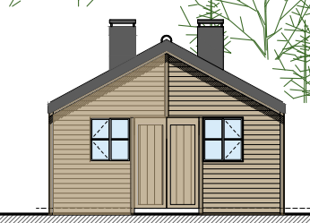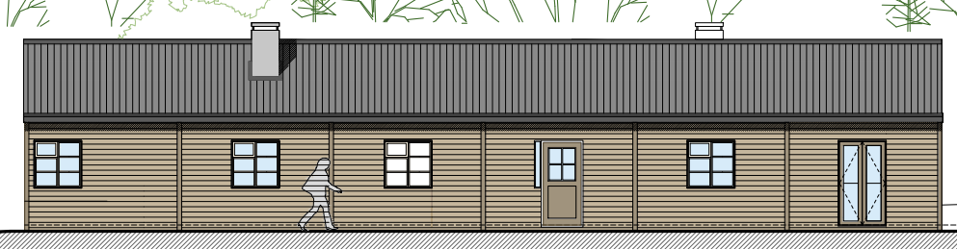
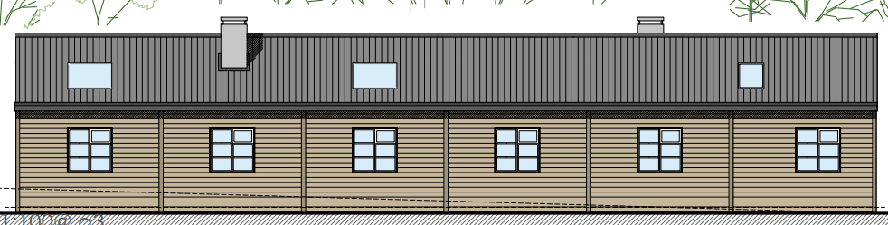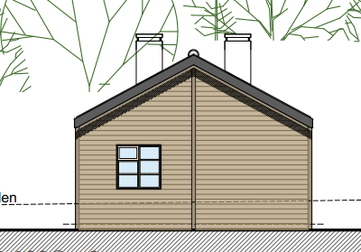

Approved Class Q floor plan
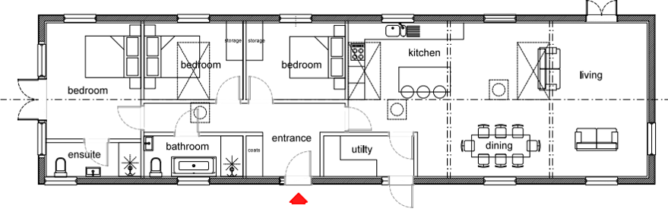
Proposed barn conversion floor plan

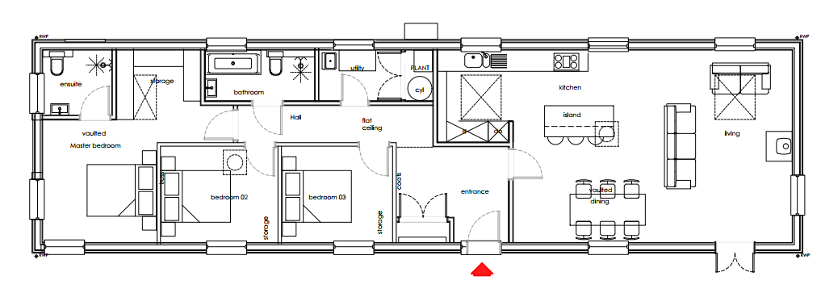

As such, the visual effects arising from the conversion of the building are largely established through the implemented Class Q fallback position. Significant weight must therefore be afforded to the fact that the building can lawfully be completed and occupied as a dwelling irrespective of the outcome of this application.

The principal difference between the approved Class Q scheme and the current proposal is the extent of the residential curtilage. Under the Class Q approval, the residential curtilage was tightly constrained around the building, whereas the current proposal incorporates a notably larger domestic garden area together with the package treatment plant. The enlarged curtilage would inevitably increase the level of domestication of the site and would extend residential activity further into the surrounding countryside than would occur under the approved Class Q scheme.

Class Q approved red line and red line with increased residential curtilage for this full planning application.

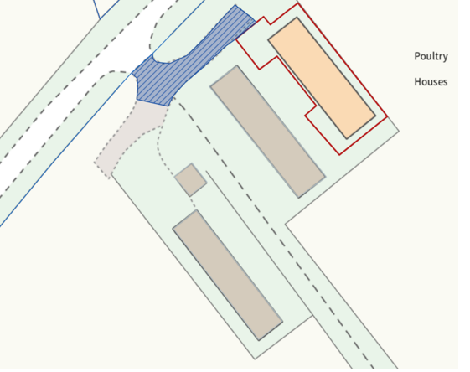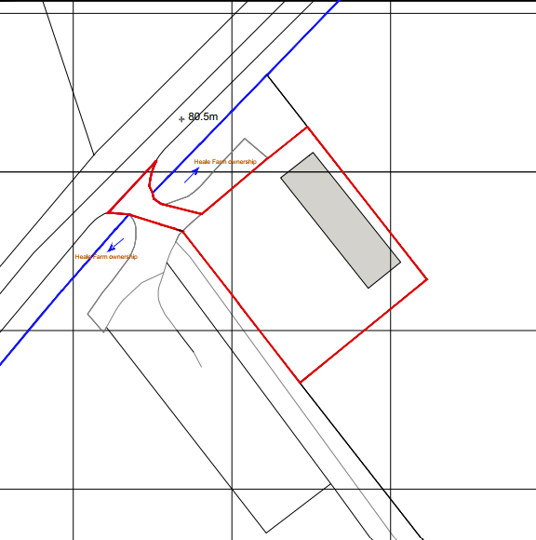

The presence of a larger garden, domestic paraphernalia, boundary treatments and associated activity would result in a greater visual impact on the rural landscape and a greater erosion of the site's agricultural character. Consequently, it is considered that the proposal would result in a degree of conflict with the objectives of Core Policy 51 and Saved Policy C6 when compared to the approved Class Q fallback.

However, the extent of harm identified is not considered to be significant enough to warrant a refusal in this instance. The enlarged curtilage remains physically and functionally related to the converted barn and does not represent an isolated encroachment into the wider countryside. Furthermore, a substantial proportion of the proposed garden area would occupy land currently associated with the former poultry unit, including the area occupied by the one of the former adjacent agricultural buildings now demolished under the implemented Class Q consent. The removal of this dilapidated and redundant structures ( a second former poultry building has also been removed) results in a visual improvement to the site and reduces the extent of built form presently associated with the former agricultural use. The package treatment plant is also a necessary component of the development and would have limited visual presence once installed and landscaped.

As mentioned above significant weight is attached to the implemented Class Q fallback position. The Local Planning Authority is not considering whether a dwelling should exist on the site, as that principle has already been established and implemented. The assessment is therefore limited to the additional impacts arising from the enlarged residential curtilage and associated works. Whilst the proposal would result in a greater degree of domestication than the approved Class Q scheme, this must be weighed against the benefits arising from the removal of the redundant agricultural buildings and associated concrete hardstanding, together with the provision of a coherent and functional residential setting for the approved dwelling.

Given the sensitivity of the site within the open countryside and Special Landscape Area, the removal of permitted development rights is considered necessary to ensure that future additions, ancillary structures and domestic alterations do not erode the barn-like character of the building or result in further urbanising influences that would harm the character and quality of the rural landscape.

On balance, the additional landscape harm is considered limited and is outweighed by the significant fallback position and the visual improvements secured through the clearance of the remaining derelict farm buildings. The proposal is therefore considered to accord overall with Core Policies 51 and 57 of the Wiltshire Core Strategy, Saved Policy C6 and the design objectives of the NPPF

Amenity

Core Policy 57 of the Wiltshire Core Strategy seeks to ensure that development does not result in unacceptable impacts upon the amenities of existing or future occupiers and that appropriate living conditions are achieved within the development itself. The NPPF similarly seeks to secure a high standard of amenity for existing and future users of land and buildings.

The site occupies a fairly isolated rural location and there are no immediate neighbouring residential properties that would be materially affected by the proposal. Given the separation distances involved, the development would not create unacceptable impacts in terms of overlooking, loss of privacy, overbearing impacts, loss of light, noise or disturbance to neighbouring occupiers. Furthermore, the dwelling itself has already been accepted as suitable for residential occupation through the grant and implementation of Class Q Prior Approval reference PL/2024/10916.

The proposed enlarged residential curtilage would provide a more functional and practical setting for the dwelling than would otherwise be available under the approved Class Q scheme. The additional garden area would provide an appropriate level of private outdoor amenity space for future occupiers, allowing for normal domestic activities, sitting out, landscaping and ancillary residential uses. The proposal therefore represents an improvement in terms of residential amenity when compared to the more constrained curtilage associated with the fallback Class Q approval.

The proposal also benefits from the demolition of the adjacent former agricultural buildings secured under the implemented Class Q consent, removing the potential for conflict with future residential occupiers and improving the overall residential environment associated with the approved dwelling.

Accordingly, it is considered that the proposal would neither harm the amenities of neighbouring occupiers nor result in poor living conditions for future residents. The development therefore accords with Core Policy 57 of the Wiltshire Core Strategy and the amenity objectives of the NPPF.

Highways Impacts/Parking and PROW

Core Policy 61 of the Wiltshire Core Strategy requires development to be served by safe and suitable access arrangements and to provide appropriate parking provision. The NPPF states that development should only be refused on highways grounds where there would be an unacceptable impact on highway safety or where the residual cumulative impacts on the road network would be severe.

The site benefits from an existing vehicular access which currently serves the agricultural holding, and which was accepted as suitable as part of the implemented Class Q Prior Approval (PL/2024/10916). The principle of vehicular access to serve a dwelling at this location has therefore already been established. Furthermore, the current proposal is for a single dwelling and would not be expected to generate a materially greater level of vehicle movements than the approved Class Q fallback position.

Wiltshire Council's Highways Officer has been consulted and raises no objection to the proposal subject to conditions. Off-street parking and turning facilities are proposed within the site and can be secured by condition to ensure that they are provided prior to occupation and retained thereafter. The development therefore provides adequate parking provision for the proposed dwelling in accordance with the Council's parking standards.

In addition, conditions are recommended requiring the provision and retention of visibility splays, consolidation and surfacing of the access, measures to prevent surface water discharging onto the highway, and the retention of parking and turning areas. Subject to these conditions, it is considered that the development would not prejudice highway safety and would provide satisfactory access arrangements for future occupiers.

Public Bridleway DURN20 shares the existing access serving the site before continuing eastwards through the surrounding countryside. The proposal does not seek to divert, alter or obstruct the route of the bridleway and the Council's Rights of Way Officer has raised no objection to the development.

Whilst some works are proposed in the vicinity of the access, the applicant does not have consent to undertake works within the public right of way itself without the prior agreement of Wiltshire Council as Highway Authority. An informative is therefore recommended reminding the applicant that it is an offence to obstruct a public right of way and that any works affecting the route must be agreed with the Council's Rights of Way team.

The use of the site as a single dwelling would not be expected to generate a level of traffic that would materially affect the operation, safety or enjoyment of the bridleway. Subject to maintaining the route free from obstruction during any remaining construction works, the proposal is not considered to result in any significant adverse impacts upon users of Public Bridleway DURN20. Accordingly, no objection is raised in respect of public rights of way.

The proposal is considered to accord with Core Policy 61 of the Wiltshire Core Strategy and the relevant provisions of the National Planning Policy Framework.

Ecology and Biodiversity

Core Policy 50 of the Wiltshire Core Strategy seeks to ensure that development protects biodiversity interests, avoids adverse impacts on protected species and habitats, and secures opportunities for biodiversity enhancement. The NPPF similarly requires planning decisions to contribute to and enhance the natural environment and secure measurable gains for biodiversity where possible.

The application is supported by a Preliminary Ecological Appraisal, Biodiversity Net Gain assessment, statutory metric calculations and supporting nutrient neutrality information. The Council's Ecologist has reviewed the submitted information and raises no objection subject to conditions.

The submitted ecological appraisal identifies that the site comprises largely modified habitats associated with the former agricultural use of the land and concludes that there are no habitats of significant ecological value within the application site. The submitted ecology information confirms that the proposal will not result in the loss of any irreplaceable habitats and that the development can proceed without unacceptable impacts on protected species subject to the recommended mitigation and enhancement measures.

In respect of protected species, the site was assessed as having negligible potential to support roosting bats, although the surrounding habitats provide opportunities for bat foraging and commuting. The Council's Ecologist is satisfied that, subject to retention of key habitat features and the implementation of an appropriate lighting strategy, the development would not adversely affect bats or other protected species. Conditions are recommended to secure biodiversity enhancements, including bat and bird boxes, hedgehog habitat features and a sensitive lighting scheme.

The application is accompanied by a Biodiversity Net Gain Assessment and Statutory Biodiversity Metric which have been reviewed by the Council's Ecologist. The submitted metric identifies a baseline biodiversity value of 0.10 habitat units, with no hedgerow or watercourse units present and no irreplaceable habitats affected. The Council's Ecologist is satisfied that the assessment accurately reflects the site's baseline habitats and confirms that the proposal will achieve the mandatory biodiversity net gain required under Schedule 7A of the Town and Country Planning Act 1990. The Biodiversity Gain Plan condition will apply to the development, and additional ecological enhancement measures, including features for bats, birds and hedgehogs, will be secured by condition.

The site lies within the catchment of the River Avon Special Area of Conservation (SAC), which is sensitive to additional nutrient loading. The application has therefore been accompanied by a nutrient budget and details of a proposed Graf One2Clean package treatment plant. The Council's Ecologist has reviewed and approved the nutrient budget, which calculates a residual phosphorus burden of 0.24kg TP/year. Whilst the package treatment plant substantially reduces phosphorus discharge, additional mitigation is required to achieve nutrient neutrality. The applicant has confirmed that the residual nutrient impact will be addressed through Wiltshire Council's strategic phosphate mitigation scheme and the purchase of the necessary phosphorus credits. Subject to securing those credits and compliance with the submitted mitigation strategy, the Council as Competent Authority can conclude through the Habitats Regulations process that the proposal would not adversely affect the integrity of the River Avon SAC.

Having regard to the submitted ecological information, the recommendations of the Council's Ecologist and the proposed mitigation and enhancement measures secured by condition, the development is considered to accord with Core Policies 50 and 69 of the Wiltshire Core Strategy, the Conservation of Habitats and Species Regulations 2017 (as amended), and the biodiversity objectives of the NPPF.

CIL

The proposed development may be liable for CIL as set out in the Wiltshire CIL Charging Schedule dated May 2015. This is a charge that local authorities can impose on new developments in their area. The money generated through the levy will contribute towards the funding of infrastructure to support growth and is payable upon commencement of development.

PLANNING BALANCE AND CONCLUSION
In reaching a decision, all identified harms and benefits must be weighed in the overall planning balance, having regard to Section 38(6) of the Planning and Compulsory Purchase Act 2004 and the provisions of the National Planning Policy Framework.

The proposal is situated within the open countryside where new residential development would normally be carefully controlled. However, significant weight must be afforded to the implemented Class Q Prior Approval (PL/2024/10916) which establishes a lawful fallback position for the completion and occupation of a dwelling on the site.

The principal harm identified relates to the enlarged residential curtilage which would result in a greater degree of domestication of the site when compared to the approved Class Q scheme. This creates a limited degree of conflict with Core Policy 51 and Saved Policy C6.

However, this harm is moderated by the fact that the curtilage remains closely related to the converted barn, incorporates land associated with the former poultry operation and facilitates the removal of the remaining redundant and derelict agricultural buildings. The proposal would also secure an appropriate foul drainage solution, nutrient neutrality mitigation, biodiversity enhancements, improved residential amenity for future occupiers and would allow the completion of a dwelling which could otherwise be lawfully implemented.

On balance, it is considered that the limited additional harm arising from the enlarged curtilage is outweighed by the substantial weight afforded to the implemented Class Q fallback position together with the visual and environmental benefits associated with the scheme. The proposal is therefore considered to accord with the development plan when read as a whole and planning permission should be granted.

RECOMMENDATION: That Planning Permission be GRANTED, subject to conditions

1. The development hereby permitted shall be carried out in accordance with the
following approved plans and documents:

Application form received 21/04/2026
Proposed elevations Drg no 0181-02-027 received 21/04/2026
Proposed elevations Drg no 0181-02-026 received 21/04/2026
Proposed plans Drg no 0181-02-025 received 21/04/2026
Location plan Drg no 0181-02-021 Rev A received 23/06/2026
Proposed site plan Drg no 0181-02-024 Rev C received 15/07/2026
Preliminary Ecological Appraisal and Biodiversity Net Gain Report. June 2026 Stark Ecology Ltd;
Natural England Nutrient Neutrality budget calculator for the River Avon SAC Netton Barn Nutrient Budget;
Performance Results: one2clean Small Wastewater Treatment System. PIA –
Prüfinstitut für Abwassertechnik GmbH. EN 12566-3 Test Report PIA2014-216B14.01.e.;
The Statutory Biodiversity Metric. 23 June 2026. Iteration. v3

REASON: For the avoidance of doubt and for the protection, mitigation and
enhancement of biodiversity.

2. Prior to the first occupation or completion of the development hereby approve, the visibility splays shall be provided between the edge of the carriageway and a line extending from a point 2.4 metres back from the edge of the carriageway, measured along the centre line of the access, to the points on the edge of the carriageway 60m in both directions from the centre of the access in accordance with the approved plans. Such splays shall thereafter be permanently maintained free from obstruction to vision above a height of 900mm above the level of the adjacent carriageway.
REASON: In the interests of highway safety.
3. The development hereby permitted shall not be occupied until the first 5m of the access, measured from the edge of the carriageway, has been consolidated and surfaced (not loose stone or gravel). The access shall be maintained as such thereafter.
REASON: In the interests of highway safety.
4. The proposed development shall not be occupied until means/works have been implemented to avoid surface water from entering the highway.
REASON: To ensure that the highway is not inundated with surface water.
5. Any gates shall be set back 4.5m from the edge of the carriageway, such gates to open inwards only.
REASON: In the interests of highway safety.
6. No part of the development hereby permitted shall be occupied until the access, turning area & parking spaces [2] have been completed in accordance with the details shown on the approved plans. The areas shall always be maintained for those purposes thereafter and maintained free from the storage of materials.
REASON: In the interests of highway safety.

7. The overnight development hereby approved shall be designed to ensure it does not exceed 110 litres per person per day water consumption levels (which includes external water usage).

REASON: To ensure compliance with the prevailing mitigation strategy for nutrient neutrality in the water catchment within which this development is located.

8. The proposed package treatment plant and drainage field shall be installed, maintained and operated in accordance with the submitted specification and details hereby approved. Any subsequent replacements shall have an equivalent or improved performance specification. The package treatment plant and drainage field shall be installed, connected and available for use before the development is occupied and they shall be maintained and operated thereafter for the lifetime of the development.

REASON: To provide ongoing and adequate nutrient mitigation for the nutrient neutrality water catchment for the life of the development and to ensure that any future package treatment plant is of an equivalent or improved standard.

9. Prior to the first occupation of the development hereby approved, details of the number, design and locations of ecological enhancement features including bat boxes, bird boxes and hedgehog hibernacula shall be submitted to the Local Authority for approval. The approved details shall be implemented for the lifetime of the development and before completion of the final works.

REASON: To provide mitigation /enhancement for biodiversity.

10. All external lighting provided on site shall be in accordance with the appropriate Environmental Zone standards set out by the Institute of Lighting Engineers in their publication GN01:2021, ‘Guidance for the Reduction of Obtrusive Light’ (ILP, 2021), and Guidance note GN08/23 “Bats and artificial lighting at night”, issued by the Bat Conservation Trust and Institution of Lighting Professionals.

REASON: In the interests of the amenities of the area and to minimize impacts on biodiversity caused by light spillage to areas above and outside the development site.

11. Notwithstanding the provisions of the Town and Country Planning (General Permitted Development) (England) Order 2015 (as amended by the Town and Country Planning (General Permitted Development) (Amendment) (No.3) (England) Order 2020 (or any Order revoking or re-enacting or amending those Orders with or without modification), no development within Schedule 2, Part 1, Classes A, B, C, D or E; or Part 2 Class A shall take place on the dwellinghouse hereby permitted or within the curtilage.

REASON: In the interests of the character and amenity of the area and to enable the Local Planning Authority to consider individually whether planning permission should be granted for additions, alterations, extensions or enlargements.

12. All boundary planting shall be of mixed native species with no non-native Evergreen screen planting allowed within or around the site. Any boundary fencing (either around the site edge or within the site) shall be post and wire or post and rail agricultural style fencing. No suburban-style panel or close-board fencing shall be used either in or around the edges of the development.

REASON: In the interests of preserving the character and appearance of the rural area.

13. The development hereby permitted shall not be occupied until evidence of compliance to
the Wiltshire Council River Avon Special Area of Conservation Mitigation scheme, or an
alternative approved mitigation package addressing the additional nutrient input arising from
the development, has been submitted to, and approved in writing by the Local Planning Authority.

REASON: To accord with the Conservation of Habitats and Species Regulations 2017, and
Wiltshire Core Strategy Core Policy 69.

INFORMATIVES

1. BNG required - The effect of paragraph 13 of Schedule 7A to the Town and Country Planning Act 1990 is that planning permission granted for the development of land in England is deemed to have been granted subject to the condition “(the biodiversity gain condition”) that development may not begin unless:

(a) a Biodiversity Gain Plan has been submitted to the planning authority, and
(b) the planning authority has approved the plan.

The planning authority, for the purposes of determining whether to approve a Biodiversity Gain Plan if one is required in respect of this permission would be Wiltshire Council. There are statutory exemptions and transitional arrangements which mean that the biodiversity gain condition does not always apply. For further information on exempt developments please refer to: https://www.gov.uk/guidance/biodiversity-net-gain-exempt-developments

Based on the information available this permission is considered to be one which will require the approval of a biodiversity gain plan before development is begun because none of the statutory exemptions or transitional arrangements are considered to apply. Irreplaceable habitat If the onsite habitat includes irreplaceable habitat (within the meaning of the Biodiversity Gain Requirements (Irreplaceable Habitat) Regulations 2024) there are additional requirements for the content and approval of Biodiversity Gain Plans.

The Biodiversity Gain Plan must include, in addition to information about steps taken or to be taken to minimise any adverse effect of the development on the habitat, information on arrangements for compensation for any impact the development has on the biodiversity of the irreplaceable habitat.

The planning authority can only approve a Biodiversity Gain Plan if satisfied that the adverse effect of the development on the biodiversity of the irreplaceable habitat is minimised and appropriate arrangements have been made for the purpose of compensating for any impact which do not include the use of biodiversity credits.

2. PROW
The applicant should note that it is a criminal offence to obstruct a public right of way under section 137 of the Highways Act 1980 and therefore no materials, plant, temporary structures or excavations of any kind should be deposited / undertaken which obstruct or adversely affect the public right of way DURN20 whilst development takes place, without prior consultation with, and the further permission of, the highways authority at Wiltshire council.
3. Highways Access
The application involves the upgrading of the existing vehicle access. The consent hereby granted shall not be construed as authority to carry out works on the highway. The applicant is advised that a licence will be required from Wiltshire’s Highway Authority before any works are carried out on any footway, footpath, carriageway, verge or other land forming part of the highway. Please contact our Vehicle Crossing Team on vehicleaccess@wiltshire.gov.uk and/or 01225 713352 or visit their website at http://wiltshire.gov.uk/highways-streets to make an application.

4. Non-Mains Drainage
A non-mains sewerage system is proposed. The area in which the development is located is within close proximity to the River Avon and may experience flooding and ground water conditions of concern. Primary responsibility for ensuring sewage systems for new developments are adequate lies with the Building Control Department. We would recommend you satisfy yourself that a non-mains sewerage system is appropriate and practicable in the circumstances taking into account ground water conditions throughout the year. For further guidance see the National Planning Practice Guidance “Water supply, wastewater and water quality.”
Any installation of a Package Treatment Plant needs to meet approval of Environment Agency’s requirements under their permitting role.

5. Protected Species
The applicant should note that under the terms of the Wildlife and Countryside Act (1981) and the Conservation of Habitats and Species Regulations 2017 (as amended) it is an offence to disturb or harm any protected species including for example, breeding birds and reptiles. The protection offered to some species such as bats, extends beyond the individual animals to the places they use for shelter or resting. Please note that this consent does not override the statutory protection afforded to any such species. In the event that your proposals could potentially affect a protected species you should seek the advice of a suitably qualified and experienced ecologist and consider the need for a licence from Natural England prior to commencing works. Please see Natural England’s website for further information on protected species.

6. Hampshire Avon Phosphorus Mitigation

Evidence of compliance to the Wiltshire Council River Avon Special Area of Conservation Mitigation Scheme means the certificate of allocation of credits and confirmation of financial contribution to the scheme. An alternative mitigation package must be approved by the local planning authority and Natural England with evidence of allocation to the scheme.

