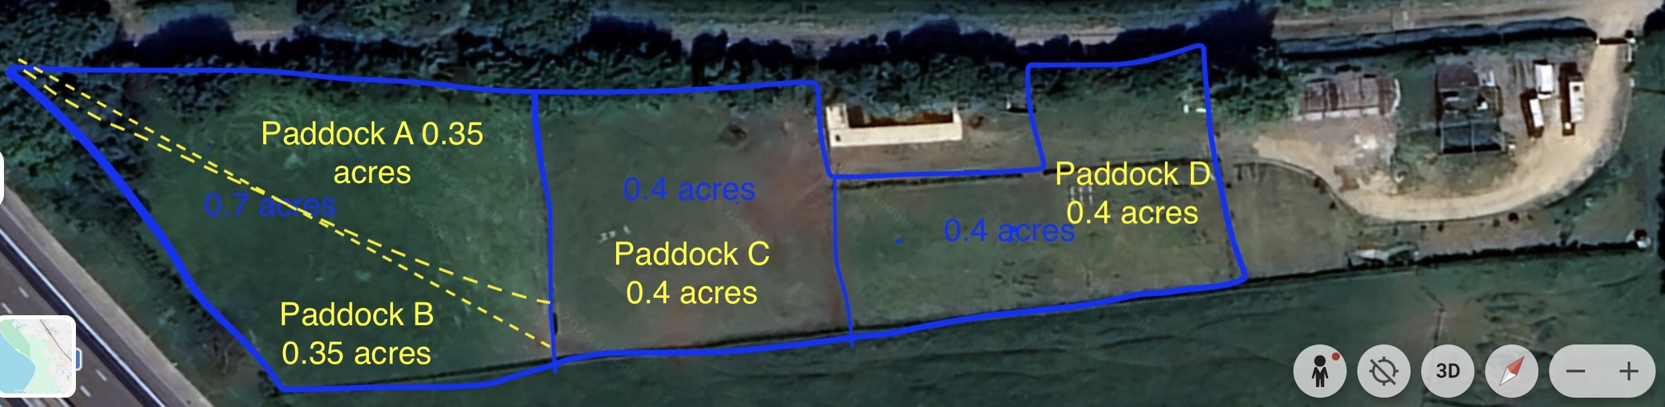
APPENDIX: PROPOSED ROTATIONAL GRAZING & PADDOCK LAYOUT
Site Location: Land at Combe Barn, Grittleton
Total Forage Area: Approx. 1.5 Acres (within a 2-acre total holding)

Paddock Key & Management Strategy:
- Paddock A: 0.35 Acres (North West)
  - Features: Formed by the temporary sub-division of the main western field using a mobile solar-electric netting system (indicated by the yellow dashed line).
  - Usage: Initial entry grazing cell for precise sward management.
- Paddock B: 0.35 Acres (South West)
  - Features: The southern half of the sub-divided western field.
  - Usage: Follow-on grazing cell, allowing Paddock A an immediate rest and recovery period.
- Paddock C: 0.4 Acres (Central)
  - Features: Centrally located pasture area allowing easy, stress-free movement of stock across the holding.
  - Usage: Mid-rotation grazing cell to keep the flock moving systematically through the forage cycle.
- Paddock D: 0.4 Acres (East)
  - Features: Situated in direct proximity to the existing stable block/isolation unit and the proposed fodder barn infrastructure.
  - Usage: Intensive rotation cell, handling area, and close-proximity grazing for vulnerable stock, hospital use, or ewes nearing lambing.

Operational Justification for Planning:
"The updated land layout demonstrates a highly efficient, four-stage intensive rotational grazing system. By dividing the 1.5 acres of forage into precise management cells (Paddocks A through D) ranging from 0.35 to 0.4 acres, the enterprise prevents overgrazing, dramatically minimises parasite burdens, and protects the soil structure of the Cotswolds National Landscape.

