APPLICATION FOR A CERTIFICATE OF LAWFULNESS FOR PROPOSED USE OR DEVELOPMENT

APPLICATION REFERENCE: | PL/2026/04453
APPLICATION TYPE: | Lawful development: Proposed use
SITE ADDRESS: | 4 Manor Farm Lane, Patney, Devizes, SN10 3RB
DEVELOPMENT DESCRIPTION: | Siting of Single Unit Caravan for Ancillary Family Accommodation
RECOMMENDATION: | Approve

PROPOSAL
This application seeks a Certificate of Lawfulness (CLP) under Section 192 of the Town and Country Planning Act 1990 (as amended) for the siting of a proposed caravan to provide ancillary domestic accommodation within the garden of a dwelling house.

The proposed site plan, as shown below outlines where the proposed caravan (log cabin) would be sited, in the rear garden of the dwelling, 8m from the rear of the dwelling, 1m from the site boundary.

Location plan and proposed site plan
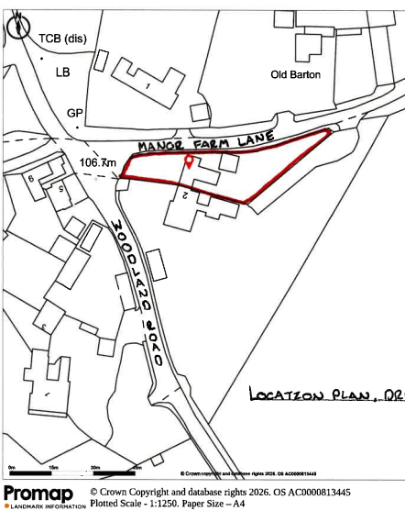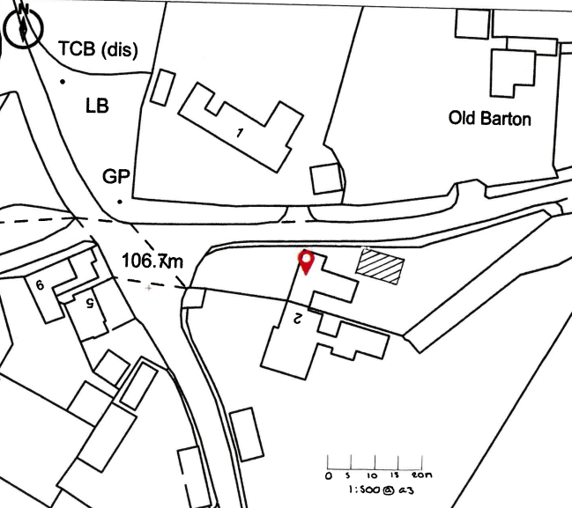

The planning merits of the proposal are not under consideration. A Certificate of Lawfulness must only confirm that a specific, precisely described development would be lawful if carried out. This is a legal test, not a planning merits judgment. Under section 192(1) of the Town and Country Planning Act 1990, a CLP may only be granted where the LPA is satisfied that: “the proposed use or development would be lawful if instituted or begun at the time of the application.”

SITE DESCRIPTION
The application relates to 4 Manor Farm Lane, Patney, a semi-detached dwelling, with associated garage, parking and access to the side (north elevation) of the site, off Manor Farm Lane. The property has a large rear garden (to the east) which is generally level, and is bordered by a predominantly mature hedgerow and some timber fencing. The application site is within the built form of the small village of Patney. There are residential neighbours to the west, north and south, and open countryside to the east.

The application site is subject to the following planning policy constraints:
- North Wessex Downs National Landscape
- Grade II Listed Building 40 metres to the northeast of the site
- Groundwater Flood Risk: Groundwater levels are either at or very near (within 0.025m of) the ground surface
- Risk of Flooding from Surface Water 1 in 100 + Climate Change (40%) along site access
- Salisbury Plain SPA - 6400m Buffer

THE EVIDENCE SUBMITTED IN SUPPORT OF THE APPLICATION
- Application form
- Covering Letter
- Location plan
- Site plan
- Floor Plan and Elevations
- Planning Statement
- Construction and Mobility Tests
- Case Law
- Supporting Applications
- Agents further emails

RELEVANT LEGISLATION AND POLICY
The statutory framework governing CLP’s is set out in Section 192 of the Town and Country Planning Act 1990 (as amended). This section establishes that a proposed development or use is "lawful" if it would not constitute a breach of planning control. A CLP can be granted if the Local Planning Authority is satisfied, on the balance of probabilities, that the proposed development or use would not require planning permission.

Town and Country Planning Act 1990 (as amended):
- Section 55 (1)
- Sections 191-193

Also, of relevance –
- Caravan Sites & Control of Development Act 1960,
- Caravan Sites Act 1968 (Definition of Caravan) (Amendment) (England) Order 2006)

LEGISLATION / PLANNING PRACTICE GUIDANCE
Section 55 (1) Subject to the following provisions of this section, in this Act, except where the context otherwise requires, “development,” means the carrying out of building, engineering, mining or other operations in, on, over or under land, or the making of any material change in the use of any buildings or other land.

Section 192(1) of the Act outlines that “if any person wishes to ascertain whether—
(a) any proposed use of buildings or other land; or
(b) any operations proposed to be carried out in, on, over or under land, would be lawful, he may make an application for the purpose to the local planning authority specifying the land and describing the use or operations in question.

Section 192(2) of the Act outlines that “if, on an application under this section, the local planning authority are provided with information satisfying them that the use or operations described in the application would be lawful if instituted or begun at the time of the application, they shall issue a certificate to that effect; and in any other case they shall refuse the application.

REPRESENTATIONS

There is no legal obligation to consult third parties, including Town/Parish Councils or neighbouring properties, for this type of application.

RELEVANT SITE HISTORY
The site has the following relevant planning history:

Proposal / Summary
K/20671 - Full planning permission Decision - Approve with Conditions Date: 23/9/1993 – EXTENSION TO DWELLING
K/82/0438 - Full planning permission Decision - Approve with Conditions Date: 29/7/1982 – Alterations and extension
K/81/1129 - Full planning permission Decision - Approve with Conditions Date: 21/1/1982 – Extension to house and erection of garage
PL/2026/02069 - Proposed caravan – Refused
PL/2026/03333 - Demolition of existing Garage - Approved

ASSESSMENT AND CONCLUSION

The Local Planning Authority needs to consider whether, on the facts of the case and relevant planning law, the specific matter is or would be lawful. Planning merits are not relevant at any stage in this particular type of application or appeal process. Views expressed by third parties on the planning merits of the case, or on whether the applicant has any private rights to carry out the operation, use, or activity in question, are therefore irrelevant when determining the application.

This Lawful Development Certificate for Proposed Use relates to the proposed siting of a single-unit caravan within the curtilage of an existing dwelling to operate as ancillary to the use of the main dwelling.

The proposed caravan unit would be sited within the garden of the host dwelling on the location of an existing double garage. The proposed caravan unit would measure 9.14m in length, 5.675m wide and the under side of the ceiling internally would be 3m as set out in the Proposed Plans and Cross Section submitted in support of the application. The proposal does not include the provision of any separate curtilage, access or parking for the caravan. In order to facilitate the siting of the caravan unit the existing garage would have to be removed from site. It is noted that the demolition of the existing garage requires prior approval and that this has been granted under application PL/2026/03333.

The primary question is whether the proposed structure constitutes a caravan within the meaning of Section 29(1) of the Caravan Sites and Control of Development Act 1960. The submitted plans indicate that the structure would measure approximately 9.14m in length, 5.675m in width, and have an internal ceiling height below 3.05m. The applicant has provided evidence that the unit would be constructed on an integral chassis and would be capable of being lifted and transported intact. On the basis of the information submitted, and on the balance of probabilities, the Local Planning Authority is satisfied that the proposed structure would meet the statutory definition of a caravan.

The Local Planning Authority must also consider whether the siting of the caravan would involve operational development. The submitted information indicates that the caravan would rest on non-permanent supports and would not be physically attached to the land by foundations or permanent anchoring. Utility connections would be capable of disconnection and would not alter the status of the structure as a caravan. In these circumstances, the siting of the unit would not amount to building operations or operational development for the purposes of Section 55(1) of the Town and Country Planning Act 1990.

Consideration must also be given to whether the proposal would result in a material change of use of the land. The caravan would be sited within the residential curtilage of the existing dwelling and would provide accommodation ancillary to the occupation of that dwelling. No separate curtilage, access, parking area, postal address or other features associated with an independent planning unit are proposed. The occupation of the caravan would remain under the control of the occupants of the main dwelling and would not operate as a separate dwellinghouse. On the balance of probabilities, the proposal would remain functionally subordinate to the residential use of the host dwelling and would not give rise to a material change of use.

The Local Planning Authority notes that prior approval for the demolition of the existing garage has been granted under application PL/2026/03333. The demolition of the garage therefore presents no impediment to the implementation of the proposal and forms part of the lawful planning context against which this application must be assessed.

Conclusion
The role of the Local Planning Authority in determining an application under Section 192 of the Town and Country Planning Act 1990 is limited to establishing whether the proposed development would be lawful if carried out at the date of the application. It is not an assessment of planning merits, policy compliance, landscape impact or residential amenity.
In this case, the evidence submitted demonstrates, on the balance of probabilities, that the proposed structure would constitute a caravan for the purposes of the Caravan Sites and Control of Development Act 1960. Furthermore, its siting would not amount to operational development and its occupation as ancillary family accommodation would remain incidental and subordinate to the enjoyment of the existing dwellinghouse. No separate planning unit would be created and no material change of use would occur.

Accordingly, the proposed siting of the caravan would not constitute development requiring planning permission. The Local Planning Authority is therefore satisfied that the proposal would be lawful if carried out at the date of the application and that a Certificate of Lawfulness for Proposed Development should be granted.

This conclusion is consistent with the statutory provisions of Sections 55 and 192 of the Town and Country Planning Act 1990 and with relevant appeal decisions relating to the siting of caravans providing ancillary residential accommodation within the curtilage of existing dwellinghouses.

RECOMMENDATION
It is recommended that the Certificate of Lawfulness for Proposed Development be APPROVED

