REPORT FOR SOUTHERN AREA PLANNING COMMITTEE
Date of Meeting | 20th August 2026
Application Number | PL/2025/05762
Site Address | Armishaw Removals, Netherhampton Road, Netherhampton, Salisbury, SP2 8RA
Proposal | Mixed-use commercial development including a convenience/food retail unit, a drive-through coffee unit, two B8 units with ancillary office use, and the retention of an existing B8 warehouse, along with associated parking, access, and servicing arrangements.
Applicant | Mr Lloyd Armishaw
Town/Parish Council | Salisbury City Council
Electoral Division | Salisbury Harnham West
Type of application | Full Planning Permission
Case Officer | Adam Madge

REASON FOR THE APPLICATION BEING CONSIDERED BY COMMITTEE

The application is before the Planning Committee at the request of the Local Division Member (Cllr Brian Dalton) for the following reasons

- Visual impact on the surrounding area
- Design, Bulk, height and general appearance
- Environmental Highway impact

- PURPOSE OF REPORT

The purpose of this report is to assess the merits of the proposed development against the policies of the development plan and other material considerations. Having considered these, the report recommends that planning permission be APPROVED

- MAIN ISSUES

- Principle of development
- Highways impacts
- Design and appearance
- Flooding and drainage
- Ecological impacts
- Trees
- Landscape
- Flooding
- Archaeology

- SITE DESCRIPTION

The site is that of Armishaw’s removals which operate out of a large industrial unit accessed off the Netherhampton Rd. The area is between an existing unit used for a form of retailing known as In-excess and to the East a relatively new housing estate which has been built on what was previously industrial land. To the rear is open farmland which rises away from this development. Whilst to the North, North/East and front of the site across the other side of the main Netherhampton road is another new area of housing. At present the application site is used partly as storage and by Armishaw’s to park their removal lorries.

The nearest retail units are –

- New retail unit at Wilton Gate – 0.4 miles (9 minute walk) (not yet built out)
- One Stop Netherhampton Road – 0.5 miles from the site (12 minute walk)
- Old Harnham Local shop – approx. 1 mile and 20 minutes walk
- Nisa Local, The Crescent Rowbarrow - 1.8 miles (39 minute Walk)

Access to the site for both vehicles and pedestrians is established from Netherhampton Road to the North via the via the existing car park entrance that also serves In Excess.

- RELEVANT PLANNING HISTORY

The site has a relatively extensive planning history most recently -

S/1997/0215 From furniture warehouse to B2 (General Industrial) & B8 (Storage & Distribution) Approved 23/6/1997

19/01104/ful Erection of B8 warehouse for a removals and storage company at a location already in use for the same purpose. Approved 4/10/2019

20/09510/ful Extension of existing warehouse. Approved 17/12/2020

Other applications of relevance close to the site include –

18/04067/OUT Erection of up to 82 dwellings and associated works. Approved 27/3/2019 Now built out as Harnham Park.

PL/2021/06594 Residential development comprising 106 dwellings including formation of vehicular access and footways, open space, drainage, landscaping and associated works. Approved 13/12/2022 Now known as Chapel Gate.

19/05824/out Mixed use development comprising of residential (Class C3) up to 640 dwellings, local centre (Class A1), primary school (1.8 ha), employment (2 ha) public open space including country park (10 ha), landscaping, 2 vehicular accesses, estate roads including loop road in detail and associated infrastructure and landscaping.
Approved 25/6/2020 Now known as Wilton Gate.

And also:

PL/2025/05931 Demolition of existing garages and erection of retail unit (Class E), together with alterations to means of access, car parking and associated works including garden pergola and festoon lighting. (at Greyfisher, New Bridge Road Harnham) Refused 16/12/2025. Currently subject of appeal.

- PROPOSAL

The proposals consist of a number of elements including the erection of a building for use as a convenience store, the erection of a drive thru, the erection of two new units for use as trade counters and alterations to the existing Armishaw’s unit on site. The site layout would be as follows with the existing warehouse to the West. Two class B8 storage buildings to the East and the new retail unit at the front of the site to the North. The Drive Thru is also proposed to the North of the existing warehouse unit.

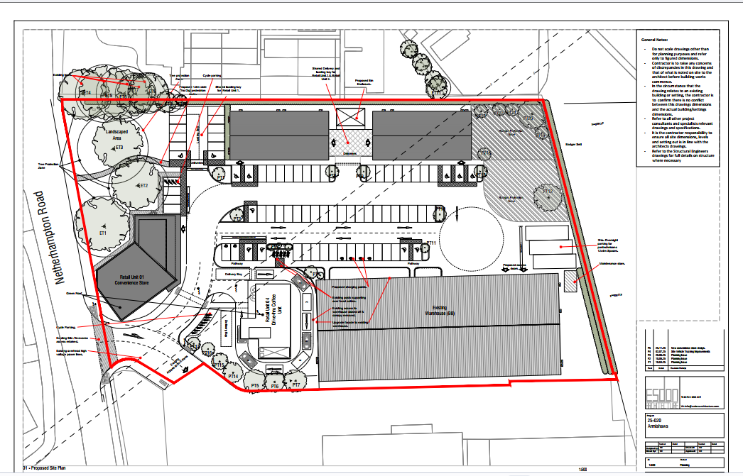

Convenience retail store

It is intended to erect a building for use as a convenience store directly adjacent the entrance to the site and Netherhampton road. It is proposed as a single storey building with a number of windows on it and a main entrance on the access road. The building is to be clad in fibre cement. It is 250 square metres in floor area.

Drive – Thru

Directly opposite the convenience store and to the front of the existing Building is a proposed new drive-thru. This will be a single storey building with a flat roof and a first floor protrusion to accommodate signage for a future operator. This is proposed as use class E(b) Food and drink with a floor area of 180 square metres

B8 Industrial Units

Two B8 storage and distribution units are proposed at the site which are proposed at two storey in height with offices on the first floor. They are shown as clad under a metal pitched roof. The floor area of the two B8 units is shoiwn as 640 square metres.

Car parking

A total of 73 car parking spaces are proposed on site which is an increase of 65 on those which exist at present. The car parking spaces will be positioned as shown on the site map and to the centre of the site. They would be shared between the proposed uses on the site.

Access arrangements.

It is intended to use the existing access and entrance arrangement to In excess and Armishaws removals as the councils highways officer has assessed this as being adequate with some changes for the new units as proposed.

Landscaping and BNG

There is limited landscaping detail provided with the application either hard or soft landscaping therefore if members were minded to approve the application it would be necessary to require the submission of hard and soft landscaping works prior to the development taking place. Information on how Bio Diversity Net Gain (BNG) requirements will be met has not been submitted in support of the application. It will be necessary for the applicants to show post determination how BNG requirements have been met If on site through the submitted landscape details.

- CONSULTATIONS

Salisbury City Council: SCC objects to the application due to concerns about inappropriate overdevelopment of the site, the impact of the proposed retail units on neighbouring residents, and the unsuitability of illuminated signage in this location. The Council also raises concerns regarding traffic impact on Netherhampton Road and considers the design to be out of keeping with the character of the surrounding area.

WC Highways: No objection subject to condition.

National Highways: No objection subject to securing a robust travel plan and contributions to the Salisbury Transport strategy.

WC Drainage: No objection subject to drainage details.

WC Archaeology: No objection given previous archaeological survey work results on the site.

WC Ecology: No objection subject to conditions

WC Arboriculturist: No objection subject to the trees on site being protected in accordance with the Tree Protection Plan and Arb Method Statement.

WC Landscape No objections subject to a condition securing a planting plan.

WC Public Protection: No objection subject to conditions.

Wessex Water: No objection subject to a series of requirements.

- REPRESENTATIONS

The application was publicised by letters posted to near neighbours and site notice

Objections summary – 11 letters of objection were received

- Access to Homes from Netherhampton Rd will be more problematic due to traffic.
- Access on to Netherhampton Rd is already difficult.
- To introduce another high volume use onto Netherhampton road would be problematic.
- Another convenience store is welcome but not here and should be put on Wilton Gate.
- Traffic volumes are already significant with tailbacks at rush hour. This will increase traffic and subsequent noise pollution.
- Concern with the Drive Thru and convenience store being directly opposite the entrance to Chapel Gate and that there would be a conflict with the traffic.
- There is the potential for illegal parking to take place at Chapel Gate.
- Proposed plans are already in place for a shop at Wilton Gate and at the Greyfisher pub, those along with the existing one stop shop are sufficient.
- Unless effort is made to shield noise and provide adequate parking the proposal will be an inconvenience to neighbouring residents.
- There is the potential for a convenience shop such as this to attract anti social behaviour opposite neighbouring properties.
- Grounds are relatively small to incorporate more industrial units.
- Could attract more litter.
- Limited crossing points on Netherhampton road.
- Concern that introducing a third shop on top of the existing one stop shop and the proposed Wilton Gate shop would impact the viability of the post office in the one stop shop.
- Loss of community facilities such as the post office in the one stop is resisted by policy.
- The proposed signage is not appropriate in a residential area such as Netherhampton road and should be refused on design grounds.
- This will increase litter in the area.
- How will the proposed junction be managed?
- The area needs a Doctors or Dentist surgery more than it needs this type of development.
- Current plans are squeezing too much onto the site.
- Industrial units are too close to houses on Riddle Way blocking out afternoon light.
- The retail and drive thru facilities should be combined.
- Design of the retail store needs improving.
- Consider the applicants boundaries on the plan are wrong as they do not own the access but have use of it.
- In excess has 20-40 heavy goods movements a day except for weekends, we have 70 staff on site and around 400 to 600 customer visits per day, average length of stay is 30-45mins.
- If the convenience store was removed then additional space could be used to build a safer entrance
- Why do we need a drive through coffee shop? It adds to pollution (car engines on as they queue) plus empty coffee cups in the roadside. Also encouraging drivers to get preoccupied as they drink when driving. Just why do we need it?
- only lived in our house for 3 months in that’s time we have had road closures, temporary traffic lights and it’s been chaos. It’s been so noisy and unbearable. I feel that if this was to go ahead the noise would be unbearable again and the house I have spent so much money on and investing in will be a waste. The road is already busy and noisy enough. Adding what is proposed is only going to make it worse.
- Car park may cause loitering and disturbances.
- insufficient attention paid to the safety of walkers and wheelers (including wheelchair users, pedestrians and cyclists as well as people with prams and mobility aids) in the design of the entrance to the proposed development, and a crossing point is necessary to allow non-motorised customers to access the site from the north side of Netherhampton Road.
- A pedestrian entrance to the site is proposed in the northeast corner, and this is welcome. From the south, there is a footpath from Riddell Close, at present blocked by a hedge. It would be a significant boost to the Council's ambitions to reduce transport emissions if these 2 alternative entrances could be made available to all walkers and wheelers.
- A drive-through coffee shop will encourage car travel and contravenes Wiltshire Council’s adopted policies on Transport (LTP4), Climate Change and the emerging Local Plan.
- In paragraph 3.4.13 of the Transport Assessment, covered cycle parking stands are referred to, but the provision is described as "Sheffield stands" only in 3.4 14 with no reference to any of them being covered. This needs to be clarified.
- In addition the applicant should contribute to upgrade the crossing point across to Chapel Gate into a safe pedestrian and cycle crossing.

Supports summary – 2 letters of support

- Harnham needs a petrol station, coffee shop and a supermarket.
- Lack of local services and facilities in South Salisbury. this will provide those facilities.
- Will have a positive impact on reducing traffic chokepoints across the city where the desired facilities are located such as Southampton Rd.
- Note other residents concerns about traffic but have yet to experience serious delay or incident on Netherhampton Rd.
- Opportunity to develop a brownfield site into something more interesting whilst providing infrastructure.

- PLANNING POLICY

Environment Act 2021/Levelling Up Regeneration Act (LURA) 2023

NPPF December 2024, much of this guidance is relevant to this application. The most relevant sections and policies are referred to throughout the following report.

NPPG – Overall design, environmental impacts, bio-diversity, amenities, flooding, retail.
National Design Guide/Code.
Wiltshire Core Strategy - The most relevant policies of this document are as follows:

CP1 & 2 – Spatial and settlement strategies
CP3 – Infrastructure
CP20 – Salisbury strategy
CP 21 – Maltings and central car park
CP41 & 42 – Sustainable construction and renewable energy
CP36 –Economic regeneration
CP38 – Retail and leisure
CP50, 51, 52 –Landscape infrastructure and biodiversity
CP55 – Air Quality
CP56 - Contamination
CP57 – Design and amenity
CP58 – Conservation of the historic environment
CP60/61 - Transport and Development
CP67 – Flood Risk
CP69 – River Avon SAC

Maltings and Central Car Park Masterplan 2019

Wiltshire Housing Site Allocations Plan - Appendix A: South Wiltshire HMA Amended Settlement Boundaries (adopted Feb 2020)

The Wiltshire Retail & Town Centres Study 2020

Adopted Central Area Framework

Wiltshire Design Guide

Salisbury City Neighbourhood Plan ‘Made’ 3rd March 2025

- Policy 1 Tree planting for carbon capture
- Policy 4 EV Charging points
- Policy 6 Design in the built environment
- Policy 11 Biodiversity Net Gain
- Policy 21 Sustainable Transport
- Policy 23 Cycle Parking
- Policy 24 Cycling for Pleasure
- Policy 28 Major Food Retail

- PLANNING CONSIDERATIONS

Planning permission is required for the development. The application must be determined in
accordance with the development plan unless material considerations indicate otherwise.
(Section 70(2) of the Town and Country planning Act and Section 38(6) of the Planning and
Compensation Act 2004).

The NPPF 2024 confirms in paragraph 11 that plans and decisions should apply a presumption in favour of sustainable development. For decision making, that means approving development proposals that accord with an up-to-date development plan without delay. Paragraph 11 also refers to the LPA needing to consider whether there are “strong” reasons for refusal based on any impacts on assets of particular importance listed in footnote 7, or adverse impacts which would significantly and demonstrably outweigh the benefits of the proposal.

9.1 Principle, employment and retail impact

The Settlement Strategy (Core Policy 1) identifies the settlements where sustainable
development will take place to improve the lives of all those who live and work in Wiltshire.
Core Policy 20 identifies Salisbury as a Principal Settlement. The Delivery Strategy is
contained within CP2 of the WCS which states:

Within the limits of development, as defined on the policies map, there is a presumption in
favour of sustainable development at the Principal Settlements, Market Towns, Local Service Centres and Large Villages.

The existing removals and storage business is located outside the settlement limits but on a previously developed employment site, which has existed for many years. The area surrounding the building is now being developed for housing as part of a wider development and therefore the development site can be seen in the context of the wider built environment. As such although the development will be located outside of the settlement boundary it is not in a remote location or a location that would not be suitable for new built development as it is now surrounded by other built development.

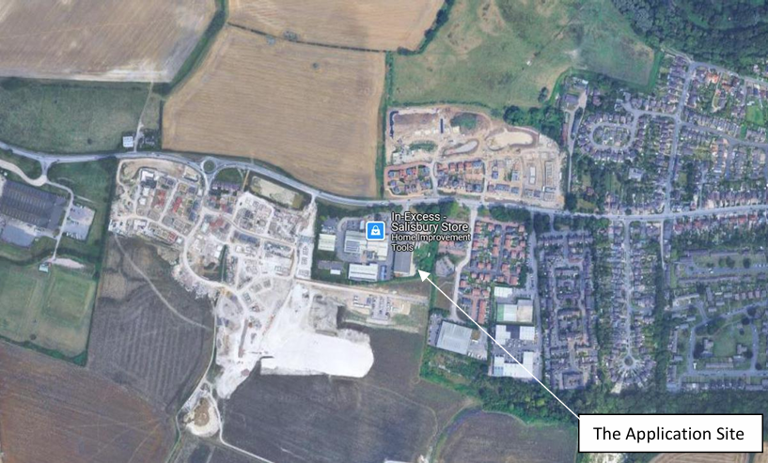

Employment units

The retention of the existing employment use of the site, and the creation of two B8 industrial units would accord with aims of CP35 of the WCS, and the general economic aims of the NPPF. The general location is considered acceptable, particularly given the historic employment use of the site itself and immediate adjacent sites along this road. The creation of employment is also a public benefit which must be considered in the overall balance and carries weight.

Retail shop and Drive Thru

CP38 of the WCS considers new retail development in out of centre locations and states:

All proposals for retail or leisure uses on sites not within a town centre in excess of 200 sqm
gross floorspace, including extension of existing units, must be accompanied by an impact
assessment which meets the requirement of national guidance and established best practice, and demonstrates that the proposal will not harm the vitality or viability of any nearby centres.

All such proposals must also comply with the sequential approach, as set out in national
guidance, to ensure that development is on the most central site available.

This policy is a material consideration when assessing the planning application and is
considered further in the following section, as is Policy 28 of the adopted SNP which relates to retail uses, although in this case, the retail proposal is not considered by officers to be “major” in scale or its impacts.

Retail impact assessment and sequential test

The NPPF states:

91 Local planning authorities should apply a sequential test to planning applications for main town centre uses which are neither in an existing centre nor in accordance with an up-to-date plan. Main town centre uses should be located in town centres, then in edge of centre locations; and only if suitable sites are not available (or expected tobecome available within a reasonable period) should out of centre sites be considered.

92. When considering edge of centre and out of centre proposals, preference should be given to accessible sites which are well connected to the town centre. Applicants and local planning authorities should demonstrate flexibility on issues such as format and scale, so that opportunities to utilise suitable town centre or edge of centre sites are fully explored.

94. When assessing applications for retail and leisure development outside town centres, which are not in accordance with an up-to-date plan, local planning authorities should require an impact assessment if the development is over a proportionate, locally set floorspace threshold (if there is no locally set threshold, the default threshold is 2,500m2 of gross floorspace). This should include assessment of:
a) the impact of the proposal on existing, committed and planned public and private
investment in a centre or centres in the catchment area of the proposal; and
b) the impact of the proposal on town centre vitality and viability, including local
consumer choice and trade in the town centre and the wider retail catchment (as
applicable to the scale and nature of the scheme).

95. Where an application fails to satisfy the sequential test or is likely to have
significant adverse impact on one or more of the considerations in paragraph 94
it should be refused.

It should be noted that the NPPF does not require an applicant or the LPA to assess the “need” for the development or to determine the impact of “competition” on other individual businesses. The emphasis is on the impact on “centre or centres” in the catchment area of the proposal.

In terms of impact on other local stores the councils retail consultant state that -

It (The proposed retail unit) is also located adjacent to the Harnham local area which is currently not served by any substantial foodstores. As such, it can be assumed that an element of trade diversion would come from a One Stop Local Convenience store (69 Netherhampton Road) which is physically the closest food store to the site, although the store is considerably smaller than the proposed. It is also assumed that similar levels of trade diversion would come from the M&S Simply Food (Downton Road) and the Nisa Local (The Crescent).

Therefore there would be trade diversion expected from both of these stores.

The impact that this proposal in terms of the retail shop and Drive Thru would potentially have on city centre retail was considered as part of work carried out by retail consultants that were appointed by the council to assess this proposal. They carried out both a retail assessment and a sequential test assessment and concluded as follows -

“With regards to the sequential test, the site is located in an out of centre location. The applicant has incorrectly determined that a sequential assessment is not required. However, we have undertaken our own assessment and concluded that there are no suitable alternative sites located in, or on the edge of, Salisbury city centre that could accommodate the proposed convenience retail unit. We consider that whilst it is feasible that the food and beverage unit could be located at one of the sequentially preferable sites listed above, it is the reality that, based on our conclusions, both units could not be accommodated in an alternative location and that is the scheme that has been submitted. As a consequence, we consider that the proposed development meets the provisions of the sequential test, as set out in Policy 38 of the development plan and paragraphs 91 and 92 of the NPPF.

The applicant has not submitted a retail impact assessment for this proposal. This is an incorrect interpretation of national and local policy. Therefore, we have conducted our own assessment which has found that the level of trade diversion from Salisbury city centre will not be of a material scale to be detrimental to its future vitality or viability.

When reaching the above conclusion, we have taken into account the following factors:

• The scale of the above proposed convenience food store

• The likely pattern of trade draw to the proposed development and trade diversion from existing stores, include the majority of the proposal’s trade to be diverted from existing out of centre food stores and supermarkets.
• The food and beverage unit is of a scale that diversion of trade from Salisbury city centre minimal and will not have a material impact on its viability and vitality.
• The health and function of Salisbury city centre, which is unlikely to be materially affected by the proposed development and its associated trading patterns.

As a consequence, we consider that the proposed development meets the provisions of Policy 38 of the development plan and paragraph 94 of the NPPF.”

As can be seen from this conclusion drawn by the councils retail consultants there are no grounds for not granting permission for the development in retail terms. There are no sequentially preferable sites available for this development and the retail draw from both the retail unit and Drive Thru would not be such that it would have an adverse effect on town centre retail. As such it is considered that in retail terms the proposal would be acceptable and would meet the requirements of National and local policy. The proposal is not considered to conflict with policy 28 SNP, given the modest scale and impacts of the proposal.

The creation of the retail uses and the employment aspect is also a public/community benefit which must be considered in the overall balance and carries weight. The proposal also therefore addresses the general aims of CP49 of the WCS. Whilst it is noted that third parties have raised issue regards other community uses they may wish to seek on this site, unfortunately, this application proposal must be considered on its merits and the impacts and benefits of the uses proposed. The impact of the proposed retail uses in terms of competition between the proposed and existing services and facilities elsewhere in Harnham area is not a matter upon which a refusal of permission could be based.

9.2 Highways impacts

The proposal it is considered has the ability to create additional traffic over and above that which is existing on Netherhampton Road. The third party comments regards this matter have been taken into account.

An assessment is therefore required of this traffic and any impact it may have on the existing road Network. The applicants have submitted a transport assessment dated July 2025 which assesses the impact of this proposal This concludes that - “The proposal is shown to accord with the adopted local plan and with Paragraphs 115 and117 of the NPPF. Overall, the scale of residual impact cannot be considered to be severe when viewed in the context of the NPPF planning test (NPPF paragraph 116). The proposals are also in line with
the development’s vision.”

The conclusion is drawn by the transport assessment on the basis that -

- The Site is surrounded by a pedestrian network that includes a number of crossing facilities, and a residential catchment within walking distance.

- The area local to the Site is conducive to cycling, with a wide range of services and amenities within cycling distance, and there are good opportunities for visitors and staff to make their journeys by bike.

- The bus stops local to the Site are served by frequent bus services, which provide access to/ from a variety of destinations.

- Salisbury rail station is also within cycling distance of the Site; some longer journeys to/from the proposed development can be made by train, with the connection between the station and the Site being made on foot, by bike, taxi, bus, or car-share.

- The proposal site also has a prominent location relative to the local highway network, and the recent local collision records indicate that there is no existing road safety problem in the vicinity of the Site.

- Overall, the Site has a good level of accessibility by all relevant transport modes in line with the proposed development’s vision.

- The proposed development will be served from the existing access junction, upgraded with white lining to formalise traffic priority between the Site and In-Excess.
Pedestrian movements are accommodated within the internal site layout.

- Swept path analysis shows that the access arrangements and layout of the proposed
development are suitable for the largest vehicles that are expected to use the site.

- The proposed on-site parking is provided broadly in accordance with the local parking standards.

- The industry-standard TRICS database has been used to identify the average vehicle trip rates for the proposed development.

- TRICS data shows that the proposed development could attract an average of 166 and 96 additional traffic movements during the weekday AM and PM peak hours respectively, taking account of the potential for linked trips.

- The assessment is based on realistic assumptions for the trip types and distribution of traffic
associated with the proposed development.

- The results show that the peak-hour traffic effect is minimal beyond the Site access junction.

- The capacity assessment indicates that the Site Access / A3094 Netherhampton Road junction will operate within capacity in the future scenario with the proposed development in place.

- The overall traffic effect is not likely to materially worsen the occurrence or materially affect the pattern of collisions on the network.”

The councils highways officers have considered this assessment and the conclusion that the proposal would be acceptable in highway terms and whilst officers take issue with parts of the assessment such as the likelihood of pedestrians walking to the development from the train station given the distances involved the overall conclusion that is drawn that the proposal would not create such significant highway impacts as to warrant refusal of the application, is accepted.

The council’s highway officer has considered the proposal and has commented as follows -

“I refer to the above planning application to which no highway objection is raised subject to the following condition being attached to any planning permission granted:

No development hereby approved shall be occupied until enough space for the parking and turning area as illustrated on the Proposed Site Plan 10-002-P5 together with the vehicular access thereto has been provided in accordance with details submitted to and approved in writing by the Local Planning Authority. The said space shall not be used other than for the parking/turning of vehicles or for the purpose of access.

The access arrangement shall be adjusted prior to first occupation as illustrated on the Proposed Site Plan, 10-002-P5.”

Given that there are no objections to the proposal from the councils highway engineers and having consulted with National Highways in respect of any impact on the junction with the A36 and they have offered no objections it is considered that in highways and traffic impact terms the proposal is not considered to be “severe” as outlined by para 116 of the NPPF, and there appears to be no strong highways related reasons for refusal. Overall, the proposal is therefore acceptable and complies with the aims of policies CP61 and 62 of the Wiltshire Core Strategy, and the aims of the NPPF.

9.3 Design and appearance/impact on area

The NPPF defines core planning principles which include that planning should always seek to secure high quality design. The third party comments regards the appearance of the scheme have been taken into account.

Core Policy 57 of the Wiltshire Core Strategy requires a high standard of design in all new developments through, in particular, enhancing local distinctiveness, retaining and enhancing existing important features, being sympathetic to and conserving historic buildings and landscapes, making efficient use of land, and ensuring compatibility of uses.

Objections have been raised that the proposal is an overdevelopment which will dominate the West side of the Netherhampton Road a key gateway into the city and will have an adverse impact upon the setting of Salisbury.

An important characteristic of the site is its prominent location with a frontage along the Netherhampton Road at a main entrance to the city. Although the site itself has been previously in a rural area. The area is now changing with the introduction of large housing estates on this side of the Netherhampton Road, although the area to the rear is still is of a rural character, consisting of scrub and grassland, the setting of the site is influenced by the developing urban context of the Netherhampton Road at this point, and the commercial/industrial development to the north and west including the existing Armishaw’s self storage/Removals building and the In Excess development.

The proposed retail building is single storey is 5.9 metres high and is pictured below -

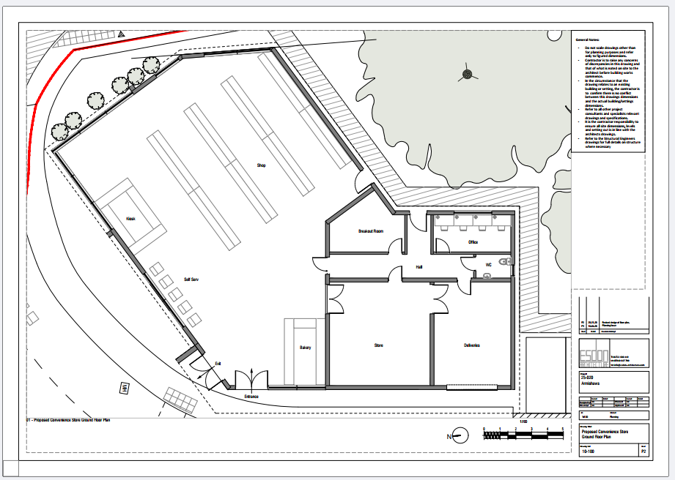

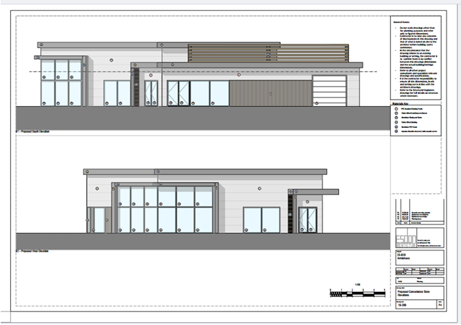

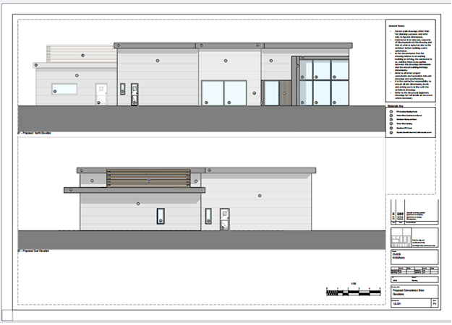

Proposed materials (which are recommended to be controlled by a planning condition) for the scheme include:

• PPC (polyester powder coating)Insulated Cladding Panels
• Timber effect Central Louvered screens
• Aluminium Glazing and Doors
• Timber effect Cladding
• Aluminium PPC fascia

The scheme was not subject to pre-application discussions on the design However having considered the design which is of a contemporary appearance it is considered acceptable.

Given the existing buildings on site which are of a significant scale and given that the retail unit as proposed is of a much smaller scale it is considered that the overall size and height of the retail unit as proposed is acceptable. The modern design reflects that of the surrounding buildings and that of the residential dwellings which are being built in the area. There are a mixture of facing materials proposed on the building which correlate with other materials used on buildings existing in the area particularly those units directly adjacent this site.

Drive Thru building

The proposed Drive Thru is 3.64metres high and then has an additional plant area which increases the height to 6.67 metres it is intended to affix a sign to the plant area although that would need to be subject to an advertisement application at a later stage.

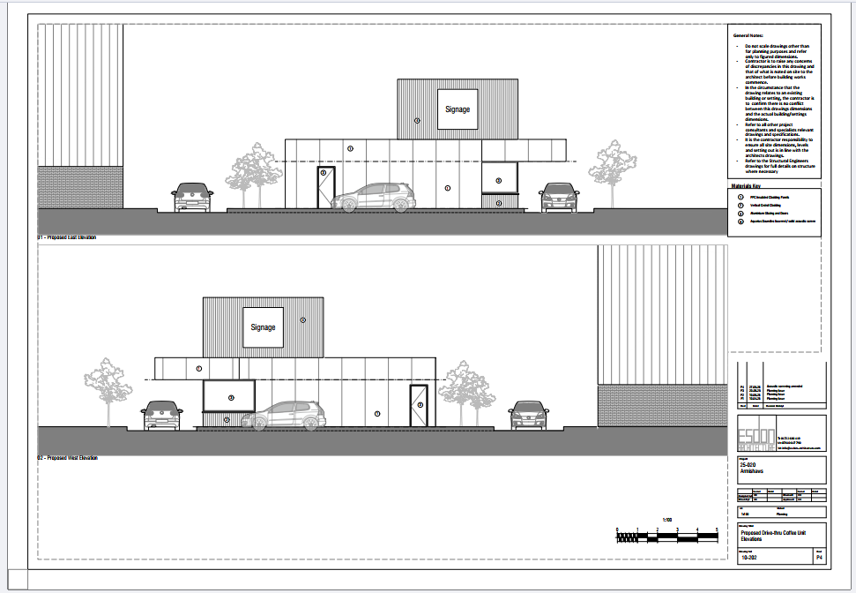

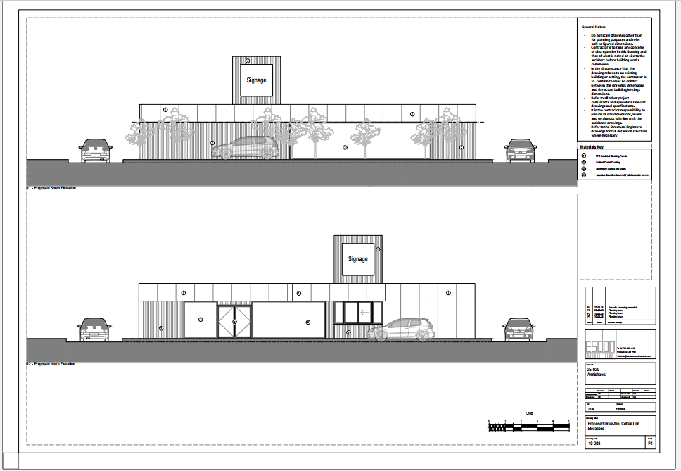

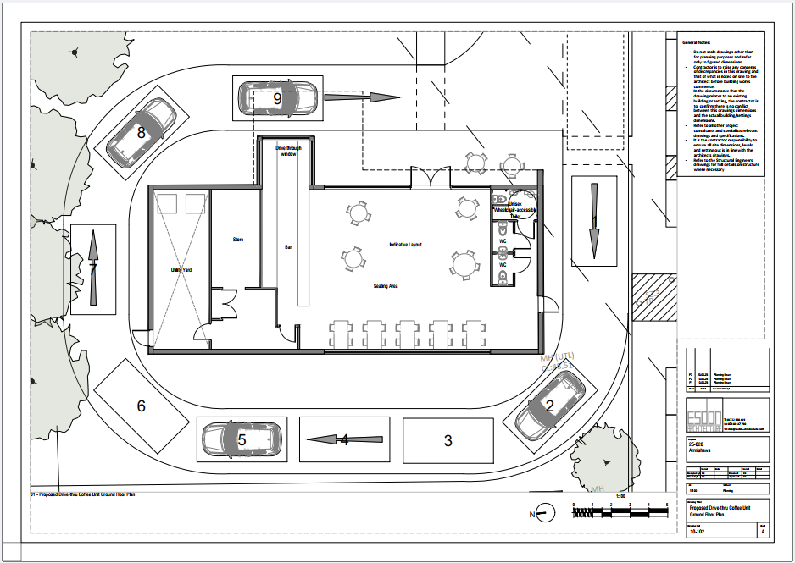
Proposed materials (which are again recommended to be controlled by a planning condition) for the scheme include:

• PPC (polyester powder coating )Insulated Cladding Panels
• Vertical Cedral Cladding
• Aluminium Glazing and doors
• Soundtec Solid Louvred Screens

The proposed materials and design of the Drive Thru are similar to that of the retail unit which will help with the cohesiveness of the site and to ensure that the site does not become a number of unrelated parts. Overall the modern design is considered acceptable

The background to the Drive Thru restaurant is the existing Armishaws building which is of a significant scale and height at 10.91metres tall the much smaller height of this Drive Thru and its additional plant room on the roof is considered acceptable in its scale and appearance and something which would be appropriate on this site and would fit with the existing aesthetic of both existing buildings and those as proposed.

B8 storage buildings

It is proposed to erect two B8 buildings on site along the Eastern boundary (B8 units can be used for a variety of uses including but not limited to the main use of Warehouse and distribution so small shop units attached to B8 units are considered ancillary.)These two new units will be 7.36 metres in height.

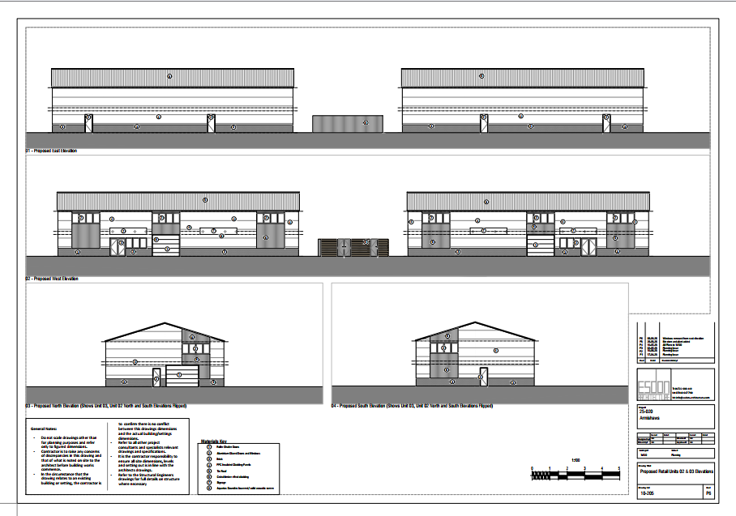

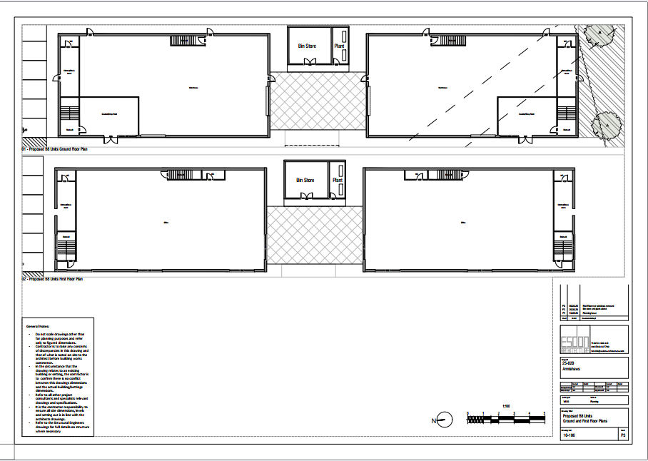

The two units proposed are of fairly standard design of two storey height under a pitched roof. The proposed materials on these two buildings include:

• Aluminium/metal Roller shutter Doors and windows and Doors
• Brick exterior
• PPC Insulated Cladding panels
• Metal Roof
• Cedral timber effect Cladding
• Soundtec Solid Louvred Screens

The design of the two B8 industrial units is different to that of the Retail unit and Drive Thru in that it is more traditional with its pitched roof and brick walls extending to two storey in height. However a number of the materials are the same as proposed on the other buildings and as such this will help tie the buildings into the surrounding site. Conditions can be used to ensure that materials used are appropriate to the context and to the other buildings on the site.

Overall The application demonstrates an appropriate response to the local context and setting in terms of Core Policy 57 of the WCS subject to the appropriate selection of facing and external materials & finishes and external lighting and may be handled by a planning condition, and subject to the appropriate applied corporate signage and associated lighting under application for advertising consent.

9.4 Impact on Amenity

Amenity is an important consideration with this application given its proximity to neighbouring properties at Riddle Close and other properties (to the east) and newer properties that are currently being built out as part of the wider Netherhampton Road housing development. Third party concerns have been received and taken into account.

There are two aspects to amenity that need to be considered both in terms of the direct proximity of new buildings to neighbouring properties and any noise and disturbance that may come from those new buildings as can be seen from the consultation responses displayed earlier in the report the council’s public protection officers have considered

Policy CP57 of the Wiltshire Core strategy requires all development to have a high standard of design and a positive contribution to the character of Wiltshire by inter alia -

Vii having regard to the compatibility of adjoining buildings and uses, the impact on the amenities of existing occupants, and ensuring that appropriate levels of amenity are achievable within the development itself, including the consideration of privacy, overshadowing, vibration, and pollution (e.g. light intrusion, noise, smoke, fumes, effluent, waste or litter)

The nearest buildings to residential properties are the two proposed two storey B8 industrial units which will back on to dwellings in the recently built estate which contains Riddell Way to the East. Houses in Riddell way side on to this site and they are positioned about 1m away from the boundary. It is proposed that the new units which measure 7.3metres in height are positioned approx. 3 metres from the boundary. A judgement therefore needs to be made about whether the new B8 industrial buildings would cause amenity issues for those new dwellings in adjacent Riddell Way to the east of the site.

The actual distance between the new B8 industrial units and the neighbouring houses is relatively small at just over 4 metres however given the oblique angles of the two buildings to the residential properties it is considered that building at this distance would be acceptable and would not cause such overbearing as to warrant refusal of the application.

The other amenity issue to consider is that of noise and disturbance and this is something that has been considered by the council’s public protection officer who has raised no objections to the application subject to conditions and has commented as follows -

Building Services plant associated with the proposed use will be installed on the roofs of the retail unit and drive thru, and building services plant will be located at ground level for two B8 units in a structure located between the two B8 units.

A Noise Impact Assessment has been submitted with the application which demonstrates, with mitigation, noise from plant will be at least 5dB below background sound level and therefore protective of amenity at the nearest noise sensitive locations.

The delivery/ service plan has been amended to ensure all deliveries/ collections to/ from the site are carried out during ‘day time’ hours, and will not take place outside of the hours 7am and 7pm.

I therefore recommend the following conditions are applied to any approval:

• Building Services plant for the drive through and retail unit, as specified on the Plant Noise Schedule at the appendix to Clarke Saunders Noise Impact Assessment (dated 20th May 2026), and mitigation measures for the B8 units (installation of acoustic screen as detailed at 8.2.3 - 8.2.5 of the report) shall be installed in full in accordance with plans submitted,and maintained in accordance with manufacturers instructions at all times thereafter.

Building Services plant for the retail unit shall be selected to ensure the sound power levels do not exceed those detailed in the Plant Noise Schedule of Clarke Saunders Noise report (dated 20th May 2026), and mitigation measures (as detailed at 8.2.5 of the report) shall be installed in full in accordance with plans submitted, and maintained in accordance with manufacturers instructions at all times thereafter.

Reason: Core policy 57, Ensuring high design and place shaping such that appropriate levels of amenity are achievable.

• Delivery/ collection shall be carried out strictly in accordance with the Esdon Architecture Delivery and Service Plan dated 6th July 2026.
No collections or deliveries shall take place between the hours of 1900hrs and 0700hrs.

Reason: Core policy 57, Ensuring high design and place shaping such that appropriate levels of amenity are achievable.

• Retail unit hereby approved shall only be open for customers between the hours of:
0700hrs and 2300hrs Monday to Saturday
0800hrs and 2200hrs Sunday/ Bank/ Public Holidays

Drive Thru hereby approved shall only be open for customers between the hours of:
0600hrs and 2100hrs

Use of the B8 Units hereby approved shall only take place between the hours of:
0700hrs and 1900hrs Monday to Saturday
1000hrs and 1600hrs Sundays/ bank/ public holidays

Reason: Core policy 57, Ensuring high design and place shaping such that appropriate levels of amenity are achievable.

• No construction or demolition work shall take place on Sundays or Public Holidays or outside the hours of 0800 to 18:00 Monday to Friday and 08:00 to 13:00 on Saturdays.

Reason: Core policy 57, Ensuring high design and place shaping such that appropriate levels of amenity are achievable.

• No development shall commence on site until a construction management plan has been submitted to and approved in writing by the local planning authority. The plan shall include details of the measures that will be taken to reduce and manage the emission of noise, vibration and dust during the demolition and/or construction phase of the development. It shall include details of the following:
i. The movement of construction vehicles;
ii. The cutting or other processing of building materials on site;
iii. Wheel washing and vehicle wash down facilities;
iv. The transportation and storage of waste and building materials;
v. The recycling of waste materials (if any)
vi. The loading and unloading of equipment and materials
vii. The location and use of generators and temporary site accommodation
viii. Where piling is required this must be Continuous flight auger piling wherever practicable to minimise impacts
The construction/demolition phase of the development will be carried out fully in accordance with the construction management plan at all times.

Reason: Core policy 57, Ensuring high design and place shaping such that appropriate levels of amenity are achievable.

• Prior to the installation of any external lighting, a scheme of external lighting together with a lighting engineer’s statement shall be submitted to and approved in writing by the Local Planning Authority. The statement shall confirm that the external lighting scheme has been designed in accordance with institute of Lighting Professionals Guidance of Reduction of Obtrusive Light Environmental Zone E3 (suburban location) and shall demonstrate that light spill, glare and sky glow have been minimised.
The lighting shall be installed and operated only in accordance with the approved details and shall thereafter be retained for the lifetime of the development.

Reason: Core policy 57, Ensuring high design and place shaping such that appropriate levels of amenity are achievable.

As can be seen from this whilst the site is close to residential properties and therefore it is important to ensure that they are properly protected from both noise and disturbance and overbearing and overlooking from the new units its felt that this can be achieved provided appropriate conditions are attached to any grant of planning permission. Subject that being applied it is considered that the proposal will comply with policy CP57 of the Wiltshire Core strategy. A refusal on amenity grounds would therefore be difficult to justify on this basis.

9.5 Flooding and drainage

Policy CP67 of the WCS relates to flooding matters, as does the NPPF. Flooding and drainage is an important consideration with this application as there has been much public concern in recent years about the potential for flooding in the local area and along Netherhampton Road particularly from the new housing developments that have been and are being built along the road. Whilst there is no known flooding incidences from this current site at present nonetheless the applicants have submitted a site specific flood risk assessment that has been considered by the council’s drainage officer and they have made the following comments.

“The application has been supported with a Site-Specific Flood Risk Assessment (FRA). It
should be noted that our comments below are reliant on the accuracy and completeness of the FRA and we do not take any responsibility for incorrect data or interpretation made by the authors.

The revised submission includes correspondence from Wessex Water (dated 09/03/2026),
confirming acceptance of a maximum surface water discharge rate of 1.0 l/s to the public
surface water sewer beneath Netherhampton Road. The proposed discharge rate is compliant with Wiltshire Council's Betterment Policy, and the applicant has submitted updated hydraulic modelling using InfoDrainage that demonstrates the proposed system can accommodate runoff for storm events up to and including the 1 in 100-year plus 45% climate change scenario, without flooding of the drainage network. On this basis, the previous objection relating to surface water discharge rate and downstream capacity has been addressed.

The applicant has revised the surface water drainage strategy accordingly, with runoff from the 0.593 ha impermeable area managed via a sealed SuDS system comprising lined permeable paving, green roofs, proprietary treatment devices, filter drains, and below-ground geocellular attenuation tanks. The applicant must provide further details on the SuDS via conditions.

While the drainage strategy refers to a CCTV survey having been undertaken, no CCTV survey report or verified outfall details have been submitted, and the final discharge location remains based on assumption. Further confirmation of the existing drainage arrangement is therefore required.

Subject to the imposition of appropriate planning conditions to secure detailed design,
confirmation of existing drainage arrangements, and long-term management and maintenance of the SuDS system, the proposed surface water drainage strategy is considered acceptable in principle.

As can be seen from this response the councils drainage officer is of the opinion that the scheme can be adequately drained subject to the submission of a drainage strategy and that the proposal would not increase the risk of flooding in the area. This is particularly the case given that much of the site is already hard surfaced in one form or another and that drainage is occurring without instance at present. The proposal is therefore considered to comply with policy 67 of the Wiltshire Core strategy which requires the consideration of such matters.

9.6 Ecological impacts

Policy CP50 of the Wiltshire Core strategy sets out the ecological criteria for development and seeks to ensure no net loss in biodiversity. There have been objections to the development of the site on ecological and biodiversity impact grounds. An Ecological Impact Assessment and an Arboricultural Impact Assessment (AIA) and Method Statement were submitted with the application and have been assessed by the councils ecologist in light of both National and local policies and each of those elements is considered below.

A Preliminary Ecological Appraisal submitted in support of the application noted that the site had been cleared prior to surveys being undertaken which included the removal of hedgerows, trees and scrub which had the potential to support a number of species.

Badgers

The councils ecologist considered the potential for Badgers on the site as follows -

“Badger setts were identified along the southern boundary of the site. Further surveys concluded that even after works had been undertaken to clear the site, badger activity continued. It appeared that none of the setts were currently in use at the time of the survey and it is unclear if the site clearance works resulted in disturbance to badger use of the setts.
Measures including a 20m exclusion zone has been proposed within the ecology report which is welcomed however, additional information will be required prior to commencement which could be secured by condition. A construction method statement will be required to be submitted to and agreed by the LPA prior to commencement of works for the protection of badgers, protected under the Badger Act 1992.

The construction method statement should include details such as:
• Pre commencement survey information
• Licence considerations
• Identification of ecological protection zones and measures to protect badger such as
fencing
• Reasonable avoidance measures to reduce impacts to badger on site
• Detailed mitigation strategy to be implemented
• Work schedules for activities including details of when an ecologist will be present on site”

As can be seen from this whilst there is potential for badgers to be present on the site any potential impact can be considered and mitigated by condition.

Great crested Newts

With regard to Great Crested Newts the councils ecologist has stated that –

Ponds have been identified within 500m of the site. Due to the nature and location of the ponds, together with the physical barriers between the ponds and the site, it is anticipated that impacts to GCN would be de minimums. However, it should be noted that these species are legally protected and planning permission does not provide a defence against prosecution. If these species are found during the works, the applicant is advised to stop work and follow advice from an independent ecologist or the Council Landscape and Design Team (ecologyconsultations@wiltshire.gov.uk).

Therefore whilst the impact on GCN must be considered it is anticipated that the impact will not be significant from this development

New Forest Protected Sites

The application site is located within a consultation zone for The New Forest and therefore has potential to result in significant adverse impact on the special features of that site.
A test of likely significance has been carried out by the relevant Competent Authority (Wiltshire Council) as required by Regulation 63 of the Conservation of Habitats and Species Regulations 2017 (as amended). This concluded that given the nature of the development there is no mechanism for adverse effect. The Habitats Regulations Assessment has concluded that the application is not likely to have significant impacts on the SAC and subsequently the application is screened out of Appropriate Assessment

River Avon Special Area of Conservation (SAC) Hampshire Catchment

The application site is located within a consultation zone for the River Avon Hampshire
Catchment and therefore has potential to result in significant adverse impact on the special
features of that site.

The councils ecologist has considered this and has stated that -

A test of likely significance has been carried out by the relevant Competent Authority (Wiltshire Council) as required by Regulation 63 of the Conservation of Habitats and Species Regulations 2017 (as amended). This concluded that given the nature of the development there is no mechanism for adverse effect. The HRA has concluded that the application is not likely to have significant impacts on the SAC and subsequently the application is screened out of Appropriate Assessment

Biodiversity Net Gain

Whilst a statutory baseline calculation has been submitted A biodiversity net gain plan has not been submitted with the application and therefore needs to be considered post decision the councils ecologist has commented that -

Under Schedule 7A of the Town and Country Planning Act 1990 (as inserted by Schedule 14 of the Environment Act 2021) this application is required to deliver 10% Biodiversity Net Gain
(BNG). The Biodiversity Gain Plan condition will automatically apply if approval is forthcoming.

A completed statutory metric calculation confirming the baseline of the site has been submitted. It is noted that the baseline represents habitats believed to be present prior to the degradation event when the site was cleared in 2024.

Information in the completed on-site baseline habitat tabs is accepted as accurate based on the information submitted. The pre-development (baseline) situation is summarised below.

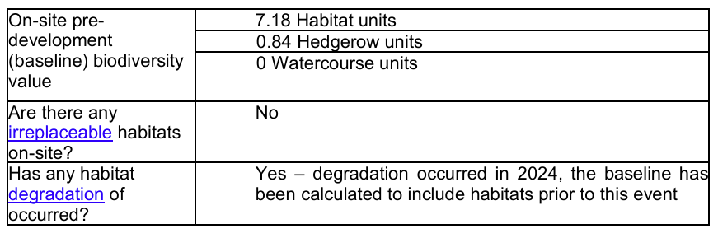

Information on how BNG requirements will be met have not been submitted in support of the
application. Although BNG is a post determination issue, should habitats on site be relied upon to provide BNG we would advise this is done prior to determination to ensure the Landscape proposals align with any BNG requirements.

Therefore subject to conditions it is considered that the site would comply with the relevant local and national planning policies, including CP50/52 of the WCS.

9.7 Trees and landscape

There are a number of mature trees on the site in the North Easter Corner of the site at present and as such an Arboricultural impact assessment and Arboricultural method statement were requested of the applicant and submitted with the application. Having viewed these two documents the councils tree officer is satisfied that subject to the trees being protected in accordance with those documents there are no objections to the proposals effects on the trees in the site.

At present there is limited detail on the landscaping to be provided for this development and a landscape plan still needs to be provided.

The council’s landscape officer has commented as follows -

I have no objection in principle to the proposals. There is however a lack of detail for the proposed landscaping. We require a fully detailed planting plan including information on size, species and density (no/m2) for all tree, shrub and herbaceous planting, including bulbs and seed mix specification. We also require tree pit details for hard and soft landscape where appropriate. Information on maintenance/management should also be included. I am happy for you to apply Wiltshire Council standard landscape conditions to secure this information.

It is considered that the development would be appropriate and could meet the requirements of core policy CP57 of the WCS provided that a quality landscape scheme is submitted. This can reasonably be secured by condition.

9.8 Archaeology

The area in around this site has previously been subject to archaeological evaluation as part of other schemes. Archaeology has been found recently on other sites nearby on some of the recent housing developments and mitigated against. The councils archaeologist was therefore consulted as part of this proposal and has made the following comment -

“As I understand it, there have been several recent planning applications (in 2017, 2019 and 2020) in relation to Armishaw Removals. The site was subject to an exploratory archaeological investigation in relation to the 2019 application. Three trial trenches were excavated in the open space to the east of the existing warehouse.

This archaeological investigation failed to identify any buried remains, despite recent excavations to the west and north in advance of residential development identifying significant Neolithic, Bronze Age and Saxon remains. The 2019 exercise also recorded truncation from groundworks and services when the existing warehouse was constructed.

On this basis, I have no archaeological concerns with this application and no further action is therefore required as regards the buried archaeological heritage in relation to this planning application.

Given this it is not considered that further archaeological investigation of the site is required. Policy CP58 of the WCS and the aims of the NPPF are therefore met.

- CONCLUSION – the ‘planning balance’

The concerns of third parties have been taken into consideration.

The NPPF 2024 confirms in paragraph 11 that plans and decisions should apply a presumption in favour of sustainable development. For decision making, that means approving development proposals that accord with an up-to-date development plan without delay. Paragraph 11 also refers to the LPA needing to consider whether there are “strong” reasons for refusal based on any impacts on assets of particular importance listed in footnote 7, or adverse impacts which would significantly and demonstrably outweigh the benefits of the proposal.

The application seeks to secure a new convenience retail store, new drive- thru, two B8 industrial units and alterations to the existing storage unit on the existing car park/open area of the Storage unit, outside of the principal settlement of Salisbury. The Local Planning Authority has commissioned a retail impact assessment which includes a sequential test to assess the impact of the Drive Thru and retail store on existing retail in Salisbury. This has concluded that the level of trade diversion from Salisbury City Centre will not be of a material scale to be detrimental to its future vitality or viability. Whilst the proposal may draw trade from other local stores, competition between retail stores is not usually a matter which can be used to refuse a retail proposal.

The proposal is considered to satisfy the policy requirements of the NPPF para 94 (a) & (b) and CP38 of the WCS. The development is not anticipated to have a “significant adverse impact” on existing, committed and planned public and private investment in a centre in the catchment area or on city centre vitality and viability. The provision of new convenience retail floorspace in the Harnham area, which is considered by the Council’s consultant to currently have limited provision, weighs positively in the planning balance. The proposal would therefore be acceptable subject to a suitable conditions to restrict the use to Class E(a). The provision of retail facilities is also a public benefit of weight in the process.

The existing warehouse/storage use is retained by the proposal, in general accordance with WCS policies and additional B8 units are proposed which will increase employment opportunities. This provision accords with the employment policies in the WCS and the NPPF, and is a public benefit of some weight.

There are no objections to the design, siting and materials for the proposed buildings and BNG provision can be secured under the standard BNG Informative. Biodiversity enhancement can also be secured by condition and this is a positive consideration in the planning balance.

In terms of potential amenity impacts, the proposal would be located adjacent the boundary with residential dwellings. Whilst the site is already used for an industrial type of activity, the proposal intensifies the use of the site, and is likely to have an impact on residential amenity due to the additional noise and general disturbance created by the additional activities. This carries weight in the overall balance, and is not a public benefit.

However, the lighting plan and noise assessment have been considered by the public protection (and ecology) officer and there are no objections subject to conditions being imposed to manage hours of operation and installation of plant and machinery. A refusal on amenity impact grounds would therefore be difficult to justify.

The highways impact of the development has been assessed by the highways officer and considered to be acceptable. This development inevitably will lead to further traffic on the already congested Netherhampton road area. However it is considered that the levels of additional traffic generated by this development much of which will be local traffic anyway is not sufficient to recommend refusal of the application.

The lack of technical objections and harm should in officer’s opinion carry significant positive weight, with some negative weight balanced against that in relation to amenity and highways harms, although provided appropriate conditions are imposed, the scheme is unlikely to have significant negative amenity and highways impacts on acknowledged interests.

Further, the scheme does present an opportunity to secure some public benefits over the existing situation on the site, by improving the retail offer in Harnham, providing additional B8 employment units and providing biodiversity net gain.

Given that consultees consider that the scheme can be made acceptable with suitable conditions and mitigation, officers conclude that the planning balance weighs overall in favour of the development. Overall, there would appear to be no “strong” reasons for refusal, and there would be no adverse impacts which would significantly and demonstrably outweigh the benefits of the proposal. On that basis, the NPPF para 11 would indicate that the scheme should be approved.

RECOMMENDATION:That the application be Granted planning permission subject to the following conditions -
- The development hereby permitted shall be begun before the expiration of three years from the date of this permission.
REASON: To comply with the provisions of Section 91 of the Town and Country Planning Act 1990 as amended by the Planning and Compulsory Purchase Act 2004.
- The development hereby permitted shall be carried out in accordance with the drawing issue sheet by Edson Architecture for project no 25 -020 Armishaws and as issued on the 6th August 2026 and received by the local planning authority on that date.
REASON: For the avoidance of doubt and in the interests of proper planning.
- The development hereby approved shall not be occupied until sufficient space for the parking and turning area as illustrated on the Proposed Site Plan 10-002-P5 together with the vehicular access thereto has been provided on site in accordance with details that shall be submitted to and approved in writing by the Local Planning Authority. That space shall not be used other than for the parking/turning of vehicles or for the purpose of access for the lifetime of the development.
The access arrangement shall be adjusted prior to first occupation as illustrated on the Proposed Site Plan, 10-002-P5.
REASON: In the interests of highway safety.
- No development shall take place until a surface water drainage strategy has been submitted to and approved in writing by the Local Planning Authority. Development shall be carried out in accordance with the agreed strategy.
REASON: To ensure that the site is adequately drained. The surface water drainage strategy shall comply with Wiltshire Council requirements, NPPF, PPG and the National Standards for SuDS
- No development shall commence on site until a construction management plan, which shall include monitoring of, and measures to retain, the existing vegetation across the site, together with details of drainage arrangements during the construction phase, has been submitted to and approved in writing by the Local Planning Authority. Development shall be carried out as approved.
REASON: In the interests of ensuring the site drains adequately
- No development shall commence on site until a scheme of hard and soft landscaping has been submitted to and approved in writing by the Local Planning Authority, the details of which shall include :-
• location and current canopy spread of all existing trees and hedgerows on the land;
• full details of any to be retained, together with measures for their protection in the course of development;
• a detailed planting specification showing all plant species, supply and planting sizes and planting densities;
• finished levels and contours;
• means of enclosure, particular along the eastern boundary of the site;
• car park layouts;
• other vehicle and pedestrian access and circulation areas;
• all hard and soft surfacing materials;
• minor artefacts and structures (e.g. furniture, refuse and other storage units, signs, lighting etc);
• proposed and existing functional services above and below ground (e.g. drainage, power, communications, cables, pipelines etc indicating lines, manholes, supports etc);
REASON: The application contained insufficient information to enable this matter to be considered prior to granting planning permission to ensure a satisfactory landscaped setting for the development and the protection of existing important landscape features.

- All soft landscaping comprised in the approved details of landscaping shall be carried out in the first planting and seeding season following the first occupation of the building(s) or the completion of the development whichever is the sooner;
All shrubs, trees and hedge planting shall be maintained free from weeds and shall be protected from damage by vermin and stock. Any trees or plants which, within a period of five years, die, are removed, or become seriously damaged or diseased shall be replaced in the next planting season with others of a similar size and species, unless otherwise agreed in writing by the local planning authority. All hard landscaping shall also be carried out in accordance with the approved details prior to the occupation of any part of the development or in accordance with a programme to be agreed in writing with the Local Planning Authority.
REASON: To ensure a satisfactory landscaped setting for the development and the protection of existing important landscape features.
- Building Services plant for the drive through and retail unit, as specified on the Plant Noise Schedule at the appendix to Clarke Saunders Noise Impact Assessment (dated 20th May 2026), and mitigation measures for the B8 units (installation of acoustic screen as detailed at 8.2.3 - 8.2.5 of the report) shall be installed in full in accordance with plans submitted, and maintained in accordance with manufacturers instructions at all times thereafter.
Building Services plant for the retail unit shall be selected to ensure the sound power levels do not exceed those detailed in the Plant Noise Schedule of Clarke Saunders Noise report (dated 20th May 2026), and mitigation measures (as detailed at 8.2.5 of the report) shall be installed in full in accordance with plans submitted, and maintained in accordance with manufacturers instructions at all times thereafter.
REASON: Core policy 57, Ensuring high design and place shaping such that appropriate levels of amenity are achievable.

- Delivery/ collection shall be carried out strictly in accordance with the Edson Architecture Delivery and Service Plan dated 6th July 2026.
No collections or deliveries shall take place between the hours of 1900hrs and 0700hrs on any day of the week.
REASON: To ensure compliance with core policy 57 of the Wiltshire Core Strategy Ensuring high design and place shaping such that appropriate levels of amenity are achievable.

- The uses hereby approved shall only be open for customers between the following hours:
Retail unit:
0700hrs and 2300hrs Monday to Saturday
0800hrs and 2200hrs Sunday/ Bank/ Public Holidays

Drive Thru:
0600hrs and 2100hrs

B8 Industrial Units:
0700hrs and 1900hrs Monday to Saturday
1000hrs and 1600hrs Sundays/ bank/ public holidays
REASON: In order to comply with Core policy 57,of the Wiltshire Core strategy. Ensuring high design and place shaping such that appropriate levels of amenity are achievable.

- No construction or demolition work shall take place on Sundays or Public Holidays or outside the hours of 0800 to 18:00 Monday to Friday and 08:00 to 13:00 on Saturdays.
REASON: Core policy 57, Ensuring high design and place shaping such that appropriate levels of amenity are achievable.

- No development shall commence on site until a construction management plan has been submitted to and approved in writing by the local planning authority. The plan shall include details of the measures that will be taken to reduce and manage the emission of noise, vibration and dust during the demolition and/or construction phase of the development, including the protection of adjacent residential amenities. It shall include details of the following:
i. The movement of construction vehicles;
ii. The cutting or other processing of building materials on site;
iii. Wheel washing and vehicle wash down facilities;
iv. The transportation and storage of waste and building materials;
v. The recycling of waste materials (if any)
vi. The loading and unloading of equipment and materials
vii. The location and use of generators and temporary site accommodation
viii. Where piling is required this must be Continuous flight auger piling wherever practicable to minimise impacts
The construction/demolition phase of the development will be carried out fully in accordance with the construction management plan at all times.
REASON: Core policy 57, Ensuring high design and place shaping such that appropriate levels of amenity are achievable.

- Any external lighting that is installed across the site shall be designed and implemented to minimise sky glow, glare and light trespass. It shall be designed in a downward facing position at all times and shall meet the criteria for Environmental Zone E3 as defined by the Institute of Lighting Professionals ‘Guidance Notes for the Reduction of Obtrusive Light’ 2021. Any external lighting installed at the site shall be retained and maintained as such thereafter for the lifetime of the development.
REASON: To ensure appropriate levels of amenity are achieved and in order to minimise light intrusion in relation to bats

14) No railings, fences, gates, walls, bollards and other means of enclosure development shall be erected in connection with the development hereby permitted until details of their design, external appearance and decorative finish have been submitted to and approved in writing by the Local Planning Authority. Development shall be carried out in accordance with the approved details prior to the development being brought into use.
REASON: In the interests of visual amenity and the character and appearance of the area.

15) The development shall be carried out in strict accordance with the following documents:
• Badger Survey Report. June 2025. Peach Ecology
• Landscaping Plan 10-110 P4. July 2025. Edson Architecture
• The Statutory Biodiversity Metric. December 2024. Arbtech
REASON: For the avoidance of doubt and for the protection, mitigation and enhancement of biodiversity.

16) No development shall commence on site (including any vegetation removal or works to existing structures), until a Construction Method Statement has been submitted to, and approved in writing by the Local Planning Authority. The Construction Method Statement shall include all precautionary measures to be implemented during the construction present within or period, for the protection of sensitive habitats and species known to be adjacent the site, with particular reference to: Badgers
The development shall be carried out in strict accordance with the approved Construction Method Statement.
REASON: To ensure adequate protection, mitigation and compensation for protected species and priority habitats throughout the construction period.
17) The development hereby approved shall be carried out in accordance with the recommendations and provisions of the Arboricultural impact assessment and tree protection plan by NB tree management dated the 2nd February 2026 and also the Arboricultural method statement and tree protection plan also dated the 2nd February 2025 and produced by NB tree management.
REASON: In order to ensure protection of the mature trees on site during and after development.
18) Notwithstanding the provisions of the Town and Country Planning (General Permitted Development) (England) Order 2015 (or any Order revoking or reenacting or amending that Order with or without modification),the following three provisos shall apply to the retail unit, the Drive Thru and the B8 units respectively:
The retail unit hereby approved shall be used solely for purposes within Class E(a) of the Schedule to the Town and Country Planning (Use Classes) Order 1987 (as amended)(or in any provisions equivalent to that class in any statutory instrument revoking or reenacting that Order with or without modification).
The Drive Thru unit hereby approved shall be used solely for the purposes within class E(b) of the Schedule to the Town and Country Planning (Use Classes) Order 1987 (as amended)(or in any provisions equivalent to that class in any statutory instrument revoking or reenacting that Order with or without modification).
The two B8 units hereby approved shall be used solely the purposes within class B8 of the Schedule to the Town and Country Planning (Use Classes) Order 1987 (as amended)(or in any provisions equivalent to that class in any statutory instrument revoking or reenacting that Order with or without modification).
REASON: The proposed uses are acceptable but the Local Planning Authority wish to consider any future proposal for a change of use, other than a use within the same class, having regard to the circumstances of the case.

INFORMATIVES:
Nesting Birds
All British birds, their nests and eggs are protected under Section 1 of the Wildlife and
Countryside Act 1981 (as amended) and the Countryside and Rights of Way Act 2000 while birds are nesting, building nests and sitting on eggs. The applicant is advised to check any structure or vegetation capable of supporting breeding birds and delay removing or altering such features until after young birds have fledged. Damage to extensive areas that could contain nests/breeding birds should be undertaken outside the breeding season. This season is usually taken to be the period between 1st March and 31st August but some species are known to breed outside these limits.

Protected Species
The applicant should note that under the terms of the Wildlife and Countryside Act (1981) and the Conservation of Habitats and Species Regulations 2017 (as amended) it is an offence to disturb or harm any protected species including for example, breeding birds and reptiles. The protection offered to some species such as bats, extends beyond the individual animals to the places they use for shelter or resting. Please note that this consent does not override the statutory protection afforded to any such species. In the event that your proposals could potentially affect a protected species you should seek the advice of a suitably qualified and experienced ecologist and consider the need for a licence from Natural England prior to commencing works. Please see Natural England’s website for further information on protected species.

BNG required
The effect of paragraph 13 of Schedule 7A to the Town and Country Planning Act 1990 is that planning permission granted for the development of land in England is deemed to have been granted subject to the condition “(the biodiversity gain condition”) that development may not begin unless:
(a) a Biodiversity Gain Plan has been submitted to the planning authority, and
(b) the planning authority has approved the plan.
The planning authority, for the purposes of determining whether to approve a Biodiversity Gain Plan if one is required in respect of this permission would be Wiltshire Council. There are statutory exemptions and transitional arrangements which mean that the biodiversity gain condition does not always apply. For further information on exempt developments please refer to: Biodiversity net gain: exempt developments

Based on the information available this permission is considered to be one which will require the approval of a biodiversity gain plan before development is begun because none of the statutory exemptions or transitional arrangements are considered to apply. Irreplaceable habitat If the onsite habitat includes irreplaceable habitat (within the meaning of the Biodiversity Gain Requirements (Irreplaceable Habitat) Regulations 2024) there are additional requirements for the content and approval of Biodiversity Gain Plans.
The Biodiversity Gain Plan must include, in addition to information about steps taken or to be taken to minimise any adverse effect of the development on the habitat, information on arrangements for compensation for any impact the development has on the biodiversity of the irreplaceable habitat.
The planning authority can only approve a Biodiversity Gain Plan if satisfied that the adverse effect of the development on the biodiversity of the irreplaceable habitat is minimised and appropriate arrangements have been made for the purpose of compensating for any impact which do not include the use of biodiversity credits.

