APPLICATION FOR HOUSEHOLDER PLANNING PERMISSION
DELEGATED REPORT

APPLICATION REFERENCE: | PL/2026/02512
APPLICATION TYPE: | Householder planning permission
SITE ADDRESS: | 34 Copheap Rise, Warminster, BA12 0AR
DEVELOPMENT DESCRIPTION: | Proposed demolition of detached garage. Erection of two storey side extension and associated works.
RECOMMENDATION: | That Planning Permission be GRANTED

SITE DESCRIPTION/CONTEXT
The subject property is a detached, two-storey dwelling in an area characterised by shared modern design and materiality on a modern road layout. The site is north east of historic Warminster, close to Cop Heap scarp, woodlands and bowl barrow. The property benefits from a larger garden stretching to the side/southwest as on the corner of the cul-de-sac.

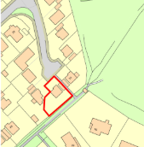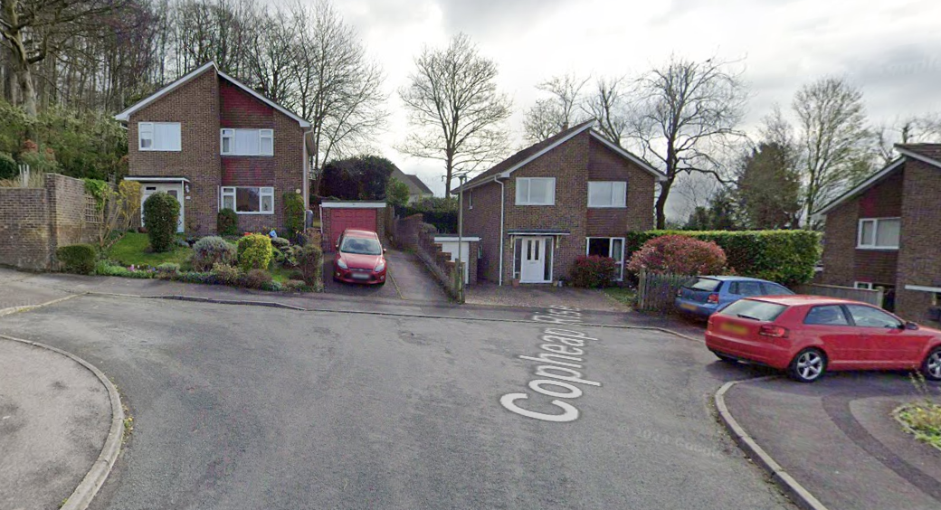

Location Plan and Google Earth Photo

Tree-lined footpath WARM21 runs to the immediate rear of the property linking the wider estate to Cop Heap.

Whilst in Flood Zone 1, of lowest risk, there is significant (50<75%) increased risk of ground water flooding.

PROPOSAL

The proposal seeks planning permission for:
- Demolition of detached garage
- Erection of 2-storey side extension to create an attached garage, covered walkway beside the boundary, relocated utility, and an additional 4th ensuite bedroom.
- Associated works include provision of a 3rd off-street parking space, knocking through from the kitchen into the existing utility to enable the creation of larger kitchen/dining space, and French doors to the side elevation, and a side window knocked through to create a doorway.

Proposed materials include matching brick, off-white colour, a grey flat roof system and grey DG UPVC windows and doors.

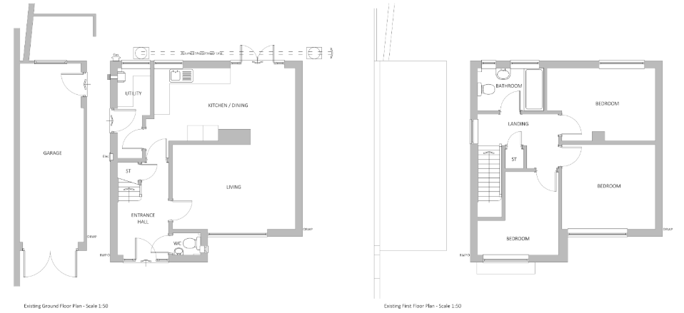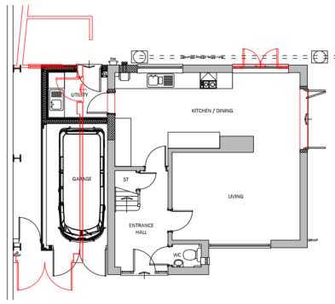

Existing and Proposed Ground Floor Plan

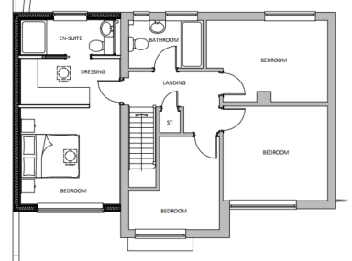

Existing and Proposed Ground Floor Plan

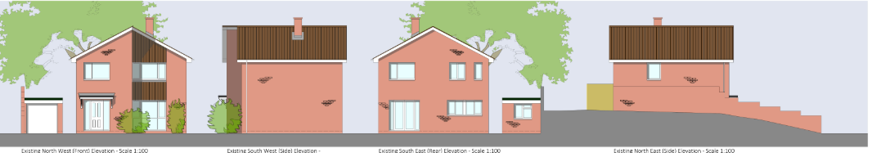

Existing Elevations

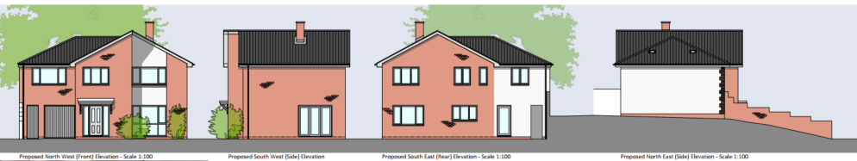

Proposed Elevations

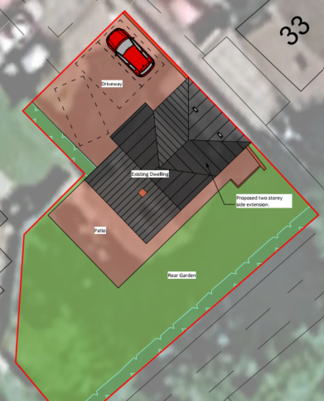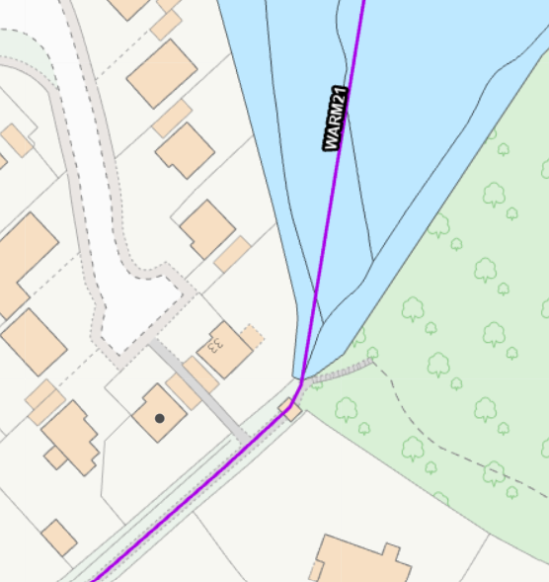

Proposed Site Plan, including parking for 3 cars and footpath to rear.

PLANNING HISTORY
- W/96/01687/FUL - Build up roof and form 2 bedrooms in the roof space – refuse – no.29.
- 18/00675/FUL - Demolition of existing utility room and erection of a new side (SS) extension – approve with conditions – no.38.

RELEVANT POLICIES AND GUIDANCE
The National Planning Policy Framework (NPPF)
The Planning Practice Guidance
National Design Guide
Wiltshire Design Guide: Appendix D – Design Guidance for Householder extensions

Wiltshire Core Strategy:
- Core Policy 57 Ensuring High Quality Design and Place Shaping
- Core Policy 61: Transport and New Development
- Core Policy 64: Demand Management
- Core Policy 67: Flood Risk

Warminster Neighbourhood Plan, made 2016
Wiltshire Local Transport Plan 2011-2026, Car Parking Strategy

CONSULTATION RESPONSES
Warminster Town Council: No objection.
Highways Department: No objection, subject to conditions, following submission of a parking plan, showing 3 parking spaces once existing vegetation/lawn is removed.

REPRESENTATIONS
No comments were received.

ASSESSMENT
Section 38(6) of the Planning and Compulsory Purchase Act 2004 states:

"If regard is to be had to the development plan for the purposes of any determination to be made under the planning Acts, the determination must be made in accordance with the plan unless material considerations indicate otherwise."

In accordance with this statutory requirement, this application has been assessed against the relevant policies of the Development Plan, including the adopted Wiltshire Core Strategy (2015) and, where applicable, any made Neighbourhood Plans.

Design and Impact upon the character and context of the area
Core Policy 57 - Ensuring High Quality Design and Place Shaping of the Wiltshire Core Strategy seeks to ensure that all new development is of high design quality, reflecting local context, character, and distinctiveness.

The proposal would entail an increased massing towards nearest neighbours no.33, extending the side building line at both ground and first floor level.

During the lifecycle of this application, revisions have been received which included a dropped roof ridge to the extension and a hipped roof, retained brick elevations, smaller areas of introduced render, which have ameliorated concerns regarding design, namely in terms of massing, bulk, respect for local character, materials and form.

These revisions ensure a subservient extension, roof form to reflect the host dwelling and reducing bulk, with materiality to match, whilst including the introduction of white render restricted to small areas so not challenging the area’s character but enabling successful integration.

Having regard to the above, the proposal complies with the design principles set out in Core Policy 57 of the Wiltshire Core Strategy and Appendix D of the Wiltshire Design Guide.

Amenity
Point vii of Core Policy 57 - Ensuring High Quality Design and Place Shaping of the Wiltshire Core Strategy seeks to ensure that developments do not adversely affect neighbouring properties.

The National Planning Policy Framework (NPPF), particularly Paragraph 135(f), stresses that planning decisions should ensure developments provide a high standard of amenity for existing and future users.

The proposed development has been assessed in terms of its potential impact on the residential amenity of neighbouring properties, with particular regard to loss of light, overshadowing, loss of privacy, and overbearing effects.

The received revisions, namely reduced roof ridge and hipped roof, effectively manage the increased massing of a two-storey extension.

Given the topography of the site, with nearest neighbours no.33 being sited 5.3m above on the slope up to the northeast, across the intervening garages and spatial gap, there are no concerns regarding overshadowing or overbearing.

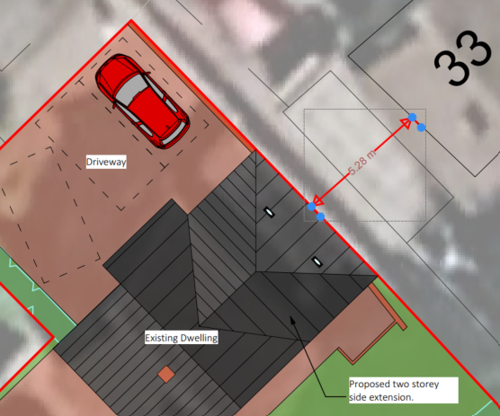

The proposal includes one new front and rear first floor windows, side (SW) French doors approx. 10m from no. 36), one rear access door, and removal of a side (NE) window at first floor level.

The proposed bedroom and ensuite windows face down the front and rear gardens so raising no concern to neighbouring privacy.

Any impact to neighbouring privacy caused by the French or access door, can be managed by standard boundary treatments.

The proposal therefore accords with Core Policy 57 point vii in respect of safeguarding residential amenity and Appendix D of the Wiltshire Design Guide.

Highways Impact
Core Policy 57 (xiv) of the Wiltshire Core Strategy seeks to ensure that development must meet the requirements of Core Policy 61. This policy requires proposals to be capable of being served by safe access to the highway network. Core Policy 64 seeks to ensure compliance with parking standards set out in the Local Transport Plan.

The National Planning Policy Framework (NPPF), particularly Paragraph 115 and 116, requires that development proposals do not have an unacceptable impact on highway safety and that safe and suitable access to the site can be achieved for all users.

The proposal includes the creation of an additional, 4th bedroom, with associated potential for increased parking demand. In line with Wiltshire’s Car Parking Strategy, 3 off-street parking spaces are required.

A revised site plan was submitted with a 3rd driveway parking space in addition to the proposed garage, and as such, sufficient parking provision has been demonstrated.

The proposed development would therefore not result in any adverse impact on highway safety, and adequate parking and turning provision is provided in accordance with Wiltshire’s adopted parking standards.

The proposal is therefore considered to comply with Core Policies 57 (xiv), 61 and 64 of the Wiltshire Core Strategy, the NPPF, and the Wiltshire Local Transport Plan.

Drainage and Flood Risk
Core Policy 67 of the Wiltshire Core Strategy and paragraph 181 of the NPPF requires that all new development avoids increasing flood risk on-site or elsewhere and, where appropriate, incorporates sustainable drainage measures. Development must also comply with national policy on flood risk management and drainage design. Paragraph 176 (via footnote 62) of the NPPF states that householder development should not be subject to the sequential test, nor the exception test.

The proposal site is within flood risk zone 1, with significant additional risk of groundwater flooding.

Householder development is considered Minor Development, under the Flood Risk planning guidance, if “physical extensions to the existing dwelling itself,” and, barring a few exceptions not relevant here, “are unlikely to raise significant flood risk.” The proposal to remodel an existing property, is therefore deemed to not result in any loss of land prone to flood risk.

The existing drainage arrangements are unaltered by the proposals and amended plans specify permeable block paving for the proposed off-street parking.

As such, the proposal is deemed to be safe for its users for the intended lifetime of the development with respect to the level and nature of the flood risk.

The proposal therefore complies with Core Policy 67 of the Wiltshire Core Strategy and the policy in the NPPF, ensuring that flood risk is not increased and that surface water drainage is appropriately managed.

Biodiversity Net Gain
Householder planning applications are exempt from the requirement to deliver Biodiversity Net Gain under Schedule 7A, Section 4(2)(a) of the Town and Country Planning Act 1990, as inserted by the Environment Act 2021.

CONCLUSION
The proposed development is considered to be acceptable in terms of its design, scale, and relationship with the surrounding area. It would not result in any unacceptable harm to the character of the locality, the amenities of neighbouring occupiers, nor the interests of highway safety, or drainage.

The proposal is therefore considered to comply with the relevant policies of the Wiltshire Core Strategy, the Wiltshire Local Plan, and the National Planning Policy Framework. As such, the application is recommended for approval, subject to the conditions set out below.

RECOMMENDATION: That Planning Permission be GRANTED subject to conditions.

