APPLICATION FOR FULL-PLANNING PERMISSION CASE OFFICER REPORT

APPLICATION REFERENCE: | PL/2026/01927
APPLICATION TYPE: | Full planning permission
SITE ADDRESS: | The Grange, Gaters Lane, Winterbourne Dauntsey, Salisbury, SP4 6ER
DEVELOPMENT DESCRIPTION: | Construction of Habitat Pond
RECOMMENDATION: | Approve with Conditions

SITE DESCRIPTION/CONTEXT

The application site is within the wider grounds of the Grade II Listed property known as The Grange, a residential dwelling dating back to 1730. The site overall is located outside the settlement boundary of the larger villages of the Winterbournes, as defined by Wiltshire Core Strategy (WCS) core policies 1 (Settlement Strategy), 2 (Delivery Strategy) and 4 (Spatial Strategy for the Amesbury Community Area). The application site itself is located approximately 350m to the southwest of The Grange and is to the west of the River Bourne which marks the edge of the designated Winterbourne Conservation Area (shaded dark green on the map extract below with listed buildings marked as black hatched).

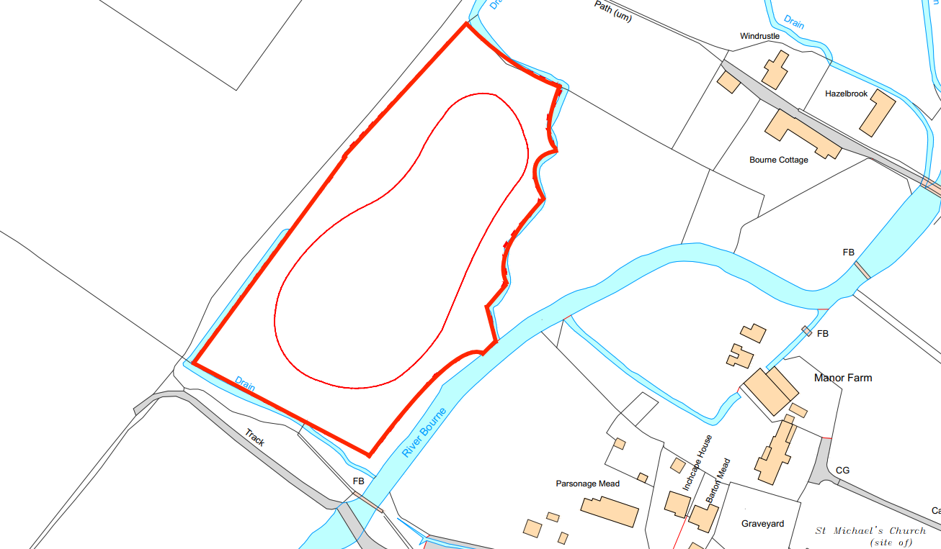

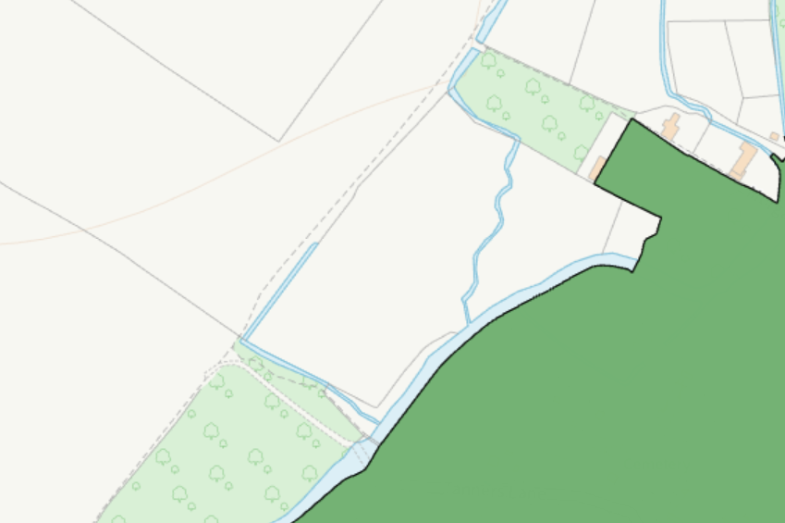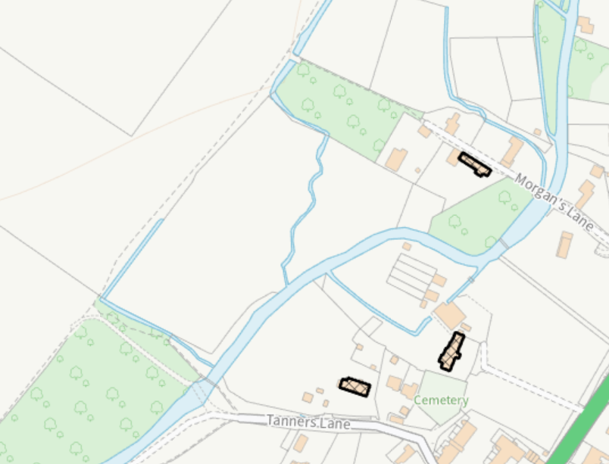

The site is currently a meadow with drainage ditches connected to the River Bourne and is partly within flood zones 1, 2 and 3.

Flood zone 3 Flood zone 2

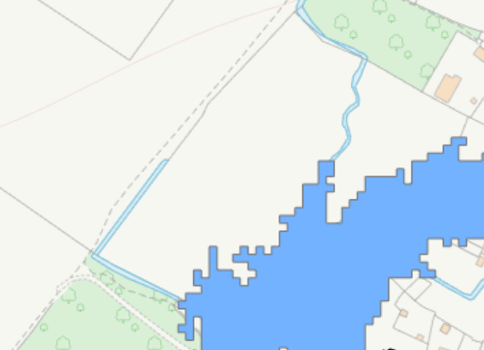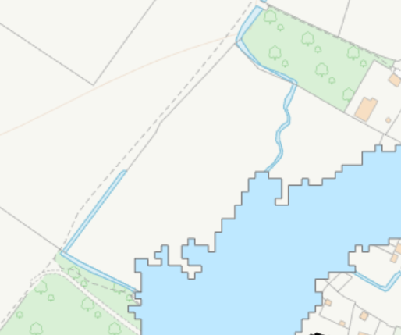

The site is also located within the Hampshire River Avon Catchment and within the New Forest Protected Sites 15km Recreation zone of influence. The site is also located within a Special Landscape Area as defined by Saved Salisbury District Local Plan (SDLP) policy C6.

There are several public rights of way in the vicinity, including routes passing immediately to the west, north and south of the site, these public rights of way are shown below with purple lines.

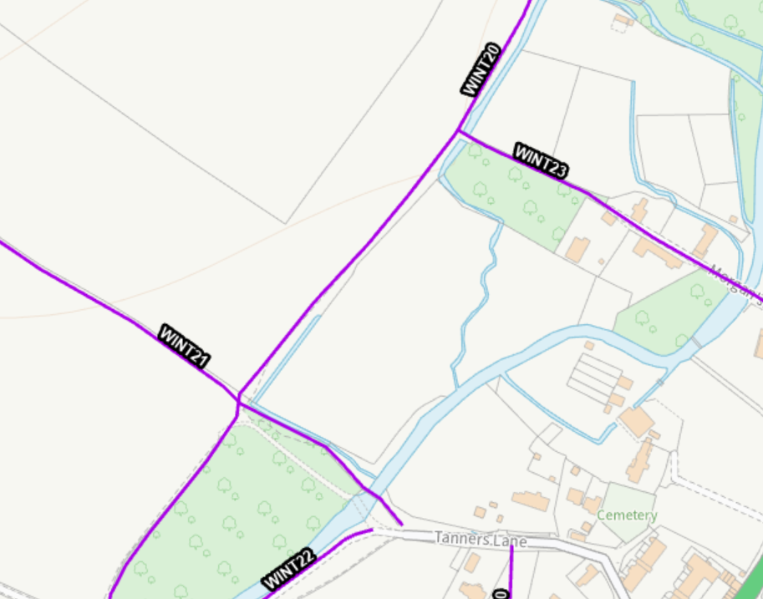

PROPOSAL

This is a planning application proposing the creation of a habitat pond plus associated works.

Artist impression of the proposed pond -

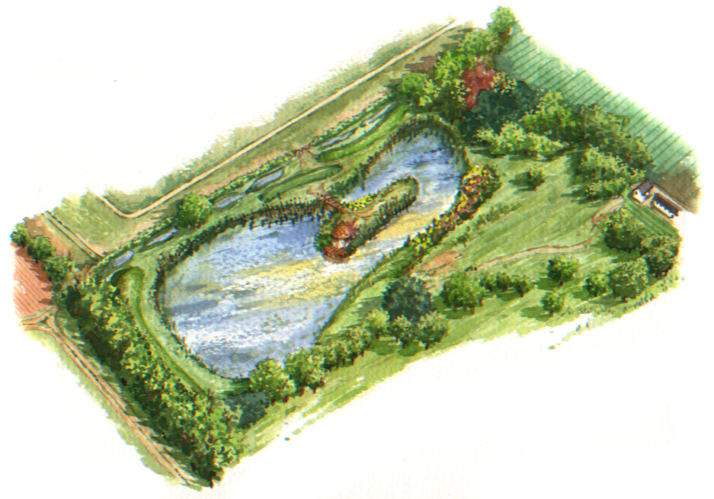

The proposed development is identical to the scheme approved under planning application PL/2021/08492 but this previous application was never implemented and the permission expired.

PLANNING HISTORY

Proposal / Summary
PL/2021/08492 - Full planning permission Decision - Approve with Conditions Date: 15/7/2022 – Construction of habitat pond

RELEVANT LEGISLATION, POLICIES AND GUIDANCE

Statutory Legislation:

S66/S72 of the Planning (Listed Buildings and Conservation Areas) Act 1990

National Planning Policy:
- National Planning Policy Framework (NPPF)
- Planning Practice Guidance (PPG)
- National Design Guide

Development Plan:
The development plan for Wiltshire comprises the Wiltshire Core Strategy (WCS) (adopted January 2015) and any made neighbourhood plans, which remains the principal statutory planning document guiding development across the county. In line with Section 38(6) of the Planning and Compulsory Purchase Act 2004, planning decisions must be made in accordance with the development plan unless material considerations indicate otherwise.

Though the development plan is considered as a whole, those parts deemed to be particularly relevant to this application are listed below:

The adopted Wiltshire Core Strategy (WCS), with particular regard to:

CP1 (Settlement Strategy)
CP2 (Delivery Strategy)
CP4 (Spatial Strategy for the Amesbury Community Area)
CP50 (Biodiversity and Geodiversity)
CP51 (Landscape)
CP52 (Green Infrastructure)
CP57 (Ensuring High Quality Design & Space Shaping)
CP58 (Ensuring the Conservation of the Historic Environment)
CP67 (Flood Risk)
CP69 (Hampshire River Avon SAC)

Saved Salisbury District Local Plan (SDLP) policy C6 – Special Landscape Area

Supplementary Planning Documents:

Creating Places Design Guide SPG (April 2006)
Wiltshire Design Guide

Neighbourhood Plan:
Winterbournes Neighbourhood Plan

ISSUES

Principle
Visual impacts, heritage impacts and landscape impacts
Neighbour amenity
Flood Risk
Ecology
Archaeology

CONSULTATION RESPONSES

Parish Council – no comments have been received

Archaeology – no objections subject to conditions

Ecology – no objections subject to conditions

Natural England – no objections but endorse the comments from the EA

Environment Agency – no objections subject to conditions and informatives

Tree officer – no objections subject to condition

REPRESENTATIONS

One letter of support has been received

ASSESSMENT

Section 38(6) of the Planning and Compulsory Purchase Act 2004 states:

"If regard is to be had to the development plan for the purposes of any determination to be made under the planning Acts, the determination must be made in accordance with the plan unless material considerations indicate otherwise."

In accordance with this statutory requirement, this application has been assessed against the relevant policies of the Development Plan, including the Wiltshire Core Strategy (2015) and, where applicable, any made Neighbourhood Plans. Consideration has also been given to the policies of the National Planning Policy Framework (NPPF) as a material consideration in the assessment.

The assessment below considers each of the main issues identified above. Each topic is assessed in turn with reference to the relevant policy context, the evidence submitted, consultee responses, and all other material considerations, before a conclusion is reached.

Environmental Impact Assessment (EIA) Screening

In accordance with the Town and Country Planning (Environmental Impact Assessment) Regulations 2017 (as amended), the local planning authority has considered whether the proposed development constitutes EIA development.

No formal screening opinion was requested or issued. However, the local planning authority has considered the scale and nature of the development as part of the application process and is satisfied that it does not constitute EIA development under the 2017 Regulations.

In reaching this view, regard has been had to the criteria set out in Schedule 2 of the EIA Regulations, including the scale, location and characteristics of the development. The proposal does not meet the relevant thresholds, nor is it considered likely to give rise to significant environmental effects by reason of factors such as its size or location.

Principle of Development

This application seeks planning permission for the creation of a habitat pond within a grassland field associated with The Grange, Winterbourne Gunner. The proposal comprises the excavation of a pond with a surface area of approximately 7,500sqm and an average depth of 1.3m, together with two central islands, a wildlife hide, associated planting, and a change of use of the land from grassland to habitat pond.

The pond is proposed within an existing wet grassland field located to the south-west of the main dwelling and adjacent to the River Bourne. The supporting information explains that the proposal is intended to create and enhance habitat for a range of species, including amphibians, birds, bats, dragonflies and other aquatic and terrestrial wildlife. The pond has been designed with varied depths, shallow marginal areas and native planting to maximise its ecological value and increase biodiversity on the site.

The site is currently undeveloped grassland, and the proposal would result in the loss of a relatively small area of agricultural land. However, the supporting statement notes that the site is already a naturally wet area and has been specifically selected due to its suitability for the creation of wetland habitat. The proposal would utilise the existing landscape setting and incorporate a landscaping scheme to ensure the development integrates into its rural surroundings.

Core Policy CP50 of the Wiltshire Core Strategy seeks to safeguard and enhance biodiversity and geodiversity, whilst Core Policy CP52 supports proposals that contribute to the retention, enhancement and creation of green infrastructure. The proposed habitat pond would provide additional wetland habitat and ecological connectivity within the wider River Bourne corridor, delivering biodiversity benefits through the creation of new habitat and opportunities for wildlife.

Subject to the detailed assessment of visual impacts, landscape, heritage, ecological, flood risk, tree and amenity impacts set out elsewhere in this report, the proposal is considered acceptable in principle

Visual impacts, heritage impacts and landscape impacts

From the point of view of the historic environment the main statutory tests are set out within the Planning (Listed Building and Conservation Areas) Act 1990. Section 66 requires that special regard be given to the desirability of preserving listed buildings, their settings or any features of special architectural or historic interest which they possess. Section 72(1) of the Act requires the Council to pay special attention to the desirability of preserving or enhancing the character or appearance of designated Conservation Areas.

The NPPF outlines government policy for planning. Chapter 16 of the NPPF 'Conserving and enhancing the historic environment' sets out the Government's high-level policies concerning heritage and sustainable development.

The Planning Practice Guidance provides guidance on interpreting the NPPF.

The Council’s Core Strategy Policy CP58 ‘Ensuring the conservation of the historic environment’ requires that designated and non-designated heritage assets and their settings will be conserved, and where appropriate enhanced, in a manner appropriate to their significance and encourages proposals which improve the condition of heritage assets at risk.

The Council’s Core Strategy CP 57: Ensuring high quality design requires a high quality of design in all new developments. The policy requires applicants to “demonstrate how the proposal will make a positive contribution to the character of Wiltshire through (amongst other things) responding to the value of the natural and historic environment and being sympathetic to and conserving historic buildings and landscapes.

Core Policy 51 of the Wiltshire Core Strategy seeks to protect and enhance landscape character, including important trees and woodland features.

Policy C6 states that 'Within the Special Landscape Area, proposals for development in the countryside will be considered having particular regard to the high quality of the landscape.

Where proposals would not have an adverse effect on the quality of the landscape, they are acceptable in this regard subject to the following criteria;

i) siting and scale sympathetic to the landscape; and
(ii) high standards of landscaping and design appropriate to the locality.

The application site comprises an enclosed meadow within the wider grounds of The Grange, adjacent to the River Bourne. Whilst the proposal would alter the appearance of the field through the creation of a habitat pond, islands, wildlife hide and associated planting, these features are consistent with the rural character of the area and are commonly associated with river valley landscapes. The pond has been designed with gently sloping banks, natural planting and landscape features that will integrate with the existing environment.

The site benefits from natural containment provided by existing trees, boundary vegetation and surrounding topography. Although visible in places from nearby public rights of way, the development would be seen within the context of the wider rural landscape and would not appear incongruous, nor would it have a harmful impact on enjoyment of users of the surrounding footpath network. The proposed planting would soften the appearance of the development over time and help it integrate into the surrounding landscape. The proposal is therefore not considered to result in harm to the character, appearance or scenic quality of the landscape, including the Special Landscape Area, and accords with Core Policy CP51 of the Wiltshire Core Strategy and Saved Policy C6 of the Salisbury District Local Plan.

The site is enclosed by mature trees and boundary vegetation which contribute positively to local landscape character. The submitted Arboricultural Report confirms that no significant tree removal is required, and the Council's Tree Officer raises no objection, subject to a condition requiring a Tree Protection Plan. Subject to this condition, the proposal would not result in unacceptable harm to retained trees and complies with Core Policies CP51 and 57 of the Wiltshire Core Strategy.

In heritage terms, the nearest designated assets comprise The Grange, a Grade II listed building, together with other listed buildings within Winterbourne Gunner and the Winterbourne Conservation Area. The proposed pond would be located approximately 350 metres south-west of The Grange and would be separated from these assets by the River Bourne, intervening vegetation and open land. Given the scale, nature and location of the development, it would preserve the setting of nearby listed buildings and the character and appearance of the conservation area. The proposal therefore complies with Sections 66 and 72 of the Planning (Listed Buildings and Conservation Areas) Act 1990, Chapter 16 of the NPPF and Core Policy CP58 of the Wiltshire Core Strategy.

Overall, the proposal would have a neutral to positive effect on the landscape through the creation of a naturalistic wetland habitat and would result in no harm to the significance or setting of nearby heritage assets. The proposal is therefore acceptable in visual, landscape and heritage terms.

Amenity

WCS policy CP57 (Ensuring High Quality Design & Space Shaping) requires that development should ensure the impact on the amenities of existing occupants/neighbours is acceptable and ensuring that appropriate levels of amenity are achievable within the development itself. The NPPF includes that planning should “always seek to secure high quality design and a good standard of amenity for all existing and future occupants of land and buildings”.

Given the nature of the proposal and its separation from neighbouring residential properties, the development is not considered likely to result in any adverse amenity impacts.

Flood Risk

Policy CP67 of the adopted WCS requires all new development to "include measures to reduce the rate of rainwater runoff and improve rainwater infiltration to soil and ground (sustainable urban drainage) unless site or environmental conditions make these measures unsuitable".

Paragraph 182 of the Framework requires local planning authorities to ensure that flood risk is not increased elsewhere when determining any planning application.

A Flood Risk Assessment (FRA) has been submitted in support of the application. The FRA identifies the River Bourne, located immediately to the south of the site, as the principal source of flood risk and confirms that whilst a small part of the site lies within Flood Zones 2 and 3, the proposed habitat pond is classified as a water-compatible form of development. The assessment concludes that the development can be accommodated safely and would not increase flood risk elsewhere. To address the limited encroachment of the pond embankment into areas at risk of flooding, compensatory flood storage is proposed to ensure there is no net loss of floodplain storage capacity. The FRA concludes that the proposal would have no significant impact on flood flows, flood storage volumes or the wider floodplain.

The Environment Agency has been consulted on the application and raises no objection, subject to a condition requiring the development to be carried out in accordance with the submitted Flood Risk Assessment and the implementation of the proposed compensatory flood storage measures. The Environment Agency is satisfied that appropriate mitigation has been identified to prevent increased flood risk elsewhere. The Agency has also provided advisory notes relating to the potential need for Environmental Permits, the management of sediment during construction to avoid impacts on the River Bourne, and the need for separate consent should fish be introduced into the pond in the future.

Ecology and Biodiversity

The Council’s ecologist has been consulted and has provided the following comments –

I have reviewed the information submitted against mapping (OS and aerial) along with photographs of the site and surrounding area, together with GIS layers of statutory and non-statutory designated sites and existing records of protected species.

Documents reviewed:
Extended Phase 1 Ecological Assessment (Phillips Ecology, March 2026)
Aquatic Planting Plan. Drwg. No. W21-002-009. P1. (The White Horse Contractors, no date) received on 23rd March 2026.
Statutory Biodiversity Metric completed by Laura Bayes on 11th March 2026.
Hydrogeological and Hydrological Desk Study for a Habitat Pond. Version 1.1 (H20 Geo, 21 December 2021).
Design and Access Statement (DS Equine, no date). (Received on 23 March 2026).
Arboricultural Report (Margaret Wright, 25 February 2026).

The application site comprises a field of seasonally waterlogged grassland situated adjacent the River Bourne. The site is bounded by scrub, trees and a wet-ditch hydrologically connected to the River Bourne, and lies within a sensitive ecological setting associated with the River Bourne corridor and the wider River Avon catchment further afield. The proposals are for the creation of a habitat pond, associated wetland features and landscaping works within the existing grassland field. Natural England have been consulted and have no objection providing that:

There is no abstraction from the River Bourne;
The pond is left to fill naturally;
An 8 m buffer is provided between the new pond and the River Bourne

The submitted Arboricultural Report confirms that no tree removal is proposed as part of the
development. Several young self-seeded willow stems within Group G4 are proposed to be relocated within retained margins, but the principal boundary and riparian tree groups are to be retained.

Mitigation measures to protect the important adjacent ecological features during the construction phase are set out within the submitted Extended Phase 1 Ecological Assessment. However, no protection plan has been submitted demonstrating how these protection measures will be implemented on site.

Therefore, a planning condition requiring the submission and approval of a Construction Protection Plan has been recommended.

Biodiversity Net Gain
Under Schedule 7A of the Town and Country Planning Act 1990 (as inserted by Schedule 14 of the Environment Act 2021) this application is required to deliver 10% Biodiversity Net Gain (BNG). The Biodiversity Gain Plan condition will automatically apply if approval is forthcoming.
A completed statutory metric calculation completed by Laura Bayes 0n 11th March 2026 confirming the baseline and predicted post- development biodiversity units of the site has been submitted. Information in the completed on-site baseline habitat tabs is accepted as accurate based on the information submitted. The pre-development (baseline) situation is summarised below.

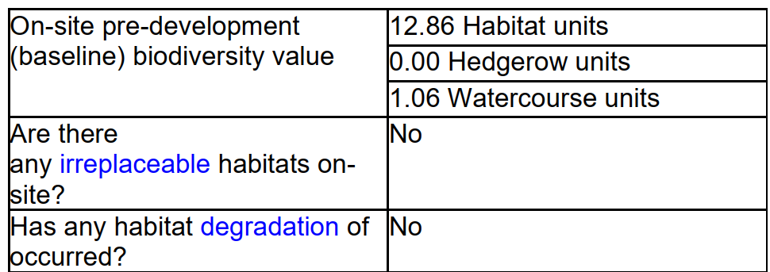

Therefore, given that there are no objections from the Council's ecologist or Natural England, subject to the imposition of appropriate conditions, no concerns are raised in relation to ecology.

Archaeology

The Council’s archaeologist has been consulted and has provided the following comments –

I am satisfied that the archaeological impacts of the construction of this proposed wildlife pond can be mitigated by a programme of archaeological work secured by condition. The programme of work should comprise the controlled stripping of the area of the pond to the level at which archaeological remains might be revealed and the investigation and recording of any remains so revealed. The following condition is therefore proposed:
No development shall commence within the area indicated by application PL/2026/01927 until:
a) A written programme of archaeological investigation, which should include on-site work and off-site work such as the analysis, publishing and archiving of the results, has been submitted to and approved in writing by the Local Planning Authority; and
b) The approved programme of archaeological work has been carried out in accordance with the approved details.
REASON: To enable the recording of any matters of archaeological interest.
This is in accordance with Paragraph 205 of the NPPF which states that ‘Local planning authorities should require developers to record and advance understanding of the significance of any heritage assets to be lost (wholly or in part) in a manner proportionate to their importance and the impact, and to make this evidence (and any archive generated) publicly accessible’.
The applicant should note that the archaeological work is not a ‘watching brief’. The initial site strip, which would have been to be undertaken as part of the development anyway, will be an archaeological exercise and that there will need to be a hiatus between the initial site strip and the excavation of the pond to enable the appropriate investigation and recording of any remains. The duration of the hiatus will depend on the presence and complexity of any remains identified. The applicant should also therefore note that, until the site has been stripped, the resources and timescales required to achieve satisfactorily the programme of archaeological work will not be known. '
The work is to be carried out following the standards and guidelines as set out by the Chartered Institute for Archaeologists (CIfA) as well as those set out in the document 'Standards and Guidance for Archaeological Assessment and Fieldwork in Wiltshire and Swindon Borough', issued by WCAS. The costs of this work are to be borne by the applicant.

Therefore, given that there are no objections from the Council's archaeologist, subject to the imposition of an appropriate condition, no concerns are raised in relation to archaeological matters.

PLANNING BALANCE AND CONCLUSION

In reaching a decision, all identified harms and benefits must be weighed in the overall planning balance, having regard to Section 38(6) of the Planning and Compulsory Purchase Act 2004 and the provisions of the National Planning Policy Framework.

Officers note that planning permission for the same development was granted under application reference PL/2021/08492 in July 2022, but was not implemented and has since expired. The proposal is materially unchanged from the previously approved scheme. Whilst the policy context has evolved since that time, principally through updates to the NPPF and the introduction of mandatory Biodiversity Net Gain requirements, these changes do not alter the overall acceptability of the development.

Overall, the proposal would create a significant area of wetland habitat, deliver biodiversity enhancements and biodiversity net gain, and would have a neutral to positive effect on the landscape. The development would preserve the setting and significance of nearby heritage assets and would not result in unacceptable impacts on trees, public rights of way, flood risk or neighbouring amenity. The proposal is therefore considered to accord with the Development Plan when read as a whole and is recommended for approval subject to conditions.

RECOMMENDATION: That Planning Permission be GRANTED, subject to conditions

1. The development hereby permitted shall be begun before the expiration of three years from the date of this permission.

REASON: To comply with the provisions of Section 91 of the Town and Country Planning Act 1990 as amended by the Planning and Compulsory Purchase Act 2004

2. The development hereby permitted shall be carried out in accordance with the following approved plans:

Application Form received 23/03/2026
Site Plan Drg no W21-002-007 Rev P2 received 08/04/2026
Proposed block plan Drg no W21-002-008 Rev P2 received 08/04/2026
Proposed Cross Sections Drg no D-D & E-E DWG: W21-002-005 Rev P1
Arboricultural report received 23/03/2026
Tree Constraints Plan Drg no DSE-681-26-AR-V1-XX-TCP-T102 Rev A received 23/03/2026
Flood risk assessment received 23/03/2026
Proposed Habitat Pond Drg no W21-002-006 Rev P2 received 23/03/2026
Aquatic Planting Plan Drg no W21-002-009 Rev P1 received 23/03/2026

REASON: For the avoidance of doubt and in the interests of proper planning.

3. No development shall commence within the area indicated by application PL/2026/01927 until:
a) A written programme of archaeological investigation, which should include on-site work and off-site work such as the analysis, publishing and archiving of the results, has been submitted to and approved in writing by the Local Planning Authority; and
b) The approved programme of archaeological work has been carried out in accordance with the approved details.
REASON: To enable the recording of any matters of archaeological interest.

4. No demolition, site clearance or development shall commence on site, and; no equipment, machinery or materials shall be brought on to site for the purpose of development, until a Tree Protection Plan showing the exact position of each tree/s and their protective fencing in accordance with British Standard 5837: 2012: “Trees in Relation to Design, Demolition and Construction - Recommendations”; has been submitted to and approved in writing by the Local Planning Authority, and;

The protective fencing shall be erected in accordance with the approved details. The protective fencing shall remain in place for the entire development phase and until all equipment, machinery and surplus materials have been removed from the site. Such fencing shall not be removed or breached during construction operations.

No retained tree/s shall be cut down, uprooted or destroyed, nor shall any retained tree/s be topped or lopped other than in accordance with the approved plans and particulars. Any topping or lopping approval shall be carried out in accordance British Standard 3998: 2010 “Tree Work – Recommendations” or arboricultural techniques where it can be demonstrated to be in the interest of good arboricultural practise.
If any retained tree is removed, uprooted, destroyed or dies, another tree shall be planted at the same place, at a size and species and planted at such time, that must be agreed in writing with the Local Planning Authority.
No fires shall be lit within 15 metres of the furthest extent of the canopy of any retained trees or hedgerows or adjoining land and no concrete, oil, cement, bitumen or other chemicals shall be mixed or stored within 10 metres of the trunk of any tree or group of trees to be retained on the site or adjoining land.

In this condition “retained tree” means an existing tree which is to be retained in accordance with the approved plans and particulars; and paragraphs above shall

have effect until the expiration of five years from the first occupation or the completion of the development, whichever is the later.

REASON: The application contained insufficient information to enable this matter to be considered prior to granting planning permission and the matter is required to be agreed with the Local Planning Authority before development commences in order that the development is undertaken in an acceptable manner, to enable the Local Planning Authority to ensure the retention of trees on the site in the interests of visual amenity and biodiversity.

5. No development shall commence on site (including vegetation clearance, groundworks or demolition) until a Construction Protection Plan has been submitted to and approved in writing by the Local Planning Authority. The Construction Protection Plan shall demonstrate how the River Bourne, the adjacent ditch, retained trees, scrub and other retained habitats will be protected during the construction phase, in accordance with the mitigation and protection measures set out within the Hydrogeological and Hydrological Desk Study (H2O Geo, 2021) and Sections 17 of the Extended Phase 1 Ecological Assessment (Phillips Ecology, 2026).

The development shall be carried out in strict accordance with the approved Construction Protection Plan.

REASON: To ensure the development avoids causing harm to the adjacent ecological receptors.

6. The development will be carried out in strict accordance with the following documents:

• Section 17 ‘Mitigation Recommendations’ and Section 18 ‘Enhancements’ of the Extended Phase 1 Ecological Assessment (Phillips Ecology, March 2026).
• Section 4 Hydrological Conceptual Site Model of the Hydrogeological and Hydrological Desk Study for a Habitat Pond. Version 1.1 (H20 Geo, 21 December 2021).

REASON: For the avoidance of doubt and for the protection, mitigation and enhancement of biodiversity.

7. No external light fixture or fitting will be installed within the application site unless details of existing and proposed new lighting have been submitted to and approved by the Local Planning Authority in writing. The submitted details will demonstrate how the proposed lighting will impact on bat habitat compared to the existing situation.

The plans will be in accordance with the appropriate Environmental Zone standards set out by the Institution of Lighting Professionals (ILP) Guidance Notes on the Avoidance of Obtrusive Light (GN 01/2021) and Guidance note GN08/23 “Bats and artificial lighting at night”, issued by the Bat Conservation Trust and Institution of Lighting Professionals.

REASON: To avoid illumination of habitat used by wildlife.

8. The development hereby approved, shall be carried out in accordance with the submitted Flood Risk Assessment (ref. 2215110/FRA/MN/RS/01 dated April 2022,Lanmor Consulting) including the provision of compensatory storage/flood storage volumes as show on the plans in Appendix C.

These mitigation measures shall be fully implemented prior to any loss of floodplain and subsequently maintained thereafter throughout the lifetime of the development.

Reason: To prevent flooding elsewhere by ensuring that compensatory storage of flood water is provided

9. All soft landscaping comprised in the approved plans shall be carried out in the first planting and seeding season following the completion of the development. All shrubs, trees and hedge planting shall be maintained free from weeds and shall be protected from damage by vermin and stock. Any trees or plants which, within a period of five years, die, are removed, or become seriously damaged or diseased shall be replaced in the next planting season with others of a similar size and species, unless otherwise agreed in writing by the local planning authority.

REASON: To ensure a satisfactory landscaped setting for the development and the protection of existing important landscape features

INFORMATIVES

1. BNG required - The effect of paragraph 13 of Schedule 7A to the Town and Country Planning Act 1990 is that planning permission granted for the development of land in England is deemed to have been granted subject to the condition “(the biodiversity gain condition”) that development may not begin unless:

(a) a Biodiversity Gain Plan has been submitted to the planning authority, and
(b) the planning authority has approved the plan.

The planning authority, for the purposes of determining whether to approve a Biodiversity Gain Plan if one is required in respect of this permission would be Wiltshire Council. There are statutory exemptions and transitional arrangements which mean that the biodiversity gain condition does not always apply. For further information on exempt developments please refer to: https://www.gov.uk/guidance/biodiversity-net-gain-exempt-developments

Based on the information available this permission is considered to be one which will require the approval of a biodiversity gain plan before development is begun because none of the statutory exemptions or transitional arrangements are considered to apply. Irreplaceable habitat If the onsite habitat includes irreplaceable habitat (within the meaning of the Biodiversity Gain Requirements (Irreplaceable Habitat) Regulations 2024) there are additional requirements for the content and approval of Biodiversity Gain Plans.

The Biodiversity Gain Plan must include, in addition to information about steps taken or to be taken to minimise any adverse effect of the development on the habitat, information on arrangements for compensation for any impact the development has on the biodiversity of the irreplaceable habitat.

The planning authority can only approve a Biodiversity Gain Plan if satisfied that the adverse effect of the development on the biodiversity of the irreplaceable habitat is minimised and appropriate arrangements have been made for the purpose of compensating for any impact which do not include the use of biodiversity credits.

2. The applicant should note that the archaeological work is not a ‘watching brief’. The initial site strip, which would have been to be undertaken as part of the development anyway, will be an archaeological exercise and that there will need to be a hiatus between the initial site strip and the excavation of the pond to enable the appropriate investigation and recording of any remains. The duration of the hiatus will depend on the presence and complexity of any remains identified. The applicant should also therefore note that, until the site has been stripped, the resources and timescales required to achieve satisfactorily the programme of archaeological work will not be known.

The work is to be carried out following the standards and guidelines as set out by the Chartered Institute for Archaeologists (CIfA) as well as those set out in the document 'Standards and Guidance for Archaeological Assessment and Fieldwork in Wiltshire and Swindon Borough', issued by WCAS. The costs of this work are to be borne by the applicant.

3. Informative – Environmental Permit
The Environmental Permitting (England and Wales) Regulations 2016 require a permit or exemption to be obtained for any of the following activities:

- erecting any temporary or permanent structure in, over or under a main river, such as a culvert, outfall, weir, dam, pipe crossing, erosion protection, scaffolding or bridge
- altering, repairing or maintaining any temporary or permanent structure in, over or under a main river, where the work could affect the flow of water in the river or affect any drainage work
- building or altering any permanent or temporary structure designed to contain or divert flood waters from a main river
- dredging, raising or removing any material from a main river, including when you are intending to improve flow in the river or use the materials removed
- diverting or impounding the flow of water or changing the level of water in a main river
- quarrying or excavation within 16 metres of any main river, flood defence (including a remote defence) or culvert
- any activity within 8 metres of the bank of a main river, or 16 metres if it is a tidal main river
- any activity within 8 metres of any flood defence structure or culvert on a main river, or 16 metres on a tidal river
- any activity within 16 metres of a sea defence structure
- activities carried out on the floodplain of a main river, more than 8 metres from the river bank, culvert or flood defence structure (or 16 metres if it is a tidal main river), if you do not have planning permission (you do not need permission to build agricultural hay stacks, straw stacks or manure clamps in these places).

For further guidance please visit Flood risk activities: environmental permits -GOV.UK or contact our National Customer Contact Centre on 03708 506 506 (Monday to Friday, 8am to 6pm) or by emailing enquiries@environment-agency.gov.uk.

The applicant should not assume that a permit will automatically be forthcoming once planning permission has been granted, and we advise them to consult with us at the earliest opportunity.

4. Informative – Sediment

Please note that once the site is cleared of vegetation and excavation begins, any rainfall could lead to large amounts of sediment entering the River Bourne channel. Assurance is needed that this would be managed appropriately.

5. Informative – Fish

If fish were to be introduced a Keeping and Introduction of Fish (KIF) permit would need to be applied for, due to the small section of the pond which falls within a floodplain, it would limit the species of fish that would be allowed to be stocked into the pond. This may be different if we were satisfied that the pond was fully enclosed and the escape of fish, even during times of flooding, was non-existent.

