APPLICATION FOR HOUSEHOLDER PLANNING PERMISSION
DELEGATED REPORT

APPLICATION REFERENCE: | PL/2026/02690
APPLICATION TYPE: | Householder Planning Permission
SITE ADDRESS: | 131a, St Thomas Road, Trowbridge, BA14 7LU
DEVELOPMENT DESCRIPTION: | Erection of a new detached garage
RECOMMENDATION: | That Planning Permission be GRANTED

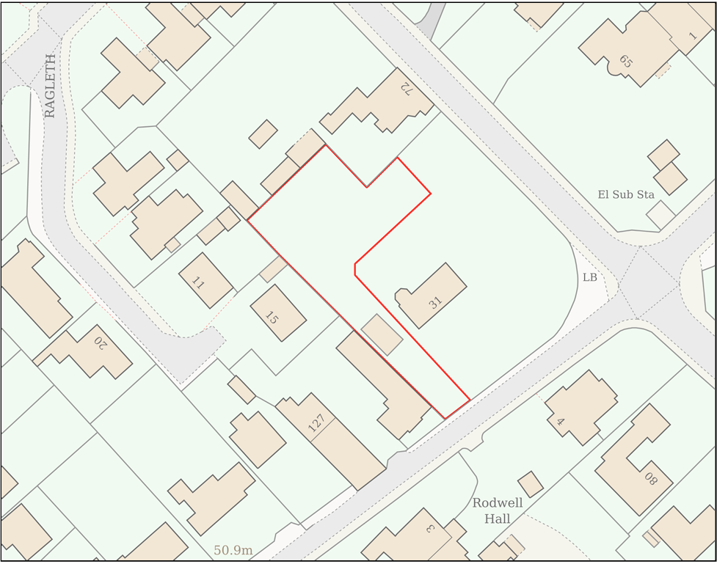

PROPOSAL

The application seeks planning permission for the erection of a detached single-storey double garage within the residential curtilage of No. 131A St Thomas Road. The building would be constructed with timber-clad elevations set upon a red brick plinth, a pitched clay tile roof, slimline aluminium windows and doors, and dark-coloured rainwater goods. The garage would provide covered parking and incidental domestic storage associated with the host dwelling.

SITE DESCRIPTION / CONTEXT

The application site comprises a modern detached bungalow and its associated residential curtilage located off St Thomas Road, Trowbridge. The surrounding area is characterised by a mixture of historic and modern residential development, including the nearby Grade II listed Rodwell Hall and the adjoining Trowbridge Hilperton Road Conservation Area, together with more recent housing on Ragleth Grove comprising chalet-style dwellings and bungalows. The site lies within the settlement boundary of Trowbridge, a Principal Settlement, and is located within Flood Zone 1. The Council's Strategic Flood Risk Assessment identifies groundwater flood susceptibility across the site and a small area of very low fluvial flood risk adjacent to the south-western boundary. The site also falls within the Trowbridge and Westbury Bat Mitigation Strategy Grey Zone and immediately adjoins, but does not lie within, the Conservation Area.

PLANNING HISTORY

Reference No. | Proposal / Summary | Decision
W/75/00493/HIS | Demolition of sun lounge and erection of 2 storey extension | Approved
W/93/00309/FUL | Erection of conservatory | Approved
PL/2021/07820 | Demolition of existing detached garage and construction of two detached dwellings in grounds of retained existing dwelling, and associated site works including formation of new access from highway. | Approved
PL/2021/07816 | New vehicular access and rebuild part of existing boundary wall as part of proposed residential development (not in conservation area) subject to separate full planning application | Approved
PL/2022/06313 | Erection of new dwelling (Amendment to PL/2022/04082 to reposition and redesign the approved dwelling) | Approved
PL/2023/03357 | Variation of condition 2 of PL/2022/06313 to allow removal of kitchen to NE elevation, remove window and replace with casement doors to NW elevation, additional obscured window to SE elevation, change of material from render to brick to gables | Approved

RELEVANT LEGISLATION, POLICIES AND GUIDANCE

Wiltshire Core Strategy:

Core Policy 1 Settlement Strategy;
Core Policy 2 Delivery Strategy;
Core Policy 29 Spatial Strategy: Trowbridge Community Area;
Core Policy 50 Biodiversity and Geodiversity;
Core Policy 51 Landscape;
Core Policy 57 Ensuring High-Quality Design and Place Shaping;
Core Policy 58 Ensuring Conservation of the Historic Environment;
Core Policy 60 Sustainable Transport;
Core Policy 61 Transport and Development;
Core Policy 64 Demand Management;
Core Policy 67 Flood Risk;

The National Planning Policy Framework (NPPF) and The Planning Practice Guidance (PPG)

Wiltshire Design Guide - Appendix D – Design Guidance for Householder extensions

The Wiltshire Local Transport Plan 2011 – 2026: Car Parking Strategy (March 2015).

The Wiltshire Local Transport Plan 4 (LTP4) (March 2025)

New Wiltshire Local Plan

At Full Council on 19 May 2026, the elected members of Wiltshire Council agreed to withdraw the emerging Wiltshire Local Plan. The said Plan has no material weight for the purposes of the application.

In accordance with Regulation 19 of the Town and Country Planning (Local Planning) (England) Regulations 2026, on 30th June 2026 Wiltshire Council published a notice of intention to prepare a new local plan for Wiltshire. The next stage is a Scoping Consultation which commences on 2nd September 2026. This plan is at a very early stage and currently carries no weight for decision making.

CONSULTATION RESPONSES

Trowbridge Town Council – No Objection

Local Highway Authority (Wiltshire Council) – No Objection

REPRESENTATIONS

Three letters of objection have been received in relation to the proposed development, including two submissions from the occupier of 15 Ragleth Grove. The representations raise concerns relating to the scale, height, massing and siting of the proposed garage, including its relationship with neighbouring properties and its potential to result in an overbearing form of development, loss of outlook, increased enclosure, loss of light and harm to residential amenity. Concerns are also raised regarding the elevated ground levels of the application site relative to neighbouring land, the visibility of the building and associated parking areas from adjoining properties, the adequacy of the applicant's assessment of amenity impacts, the perceived intensification of development on the site, the effect on the character of the area and the compatibility of the proposal with Core Policy 57 and the Wiltshire Design Guide. Additional concerns were raised regarding parking and turning arrangements within the site, the use of the proposed storage area within the garage, and the proximity of the development to adjoining boundaries.

In assessing the proposal, limited weight has been afforded to a number of matters raised which do not constitute material planning considerations. These include references to the status of the host dwelling as a bungalow or chalet bungalow, speculation regarding the future use or development of the dwelling's roof space, assumptions concerning the relocation of solar photovoltaic equipment, and suggestions that future alterations may occur outside the scope of the current application. Equally, the suitability of the proposal under permitted development legislation is not determinative, as the garage is the subject of a full planning application and must be assessed on its planning merits. Concerns regarding potential damage to the existing boundary wall are matters of private property rights, construction management and building control rather than planning considerations. Finally, objections relating to the loss of private views, including views of mature trees or open skyline, and the applicant's personal justification or need for a garage carry little weight in the determination of the application, which must instead be considered against the relevant development plan policies and other material planning considerations.

ASSESSMENT

Section 38(6) of the Planning and Compulsory Purchase Act 2004 states:

"If regard is to be had to the development plan for the purposes of any determination to be made under the planning Acts, the determination must be made in accordance with the plan unless material considerations indicate otherwise."

In accordance with this statutory requirement, this application has been assessed against the relevant policies of the Development Plan, including the adopted Wiltshire Core Strategy (2015) and, where applicable, any made Neighbourhood Plans.

The principle of domestic outbuildings within the curtilage of an existing dwelling is considered acceptable and is consistent with the established residential use of the site. The submitted plans indicate the building would be used solely for vehicle parking and storage, with no facilities suggesting independent residential occupation. Given the site's planning history and the importance of maintaining the approved parking arrangements, a condition restricting the building to incidental domestic purposes and preventing its use as additional living accommodation is considered necessary and reasonable.

Design and Impact the upon the character and context of the area

Core Policy 57 Ensuring High Quality Design and Place Shaping of the Wiltshire Core Strategy requires all new development to achieve a high standard of design that responds positively to its local context. Proposals must reinforce and enhance local character and distinctiveness, relate appropriately to the surrounding landscape, and demonstrate a thoughtful response to existing townscape features. This includes careful consideration of elements such as building height, scale, massing, building line, materials, and overall appearance, ensuring new development integrates harmoniously with its setting.

The proposed garage is considered to be of an appropriate design, scale and appearance for its setting. The use of a clay tile roof reflects the materials of the host dwelling, whilst the timber cladding is characteristic of a variety of domestic outbuildings and detailing found within the surrounding area. The incorporation of dark-coloured fenestration and rainwater goods provides further visual continuity with the dwelling. In terms of scale, the building remains subordinate to the host bungalow, sitting below its ridge line and occupying a modest footprint relative to the size of the plot. The pitched roof form and simple detailing contribute to a traditional outbuilding appearance that integrates successfully within the site and avoids appearing as a dominant or incongruous feature.

Having regard to the above, the proposal complies with the design principles set out in Core Policy 57 of the Wiltshire Core Strategy and Appendix D of the Wiltshire Design Guide.

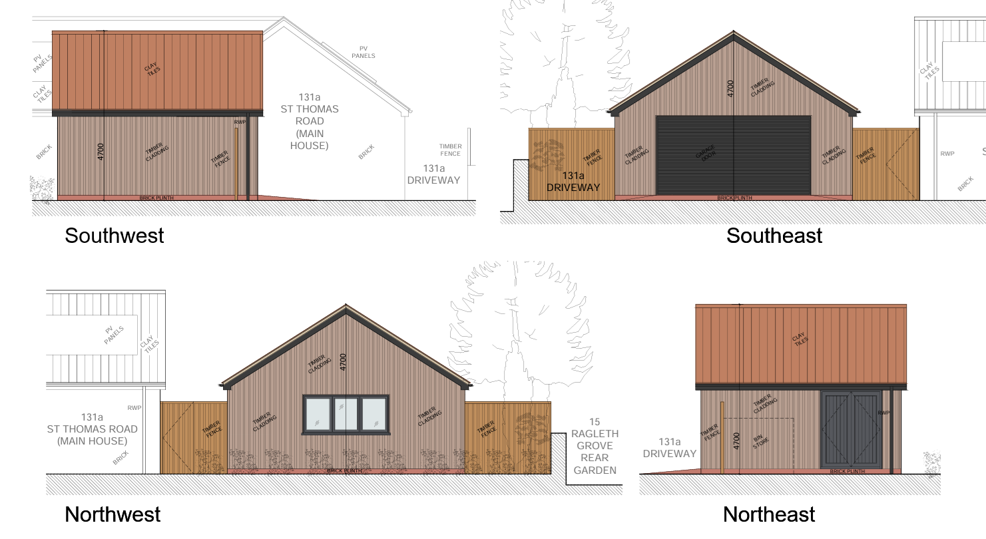
Proposed Elevations

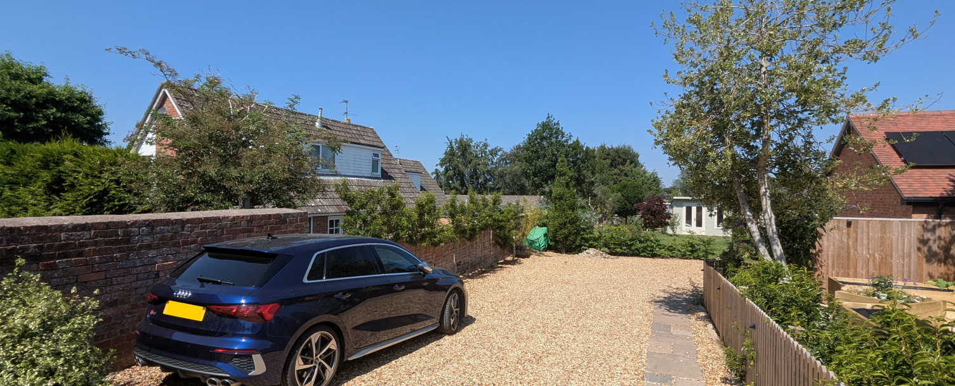
Site Photo

Conservation and Heritage

Core Policy 58 outlines development consideration with regard to the historic environment. The policy states that heritage assets and their settings must be conserved and, where appropriate, enhanced through any proposed development.

Section 72 of the Planning (Listed Buildings and Conservation Areas) Act 1990 states that in the exercise of any functions, with respect to any buildings or other land in a conservation area, under or by virtue of any of the provisions mentioned in this Section, special attention shall be paid to the desirability of preserving or enhancing the character or appearance of that area. Section 66 of the Planning (Listed Buildings and Conservation Areas) Act 1990 requires ‘special regard’ to be given to the desirability of preserving a listed building or its setting.

Although the site adjoins the Trowbridge Hilperton Road Conservation Area and lies in the wider setting of heritage assets including Grade II listed Rodwell Hall, the scale and siting of the proposed garage would preserve the character and appearance of the Conservation Area and would not adversely affect the significance of nearby heritage assets. The garage would be located approximately 42 metres back from St Thomas Road, substantially reducing its visibility from public viewpoints within the Conservation Area. Whilst the outbuilding adopts a contemporary interpretation of a domestic garage, this reflects the character of the host dwelling itself, which is a modern bungalow. Given its subordinate scale, limited visibility and relationship to an existing modern dwelling, the proposal would result in no harm to designated heritage assets or their settings.

Amenity

Point vii of Core Policy 57 Ensuring High Quality Design and Place Shaping of the Wiltshire Core Strategy seeks to ensure that developments do not adversely affect neighbouring properties. The National Planning Policy Framework (NPPF), particularly Paragraph 135, stresses that planning decisions should ensure developments provide a high standard of amenity for existing and future users.

The proposed garage would not give rise to any unacceptable impacts in terms of overlooking, loss of privacy or loss of light. The only windows proposed are at ground floor level and positioned on the north-western elevation facing into the application site itself, preventing any direct overlooking of neighbouring properties. Given the single-storey nature of the building and its separation distances from surrounding dwellings, no significant adverse impacts upon neighbouring levels of privacy are identified. Furthermore, due to the orientation of the site and the path of the sun, any shadowing effects resulting from the building would be avoided or limited and the proposal would not materially affect neighbouring occupiers in this regard.

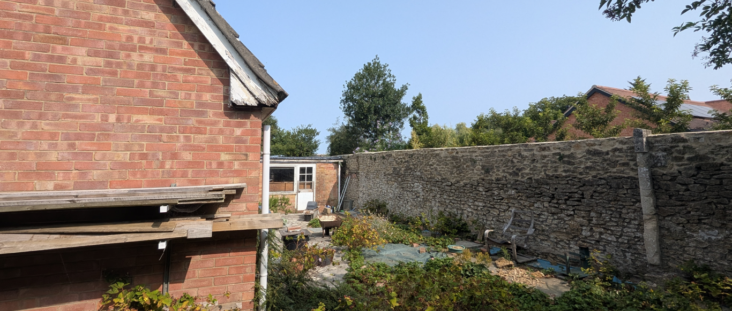
15 Ragleth Grove Photo

Particular consideration has been given to the relationship with neighbouring properties on Ragleth Grove, notably Nos. 11 and 15, the occupiers of which have raised concerns regarding overbearing impacts. Whilst it is acknowledged that the properties to the west of the site sit at a lower ground level than the application site, the proposed garage remains separated from the nearest part of No. 11 by approximately 16m. Whilst the proposed single storey structure would be visible above the height of the existing boundary wall, it would not materially affect the outlook from this property or result an overbearing form of development, loss of privacy or overshadowing. The footprint of the garage is in closer proximity in relation to No. 15, being approximately 8m from the rear wall of this dwelling and approximately 2.3m from the existing stone boundary wall. by approximately 2.3m. The original scheme proposed a gable end facing this shared boundary. Following discussions, the design has been amended so that the roof is now slopes away from the boundary. As a result, whilst a section of the garage and the roof of the garage would remain visible above the existing boundary wall, the visual mass of the building would be significantly reduced when viewed from this property. It is acknowledged that the proposed development would be visible from the adjacent dwellings and therefore it would inevitably alter aspects of the outlook beyond the boundary of the two nearest adjacent dwellings, however the amended design together with the scale, siting and orientation ensures that the impact is not materially harmful on the outlook or overbearing to the neighbouring properties and there would be no demonstrable loss of light or privacy. As such refusal of the proposal on amenity grounds would not be justified.

The proposal therefore accords with Core Policy 57 point vii in respect of safeguarding residential amenity and Appendix D of the Wiltshire Design Guide.

Transport and Highways

Core Policy 60 of the WCS states that Council will support and encourage safe and efficient movement of people and, where necessary, mitigate the impact of development on transport users and local communities. Core Policy 61 specifies that development should demonstrate that consideration has been given to a hierarchy of transport users and that proposals must, where relevant, serve as a safe access to the highway network. Paragraph 116 of the NPPF states that “Development should only be prevented or refused on highways grounds if there would be an unacceptable impact on highway safety, or the residual cumulative impacts on the road network, following mitigation, would be severe, taking into account all reasonable future scenarios”.

The WCS, through Core Policy 64, outlines the need for development to comply with a minimum level of parking standards. This is further discussed through the Wiltshire Local Transport Plan, and policy PS6 which identifies that new residential development is required to take account of dwelling size and the mix of associated parking function.

Highway considerations formed a significant aspect of the assessment process. Earlier iterations of the proposal positioned the garage further forward within the site, resulting in the loss of sufficient turning space for vehicles to enter and leave the site in a forward gear. The applicant initially sought to rely upon a turning area located beyond the application site boundary; however, the Local Highway Authority advised that this area fell outside the applicant's ownership and could not reasonably be secured through planning conditions. Consequently, an objection was raised on the basis that vehicles could be required to reverse onto St Thomas Road, creating highway safety concerns.

In response, the proposal was amended to reposition the garage further from the access route, creating a turning area within the applicant's ownership. Further discussions followed regarding the adequacy of this arrangement, including the submission of vehicle tracking information and evidence demonstrating vehicle manoeuvrability on site. Although concerns initially remained regarding the ability of vehicles to turn safely, subsequent amendments removed the two lay-by parking spaces previously shown along the access track and rationalised parking provision to the level necessary for the approved two-bedroom dwelling. On the basis of the amended layout, which retains adequate parking and turning facilities within the site, the Local Highway Authority confirmed that their objection was removed. Having regard to the final layout arrangement and the specialist advice received, the proposal is considered acceptable in highway safety and parking terms.

Accordingly, the proposal is considered to accord with Core Policies 60, 61 and 64 of the Wiltshire Core Strategy, Policy PS6 of the Wiltshire Local Transport Plan, and the guidance contained within paragraph 116 of the National Planning Policy Framework.

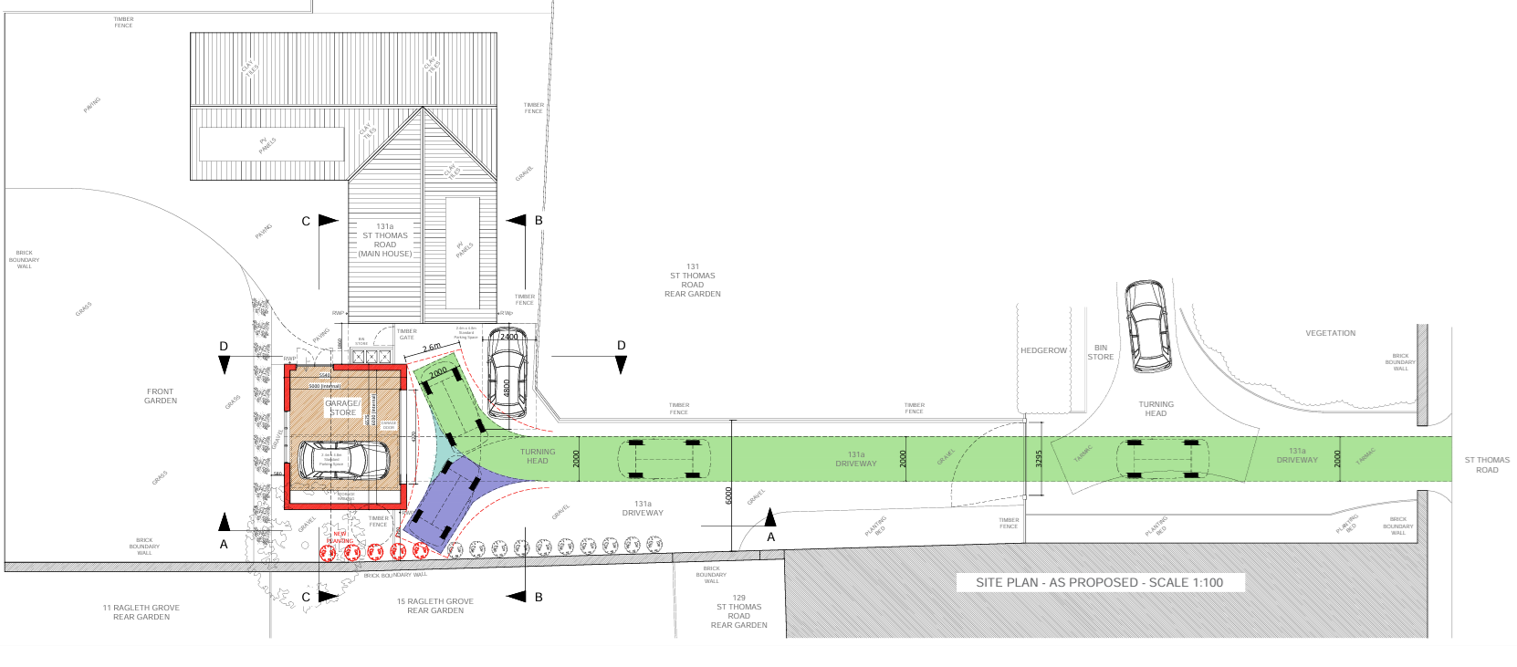
Site Plan and Tracking

Ecology

The WCS, through Core Policy 50, states that development proposals are expected to avoid and reduce disturbance of sensitive wildlife species and habitats. Biodiversity Net Gain (BNG) was established as a mandatory aspect of planning evaluation through Schedule 7A of the Town and Country Planning Act 1990 (as amended by the Environment Act 2021 Schedule 14). Householder planning applications are exempt from the requirement to deliver Biodiversity Net Gain under Schedule 7A, Section 4(2)(a) of the Town and Country Planning Act 1990, as inserted by the Environment Act 2021.

The site comprises established residential garden land and associated hardstanding associated with a relatively recently constructed dwelling which has limited ecological value. The proposal involves the erection of a garage within a managed domestic curtilage and would not result in the loss of significant habitat features. Whilst the site falls within the Trowbridge and Westbury Bat Mitigation Strategy Grey Zone, the proposal does not result in the provision of a new dwelling and therefore there is no mechanism for effect on the mitigation strategy for new residential development. The nature and scale of the proposal, together with its location within an existing residential setting, indicates a low likelihood of adverse ecological effects with regard to protected species and habitats. No significant ecological constraints have been identified and the proposal raises no ecology-related concerns for the proposed development.

Flooding and Drainage

Core Policy 67 Flood Risk of the Wiltshire Core Strategy requires all development to be located, designed and constructed so as to minimise vulnerability to flooding and avoid increasing flood risk elsewhere. Proposals should incorporate appropriate measures for the management of surface water and ensure that flood risk is not exacerbated either on-site or beyond the application boundary. The NPPF similarly promotes a risk-based approach to development, directing development away from areas at greatest risk of flooding and requiring flood risk to be appropriately managed.

The site lies within Flood Zone 1, which represents land at the lowest probability of fluvial flooding. Whilst Council mapping identifies areas of groundwater flood susceptibility across the site and a very limited area of low probability surface water flood risk adjacent to the south-western boundary, the proposal relates to a modest domestic outbuilding occupying approximately 36.3sqm within an existing residential curtilage. Given the limited scale of the development, the relatively small increase in built footprint/hardstanding, and the absence of any significant flooding constraints affecting the proposed siting of the garage, it is not considered that the proposal would materially increase flood risk or give rise to drainage concerns. The development is therefore considered to accord with the aims and objectives of Core Policy 67.

CONCLUSION

Following revisions to the layout and design, the proposed garage represents an appropriately designed and scaled domestic outbuilding that would remain subordinate to the host dwelling and integrate satisfactorily within its surroundings. The development would not result in demonstrable unacceptable impacts upon neighbouring amenity, heritage assets, ecology, drainage or highway safety, and all technical consultees' concerns have been satisfactorily resolved through amendments to the scheme. Subject to appropriate conditions, including a restriction preventing use of the building as independent residential accommodation, the proposal is considered to accord with the development plan and is recommended for approval.

RECOMMENDATION: That Planning Permission be GRANTED subject to the following conditions:

1.
The development hereby permitted shall be begun before the expiration of three years from the date of this permission.
REASON: To comply with the provisions of Section 91 of the Town and Country Planning Act 1990 as amended by the Planning and Compulsory Purchase Act 2004.

2.
The development hereby permitted shall be carried out in accordance with the following approved plans and documents:

Garage Plan, Site Plan and Sections As Proposed 2026-10e (12 August 2026)
Location Plan (27 April 2026)

REASON: For the avoidance of doubt and in the interests of proper planning.

3.
The garage hereby permitted shall be used solely for the parking of private motor vehicles and for purposes incidental to the enjoyment of the dwellinghouse known as 131A St Thomas Road. The building shall not be occupied as living accommodation, used as a separate unit of residential accommodation, or otherwise adapted or fitted out for such purposes at any time.

REASON: The application has been assessed on the basis of a domestic outbuilding for garaging and storage purposes. Use of the building as residential accommodation would constitute a materially different form of development that has not been assessed as part of this application.

