Barn at
Shalbourne Manor,
Kingston Road,
Shalbourne,
Marlborough
SN8 3QD

PHASE 2 BAT EMERGENCE SURVEYS
2025-26

Dr.Jonty Denton (Chartered Ecologist) FRES FLS MCIEEM CECol

Prepared by
Dr. Jonty Denton Bsc (Hons) D(Phil) FRES, FLS, MCIEEM, CEcol
(Chartered Ecologist)
31 Thorn Lane, Four Marks, Hampshire, GU34 5BX
Phone: (01420) 565647 mobile: 07935594093

SUMMARY
Dusk emergence surveys were carried out on evening of 8th October 2025 and 2nd may and 10th June 2026. All potential openings were covered by the surveyors with Canon XA40 HD digital camcorders with IR illumination and EchotouchPro detectors employed to monitor and record bat activity.
The evening was calm dry and very mild with starting temperature of 16°C falling to 14.5°C.
Three species of bats were recorded with up to 4 common pipistrelles foraging (unusually) high overhead. One pass by a noctule was seen to the southwest. A soprano pipistrelle foraging over pond and occasionally around the barn.
No bats emerged from the barn, and no activity was recorded within the barn.
The second dusk emergence survey was carried out on evening of 2nd May 2026. A peak count of three common pipistrelles was recorded foraging over the pond to the south, with occasional passes over the barn roof.
No bats emerged from the barn, and no activity was recorded inside the barn.

The third dusk emergence survey was carried out on evening of 10th June 2026. A total of ten soprano pipistrelles flew up over stable building from the south and the flight lines suggested they were coming from a significantly sized common roost. A single common pipistrelle flew in from southeast and off to northwest over stable roof.
No bats emerged from the barn, and no activity was recorded inside the barn.

TIMING AND METHODS
Dusk emergence surveys were carried out on evening of 8th October 2025 and 2nd may and 10th June 2026. All potential openings were covered by the surveyors with Canon XA40 HD digital camcorders with IR illumination and EchotouchPro detectors employed to monitor and record bat activity.
A camera and detector were placed inside the barn to monitor any internal activity.
Survey commenced 30 minutes before sunset and continued until 90 minutes after sundown. EchotouchPro detectors were employed to monitor and record bat activity.
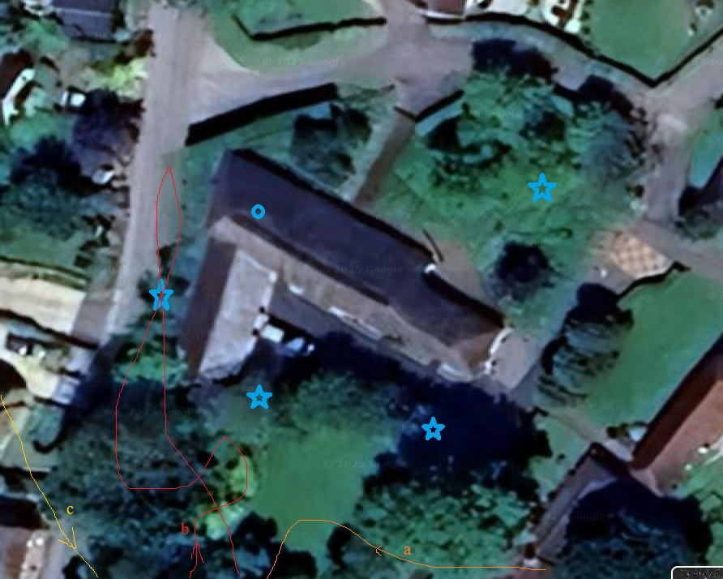
Figure 1. Surveyors and cameras (blue stars).

RESULTS
No bats were recorded inside the barn and a search of internal surfaces found no fresh droppings.

The dusk emergence survey was carried out on evening of 8th October 2025. Three species of bats were recorded with up to 4 common pipistrelles foraging (unusually) high overhead. One pass by a noctule was seen to the southwest. A soprano pipistrelle foraging over pond and occasionally around the barn.

The second dusk emergence survey was carried out on evening of 2nd May 2026. A peak count of three common pipistrelles was recorded foraging over the pond to the south, with occasional passes over the barn roof.
No bats emerged from the barn and no activity was recorded inside the barn.

The third dusk emergence survey was carried out on evening of 10th June 2026. A total of ten soprano pipistrelles flew up over stable building from the south and the flight lines suggested they were coming from a significantly sized common roost. A single common pipistrelle flew in from southeast and off to northwest over stable roof.
No bats emerged from the barn and no activity was recorded inside the barn.

CONCLUSIONS

No bats emerged from the barn and there was no sign of internal activity post the repairs to the weather boarding.

The historic useage of the barn can be summarised as feeding roosts by serotine.

Ecological Enhancements
Based on the foraging habitat recorded on-site and the absence of active roosts within the barn, the following proportionate enhancement measures are recommended to deliver a wildlife enhancement.
1. Integrated Roosting Features
- The proposed building renovation would not support any viable integrated roosting features.
2. Tree-Mounted Roost Enhancement
- Equipment: One heavy-duty, woodcrete exterior box (e.g., Schwegler 1FF) or an FSC certified timber crevice box will be installed on a mature tree along the western boundary.
- Installation: Attached at a minimum height of 4 metres using tree-friendly aluminium nails or adjustable nylon straps to protect the timber.
- Microclimate: Facing south-southeast to maximise daily thermal solar gain, which is highly preferred by transitional roosting bats.

3. Foraging & Commuting Habitat Enhancements
Bats are entirely insectivorous; therefore, enhancements must focus on boosting the local nocturnal insect biomass.
- Wildflower Areas: Establish a 2-metre wide strip alongside the driveway sown with a diverse native wildflower seed mix (e.g., Emorsgate N1) left un-mown between April and October.
4. Sensitive Lighting Strategy
To protect existing navigation pathways and prevent the displacement of light-sensitive species (such as Brown Long-eared bats), a strict lighting plan must be enforced:
- Zero-Light Zones: No external artificial lighting may illuminate the newly installed bat box.
- Luminaire Specifications: Any necessary security lighting must utilise narrow-spectrum warm LED luminaires (<2700 Kelvin) with completely flat cut-off cowls to eliminate upward light spill.

APPENDIX 1. FIELD DATA
Project |  | Start time | 17.40 | Finish | 19.55 | Temperature | 16 C at start 14 C at finish
 |  | 8.10.25 |  | sunset | 18.26 | Weather  10% cloud beaufort 0
 | Bat passes heard
Station no. | Start time |  | No. | passes | comments
N, S | 18.25 | Common pipistrelle | 2 | 5+ | Flew up from Manor house climbed high to west foraging over trees to south of barn (a on figure 1)
N, S | 18.27 | Common pipistrelle | 1 | 1 | Flew up from Manor house climbed high to west foraging over trees to south of barn (a on figure 1)
N, S | 18.29-35 | Common pipistrelle | 2-4 | 20+ | foraging high over trees to south of barn
N, S | 18.38 | Soprano pipistrelle | 1 | 2 | foraging over pond and flew over barn briefly (b on figure 1)
All | 18.39 | Noctule | 1 | 1 | Flew high to southeast (c on figure 1)
N, W | 18.40-1 | Soprano pipistrelle | 1 | 2 | foraging over pond and around barn along lane
All | 18.44-50 | Common/soprano pipistrelle | 2-3 | 10+ | foraging high over trees to south of barn
N, S | 18.51-59 | Common/soprano pipistrelle | 2-3 | 10+ | foraging high over trees to south of barn

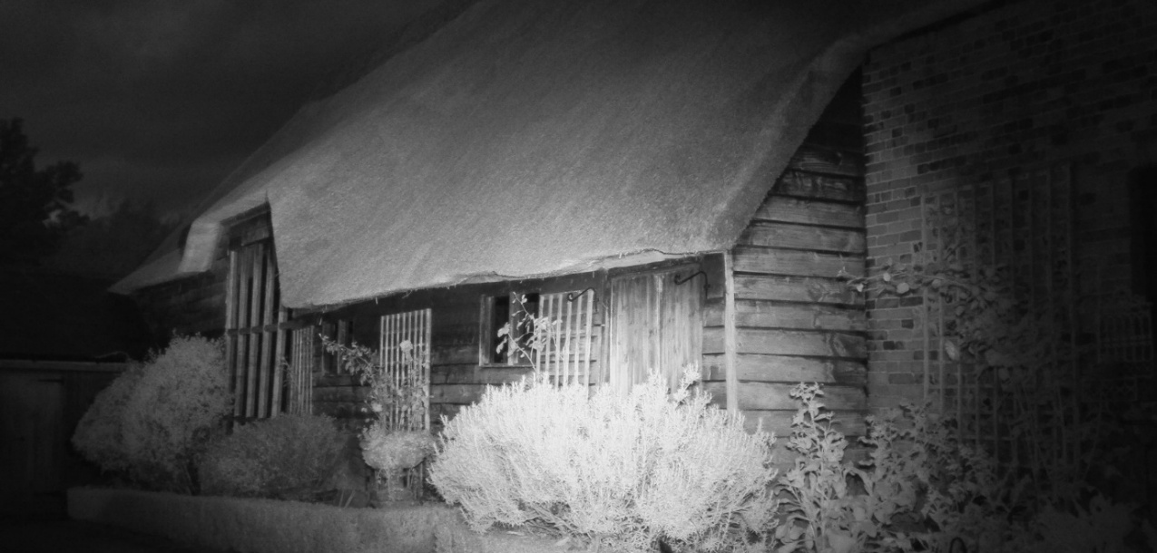
Figure 2. Southeast camera dark sky 8.10.2025

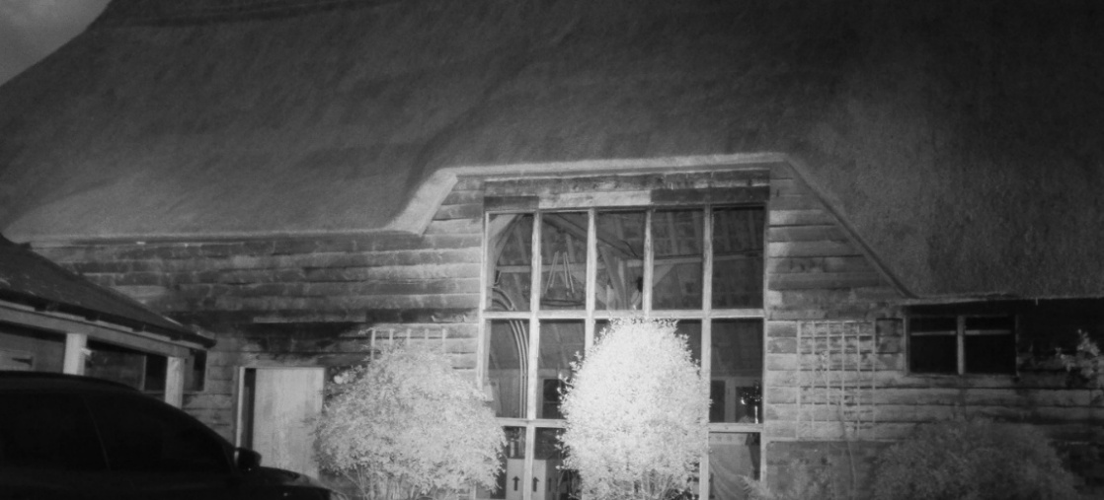
Figure 3. South camera dark sky 8.10.2025

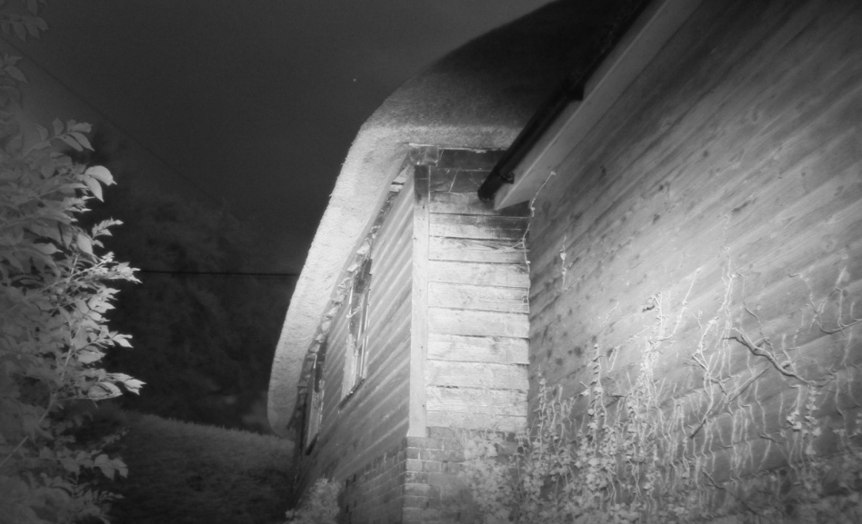
Figure 4. Southwest camera dark sky 8.10.2025

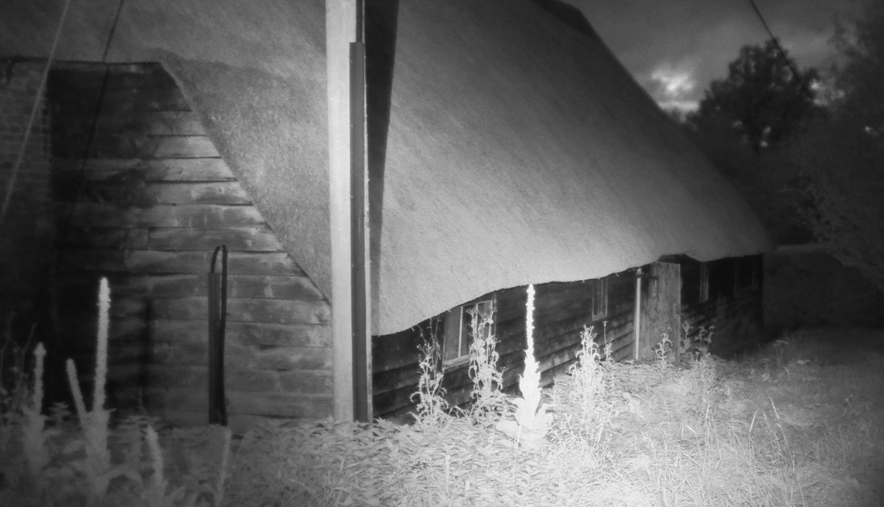
Figure 5. Northeast camera dark sky 8.10.2025

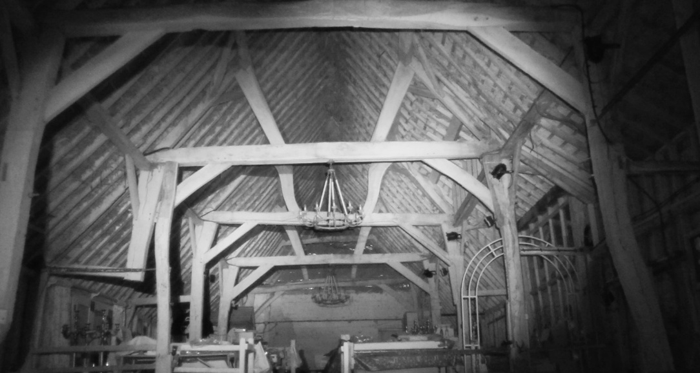
Figure 6. Barn interior looking east

2nd May 2026
Project |  | Start time | 20.06 | Finish | 22.06 | Temperature | 15 C at start 13.4 C at finish
 |  | 2.5.26 |  | sunset | 20.36 | Weather  100% cloud beaufort 1
 | Bat passes heard
Station no. | Start time |  | No. | passes | comments
N, S | 20.33-48 | Common pipistrelle | 2-3 | 35+ | Foraging and chasing each other around pond tosouth and over yard (a on figure 7)
N, S | 20.51 | Common pipistrelle | 1 | 1 | Flew west from Manor house over stables (B on figure 7)
N, S | 21.18 | Common pipistrelle | 1 | 1 | HNS
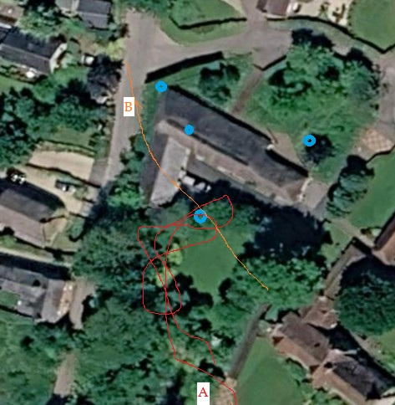
Figure 7. Bat flightpaths 2.5.2026

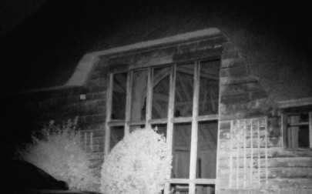
Figure 8. Southeast camera dark sky 2.5.2026

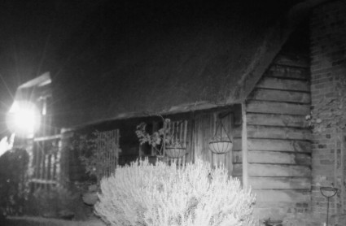
Figure 9. Southwest camera dark sky 2.5.2026

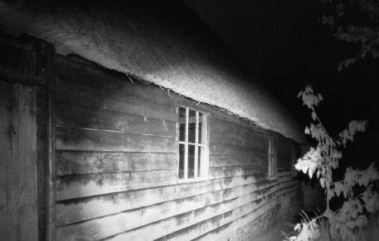
Figure 10. Northeast camera dark sky 2.5.2026

10th June 2026

Project |  | Start time | 20.40 | Finish | 22.50 | Temperature | 15 C at start 13 C at finish
 |  | 10.6.26 |  | sunset | 21.20 | Weather  0% cloud beaufort 0
 | Bat passes heard
Station no. | Start time |  | No. | passes | comments
S | 21.28 | Soprano pipistrelle | 1 | 1 | Flew in from south over pond and off over stable (a on figure 1)
S | 21.33 | Soprano pipistrelle | 1 | 1 | Flew in from south over pond and off over stable (a on figure 1)
N, S | 21.34 | Soprano pipistrelle | 2 | 2 | Flew in from south over pond and off over stable (a on figure 1)
S | 21.35 | Soprano pipistrelle | 2 | 2 | Flew in from south over pond and off over stable (a on figure 1)
S | 21.37 | Soprano pipistrelle | 1 | 1 | Flew in from south over pond and off over stable (C on figure 1)
S | 21.38 | Soprano pipistrelle | 1 | 1 | Flew in from south over pond and off over stable (a on figure 1)
S | 21.39 | Soprano pipistrelle | 1 | 1 | Flew in from south over pond and off over stable (a on figure 1)
S | 21.43 | Soprano pipistrelle | 1 | 1 | Flew in from south over pond and off over stable (a on figure 1)
S | 21.55 | common pipistrelle | 1 | 1 | Flew in from southeast over yard and off over stable (D on figure 1)

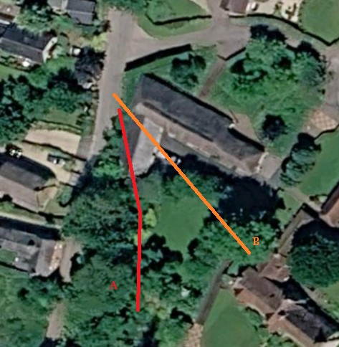
Figure 11. Bat flightpaths 10.6.2026

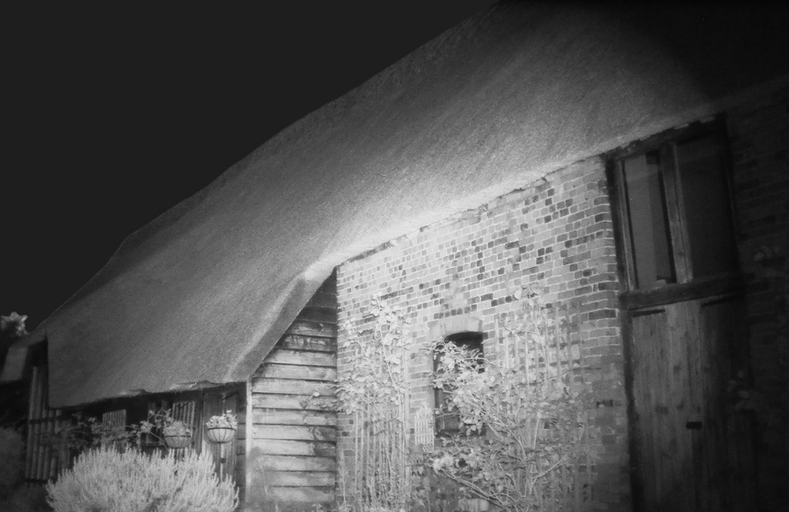
Figure 12. Southeast camera dark sky 10.6.2026

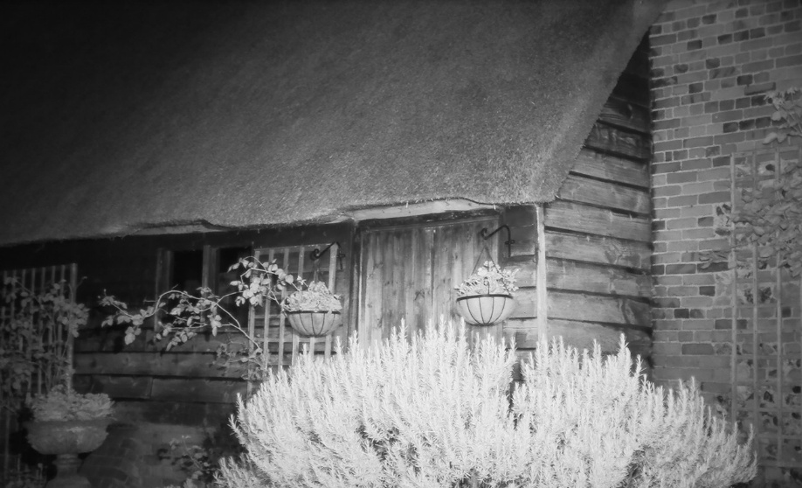
Figure 13. South camera dark sky 10.6.2026

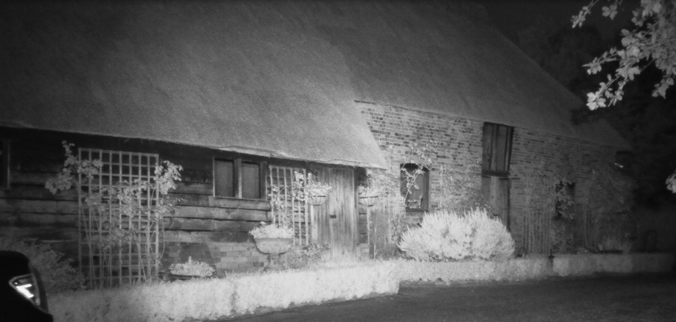
Figure 14. Southwest camera dark sky 10.6.2026

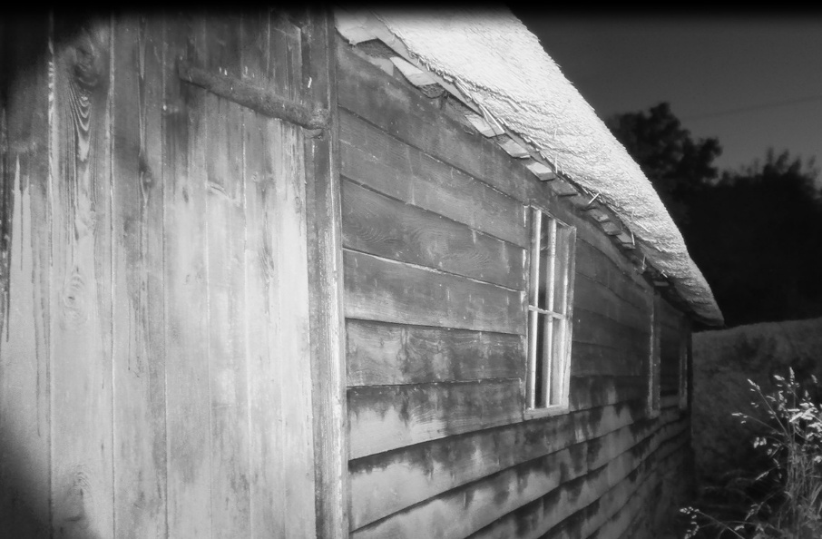
Figure 15. Northeast camera dark sky 10.6.2026

