APPLICATION FOR FULL PLANNING PERMISSION
DELEGATED REPORT

APPLICATION REFERENCE: | PL/2025/07604
APPLICATION TYPE: | Full Planning Permission
SITE ADDRESS: | Tarmac Construction Ltd, Trowbridge Road, Westbury, BA13 4LX
DEVELOPMENT DESCRIPTION: | Install new foul primary settlement tank at the eastern extremity of the “known to be serviceable” system. Install pump chamber which will pump settled effluent to the dosing syphon of existing plant, discharging into renovated existing filter beds & ultimately discharged into the Pond System. Depth of primary tank would be approx. 5m deep with an inlet some 2m below existing ground level affording gravity connections into the primary tank. Rising main from pumped effluent would be shallow & avoid deep excavations likely to encounter existing foundations & services.
RECOMMENDATION: | That Planning Permission be GRANTED

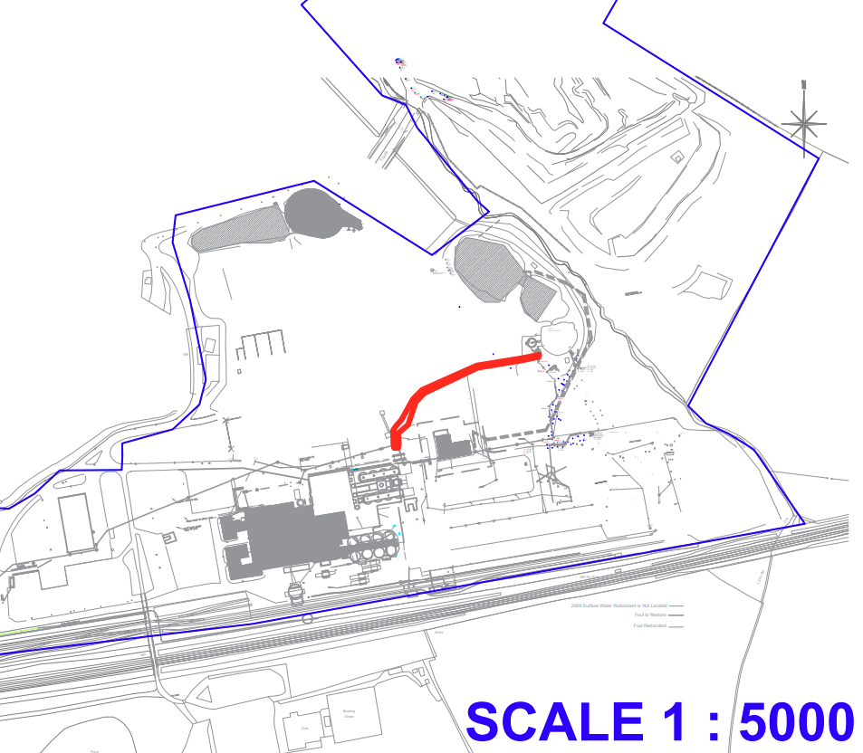

PROPOSAL

The proposal seeks to reinstate and upgrade the existing sewage treatment facilities at the Tarmac Site. The works comprise installing a new foul primary settlement tank at the eastern end of the remaining serviceable network, together with a new pump chamber to transfer settled effluent to the existing dosing syphon and renovated rotating biological filters, before final discharge to the existing pond system. The primary tank will be approximately 5 m deep with gravity-fed connections, and the rising main will be kept shallow to avoid deep excavations near existing foundations and services.

SITE DESCRIPTION / CONTEXT

The application site forms part of the wider Tarmac Site at the Westbury Sewage Treatment Plant and comprises land containing existing foul water treatment infrastructure in a deteriorated and partially non‑operational condition. The Design and Access Statement confirms that the primary tank roof has collapsed, the pumping station is non‑functional, and the below‑ground pipe network is in a poor state of repair, necessitating substantial renovation works within the existing operational envelope of the site. The site lies within the 6,400m buffer of the Salisbury Plain Special Protection Area (SPA), with a Public Right of Way (HEYW27) located approximately 90m to the northeast. According to the Strategic Flood Risk Assessment, the land is within Flood Zone 1 but is subject to a minor surface‑water flood risk associated with a 0.1% AEP (1 in 1,000‑year) event. The site also adjoins an area of Priority Habitat, though all proposed works remain within the existing developed and previously engineered land associated with the sewage treatment facility. Access to the site is taken from Trowbridge Road.

The application site is subject to the following planning policy constraints:

- Salisbury Plain SPA 6400m Buffer
- Public Right of Way (PROW) 90m Northeast (HEYW27)
- Strategic Flood Risk Assessment (sFRA) minor risk of surface flooding (0.1% AEP)
- Flood Zone 1
- Adjacent Priority Habitat

PLANNING HISTORY

Reference No. | Proposal / Summary | Decision
W/79/00347/HIS | New conveyors and gantries for clinker handling improvement scheme | Approved
W/87/00531/FUL | Extension to clinker store for low alkali cement scheme | Approved
W/92/00484/WCC | Registration of Interim Development Order Permission for the winning and working of chalk and clay | Approved
W/04/02173/WCM | Installation of new raw materials storage area and handling plant | Approved
W/10/02381/WCM | Certificate of Lawfulness for Proposed Use or Development at Lafarge Cement UK Westbury Works: Proposed continuation of cement milling, blending, packing and distribution post closure of cement kilns and quarries | Approved
15/09148/DEM | Prior notification of proposed demolition | Approved
17/10578/OUT | Development of a rail-served slab track manufacturing facility accommodating manufacturing and ancillary office, laboratory and welfare functions; a concrete batching plant; provision for open and covered storage, handling and transfer of raw and finished product; reconfiguration of the existing rail sidings (within the private rail network); use of the existing site access onto the A350 Trowbridge Road and use of existing on-site roadways; together with the provision and/or modification of landscaping, infrastructure, utilities, drainage systems, and engineering works. | Approved

RELEVANT LEGILSATION, POLICIES AND GUIDANCE

Wiltshire Core Strategy:

Core Policy 1 Settlement Strategy;
Core Policy 2 Delivery Strategy;
Core Policy 32 Spatial Strategy: Westbury Community Area;
Core Policy 50 Biodiversity and Geodiversity;
Core Policy 51 Landscape;
Core Policy 52 Green Infrastructure;
Core Policy 56 Contaminated Land;
Core Policy 57 Ensuring High-Quality Design and Place Shaping;
Core Policy 60 Sustainable Transport;
Core Policy 61 Transport and Development;
Core Policy 64 Demand Management;
Core Policy 67 Flood Risk;

Westbury Neighbourhood Plan 2023-2036

The National Planning Policy Framework (NPPF) and The Planning Practice Guidance (PPG)

Wiltshire Design Guide

The Wiltshire Local Transport Plan 2011 – 2026: Car Parking Strategy (March 2015).

The Wiltshire Local Transport Plan 4 (LTP4) (March 2025)

New Wiltshire Local Plan

At Full Council on 19 May 2026, the elected members of Wiltshire Council agreed to withdraw the emerging Wiltshire Local Plan. The said Plan has no material weight for the purposes of the application.

In accordance with Regulation 19 of the Town and Country Planning (Local Planning) (England) Regulations 2026, on 30th June 2026 Wiltshire Council published a notice of intention to prepare a new local plan for Wiltshire. The next stage is a Scoping Consultation which commences on 2nd September 2026. This plan is at a very early stage and currently carries no weight for decision making.

CONSULTATION RESPONSES

Bratton Parish Council – No Objection

Westbury Town Council – No Objection

Heywood Parish Council – No Objection

Environment Agency - No Objection

Drainage (Wiltshire Council) – No Objection

Ecology (Wiltshire Council) – No Objection (subject to conditions)

REPRESENTATIONS

No comments received.

ASSESSMENT

Section 38(6) of the Planning and Compulsory Purchase Act 2004 states:

"If regard is to be had to the development plan for the purposes of any determination to be made under the planning Acts, the determination must be made in accordance with the plan unless material considerations indicate otherwise."

In accordance with this statutory requirement, this application has been assessed against the relevant policies of the Development Plan, including the adopted Wiltshire Core Strategy (2015) and, where applicable, any made Neighbourhood Plans.

Core Policies 1 (Settlement Strategy) and 2 (Delivery Strategy) of the Wiltshire Core Strategy set out a spatial approach that directs new development to the most sustainable locations, prioritising growth within defined settlement boundaries. Development occurring outside these boundaries is strictly controlled and is generally only supported where it accords with specific policies that enable exceptions to normal settlement‑based restraint. In this case, the application site lies outside any defined settlement boundary, and therefore the proposal represents development in the open countryside contrary to the general presumption of Core Policies 1 and 2.

However, the proposal relates to the refurbishment and reinstatement of an existing sewage treatment plant and associated foul water infrastructure, located within the established Tarmac Site at Westbury Sewage Treatment Plant. The Design and Access Statement confirms that the existing facility has suffered significant structural and operational failure, including a collapsed primary tank roof, a non‑operational pumping station and deteriorated biological filter system, necessitating essential engineering works to restore its operational capacity and to continue serving the retained CRH. The works do not introduce new land uses but instead upgrade, repair and replace existing utility infrastructure within a previously developed operational site.

Given that the proposal constitutes essential infrastructure maintenance and improvement, rather than new standalone development, it is considered that the aims of Core Policies 1 and 2—in respect of directing growth to sustainable locations—carry reduced weight in this context. The proposal supports the continued functioning of an established wastewater facility and does not conflict with the overarching purpose of settlement boundaries, which is to manage the scale and distribution of new built development. Accordingly, while the site’s location outside a defined settlement boundary represents a technical conflict with the settlement strategy, the nature of the proposal as essential utility infrastructure forms a material consideration that weighs significantly in favour of the development proceeding.

Design and Impact upon the upon the character and context of the area

Core Policy 57 Ensuring High Quality Design and Place Shaping of the Wiltshire Core Strategy requires all new development to achieve a high standard of design that responds positively to its local context. Proposals must reinforce and enhance local character and distinctiveness, relate appropriately to the surrounding landscape, and demonstrate a thoughtful response to existing townscape features. This includes careful consideration of elements such as building height, scale, massing, building line, materials, and overall appearance, ensuring new development integrates harmoniously with its setting.

The image below illustrates the location of the proposed works in relation to the site’s aerial layout. At the western side of the plan, the position of the new primary settlement tank and pump chamber—both to be installed below ground—can be identified. The central annotation highlights the approximate 150-metre length of the rising main, while the eastern end of the plan shows where the rising main connects to the existing dosing syphon, and where the current filter beds are proposed to be refurbished.

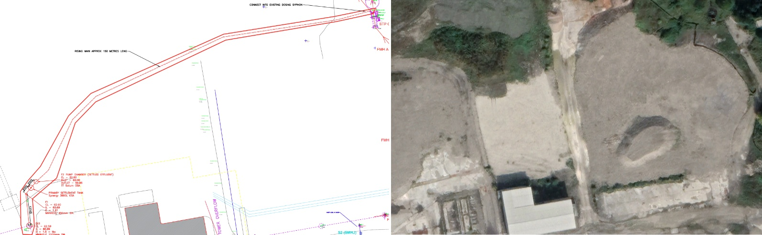
Plant Design and Site Aerial

The majority of the proposed works— including the new primary settlement tank, associated pipework, and elements of the pump chamber—are located below ground, resulting in little to no change to the visible appearance of the site. While some above-ground features such as access covers, control kiosks, and refurbished rotating biological filters will remain present, these represent minor operational components of a type already characteristic of the site.

The application site forms part of an existing and long-established industrial sewage treatment facility, where utilitarian engineering structures are an expected and inherent part of the character. As such, the above-ground elements proposed are low-impact, visually contained within the existing operational envelope, and entirely in keeping with the site’s functional and industrial setting. The development therefore does not introduce incongruous built form or result in any material change to the site's landscape presence. Given the predominantly below-ground nature of the engineering works and the industrial context in which they sit, the proposal is considered to have a neutral effect on the appearance and character of the area, and is compliant with Core Policy 57.

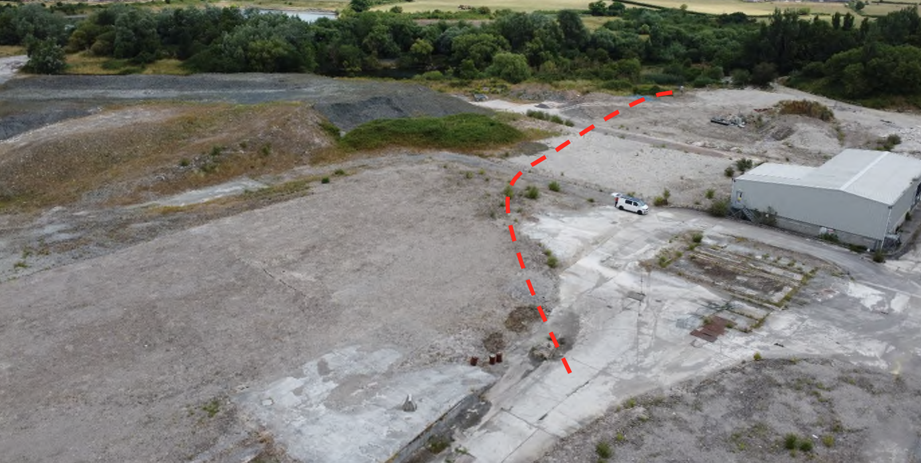
Site Aerial Image and route of network

Amenity

Point vii of Core Policy 57 Ensuring High Quality Design and Place Shaping of the Wiltshire Core Strategy seeks to ensure that developments do not adversely affect neighbouring properties. The National Planning Policy Framework (NPPF), particularly Paragraph 135, stresses that planning decisions should ensure developments provide a high standard of amenity for existing and future users.

The nearest residential receptors are located approximately 500 metres to the north, and the proposal largely comprises the renovation and reinstatement of existing wastewater infrastructure within an established operational site. The majority of the engineering works—such as the primary settlement tank, pump chamber, and new rising main—are located below ground, with only limited above‑ground features necessary for operational access.

Given the substantial separation distance, the enclosed industrial context, and the minimal extent of above‑ground structures, the proposal is not expected to give rise to any material noise, visual, or overbearing impacts on nearby residential properties. The works do not introduce new odour‑generating processes beyond those historically associated with the existing treatment system, and the proposal is intended to improve the functioning of the current facilities rather than intensify them. Construction activities are contained within the Tarmac Site and will not encroach toward sensitive receptors, thereby limiting temporary disturbance.

The proposal is appropriately sited, designed, and oriented to ensure that it would not result in unacceptable impact upon/to the amenities or living conditions of neighbouring residential occupiers, particularly in terms of outlook, privacy, or access to natural light. The proposal therefore accords with Core Policy 57 point vii in respect of safeguarding residential amenity.

Ecology

Core Policy 50 of the Wiltshire Core Strategy seeks to ensure that development protects, maintains and where possible enhances biodiversity and ecological networks. The policy requires proposals to avoid adverse impacts on designated sites, protected species and priority habitats, whilst securing appropriate mitigation and enhancement measures where necessary. The application has also been considered against the requirements of the Conservation of Habitats and Species Regulations 2017 (as amended), the National Planning Policy Framework and relevant ecological guidance.

The application site lies within the 6.4km buffer of the Salisbury Plain Special Protection Area (SPA). Wiltshire Council, as the competent authority, undertook a Test of Likely Significant Effects under Regulation 63 of the Habitats Regulations. Given the scale and nature of the proposal, which does not include the creation of any residential accommodation or other development likely to increase recreational pressure on the SPA, it was concluded that there is no pathway for adverse effects. The proposal has therefore been screened out from Appropriate Assessment in respect of the Salisbury Plain SPA.

The site also lies within the grey zone of the Trowbridge and Westbury Bat Mitigation Strategy, relating to the Bath and Bradford-on-Avon Bats Special Area of Conservation (SAC). Ecology officers advised that the proposal is not residential development, will not result in the loss of bat habitat, and does not introduce new lighting. Consequently, there is no likelihood of significant effects upon roosting, foraging or commuting bats associated with the SAC. The proposal was therefore screened out from Appropriate Assessment in respect of the Bath and Bradford-on-Avon Bats SAC.

During the initial consultation, concerns were raised regarding the potential impacts of the treated effluent discharge on the adjacent pond system and surrounding priority habitats. The ponds are considered Habitat of Principal Importance under Section 41 of the Natural Environment and Rural Communities Act 2006, and nearby woodland is identified within the Priority Habitat Inventory as Lowland Mixed Deciduous Woodland. Ecology officers requested additional information to demonstrate that the proposed renovation works would not adversely affect these ecological features.

In response, the applicant submitted further information, including evidence of an existing Environment Agency permit regulating the discharge of domestic effluent into the pond system, together with details regarding operational controls and monitoring arrangements. The Environment Agency reviewed the proposal and confirmed that it had no objection to the renovation of the treatment plant, subject to compliance with the relevant environmental permit and discharge consent requirements.

Having reviewed the additional information, the Council's Ecologist concluded that the concerns relating to the pond system and priority habitats had been satisfactorily addressed. It was noted that the proposal would result in environmental betterment, as untreated sewage has been discharged directly into the ponds in recent years, whereas the proposed works would restore and improve the treatment process before discharge. On this basis, the Ecologist withdrew their previous objection and raised no objection to the proposal subject to conditions securing ecological mitigation and enhancement measures.

With regard to Biodiversity Net Gain (BNG), the proposal benefits from the de minimis exemption under Schedule 7A of the Town and Country Planning Act 1990, as amended by the Environment Act 2021. The development does not impact any onsite priority habitat and affects less than 25m² of habitat with biodiversity value. Accordingly, a statutory Biodiversity Gain Plan is not required.

Notwithstanding the BNG exemption, ecological enhancements have been proposed through the submitted Ecological Enhancement Plan. These include the provision of two bird boxes, two bat boxes, a hedgehog nesting box, hibernacula, and additional water-tolerant tree and shrub planting around the pond margins. Ecology officers have confirmed that these measures should be secured by condition. Further mitigation in the form of a Construction Method Statement is also required to safeguard sensitive habitats and species, particularly reptiles and habitats associated with the pond system, during the construction phase.

Subject to the recommended planning conditions, it is considered that the proposal would not adversely affect designated sites, protected species, priority habitats or ecological networks. The development would provide ecological enhancements and biodiversity betterment over the existing situation and is therefore considered to accord with Core Policy 50 of the Wiltshire Core Strategy and the relevant provisions of the NPPF.

Flooding and Drainage

Core Policy 67 Flood Risk of the Wiltshire Core Strategy requires all development to be located, designed, and constructed to minimise vulnerability to flooding and to avoid increasing flood risk elsewhere. Proposals must demonstrate that surface water can be managed safely and sustainably, incorporating appropriate drainage solutions—such as sustainable drainage systems (SuDS)—that ensure runoff rates and volumes do not exceed pre‑development levels. Development should provide measurable betterment where necessary, ensuring that drainage strategies are robust, technically compliant, and aligned with national policy. The NPPF sets out the application of a sequential, risk-based approach to the location of new development in paragraph 172.

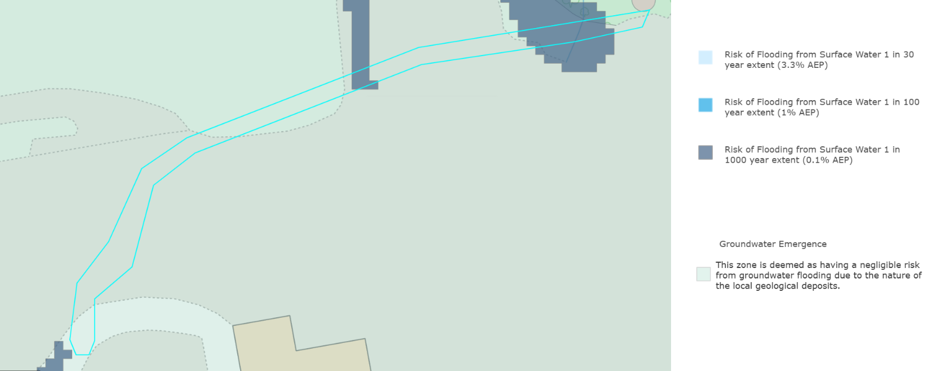
sFRA Ground and Surface Water Flood Risk

Consultation was received from the Drainage Officer, who noted that the site lies within Flood Zone 1 and is at a low risk of flooding from all sources, including fluvial, surface-water, and groundwater flooding, as confirmed by the Risk of Flooding from Rivers and the Sea (2025) mapping and the Wiltshire Council Strategic Flood Risk Assessment. The Drainage Officer noted that although surface-water mapping indicates the potential for some localised ponding, the proposed works are minor in nature and will not increase impermeable area or elevate flood risk when compared with the existing baseline. Following review of the Flood Risk Statement and submitted plans, the officer concluded that the development would not result in any adverse drainage impacts and therefore raised no objection to the proposal.

Having regard to the Drainage Officer’s no-objection comments and the applicant’s Flood Risk Statement and submitted plans, it is considered that the proposal would not place the development at increased risk of surface-water flooding, nor would it increase flood risk to adjoining land. The works do not materially increase impermeable area, and they maintain the site’s existing drainage characteristics, thereby complying with Core Policy 67 (Flood Risk) of the Wiltshire Core Strategy, which requires development to be directed to areas of lowest flood risk and to ensure that flood risk is not increased elsewhere.

In line with the Planning Practice Guidance and applying a proportionate approach, the following principle is directly relevant:

“In applying paragraph 175 a proportionate approach should be taken. Where a site-specific flood risk assessment demonstrates clearly that the proposed layout, design, and mitigation measures would ensure that occupiers and users would remain safe from current and future surface water flood risk for the lifetime of the development (therefore addressing the risks identified e.g. by Environment Agency flood risk mapping), without increasing flood risk elsewhere, then the sequential test need not be applied.”

On this basis, and given the evidence before the authority, the Sequential Test is not required for this proposal, and the development is acceptable in flood-risk and drainage terms.

Transport and Highways

The proposed works relate solely to the refurbishment and reinstatement of existing wastewater infrastructure and do not alter the site’s established access arrangements or affect vehicle parking or egress in any way. All construction activity is contained within the operational boundary, and no changes are proposed to the existing access taken from Trowbridge Road. As such, the development raises no transport or highway concerns and is considered acceptable with regard to the relevant transport policies of the Wiltshire Core Strategy and the National Planning Policy Framework, both of which require safe and suitable access for all users and ensure that development does not result in an unacceptable impact on highway safety.

Contaminated Land

Core Policy 56 (Contaminated Land) of the Wiltshire Core Strategy seeks to ensure that development does not give rise to unacceptable risks to human health, controlled waters or the wider environment arising from land contamination. Given the site's history as part of the wider former cement works, together with the proposed excavation works required to install the new settlement tank and associated infrastructure, the potential for contaminated ground to be encountered is a material consideration.

However, the proposal relates to engineering works within an established industrial site and does not introduce a more sensitive land use. Furthermore, no concerns have been raised by technical consultees regarding land contamination or pollution risks, and the development will improve the operation of the site's wastewater treatment infrastructure, resulting in environmental betterment over the existing situation. As such, the proposal is not considered to give rise to unacceptable contamination risks and is considered to accord with Core Policy 56 of the Wiltshire Core Strategy.

CONCLUSION

The proposed development comprises the reinstatement and upgrading of existing sewage treatment infrastructure within an established operational site. Whilst the site lies outside a defined settlement boundary, the works constitute essential utility infrastructure required to restore the effective operation of the existing treatment system and do not result in the introduction of a new land use. The proposal would not give rise to unacceptable impacts in respect of visual amenity, residential amenity, ecology, flood risk, drainage or highway safety. Following the submission of additional ecological information, both Wiltshire Council Ecology and the Environment Agency have raised no objection, subject to conditions. The development is therefore considered to accord with the relevant policies of the Wiltshire Core Strategy and the National Planning Policy Framework and, on balance, planning permission is recommended for approval.

RECOMMENDATION: That Planning Permission be GRANTED subject to the following conditions:

1.
The development hereby permitted shall be begun before the expiration of three years from the date of this permission.
REASON: To comply with the provisions of Section 91 of the Town and Country Planning Act 1990 as amended by the Planning and Compulsory Purchase Act 2004.

2.
The development hereby permitted shall be carried out in accordance with the following approved plans and documents:

Preliminary Ecological Assessment (19 September 2025)
Design and Access Statement (19 September 2025)
Flood Risk Statement (19 September 2025)
Planning Statement (19 September 2025)
Sewage Treatment Plan Design 80620-02D (31 October 2025)
Cross Sections 80620-02D (31 October 2025)
Saturn Package Pumping Station Datasheet (31 October 2025)
Synergy Spherical Septic Tanks SD0901/ROBUSTA (31 October 2025)
Site Plan and Location Plan 80620-03B (31 October 2025)

REASON: For the avoidance of doubt and in the interests of proper planning.

3.
The development will be carried out in strict accordance with the following documents:

Preliminary Ecological Assessment, Alder Ecology, July 2025
Ecological Enhancement Plan, Such Salinger Peters, July 2026

REASON: For the avoidance of doubt and for the protection, mitigation and enhancement of biodiversity.

4.
No site clearance, vegetation removal or demolition works shall commence until a Construction Method Statement has been submitted to, and approved in writing by the Local Planning Authority. The Construction Method Statement shall include all precautionary measures to be implemented during the construction period, for the protection of sensitive habitats and species known to be present within or adjacent the site, with particular reference to the pond, and reptiles. The development shall be carried out in strict accordance with the approved Construction Method Statement.

REASON: To ensure adequate protection, mitigation and compensation for protected species and priority habitats throughout the construction period.

Informative – Artificial Lighting
The habitat within the proposed development site and the surrounding area is suitable for roosting, foraging and commuting bats. An increase in artificial lux levels can deter bats which could result in roost abandonment and/or the severance of key foraging areas. This will likely result in a significant negative impact upon the health of bat populations across the region. Artificial light at night can have a substantial adverse effect on biodiversity. Any new lighting should be for the purposes for safe access and security and be in accordance with the appropriate Environmental Zone standards set out by the Institute of Lighting Engineers in their publication GN01:2021, ‘Guidance for the Reduction of Obtrusive Light’ (ILP, 2021), and Guidance note GN08-18 “Bats and artificial lighting in the UK”, issued by the Bat Conservation Trust and Institution of Lighting Professionals.

Informative – Environment Agency
The Sewage treatment plant is regulated by the Environment Agency under Environmental Permit EPR/ZP3229GC. The proposed renovation of the plant must ensure that the plant can still comply with the conditions of this permit. The applicant must also ensure that the renovated system satisfies the conditions of the Active Discharge Consent or consider variation of the Discharge Consent.

