APPLICATION FOR FULL-PLANNING PERMISSION
CASE OFFICER REPORT

APPLICATION REFERENCE: | PL/2026/04001
APPLICATION TYPE: | Full planning permission
SITE ADDRESS: | Wiltshire College, College Road, Trowbridge, BA14 0ES
DEVELOPMENT DESCRIPTION: | Over-cladding and replacement of the windows of the existing Ashton, Broughton, Edington and Arc Theatre buildings. Respraying of the The Kennet building and Main Entrance.
RECOMMENDATION: | Approve with Conditions

SITE DESCRIPTION/CONTEXT

The site is the existing building of the Trowbridge campus of Wiltshire College.

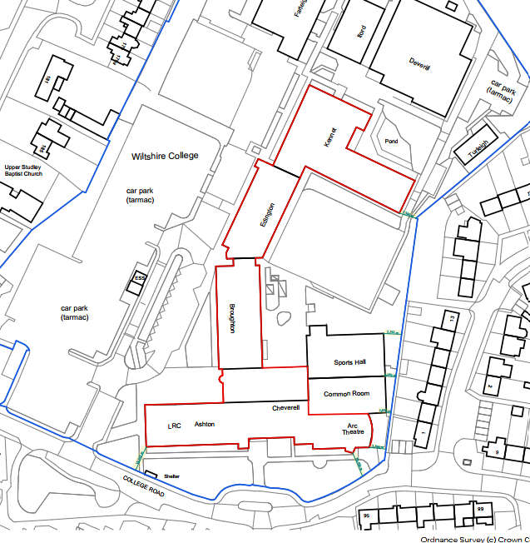

The site is subject to the following key constraints and designations: It is within the grey zone of the Trowbridge and Westbury Bat Mitigation Strategy (TWBMS) and the site is susceptible to surface water flooding events.

PROPOSAL

The proposal seeks the over-cladding and replacement of the windows of the existing Ashton, Broughton, Edington and Arc Theatre buildings. As well as the respraying of the Kennet building and Main Entrance.

Existing building:
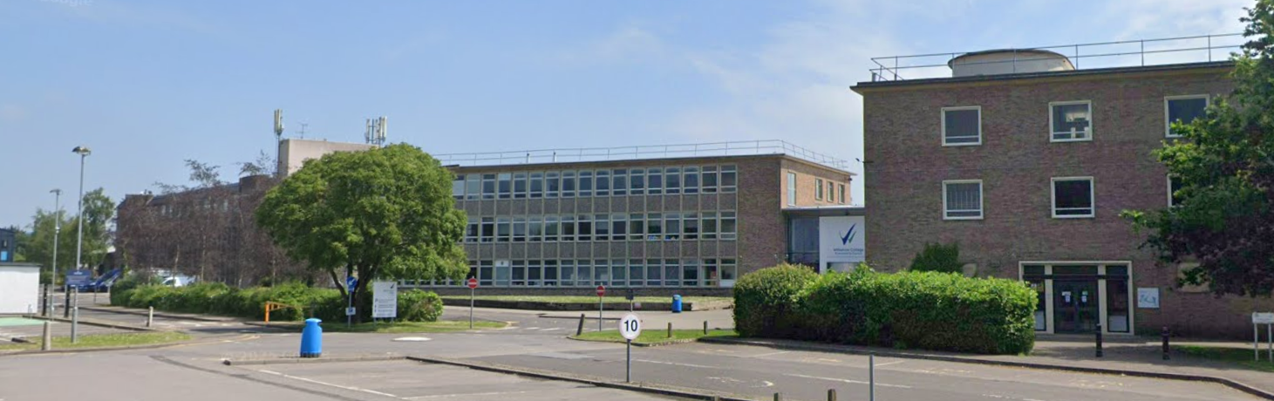

Proposed example elevation:
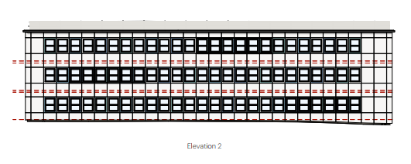
Example from Salisbury campus:
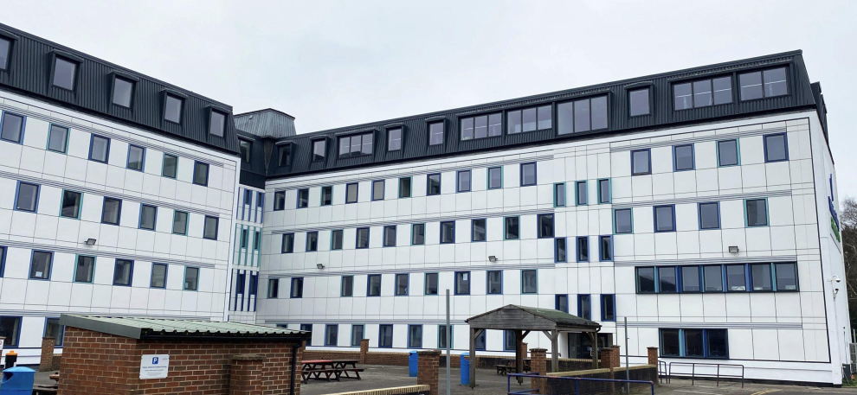

PLANNING HISTORY

None relevant.

RELEVANT LEGISLATION, POLICIES AND GUIDANCE

National Planning Policy:
- National Planning Policy Framework (NPPF)
- Planning Practice Guidance (PPG)
- National Design Guide
Development Plan:
The development plan for Wiltshire comprises the Wiltshire Core Strategy (WCS) (adopted January 2015) and any made neighbourhood plans, which remains the principal statutory planning document guiding development across the county. In line with Section 38(6) of the Planning and Compulsory Purchase Act 2004, planning decisions must be made in accordance with the development plan unless material considerations indicate otherwise.

Though the development plan is considered as a whole, those parts deemed to be particularly relevant to this application are listed below:

The adopted Wiltshire Core Strategy (WCS), with particular regard to:

- Core Policy 1 Settlement Strategy;
- Core Policy 2 Delivery Strategy;
- Core Policy 3 Infrastructure Requirements;
- Core Policy 29 Spatial Strategy: Trowbridge Community Area
- Core Policy 41 Sustainable Construction and Low-Carbon Energy;
- Core Policy 50 Biodiversity and Geodiversity;
- Core Policy 57 Ensuring High Quality Design and Place Shaping;
- Core Policy 67 Flood Risk;
- Core Policy 68 Water Resources;

Emerging Local Plan:
At Full Council on 19 May 2026, the elected members of Wiltshire Council agreed to withdraw the emerging Wiltshire Local Plan. The said Plan has no material weight for the purposes of the application.

In accordance with Regulation 19 of the Town and Country Planning (Local Planning) (England) Regulations 2026, on 30th June 2026 Wiltshire Council published a notice of intention to prepare a new local plan for Wiltshire. The next stage is a Scoping Consultation which commences on 2nd September 2026. This plan is at a very early stage and currently carries no weight for decision making.

Supplementary Planning Documents and other Guidance:
- Wiltshire Design Guide (adopted April 2024)

ISSUES

The main issues that need to be addressed in this case include:

- Whether the development is acceptable in principle (CP 1 and 2)
- Whether the scheme constitutes high quality design (CP 57)
- Are there any other planning issues raised by the development?
  - Ecology
  - Flood risk
  - Amenity

CONSULTATION RESPONSES

The views of consultees are material considerations in the determination of the application. However, the decision-maker must exercise their own planning judgement. Where consultees raise concerns or recommend conditions, these have been considered and are addressed within the assessment section of this report.

Town Council: No objection

REPRESENTATIONS
In accordance with the requirements of the Town and Country Planning (Development Management Procedure) (England) Order 2015 (as amended), the application was publicised by way of:

- Neighbour notification letters sent to adjoining and nearby properties;
- A site notice displayed near the site;

These methods were used to inform interested parties and provide a period of 21 days for comments to be submitted.

No representations have been received.

ASSESSMENT
Section 38(6) of the Planning and Compulsory Purchase Act 2004 states:

"If regard is to be had to the development plan for the purposes of any determination to be made under the planning Acts, the determination must be made in accordance with the plan unless material considerations indicate otherwise."

In accordance with this statutory requirement, this application has been assessed against the relevant policies of the Development Plan, including the Wiltshire Core Strategy (2015). Consideration has also been given to the policies of the National Planning Policy Framework (NPPF) as a material consideration in the assessment.

The assessment below considers each of the main issues identified above. Each topic is assessed in turn with reference to the relevant policy context, the evidence submitted, consultee responses, and all other material considerations, before a conclusion is reached.

Principle of Development
Policy Context
Core Policy 1: Settlement Strategy of the WCS establishes a hierarchy of settlements to guide where development should be focused. The policy prioritises growth in:
- Principal Settlements (e.g., Salisbury, Chippenham, Trowbridge) – main focus for strategic growth.

Core Policy 2: Delivery Strategy of the WCS sets out how development will be distributed and delivered across Wiltshire. The policy emphasises:
- Sustainable patterns of growth, reducing the need to travel and supporting local services.

Together, CP1 and CP2 ensure that new development is strategically located, sustainable, and supports the character and function of Wiltshire’s communities.

Assessment

This is an existing set of buildings that form the Trowbridge campus of Wiltshire College. The buildings are somewhat dated and the proposal for cladding and re-fenestration would bring their appearance up to date, and this would result in a more appealing local service.

The buildings would also become more sustainable, as will be discussed later in this report.

Conclusion

The proposal is in line with the strategic policies due to the upgrade potential for this important local service as an education establishment.

Design and Impact on the Character and Appearance of the Area
Policy Context
Core Policy 57 of the WCS requires high-quality design that:
- Enhances local character.
- Responds to the natural, historic, and built environment.
- Retains important features (e.g., trees, hedges).
- Supports sustainable construction and compatibility with surrounding uses.
- Creates safe, legible, and accessible spaces.

Section 12 of the NPPF emphasises design that is:
- Visually attractive.
- Functionally effective.
- Contributes to the quality of the built environment.

The Wiltshire Design Guide encourages sensitivity to local character, materials, and architectural styles and supports modern living standards while maintaining aesthetic and functional quality.

Assessment
In assessing this aspect of the proposal, regard has been had to the site context, the details of the proposed development, the relevant development plan policies, and all other material considerations.

The existing buildings are tired and dated in their design and use of materials. The cladding and replacement windows would represent a strong upgrade in terms of enhanced visual appearance. This would result in a more welcoming and attractive campus for Wiltshire College.

In terms of the specific materials, the application form and plans state the cladding type and RAL colour numbers clearly, and these are considered to be acceptable.

Conclusion
Having regard to the above, it is considered that there are clear benefits in upgrading the appearance of the buildings and therefore the proposal meets the high quality design criteria.

Climate Change / Carbon Impact Section
Policy Context
Core Policy 41 of the Wiltshire Core Strategy seeks to minimise emissions and support the transition to a low-carbon economy. The National Planning Policy Framework requires development to support the transition to a low carbon future and to help shape places in ways that contribute to radical reductions in greenhouse gas emissions.

Assessment
In assessing the proposal, regard has been had to:

- The energy efficiency of the proposed development;
- The incorporation of low carbon or renewable energy measures;

The cladding and re-fenestration of the buildings would introduce a much better thermal performance than the existing buildings provide. Therefore, the energy and carbon consumption of running the college would decrease, resulting in sustainable buildings and thus giving benefits towards the low-carbon economy.

Conclusion
The proposal is considered to accord with the aims of sustainable development in respect of climate change mitigation and adaptation.

Other Issues

The below issues are material planning considerations that can be dealt with briefly:

Ecology

The site lies in the grey zone of the TWBMS. The site contains an existing set of buildings and these are proposed to be clad and refenestrated. As this is non-residential development, and no new buildings are proposed, there would be no impact on the TWBMS.

The site falls below the threshold for a biodiversity net gain requirement.

Flood risk

The site shows as having some surface water flood risk. The cladding of the existing buildings would not result in any change that would impact the existing situation. Therefore there are no objections in this regard.

Amenity

The buildings would have replacement windows in the same places as the existing windows, and therefore there would be no impact on the amenities of the neighbouring properties over and above the existing situation.

Public Sector Equality Duty (PSED)
In reaching this decision, due regard has been had to the Public Sector Equality Duty under Section 149 of the Equality Act 2010. This requires the Local Planning Authority to have regard to the need to eliminate discrimination, advance equality of opportunity and foster good relations between persons who share a protected characteristic and those who do not.

The Local Planning Authority is satisfied that the proposal would not result in any unlawful discrimination and that any impacts on protected groups have been appropriately considered as part of this assessment.

PLANNING BALANCE AND CONCLUSION
In reaching a decision, all identified harms and benefits must be weighed in the overall planning balance, having regard to Section 38(6) of the Planning and Compulsory Purchase Act 2004 and the provisions of the National Planning Policy Framework.

At the heart of the NPPF there is a presumption in favour of sustainable development requiring local planning authorities to approve development proposals that accord with an up-to-date development plan without delay; and where there are no relevant development plan policies, or the policies which are most important for determining the application are out-of-date, permission should be granted unless (taken from paragraph 11d of the NPPF):

- The application of policies in the NPPF that protect areas or assets of particular importance provides a clear reason for refusing development proposed; or
- any adverse impacts of doing so would significantly and demonstrably outweigh the benefits, when assessed against the policies in the NPPF taken as a whole;

In weighing the planning balance, the following factors have been considered:

The principle of development is considered acceptable when assessed against the settlement strategy of the Wiltshire Core Strategy and the emerging Local Plan.

The proposal is broadly compliant with relevant local and national planning policies in respect of high quality design, residential amenity, flood risk, ecology and biodiversity, and environmental impacts.

The development would deliver clear benefits, including creating a more attractive and sustainable education site, as well as delivering benefits to the low-carbon economy, which weigh positively in the overall planning balance.

No material considerations have been identified that would significantly and demonstrably outweigh these benefits or indicate that permission should be refused, having regard to the assessment above.

Accordingly, the proposal is considered acceptable in planning terms and in accordance with the Wiltshire Core Strategy, the National Planning Policy Framework, and all other relevant material considerations.

RECOMMENDATION:
That Planning Permission be GRANTED, subject to conditions

All conditions imposed have been assessed against the six tests set out in paragraph 56 of the National Planning Policy Framework and are considered to be necessary, relevant to planning, relevant to the development to be permitted, enforceable, precise and reasonable in all other respects.

