APPLICATION FOR HOUSEHOLDER PLANNING PERMISSION
DELEGATED REPORT

APPLICATION REFERENCE: | PL/2026/03715
APPLICATION TYPE: | Householder Planning Permission
SITE ADDRESS: | 8 The Firs, Limpley Stoke, Bath, BA2 7GQ
DEVELOPMENT DESCRIPTION: | Removal of existing UPVC conservatory at the rear of the property and replaced with timber-clad garden room extension.
RECOMMENDATION: | That Planning Permission be GRANTED

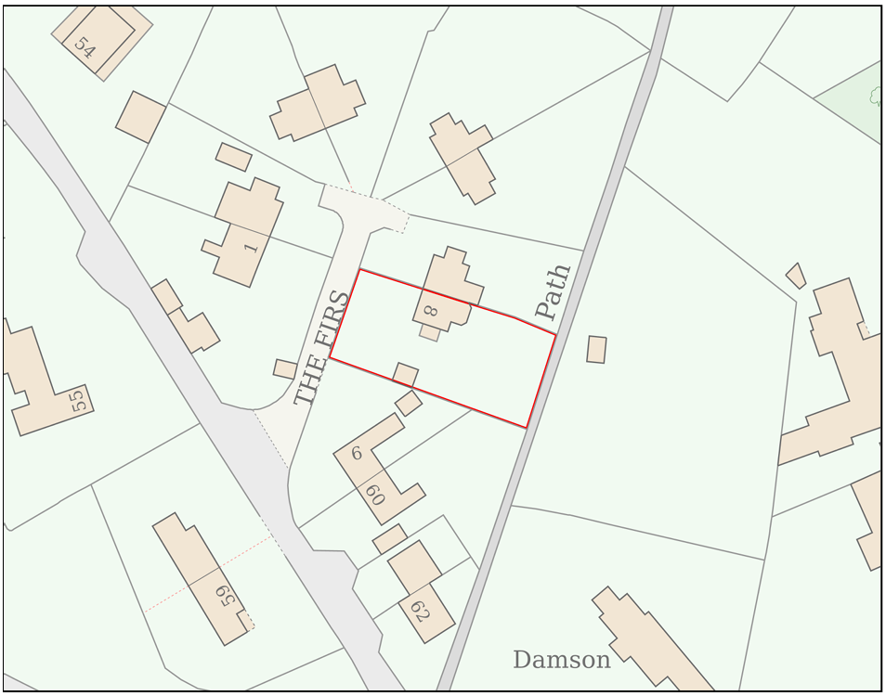
PROPOSAL

The application seeks planning permission for the replacement of an existing rear uPVC conservatory with a timber-clad garden room extension. The proposed extension would project approximately 3.8 metres from the rear elevation of the dwelling, have a width of approximately 5 metres and an overall height of approximately 3.4 metres. External materials would comprise horizontal British Western Red Cedar cladding, thermally broken aluminium glazing finished in dark grey anodised coating, and a lightweight dark grey metal roof incorporating a proprietary rooflight.

SITE DESCRIPTION / CONTEXT

The application site comprises a two-storey semi-detached dwelling and associated residential curtilage located within The Firs, Limpley Stoke. The surrounding area is characterised by similarly designed residential properties featuring stone-effect elevations, tiled roofs and gabled forms within a low-density village setting. The site lies within the West Wiltshire Green Belt and the Cotswolds National Landscape, and is subject to a number of ecological constraints associated with the Bath and Bradford-on-Avon Bats Special Area of Conservation, including Greater and Lesser Horseshoe Bat consultation buffers. A public right of way (LSTO8) runs along the eastern site boundary. The site is located within Flood Zone 1 and Council mapping indicates negligible risk from groundwater and surface water flooding.

PLANNING HISTORY

No relevant planning history has been identified.

RELEVANT LEGISLATION, POLICIES AND GUIDANCE

Wiltshire Core Strategy:

Core Policy 1 Settlement Strategy;
Core Policy 2 Delivery Strategy;
Core Policy 7 Spatial Strategy: Bradford on Avon Community Area;
Core Policy 50 Biodiversity and Geodiversity;
Core Policy 51 Landscape;
Core Policy 57 Ensuring High-Quality Design and Place Shaping;
Core Policy 60 Sustainable Transport;
Core Policy 61 Transport and Development;
Core Policy 64 Demand Management;
Core Policy 67 Flood Risk;

Freshford & Limpley Stoke Neighbourhood Plan 2014-2039

The National Planning Policy Framework (NPPF)

The Planning Practice Guidance (PPG)

Wiltshire Design Guide - Appendix D – Design Guidance for Householder extensions

The Wiltshire Local Transport Plan 2011 – 2026: Car Parking Strategy (March 2015).

The Wiltshire Local Transport Plan 4 (LTP4) (March 2025)

New Wiltshire Local Plan

At Full Council on 19 May 2026, the elected members of Wiltshire Council agreed to withdraw the emerging Wiltshire Local Plan. The said Plan has no material weight for the purposes of the application.

In accordance with Regulation 19 of the Town and Country Planning (Local Planning) (England) Regulations 2026, on 30th June 2026 Wiltshire Council published a notice of intention to prepare a new local plan for Wiltshire. The next stage is a Scoping Consultation which commences on 2nd September 2026. This plan is at a very early stage and currently carries no weight for decision making.

CONSULTATION RESPONSES

Limpley Stoke Parish Council – Supports

REPRESENTATIONS

No comments received.

ASSESSMENT

Section 38(6) of the Planning and Compulsory Purchase Act 2004 states:

"If regard is to be had to the development plan for the purposes of any determination to be made under the planning Acts, the determination must be made in accordance with the plan unless material considerations indicate otherwise."

In accordance with this statutory requirement, this application has been assessed against the relevant policies of the Development Plan, including the adopted Wiltshire Core Strategy (2015) and, where applicable, any made Neighbourhood Plans.

The proposal relates to the alteration and extension of an existing dwellinghouse within an established residential curtilage. The replacement of an existing conservatory with a modest garden room extension represents a form of domestic development that is acceptable in principle, subject to consideration of its impacts on the character and appearance of the area, residential amenity, Green Belt openness, ecology and other material planning considerations. Given the limited scale of the proposal and its location within the residential curtilage, the development is considered acceptable in principle.

Greenbelt

The NPPF at paragraph 153 states that “when considering any planning application, local planning authorities should ensure that substantial weight is given to any harm to the Green Belt, including harm to its openness”. It goes on to state that “inappropriate development is, by definition, harmful to the Green Belt and should not be approved except in very special circumstances”. Paragraph 154 establishes that development would not be considered inappropriate where it comprises the extension or alteration of a building provided that it does not result in disproportionate additions over and above the size of the original building.

The site lies within the West Wiltshire Green Belt, where significant weight is afforded to preserving openness and avoiding inappropriate development. The proposal would replace an existing conservatory with a slightly larger garden room extension, resulting in only a modest increase in footprint and built volume. Assessment of the property's development history indicates that the cumulative increase in cubic content relative to the original dwelling would remain limited, amounting to approximately a 10% increase over the original dwelling volume. The extension would remain proportionate in scale, subordinate to the host dwelling and would not materially affect the openness of the Green Belt or conflict with the purposes of including land within it. The proposal is therefore considered to constitute a proportionate addition to the existing dwelling and is acceptable in Green Belt terms.

Design and Impact the upon the character and context of the area

Core Policy 57 Ensuring High Quality Design and Place Shaping of the Wiltshire Core Strategy requires all new development to achieve a high standard of design that responds positively to its local context. Proposals must reinforce and enhance local character and distinctiveness, relate appropriately to the surrounding landscape, and demonstrate a thoughtful response to existing townscape features. This includes careful consideration of elements such as building height, scale, massing, building line, materials, and overall appearance, ensuring new development integrates harmoniously with its setting.

The proposed extension adopts a simple contemporary design incorporating horizontal cedar cladding, extensive glazing and a lightweight metal roof. The extension would remain subservient to the host dwelling and would be positioned to the rear where visibility from the public realm is limited. It is noted that the adjoining semi-detached property benefits from a similar rear extension approved under application reference W/08/00879/FUL, incorporating horizontal timber boarding and a box-style form. The proposal would therefore maintain a degree of symmetry within the pair of dwellings and is considered to represent a visual improvement over the existing uPVC conservatory. The design, form and materials are considered appropriate to the host dwelling and would preserve the character and appearance of the area.

Having regard to the above, the proposal complies with the design principles set out in Core Policy 57 of the Wiltshire Core Strategy and Appendix D of the Wiltshire Design Guide.

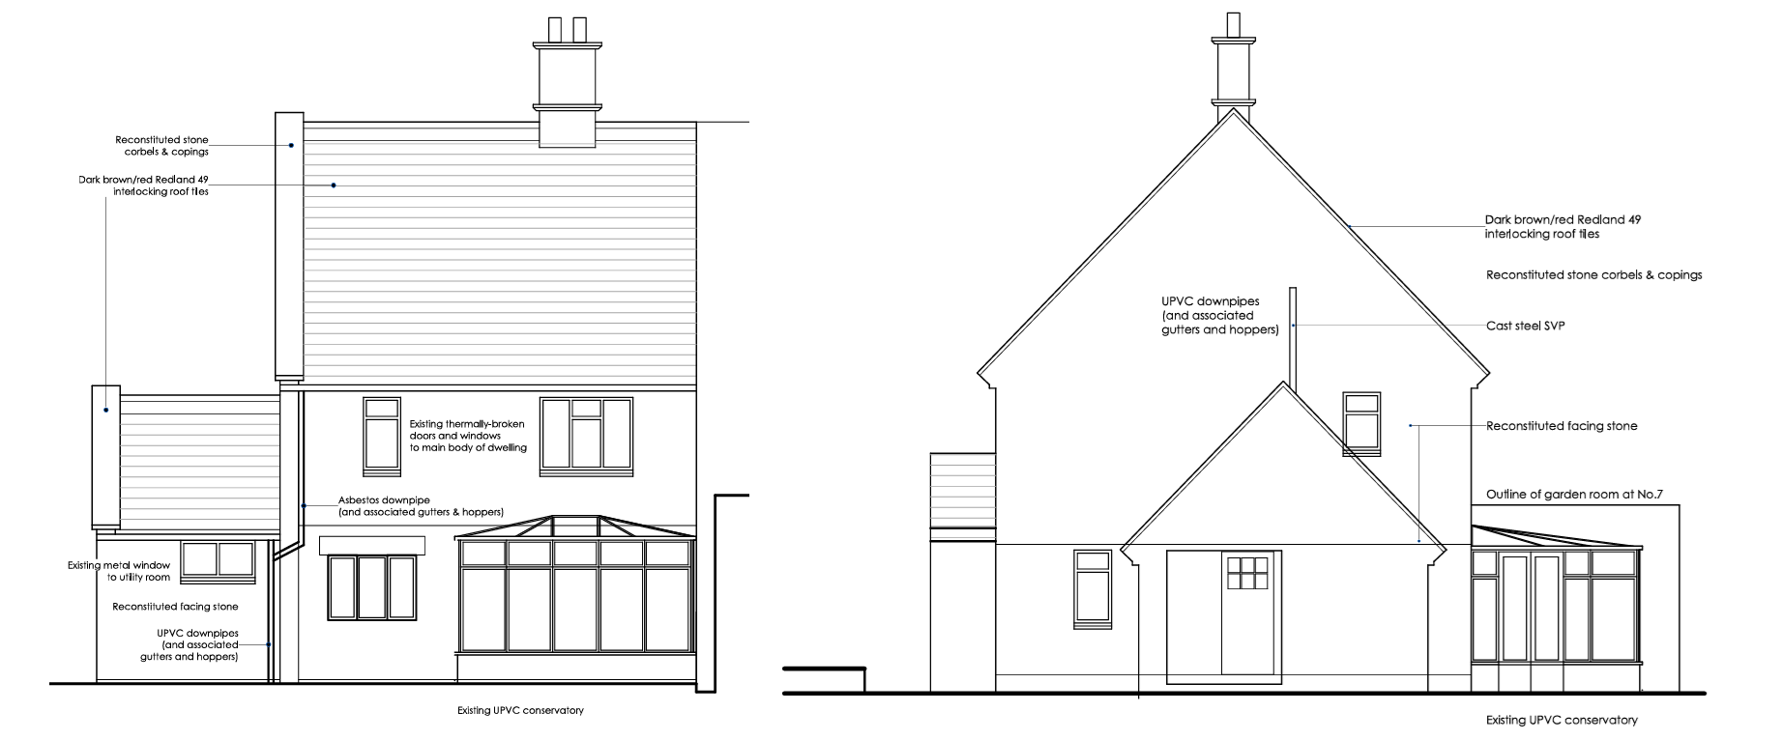
Existing Rear and Side Elevations

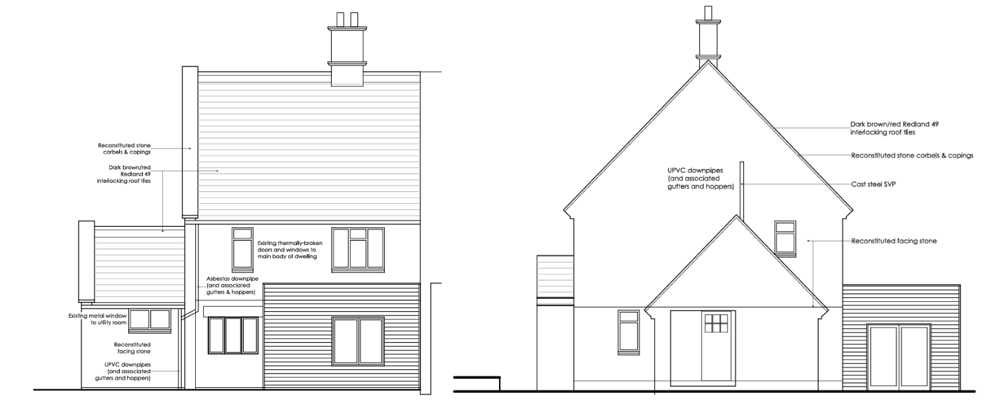
Proposed Rear and Side Elevation

Amenity

Point vii of Core Policy 57 Ensuring High Quality Design and Place Shaping of the Wiltshire Core Strategy seeks to ensure that developments do not adversely affect neighbouring properties. The National Planning Policy Framework (NPPF), particularly Paragraph 135, stresses that planning decisions should ensure developments provide a high standard of amenity for existing and future users.

The proposed extension would occupy a broadly similar position to the conservatory it replaces and would only increase the projection from the rear elevation by approximately 0.8 metres. Whilst the height would increase by approximately 0.7 metres, the extension would remain single storey in scale and would adjoin the neighbouring property's existing rear extension. The development contains glazing directed towards the applicant's rear garden and would not introduce any significant overlooking. Having regard to its modest scale, positioning and relationship to neighbouring development, the proposal is not considered to result in any unacceptable loss of light, overbearing impact or loss of privacy to adjoining occupiers.

The proposal therefore accords with Core Policy 57 point vii in respect of safeguarding residential amenity and Appendix D of the Wiltshire Design Guide.

Transport and Highways

Core Policy 60 of the WCS states that Council will support and encourage safe and efficient movement of people and, where necessary, mitigate the impact of development on transport users and local communities. Core Policy 61 specifies that development should demonstrate that consideration has been given to a hierarchy of transport users and that proposals must, where relevant, serve as a safe access to the highway network. Paragraph 116 of the NPPF states that “Development should only be prevented or refused on highways grounds if there would be an unacceptable impact on highway safety, or the residual cumulative impacts on the road network, following mitigation, would be severe, taking into account all reasonable future scenarios”.

The proposal would not alter the use of the property and would not result in the creation of additional bedrooms or a material intensification of residential use. No changes are proposed to existing means of access, parking arrangements or vehicle movements associated with the dwelling. As such, the development would not give rise to any adverse highway safety or parking impacts and is considered acceptable in this regard.

Ecology

The WCS, through Core Policy 50, states that development proposals are expected to avoid and reduce disturbance of sensitive wildlife species and habitats. Biodiversity Net Gain (BNG) was established as a mandatory aspect of planning evaluation through Schedule 7A of the Town and Country Planning Act 1990 (as amended by the Environment Act 2021 Schedule 14). Householder planning applications are exempt from the requirement to deliver Biodiversity Net Gain under Schedule 7A, Section 4(2)(a) of the Town and Country Planning Act 1990, as inserted by the Environment Act 2021.

The site is subject to a number of ecological constraints associated with the Bath and Bradford-on-Avon Bats SAC and associated consultation zones. However, the proposal involves the replacement of an existing conservatory within a domestic garden setting and requires only a very limited increase in footprint. The development would not involve works to the main roof structure of the dwelling, removal of trees, or disturbance of features likely to support protected species. Given the limited scale and nature of the proposal, together with its location on previously developed domestic land, it is not considered likely to result in adverse impacts on designated sites, protected species or ecological interests. The proposal is screened out the requirement for Appropriate Assessment under the Habitats Regulations on the basis that significant effects on the integrity of the Bath and Bradford on Avon Bat SAC can be ruled out in this instance.

Flooding and Drainage

Core Policy 67 Flood Risk of the Wiltshire Core Strategy requires all development to be located, designed, and constructed to minimise vulnerability to flooding and to avoid increasing flood risk elsewhere. Proposals must demonstrate that surface water can be managed safely and sustainably, incorporating appropriate drainage solutions—such as sustainable drainage systems (SuDS)—that ensure runoff rates and volumes do not exceed pre‑development levels. Development should provide measurable betterment where necessary, ensuring that drainage strategies are robust, technically compliant, and aligned with national policy. The NPPF sets out the application of a sequential, risk-based approach to the location of new development in paragraph 172.

The site lies within Flood Zone 1, which is identified as having the lowest probability of flooding. Council mapping further indicates negligible risk from groundwater and surface water flooding. The proposal would result in only a very minor increase in built footprint, approximately 4 square metres beyond the existing conservatory, and there are no known drainage constraints affecting the site. Given the scale of development and location within an area of low flood risk, the proposal is not considered to result in any unacceptable drainage or flood risk impacts.

CONCLUSION

The proposed replacement of the existing conservatory with a modest single-storey garden room extension is considered to represent an appropriate and proportionate form of development within the residential curtilage of the dwelling. The proposal would be sympathetic in design, would not result in unacceptable impacts on neighbouring residential amenity, would preserve the openness of the Green Belt, and would not give rise to harmful effects in relation to ecology, highways, drainage or flood risk. Furthermore, having had regard to the site's location within the Cotswolds National Landscape and the statutory duty under Section 85 of the Countryside and Rights of Way Act 2000, the proposal is considered to conserve the character and scenic beauty of the designated landscape. Accordingly, the development is considered to comply with relevant development plan policies and material planning considerations, and is recommended for approval.

RECOMMENDATION: That Planning Permission be GRANTED subject to the following conditions:

1.
The development hereby permitted shall be begun before the expiration of three years from the date of this permission.
REASON: To comply with the provisions of Section 91 of the Town and Country Planning Act 1990 as amended by the Planning and Compulsory Purchase Act 2004.

2.
The development hereby permitted shall be carried out in accordance with the following approved plans and documents:

Proposed Ground Floor Plan 025-P-030
Proposed Front / Rear Elevations 025-P-040
Proposed Side Elevation 025-P-041
Proposed First Floor / Roof Plan 025-P-031
Existing / Proposed Site Plan 025-P-03
Location Plan (11 June 2026)

REASON: For the avoidance of doubt and in the interests of proper planning.

