APPLICATION FOR PRIOR NOTIFICATION - AGRICULTURAL
CASE OFFICER REPORT

APPLICATION REFERENCE: | PL/2026/04607
APPLICATION TYPE: | Prior notification: Building
SITE ADDRESS: | Chisbury Lane Farm, Chisbury, Marlborough, SN8 3JA
DEVELOPMENT DESCRIPTION: | Proposed New Agricultural Storage building for the purposes of storing straw
RECOMMENDATION: | Prior Approval Not Required

SITE DESCRIPTION/CONTEXT

Chisbury Lane Farm is an established commercial dairy farm comprising approximately 128 hectares, operating as a well-established agricultural unit.

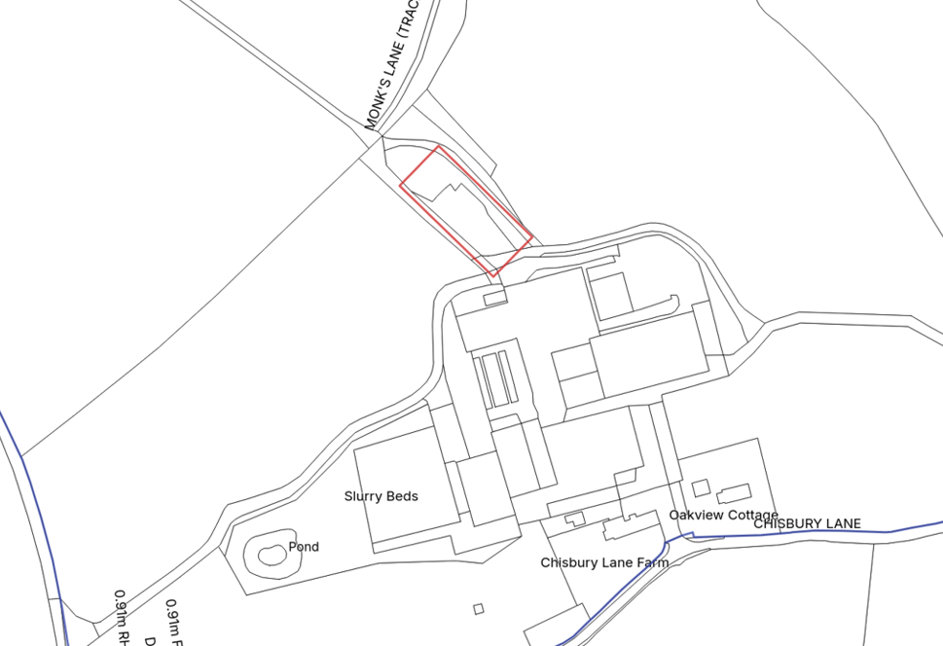
Location Plan

The farm supports a herd of approximately 240 autumn-calving dairy cows, together with around 140 youngstock. During the winter months, all milking cows and bulling heifers are housed in cubicle accommodation bedded on milled straw, whilst calves are loose housed using deep straw bedding.

PROPOSAL

The application proposes to erect a new straw storage building on the existing hardstanding immediately adjacent to the existing farm buildings. It will utilise the existing farm access and circulation routes within the farmyard.

The submitted application form states that the barn would measure 36.58m long x 13.71m wide, 6.1m to the eaves and 7.4m to the ridge. The building will be a steel portal frame design, with fibre cement roof sheeting in RAL 7033. It will be open sided to allow for access.

RELEVANT PLANNING HISTORY

Proposal / Summary
K/46692 - Full planning permission Decision - Approve with Conditions Date: 6/1/2004 – Erection of a new covered yard and covering collecting yard.
18/10332/FUL - Full planning permission Decision - Approve with Conditions Date: 12/12/2018 – Erection of a new cattle building adjacent to proposed parlour building
18/10097/APD - Agricultural & Forestry - Detailed matters Decision - Prior Approval Not Required Date: 22/11/2018 – Erection of steel portal framed building to house dairy parlour and cattle handling facilities.

RELEVANT LEGISLATION, POLICY AND GUIDANCE
This application is assessed under Article 3 of the Town and Country Planning (General Permitted Development) (England) Order 2015 (as amended), which grants planning permission for certain types of development described in Schedule 2 of the Order. The grant of permission is subject to the limitations, conditions, and provisions set out within the relevant Classes of permitted development.

Under Schedule 2, Part 6, Class A of the Town and Country Planning (General Permitted Development) (England) Order 2015 (as amended), certain types of agricultural development may be permitted, including:

- The erection, extension, or alteration of a building;
- The formation or alteration of a private way;
- Excavations or the deposit of waste material (where the relevant area exceeds 0.5 hectares);
- The placing or assembly of a tank in any waters.

Where such development is proposed, the developer is required to apply to the local planning authority for a determination as to whether prior approval is needed. This prior approval process is limited in scope and relates only to the following matters:

- The siting, design, and external appearance of the building;
- The siting and means of construction of the private way;
- The siting of the excavation or deposit;
- The siting and appearance of the tank.

ASSESSMENT

Does the Proposal Qualify as Permitted Development?

During assessment of the proposal, it appeared from the submitted Application Form that the development would be on a separate parcel of land less than 0.4 hectares in area and therefore it would fail Criterion A.1(a) of Class A, which requires the area of land to be at least 1 hectare. However, the submitted Planning Statement and proposed site plan indicated that the proposed building would be sited on an existing hardstanding adjacent to the existing farmstead. The size of the parcel of land was queried with the applicant, who confirmed that the land parcel in which the barn is to be situated on its greater than 1 hectare on a parcel of land that contains the existing farmstead and most of the agricultural holding.

In light of this and having completed the detailed assessment checklist at Appendix 1 of this report, it is concluded that the proposed development qualifies as permitted development under Schedule 2, Part 6, Class A of the Town and Country Planning (General Permitted Development) (England) Order 2015 (as amended), and the assessment may now proceed to consider the siting, design, and external appearance of the development as required by the GPDO.

Is Prior Approval Required?

The proposed development comprises the erection of an agricultural building for the purpose of storing straw within the existing farm complex at Chisbury Lane Farm.

The building would be located adjacent to the existing group of agricultural buildings on land associated with the established farmstead.

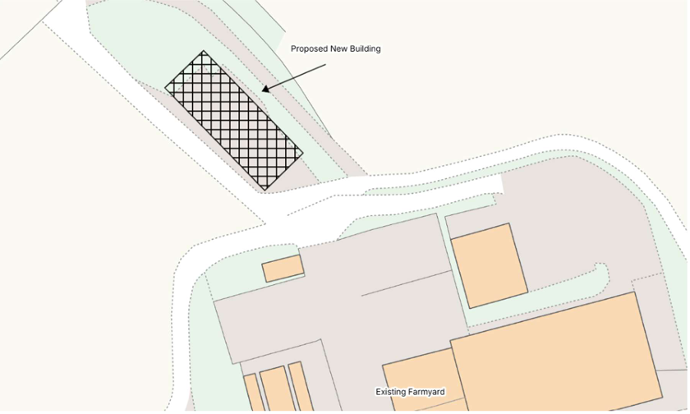
Block Plan

As shown on the submitted site plan, the proposed barn would form part of the existing cluster of agricultural development and would not result in sporadic or isolated built form within the surrounding countryside. Its siting is considered logical in operational terms and reflects the established pattern of development at the farm.

In terms of its design and appearance, the proposed building is typical of modern agricultural development. The scale, form and utilitarian appearance are characteristic of buildings commonly found within working farmyards and are considered appropriate within this context. Furthermore, the proposed building would be viewed alongside existing agricultural structures and would be read as an extension to the existing farm complex rather than a separate or incongruous feature in the landscape. Existing vegetation around the site would also assist in limiting wider visual impacts.

Whilst detailed elevation drawings have not been submitted, sufficient information has been provided to enable an assessment of the siting, design and external appearance of the proposed building. The submitted plans and supporting information identify the building's location, footprint, dimensions and proposed materials, allowing the Local Planning Authority to adequately assess the matters subject to the prior approval process.

Having assessed the siting, design and external appearance of the proposed building, and having regard to the information submitted, it is considered that no material planning concerns arise which would justify the submission of further details under the prior approval procedure. The proposed development represents a modest addition to an established agricultural holding and would integrate satisfactorily with the existing farmstead.

It is therefore concluded that the proposed building constitutes permitted development under Schedule 2, Part 6, Class A of the Town and Country Planning (General Permitted Development) (England) Order 2015 (as amended). Accordingly, prior approval of the siting, design and external appearance of the development is not required.

CONCLUSION

The proposed development has been assessed against the provisions, limitations, and conditions set out in Schedule 2, Part 6, Class A of the Town and Country Planning (General Permitted Development) (England) Order 2015 (as amended). Based on the submitted plans, supporting information, and the findings of this report, it is concluded that the proposal complies with the criteria for permitted development, and therefore falls within the scope of Class A. As such, the local planning authority has considered whether prior approval is required in relation to the siting, design, and external appearance of the development. In this case, it is concluded that prior approval is not required, and the development may proceed in accordance with the submitted details.

RECOMMENDATION:
That Prior Approval is NOT required.

A
APPENDIX 1 – PERMITTED DEVELOPMENT CHECKLIST
 | Permitted Development | Yes / No
A | Does the proposal involve the carrying out, on agricultural land forming part of an agricultural unit of 5 hectares or more, of either:  (a) works for the erection, extension, or alteration of a building; or  (b) any excavation or engineering operations,  which are reasonably necessary for the purposes of agriculture within that unit? | Yes - the submitted Planning Statement confirms that the proposed building is reasonably necessary for the efficient operation of the existing dairy enterprise within an agricultural unit of 128 hectares.
Criteria (A.1) – Development not permitted by Class A:
(a) | Is the development proposed to be carried out on a separate parcel of land forming part of the agricultural unit that is less than 1 hectare in area? | No
(b) | Would the development consist of the erection or extension of any agricultural building on an established agricultural unit where development under Class Q or Class S of Part 3 (changes of use) has been carried out within the last 10 years? | No
(c) | Would the development consist of, or include, the erection, extension, or alteration of a dwelling? | No
(d) | Would it involve the provision of a building, structure or works not designed for agricultural purposes? | No
(e)(i) | Would the ground area covered by any works or structures (excluding fences) for accommodating livestock or plant/machinery arising from engineering operations exceed 1,000 square metres? | No
(e)(ii) | Would the ground area of any building erected, extended, or altered under Class A exceed 1,500 square metres? | No
(f) | Is any part of the proposed building, structure, or works within 3 kilometres of the perimeter of an aerodrome and would exceed 3 metres in height? | No
(g) | Is any part of the proposed building, structure, or works not within 3 kilometres of an aerodrome and would exceed 12 metres in height? | No
(h) | Would any part of the development be within 25 metres of a metalled part of a trunk road or classified road? | No
(i) | Would the development consist of, or include, the erection or construction of, or works to, a building, structure, or excavation used or intended for the accommodation of livestock or storage of slurry/sewage sludge, and be within 400 metres of the curtilage of a protected building? | No
(j) | Would the development involve excavations or engineering operations on or over article 2(4) land that are connected with fish farming? | No
(k)(i) | Would any building for storing fuel for or waste from a biomass boiler or anaerobic digestion system be used for storing waste not produced by that system or fuel not produced on land within the unit and be within 400 metres of the curtilage of a protected building? | No
(k)(ii) | Would any building for storing fuel for or waste from a biomass boiler or anaerobic digestion system and be within 400 metres of the curtilage of a protected building? | No
(l) | Would the erection or extension of a building be carried out on land or a building that is, or is within the curtilage of, a scheduled monument? | No

