

Heritage Statement

Proposal: Installation of a ground-mounted solar photovoltaic array.
Site: Land East of Cadley Farmhouse,
Chute Cadley, Andover, SP11 9EB
Applicant: Gordon White
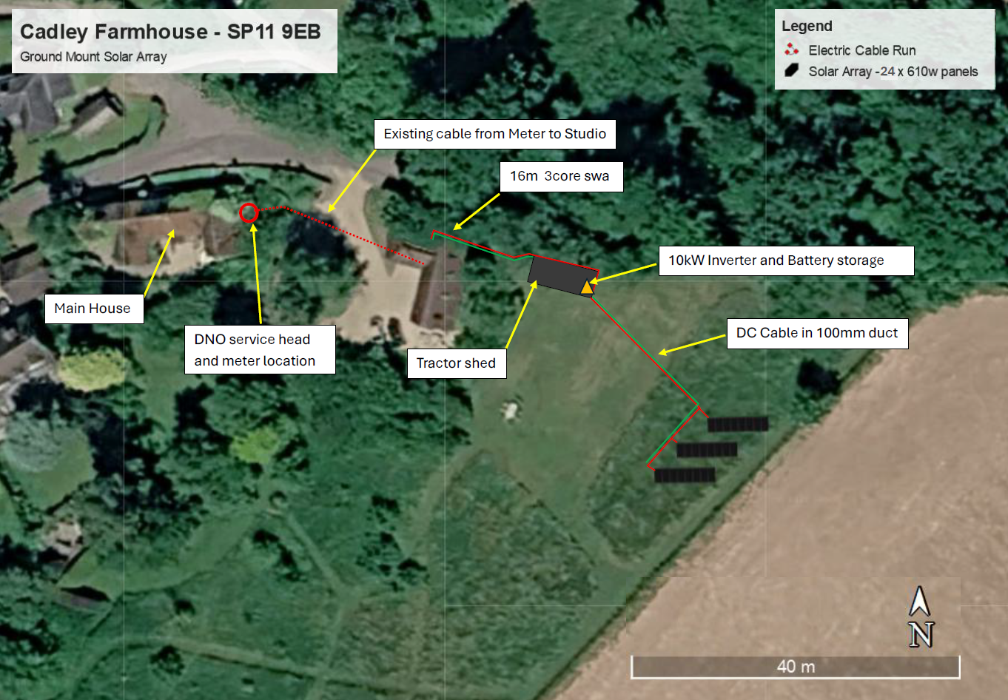
Prepared by:
Equestrian Blueprint
enquiries@equestrianblueprint.co.uk
https://equestrianblueprint.co.uk/
Date
Contents
1. Introduction 3
2. Site and Surroundings 3
3. Proposed Development 3
4. Heritage Assets 4
5. Contribution Made by Setting 5
6. Assessment of Heritage Effects 6
7. Planning Policy and Legislation 7
8. Conclusion 7
9. Photomontage 8

1. Introduction

This Heritage Statement accompanies a planning application for the installation of a ground-mounted solar photovoltaic array on land east of Cadley Farmhouse, Chute Cadley.

The application site lies outside the Chute Cadley and Lower Chute Conservation Area. Cadley Farmhouse lies within the conservation area and is a Grade II listed building. This statement therefore considers whether the proposal would affect:

The significance and setting of Cadley Farmhouse;
The significance, character or appearance of the Chute Cadley and Lower Chute Conservation Area; and
Any other heritage assets potentially affected by the development.

The assessment is proportionate to the nature and scale of the proposal and has been informed by the National Heritage List for England, the site plans, a site inspection and the accompanying viewpoint photographs.

2. Site and Surroundings

The application site comprises land to the east of Cadley Farmhouse, close to the eastern edge of the village. The area is presently maintained as informal wild or meadow-like ground, except for an approximately 2-metre-wide perimeter path that is periodically cut.

The site is enclosed by stock-proof timber post-and-rail fencing approximately 1.5 metres high. The adjoining land to the east is in agricultural use.

Cadley Farmhouse stands some distance to the west of the proposed array. A more recent, unlisted barn and associated parking and circulation areas occupy the intervening land. Mature trees and other established vegetation provide further physical and visual separation between the farmhouse and the application site.

Although the land is associated with Cadley Farmhouse, the proposed array site is experienced as a separate, peripheral area adjoining the wider agricultural landscape. It does not form part of the immediate domestic surroundings in which the listed farmhouse is principally seen or appreciated.

3. Proposed Development

The proposal comprises 24 ground-mounted solar panels arranged in three parallel banks of eight panels. The panels would be mounted in portrait orientation and inclined at approximately 30 degrees.

The proposed array would have an approximate overall envelope of 9.1 metres by 14.75 metres. Its maximum height would be approximately 2.2 metres above existing ground level.

The panels would be supported by a SolarPort mounting structure comprising galvanised steel posts and steel cross-rails. The supporting posts would be driven directly into the ground, avoiding permanent concrete foundations. This would make the installation reversible and allow the equipment to be removed and the land reinstated when it is no longer required.

Underground cabling would connect the array to electrical equipment accommodated in or adjacent to the existing store. No external lighting, CCTV, security fencing, new vehicular access or other visually prominent ancillary equipment is proposed.

4. Heritage Assets
4.1 Cadley Farmhouse

Cadley Farmhouse is included on the National Heritage List for England at Grade II under list entry number 1067532.

The farmhouse dates principally from the early 18th century, with 19th-century extensions and subsequent alterations. It is constructed from knapped flint with brick dressings and has a plain tiled roof, gabled ends and brick axial and gable-end chimney stacks. Its original plan was based on a three-room arrangement with a lobby entrance and an integral rear outshut.

The building’s heritage significance principally derives from:

Its surviving early-18th-century form and plan;
The architectural interest of its traditional flint and brick construction;
Its tiled roof, chimney stacks and vernacular detailing;
Its historic function as a rural farmhouse;
Its contribution to the historic character of Chute Cadley; and
Its relationship with its immediate garden, entrance, traditional settlement pattern and surrounding rural landscape.

The National Heritage List entry is available from Historic England.

4.2 Chute Cadley and Lower Chute Conservation Area

Cadley Farmhouse lies within the Chute Cadley and Lower Chute Conservation Area. The proposed array and associated construction works would, however, be outside its designated boundary.

The significance of the conservation area is understood to derive from the rural character and historic development of the settlements, including their traditional buildings, use of local materials, established trees and vegetation, informal spatial character and relationship with the surrounding countryside.

The application site lies beyond the conservation-area boundary and does not form part of its historic built fabric. Its relevance is therefore limited to any contribution it may make to the surroundings in which the conservation area is experienced.

5. Contribution Made by Setting

The setting of Cadley Farmhouse is not defined solely by ownership, distance or visibility. It comprises those surroundings from which the significance of the listed building can be understood and appreciated.

The immediate garden, driveway, entrance, mature vegetation and the historic rural character of Chute Cadley are likely to make the most important contributions to the farmhouse’s setting.

The application site lies farther east, beyond the more recent unlisted barn and associated surfaced and parking areas. These intervening features create a clear degree of physical and functional separation between the array site and the historic farmhouse.

The photographic evidence demonstrates that there is also very limited intervisibility:

Photograph E, taken from the proposed array site towards Cadley Farmhouse, shows that the listed building is screened by mature trees and vegetation.
Photograph F, taken from the garden gate beside the farmhouse driveway, shows that the application site is only partly and incidentally visible through a restricted opening. The view is already influenced by the intervening barn, parking area and vegetation.
The remaining photographs show the site’s closer visual relationship with the open land to the east and its position at the edge of the village.

The photographs were taken when the intervening trees were in leaf and screening may be less complete during winter. Nevertheless, the separation distance, retained tree structure and intervening barn would remain throughout the year. Any winter visibility would therefore be filtered and incidental rather than forming a clear or important shared view.

The application site consequently makes, at most, a very limited contribution to the significance of Cadley Farmhouse. It does not form part of an important designed view, historic approach, formal garden composition or evident historic functional relationship through which the special interest of the listed building is principally understood.

6. Assessment of Heritage Effects

The proposal would not alter the fabric, plan form or architectural features of Cadley Farmhouse. Its potential effect is therefore confined to the setting of the listed building and the surroundings of the conservation area.

The array has been positioned to the east of the intervening modern barn and away from the listed farmhouse. This is a discreet location in heritage terms because:

There is considerable separation from the farmhouse;
The array would not interrupt an identified important view of or from the listed building;
Mature vegetation provides substantial screening;
The more recent barn intervenes between the heritage asset and the array;
The array would have a relatively low and visually recessive form;
No lighting, security fencing or other visually prominent infrastructure is proposed;
The galvanised frame would be utilitarian but consistent with the site’s rural and agricultural-edge context; and
The driven-post construction makes the development reversible.

Photographs E and F confirm that the farmhouse and solar array would not normally be perceived together. Where a restricted view towards the site is available from the garden gate, the array would be experienced beyond the intervening modern development rather than as part of the immediate setting of the farmhouse.

The development would not challenge the farmhouse’s visual prominence, obscure its architectural form or interfere with the appreciation of its historic character. It would not change the historic settlement pattern or result in the loss of any feature contributing to the significance of the listed building or conservation area.

The proposal would therefore preserve the significance and setting of Cadley Farmhouse. It would also preserve the character, appearance and significance of the Chute Cadley and Lower Chute Conservation Area.

7. Planning Policy and Legislation

Section 66(1) of the Planning (Listed Buildings and Conservation Areas) Act 1990 requires special regard to be paid to the desirability of preserving a listed building, its setting and any features of special architectural or historic interest that it possesses.

The National Planning Policy Framework requires applicants to describe the significance of heritage assets affected by a proposal, including any contribution made by their setting. The assessment should be proportionate to the asset’s importance and sufficient to understand the likely effect of the development.

Paragraphs 208–215 require the decision-maker to assess the particular significance affected, give great weight to the conservation of designated heritage assets and apply the appropriate policy test where harm is identified. National Planning Policy Framework – historic environment.

Wiltshire Core Strategy Core Policy 58 seeks to ensure that designated heritage assets and their settings are conserved, and where appropriate enhanced, in a manner appropriate to their significance. Wiltshire Core Strategy.

The assessment also follows the principles in Historic England’s The Setting of Heritage Assets: Historic Environment Good Practice Advice in Planning Note 3, including consideration of how the surroundings contribute to significance and how the proposed change would affect that contribution. Historic England GPA3.

8. Conclusion

Cadley Farmhouse is a Grade II listed building whose significance derives principally from its early-18th-century architectural character, traditional materials, historic form and relationship with the historic settlement and its immediate rural surroundings.

The proposed solar array would be located outside the Chute Cadley and Lower Chute Conservation Area, on peripheral land to the east of the farmhouse. It would be separated from the listed building by a substantial distance, mature vegetation, an existing modern barn and associated parking and circulation areas.

The accompanying photographs demonstrate that there is no meaningful direct visual relationship between the farmhouse and the proposed array site. Any more limited winter views would remain filtered and would be interrupted by the intervening barn.

The array would be relatively low, unlit and reversible. It would require no concrete foundations and would not remove or alter any historic fabric, traditional boundary or other feature contributing to heritage significance.

Accordingly, the development would preserve the setting and significance of Cadley Farmhouse and would preserve the character, appearance and significance of the Chute Cadley and Lower Chute Conservation Area. No harm to a designated heritage asset has been identified, and the proposal accords with Section 66(1) of the 1990 Act, the National Planning Policy Framework and Wiltshire Core Strategy Core Policy 58.

9. Photomontage

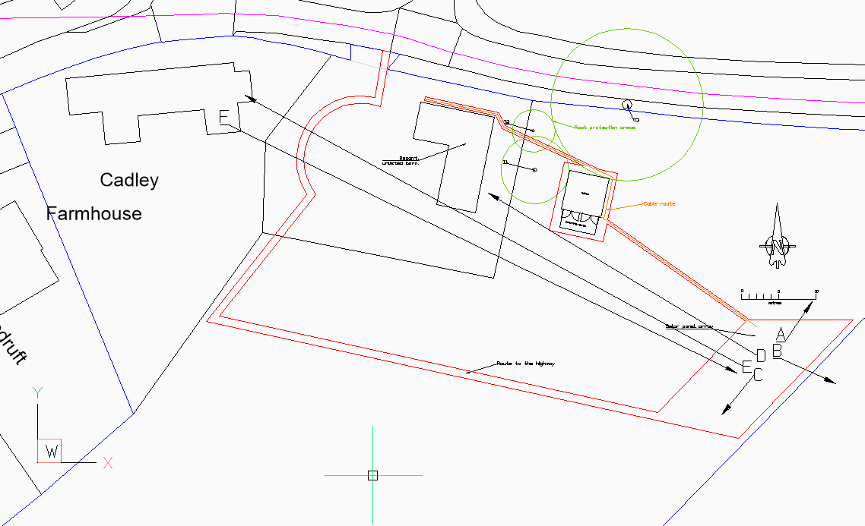
Figure 1 Legend

SITE PHOTOGRAPHS
Land East of Cadley Farmhouse, Chute Cadley, Andover, SP11 9EB
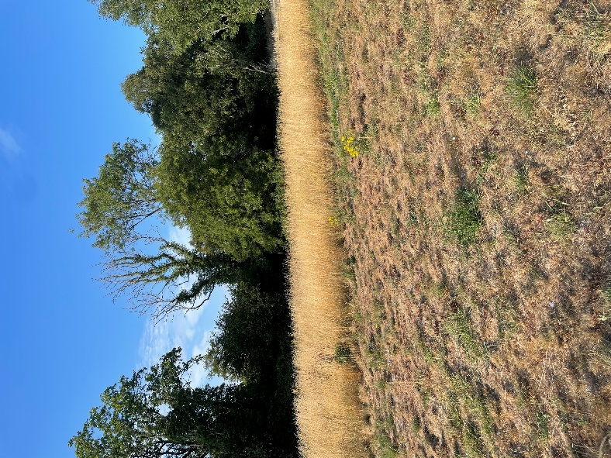 | 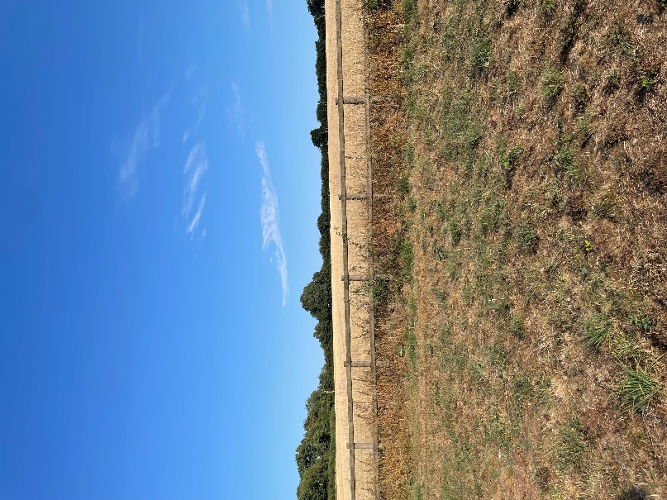
Photograph A: North | Photograph B: East
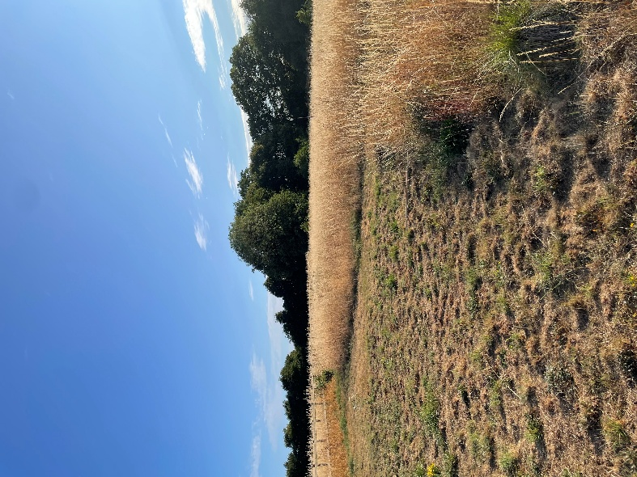 | 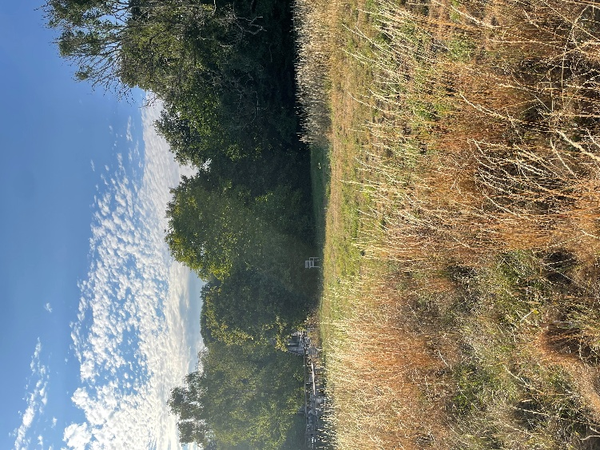
Photograph C: South | Photograph D: West
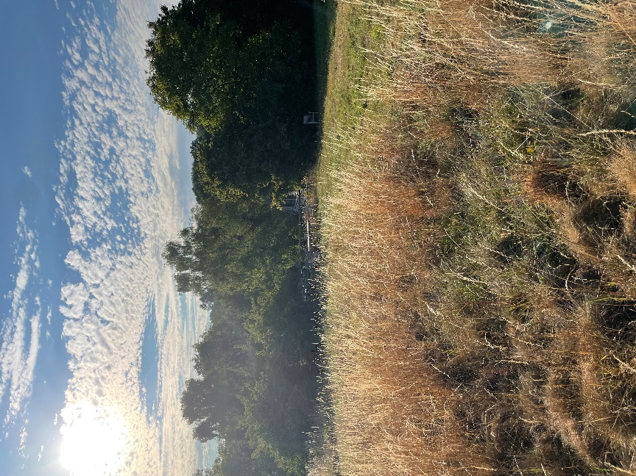 | 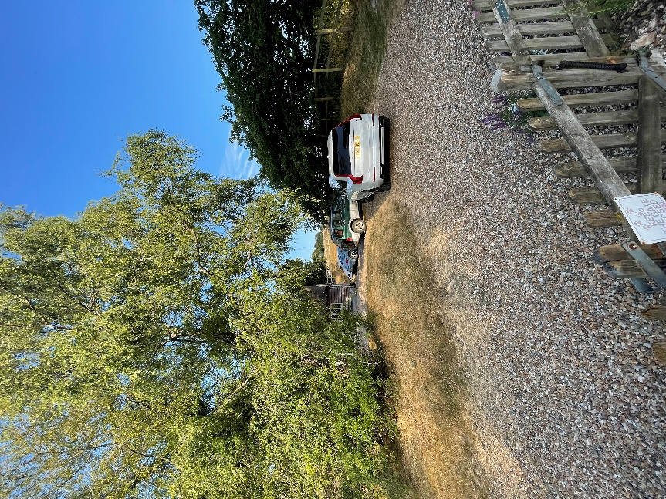
Photograph E: Towards Cadley Farmhouse | Photograph F: From Cadley Farmhouse Garden

