

Design and Access Statement

Proposal: Installation of a ground-mounted solar photovoltaic array.
Site: Land East of Cadley Farmhouse,
Chute Cadley, Andover, SP11 9EB
Applicant: Gordon White
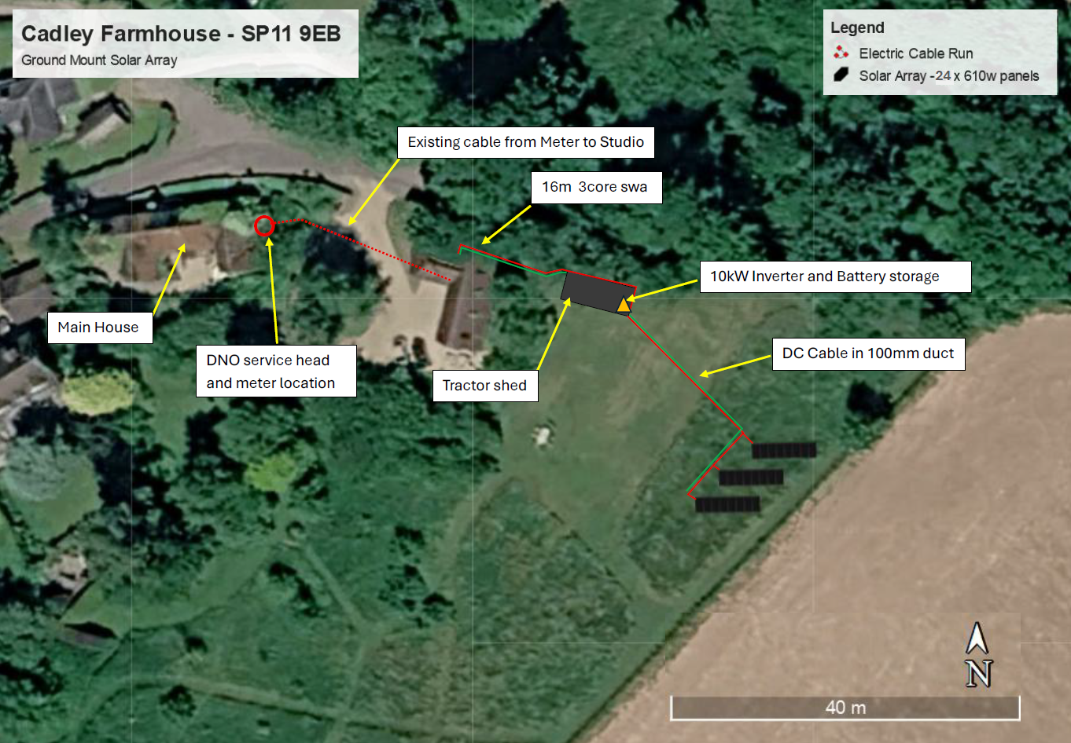
Prepared by:
Equestrian Blueprint
enquiries@equestrianblueprint.co.uk
https://equestrianblueprint.co.uk/
August 2026

1. Introduction

This Design and Access Statement accompanies an application for the installation of a ground-mounted solar photovoltaic array on land east of Cadley Farmhouse, Chute Cadley.

The statement describes the application site and proposed development and considers the proposal’s design, landscape, village character, heritage, biodiversity and access implications.

The application site lies within the North Wessex Downs National Landscape but outside the Chute Cadley and Lower Chute Conservation Area. Cadley Farmhouse is a Grade II listed building situated within the conservation area to the west of the application site. Heritage considerations are addressed in greater detail within the accompanying standalone Heritage Statement.

2. Site and Surroundings

The application site comprises land to the east of Cadley Farmhouse, close to the eastern edge of Chute Cadley. The proposed array would occupy a small part of an area presently maintained as informal wild or meadow-like ground, with a perimeter path cut periodically during the summer.

The site is enclosed by stock-proof timber post-and-rail fencing approximately 1.5 metres high. Agricultural land lies immediately beyond the eastern boundary.

Cadley Farmhouse is situated some distance to the west. A more recent unlisted barn, together with associated parking and circulation areas, occupies the intervening land. Mature trees and established vegetation provide further physical and visual separation between the farmhouse and the application site.

The site is accessed using the existing driveway and internal access arrangements serving Cadley Farmhouse and the associated buildings. No new vehicular access is required.

3. Description of the Proposal

The proposal comprises the installation of 24 ground-mounted photovoltaic panels arranged as three separate parallel banks, each containing eight panels.

The panels would be installed in portrait orientation and would face generally south. Their inclination would be between approximately 20 and 30 degrees to the horizontal.

Each panel measures approximately 2,382 mm by 1,134 mm. The three banks would together occupy an overall ground area of approximately:

9.1 metres in width; and
15.25 metres from front to back.

The maximum height of the array would be approximately 2120 mm above existing ground level. Although the upper edge would extend slightly above the existing approximately 1.5-metre-high boundary fence, the limited difference in height would substantially restrict the extent to which the array could be perceived from surrounding land.

The panels would be installed on a purpose-designed SolarPort mounting system comprising galvanised steel posts and steel cross-rails. The panels would be mechanically clamped to the supporting frame. The posts would be driven directly into the ground, avoiding permanent concrete foundations and allowing the installation to be removed and the land reinstated when it is no longer required.

Underground cabling would connect the array to the associated inverter and battery-storage equipment accommodated in or adjacent to the existing store approved under application number PL/2026/02486. No external lighting, CCTV, separate security fencing or new access is proposed.

Construction, including installation of the supporting posts, cable trenching and electrical connections, is expected to take approximately two weeks.

4. Use and Need

The array would generate renewable electricity for Cadley Farmhouse and its associated buildings. It would reduce the property’s reliance on electricity imported from the distribution network and assist in meeting existing and anticipated future energy requirements.

The installation would support the gradual transition away from fossil-fuel-based energy, including the potential future use of electric vehicles and electrically powered heating systems.

The proposal is small in scale and directly associated with the energy requirements of the existing property. It is not a commercial solar farm and would not introduce employees, deliveries or regular additional traffic.

National planning policy recognises the contribution made by small-scale renewable-energy installations and requires significant weight to be given to their renewable and low-carbon energy benefits. National Planning Policy Framework.

5. Amount, Layout and Siting

The overall ground envelope of approximately 9.8 by 14.75 metres represents a very limited area in relation to the surrounding land.

The arrangement in three banks allows the panels to be orientated effectively while maintaining adequate separation to avoid overshadowing. Locating the array towards the eastern edge of the site also:

Places it away from Cadley Farmhouse and the historic centre of the village;
Takes advantage of the intervening unlisted barn and established vegetation;
Avoids development within the conservation area;
Retains the more sensitive immediate surroundings of the listed farmhouse;
Avoids the removal of trees or established vegetation; and
Allows the existing access and electrical infrastructure to be used.

The array has therefore been positioned to provide renewable energy while minimising its effect upon village character, heritage significance and the wider landscape.

6. Scale and Appearance

The installation would have a maximum height of approximately 1.65 metres. This modest height is important to its visual integration, particularly when considered alongside the approximately 1.5-metre-high boundary fence, longer grassland vegetation and existing buildings and trees.

The panels would have the dark, non-reflective appearance typically associated with modern photovoltaic equipment. The supporting structure would comprise narrow galvanised steel posts and rails, creating a lightweight and recessive form rather than a solid built structure.

There would be no concrete base, perimeter security fencing, lighting, CCTV columns or other ancillary infrastructure that could give the development a commercial or urbanising appearance.

Vegetation would remain beneath and around the raised panels. This would soften the appearance of the installation and retain the predominantly green and rural character of the site.

7. Chute Cadley Village Considerations

Chute Cadley has a dispersed rural character defined by traditional buildings, mature vegetation, informal boundaries, narrow routes and a close relationship with the surrounding countryside. The Chute Design Guide is a material consideration and supports development that responds sensitively to local character and avoids unnecessary suburban or urbanising features.

The proposed development respects these characteristics because:

It is a small-scale installation serving an existing property;
It would be located at the village edge, adjoining agricultural land;
It would be separated from the historic farmhouse and core village area;
Its height and footprint would be limited;
Existing trees, vegetation and boundary treatments would be retained;
No new road, formal access, lighting or security infrastructure would be introduced;
The array would be seen, where visible, against a rural and agricultural-edge background; and
The supporting structure would be reversible, allowing the land to be reinstated.

The development would not alter the village’s settlement pattern or introduce a prominent built feature into an important street scene. Its limited and functional appearance would be compatible with the site’s relationship to the surrounding countryside and existing agricultural-style buildings.

8. Landscape and Visual Considerations

The site lies within the North Wessex Downs National Landscape. Great weight must therefore be given to conserving and enhancing its landscape and scenic beauty.

The proposal is nevertheless very limited in scale. It would occupy only a small part of the site and would not involve extensive ground engineering, changes to landform or the removal of trees, hedgerows or other established landscape features.

The accompanying viewpoint photographs demonstrate that the site is relatively enclosed and has limited visibility from its surroundings. The array’s principal visual characteristics would be:

A maximum height of approximately 1.65 metres;
A restricted overall footprint;
Three low, parallel banks rather than a large continuous structure;
A dark panel finish;
A lightweight supporting frame;
Retention of vegetation beneath and around the panels; and
The absence of lighting and prominent ancillary equipment.

Views from the surrounding countryside would be restricted by the boundary fence, vegetation, topography and existing buildings. The site would continue to read as a peripheral area at the edge of the settlement rather than as an extensive energy-generating development within the open landscape.

The proposal would not materially affect the wider scenic quality, tranquillity or rural character of the National Landscape. Its modest renewable-energy benefits can therefore be achieved without unacceptable landscape or visual effects.

9. Heritage Considerations

The array would be outside the Chute Cadley and Lower Chute Conservation Area. Cadley Farmhouse, a Grade II listed building, lies within the conservation area to the west.

The proposal would not affect the fabric of the listed building. Its potential heritage effect is consequently limited to whether it would change the surroundings in which Cadley Farmhouse and the conservation area are experienced.

Although vegetation screening may be less complete during winter, the separation distance, intervening barn and retained tree structure would remain. The farmhouse and proposed array would not normally be perceived together in a clear or important view.

The application site makes, at most, a very limited contribution to the significance of Cadley Farmhouse. It does not form part of an identified historic approach, designed view or formal garden composition. The low and reversible array would therefore preserve the setting and significance of the listed building and the character and appearance of the conservation area.

The detailed assessment is contained in the accompanying Heritage Statement.

10. Landscaping and Vegetation

No trees or established vegetation would be removed to accommodate the development.

The existing informal grassland vegetation would be retained beneath and around the panels. Because the panels would be raised above ground level, vegetation management could continue throughout the operational use of the array.

The existing timber post-and-rail boundary fence would also be retained. No ornamental landscaping, close-boarded fencing or other suburban boundary treatment is proposed.

The retention of the existing vegetation and boundary treatment represents the most appropriate landscape response because it maintains the site’s informal rural character and avoids drawing additional attention to the installation.

11. Protection of Trees

The proposed underground cable trench will be routed through the available corridor between the calculated root protection areas of the two relatively young trees shown in the accompanying photograph, taken in approximately May 2026. Although the trees are juvenile specimens of limited arboricultural value, both will be retained and protected in accordance with BS 5837:2012 – Trees in relation to design, demolition and construction: Recommendations. Before work begins, protective Heras fencing will be securely erected along the outer edge of each root protection area to form clearly defined construction-exclusion zones. No machinery, materials, excavated spoil or chemicals will be permitted within these protected areas, and existing ground levels will not be altered. The cable trench will be excavated carefully within the intervening corridor and, wherever work approaches or unavoidably enters a root protection area, excavation will be undertaken by hand or with suitable non-destructive techniques in accordance with BS 5837. Exposed roots will be protected from drying and physical damage; roots exceeding 25 mm in diameter will not be severed without appropriate arboricultural advice, while any smaller roots requiring removal will be cut cleanly using sharp hand tools. The trench will be backfilled promptly with suitable excavated material, thereby ensuring that the installation does not adversely affect the health, stability or future development of either tree.

12. Biodiversity Net Gain

The application site would be no larger than 0.2 hectares. It includes only the land reasonably required to accommodate the solar array, the underground cable connection and the existing access necessary for installation and occasional maintenance. Land that is not required for the development has been excluded from the application boundary. The red-line area therefore represents the minimum practical site area needed to install, operate and maintain the development safely, rather than an artificially restricted or arbitrary boundary.

Development on a site no larger than 0.2 hectares is exempt from the statutory biodiversity net gain requirement, provided that it does not affect onsite priority habitat. The proposal would satisfy these criteria and would therefore fall within the applicable exemption.

The site consists of modified or informally managed grassland and does not contain priority habitat. No trees, hedgerows or established vegetation would be removed. The two juvenile trees adjoining the proposed cable route would be retained and protected during construction in accordance with BS 5837:2012.

The panels would be raised above ground level, allowing grassland vegetation to remain beneath and around the installation. Direct ground disturbance would be highly localised, principally comprising the driven supporting posts and the narrow underground cable trench. No concrete foundations, extensive hardstanding or permanent changes to the ground profile are proposed.

Although a statutory biodiversity metric and Biodiversity Gain Plan would not be required, the development follows the mitigation hierarchy by avoiding impacts on established vegetation, minimising the extent and duration of ground disturbance and retaining the ability to remove the installation and reinstate the land when it is no longer required.

13. Access and Movement

Construction and subsequent maintenance would use the existing vehicular access and internal routes serving Cadley Farmhouse and the associated buildings. No alteration to the existing highway access is proposed.

Construction activity would be temporary and limited to the delivery and installation of the panels, mounting system and associated electrical equipment. The works are expected to be completed within approximately two weeks.

Once operational, the array would generate no regular traffic. Access would be required only occasionally for inspection, maintenance or repair and would continue to use the existing arrangements.

The development would therefore have no material effect upon highway safety, parking capacity or the movement of vehicles and pedestrians through the village.

14. Sustainability

The principal purpose of the development is to generate renewable electricity for an existing property. It would reduce reliance upon imported grid electricity and assist with the transition towards lower-carbon energy and heating.

The proposal also incorporates sustainability through its physical design:

Driven posts avoid permanent concrete foundations;
Existing vegetation would remain beneath and around the panels;
No new access or extensive hard surfacing is required;
Underground cabling limits visible infrastructure;
The development would require no external lighting;
Existing buildings would accommodate the associated electrical equipment; and
The array can be removed and the land reinstated when it is no longer required.

The proposal therefore combines renewable-energy generation with a low-impact and reversible construction method.

15. Planning Policy Assessment

Wiltshire Core Strategy Core Policy 42 supports standalone renewable-energy installations where their environmental, social and economic effects can be satisfactorily addressed. The proposal would provide small-scale renewable energy without unacceptable effects upon landscape character, heritage assets, residential amenity or highway safety.

Core Policy 51 requires development to protect, conserve and, where possible, enhance landscape character. The proposal’s limited height and footprint, retention of vegetation, absence of lighting and visually enclosed position would conserve the character of the National Landscape.

Core Policy 57 requires development to achieve a high standard of design and respond positively to local context. The siting, scale, simple materials and retention of existing boundary features provide an appropriately restrained response to the rural edge of Chute Cadley.

Core Policy 58 requires designated heritage assets and their settings to be conserved in a manner appropriate to their significance. The physical separation, intervening barn and limited intervisibility mean that the proposal would preserve the setting and significance of Cadley Farmhouse and the nearby conservation area.

At national level, the National Planning Policy Framework gives significant weight to renewable and low-carbon energy benefits and recognises that small-scale installations make a valuable contribution to reducing greenhouse-gas emissions. It also requires great weight to be given to conserving landscape and scenic beauty within National Landscapes. The proposal satisfies both objectives by delivering renewable energy through a small, low-profile and sensitively positioned installation.

16. Conclusion

The proposal comprises a modest ground-mounted photovoltaic array serving Cadley Farmhouse. Its 24 panels would be arranged in three banks of eight, occupying an overall ground area of approximately 9.1 by 15.25 metres and reaching a maximum height of approximately 1.65 metres.

The array has been positioned away from Cadley Farmhouse and outside the conservation area, beyond an intervening modern barn and established vegetation. The accompanying photographs demonstrate that there is no meaningful direct visual relationship between the array site and the listed farmhouse.

The proposal would:

Preserve the character and scenic quality of the North Wessex Downs National Landscape;
Respect the dispersed rural character of Chute Cadley;
Preserve the setting and significance of Cadley Farmhouse and the conservation area;
Require no removal of trees or established vegetation;
Introduce no lighting, security fencing or new vehicular access;
Generate no material operational traffic;
Retain vegetation beneath and around the panels; and
Provide a reversible source of renewable energy for the existing property.

The development represents a proportionate and sensitively designed renewable-energy installation. Its limited landscape and visual effects would be acceptable and would be outweighed by its contribution towards reducing reliance on non-renewable energy and supporting the transition to a low-carbon future.

