226001 – PHOTOGRAPHS
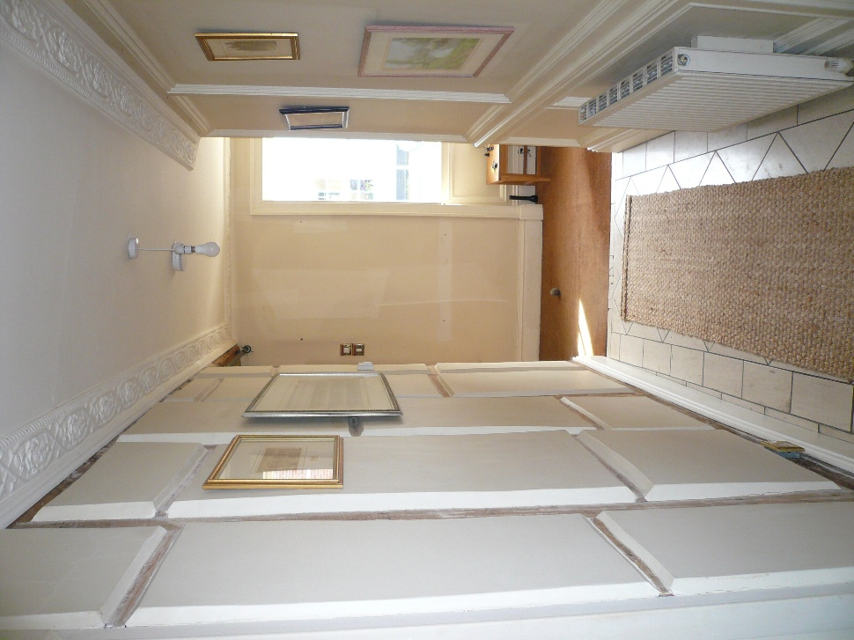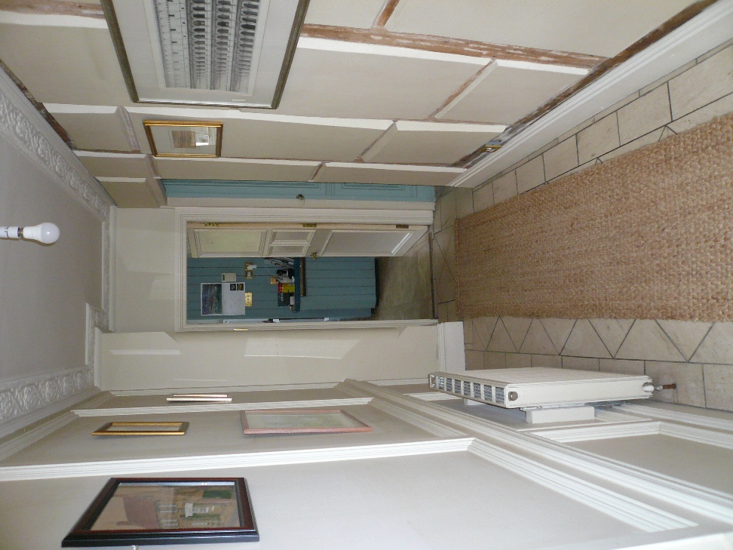
Entrance Hall looking south Entrance Hall looking north

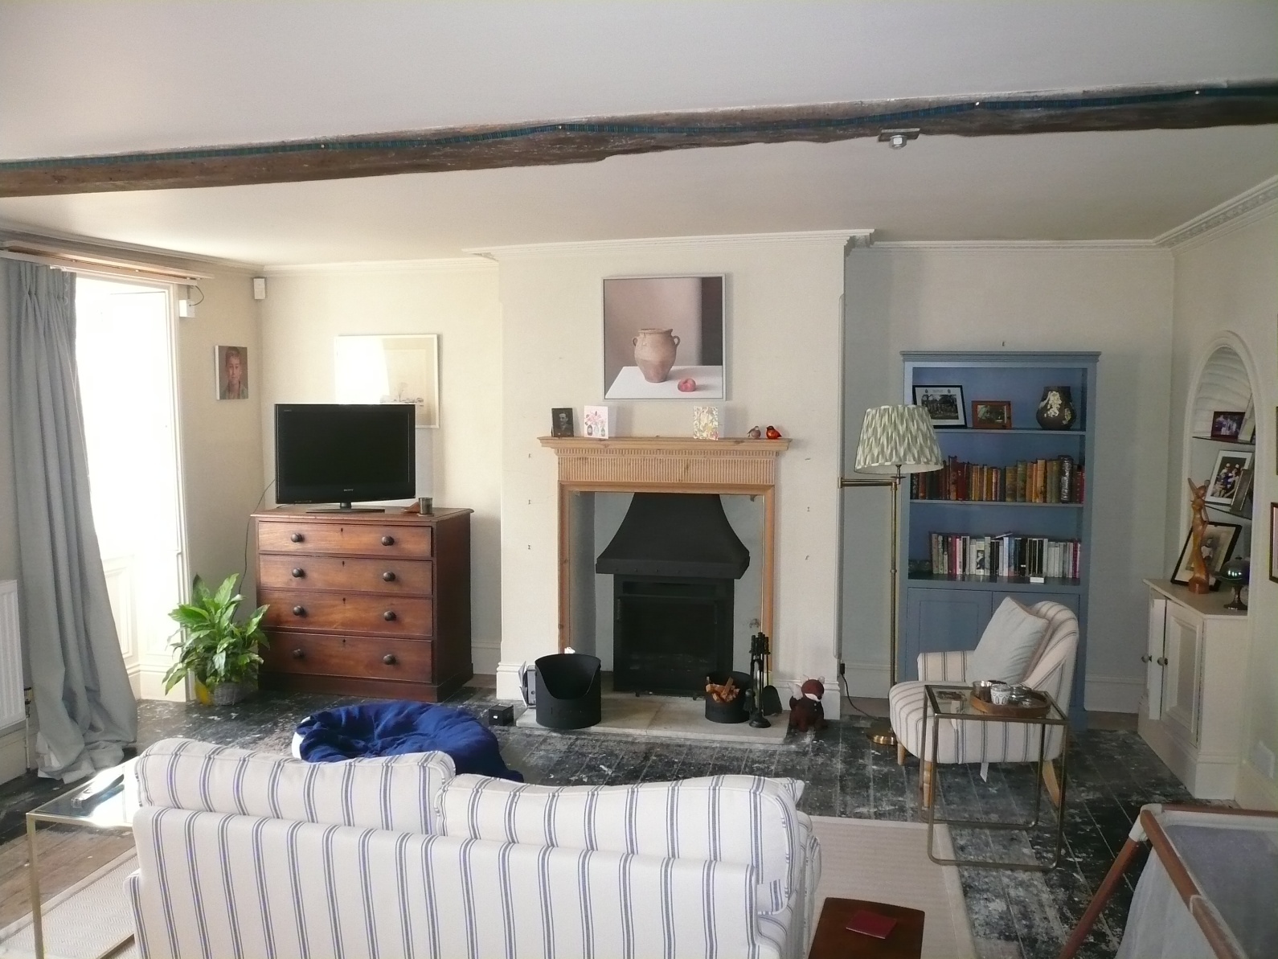
Drawing Room looking west
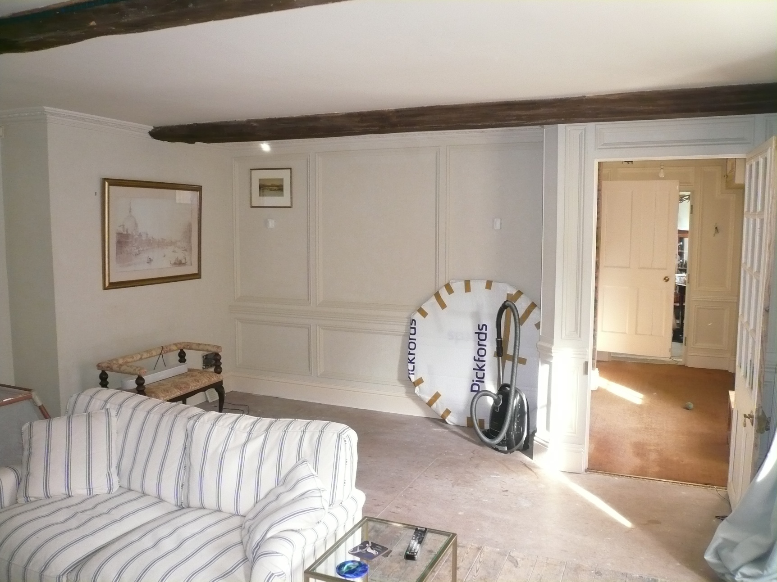
Drawing Room looking east
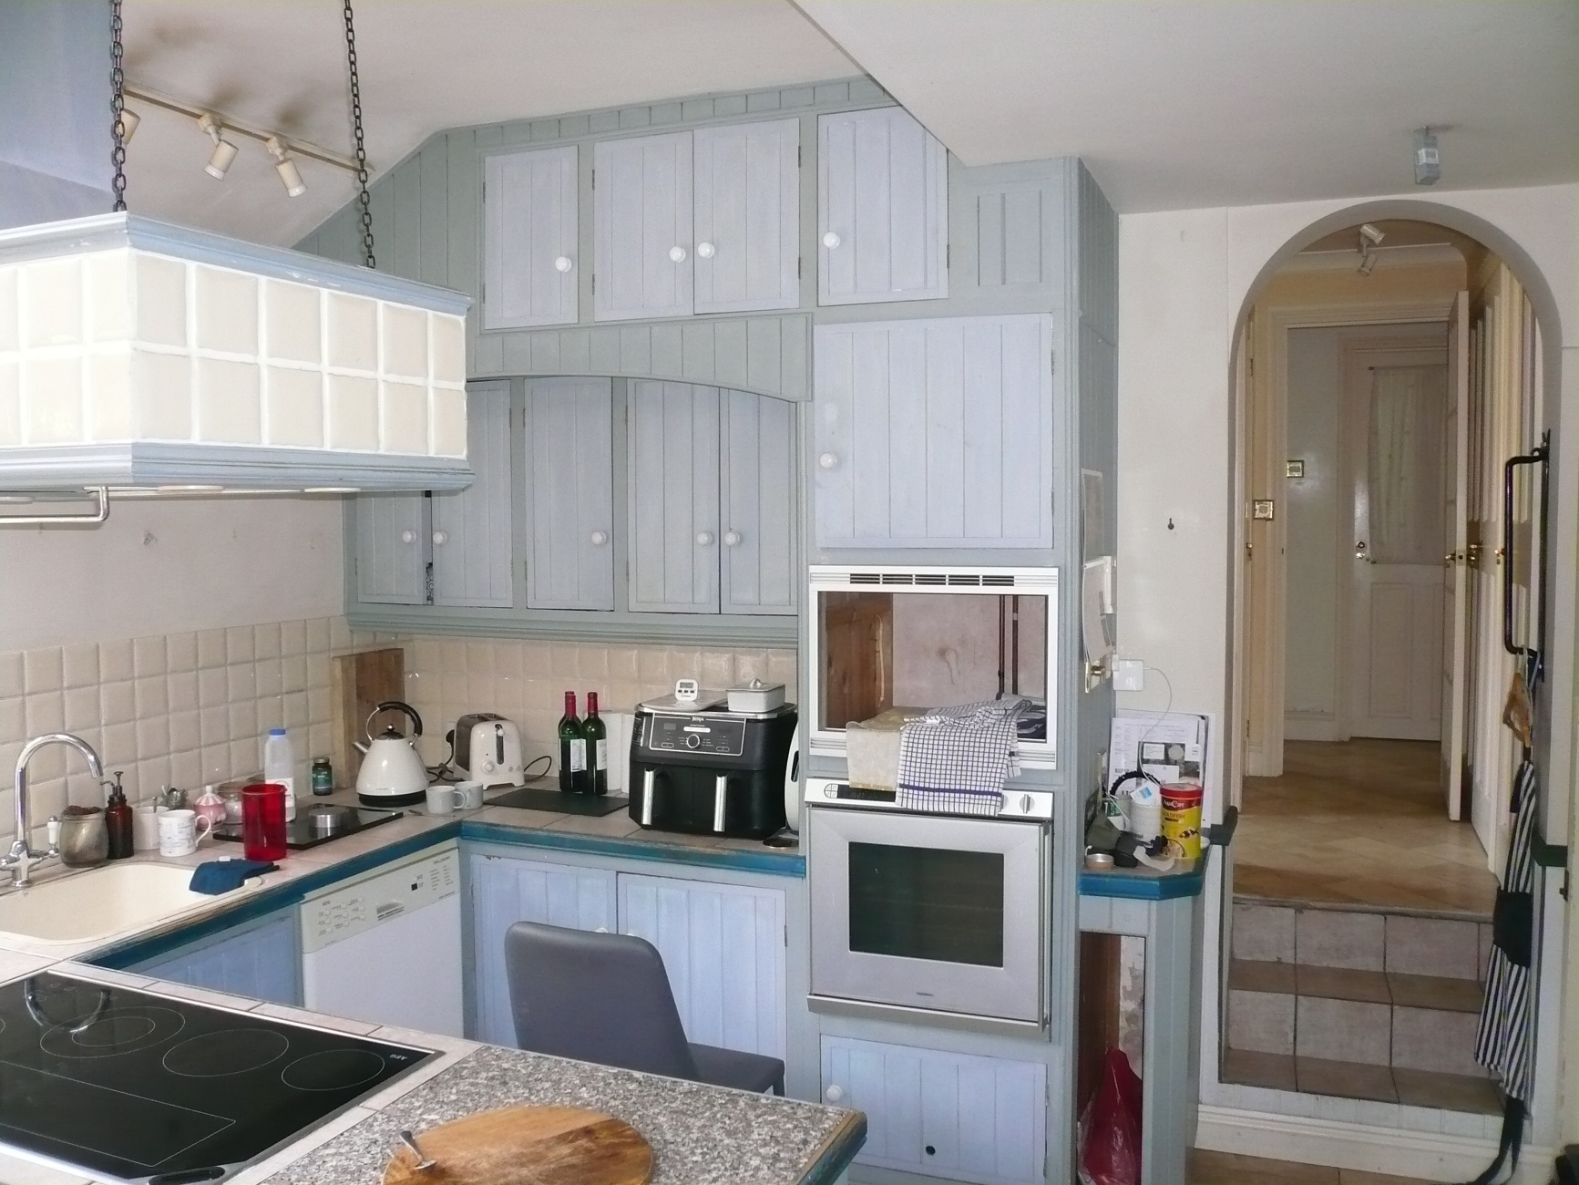
Kitchen looking east
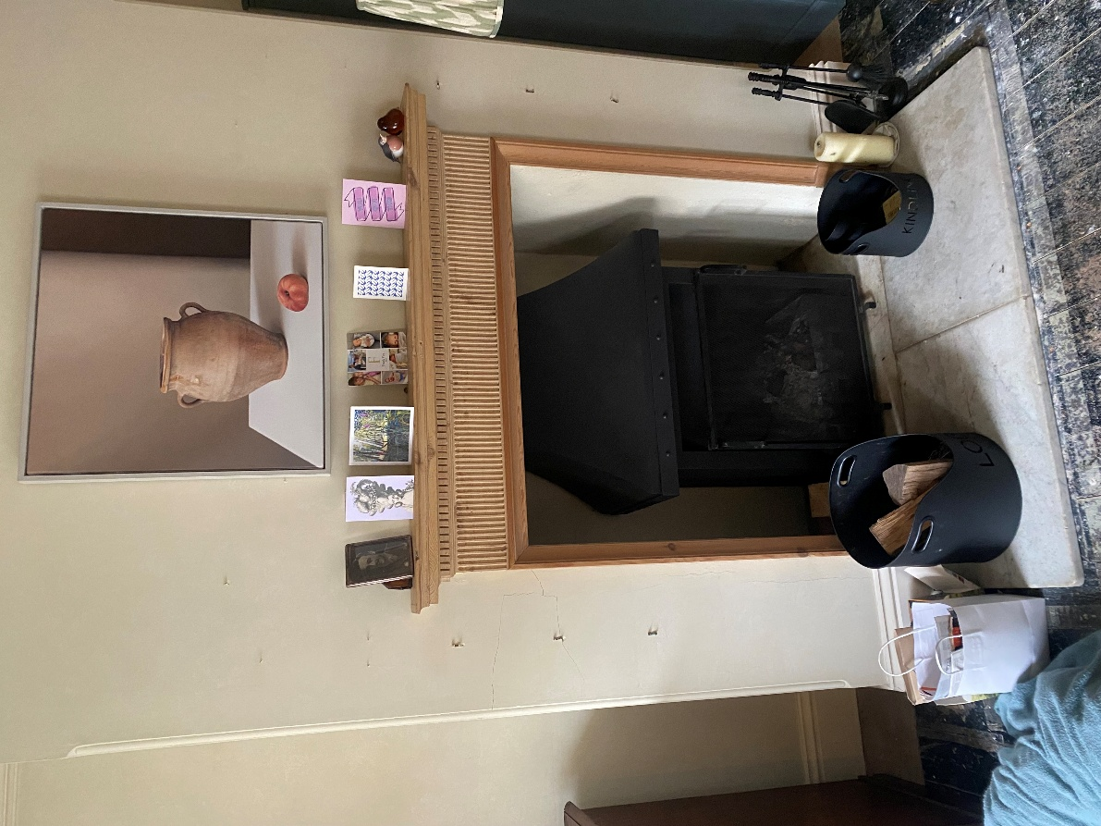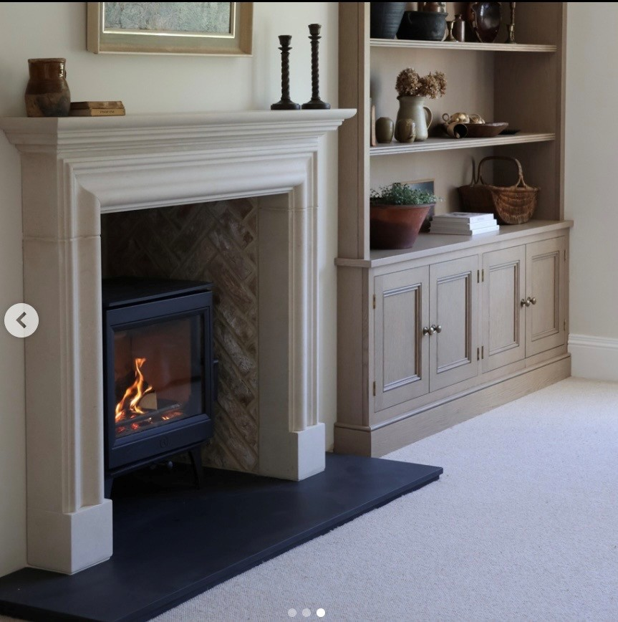
Close view of existing Drawing Room fireplace Image illustrating proposed fireplace style/fitted furniture
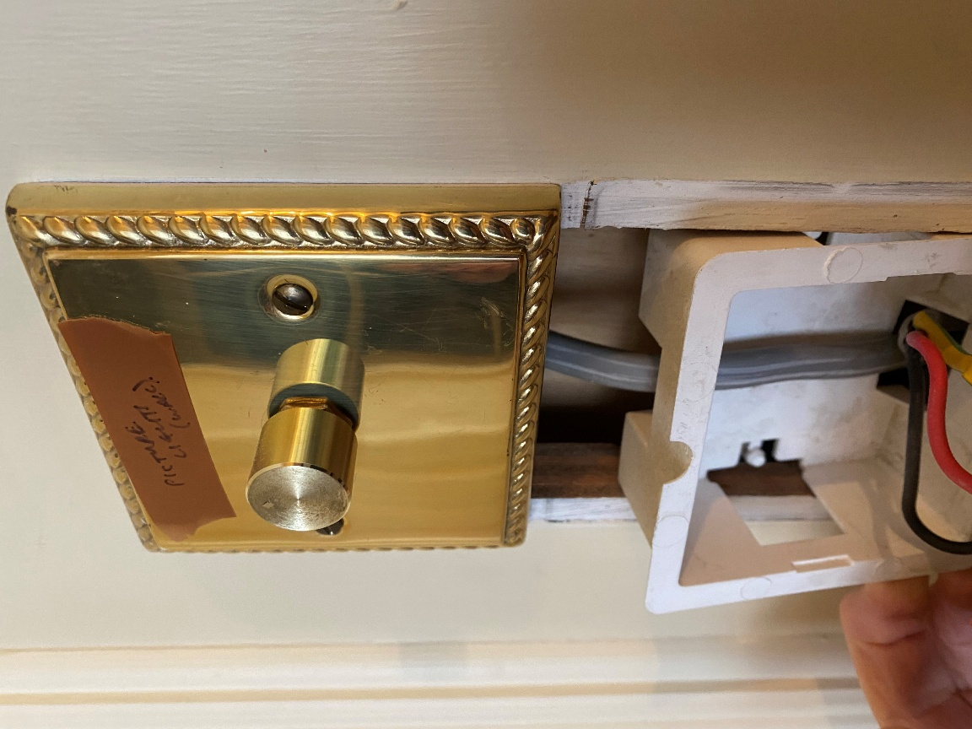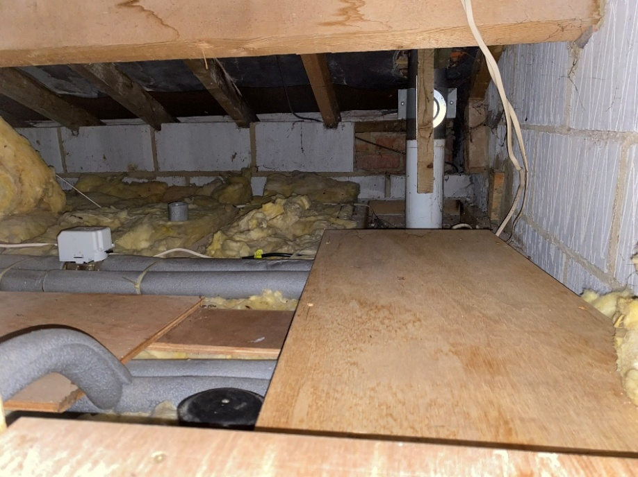
Removal of Hall switchplate showing modern partition make up Roof void over Plant/Drying Room and Snug showing modern materials

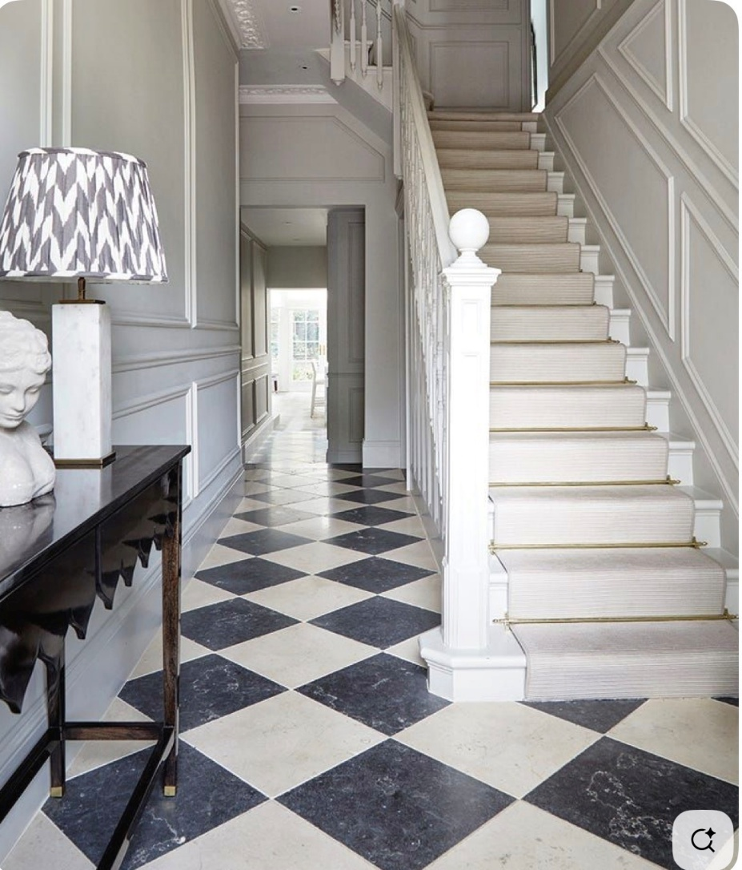
Image showing floor tiling as proposed to Entrance Hall

