HERITAGE/DESIGN AND ACCESS STATEMENT for
ALTERATIONS at
THE SHAMBLES, 69 HIGH STREET, HEYTESBURY, WARMINSTER, WILTSHIRE
INTRODUCTION
69 High Street, Heytesbury is in new ownership and works of alteration are proposed to the property.

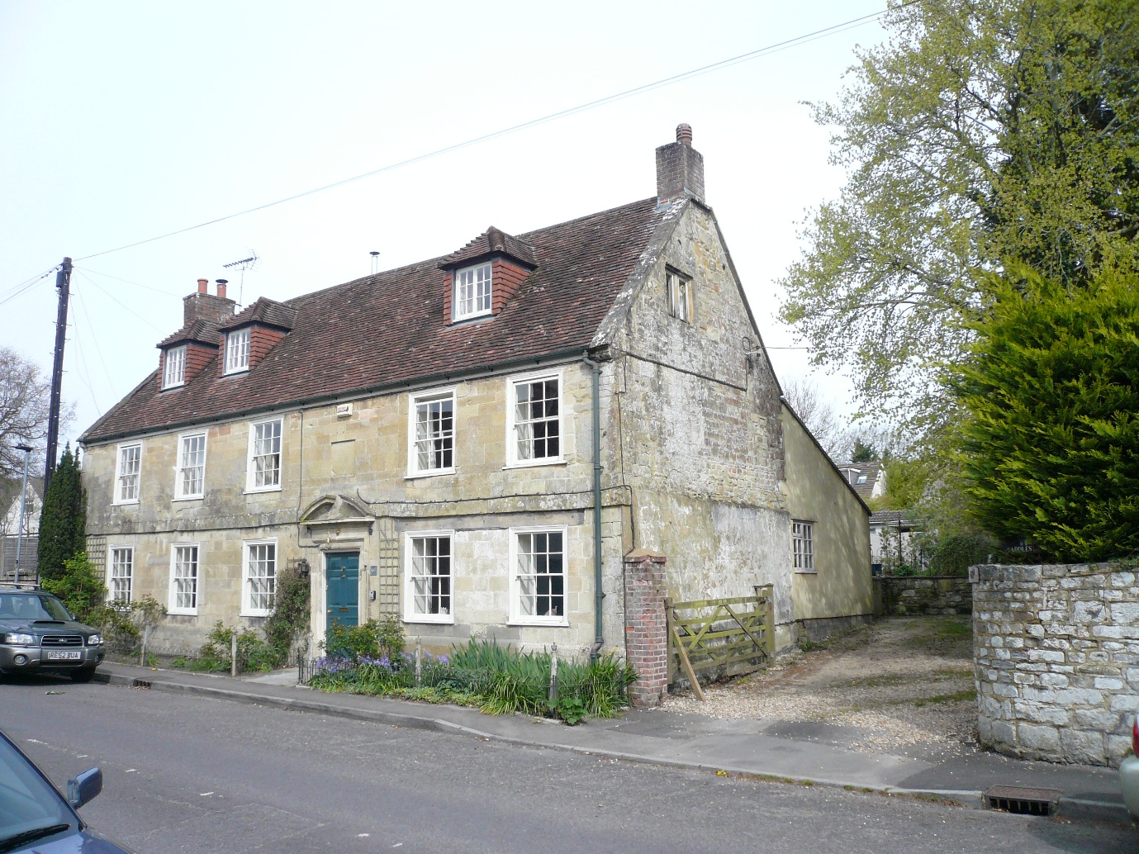
View looking north west from High Street

CONTEXT
The subject property, also known as The Shambles is located to the north side of High Street and presents a 2 storey facade to the frontage with dormers to the south roof pitch serving converted roofspace. To the east and west are neighbouring, modern residential properties (69A and 69B respectively) constructed within the former wider extent of the property. To the rear the roof adopts a monopitch/catslide roof with dormer roof extensions. The extensive curtilage provides domestic garden including an outbuilding which is currently constructed to shell only (the footprint of the outbuilding being a remnant of a single storey range extending along the west site boundary and linking to the main house/frontage building).

The property is a Grade II Listed Building for which the Schedule is copied below-

HEYTESBURY HIGH STREET ST 92 SW (north side) 9/52 No. 69 11.9.68
GV II
Detached house. Mid C18. Limestone ashlar, tiled roof with coped verges and gable end brick stacks. Two storey, 5-windowed front; sashes. Door with 6 fielded panels in eared moulded stone architrave with broken segmental pediment, to left are three flush 12-pane sashes in moulded wooden architraves, to right are two C20 twelve-pane sashes, replacing former shop window. Plat band to first floor; five sashes and blank panel over doorway. Right return has single-light casement to first floor, 2-light recessed chamfered mullioned casement to attic. Left return has blocked 2- light mullioned window to ground and first floors. Rear has C20 outshut. Interior not accessible at time of survey (June 1985). Attached to front left are cast-iron bollards with chain fence.
Listing NGR: ST9264942612
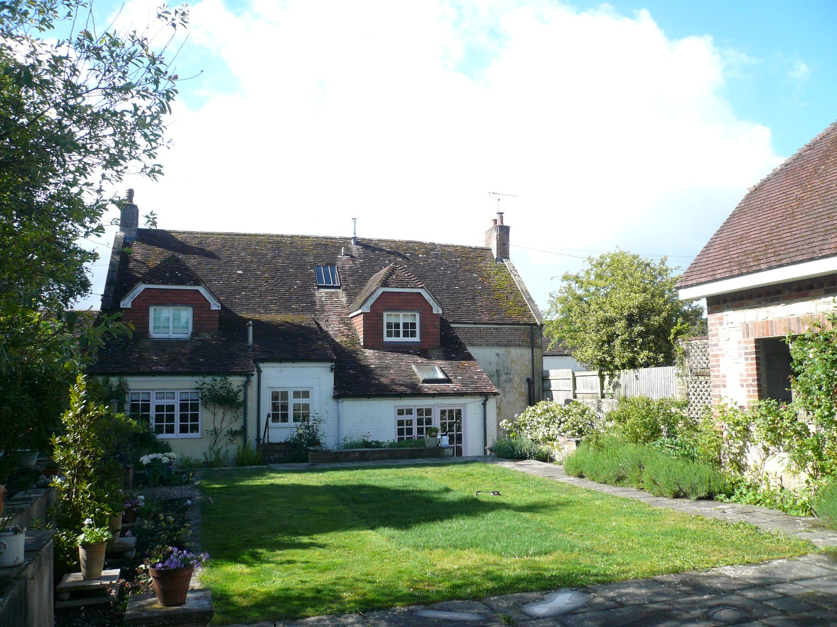
View looking southwest to rear elevation (outbuilding to right of image)

HISTORIC BACKGROUND
An exact construction date for then property is not known but it was established by 1765 when the Great Fire of Heytesbury broke out and destroyed most of the properties in the village. Number 69 had fire insurance, it was also brick built with a tiled roof, all of which aided its survival. A stone plaque above the door may have housed the fire insurance badge (there is a similar shaped plaque complete with badge in another property in the village that also survived the fire).
The property, in common with all the properties in Heytesbury, was part of the estate of the Holmes A’Court family, the prominent aristocratic family in the area. The head of the Homes A’Court family was ennobled in 1828, becoming Baron Heytesbury.
The house may have at some time had an earlier iteration as an apothecary shop as prescriptions dating from 1798 have been found used as packing in the floor beams. Whether this is the case or not, it is known that the site was used as a butchers shop, (and the house and buildings leased from Baron Heytesbury) from at least 1841 when the census lists the occupier as Jonathan Dann, a butcher, together with his assistant Richard Dann who became Master Butcher in the property in 1848.
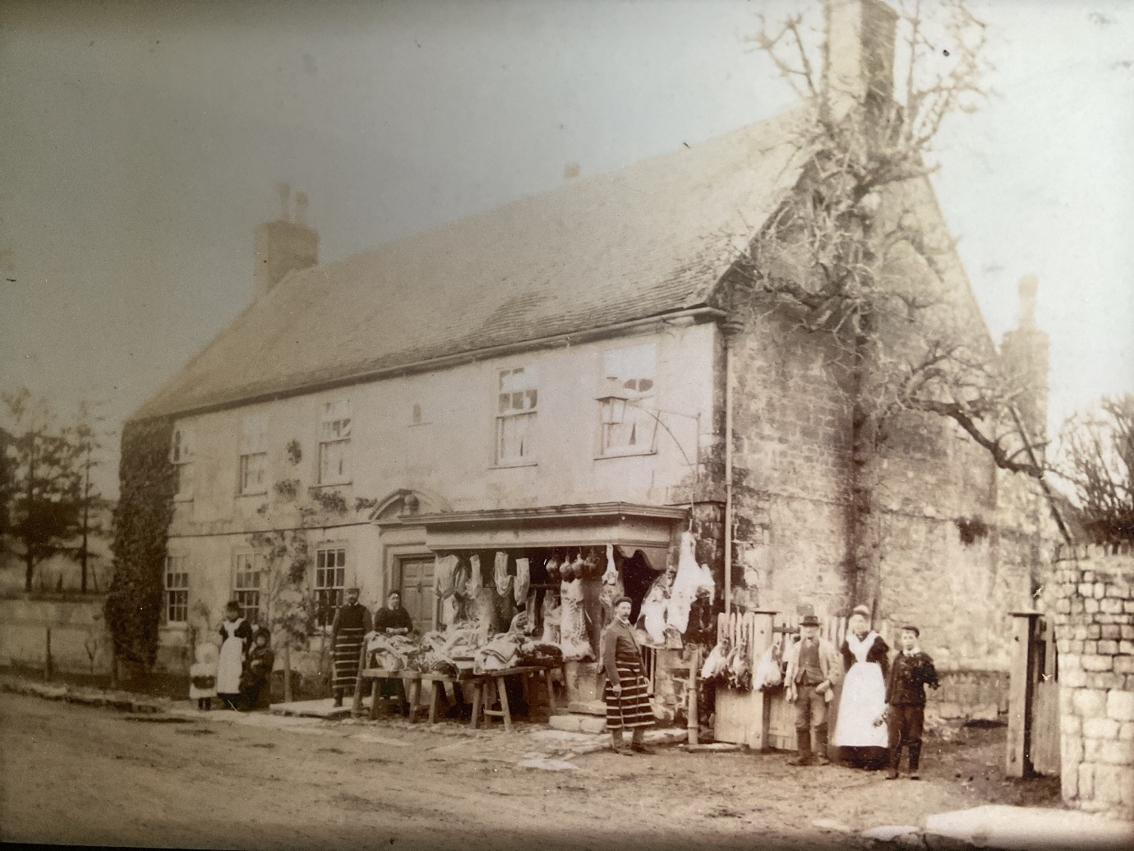
The property remained a butcher’s shop throughout the rest of the 19th century and well into the 20th. When death duties forced the then Baron Heytesbury to break up the estate in 1923, the property was sold to George Gillett, Butcher and Grazier.
The auction catalogue describes the property (lot 11) as:
Valuable Business Premises (Number 69 Heytesbury) situated in the High Street, in a commanding position, comprising a:
Superior House. Stone and brick built, with tiled roof, containing Four Bedrooms, Bath Room (cold), Two Sitting Rooms, Kitchen, Scullery, Dairy (Electric Light is installed and Company’s water laid on) together with Butcher’s Shop and Premises
Comprising wood and iron Trap Shed, Cow House for 2 and Hay House, Two Cattle Pens and Slaughterhouse, Boiler Shed, Stabling for 2, with Loft over, Coal House, E.C, Garden and Paddock, in all.
At that juncture the property was being let to Chinn Bros of Warminster (butchers) and the map of the lot showed the property and land extending from the High Street to New Town.
George Gillett installed Denzil Sharpe as manager of the butchers from 1923. Denzil took over the business after George Gillett retired in 1939. After the death of Denzil in 1945, his wife Margaret carried on the business, assisted by their son, Claude.
In 1955, Claude built a bungalow on land behind the abattoir, the property was called Sundew and was accessed via Newtown.
In around 1956, Claude brought a Kenneth Chant in to assist him in the butcher's shop. In the late 1950s, the Chants moved into 69 High Street although the business was still owned by Margaret Sharpe.
The business was sold to three local farmers in the late 1950s. They retained Kenneth Chant as Manager and Claude Sharpe as Assistant. The Chants continued to occupy 69 High Street into the 1960s. In 1963, one of the co-owners sold his share of the business to Grahams Wakeling, a butcher in Surrey. In the mid-1960s, the Wakelings built their own house on part of the garden to the east - 9 69A High Street, also known as Saddle Stones.
In 1969, Graham Wakeling bought out the other 2 co-owners and became sole proprietor of the business and opened another in Warminster.
In 1970 the Wakelings sold Saddle Stones, at this point, the butchers trade had become mostly orders to local villages and the dwindling business was sold to Rob Bailey and his brother who concentrated on the production of dog food. The Parish Council received numerous complaints about the Bailey Bros Meat Factory and pollution from the factory was on the agenda for the Parish Council in 1976.
By 1979, the business was declared bankrupt, and the property was sold by the administrators in lots. David Haines, the then owner of Saddle Stones, purchased land behind the abattoir to build a workshop for his upholstery business.
The remaining land and property was sold to a pair of brothers who were given permission to add dormer windows to 69, extend the kitchen and replace the shop front with sash windows to match the other side as well as create offices from the former meat factory storage buildings.
The property changed hands in the late 1980s and then then again in 1994 and was acquired by the now owners in late 2025.

The property has been used for the various purposes noted and the arrangement as extant has evolved accordingly. The most recent planning history at the site was in 2014 when Planning Permission and Listed Building Consent were granted for extension to the kitchen and reconstruction of the outbuilding as an annexe including an attached garden room.

HERITAGE STATEMENT
No.69 must be considered a significant building both in terms of its origin/historic significance and it’s perception within the street scene and the immediate and wider setting of the site. The property contributes to the variety of architectural styles and forms of High Street.

It is noted that the works the subject of this submission are internal/affect the rear elevation of the property and thus retain the public perception of the building without alteration.

SCOPE OF WORKS
The situation as existing is shown in drawings 226001/04, /06 and /07. The proposals are outlined in drawings 226001/08, /09 and /10.

- To improve the existing entrance Hall/corridor it is proposed to insert a pair of glazed doors to an existing modern partition - the latter having been determined as plywood sheathing to timber studs (the wall is also not manifest in drawings from submission in 1980). To the Drawing Room side of the existing partition faux panelling will be removed and replaced with plasterboard and skim to provide improved fire resistance. The new lining will be set to the existing cornice line and skirting/joinery reinstated. The existing door will be blocked in materials to match existing. It is also proposed to remove the door from the foot of the stairs rising to the first floor. The existing tile flooring is to be carefully removed and reinstated in new tiles (image of tiling as proposed included in Photographs appendix).
- The Drawing Room fireplace is to be improved with fire brick lining and natural stone fire surround/hearth (image as proposed included in Photographs appendix) with fitted bookcasing to the north and west walls either side of the fireplace (set away from wall and ceiling to preserve existing skirting and cornice). An existing modern steel panel radiator will be replaced by floor standing column type radiators set in the window recesses. The existing mix of historic and modern floor boards will be retained insitu and finished with Amtico plank flooring. It will be necessary to install an external vent to provide combustion air to the proposed woodburning stove with new flue liner and terminal accordingly in accordance with statutory requirements.
- The heating and flooring to the Dining Room will be similarly upgraded and an existing opening to the rear wall blocked to reinstate the original form of the room.
- To the rear the shower to the existing cloakroom will be removed and new fitments installed connecting to existing services. To the TV/Snug room a door will be formed as part of the existing window to provide access to the garden. This part of the property appears to be modern construction (comprising metric bricks, insulation blocks and squared timbers – photograph refers).
- The existing kitchen fitments will be stripped out with new furniture accordingly. It is proposed to alter the existing window/door combination to a 3 casement window with the door temporarily reused to a former opening in the side/west wall (pending extension to that part of the property for which proposals will follow in due course).

- To improve fire resistance it is proposed to provide plasterboard lining to the walls of the Cellar stairs and soffit of the flight rising to first floor. As part of the works the ceiling to the cellar will be upgraded/overboarded with plasterboard to ensure continuity and fire resistance to the Drawing Room and Entrance Hall over.

QUANTUM
The proposals will not increase floor area or accommodation provided by the property.

LANDSCAPING
The proposals will not affect the footprint of the property and outside spaces which will remain as domestic garden.

ACCESS
The proposals will not affect arrangements for car parking and service/emergency vehicles.
Arrangements for refuse/recycling will remain as existing.


226001/August 2026

