APPLICATION FOR LISTED BUILDING CONSENT
OFFICER DELGATED REPORT

APPLICATION REFERENCE: | PL/2026/03623
APPLICATION TYPE: | Listed building consent (Alt/Ext)
SITE ADDRESS: | 261 Cottles Lane, Turleigh, Bradford On Avon, BA15 2HJ
DESCRIPTION OF WORKS: | Installation of radon mitigation measures.
RECOMMENDATION: | Approve with Conditions

Initially, both LBC and PP applications were submitted, but following advice from the Conservation Officer, it was suggested the PP be withdrawn as unnecessary due to the extent of the proposed works that can be managed purely under the LBC.

As such assessment of impact to neighbouring listed buildings, Conservation Area character and Neighbouring Amenity is not relevant.

During the lifecycle of the application, the description of development was revised, to remove a proposal to remove a non-period fire insert. Submitted photos of the fire insert showed a period fire grate whose removal would not be approved.

SITE DESCRIPTION/CONTEXT
The subject property is a GII-listed, detached early C19 dwelling, in ashlar and rubble stone under tiled and later clay tiled roofs, with a conservatory and a modern extensions.

The building is designated for its special architectural and/or historic interest under the Planning (Listed Buildings and Conservation Areas) Act 1990.

The site is within the historic core of the village of Turleigh, and within Turleigh Conservation Area, the last on the lane as it exits the village going north, with neighbouring listed buildings.

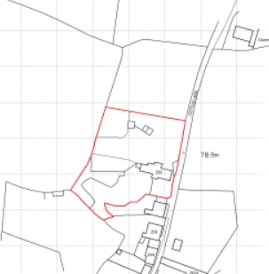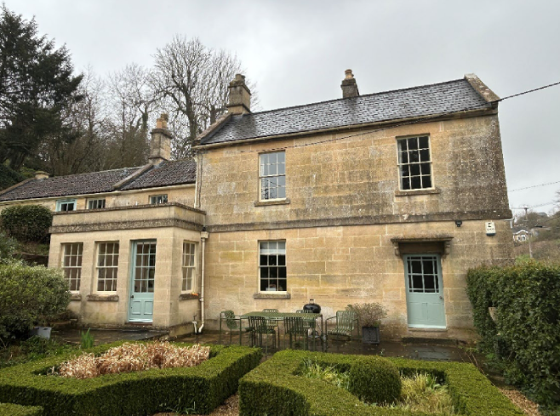
Location Plan and submitted site photo

The list entry, for means of identification purposes only, provides the following description:

House, early Cl9, ashlar with slate roof, coped gables and west end stack. Basement and two storeys, two-window range, with two 12- pane sashes above, plate glass sash and door with hood on brackets below. Raised plinth, band and eaves band. East end wall has apex dove-holes, ground and first floor sashes and basement door. Central axial stack on rear roof slope. A lower range to west has Bridgwater tiles, squared rubble stone walling, 12-pane sash each floor and door to right. A further range beyond has 16-pane window and door at upper level due to slope of hill. Owned by Heal family during C19, a stone quarry behind is noted in 1841 Tithe map survey. Said to have been a bakery in later C19.

The proposal site is within West Wiltshire Green Belt, the Cotswolds National Landscape, and within the Special Area of Conservation for Bats.

A submitted Radon report states that the site is within a radon Affected Area, 1-3% above actionable level.

PROPOSAL
The proposal is for:
- the installation of radon mitigation measures, namely surface-mounted internal and external ductwork, including the requirement of ducting holes through both historic and modern fabric.
- the removal of a non-period fire insert in the kitchen fire surround

The Radon Reports states that basement and cellar areas are considered at additional risk from high radon levels.

The drawings below highlight the locations of proposed 14 ducting holes, and additional white uPVC ducts either internally clad in plasterboard enclosures, or colour-matched to existing rainwater goods externally.

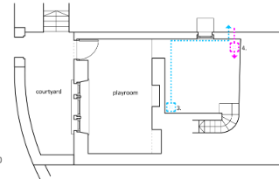
Proposed Basement Plan - Basement Stairs Lobby intake and extract vents

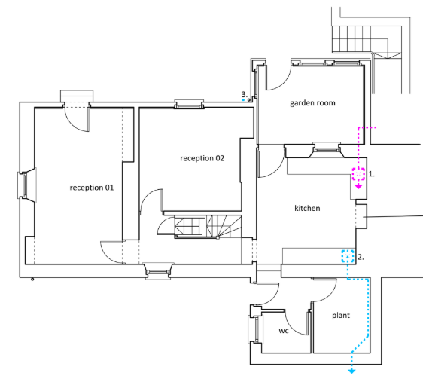
Proposed Ground Floor Plan - 2 locations - Kitchen/Conservatory, and Kitchen/Plant Room

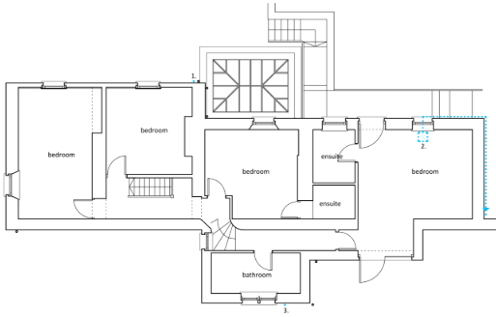
Proposed First Floor Plan - 3 locations - Bedroom, master Bedroom and Family Bathroom

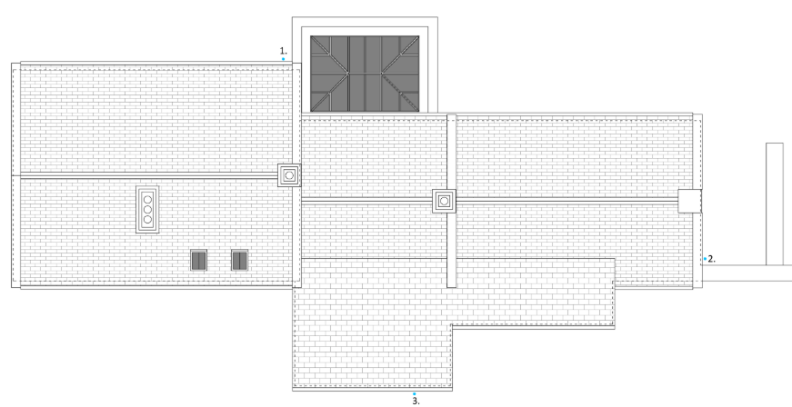
Proposed Roof Plan – 3 locations of vents/floor-level sumps, encased in 110mm pipework

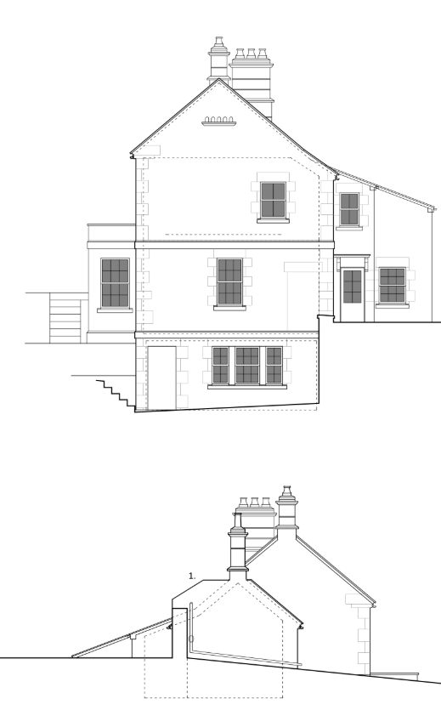
Proposed East and West
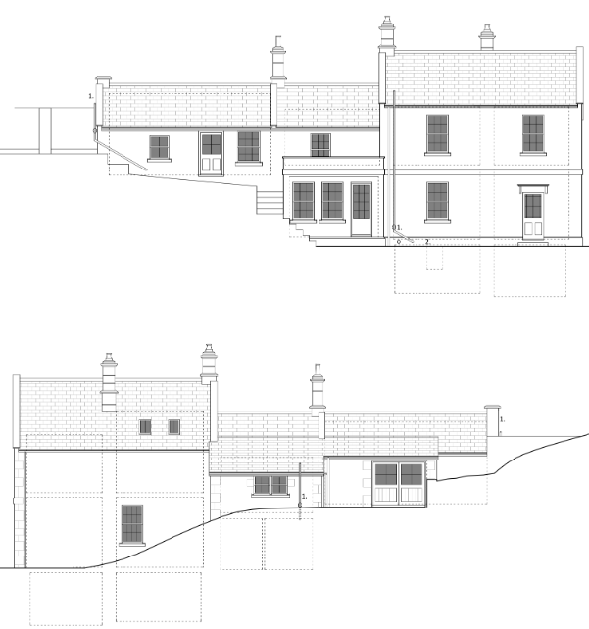
Proposed South and North Elevations

RELEVANT PLANNING HISTORY
W/02/01992/LBC - Listed building consent Decision - Approve with Conditions Date: 16/4/2003 – House extension
W/02/01993/FUL - Full planning permission Decision - Approve with Conditions Date: 16/4/2003 – House extension
19/05269/FUL - Full planning permission Decision - Approve with Conditions Date: 29/8/2019 – Proposed new single storey extension and internal alterations.
19/05637/LBC - Listed building consent Decision - Approve with Conditions Date: 29/8/2019 – Proposed new single storey extension and internal alterations

RELEVANT LEGISLATION, POLICIES AND GUIDANCE

Legislation
From the point of view of the historic environment the main statutory tests are set out within the Planning (Listed Building and Conservation Areas) Act 1990. Section 16 requires that special regard be given to the desirability of preserving listed buildings, their settings or any features of special architectural or historic interest which they possess.

Section 72(1) of the Planning (Listed Building and Conservation Areas) Act 1990 also requires the Council to pay special attention to the desirability of preserving or enhancing the character or appearance of designated Conservation Areas.

National Policy and Guidance
The National Planning Policy Framework (NPPF) sets out government policy, including in respect of the historic environment.

Section 16 of the NPPF ('Conserving and enhancing the historic environment') sets out the Government's high-level policies concerning heritage and sustainable development.

Paragraphs 213-215 of the NPPF require a balanced approach with any harm which would be caused being weighed against the potential public benefits which might be achieved. Paragraph 210 requires local planning authorities to take account of the desirability of sustaining and enhancing the significance of heritage assets and of new development making a positive contribution to local character and distinctiveness.

Section 14 of the NPPF addresses the challenge of climate change, flooding and coastal change.

Paragraph 167 advises that “Local planning authorities should also give significant weight to the need to support energy efficiency and low carbon heating improvements to existing buildings, both domestic and non-domestic (including through installation of heat pumps and solar panels where these do not already benefit from permitted development rights).

National Planning Practice Guidance provides guidance on interpreting the NPPF.

Historic England Advice Note 2: Making changes to Heritage Assets, illustrates the application of policies set out in the NPPF in determining applications for LBC (and planning permission).

Wiltshire Core Strategy:
Whilst not directly relevant to listed building consent applications, the below policies give an indication of the Council’s approach to development affecting heritage assets:

- Core Policy 57 ‘Ensuring high quality design and place shaping’: A high standard of design is required in all new developments, including extensions, alterations, and changes of use of existing buildings. Development is expected to create a strong sense of place through drawing on the local context and being complementary to the locality.

- Core Policy 58 ‘Ensuring the conservation of the historic environment’ requires that “designated heritage assets and their settings will be conserved, and where appropriate enhanced, in a manner appropriate to their significance.”

ISSUES
Impact upon the preservation of the listed building or any features of special architectural and/or historic interest.

CONSULTATION RESPONSES

Winsley Parish Council: No Objection.

Conservation: No Objection. In this case I have considered the evidence provided by the applicant and confirm my agreement with the assessment detailed in the Design Access and Heritage Statement.
The works would alter the appearance of the building but are considered to be of a discrete format and necessary to retain the building in its optimum viable use.
The proposed works to the building do not appear to be development I therefore suggest the PP is withdrawn as a result.

REPRESENTATIONS
In accordance with the requirements of Section 5(1) of the Planning (Listed Buildings and Conservation Areas) Regulations 1990 (as amended) the application for listed building consent was to be publicised by way of:

- A site notice displayed near the site;
- An advertisement placed in the local press.

These methods were used to inform interested parties and to allow a statutory consultation period of 21 days for representations to be submitted.

However, given that the PP is not required, evidence of the site notice being displayed was not sought.

In accordance with the requirements of Section 5(3)(a) of the Planning (Listed Buildings and Conservation Areas) Regulations 1990 (as amended) publicity is not required for listed building consent to carry out works affecting only the interior of a Grade II (unstarred) listed building.

No third-party comments were received.

ASSESSMENT
In accordance with Section 16(2) of the Planning (Listed Buildings and Conservation Areas) Act 1990, special regard has been given to the significance of the listed building, including its architectural and historic interest, and the desirability of preserving both the building and its setting. Relevant policies within the National Planning Policy Framework (NPPF), particularly Section 16: Conserving and Enhancing the Historic Environment, have also been taken into account. These policies require that any harm to the significance of a designated heritage asset must be clearly justified and weighed against the public benefits of the proposal.

In order to be acceptable, the application needs to be assessed against the following criteria:

Information considered/submitted
Paragraph 207 requires that applicants describe the significance of any heritage assets affected, including any contribution made by their setting. This should include sufficient information to provide a clear understanding of the significance of the heritage asset and its setting and the potential impact of any proposals on that significance.

Limited information is included within the submitted Design, Access and Heritage Statement and fails to provide any objective assessment of significance.

Assessment of significance:
According to the National Planning Policy Framework (NPPF), significance is defined as:

“The value of a heritage asset to this and future generations because of its heritage interest. The interest may be archaeological, architectural, artistic or historic. Significance derives not only from a heritage asset’s physical presence, but also from its setting.”

Historic England further categorises significance into four key values:

- Evidential – the potential of the asset to yield evidence about past human activity.
- Historic – the ways in which the asset illustrates aspects of history.
- Aesthetic – the sensory and design qualities of the asset.
- Communal – the meanings and associations attached to the asset by people.

The significance of the building lies largely with its historic fabric and architecture - its form, layout and architectural expression/detailing and use of high-quality design materials which have significant aesthetic and architectural interest, and which contribute to the character of the Conservation Area.

Impact of proposals on the significance and setting of the building/structure:
Understanding the impact of proposed works on a listed building requires a careful and proportionate assessment of how those changes affect the asset’s heritage significance and its setting. This includes both the physical alterations to the building itself and any changes to its spatial or visual relationship with surrounding structures or spaces.

The significance of a heritage asset is not static; it is shaped by its architectural, historic, and communal values, and by how these are experienced in context. Therefore, any intervention must be considered in light of the asset’s identified significance, with attention given to both potential harm and benefits. Benefits may include repairs that support the long-term conservation of the building, improved energy performance, or enhanced public access and understanding.

This assessment is grounded in the statutory duty under Section 16 of the Planning (Listed Buildings and Conservation Areas) Act 1990, which requires special regard to be given to the desirability of preserving the building and its features of special interest. It is also informed by national policy, particularly paragraphs 212-221 of the National Planning Policy Framework (NPPF), and relevant local heritage policies and guidance.

The proposed radon mitigation measures include the surface-mounting of ducting runs which will entail minimal attachment points and so have limited impact on historic fabric. Various ducting holes are required through both modern fabric, of which there are no concerns, and historic fabric. These holes would be 115mm in diameter, and so not reversible, but can be hidden by the proposed discreet sitings. The proposed works would therefore have a harmful impact on small areas of historic fabric only and not architectural detailing, but at the lower end of the less than substantial scale.

The ducting is required as part of wider radon mitigation measures, and as such are necessary and proportionate, and which have the public benefit of ensuring the property remains a viable dwelling.

As a result the requirements of current conservation legislation, policy or guidance are considered to be met and there is therefore no objection to the approval of the application.

The scheme is appraised as complying with the relevant policies in the NPPF, the Adopted (2015) Wiltshire Core Strategy and other relevant planning documents/policies and legislation. It is therefore recommended that this application is approved with conditions.

Impact on Ecology
While Sections 16 and 72 of the Planning (Listed Buildings and Conservation Areas) Act 1990 do not explicitly reference protected species, Local Planning Authorities have a statutory duty to consider potential impacts on protected species when determining applications. This responsibility arises from broader environmental legislation and national planning policy and must be taken into account where relevant.

Whilst the site is within a designated area, the proposed works are of a scale and siting as to not impact features where the protected species is likely to be present and as such raise no concerns regarding protected species.

Does the site or proposed development possess/impact on any of the features where
protected species are likely to be present (assessed against Natural England’s standing
advice) and where species are likely to be found?

CONCLUSION
The NPPF confirms that when considering the impact of a proposed development on the significance of a designated heritage asset, great weight should be given to the asset’s conservation (and the more important the asset, the greater the weight should be). It makes clear that any harm to a designated heritage asset requires clear and convincing justification.

In this case, the proposals will result in harm to the building via the loss of small areas of historic fabric. The proposals involve only part of the building and could therefore be considered as causing ‘less than substantial harm’ for the purposes of interpreting the NPPF. The wording of the NPPF and the ‘special regard’ by Sections 16 and 66 of the Act requires that any level harm caused should be taken seriously.

Paragraph 215 allows that a level of harm may be offset by public benefits, which could include conservation benefits. In this case, the justification is the requirement under radon mitigation measures.

RECOMMENDATION:
That Listed Building Consent be GRANTED, subject to conditions.

