APPLICATION FOR FULL-PLANNING PERMISSION
CASE OFFICER REPORT

APPLICATION REFERENCE: | PL/2026/03024
APPLICATION TYPE: | Full planning permission
SITE ADDRESS: | Land to the north of Leap Gate, Ashton Park, Trowbridge
DEVELOPMENT DESCRIPTION: | Erection of a switching station, with associated hard and soft landscaping
RECOMMENDATION: | Approve with Conditions

SITE DESCRIPTION/CONTEXT: The site is a small area of the wider Ashton Park strategic allocation, as approved under application reference 15/04736/OUT, to the southeast of Trowbridge. The site in question lies off a junction spur off Leap Gate road that has been created for a future development.

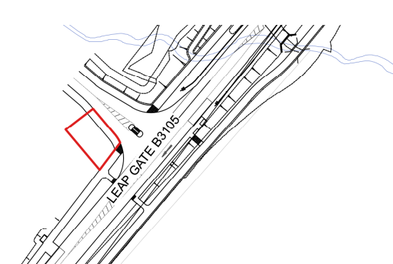

The site is subject to the following key constraints and designations: The site is part of the Biss Wood WWT Reserve and within the yellow zone of the Trowbridge and Westbury Bat Mitigation Strategy (TWBMS). It is also outside of the local flood zones.

PROPOSAL: The application seeks the erection of a switching station, with associated hard and soft landscaping.

This facility is required in association with the development on a site immediately to the south of Leap Gate road which has outline planning permission for the following description of development (granted on the 2nd September 2025):

“Outline planning application for mixed use development comprising: residential (up to 2,500 dwellings - Classes C3 & C2); employment (Class E (‘Business’ only), B2, and B8); two local centres (Classes E, C2, and C3); two primary schools, one secondary school, ecological visitors facility, public open space, landscaping and associated highway works including for the ‘Yarnbrook / West Ashton Relief Road’ and the access junctions.”

The proposals are for a single story building to contain a Last Mile 11kv Switchroom. The proposals also include hard and soft landscaping including tree and hedgerow planting. A single vehicle parking space is proposed taking access from the unnamed road to the north eastern site boundary (which is turn leads on to Leap Gate road). A removable bollard is proposed at the access to the site to prevent unauthorised access to the structure.

PLANNING HISTORY

Proposal / Summary
15/04736/OUT - Outline planning application for mixed use development comprising: residential (up to 2,500 dwellings - Classes C3 & C2); employment (Class E (‘Business’ only), B2, and B8); two local centres (Classes E, C2, and C3); two primary schools, one secondary school, ecological visitor facility, public open space, landscaping and associated highway works including for the ‘Yarnbrook / West Ashton Relief Road’ and the access junctions. – Approved 02/09/2025

RELEVANT LEGISLATION, POLICIES AND GUIDANCE

National Planning Policy:
- National Planning Policy Framework (NPPF)
- Planning Practice Guidance (PPG)
- National Design Guide
Development Plan: The development plan for Wiltshire comprises the Wiltshire Core Strategy (WCS) (adopted January 2015) and any made neighbourhood plans, which remain the principal statutory planning document guiding development across the county. In line with Section 38(6) of the Planning and Compulsory Purchase Act 2004, planning decisions must be made in accordance with the development plan unless material considerations indicate otherwise.

Though the development plan is considered as a whole, those parts deemed to be particularly relevant to this application are listed below:

The adopted Wiltshire Core Strategy (WCS), with particular regard to:

- Core Policy 1 Settlement Strategy;
- Core Policy 2 Delivery Strategy;
- Core Policy 3 Infrastructure Requirements;
- Core Policy 29 Spatial Strategy: Trowbridge Community Area;
- Core Policy 50 Biodiversity and Geodiversity;
- Core Policy 51 Landscape;
- Core Policy 56 Contaminated Land;
- Core Policy 57 Ensuring High Quality Design and Place Shaping;
- Core Policy 60 Sustainable Transport;
- Core Policy 61 Transport & Development;
- Core Policy 62 Development Impacts on the Transport Network;
- Core Policy 63 Transport Strategies;
- Core Policy 64 Demand Management

Draft Wiltshire Local Plan: At Full Council on 19 May 2026, the elected members of Wiltshire Council agreed to withdraw the emerging Wiltshire Local Plan. The said Plan has no material weight for the purposes of the application.

In accordance with Regulation 19 of the Town and Country Planning (Local Planning) (England) Regulations 2026, on 30th June 2026 Wiltshire Council published a notice of intention to prepare a new local plan for Wiltshire. The next stage is a Scoping Consultation which commences on 2nd September 2026. This plan is at a very early stage and currently carries no weight for decision making.

ISSUES

The main issues that need to be addressed in this case include:

- Whether the development is acceptable in principle (CP 1 and 2)
- Whether the scheme constitutes high quality design (CP 57) and would have an acceptable landscape impact (CP 51)
- Whether the scheme would have an acceptable impact upon the reasonable living conditions of the adjoining occupants (CP 57)
- Whether the proposal would have a negative effect upon highway safety (CP 61 and 64)
- Whether there would be any harmful impacts upon protected species or priority habitats (CP 50)

CONSULTATION RESPONSES: The views of consultees are material considerations in the determination of the application. However, the decision-maker must exercise their own planning judgement. Where consultees raise concerns or recommend conditions, these have been considered and are addressed within the assessment section of this report.

WC Highways: No objection in principle but require further clarification.

Parish/Town Council: No objection.

REPRESENTATIONS: In accordance with the requirements of the Town and Country Planning (Development Management Procedure) (England) Order 2015 (as amended), the application was publicised by way of a site notice displayed near the site.

This method was used to inform interested parties and provide a period of 21 days for comments to be submitted.

No representations were received.

ASSESSMENT: Section 38(6) of the Planning and Compulsory Purchase Act 2004 states:

"If regard is to be had to the development plan for the purposes of any determination to be made under the planning Acts, the determination must be made in accordance with the plan unless material considerations indicate otherwise."

In accordance with this statutory requirement, this application has been assessed against the relevant policies of the Development Plan, including the Wiltshire Core Strategy (2015) and, where applicable, any made Neighbourhood Plans. Consideration has also been given to the policies of the National Planning Policy Framework (NPPF) as a material consideration in the assessment.

The assessment below considers each of the main issues identified above. Each topic is assessed in turn with reference to the relevant policy context, the evidence submitted, consultee responses, and all other material considerations, before a conclusion is reached.

Principle of Development: Core Policy 1: Settlement Strategy of the WCS establishes a hierarchy of settlements to guide where development should be focused. The policy prioritises growth in:
- Principal Settlements (e.g., Salisbury, Chippenham, Trowbridge) – main focus for strategic growth.
- Market Towns – support local services and employment; suitable for sustainable development.
- Local Service Centres – smaller towns and villages with a range of services; limited development supported.
- Large and Small Villages – development should be limited and respond to local needs.
- Outside the defined settlements – development is strictly controlled and generally not supported unless exceptional circumstances apply.
.
Core Policy 2: Delivery Strategy of the WCS sets out how development will be distributed and delivered across Wiltshire. The policy emphasises:
- Sustainable patterns of growth, reducing the need to travel and supporting local services.
- Development should be plan-led, aligning with the settlement strategy and supported by infrastructure.
- Windfall development (not allocated in plans) must still comply with the principles of sustainable development.
- Development outside settlement boundaries is generally not permitted, unless it meets specific policy exceptions (as set out in paragraph 4.25 of the WCS).

Together, CP1 and CP2 ensure that new development is strategically located, sustainable, and supports the character and function of Wiltshire’s communities.

This proposed switching station forms an important part of the power infrastructure for the expansion of Trowbridge, as approved at outline stage, and reserved matters applications currently moving through the planning system.

As mentioned above, the application site forms part of the Ashton Park strategic allocation and the proposal is directly associated with the delivery of infrastructure required to support development already accepted in principle through outline permission 15/04736/OUT. The proposed switching station is not a standalone form of development but an ancillary infrastructure element necessary to support the delivery of the approved residential and employment growth.

Policy CP3 seeks to ensure that development is supported by and contributes toward the delivery of necessary infrastructure. The proposed switching station would form an essential component of the electricity supply infrastructure required to facilitate the implementation of the approved Ashton Park strategic allocation and is therefore consistent with the aims of CP3.

The proposal is therefore considered to be policy compliant and therefore should be supported.

High Quality Design, Landscape and Visual Impact: Core Policy 51 of the Wiltshire Core Strategy requires development to:
- Protect, conserve, and enhance landscape character and quality.
- Respect local distinctiveness, key views, and visual receptors.
- Give particular weight to impacts on National Landscapes (formerly AONBs) and locally valued landscapes.

Core Policy 57 requires high quality design.

The Green & Blue Infrastructure Strategy (2022–2030) supports landscape protection through green infrastructure, habitat connectivity, and nature-based solutions.

The NPPF emphasises the need to protect and enhance valued landscapes, particularly those with scenic, historic, or ecological significance. Planning decisions should:

- Recognise the intrinsic character and beauty of the countryside.
- Safeguard key views, local distinctiveness, and landscape settings.
- Ensure development is well-integrated into its surroundings and avoids visual intrusion, especially in sensitive or designated areas.

Landscape impact must be considered alongside biodiversity, heritage, and green infrastructure objectives, with mitigation measures encouraged where harm cannot be avoided.

In assessing this aspect of the proposal, regard has been had to the site context, the details of the proposed development, the relevant development plan policies, and all other material considerations. The key considerations are set out below.

The switching station is necessarily of a utilitarian design, given that it is a specifically functional building.

However, the building is small, single storey and can adequately be screened by landscaping on three sides:

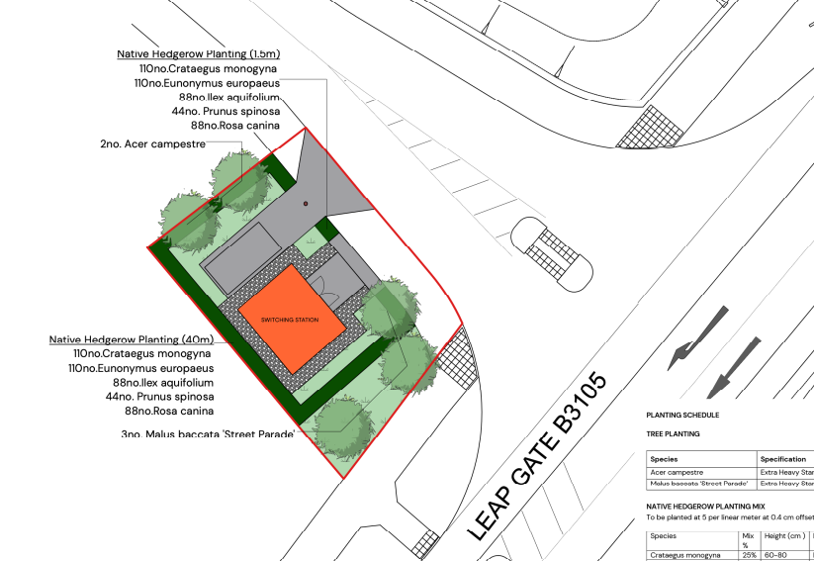

The front elevation would be seen from the junction:
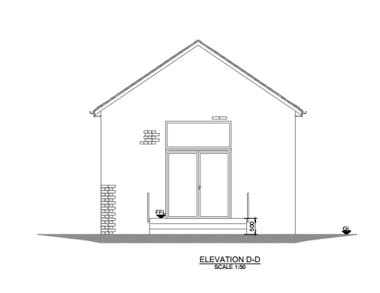
It would be a brick structure with a traditional pitched roof. Therefore, the building would fit within the prevailing built character of the wider allocation.

Given that the proposed structure would be modest in scale and subordinate to the wider approved development, whilst of a functional appearance, the use of brick elevations and a pitched roof would assist in its integration into the emerging built form of the allocation. The submitted landscaping scheme would soften the visual impacts of the proposal and provide screening from public viewpoints.

Whilst currently an open edge of town site, this area has been allocated for urban expansion and therefore the switching station would not remain in isolation for very long.

Accordingly, the proposal would achieve an acceptable standard of design having regard to CP 57 and the NPPF.

Amenity: Core Policy 57 (Point vii) of the Wiltshire Core Strategy requires development to respect the amenity of existing occupants and ensure appropriate amenity levels for future residents.

The National Planning Policy Framework (NPPF), particularly Paragraph 135, reinforces the need for development to provide a high standard of amenity for both existing and future users.

These policies guide the assessment of amenity impacts.

The switching station would not be surrounded by residential development, given that on this side of Leap Gate the allocation is for mixed use commercial development.

The switching station is opposite residential development across Leap Gate at approximately 50m distance.

Given the separation distance to existing dwellings and the small scale of the building, no harmful impacts on residential amenity would arise. The operational characteristics of the switching station are such that significant activity levels are not anticipated. It is therefore concluded that the proposal would safeguard residential amenity in accordance with CP57 and paragraph 135(f) of the NPPF.

Highways Impacts: In assessing this aspect of the proposal, regard has been had to the site context, the details of the proposed development, the relevant development plan policies, and all other material considerations.

The Council’s Highways Officer comments:

“Whilst I have no objection to the proposed switching station in principle, it is shown to be access from the undeveloped access road for the business development site. Whilst the access to Leapgate is formed, the section of access road where the switching station is proposed to be access from is not. Therefore, I seek clarity in how this will be accessed – will the business access road be extended to facilitate this and if so, to what extent/form?”

The applicant has provided an additional plan to show that the access off Leap Gate has been formed:
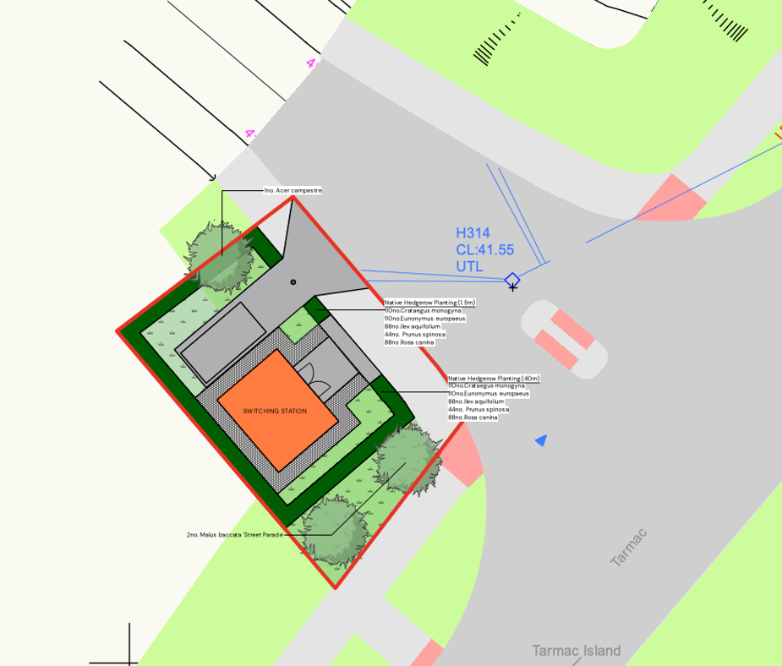

This is also evident from the aerial views of this site:

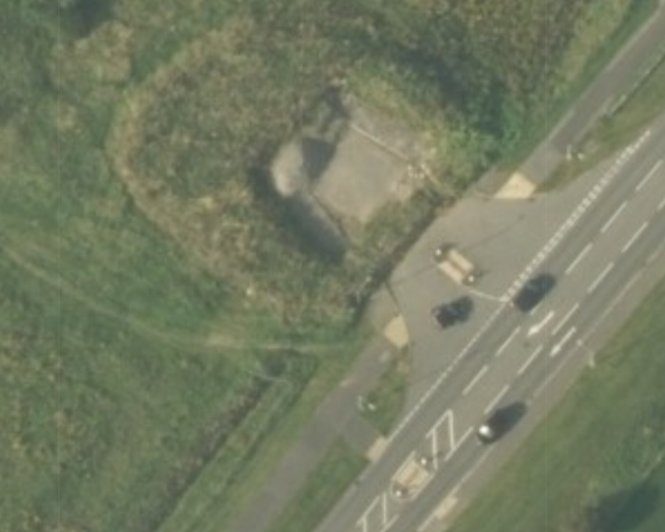

The junction appears, at road level, not to be in place due to the line of vegetation used to deter people from entering the forthcoming allocation. However, it can be seen that the access is in fact constructed. The line of sacrificial vegetation would be removed upon the commencement of development.

Having regard to the above, it is considered that there would be safe and existing access to the switching station site.

Ecology and Biodiversity: The ecological impact of development is a key planning consideration. Proposals must assess and address potential effects on:

- Protected species
- Priority habitats
- Ecological networks
- Green and blue infrastructure

Core Policy 50 of the Wiltshire Core Strategy requires development to:

- Avoid harm to ecological assets.
- Deliver measurable Biodiversity Net Gain (BNG), in line with the Environment Act 2021.
- Support habitat restoration and connectivity.
- Integrate biodiversity into site design.

The Green & Blue Infrastructure Strategy (2022–2030) promotes nature recovery, ecosystem services, and habitat connectivity through development.

Unless exempt, National policy requires a minimum of 10% Biodiversity Net Gain (BNG) for major developments, demonstrated via:

- Biodiversity Metric calculations
- Ecological assessments (e.g. PEAs, Phase 1 surveys, protected species surveys)

In assessing this aspect of the proposal, regard has been had to the site context, the details of the proposed development, the relevant development plan policies, and all other material considerations. The key considerations are set out below.

This site integrates into the wider allocation that has been through extensive negotiations regarding ecological interests. The wider site is subject to a bespoke ecological mitigation package that has been approved by the Council and Natural England. The proposed switching station would have its own landscaping scheme that would serve to result in no net loss of habitat. It would not have a negative impact on the bespoke scheme mentioned above.

The proposal is supported by a biodiversity net gain metric, showing a 16.79% gain. This is in excess of the 10% statutory requirement and therefore is satisfactory, and this should be supported.

The site lies within the TWBMS area. Having regard to the limited scale of development, the existing strategic mitigation secured across Ashton Park and the ecological information submitted, it is not considered that the proposal would undermine the objectives of the mitigation strategy.

Having regard to the above, it is considered that the switching station would not interfere with the effectiveness of the bespoke ecological mitigation package for Ashton Park. Moreover, it would result in no net loss of habitat due to the landscaping scheme proposed, along with confirming that there would be a BNG of 16.79%.

Public Sector Equality Duty (PSED): In reaching this decision, due regard has been had to the Public Sector Equality Duty under Section 149 of the Equality Act 2010. This requires the Local Planning Authority to have regard to the need to eliminate discrimination, advance equality of opportunity and foster good relations between persons who share a protected characteristic and those who do not.

The Local Planning Authority is satisfied that the proposal would not result in any unlawful discrimination and that any impacts on protected groups have been appropriately considered as part of this assessment.

PLANNING BALANCE AND CONCLUSION: In reaching a decision, all identified harms and benefits must be weighed in the overall planning balance, having regard to Section 38(6) of the Planning and Compulsory Purchase Act 2004 and the provisions of the National Planning Policy Framework.

At the heart of the NPPF there is a presumption in favour of sustainable development requiring local planning authorities to approve development proposals that accord with an up-to-date development plan without delay; and where there are no relevant development plan policies, or the policies which are most important for determining the application are out-of-date, permission should be granted unless (taken from paragraph 11d of the NPPF):

- The application of policies in the NPPF that protect areas or assets of particular importance provides a clear reason for refusing development proposed; or
- any adverse impacts of doing so would significantly and demonstrably outweigh the benefits, when assessed against the policies in the NPPF taken as a whole;

The principle of development is considered acceptable when assessed against the settlement strategy of the Wiltshire Core Strategy.

The proposal is compliant with relevant local and national planning policies in respect of design, scale, residential amenity, landscape, highway safety, and ecology and biodiversity, subject to the recommended conditions and any necessary mitigation measures.

The proposal would provide essential electrical infrastructure necessary for implementation of the approved Ashton Park strategic allocation and would therefore make a positive contribution toward delivery of planned growth within Trowbridge. The development would be modest in scale, would not result in unacceptable visual, residential amenity, highway or ecological impacts and would secure biodiversity net gain in excess of statutory requirements.

The development would deliver clear benefits, including forming a key part of the infrastructure required to support the approved Ashton Park strategic allocation, which weigh positively in the overall planning balance.

No material considerations have been identified that would significantly and demonstrably outweigh these benefits or indicate that permission should be refused, having regard to the assessment above and the consultation comments received.

Accordingly, the proposal is considered acceptable in planning terms and in accordance with the Wiltshire Core Strategy, the National Planning Policy Framework, and all other relevant material considerations.

RECOMMENDATION: That Planning Permission be GRANTED, subject to conditions.

All conditions imposed have been assessed against the six tests set out in paragraph 56 of the National Planning Policy Framework and are considered to be necessary, relevant to planning, relevant to the development to be permitted, enforceable, precise and reasonable in all other respects.

