APPLICATION FOR VARIATION/REMOVAL OF CONDITION
CASE OFFICER REPORT

APPLICATION REFERENCE: | PL/2026/02793
APPLICATION TYPE: | Removal/variation of conditions
SITE ADDRESS: | Rose And Crown, Middle Stoke, Limpley Stoke, Bath, BA2 7GE
DEVELOPMENT DESCRIPTION: | Variation of condition 2 (Approved plans) on 16/10880/FUL, to allow for an alternative proposal for car park and access arrangement.
RECOMMENDATION: | That Planning Permission be GRANTED

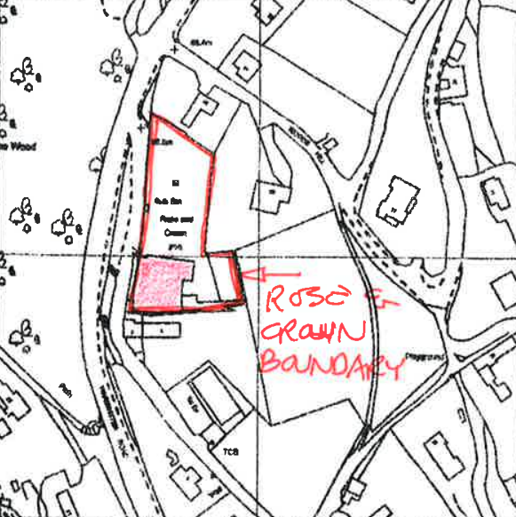

SITE DESCRIPTION/CONTEXT: The application site comprises the former Rose and Crown public house, a two‑storey building of traditional stone and tile construction set within a hillside plot with associated car parking and garden areas, located on the eastern side of the A36 at the edge of Limpley Stoke. The site occupies a prominent but visually contained position within the Avon valley, characterised by steep topography and expansive views across open countryside.

The subject site is located within the Cotswolds National Landscape (CNL) and also lies within the Green Belt and the locally designated Special Landscape Area (SLA), which includes areas on the southern fringes of The Cotswolds.

It is noted that the Rose and Crown public house is identified in the made neighbourhood plan as a safeguarded community asset, as detailed on Map 5 and within Table 2 of the made plan. However, planning permission was previously granted under application reference 16/10880/FUL to change the use of the public house into a mixed use including a children’s nursery and office.

The site is constrained by its relationship to the heavily trafficked A36 and the narrow Middle Stoke road, which provides the principal access, as well as nearby public rights of way. It is also located within ecological consultation buffers associated with the Bath and Bradford on Avon Bats SAC, with nearby priority woodland habitat including Limpley Stoke Wood, which is subject to a Tree Preservation Order designation (reference W/83/00001/WOOD/W1). Notwithstanding these constraints, the site itself lies within Flood Zone 1 with no identified surface or groundwater flood risk.

PROPOSAL: This application seeks planning permission under Section 73 of the Town and Country Planning Act 1990 to vary Condition 2 (approved plans) of planning permission 16/10880/FUL in order to substitute a revised car parking layout and access arrangement. The approved development comprises the change of use of the former Rose and Crown public house to a mixed-use scheme including a children’s day nursery and office accommodation. The amendment proposes the reconfiguration of the car park to incorporate a one‑way circulation system with a revised point of entry and exit onto Middle Stoke, intended to respond to changes in local highway conditions, including the closure of Woods Hill and increased on-street parking, and to improve the safe operation of the junction with the A36.

With reference to the submitted Cover Letter, the original permission (as approved under application reference 16/10880/FUL) has been lawfully implemented, as the “proposed works have now been substantially implemented” and therefore the parent application remains extant. The current application seeks to vary the original permission and obtain permission under Section 73 by varying Condition 2 only in respect of the car parking and access arrangements.

RELEVANT PLANNING HISTORY

Reference No. | Proposal / Summary | Decision
W/78/00749/HIS | Extension of bar, dining area and car park | Approved
W/91/00260/FUL | Remedial works to retaining walls to car park | Approved
W/98/00785/FUL | Alterations to boundary fencing extension to patio area formalisation of parking area behind pub new planting beds for screening | Approved
W/01/00522/FUL | Change of use from tarmac parking area to grass and patio area | Approved
W/08/00202/FUL | Extend existing raised patio in external garden area and provide natural canvas awning | Approved
W/13/00783/FUL | Construction on new entrance porch and level access to existing entrance to public house | Approved
16/10880/FUL | Change of use from public house (use class A4) to mixed use: childrens day nursery (use class D1) and self contained offices (use class B1) with associated works and alterations to access and parking (resubmission of 15/09814/FUL) | Approved

RELEVANT LEGISLATION, POLICIES AND GUIDANCE

Town and Country Planning Act. 1990 (as amended): Section 73 of the Town and Country Planning Act. 1990 (as amended) relates to the determination of applications to develop land without compliance with conditions previously attached. It states that:

(2) On such an application the local planning authority shall consider only the question of the conditions subject to which planning permission should be granted, and—

- if they decide that planning permission should be granted subject to conditions differing from those subject to which the previous permission was granted, or that it should be granted unconditionally, they shall grant planning permission accordingly, and

- if they decide that planning permission should be granted subject to the same conditions as those subject to which the previous permission was granted, they shall refuse the application.

The National Planning Practice Guidance (PPG) states the following:

- Nature of the Application: A Section 73 application is treated as a new planning permission, although it does not alter the original permission itself. The original permission remains intact and can still be implemented unless it has expired or been superseded.
- Limitations:
  - Section 73 cannot be used to change the description of development or the operative part of the permission (e.g. the nature or extent of the approved use).
  - It cannot be used to extend the time limit for implementing the original permission.
  - If the proposed changes go beyond what can reasonably be considered under Section 73, a new planning application under Section 70 would be required.
- Decision-making: The local planning authority must consider the application only in relation to the conditions subject to which the original permission was granted. However, it may impose new or revised conditions if granting a new permission.
- Legal Agreements: Because a Section 73 application results in a new permission, any existing Section 106 agreement may need to be varied or replaced via a deed of variation to ensure obligations continue to apply to the new permission.

National Planning Policy:
- National Planning Policy Framework (NPPF)
- Planning Practice Guidance (PPG)
- National Design Guide
Development Plan: The development plan for Wiltshire comprises the Wiltshire Core Strategy (WCS) (adopted January 2015) and any made neighbourhood plans, which remains the principal statutory planning document guiding development across the county. In line with Section 38(6) of the Planning and Compulsory Purchase Act 2004, planning decisions must be made in accordance with the development plan unless material considerations indicate otherwise.

Though the development plan is considered as a whole, those parts deemed to be particularly relevant to this application are listed below:

The adopted Wiltshire Core Strategy (WCS), with particular regard to:

- Core Policy 1 Settlement Strategy;
- Core Policy 2 Delivery Strategy;
- Core Policy 7 Spatial Strategy: Bradford on Avon Community Area;
- Core Policy 34 Additional Employment Land;
- Core Policy 41 Sustainable Construction and Low-Carbon Energy;
- Core Policy 48 Supporting Rural Life;
- Core Policy 49 Protection of Rural Services and Community Facilities;
- Core Policy 50 Biodiversity and Geodiversity;
- Core Policy 51 Landscape;
- Core Policy 57 Ensuring High Quality Design and Place Shaping;
- Core Policy 60 Sustainable Transport;
- Core Policy 61 Transport & Development;
- Core Policy 62 Development Impacts on the Transport Network;
- Core Policy 64 Demand Management;
- Core Policy 67 Flood Risk

Saved policy C3 (Special Landscape Areas) of the West Wiltshire District Local Plan 1st Alteration, 2004

New Wiltshire Local Plan: At Full Council on 19 May 2026, the elected members of Wiltshire Council agreed to withdraw the emerging Wiltshire Local Plan. The said Plan has no material weight for the purposes of the application.
In accordance with Regulation 19 of the Town and Country Planning (Local Planning) (England) Regulations 2026, on 30th June 2026 Wiltshire Council published a notice of intention to prepare a new local plan for Wiltshire. The next stage is a Scoping Consultation which commences on 2nd September 2026. This plan is at a very early stage and currently carries no weight for decision making.
Neighbourhood Plan: Freshford and Limpley Stoke Neighbourhood Plan 2014 - 2039

Supplementary Guidance Documents:
- Wiltshire Design Guide;
- The Wiltshire Local Transport Plan 2011 – 2026: Car Parking Strategy (March 2015);
- The Wiltshire Local Transport Plan 4 (LTP4) (March 2025)

ISSUES: The key considerations in the assessment of this application are as follows:

- Determining whether the proposed amendments fall within the scope of Section 73 of the Town and Country Planning Act 1990 which allows for the variation or removal of conditions attached to an existing planning permission.
- Assessing whether the development, as amended, remains in accordance with the relevant policies and provisions of the development plan, and whether the changes materially alter the nature or impacts of the approved scheme.

CONSULTATION RESPONSES

Limpley Stoke Parish Council: No Objection

Highways Officer (Wiltshire Council): No Objection

The Highway Officer ultimately raises no objection to the proposal. Whilst initial concerns were raised regarding the potential for vehicles to queue on the A36 due to the proposed barrier system, these concerns were subsequently addressed through the submission of the Access Management Plan. Clarification regarding the provision of an internal vehicle waiting area was also accepted by the Highway Officer. The Highway Authority therefore concludes that the proposed arrangement is acceptable from a highway safety perspective.

REPRESENTATIONS: No comments received.

ASSESSMENT: Section 38(6) of the Planning and Compulsory Purchase Act 2004 states:

"If regard is to be had to the development plan for the purposes of any determination to be made under the planning Acts, the determination must be made in accordance with the plan unless material considerations indicate otherwise."

In accordance with this statutory requirement, this application has been assessed against the relevant policies of the Development Plan, including the Wiltshire Core Strategy (2015) and, where applicable, any made Neighbourhood Plans. Consideration has also been given to the policies of the National Planning Policy Framework (NPPF) as a material consideration in the assessment.

Principle of the Development – Do the proposed amendments fall within the scope of s73?

The application seeks to vary Condition 2 (Approved Plans) of planning permission 16/10880/FUL to allow an amended parking and vehicular access arrangement. The approved development remains unchanged in terms of its description, namely the change of use of the former Rose and Crown public house to a mixed-use development comprising a children's day nursery and office accommodation.

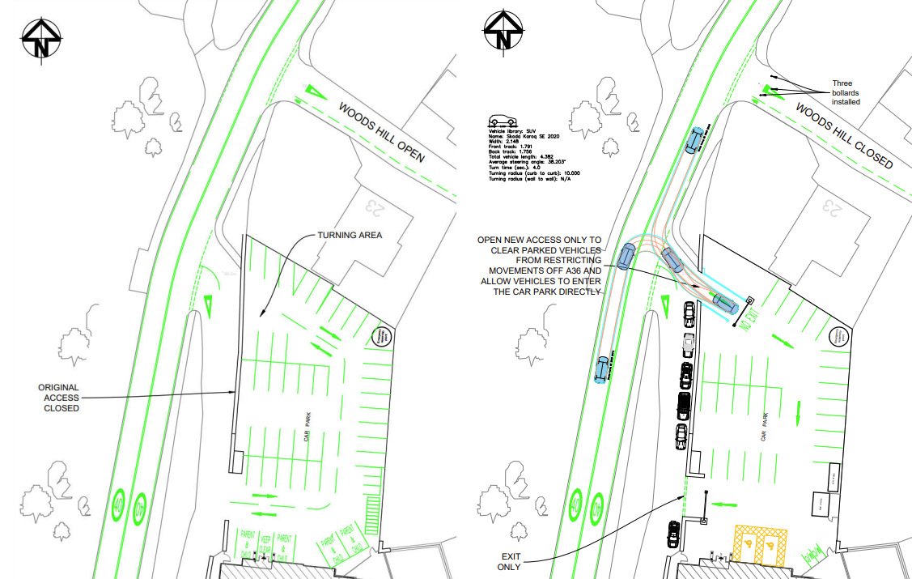
Previously approved plan to left and proposed parking and access shown to the right

The proposed amendments are limited to the reconfiguration of the approved parking layout and the introduction of a one-way circulation system with separate entry and exit points onto Middle Stoke. No changes are proposed to the approved land uses, floor areas, external appearance of the building, or the scale and nature of the development.

The amended scheme has been reviewed against the limitations of Section 73 of the Town and Country Planning Act 1990. The proposed changes do not alter the description of development, do not seek to extend the implementation period of the original permission, and would not result in a fundamentally different form of development from that previously approved.
Accordingly, the proposed amendments are considered to fall within the scope of Section 73 and the application can be properly determined as a variation of Condition 2 attached to planning permission 16/10880/FUL.

The extracts provided below illustrate the proposed changes to the approved plans and the revisions to the car parking layout and access arrangement this application is seeking consent for:

Green Belt

The site lies within the Bristol/Bath Green Belt where the provisions of Section 13 of the NPPF apply. Paragraph 153 of the Framework confirms that substantial weight should be given to any harm to the Green Belt.

The current application does not propose any additional built development beyond that approved under planning permission 16/10880/FUL. The amendments are limited to alterations to the parking and access arrangement.

When granting the original permission, it was concluded that the proposal would not adversely affect the openness of the Green Belt and that the associated works were acceptable in Green Belt terms. The current proposal does not alter that position.

As no additional built form is proposed, the amendments do not constitute inappropriate development within the Green Belt and would preserve openness and the purposes of including land within it. The proposal therefore remains acceptable having regard to the NPPF and Core Policy 51 of the Wiltshire Core Strategy.

Design and Impact upon the Character and Context of the Area including the CNL and SLA

Core Policy 57 of the Wiltshire Core Strategy requires development to respond positively to local character and distinctiveness, whilst Core Policy 51 seeks to conserve landscape character.

The application proposes no changes to the approved building works, scale, form, massing, external appearance or materials associated with the development approved under planning permission 16/10880/FUL. The amendments are limited to the reconfiguration of the approved parking and access arrangements.

The site occupies a visually contained position within the Avon Valley and Cotswolds National Landscape, in addition to the site also being located within the locally designed SLA. The proposed alterations are confined largely to existing areas of hardstanding and do not introduce any significant new built form into the site.

In determining application 16/10880/FUL, it was concluded that the development would have no detrimental impact upon the overall design of the building, the street scene or the nationally important landscape designation. The current proposal does not alter those previously assessed elements and there have been no material policy changes that would lead to a different conclusion.

The proposed amendments do not affect the scenic quality, natural beauty or special qualities of the Cotswolds National Landscape or the landscape character of the Special Landscape Area.

The proposal is therefore considered to remain in accordance with Core Policies 51 and 57 of the Wiltshire Core Strategy, the Wiltshire Design Guide and the design objectives of the NPPF.

Residential Amenity

Point vii of Core Policy 57 seeks to ensure that development does not have an unacceptable impact on neighbouring residential amenity.

Paragraph 135(f) of the NPPF seeks a high standard of amenity for existing and future users. The amendments would not materially alter previously assessed amenity impacts.

The proposed amendments relate solely to the approved parking and access layout and do not introduce any additional floorspace, intensify the approved use, or alter the relationship between the development and neighbouring properties.

The original permission established the acceptability of the mixed-use nursery and office development in amenity terms. The current proposal would not materially alter levels of activity associated with the approved development but instead seeks to improve the internal operation of the site.

It is therefore considered that the development, as amended, would not result in any unacceptable impacts in terms of noise, disturbance, privacy, outlook or access to daylight and sunlight. Accordingly, the proposal continues to accord with Core Policy 57 of the Wiltshire Core Strategy and the relevant provisions of the NPPF.

Transport and Highways

Core Policies 60, 61 and 62 of the Wiltshire Core Strategy seek to ensure safe and suitable access arrangements and require development to mitigate transport impacts where necessary. Paragraph 116 of the NPPF advises that development should only be refused on highway grounds where there would be an unacceptable impact on highway safety or where the residual cumulative impacts would be severe.

This application principally relates to highway matters and seeks approval for a revised one-way circulation system and amended access arrangement.

The original permission was granted following detailed assessment by both Wiltshire Council Highways and Highways England. Although concerns were acknowledged regarding the constrained nature of the A36/Middle Stoke junction, neither body objected and it was concluded that the development would not result in a severe impact upon highway safety or the wider road network.

In the current application, the Council’s Highway Officer initially sought clarification regarding the proposed barrier system and the reference to a vehicle pull-in area. Following the submission of the Access Management Plan and subsequent clarification from the applicant, the Highway Officer confirmed that the proposed arrangements were acceptable and raised no objection to the development. The management strategy includes opening the barrier during peak nursery drop-off and collection periods, provision of a manual override mechanism, and ongoing monitoring through the site's travel plan.

Limpley Stoke Parish Council has confirmed that it has no comments to make on the application. It is noted that Highways England (now National Highways) raised no objection to the original application despite acknowledging the constraints associated with the A36/Middle Stoke junction. The current proposal does not increase the scale or intensity of the approved development and is limited to revisions to the internal parking and access arrangement. Accordingly, there is no evidence to suggest that the impact upon the strategic or local highway network would materially differ from that previously assessed and found acceptable.

Given that no increase in the scale or intensity of the approved development is proposed, and having regard to the Highway Authority's final position, it is considered that the revised parking and access arrangements would not result in an unacceptable impact on highway safety. The proposal therefore accords with Core Policies 60, 61 and 62 of the Wiltshire Core Strategy and the NPPF.

Ecology

Core Policy 50 seeks to protect biodiversity and ecological networks.

The site remains within the ecological consultation area associated with the Bath and Bradford-on-Avon Bats Special Area of Conservation. As part of the original permission, ecological matters were considered in detail by the Council's Ecologist, who concluded that the development could be screened out from Habitats Regulations Assessment and would not adversely affect the integrity of the SAC. Appropriate mitigation was secured by condition.

As the amendments do not alter the development previously screened under the Habitats Regulations, there is no basis to reach a different conclusion from that previously adopted in the determination of 16/10880/FUL.

The current application does not propose any changes to the building, surrounding habitats, landscaping or ecological mitigation previously approved. The revised parking layout would not give rise to any additional ecological impacts beyond those previously assessed. Accordingly, the proposal remains consistent with Core Policy 50 of the Wiltshire Core Strategy.

Flood Risk and Drainage

Core Policy 67 of the Wiltshire Core Strategy requires development to minimise flood risk and ensure satisfactory drainage arrangements.

The application site lies within Flood Zone 1 and is not identified as being at significant risk from fluvial flooding. The proposed amendments do not involve any substantive increase in built footprint and are confined to alterations to an existing parking and access arrangement.

Flood risk and drainage matters were considered acceptable when planning permission 16/10880/FUL was granted and no additional flood risk constraints have subsequently been identified. The development remains of a scale and nature that would not warrant a revised drainage assessment.

Accordingly, it is considered that the development would not increase flood risk on or off-site and remains compliant with Core Policy 67 of the Wiltshire Core Strategy and the flood risk objectives of the NPPF.

Assessment of Conditions

The application seeks specifically to vary Condition 2 (Approved Plans) to substitute revised parking and access drawings. The principal matter for consideration is whether the amended plans introduce any adverse impacts that would render the approved development unacceptable.

It is noted that elements of planning permission 16/10880/FUL appear to have been substantially implemented, including alterations to the building and accessibility works observed during the officer site inspection. However, the approved mixed-use development has not been brought into use and a number of conditions relating to the parking, cycle parking and refuse storage arrangements remain outstanding. It is therefore appropriate that these matters are reconsidered as part of the current Section 73 permission and updated where necessary to reflect the amended scheme.

The Local Highway Authority initially expressed concern regarding the proposed barrier-controlled access. Specifically, concern was raised that delays associated with operation of the barrier could result in vehicles queuing back onto the A36. Clarification was therefore sought from the applicant.

In response, the applicant submitted an Access Management Plan which confirms:

- The barrier will remain open during morning and afternoon peak nursery drop-off and pick-up periods (0730–0830 and 1500–1600);
- Outside peak periods access will be controlled via a fob-entry system;
- A manual override system will be available in the event of equipment failure;
- The arrangements will be monitored and reviewed through the site's existing Travel Plan process;
- The access controls are proposed in the interests of child safety and site security.

Following receipt of this information, the Highway Officer confirmed that the proposed management arrangements represented a reasonable compromise and addressed the initial concerns regarding barrier operation.

The Highway Officer subsequently sought clarification regarding references within the submitted supporting information to a "pull in bay". Following further discussion, it was confirmed that this referred to the internal vehicle waiting area within the site where vehicles could safely pull clear of the public highway before reaching the access barrier. The Highway Officer confirmed that this clarification satisfactorily addressed the remaining query and raised no further concerns.

Given the above, it is considered reasonable and necessary that the submitted Access Management Plan be secured by condition as part of any varied permission. This would ensure the access operates in the manner assessed by the Highway Authority.

Subject to the substitution of the revised plans and the inclusion of a condition requiring compliance with the Access Management Plan, the amended scheme is considered acceptable.

The applicant has also sought clarification in respect of the Travel Plan condition attached to the original permission. Having reviewed the original planning file, it is noted that the Transport Assessment submitted in support of application 16/10880/FUL contains a dedicated Travel Plan at Section 5 which sets out measures intended to encourage sustainable travel choices for staff and users of the development. The document was available to the Local Planning Authority and Highway Authority during determination of the original application and no alternative Travel Plan document has been identified. In these circumstances, and given that the current Highway Authority response raises no concerns regarding travel planning measures, it is considered reasonable and proportionate to update the condition to require compliance with the Travel Plan contained within Section 5 of the approved Transport Assessment rather than requiring the submission of a further document.

Further information has been submitted during the course of the application in respect of Conditions 5 and 7 attached to planning permission 16/10880/FUL, which required the submission of details relating to cycle parking facilities and refuse/recycling storage respectively.

In relation to Condition 5, the applicant has provided details of the proposed cycle store, including its location, dimensions, external appearance and method of use. The cycle store is shown on the submitted site layout, occupies a footprint of approximately 2.7 metres by 3.9 metres and has an overall height of approximately 2.2 metres. The applicant has confirmed that the structure incorporates timber-clad sides beneath a curved metal roof and will contain floor-fixed Sheffield stands to provide secure cycle storage.

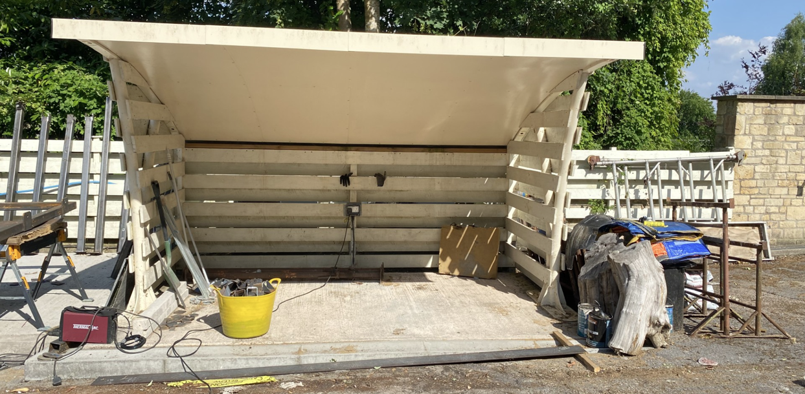
Cycle Store

With regard to Condition 7, the applicant has provided details of the proposed refuse and recycling storage facility, including its location, dimensions, means of enclosure and materials. The refuse store is shown along the eastern site boundary adjacent to the cycle store and measures approximately 3.2 metres by 4.6 metres. The applicant has confirmed that it would comprise a lockable enclosed structure with hit-and-miss timber cladding, a metal roof and an overall height of 2.2 metres reducing to 1.9 metres at the rear.

The original conditions required the submission of details for written approval by the Local Planning Authority but did not prescribe any particular format for the submission of such details. Having reviewed the information provided, including the submitted plans, photographs and accompanying specifications, it is considered that sufficient information has now been supplied to enable the Local Planning Authority to fully assess both structures.

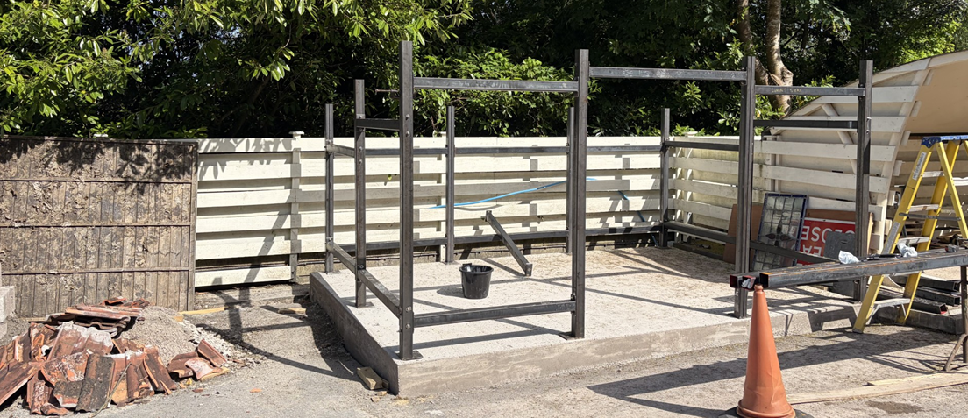
Bin Store

The proposed cycle and refuse storage facilities are modest in scale, are located within the approved parking and servicing area of the site and are positioned adjacent to the site boundary where they would be viewed in the context of existing fencing, hardstanding and associated site infrastructure. Given their limited scale, design and siting, they are not considered to result in any unacceptable impact upon the character or appearance of the area, neighbouring residential amenity, ecological interests, drainage arrangements or any other material planning consideration.

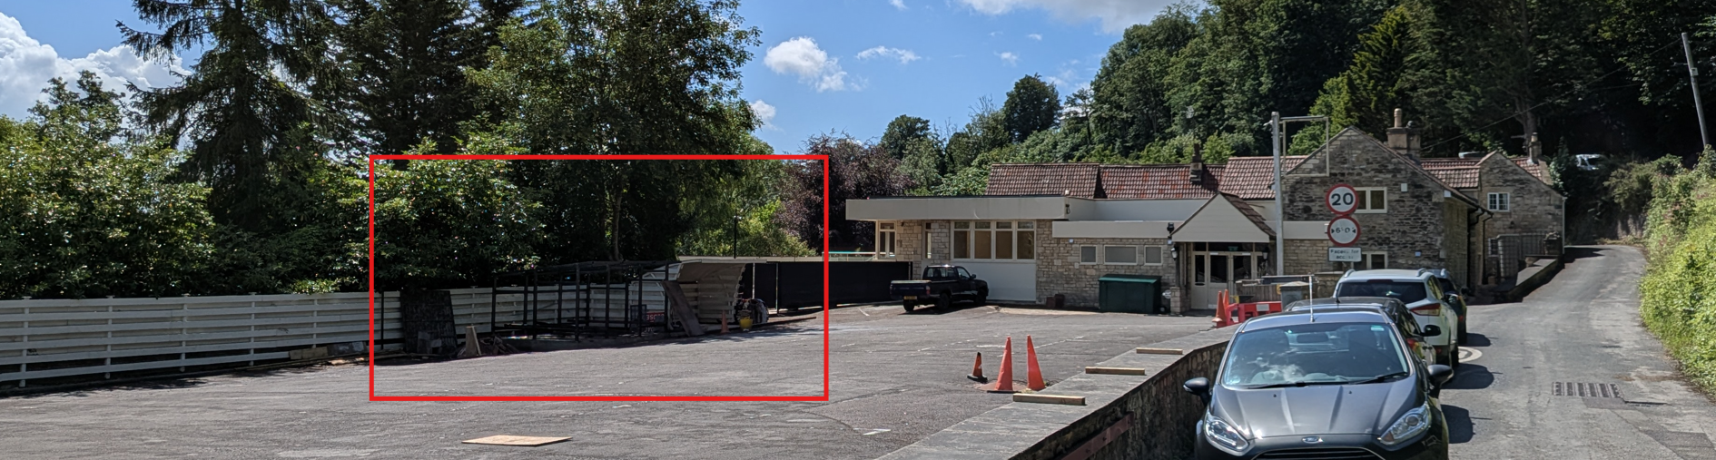
Site Visit (Bin Store and Cycle Store)

Accordingly, it is considered that the requirements of Conditions 5 and 7 attached to planning permission 16/10880/FUL have now been satisfactorily addressed through the information submitted as part of this current s73 application. It is therefore reasonable and appropriate for this permission to secure these facilities through compliance and retention conditions rather than requiring the subsequent submission and approval of further details.

PLANNING BALANCE AND CONCLUSION: In determining this application under Section 73 of the Town and Country Planning Act 1990, the Local Planning Authority has considered whether the proposed amendments fall within the scope of Section 73. The proposed amendments have been assessed against the relevant policies of the Wiltshire Core Strategy, the Freshford and Limpley Stoke Neighbourhood Plan and the National Planning Policy Framework. The assessment has also considered whether the development, as amended, materially alters the nature or impacts of the approved scheme.

In weighing the planning balance, the following factors have been considered:

Benefits: The revised layout provides a more structured and efficient one-way circulation system within the site; improves vehicle management and manoeuvring arrangements; reduces the potential for vehicle conflict at the site access; incorporates an access management strategy designed to prevent queuing on the A36; and enhances operational safety for nursery users, particularly young children.

Harms: Limited concerns were initially identified regarding the potential for vehicles to queue on the public highway as a result of the proposed barrier-controlled access. However, these concerns have been satisfactorily resolved through the submission of the Access Management Plan and subsequent clarification provided to the Local Highway Authority.

The proposed variation of Condition 2 is considered acceptable. The amendments do not materially alter the nature of the approved development, remain within the scope of Section 73 and would not give rise to any unacceptable impacts. The revised access and parking arrangements are supported by the Local Highway Authority and are considered to improve the operation of the approved development within a constrained highway environment.

The proposed amendments are limited in scope and relate solely to the internal operation of the approved development. The revised access arrangement has been assessed by the Local Highway Authority and found acceptable subject to the submitted Access Management Plan. No additional built development is proposed, and there would be no materially different impacts upon the Green Belt, landscape character, ecology, neighbouring amenity, drainage or the highway network. The proposal therefore remains in accordance with the relevant policies of the Wiltshire Core Strategy, the Freshford and Limpley Stoke Neighbourhood Plan and the National Planning Policy Framework. There are no material considerations that indicate planning permission should be withheld.

RECOMMENDATION: That Planning Permission be GRANTED subject to conditions

